Computer Networks Mini-Project — Second Review Submission Template
Field | Details to be filled by student/team
Institution / Department | Vellore Institute of Technology, Vellore — School of Computer Science and Engineering (SCOPE)
Programme / Semester / Section | B.Tech Computer Science and Business Systems (CSBS) / Semester III (Fall 2026–27) / Slot B2+TB2
Course title and code | Computer Networks — BACSE203
Mini-project title | Local Email Transfer System with MIME Attachment Support
Project domain / selected topic | Application-layer protocols — Email transfer (SMTP, POP3) and MIME encoding
Team number
Student name(s) and register number(s) | Suyash Agarwal — 25BBS0088  Kapish Mandhane — 25BCE2375  Yashraj Ujjain — 25BCE0822
Faculty guide | Prakash G
Review number | Second Review
Review date | 02/09/2026
Project duration | 2 months / 8 weeks

1. Executive Summary
Everyday email depends on external providers, which hides how mail is actually transferred and requires internet access. This project builds a self-contained Local Email Transfer System that sends and retrieves mail with file attachments between user accounts on a single host or a local area network, with no external mail server. The team has implemented its own SMTP server for sending and its own POP3 server for retrieval, written directly on TCP sockets in Python, so every command and reply of both protocols is handled explicitly rather than hidden inside a library. Messages and attachments are encoded with MIME (multipart/mixed, base64). After Review-1, attachment handling was revised into a size-based tiered scheme: files up to 1 MB are sent inline, files of 1–10 MB are sent as a reference to a server-side store, and files of 10–25 MB are split into fragments that the receiver reassembles and verifies with a SHA-256 checksum. Implementation status: all four modules are implemented and pass a 90-test automated suite, and every transfer tier has been demonstrated end to end (Section 6.4). The expected final output is a working mail client and server pair, demonstrated with Wireshark captures of the protocol exchange.

2. Final Problem Statement
Target environment: a single computer or a small LAN (for example a lab or hostel network) with no internet access and no external mail provider.
Problem: hosted mail services and high-level mail libraries hide the SMTP and POP3 command exchange, so the transfer mechanics cannot be observed or controlled. Attachments sent inline as base64 grow by about one third, and a large file travels as one oversized message that is slow to send and is lost entirely if the transfer is interrupted.
Intended outcome: users on the LAN exchange mail with attachments up to 25 MB through team-built SMTP and POP3 servers, with the attachment delivery method chosen by file size and every large file verified for integrity on arrival.

3. Review-1 Feedback and Corrective Action
Review-1 feedback/issue identified | Corrective action taken | Evidence/page/screenshot reference | Status
Attachment handling: keep attachments inline in the message, or move them to a local store and send only a reference? | Adopted a size-based tiered scheme: ≤1 MB inline; 1–10 MB by reference to a server-side store; 10–25 MB split into fragments with sequence headers and a SHA-256 checksum. Size is measured on raw bytes before base64. | Sections 4.2, 5.2 (Module 3), 6.3; Evidence 4 | Completed
Scope: implement SMTP and POP3 ourselves, or build on an existing local mail server? | Built custom socket-based SMTP and POP3 servers instead of a library-based (aiosmtpd) server. Python’s smtplib and poplib are used only as reference test clients, and both work against our servers. | Sections 4.1, 5.2 (Modules 1–2); Evidence 1, 2, 5 | Completed
Review-1 risks: concurrent writes could corrupt mailbox files; non-ASCII filenames could break on the round trip. | Implemented per-mailbox file locking on every write (tested with 20 concurrent deliveries) and RFC 2231 encoding for attachment filenames (round trip tested). | Sections 4.2, 5.1; Evidence 3, 5 | Completed

4. Protocol and Technical Background

4.1 Relevant Networking Layer and Protocol
Parameter | Details
OSI / TCP-IP layer | Application layer (TCP/IP) — OSI Layer 7; MIME encoding sits at the presentation level (OSI Layer 6). Runs over the transport layer (TCP).
Protocol(s) / concept(s) used | SMTP (RFC 5321), POP3 (RFC 1939), MIME (RFC 2045–2049), RFC 2231 filename encoding, TCP sockets; HTTP for fetching referenced files.
Default port number(s), if applicable | Standard: SMTP 25, POP3 110. Project: SMTP 2525 and POP3 1110 (non-privileged ports, no admin rights needed); reference store HTTP 8000.
Transport protocol, if applicable | TCP
Addressing used | IPv4 (127.0.0.1 loopback for single-host tests; private LAN addresses for multi-host) + TCP port numbers; mailbox addresses of the form user@localmail.
Key messages, commands, or packet fields | SMTP: EHLO, MAIL FROM, RCPT TO, DATA, QUIT; replies 220, 250, 354, 221, 550.  POP3: USER, PASS, STAT, LIST, RETR, DELE, QUIT; replies +OK / -ERR.  MIME: MIME-Version, Content-Type multipart/mixed; boundary, Content-Transfer-Encoding: base64, Content-Disposition.  Custom headers: X-Transfer-Mode, X-Ref-ID, X-Fragment-ID, X-Fragment-Index, X-Fragment-Total, X-File-SHA256.

4.2 Working Principle
Sending (SMTP). The client opens a TCP connection to the server on port 2525 and the server greets it with 220. The client identifies itself with EHLO, names the sender with MAIL FROM and each recipient with RCPT TO; the server checks that the mailbox exists and answers 250, or 550 if it does not. After DATA the server replies 354, and the client streams the MIME message, ending it with <CRLF>.<CRLF> (lines beginning with a dot are dot-stuffed). The server replies 250, writes the message into each recipient's mailbox directory under a per-mailbox lock, and closes the session on QUIT with 221.
Retrieval (POP3). The receiving client connects to port 1110 and gets +OK. In the AUTHORIZATION state it sends USER and PASS. In the TRANSACTION state it uses STAT and LIST to see the mailbox, RETR n to download a message and DELE n to mark it for deletion. QUIT moves the session to the UPDATE state, where the server permanently removes the marked messages.
MIME encoding. Each message is multipart/mixed with a unique boundary: a text/plain body part followed by one part per attachment, sent as application/octet-stream with base64 transfer encoding and a Content-Disposition filename (RFC 2231-encoded when the name is not ASCII). The receiver splits the message on the boundary, decodes each part and saves the files.
Tiered attachment transfer. File size is measured on the raw bytes, before base64 encoding. Tier 1 (≤1 MB) is attached inline as above. Tier 2 (1–10 MB) is uploaded to the server's reference store; the mail carries X-Transfer-Mode: reference, a reference ID and the file's SHA-256, and the receiving client downloads the file when it retrieves the mail. Tier 3 (10–25 MB) is split into fixed-size chunks of 2 MB, each sent as its own SMTP message with X-Fragment-ID, X-Fragment-Index, X-Fragment-Total and X-File-SHA256 headers. The receiving client groups fragments by ID, orders them by index, joins them and compares the SHA-256 of the result with the header; if a fragment is missing or the hash differs, the file is reported as incomplete instead of being saved.

4.3 Protocol Flow / Sequence Diagram
The sequence below shows one message sent by Client A over SMTP and retrieved by Client B over POP3.

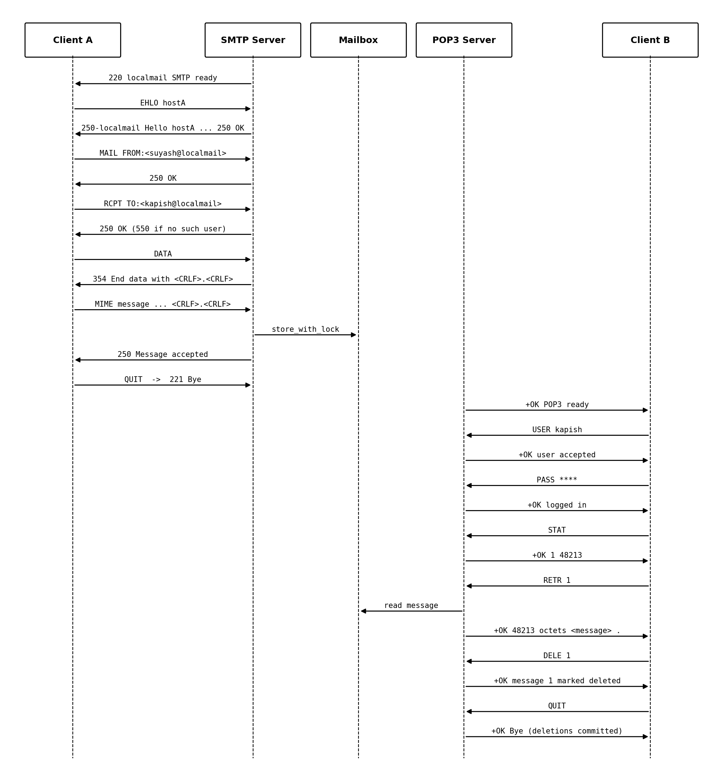
Figure 3: SMTP send and POP3 retrieve sequence (Client A → Client B)
4.4 Related Work / References Studied
No. | Source / RFC / textbook / official documentation | Key learning used in this project
1 | RFC 5321 — Simple Mail Transfer Protocol (IETF) | SMTP command sequence, reply codes, dot-stuffing and the <CRLF>.<CRLF> end-of-data rule used by the custom server.
2 | RFC 1939 — Post Office Protocol, Version 3 (IETF) | POP3 AUTHORIZATION / TRANSACTION / UPDATE states and the USER, PASS, STAT, LIST, RETR, DELE, QUIT commands.
3 | RFC 2045–2049 (MIME) and RFC 2231 (IETF) | multipart/mixed structure, base64 transfer encoding, Content-Disposition, and encoding of non-ASCII filenames.
4 | Kurose & Ross, Computer Networking: A Top-Down Approach — Application Layer chapter (electronic mail) | How SMTP push and mail-access protocols fit together in the overall email architecture.
5 | Python documentation — socket, email, hashlib modules | TCP socket server design, MIME message building/parsing, SHA-256 hashing.

5 System Design

5.1 Overall Architecture
Each user host runs the mail client; one host also runs the mail server. The client's MIME & Tier Engine decides how each attachment travels, the SMTP client pushes mail to the custom SMTP server, and the POP3 client pulls mail from the custom POP3 server. The server stores mail in per-user Maildir directories with an SQLite index, and keeps 1–10 MB files in a separate reference store served over HTTP.

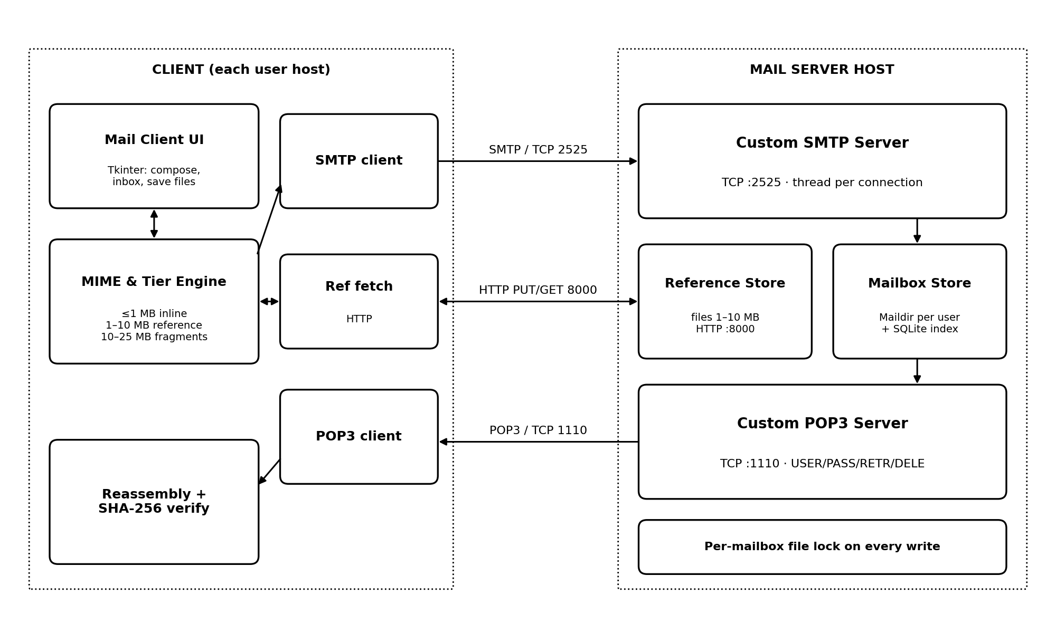
Figure 1: System architecture

5.2 Module Description
Module | Purpose | Inputs | Outputs | Completion status
Module 1: SMTP server | Accept mail from clients and store it in recipient mailboxes | TCP connections on 2525; SMTP commands; MIME message data | Reply codes (220/250/354/221/550); message files in recipient Maildir + index entry | Complete
Module 2: POP3 server | Authenticate users and serve their mailbox | TCP connections on 1110; USER, PASS, STAT, LIST, RETR, DELE, QUIT | +OK / -ERR replies; raw message content; deletions committed on QUIT | Complete
Module 3: MIME & tier engine | Build and parse MIME messages; choose delivery tier by file size; reassemble and verify | Message text; attachment files | Inline parts, reference messages or fragment messages; reassembled files with SHA-256 check | Complete
Module 4: Client application (Tkinter) | Interface to compose, send, read and save mail | User input; selected files; POP3 data | Mail sent via SMTP; inbox view; saved attachments | Complete

5.3 Network Topology / Data Flow
All hosts sit on one LAN subnet behind a switch or Wi-Fi access point. Mail flows ① from the sender to the server over SMTP, then ② from the server to the receiver over POP3; referenced files follow path ③ over HTTP. For single-host testing, all three roles run on 127.0.0.1.
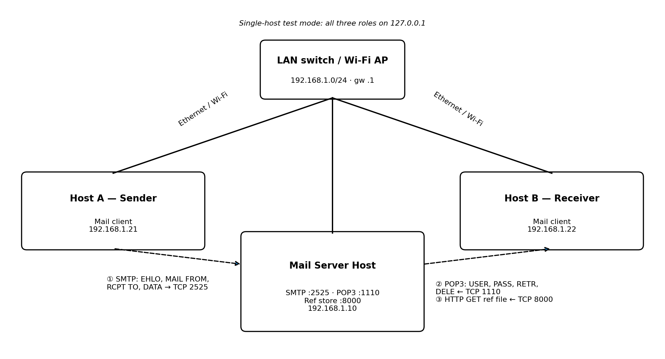
Figure 2: Network topology/data flow
6 Configuration and Implementation Details
6.1 Tools and Technology Stack
Purpose | Tool/technology | Version/platform | Justification
Programming language | Python | 3.13 (macOS), 3.12 (Ubuntu test runs) | Standard library covers sockets, threads, MIME and hashing, so all protocol logic can be written by the team without third-party frameworks.
Network simulator | Not used | — | The system runs on real TCP sockets over loopback and LAN, so live traffic is captured instead of simulated.
Packet analyser | Wireshark | 4.2.2 | Verifies SMTP/POP3 command–reply exchanges and fragment traffic on ports 2525 and 1110.
OS / platform | macOS 26 (development); Ubuntu 24.04 (test runs, captures) | Team laptop; test machine | The same Python code runs unchanged on both; the Section 6.4 evidence was captured on the Ubuntu test machine.
Libraries / APIs | socket, threading, email.mime, base64, hashlib, sqlite3, http.server, tkinter | Python standard library | No external dependencies; each module maps to one protocol task.
Testing tools | netcat / telnet; smtplib and poplib as reference clients; unittest | — | Manual protocol sessions; standard clients confirm the custom servers follow the RFCs.
6.2 Addressing / Port / Rule Plan
Tables A and B apply to this project. Table C is not applicable because the project has no firewall component.
A. IP Addressing Table — for forwarding, subnetting, ARP, firewall, or Packet Tracer projects
Device / Interface | IP address | Prefix/mask | Default gateway / next hop | VLAN / subnet | Purpose
Mail server host (Wi-Fi/Ethernet) | 192.168.1.10 | /24 (255.255.255.0) | 192.168.1.1 (LAN router) | Single LAN subnet | Runs SMTP, POP3 and reference store
Client host A (sender) | 192.168.1.21 (DHCP) | /24 | 192.168.1.1 | Same subnet | Mail client
Client host B (receiver) | 192.168.1.22 (DHCP) | /24 | 192.168.1.1 | Same subnet | Mail client
Loopback (single-host test) | 127.0.0.1 | /8 | — | — | All roles on one machine
B. Port and Service Table — for SMTP, POP3, HTTP, FTP, Telnet, or socket projects
Component | IP / hostname | Transport | Port | Service/command | Purpose
SMTP server | Server IP / 127.0.0.1 | TCP | 2525 | EHLO, MAIL FROM, RCPT TO, DATA, QUIT | Accept and store outgoing mail
POP3 server | Server IP / 127.0.0.1 | TCP | 1110 | USER, PASS, STAT, LIST, RETR, DELE, QUIT | Mailbox retrieval
Reference store | Server IP / 127.0.0.1 | TCP | 8000 | HTTP PUT / GET /ref/<id> | Upload and download 1–10 MB files
Mail client | Client IP | TCP | Ephemeral (OS-assigned) | — | Opens SMTP, POP3 and HTTP connections

C. Firewall Rule Table — for firewall projects
Rule ID | Source | Destination | Protocol | Port | Action | Reason/policy
— | N/A | N/A | N/A | N/A | N/A | Not applicable: no firewall in this project
6.3 Key Configuration / Code Extracts
Extracts from the implemented code: the SMTP connection handler (localmail/server/smtp_server.py) and the tier-selection function (localmail/client/tiering.py). The full source code is attached separately.
# SMTP connection handler — localmail/server/smtp_server.py, lines 64-119 (excerpt)
def handle_client(conn, peer, cfg, store):
reader = LineReader(conn)
send(conn, "220 %s SMTP ready" % cfg["domain"], TAG)
state, sender, rcpts = "INIT", None, []
for line in recv_lines(reader):
log_line(TAG, "C", line)
cmd, _, arg = line.partition(" ")
cmd = cmd.strip().upper()
# ... lines 72-95: EHLO/HELO, MAIL FROM, RCPT TO (503 / 501 / 550 checks) ...
elif cmd == "DATA":
if state != "RCPT":
send(conn, "503 Bad sequence of commands", TAG)
continue
send(conn, "354 End data with <CRLF>.<CRLF>", TAG)
data, oversize = read_until_dot(reader, cfg["hard_max"])
log_line(TAG, "C", "<%d bytes of message data>" % len(data))
if oversize:
send(conn, "552 Message size exceeds limit", TAG)
else:
data = add_received(data, sender, rcpts, peer, cfg["domain"])
for rcpt in rcpts:
store_with_lock(store, rcpt.partition("@")[0], data)
send(conn, "250 Message accepted", TAG)
sender, rcpts, state = None, [], "READY"
# ... lines 111-116: RSET, NOOP ...
elif cmd == "QUIT":
send(conn, "221 Bye", TAG)
break

# Tier selection — localmail/client/tiering.py, lines 23-31 (complete)
def choose_tier(size, cfg):
# tier is decided on RAW bytes, before base64
if size <= cfg["inline_max"]:
return "inline"
if size <= cfg["reference_max"]:
return "reference"
if size <= cfg["hard_max"]:
return "fragment"
return "reject"

6.4 Implementation Evidence
All screenshots below are from real runs of the implemented system on 30/09/2026 (servers on 127.0.0.1; Ubuntu 24.04 test machine; Python 3.12; Wireshark 4.2.2).
Evidence no. | Screenshot/output description | What it proves
1 | Wireshark capture on the loopback interface (TCP 2525, decoded as SMTP): packet list and Follow TCP Stream showing 220 → EHLO → MAIL FROM → RCPT TO → DATA → 354 → MIME message → 250 Message accepted → QUIT → 221 Bye | The custom SMTP server follows the RFC 5321 command–reply sequence and carries a multipart/mixed MIME message.
2 | Manual netcat session on TCP 1110: USER, PASS, STAT, LIST, RETR, DELE, QUIT; a second session shows STAT +OK 0 0 | The custom POP3 server implements the RFC 1939 states, and DELE is committed only at QUIT.
3 | Tkinter client: inline attachment संदेश_é.txt received over POP3, opened in the OS text editor and saved (status bar) | MIME decoding and RFC 2231 non-ASCII filenames work end to end; UTF-8 content arrives intact.
4 | Client log: 500 KB inline, 5 MB reference and 15 MB fragmented transfers; 8 fragments reassembled; SHA-256 match for all three | All three transfer tiers, fragment reassembly and the integrity check work.
5 | Automated unittest suite: 90 tests across SMTP, POP3, MIME, tiering, reference store, concurrency, GUI and reference clients | The implementation is verified by repeatable automated tests, all passing.
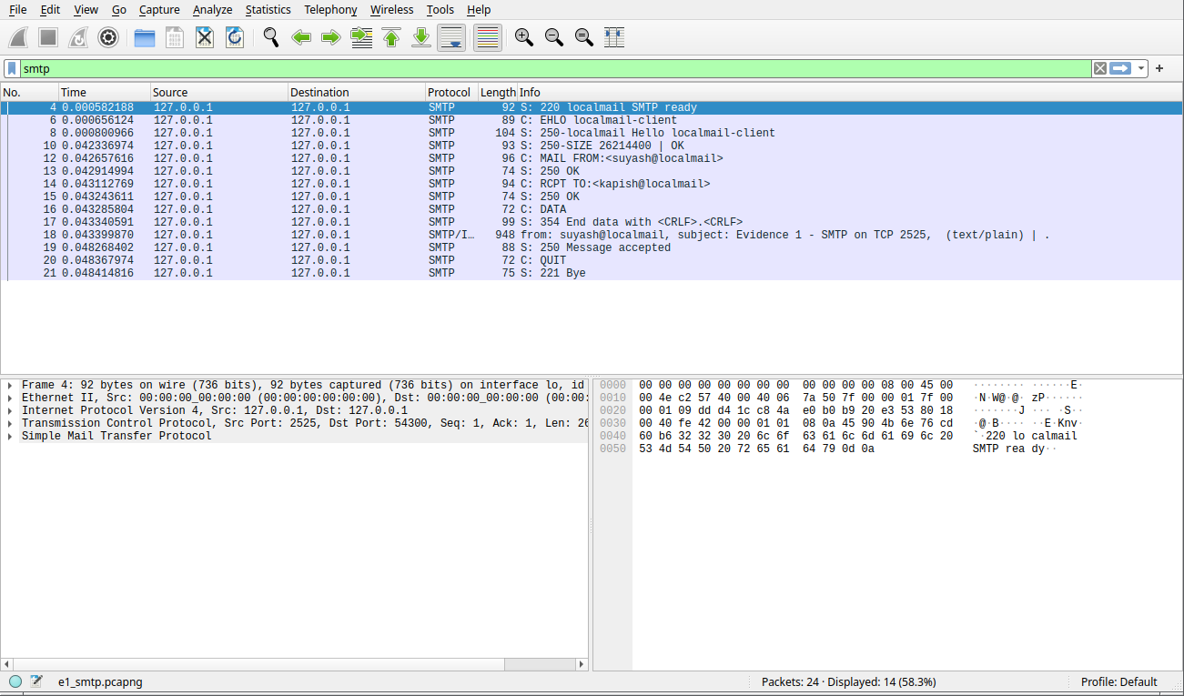
Evidence 1a: SMTP session on TCP 2525 in Wireshark (packet list, decoded as SMTP)
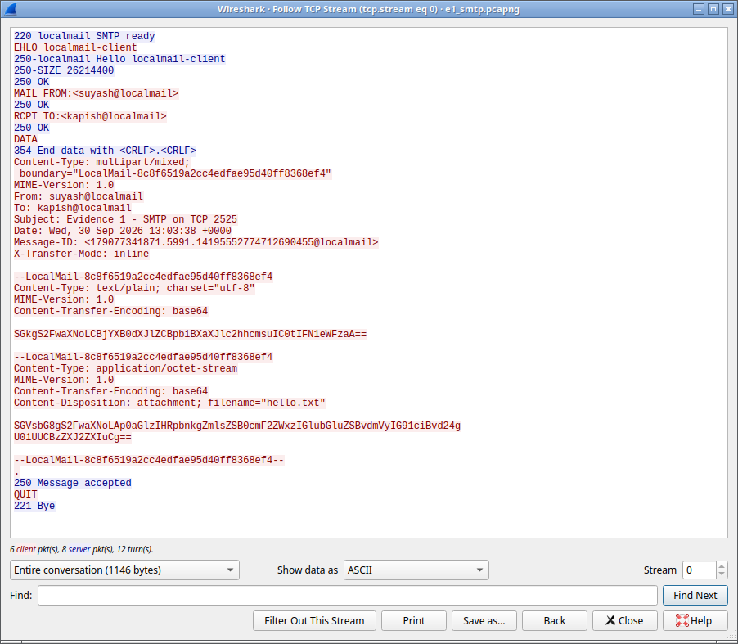
Evidence 1b: Follow TCP Stream of the same session, showing every command, reply and the MIME body
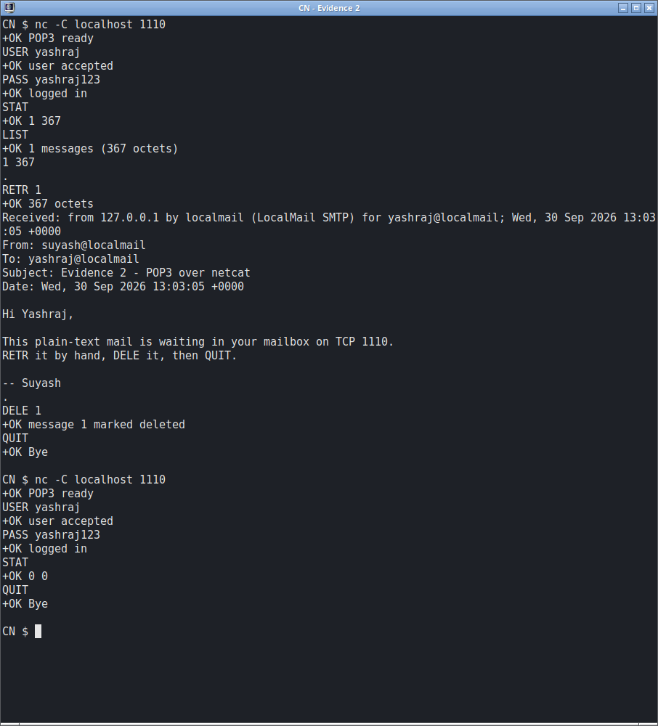
Evidence 2: manual POP3 session over netcat on TCP 1110; the reconnect shows DELE committed at QUIT
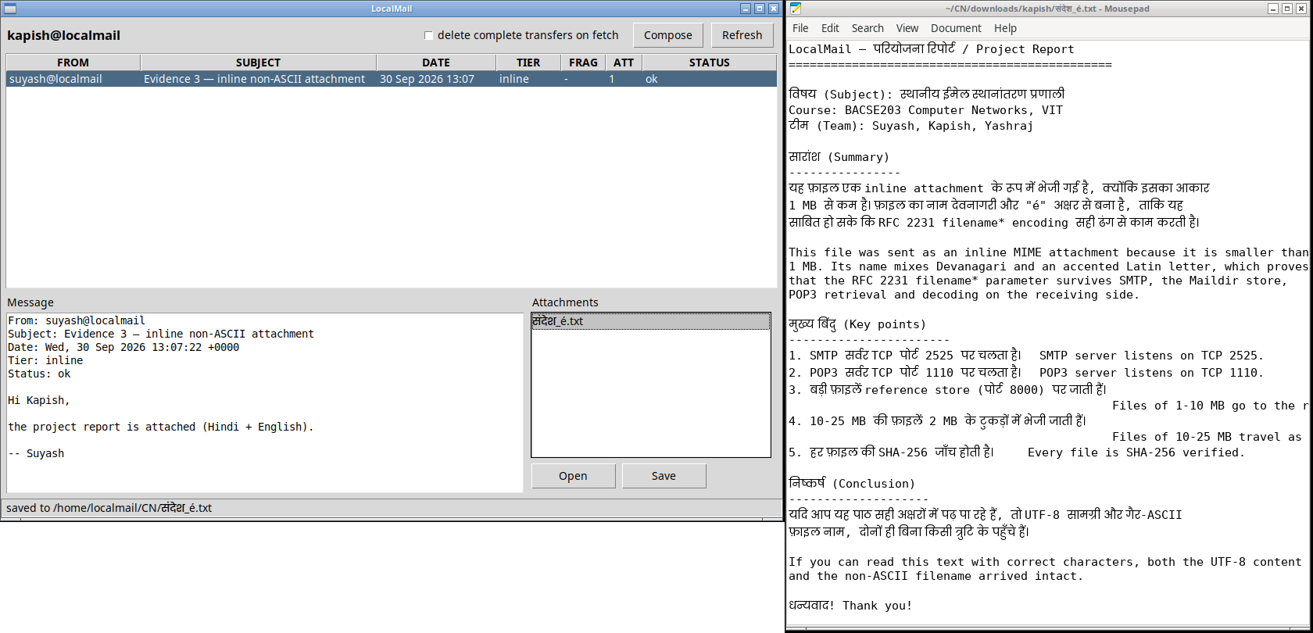
Evidence 3: inline attachment with a non-ASCII (Devanagari) filename, opened in the text editor and saved
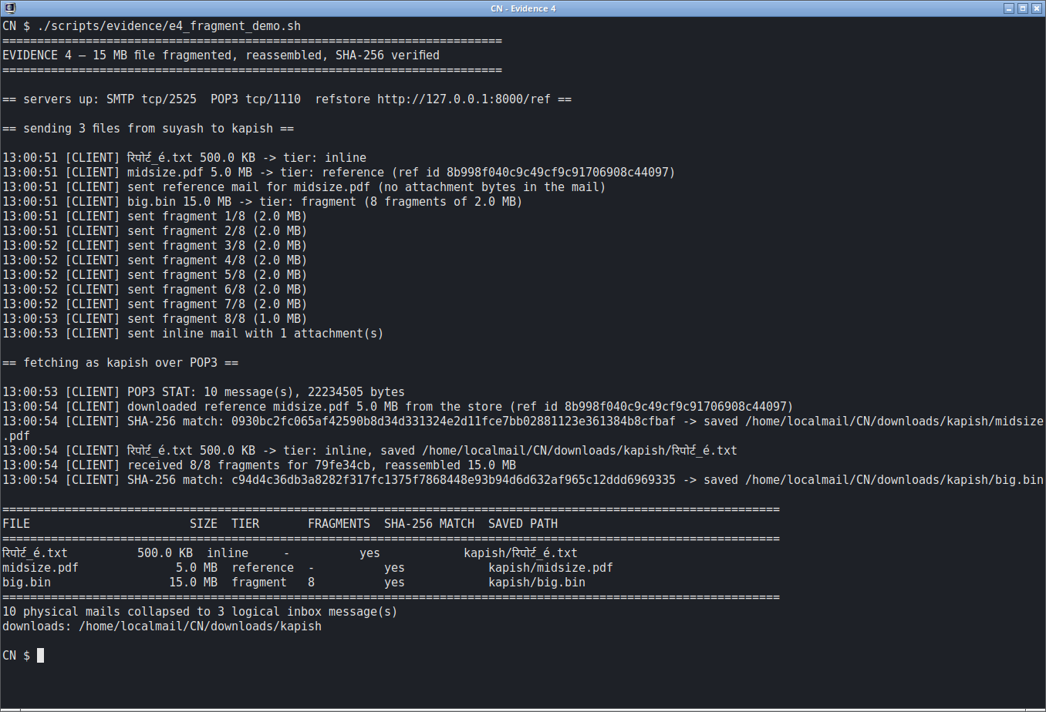
Evidence 4: 500 KB inline, 5 MB reference and 15 MB fragmented transfers with SHA-256 verification
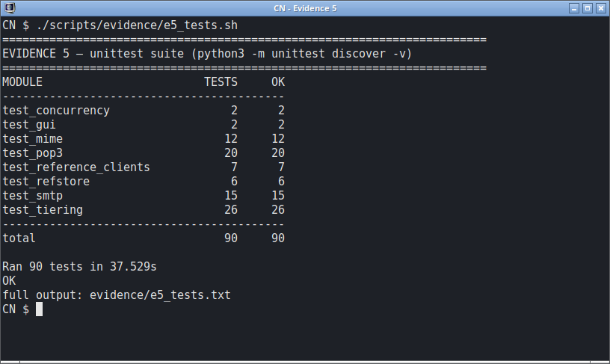
Evidence 5: automated test suite, 90 tests passing

