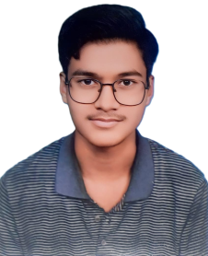
UTKARSH AGARWAL
BCA STUDENT & COMPUTER APPLICATION SPECIALIST
 Mobile: 7818026130
 Email: agarwalurtkarsh1948@gmail.com
 Address: Moh. Sahukara, Station Road, Near C.A.S. Inter College, Ram Leela Ground, Faridpur, Bareilly, Uttar Pradesh
-*

CAREER OBJECTIVE
A motivated and dedicated BCA student currently pursuing graduation from Invertis University, Bareilly. I am passionate about programming and computer applications and eager to start my professional journey in the IT field. I aim to utilize my communication skills, technical knowledge, and willingness to learn while contributing to the growth of an organization.

EDUCATIONAL QUALIFICATIONS

Graduation Bachelor of Computer Applications (BCA)
Invertis University, Bareilly

[Currently Pursuing]
Class 12 Photography Professional Stream
Passed with 75.5%
Class 10 Completed

TECHNICAL SKILLS & SPECIALIZATIONS

Technical Core:
- Advanced MS Office
- Microsoft Excel (Specialization)
- Computer Fundamentals
- Programming Fundamentals
- Data Entry & Documentation
- Internet & Email Handling

Specialized Concepts:
- ABCA (Advanced Business Computer Applications)
- ADCB (Advanced Data Computer Basics)
- Office Productivity Tools & Data Management
- Computer Applications & IT Systems

KEY SOFT SKILLS & CURRENT LEARNINGS

Core Strengths:
- Good English & Local Communication Skills
- Teamwork & Collaborative Spirit
- Quick Learner with Adaptability
- Problem-Solving & Time Management Ability

Areas of Focus (Current Learning):
- Programming Languages
- Advanced Computer Applications
- IT & Software Development Fundamentals

WORK EXPERIENCE
Fresher — Currently focusing heavily on academic studies, technical skill development in programming, computer applications, and corporate communication.

PERSONAL DETAILS
Father's Name: Mr. Devedra Kumar Agarwal
Date of Birth: 30-05-2007
Nationality: Indian
Languages Known: Hindi, English

Declaration:
I hereby declare that the information provided above is true and correct to the best of my knowledge and belief.

Date: 31/05/2026

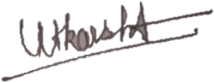
Place: Faridpur, Bareilly, UP

