**Amazon RDS: Quick way to get database on cloud for quick deployment and very less investment.**

**We bought one instance of MySQL on Amazon RDS.**

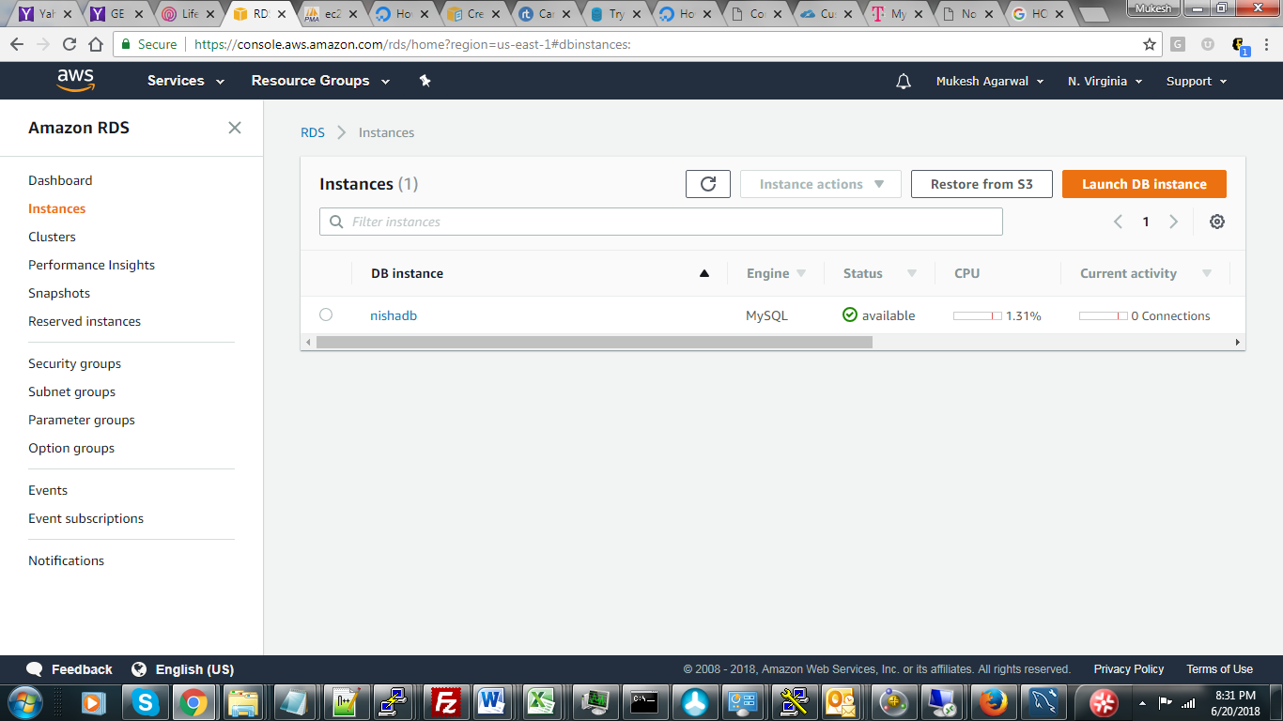

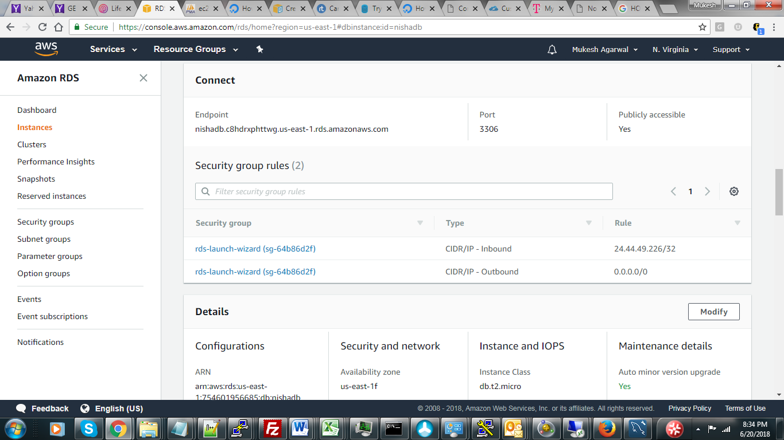

**End point and Port# is needed to connect to Amazon RDS.**

**STEPS TO PREPARE DATABASE:**

* **Due to Port# 3306 being blocked in Rutgers Class, we have decided to use local copy of the database.**
* **Build Database**

Create database bootcamp;

* **Create database table compatible with CSV World Bank file**

create table country_indicator_flat (

country_name nvarchar(1000) DEFAULT NULL,

country_code nvarchar(20) DEFAULT NULL,

indicator_name nvarchar(1000) DEFAULT NULL,

indicator_code nvarchar(25) DEFAULT NULL,

yr_1960 nvarchar(25) DEFAULT NULL,

yr_1961 nvarchar(25) DEFAULT NULL,

yr_1962 nvarchar(25) DEFAULT NULL,

yr_2015 nvarchar(25) DEFAULT NULL,

yr_2016 nvarchar(25) DEFAULT NULL,

yr_2017 nvarchar(25) DEFAULT NULL

) ENGINE=INNODB DEFAULT CHARSET=ascii COLLATE=ascii_bin;

* **Load CSV file into database table “country_indicator_flat”**

LOAD DATA LOCAL INFILE '$DIR/WorldBankData.csv'

INTO TABLE country_indicator_flat

FIELDS TERMINATED BY ','

ENCLOSED BY '\"'

LINES TERMINATED BY '\n'

IGNORE 1 LINES

* **Build another table to organize data by country, year and indicator type.**

create table country_indicator (

country_indicator_id INT(11) AUTO_INCREMENT PRIMARY KEY,

country_code nvarchar(20) NULL,

country_id int NULL,

indicator_code nvarchar(25) NULL,

indicator_id int NULL,

year int NULL,

indicator_value double NULL

);

* **Load country_indicator table as follows:**

insert into country_indicator (country_code, indicator_code, year, indicator_value) select country_code, indicator_code, 1960, CAST(yr_1960 as decimal(22,6)) from country_indicator_flat where yr_1960 is not NULL and yr_1960 REGEXP '[eE+-.0-9]';

insert into country_indicator (country_code, indicator_code, year, indicator_value)

select country_code, indicator_code, 1961, CAST(yr_1961 as decimal(22,6)) from country_indicator_flat where yr_1961 is not NULL and yr_1961 REGEXP '[eE+-.0-9]';

insert into country_indicator (country_code, indicator_code, year, indicator_value) select country_code, indicator_code, 1962, CAST(yr_1962 as decimal(22,6)) from country_indicator_flat where yr_1962 is not NULL and yr_1962 REGEXP '[eE+-.0-9]';

insert into country_indicator (country_code, indicator_code, year, indicator_value) select country_code, indicator_code, 1963, CAST(yr_1963 as decimal(22,6)) from country_indicator_flat where yr_1963 is not NULL and yr_1963 REGEXP '[eE+-.0-9]';

insert into country_indicator (country_code, indicator_code, year, indicator_value) select country_code, indicator_code, 2016, CAST(yr_2016 as decimal(22,6)) from country_indicator_flat where yr_2016 is not NULL and yr_2016 REGEXP '[eE+-.0-9]';

insert into country_indicator (country_code, indicator_code, year, indicator_value) select country_code, indicator_code, 2017, CAST(yr_2017 as decimal(22,6)) from country_indicator_flat where yr_2017 is not NULL and yr_2017 REGEXP '[eE+-.0-9]';

**We have approx. 4 million rows.**

* **Create abbreviated table to house indicators that we need for report.**

CREATE TABLE `country_indicator_abbr` (

`country_indicator_id` int(11) NOT NULL AUTO_INCREMENT,

`country_code` varchar(20) CHARACTER SET utf8 COLLATE utf8_general_ci DEFAULT NULL,

`country_id` int(11) DEFAULT NULL,

`indicator_code` varchar(25) CHARACTER SET utf8 COLLATE utf8_general_ci DEFAULT NULL,

`indicator_id` int(11) DEFAULT NULL,

`year` int(11) DEFAULT NULL,

`indicator_value` double DEFAULT NULL,

PRIMARY KEY (`country_indicator_id`),

KEY `idx1_country_code` (`country_code`),

KEY `idx2_indicator_code` (`indicator_code`)

) ENGINE=InnoDB AUTO_INCREMENT=5341098 DEFAULT CHARSET=utf8mb4 COLLATE=utf8mb4_0900_ai_ci;

* **Load abbreviated table.**
* **Created views for reports**

CREATE VIEW GDP_IN_USD_ABBR_VIEW AS SELECT year, ci.country_code, country_name, ci.indicator_code, indicator_name, indicator_value FROM country_indicator_abbr ci

LEFT JOIN indicator i ON ci.indicator_id = i.indicator_id LEFT JOIN country c ON ci.country_id = c.country_id

WHERE i.indicator_code = 'NY.GDP.MKTP.CD' AND year BETWEEN 1990 AND 2016;

SELECT * FROM GDP_IN_USD_ABBR_VIEW;

CREATE VIEW TOTAL_POPULATION_ABBR_VIEW AS SELECT year, ci.country_code, country_name, ci.indicator_code, indicator_name, indicator_value FROM country_indicator_abbr ci

LEFT JOIN indicator i ON ci.indicator_id = i.indicator_id LEFT JOIN country c ON ci.country_id = c.country_id

WHERE i.indicator_code = 'SP.POP.TOTL' AND year BETWEEN 1990 AND 2016;

SELECT * FROM TOTAL_POPULATION_ABBR_VIEW;

CREATE VIEW PCT_RENEWABLE_ENERGY_ABBR_VIEW AS SELECT year, ci.country_code, country_name, ci.indicator_code, indicator_name, indicator_value FROM country_indicator_abbr ci

LEFT JOIN indicator i ON ci.indicator_id = i.indicator_id LEFT JOIN country c ON ci.country_id = c.country_id

WHERE i.indicator_code = 'EG.ELC.RNEW.ZS' AND year BETWEEN 1990 AND 2016;

SELECT * FROM PCT_RENEWABLE_ENERGY_ABBR_VIEW;

CREATE VIEW PCT_ACCESS_TO_ELECTRICITY_ABBR_VIEW AS SELECT year, ci.country_code, country_name, ci.indicator_code, indicator_name, indicator_value FROM country_indicator_abbr ci

LEFT JOIN indicator i ON ci.indicator_id = i.indicator_id LEFT JOIN country c ON ci.country_id = c.country_id

WHERE i.indicator_code = 'EG.ELC.ACCS.ZS' AND year BETWEEN 1990 AND 2016;

SELECT * FROM PCT_ACCESS_TO_ELECTRICITY_ABBR_VIEW;

CREATE VIEW CO2_EMISSION_KT_ABBR_VIEW AS SELECT year, ci.country_code, country_name, ci.indicator_code, indicator_name, indicator_value FROM country_indicator_abbr ci

LEFT JOIN indicator i ON ci.indicator_id = i.indicator_id LEFT JOIN country c ON ci.country_id = c.country_id

WHERE i.indicator_code = 'EN.ATM.CO2E.KT' AND year BETWEEN 1990 AND 2016;

SELECT * FROM CO2_EMISSION_KT_ABBR_VIEW;