## Predicting the optimal location for opening new restaurant in the city of Pune India

Pooja Agarwal

March 6th 2020

**Table of contents**

* Introduction: Business Problem
* Data
* Methodology
* Analysis
* Results and Discussion
* Conclusion
* References

**1**. **Introduction**

**1.1 Background**:

Pune is one of the fastest growing cities of India. The city has seen a major growth in population as it is moving ahead in its path of being a hub for IT and Education services. It is also in the process of becoming a SMART city attracting even more people. The property costs in Pune are not as high as other major cities of India. But with good average income, this city is a good candidate for business. Specially Restaurant business as the city has people from all over India as well as people from outside India residing in the city working for the IT companies. It seems to be a good time to open a multi-cuisine or franchise (McD, KFC etc) restaurant in the growing city of Pune.

**1.2 Problem**:

Best location to open a new restaurant in Pune. The success of a restaurant is affected by its location, area population and other attractions in the area. Hence, it is very important to do a thorough analysis of the optimal location for opening the new restaurant.

**1.3 Audience**:

*Someone looking to open a new restaurant in the city.*

**1.4** **Solution Approach**:

In this project we will try to find an optimal location for a restaurant in the city of Pune India.

Using data analysis techniques we will find out the density of restaurants in various neighborhoods of the city. We will also find the top venues of the area.

Then we will find areas with low density of restaurants and some new attractions coming in like a big IT firm opening their office or a new multiplex being constructed in the area etc.

1. **Data Acquisition and Cleaning**

**2.1** For the problem discussed above, I have taken below **data** for the city of Pune, India:

* Neighborhoods of the city
* Map coordinates of the neighborhoods
* Various types of venues in 500m of the neighborhoods
* Current attraction - a new/undergoing project

**2.2 Sources:**

* Neighborhoods data is taken from Wikipedia
* Coordinates are taken using Google Maps API geocoders
* Venues data is taken from Foursquare API

**2.3** Further I will be using Google to check for news of any new/ongoing projects, IT offices, multiplexes being constructed in the areas of choice we get. So that we are able to make an even better suggestion.

**2.4** **For Example** - Lets say after our analysis, we get two neighborhoods n1 and n2 that seems like optimal options for opening a restaurant. Then using the additional data, we can if there is a new/ongoing IT SEZ office with a capacity of 10,000 people is being/newly constructed in (say) n1. On the other hand there are no such activities going on in n2. According to this, we will be able to recommend n1 over n2.

The dataset created contains information about the venues (from Foursquare.com) under 64 unique venue categories for all neighborhoods in the city.

**2.5 Additional data points**

I will analyze the data further on below points:

* number of venue in restaurants/food category in the neighborhoods
* neighborhoods with nearby venues like IT Center, Malls, Multiplexes or Cineplex, Education centers will be given preference in selection
* neighborhoods with high rate of housing sales will be further given preference

1. **Methodology**

* Using the above data, we will try to find the area in the city which will be optimal for opening a restaurant. This area is expected to have **fewer numbers of restaurants** as compared to other areas.
* Another factor to keep check of is the location of the area in the city. A restaurant closer to cities center has higher chances of success than an area in the outskirts.
* To prepare the data, we will take all neighborhoods and their coordinates using **Foursquare API**.
* Further we will take **trending venues** in the neighborhoods within a radius of 0.5 km. We will categories the neighborhoods with the venue density to get an idea of the neighborhoods with most and least number of Restaurants.
* Then we will take the top 10 most common venues for each neighborhood. Next we will merge it with location coordinates. Then using this data we will create clusters using **k-means clustering** and will plot the clusters on a map using **folium**.
* Finally we will recognize the neighborhoods with low density of restaurants and further add the **Property Rates** of the neighborhoods. To find for a good solution, we will identify the area with optimal venue density and Property Rate. As both these are factors in selecting an area for a new restaurant.

1. **Exploratory Data Analysis**

* We collected the Pune city neighborhood data from Wikipedia. Then we used Google geocoder the fetch latitude and longitude coordinates for each neighborhood.

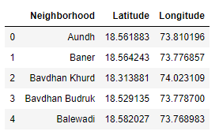

* Next, we plotted the neighborhood data using a folium map

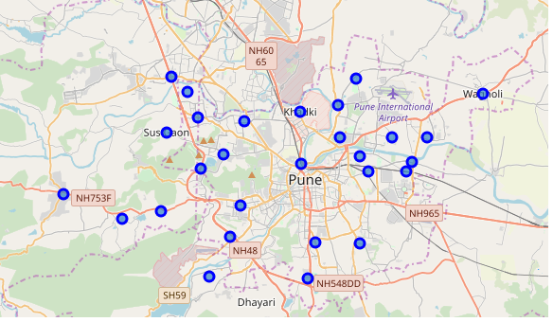

* Then we fetched venues nearby all the neighborhoods in the city using Foursquare explore API
* From the Foursquare lab in the previous module, we know that all the information is in the items key. We used the get_category_type function from the Foursquare lab.
* We created a function to clean the json returned from Foursquare api and structure it into a pandas dataframe for all the neighborhoods in Pune India
* We provided the Foursquare credentials for making a connection for API calls
* Then we declared LIMIT=100 and radius=500m for the Foursquare API call
* Next we have written the code to run the above function on each neighborhood and create a new dataframe.

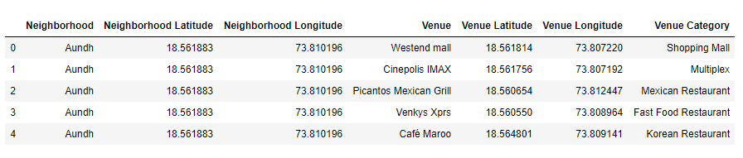

* Then we mapped the data to find 5 areas with most and least venues count

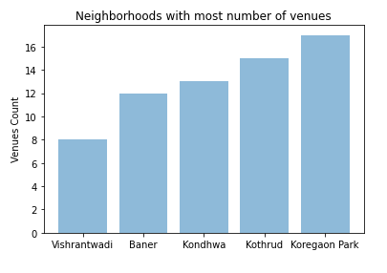

**Chart1**: Neighborhoods with most number of venues

**Chart2**: Neighborhoods with least number of venues

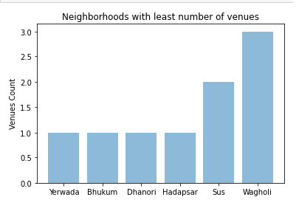

* After that we checked the unique categories returned for the city. And there were 68 unique categories.
* Then we found every venue in the neighborhood using **one hot encoding**

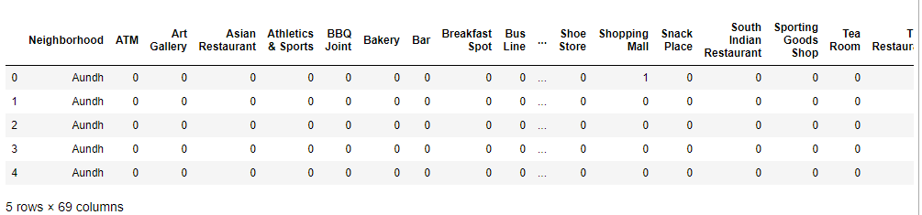

* Next we created the new dataframe and display the top 10 venues for each neighborhood.

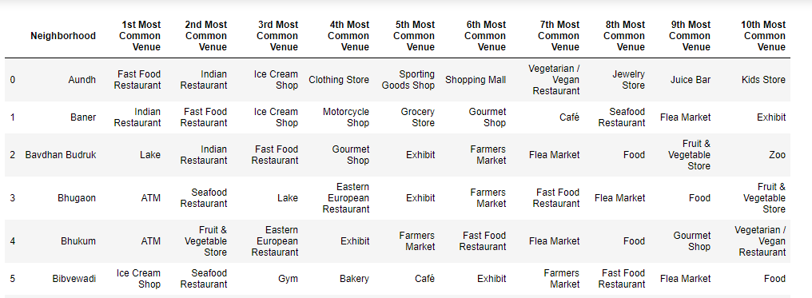

* After this we created cluster on Neighborhoods. We used k-means clustering approach to cluster the neighborhood into 5 clusters.
* Then we created a new dataframe that includes the cluster as well as the top 10 venues for each neighborhood.

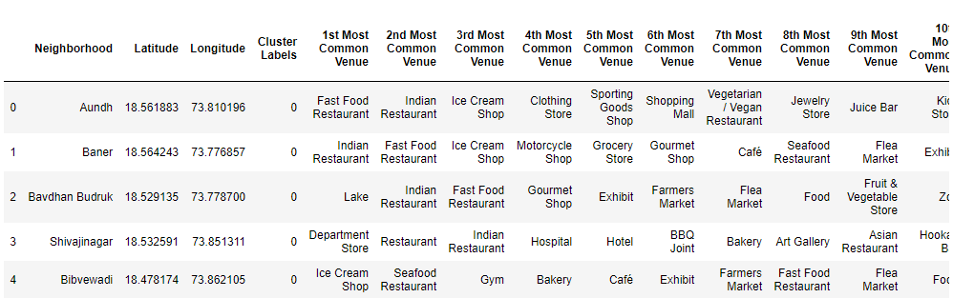

* Finally, we visualize the resulting clusters

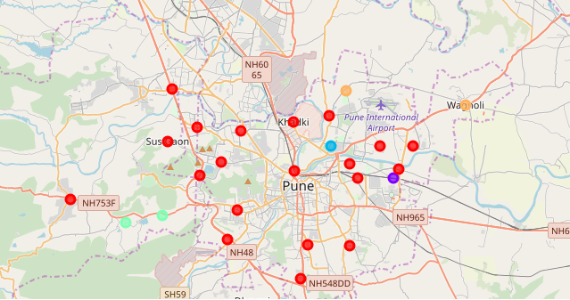

* From above it was seen that we are able to select some neighborhoods that look potential optimal options. Like Hadapsar, Yerwada, Dhanori and Wagholi.
* Then we included the Property Rates in price per sq ft. for the shortlisted areas.
* Finally we added the distance of these neighborhoods to Pune cities center. To the dataframe.

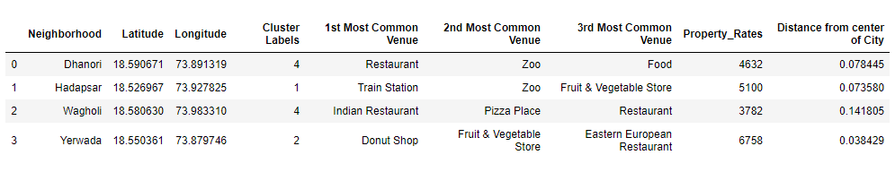

1. **Results and Discussion**

* Our analysis shows that above are the areas with low density of venues as compared to other areas of the city. Interesting to note that three of these areas are not very far from the city center.
* On further analyzing these areas on factors like population density, and other major attractions in the area, we see that the area 'Yerwada' contains a lot of Business Parks, big Hotels, golf course ground and more. Even though property rates are a nit high but this area also has least distance from city center. This looks like a good trade off.
* Another location that looks promising is 'Hadapsar' where on further analysis we found that a lot of new construction is going on in this area. And it is nearby to international airport.

1. **Conclusion**

* The purpose of this project was to identify an optimal location to open a new restaurant in the city of Pune India.
* The above data has been created using the neighborhoods of the city, the coordinates and the various venues density in the neighborhoods. Using the method of clustering, the above locations were divided in to clusters depending on most famous venues in the areas. As expected the old and highly developed/expensive parts of the city were found part of one cluster. That proved the accuracy of the measures. Above areas listed as optimal options were not parts of such clusters, hence good candidates for the problems solution.
* The results can help an interested audience to take an informed decision. As there is no limitation to data, more factors can be taken into account along with above information to finalize a location. Details like new/ongoing projects, Business Parks or Cineplex in the area, connectivity of metro lines to the area, population of the area etc. are few factors that can add value to take a decision.

1. **References**

* Google geocoder API
* Foursquare API
* https://www.99acres.com/property-rates-and-price-trends-in-pune
* https://en.wikipedia.org/wiki/List_of_neighbourhoods_in_Pune