TASKEASE APP

INTRODUCTION
TaskEase is a redesigned task management application created to make productivity simple, organized, and enjoyable.
This project focuses on improving user interaction, visual clarity, and reducing complexity.
By following a user-cantered design approach, TaskEase helps users manage goals efficiently.
Prototyped in Figma, it emphasizes minimalism and accessibility.

PROBLEM STATEMENT
Most existing task management apps are cluttered, overwhelming, and unintuitive.
Users struggle to prioritize tasks, track progress, and stay motivated because of poor UI organization, too many menus, and lack of personalization.
This complexity reduces productivity and causes frustration, especially for busy professionals and students.

💡 SOLUTION OVERVIEW
TaskEase solves these challenges through a clean, focused, and intuitive interface.
It simplifies task creation and organization with color-coded priorities, drag-and-drop control, and smart reminders.
The redesign focuses on usability, clarity, and motivation, helping users manage goals effortlessly and stay productive.

RESEARCH PROCESS

We used both quantitative and qualitative research:
Surveys: Showed users prefer clean layouts, fewer menus, and color-coded priorities.
Interviews: Revealed frustrations with complex navigation and small icons.
These insights guided the redesign toward a simple, accessible, and modern layout.

TARGET AUDIENCE

- Working Professionals (25–45): Need fast, efficient tools for planning.
- Students: Require a simple app for assignments and focus sessions.
- Freelancers: Want flexibility, customization, and progress tracking.
Each user group values clarity, ease of use, and smart automation.

DESIGN APPROACH

The design emphasizes:
Minimalism: Reduced clutter, focused screens.
Consistency: Simple icons and typography.
Accessibility: High contrast and large buttons.
Colour Palette: Blue (#1E90FF) and black for a professional modern feel.

[Insert Screenshot 1 – Splash Screen Here]


APP STRUCTURE / USER FLOW

Flow Diagram:

Splash → Login → Dashboard → Task Page → Calendar → Progress → Settings

This flow ensures users can navigate easily between sections.
[Insert Screenshot 2 – Dashboard Screen Here]
Caption: “Figure 2: Dashboard Page”

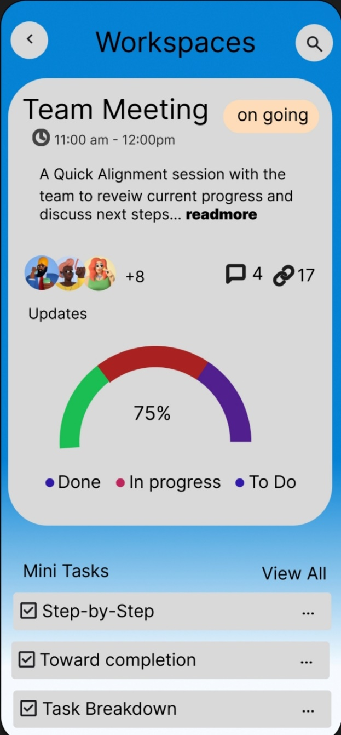
FINAL UI SCREENS
Final UI Screens Section Will Make Your Taskease Case Study Feel Completer and More Professional (Like What Real UX Designers Include IN Behance or Portfolio Write-Ups).
Below is the improved version of your “final UI screen “section -you can copy this directly into your google doc or canva layout

[Insert Screenshot 3 – Task List Page Here]
Caption: “Figure 3: Task List Screen”

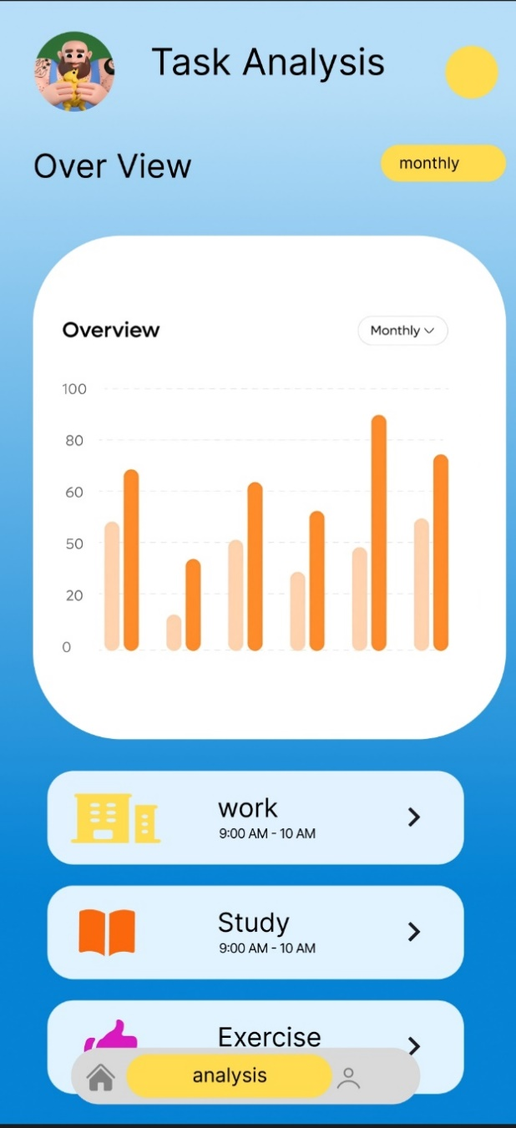

[Insert Screenshot 4 – Progress or Calendar Page Here]
Caption: “Figure 4: Progress / Calendar Screen”

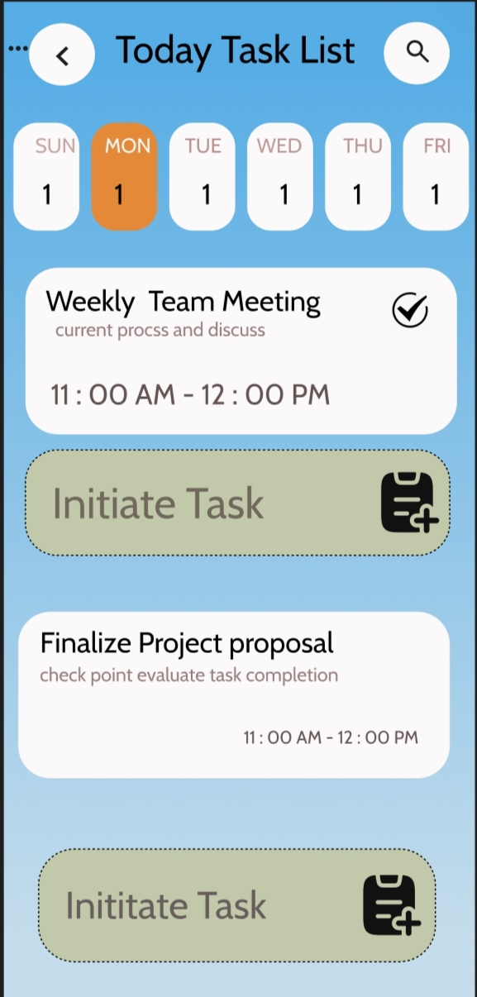

FEATURES & OUTCOMES
- Smart Task Creation (Natural Input)
- Customizable Views (List / Board / Calendar)
- Focus Timer (Pomodoro)
- Reminders & Notifications
- Dark & Light Modes
- Collaboration & Sync Options
- Outcomes
- Simplified user experience
- Reduced visual clutter
- Improved navigation and task visibility
- Positive user feedback

Team Members:
AGASH K – UI/UX Designer & Project Lead
DHINESH PREETHIP S – UX Researcher
HARISH R – Visual Designer
SIVASUBRAMANIYAN V – Front-End Developer
NIRANJAN V – Data Analyst / Tester

CONCLUSION
Conclusion
TaskEase redefines task management with a modern, user-focused interface.
It combines usability, aesthetics, and smart design to help users stay productive.
The redesign proves that simplicity and clarity drive better engagement.

Future Enhancements
AI-powered task suggestions
Voice commands
Cross-device synchronization

