





NAAN MUDHALVAN UI / UX

Submitted by
AGASH K – 421323205003
NM1020 - UI / UX
DEPARTMENT OF INFORMATION TECHNOLOGY
Year / Semester – III / V

ANNA UNIVERSITY : CHENNAI 600025
November – December 2025



BONAFIDE CERTIFICATE

Name: | AGASH K
Reg.No: | 421323205003
Sem / Dept: | V SEMESTER / IT
Course Name: | NM1020 – UI / UX

Certified that this is the bonafide record of work done by the above student in the NM courses NM1020 – UI / UX during the academic year 2025 – 2026.

Signature of the course coordinator Signature of the HOD

Submitted for the practical examination held on……………………………….

Internal Examiner External Examine
TABLE OF CONTENT

CHAPTER | CONTENT
1. | About the Project
2 | Problem Statement
3. | Solution Statement
4. | Qualitative Metrics
5. | Quantitative Indicators
6. | New Features
7. | Comparision Table
8. | User persona
9. | Target Audience
10. | User Flow
11. | Low Fedlity Screens
12. | High Fedlity Screens
13. | Goals
14. | Conclusion

TASH MANAGEMENT APP

PROJECT DEFINITION:
The Task Management App is a productivity-focused digital solution designed to help users plan, organize, and track their daily, weekly, and long-term tasks efficiently. The core idea is to create a platform that simplifies task organization and enhances time management for both individuals and teams.

The app combines essential features such as task creation, prioritization, reminders, progress tracking, and collaboration tools in one seamless experience. It aims to minimize the cognitive load of managing multiple responsibilities by providing a structured and visually appealing interface.
The project focuses on usability, accessibility, and efficiency, ensuring that users can manage their workload effortlessly—whether they are students, professionals, or business teams. The development approach emphasizes user-centered design principles, consistent interface design, and integration with existing tools like calendars and email systems to create a comprehensive productivity ecosystem.

PROBLEM STATEMENT:
In today’s fast-paced environment, individuals and teams often struggle to stay organized and productive due to the lack of an efficient system for managing their daily tasks. Many uses rely on multiple platforms—such as notes, calendars, and messaging apps—to keep track of deadlines, leading to confusion and missed responsibilities.
Existing task management tools can be overly complex, cluttered with unnecessary features, or lack proper integration, making them difficult for users to adopt consistently. As a result, people experience decreased productivity, poor time management, and increased stress when trying to balance multiple projects or responsibilities.
There is a clear need for a simple, intuitive, and well-structured task management app that can help users create, prioritize, and track their tasks effectively—all in one place—without overwhelming them with complicated interfaces.
.

PROBLEM SOLVING :
- Designed a simple and user-friendly interface for easy task management.
- Allows users to create, categorize, and prioritize tasks efficiently.
- Includes reminders and notifications to prevent missed deadlines.
- Provides progress tracking to monitor task completion.
- Enables team collaboration through shared task lists and projects.
- Accessible across devices for better flexibility and convenience.
- Focuses on improving productivity and reducing time management stress.

USER PERSONA
Name: Rahul Kumar
Age: 21
Occupation: College Student
Educational Background: B.Tech in INFORMATION TECHNPLOGY

GOALS:
- Simplify daily task organization.
- Improve personal and team productivity.
- Provide an easy and intuitive user experience.
- Enable collaboration and task sharing.
- Offer reminders and progress tracking features.

PAIN POINTS:
- Difficulty managing multiple tasks across different apps.
- Lack of timely reminders causing missed deadlines.
- Complicated and cluttered interfaces in existing tools.
- Limited collaboration options for team projects.
- No clear way to track task progress efficiently.

QUOTE:

“Productivity is never an accident. It is always the result of a commitment to excellence, intelligent planning, and focused effort.”

WIREFRAMING

About Wireframing:
Wireframing is the process of designing the basic structure of the app before final visual design. It helps visualize layout, content placement, and navigation flow.

Wireframes include:
Layout: Sections for Home Dashboard, Task List, Calendar, and Notifications.
Content: Placeholder text for tasks, deadlines, priority labels, and reminders.
Functionality: Buttons for “Add Task,” “Mark Complete,” “Set Reminder,” “Edit Task.”
Hierarchy: Important elements like overdue tasks and high-priority tasks shown prominently.
Navigation: Bottom navigation bar – Home | Tasks | Calendar | Profile.

DESIGNS OF WIREFRAMING:
- Home screen showing daily summary and quick access buttons.
- Progress screen with charts for calories, steps, and hydration.
- Wellness screen for meditation, breathing exercises, and mood logs.

Prototyping
- About Prototyping
Prototyping involves creating an interactive model of the Task Management App to test usability, workflow, and task management experience before actual development.

Importance
- Helps collect user feedback on task creation, tracking, and collaboration features early.
- Allows visualizing real interactions such as adding tasks, setting reminders, and marking tasks complete.
- Enables iterative improvements to navigation, task flow, and dashboard layout based on testing.

How it’s done
- Low-Fidelity Prototypes: Basic task list, dashboard, and calendar outlines using tools like Figma or Adobe XD.
- High-Fidelity Prototypes: Interactive screens showing tasks, priorities, reminders, and collaboration features with colors, icons, and transitions.
- User Testing: Conduct feedback sessions with sample users to refine task creation, progress tracking, and overall usability.

DESIGN:

- Splash Screen App logo with clean and professional color scheme
- Dashboard Displays task overview, upcoming deadlines, and quick actions
- Task List Shows all tasks with priorities, due dates, and completion status
- Calendar View Visualizes tasks and deadlines on a monthly/weekly calendar
- Task Details Section Allows adding descriptions, subtasks, reminders, and notes

WIREFRAME:
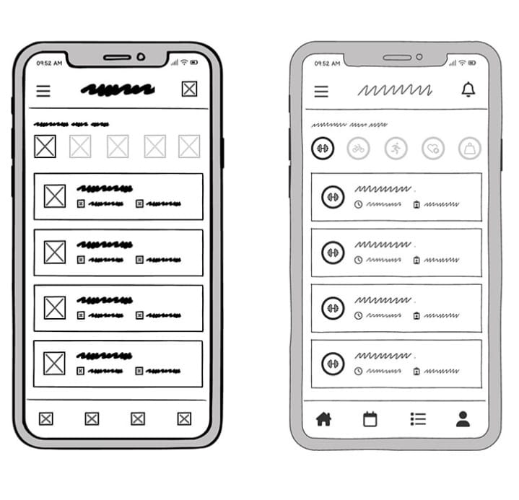

SCREENSHOTS:

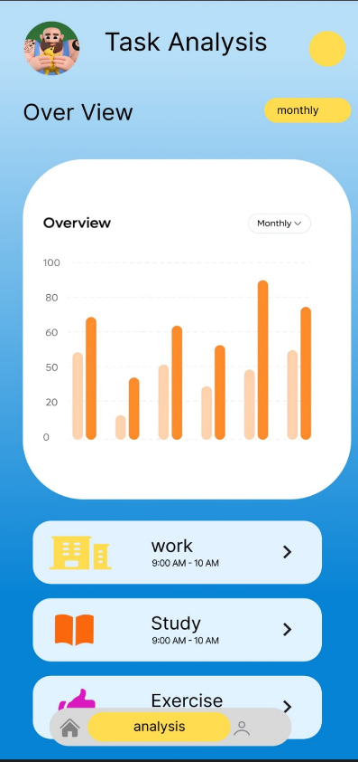

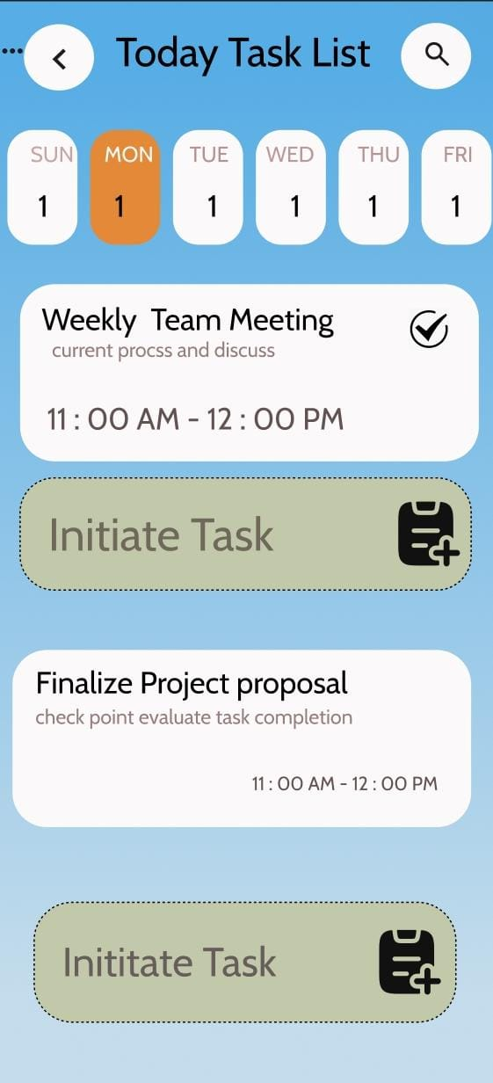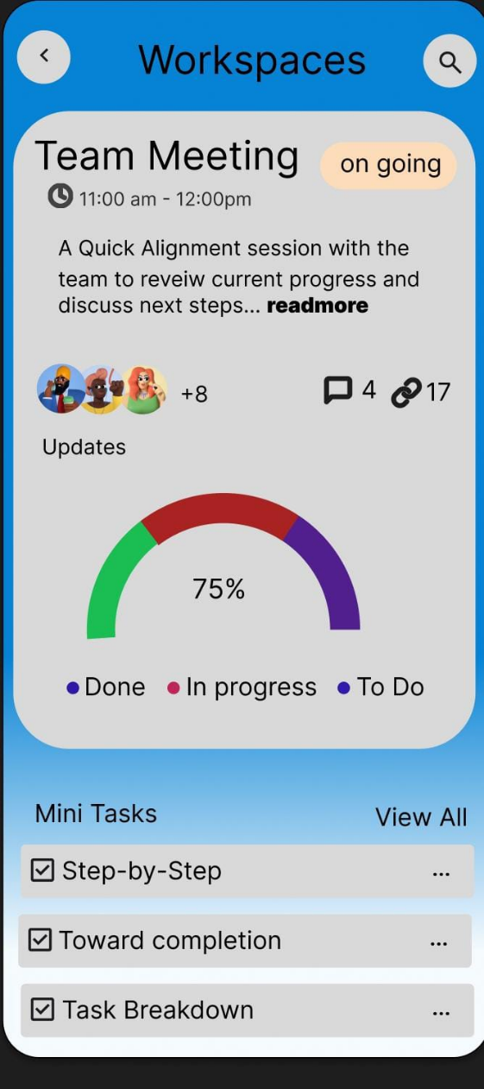

CONCLUSION:
The Task Management App successfully addresses common productivity challenges by offering a user-friendly and efficient platform for task organization. Through research, design iteration, and user testing, the final product demonstrates improved usability and productivity outcomes for target users.

