RAMAIAH INSTITUTE OF TECHNOLOGY
Bangalore,Karnataka-560054



An Autonomous Institute, Affiliated toVisvesvarayaTechnological University, Belgaum.

TRANSPORT DEPARTMENT SYSTEM

Submitted by

Agasthya HD 1MS14IS141
Aaditya Krishnan 1MS14IS001

Under the guidance of

Siddesh ID Sir

Introduction

We have built a Transportation Department System that handles the need of the manager who looks after the transportation company or department.
An admin can login using the password given to him.
There are various details that have to be filled by the adminstrator regarding the department .

The details of all employees who work in the department are written into a table.The details of all the vehicles have to be noted down for booking purposes.The details of the routes have to specified for each route that the transportation company wants its vehicles to ply on.After all these details have been given then we can book vehicles and drivers for various paths available currently and the estimated cost also taken.

We display the total revenue and the all the details of all the bookings that have been done so far in the current status page.

The Transportation department is a essential part of every major company and multi-million business indusrty for delivery of goods throughout the country.A typicalscenario would include both inbound (procurement) and outbound (shipping) orders to be evaluated by the TMS Planning Module offering the user various suggested routing solutions. These solutions are evaluated by the user for reasonableness and are passed along to the transportation provider analysis module to select the best mode and least cost provider. Once the best provider is selected, the solution typically generates electronic load tendering and track/trace to execute the optimized shipment with the selected carrier, and later to support freight audit and payment (settlement process).

TOOLS USED IN THE PROJECT

1.Mysql-
The mysql is the open-source relational database management system(RDBMS)
Mysql is the popular choice for database in web applications and central component in LAMP(linux,Apache,Mysql,Perl/php/Python/).
The mysql is the database application used to store the project and show the results in the front end application.
Mysql provides the back-end solution to the project.
2.Php-
php is a widely-used open source general-purpose scripting language that is especially suited for web development and can be embedded into HTML.
The php application acts as a interface between the front end html page and the background to retrieve data and display it in the front end.
3.HTML and CSS-
The html and css are used as front development part of the application to get information from the user and display information in proper format and design so the user can use application easily.CSS provides the design needs to the front end part of the application.
4.Apache Server-
The apache is the HTTP server widely used in world wide web.
The Apache Server hosts the php and html pages as localhost.

TRANSPORT DEPARTMENT

The project has a database with four tables for storing employee details,vehicle details ,route information details and bookings details.

Let us first look into the details of each table:
EMPLOYEE DETAILS TABLE:
The employee details table has five attributes respectively employee id,employee name, employee salary, employee address and phone number.

VEHICLE DETAILS TABLE:
The vehicle details like the vehicle id,type,model are stored as attributes in the table.
The details are required for the booking of the vehicles in the booking details.
The primary key is the vehicle id that is used in the booking detail table also.

ROUTE DETAILS TABLE:
The route details table has the details of the from location and to location and the distance of the route.Each route has route id which is the primary key for the table.The route id is used in the bookingds details table as a foreign key.

BOOKING TABLE:
New booking can be done by using the driver id , vehicle id, route id and cost of the booking is also entered in the table.
Driver id,vehicle id, route id can be used as candidate keys to form a super key.
The bookings are displayed in the current status page in detail.

All the table are complying the 1NF and 2NF forms.
All the tables do not have multivalued attributes so they are in 1NF form. All non prime attributes are not functionaly dependent on any prime attribute so all the tables are in the 2NF form.

TOOLS USED IN THE PROJECT

1.Mysql-
The mysql is the open-source relational database management system(RDBMS)
Mysql is the popular choice for database in web applications and central component in LAMP(linux,Apache,Mysql,Perl/php/Python/).
The mysql is the database application used to store the project and show the results in the front end application.
Mysql provides the back-end solution to the project.
2.Php-
php is a widely-used open source general-purpose scripting language that is especially suited for web development and can be embedded into HTML.
The php application acts as a interface between the front end html page and the background to retrieve data and display it in the front end.
3.HTML and CSS-
The html and css are used as front development part of the application to get information from the user and display information in proper format and design so the user can use application easily.CSS provides the design needs to the front end part of the application.
4.Apache Server-
The apache is the HTTP server widely used in world wide web.
The Apache Server hosts the php and html pages as localhost.

RESULT:
1.Login Page:
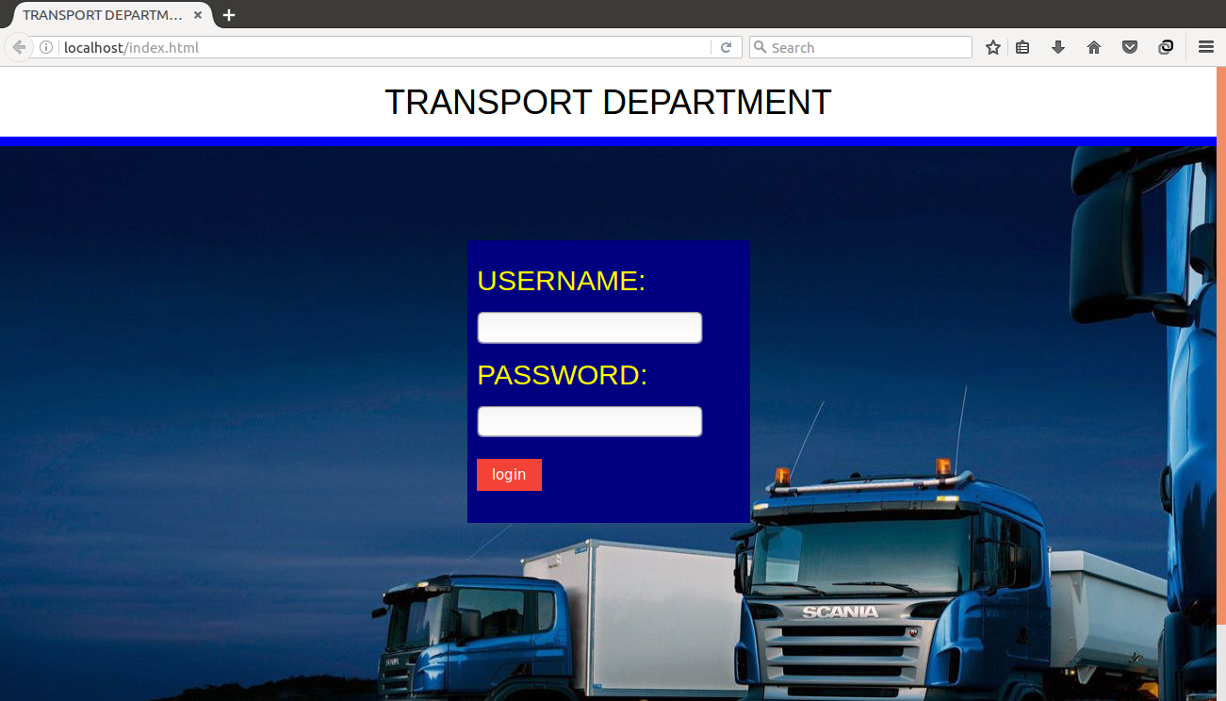

The login page serves as first page in the project where admin can login
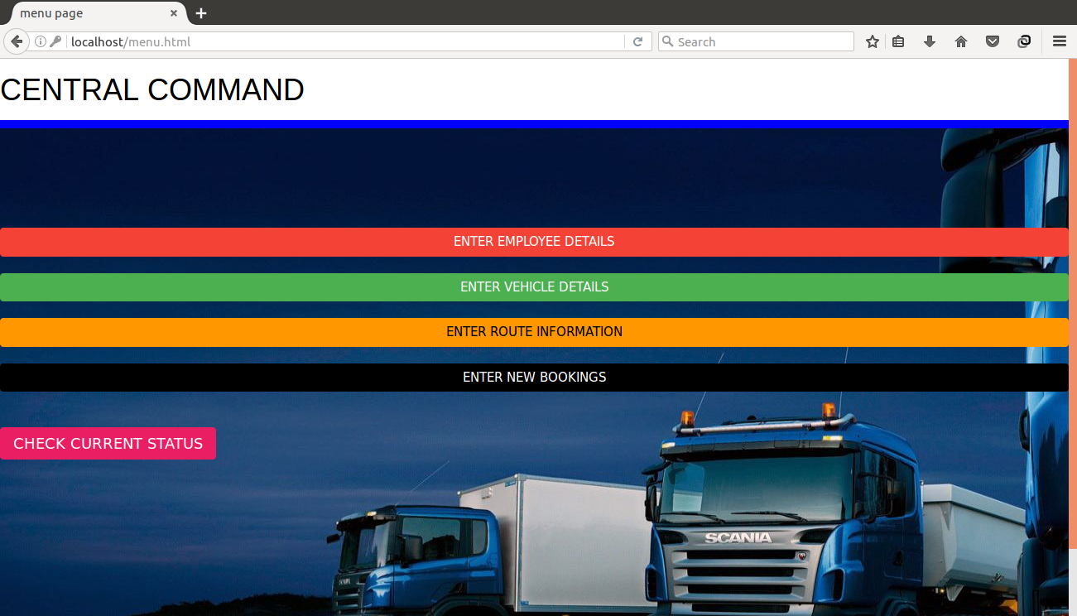
2.MAIN PAGEThis is the main page where we have options to enter the employee details,vehicle details,route information and make new bookings.
Also we can check the current status of all bookings.

3.EMPLOYEE DETAILS PAGE:
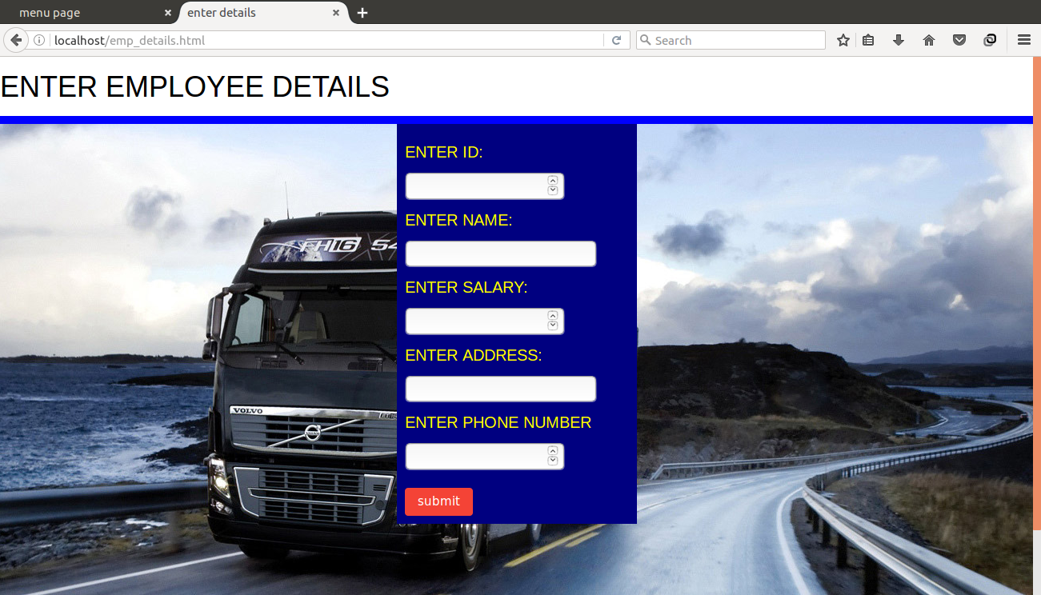
Here we enter the various details of employees.
4.VEHICLE DETAILS PAGE:
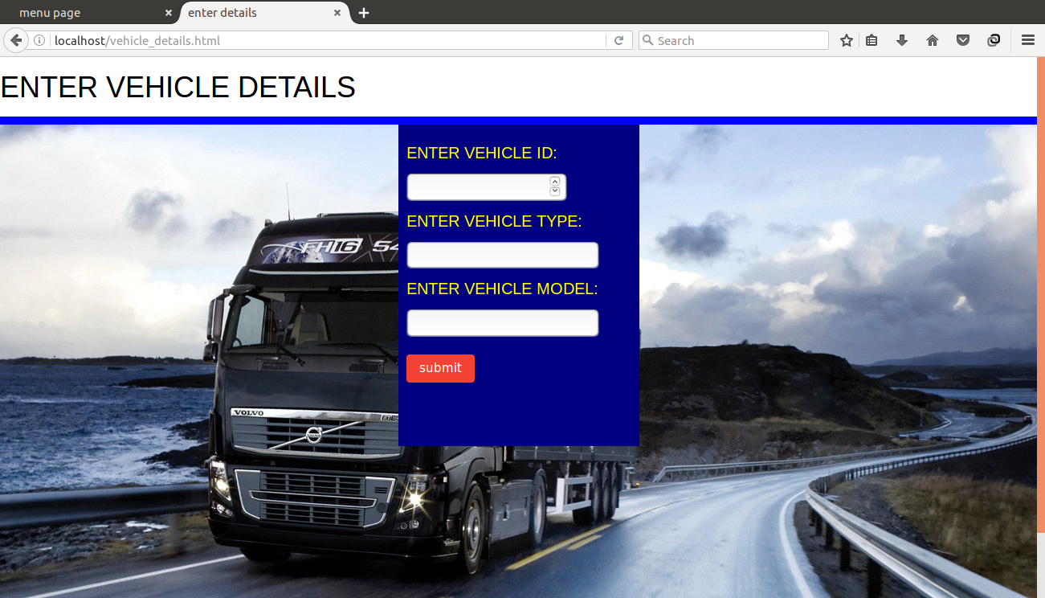
Vehicle details are entered in this page.

5.ROUTE DETAILS PAGE:
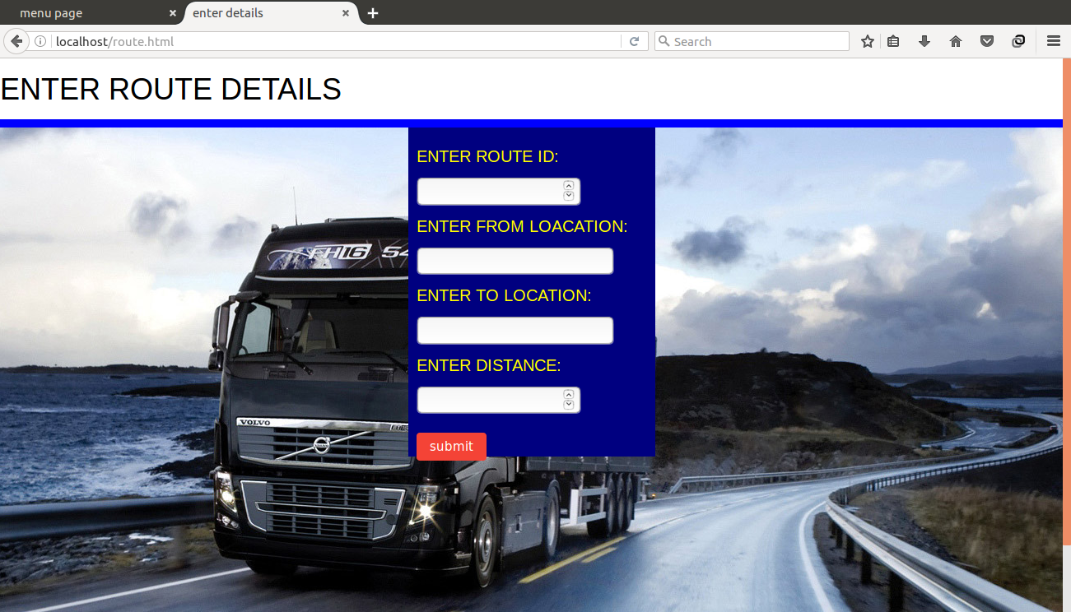
Enter the route details in this html page.
6.BOOKING DETAILS PAGE:
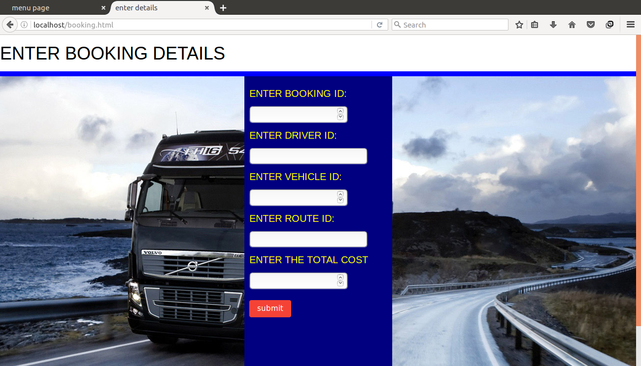

Booking details are entered in this html page.

6.ERROR REDIRECT PAGE:
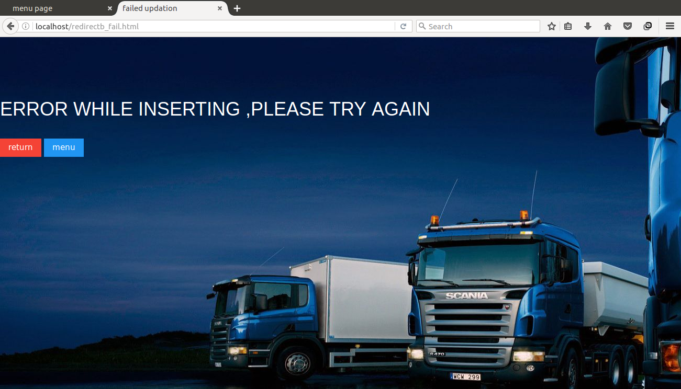
The return button returns to the page where data was not properly entered or no data was entered and menu button redirects to the main page.

SUMMARY:
The project acts a prototype which can be developed further to a comprehensive transportation department or transportation company.This project throws light on all the essentials of a transpotation department and developed further to make it deloyable in real life scenarios.The project has huge scope in the world today of startups especially e-commerce where logistics and delivery throughout the country is required.

