***Analysis of payroll satisfaction level of the employees in air filters industry***

*Project report submitted to the SRM Institute of Science and Technology (Deemed to be University), Chennai*

*in partial fulfilment of the requirements*

*for the award of the Degree of*

**MASTER OF BUSINESS ADMINISTRATION**

***Submitted by***

Aravindh M

[Enrollment No: DC2052305010264]

Under Guidance of

**Dr. Venkatasalem Suresh | Assistant Professor**, SRMIST, DDE, KTR

In Partial Fulfilment of the Requirements for the Degree of



**DEPARTMENT OF MANAGEMENT**

**DIRECTORATE OF DISTANCE EDUCATION**

**SRM INSTITUTE OF SCIENCE AND TECHNOLOGY**

(Deemed to be university u/s 3 of UGC Act, 1956)

CHENGALPATTU – 603203

SEPTEMBER 2022



**CERTIFICATE**

This is to certify that the Project Work entitled **“Analysis of payroll satisfaction level of the employees in air filters industry”** submitted by **ARAVINDH M** (**DA2052305010264**) of MBA, Directorate of Distance Education, SRM Institute of Science and Technology, Kattankulathur is a Bonafide Record of Project Work carried out by him/her in partial fulfilment of the requirement for the award of degree of Master of Business Administration.

**RESEARCH SUPERVISOR HEAD OF THE DEPARTMENT**

**INTERNAL EXAMINER EXTERNAL EXAMINER**

**DECLARATION**

I hereby declare that the Project Work entitled “ANALYSIS OF PAYROLL SATISFACTION LEVEL OF EMPLOYEES IN AIR FILTERS INDUSTRY**”** submitted by me for partial fulfilment of the degree of Master of Business Administration, under the guidance of Dr **Venkatasalem Suresh**, SRMIST, DDE, KTR**,** Directorate of Distance Education, SRM Institute of Science and Technology is my original work and has not been submitted earlier to any other University/Institutions. The matter presented in this project report has not been submitted elsewhere for the award of any other degree/diploma. I declare that I have faithfully acknowledged, given credit to and referred to the research workers wherever their works have been cited in the text and the body of the project I further certify that I have not wilfully lifted up some other’s work, Para, text, data, results, etc., reported in the journals, books, magazines, reports, dissertations, theses, etc., or available at web-sites and have not included them in this project report and cited as my own work.

Place:

Date: **(ARAVINDH M)**

### **ACKNOWLEDGEMENT**

I wish to record my gratitude with my hands folded to Almighty for making me successfully complete my project report.

I express my deep sense of gratitude to the Director **Dr. R. Rajagopal,** and overallcourse Coordinator **Dr. G. Venugopalan** for their wholehearted support and encouragement.

I am indebted to my Course Coordinator and Research Supervisor

**Dr. Venkatasalem Suresh** for her continuous guidance and encouragement to complete my Project Work in a successful manner.

I am also thankful to all the faculty members of the Department of Distance Education for their support and Guidance.

I also acknowledge with a deep sense of reverence, my gratitude towards my parents and members of my family who have always supported me morally as well as economically.

I take this opportunity to thank all those who have helped me to complete my Project Work within the scheduled time.

#### **TABLE OF CONTENTS**

|  |  |  |
| --- | --- | --- |
| **CHAPTER** | **CONTENTS** | **PAGE NO** |
| **1** | **INDUSTRY PROFILE** | **1-3** |
| **2** | **INTRODUCTION** | **4-18** |
| **3** | **LITERATURE REVIEW** | **19-30** |
| **4** | **OBJECTIVE AND SCOPE** | **31-32** |
| **5** | **RESEARCH METHODOLOGY** | **33-34** |
| 6 | **DATA ANALYSIS AND INTERPRETATION** | **35-57** |
| 7 | **FINDINGS, SUGGESTIONS AND CONCLUTIONS** | **58-60** |
| 8 | **ANNEXURE AND REFERENCES** | **61-68** |

**LIST OF FIGURES**

|  |  |  |
| --- | --- | --- |
| **FIGURE NO.** | **DESCRIPTION** | **PAGE NO.** |
| 2.1.1 | COMPONENTS OF PAYROLL | 5 |
| 2.1.2 | EXECUTION OF PAYROLL | 6 |
| 2.2 | FLOWCHART OF PAYROLL | 8 |
| 2.3.1 | SOFTWARE BENEFITS OF PAYROLL | 10 |
| 2.3.2 | DIFFERENCE BETWEEN SOFTWARE AND MANUAL PAYROLL | 11 |
| 2.6 | CONNECTIONS OF WORKING FOR PAYROLL | 13 |

**LIST OF TABLES**

|  |  |  |
| --- | --- | --- |
| **TABLE NO.** | **DESCRIPTION** | **PAGE NO.** |
| 6.1.1 | CLASSIFICATION OF RESPONDENTS BASED ON THEIR AGE | 37 |
| 6.1.2 | CLASSIFICATION OF RESPONDENTS BASED ON GENDER | 38 |
| 6.1.3 | CLASSIFICATION OF RESPONDENTS BASED ON THEIR SALARY | 39 |
| 6.1.4 | CLASSIFICATION OF RESPONDENTS BASED ON THEIR RETIREMENT PLAN | 40 |
| 6.1.5 | CLASSIFICATION OF RESPONDENTS BASED ON THEIR OPPORTUNITIES FOR PROMOTION, RAISES, AND BONUSES. | 41 |
| 6.1.6 | CLASSIFICATION OF RESPONDENTS BASED ON THEIR FINANCIAL BENEFITS | 42 |
| 6.1.7 | CLASSIFICATION OF RESPONDENTS BASED ON THEIR HEALTH PLAN | 43 |
| 6.1.8 | CLASSIFICATION OF RESPONDENTS BASED ON THEIR LONG-TERM DISABILITY INSURANCE | 44 |
| 6.1.9 | CLASSIFICATION OF RESPONDENTS BASED ON THEIR SHORT-TERM DISABILITY INSURANCE | 45 |
| 6.1.10 | CLASSIFICATION OF RESPONDENTS BASED ON THEIR DENTAL/VISION PLAN | 46 |
| 6.1.11 | CLASSIFICATION OF RESPONDENTS BASED ON THEIR HEALTH BENEFITS | 47 |
| 6.1.12 | CLASSIFICATION OF RESPONDENTS BASED ON THEIR TRAVEL AND EXPENDITURES | 48 |
| 6.1.13 | CLASSIFICATION OF RESPONDENTS BASED ON THEIR NUMBER OF VACATION, SICK AND PERSONAL DAYS | 49 |
| 6.1.14 | CLASSIFICATION OF RESPONDENTS BASED ON THEIR PAID TIME OFF | 50 |
| 6.1.15 | CLASSIFICATION OF RESPONDENTS BASED ON THEIR PROFESSIONALISM OF PAY ROLL STAFF | 51 |
| 6.1.16 | CLASSIFICATION OF RESPONDENTS BASED ON THEIR CONTACTED OR VISITED THE PAYROLL OFFICE | 52 |
| 6.1.17 | CLASSIFICATION OF RESPONDENTS BASED ON THEIR MAKE A IN YOUR EXPERIENCE WITH THE PAYROLL OFFICE | 53 |
| 6.1.18 | CLASSIFICATION OF RESPONDENTS BASED ON THEIR PAYMENT PASSES THROUGH PAYROLL SYSTEM | 54 |
| 6.1.19 | CLASSIFICATION OF RESPONDENTS BASED ON THEIR REIMBURSEMENT EXPENDITURE | 55 |
| 6.1.20 | CLASSIFICATION OF RESPONDENTS BASED ON THEIR ACCURACY OF PAYROLL | 56 |
| 6.1.21 | CLASSIFICATION OF RESPONDENTS BASED ON THEIR OVERTIME PAY | 57 |

**LIST OF CHARTS**

|  |  |  |
| --- | --- | --- |
| **CHART NO.** | **DESCRIPTION** | **PAGE NO.** |
| 6.1.1 | CLASSIFICATION OF RESPONDENTS BASED ON THEIR AGE | 37 |
| 6.1.2 | CLASSIFICATION OF RESPONDENTS BASED ON GENDER | 38 |
| 6.1.3 | CLASSIFICATION OF RESPONDENTS BASED ON THEIR SALARY | 39 |
| 6.1.4 | CLASSIFICATION OF RESPONDENTS BASED ON THEIR RETIREMENT PLAN | 40 |
| 6.1.5 | CLASSIFICATION OF RESPONDENTS BASED ON THEIR OPPORTUNITIES FOR PROMOTION, RAISES, AND BONUSES. | 41 |
| 6.1.6 | CLASSIFICATION OF RESPONDENTS BASED ON THEIR FINANCIAL BENEFITS | 42 |
| 6.1.7 | CLASSIFICATION OF RESPONDENTS BASED ON THEIR HEALTH PLAN | 43 |
| 6.1.8 | CLASSIFICATION OF RESPONDENTS BASED ON THEIR LONG-TERM DISABILITY INSURANCE | 44 |
| 6.1.9 | CLASSIFICATION OF RESPONDENTS BASED ON THEIR SHORT-TERM DISABILITY INSURANCE | 45 |
| 6.1.10 | CLASSIFICATION OF RESPONDENTS BASED ON THEIR DENTAL/VISION PLAN | 46 |
| 6.1.11 | CLASSIFICATION OF RESPONDENTS BASED ON THEIR HEALTH BENEFITS | 47 |
| 6.1.12 | CLASSIFICATION OF RESPONDENTS BASED ON THEIR TRAVEL AND EXPENDITURES | 48 |
| 6.1.13 | CLASSIFICATION OF RESPONDENTS BASED ON THEIR NUMBER OF VACATION, SICK AND PERSONAL DAYS | 49 |
| 6.1.14 | CLASSIFICATION OF RESPONDENTS BASED ON THEIR PAID TIME OFF | 50 |
| 6.1.15 | CLASSIFICATION OF RESPONDENTS BASED ON THEIR PROFESSIONALISM OF PAY ROLL STAFF | 51 |
| 6.1.16 | CLASSIFICATION OF RESPONDENTS BASED ON THEIR CONTACTED OR VISITED THE PAYROLL OFFICE | 52 |
| 6.1.17 | CLASSIFICATION OF RESPONDENTS BASED ON THEIR MAKE A IN YOUR EXPERIENCE WITH THE PAYROLL OFFICE | 53 |
| 6.1.18 | CLASSIFICATION OF RESPONDENTS BASED ON THEIR PAYMENT PASSES THROUGH PAYROLL SYSTEM | 54 |
| 6.1.19 | CLASSIFICATION OF RESPONDENTS BASED ON THEIR REIMBURSEMENT EXPENDITURE | 55 |
| 6.1.20 | CLASSIFICATION OF RESPONDENTS BASED ON THEIR ACCURACY OF PAYROLL | 56 |
| 6.1.21 | CLASSIFICATION OF RESPONDENTS BASED ON THEIR OVERTIME PAY | 57 |

**ABSTRACT**

Payroll is defined as a method of administrating employees’ salaries in the organizations. The process consists of calculation of salaries and tax deductions of the employees, administrating the retirement benefits and disbursements of salaries to employees. It can also be called as an accounts activity which undertakes the salary administration of employees in the organization. Administrating the employees’ salaries is not an easy task, the HR and accounts department work together to calculate and disburse the salary to the employees. Thus, payroll management can be further subdivided into two sub processes, i.e., Payroll accounting and payroll administration. Payroll refers to the administration of employees' salaries, wages, bonuses, net pay, and deductions. It consists of the employee ID, employee name, date of joining, daily attendance record, basic salary, allowances, overtime pay, bonus, commissions, incentives, pay for holidays, vacations and sickness, value of meals and lodging etc. There are some deductions such as PF, taxes, loan instalments or advances taken by employee.

Payroll administration can be very simple, involving the payment of just a handful of employees, or very complicated, involving payroll for thousands of employees and contractors. In some, very small companies, payroll may be handled by the owner of the company or an employee. However, other companies may have many employees to pay and keep track of necessitating a well-planned, efficient payroll administration system.

The specific tasks involved in payroll administration tend to vary according to the needs of each unique company or organization. For example, some companies have workers that receive commissions in addition to salaries. In these companies, including commissions in employee salaries is a part of payroll administration. For some companies, it also involves assigning exempt or non-exempt status to workers, adding bonuses into pay checks, calculating overtime payments, and adhering to applicable employment laws. Later going to collect all the information from employees using graph analysis to know their satisfaction of payroll given by the companies on different level. To ensure the retention of the employees.

**TABLE OF CONTENTS**

## **CHAPTER 1 INDUSTRY PROFILE**

1. Introduction
   1. About Us
   2. Our Vision
   3. Our Mission
   4. Our Strategy
   5. Our Strength

## **CHAPTER 2 INTRODUCTION**

1. Introduction
   1. Introduction Of Payroll
   2. Pay Roll Management Process
   3. Benefits Of Payroll Software
   4. General Objective
   5. Specific Objective
   6. Theoretical Assumption
   7. Biometric
   8. To The Management
   9. To The Employees
   10. Definition Of Employee Satisfaction
       1. Factors Determining Employee Satisfaction
       2. Outcomes Of Employee Satisfaction
       3. Satisfaction And Performance
       4. Satisfaction And Turnover
       5. Satisfaction And Absenteeism
   11. Definition Of Job Satisfaction
   12. Hypothesis

**CHAPTER 3 LITERATURE REVIEW**

**CHAPTER 4 OBJECTIVE AND SCOPE**

4.1 Objective of the project

4.2 Scope of the project

**CHAPTER 5 RESEARCH METHODOLOGY**

5. Methodology

5.1 Data processing and analysing

**CHAPTER 6 DATA ANALYSIS AND INTERPRETATION**

6. Data analysis and interpretation

6.1 Data analysis question

**CHAPTER 7 FINDINGS, SUGGESTIONS AND CONCLUSION**

7. Findings, suggestions and conclusions

7.1 Findings

7.2 Suggestions

7.3 Conclusion

**CHAPTER 8 ANNEXURE AND REFERENCES**

8. Annexure and references

8.1 Annexure

8.2 References

# CHAPTER - 1

# INDUSTRY PROFILE

1. **Introduction**

**Instromed Medical Devices and Solutions** is one of the fastest growing Air Filters companies of India, we provide clean air to the environment. In the market we are delivering the product in the name of InFinite Filters. Our company was started on May 1st, 2020 under the companies act by the name of Instromed Medical Devices and Solutions. And our company located at Bhosari, Pune, Maharashtra-411026.

* 1. **About Us**

InFinite Filters is a leading Manufacturer of Air Filters with a state- of- the- art expertise and Infrastructure. Air Filters Industry in India is growing at a rapid rate due to the demand and due to the awareness of air filtration importance. This has led to pave a way for incorporating newest ideas and features in the existing technology. InFinite filters are aiming to bring and improvised technical features into the Air filters industry. We believe that this will help in developing good quality air filters backed with technical expertise and advanced engineering.

Air Filter plays a major role in various factors such as Environmental Safety, Industrial Protection, Health Care Norms, Staffs & Human Resource well-being, Air quality Index maintenance etc. We at InFinite filters, keep all the welfare factors intact and examine even the delicate details for Innovation and Manufacturing of each filter. The founder of InFinite filters is a Biomedical Engineer and possesses vast experience in clean room environment with technical expertise in air sterility & purification.

In general, air filters are considered as a Regular - Easy to make - Not so complicated- product. But in actual it is a sophisticated product with lots of technical mastery, air science study, manufacturing regulations etc. Any individual without the all-round knowledge about air filtration factors cannot contribute to a valuable product. InFinite Filters is backed with technical proficiency and standard infrastructure with all the In-House facilities. Thus, we are enlightened to say that InFinite filters offers a good quality and technologically advanced filters which makes us competitive in the market.

InFinite filters have always kept a customer-oriented approach and will always want to be established in the same way. We cater to the client requirements according to their dictate and are ever-ready for customization as per client request. We take pleasure in supporting and guiding our clients in various air handling and air safety precautions in accordance with the regulatory norms.

* 1. **Our Vision**

To clean the indoor air around the globe, improving our quality of life, making us more productive, protecting critical processes and equipment, and creating products that advance the human condition.

* 1. **Our Mission**

To help you protect your environment, improve your health, reduce your risk, and optimize your clean air related spending.

* 1. **Our Strategy**

Our business target is to have a balanced portfolio of business with revenue predictability, profitability and quality of contracts as the key determinants.

* 1. **Our strength**

We have been successfully operating in difficult operating terrains and in adverse weather conditions. These conditions present challenges of trained personnel, timely supply of material, efficient functioning of machinery and security concerns.  
Our hands on entrepreneurial management and enterprise of our team ensures that these challenges are met consistently to the satisfaction of our employers.

# CHAPTER - 2

# INTRODUCTION

# 2. Introduction

# 2.1 Introduction of payroll

Payroll system is an operation for every organization to pay employee accurately their salary. It is the administration of the financial record of employees' salaries, wages, bonuses, net pay, and deductions. It is supported by a database consisting of its employee's details and their attendance details. According to that end of each month the salary is paid to the corresponding bank account of the employee.

# The idea of taking control of employees pay calculations are quite tedious if done manually and require more effort and time mainly for big organizations. Hence if this process is automated, it would be of great benefit as it would require less time to calculate the salary of the employees. The software for payroll management system service on the cloud is provided as a solution in this paper. This system provides multiple user data access. Each user like employee or HR or admin can login into the software by writing username and password which are allocated to them from the company. It involves keeping track of hours worked and is capable of keeping a record of employee data including their pay, allowances, deductions and taxes on monthly bases so that fresh definitions are reflected from the month onwards, which leaves all the past data intact. The proposed payroll system is advantageous as it provides a user-friendly environment and also increases security and minimizes human calculation errors.

# While administrating the monthly payroll basic salary, HRA, conveyance, and other special allowances such mobile, etc. are considered. There are some deductions.

# http://payroll.naukrihub.com/images/51.JPG

# Figure 2.1.1 Components of Payroll

# Allowances, incentives, bonuses and reimbursements are based on organizational policies. Some organizations provided the allowances on a fixed rate say 10% or 12% of the basic salary. Some organizations go for performance-based incentives.

# 

# Figure 2.1.2 Execution of Payroll

**2.2 Payroll Management Processes**

Calculation of gross salaries and deductible amounts is a tedious task which involves risk. Some of the organizations use the traditional manual method of payroll processing and some go for the advanced payroll processing software.

An organization opts for any of the following payroll processing methods available:

1. **Manual System**: Manual payroll system is the traditional payroll system which involves pen and ink, adding machine, spreadsheet, etc instead of computers, software and other computerized aids. The process was very popular when there were no computerized means for payroll processing.
2. **Accountant**: Accountant is a professional having a degree or diploma in finance or accountancy. He /she is responsible for all activities related to payroll accounting. He/she has sound knowledge of accounting principle and globally accepted standards. The process adds cost and value to the organization.
3. **Pay roll**: - Pay roll outsourcing involves a third party in the calculation of salaries and deduction. It saves time and cost for the organization. If there is a greater number of employees, say more than 900-1000, in the organization, payroll outsourcing must be very beneficial.

The data is provided to the consultants/outsourcing firms. The various payroll functions undertaken by the outsourcing organizations are as follows:

* Analysis of Payroll records, payroll taxes
* Medical claim processing
* Employee Insurance & Provident fund processing
* Quality Audit procedures & planning

The proposed system will run through computer for payroll record with an integration of biometric fingerprint scanner for time keeping. It contains the automation of time keeping for every employee to generate payroll transaction. It can update employee information, individual and groups reports, file leave, set a non-working or working Holiday, access control and also calculation of 13th month pay and tax refund yearly report.

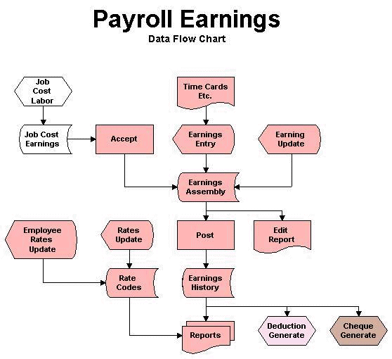

# Figure 2.2. Flowchart of Payroll

1. Some common problems encountered by the accounting staff of some organization in terms of using their manual system in processing payroll and time keeping?

2. Does a LAN-Based Timekeeping and Payroll system using Biometrics will help the accounting staff in terms of the generating payroll transaction, easy way timekeeping using biometrics, secure all payroll records, calculating 13 months’ pay, tax refund and generate all payroll reports?

3. If a LAN-Based Timekeeping and Payroll system using Biometrics will be used and will it be more efficient and effective than the current manual system?

4. What is the level of efficiency of the system when evaluated by the user evaluation result of the existing, the prototype system and the proposed system in terms of Correctness, Reliability, Efficiency, Testability and portability?

5. What is the level of efficiency in the system when evaluated by the system testing result?

6. Is there a significant difference between effectiveness of the system when evaluated by the user evaluation result of the present, the proposed system and the prototype system in terms of Correctness, Reliability, Efficiency, testability and Portability?

**2.3 Benefits of Payroll Software**

Payroll management includes everything relating to paying employees and employment tax filing. The traditional method for managing payroll using spreadsheets has become outdated today and is highly prone to human errors. Also, this method suits organizations having very few employees to manage or are in their initial stage of operations.

As per the report by researchers at the University of Hawaii, 88% of spreadsheets contain errors. Generally, errors occur due to mistakes in data entry, copy-paste, format, formulae, etc. These errors go unnoticed and create a major problem in the salary calculation of the employees, and even the final accounting statements of the companies.

For employees, salary is the only source of income. If there are mistakes in processing their salary, or in case of delayed wages, it can create discontent among the employees and affect adversely the productivity of the company. Moreover, if the company doesn't adhere to the regulations relating to income tax, PF, labour law, etc., it can result in serious compliance and legal issues.

To eliminate errors in payroll processing and remain in compliance with the statutory laws, many companies these days, [use payroll software](https://www.goodfirms.co/payroll-software/). Before we discuss further the free and open-source payroll software which can help you in processing payroll accurately, let’s know the basics of a payroll process and the benefits of using a payroll system.

The list of employees getting paid by the company is known as the payroll. It also refers to the total amount an employer pays to the employees after adding the incentives and subtracting the deductions. A systematic workflow required to calculate the net pay of the employees is known as the payroll process.

The entire payroll process is done using spreadsheets can be tedious, especially if your company has more than 100 employees. Moreover, even a single mistake in payroll processing can prove to be expensive for businesses in terms of staff retention, reputation, and finance.

Companies having more than one employee should use powerful payroll management software which can ensure the completion of the entire payroll process accurately within a limited time frame. Paying employees consistently with precision reflects the financial stability of the company. Thus, [payroll management software](https://www.goodfirms.co/payroll-software/) improves the reputation of the company, eliminates the chances of breaking the labour laws, and above all, it boosts the morale of the employees and motivates them to deliver better performance.

Payroll processing is a time-consuming process that needs to be repeated every week, bi-weekly, or monthly depending on your company policy relating to the salary payment. Payroll management software can make this monotonous task interesting and quick. With a single click, the list of your employees and their net salary is in front of your eyes. All your employees are paid on time. Also, payroll software can generate reports in the format specified by law, and filing those reports with concerned Government Departments becomes easy.

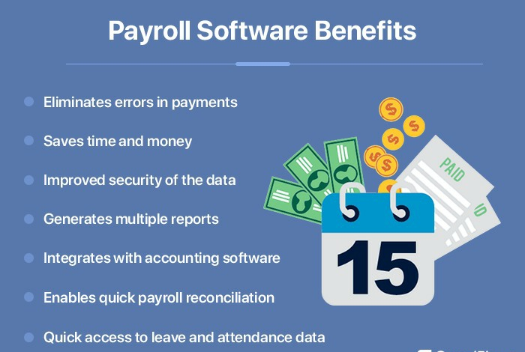

# Figure 2.3.1 Software Benefits of Payroll

# To get a better idea about the benefits of software, let’s look at the difference between processing payroll manually and using payroll software.

# 

# Figure 2.3.2 Difference between Manual vs Software Payroll

# Now, when you know why using software is better than processing payroll manually, let's have a look at the features you need to look for in payroll software as that can help you in selecting the perfect one for your business.

**2.4 General Objective**

This study aimed to help a company to have an efficient and effective way of monitoring their employee’s time keeping and payroll system to give a higher quality of service.

**2.5 Specific Objective**

Specifically, attain to:

* Develop a system that will improve the company’s process in the Timekeeping and Payroll;
* Develop a system that will monitor employee’s data that is efficient to use;
* Use biometrics tool (Fingerprint scanner) that will provide an easy log-in and log-out of the employees and staff.
* Secure the records of employees and to have more manageable files;
* Calculate payroll transaction easily; and
* Summarize all the Deducted Contribution of Employees.

**2.6 Theoretical Assumption**

* The proponents act fully responsibility to improve the Blanco Family Academy operation in the Time Keeping and Payroll System to implement the needs of the user of the system.
* The proponents established that if the system will crash, the proponents will prepare a back-up system which it can be restore the system but before the proponents restore the system, the user should have back-up all the files and data in the system.
* The proposed system will secure the records of employees and have more manageable files.
* The proposed system will provide a (Local Area Network) LAN-Based to easily share information accurately and it also transfer data faster.
* The proposed system will monitor employees’ data which is efficient to use.

# topology

# Figure 2.6 Connections of working for payroll

# 2.7 Biometrics

If any company used time card in their timekeeping, when the system implemented, the employees will use biometrics (finger scanner) for their timekeeping to have an easy way of timekeeping and calculating their time of work.

**2.8 To the management**

An organization will greatly benefit with the proponent’s study because they don’t need to hire any programmers to do the work in their system. The proponents will develop their system. So, the proponents ask for the support of the company. This will lead in lessening the expenses of the company which can be used in their other expenses. They will also find it easier to do task with the system like the biometrics wherein they can assure that their time keeping system is secure.

**2.9 To the employees**

The Employees will benefit in the system. They will find it easier to transact about their records since searching in the system is faster than tracking in the record book or log book. The biometrics will give them an easier time with their time log and they don’t have to worry about losing their time cards because it is not necessary.

Human Resources Personnel managing the time keeping will not be the same again as they will experience relieve. It would be fast and easy for them to handle transactions such as report making and monitoring time entries. Further determining or computing the payroll manually will be eliminated that will lead to faster transaction.

Accountant will able to manage employee services, hours, pay rates. An automated time and attendance employee system also helps in implementing and enforcing fair pay policies. By using the Security, Time Keeping and Payroll System employee software, actual balances, and flexible labour distribution for projects and work orders can be maintained. Other benefits of the time and attendance employees’ software include the elimination of time cards and unauthorized overtimes.

##### **2.10 Definition of Employee satisfaction**

Employee satisfaction is in regard to one's feeling or state of mind regarding the nature of their work. It can be influenced by a variety of factors e.g.: quality of one's relationships with their supervisor, quality of physical environment in which they work, degree of fulfilment in their work etc.

Locke gives a comprehensive definition of job satisfaction as involving cognitive, effective and evaluative reactions or attitudes and states it is "a pleasurable or positive emotional state resulting from the appraisal of one's job or job experience." Job satisfaction is a result of employees' perception of how well their job provides those things that are viewed as important.

There are three generally accepted dimensions to job satisfaction.

First, job satisfaction is an emotional response to a job situation, as such it cannot be seen; it can only be inferred.

Second, job satisfaction is often determined by how well outcomes meet or exceed expectations. For example, if organizational participants feel that they are working more harder than others in the department but are receiving fewer rewards, they will probably have a negative attitude toward the work, the boss or the co-workers. They will be dissatisfied. On the other hand, if they feel they are being treated very well and are being paid equitably, they are likely to have a positive attitude toward the job. They will be job - satisfied.

Third, job satisfaction represents several related attitudes.

**2.10.1 Factors determining employee satisfaction**

Factors affecting jobs are the main factors of job satisfaction, which may be challenging work, reward systems, working conditions, colleagues, learning and personality. Skill variety autonomy and significance are challenging tasks, which provide maximum satisfaction to employees. Many people feel bored if a job is too simple and routine, but many employees also enjoy simple and routine jobs.

• The job characteristics are important factors for providing satisfaction. Reward systems, equitable rewards, equal pay for equal work, promotion avenues, etc are satisfaction factors. Money is important to employees having unfulfilled basic needs, i.e., they require more award and recognition.

• Fairness in promotion, unbiased attitude of management, responsibilities and social status are the factors that are said to be providing satisfaction to employees.

• Working conditions influence employee's level of satisfaction. Under conducive working condition, people prefer to work hard while in an adverse atmosphere people avoid work. Working condition not only include physicals of the work but also the working relationships in the organization. The physical conditions, for example, are the light, temperature, willingness, etc. A clerk working under routine conditions likes to work hard in an air-conditioner atmosphere with computer facilities. It increases the working capacity of the employee.

• The relationships between the employees and the managers have an important bearing on job satisfaction.

• Job satisfaction is greater in case the higher authority is sympathetic, friendly and willing to help the employees. Employees feel satisfied when their views are listened to and regarded by their higher authorities

• Personal attitude and perceptions are the employees' angles of satisfaction, which should be taken into consideration while motivating people to arrive at job satisfaction

• Feedback from the job itself and autonomy are two of the major job-related motivational factors. A recent found that career development was most important to both younger and older employees.

• Supervision is another moderately important of job satisfaction. There seem to be two dimensions of supervisory style that affect job satisfaction. One is employee ­centeredness, which is measured by the degree to which a supervisor takes a personal interest and cares about the employee.

It commonly is manifested in ways such as checking to see how well the employee is doing, providing advice and assistance to the individual, and communicating with the associate on a personal as well as an official level. The other dimension is participation or influence, as illustrated by managers who allow their people to participate in decisions that affect their own jobs. In most case, this approach leads higher job satisfaction.

• Friendly, cooperative co-workers or team members are a modest source of job satisfaction to individual employees. The group, especially a "tight" team, serves as a source of support, comfort, advice, and assistance to the individual member.

**2.10.2 Outcomes of employee satisfaction**

To society as a whole as well as from an individual employee's standpoint, job satisfaction in and of itself is a desirable outcome. It is important to know, if at all, satisfaction relates to outcomes variable. For example, if job satisfaction is high, will the employee perform better and the organization be more effective? If job satisfaction is low, will there be performance problems and ineffectiveness? The following sections examine the most important of these.

**2.10.3 Satisfaction and performance**

Most assume a positive relationship; the research to date indicates that there is no strong linkage between satisfaction and performance. Conceptual, methodological, and empirical analyses have questioned and argued against these results.

The best conclusion about satisfaction and performance is that there is, definitely a relationship. The relationship may even be more complex than others in organization behaviour. For example, there seem to be many possible-moderating variables, the most important of which is reward. If people receive reward, they feel are equitable, they will be satisfied, and is likely to result in greater performance effort.

**2.10.4 Satisfaction and turnover**

Unlike that between satisfaction and performance, research has uncovered a moderately negatively relationship between satisfaction and turnover. High job satisfaction will not, in and of itself, keep turnover low, but it does seem to help. On the other hand, if there is considerable job dissatisfaction, there is likely to be high turnover. Obviously, other variables enter into an employee’s decision to quit besides job satisfaction. For example, age tenure in the organization, and commitments to the organization, may play a role. Some people cannot see themselves working anywhere else, so they remain regardless of how dissatisfied they feel.

Another factor is the general economy, typically there will be an increase in turnover because will being looking for better opportunities with other organization.

**2.10.5 Satisfaction and absenteeism**

Research has only demonstrated a weak negative relationship between satisfaction and absenteeism. As with turnover, many variables enter into the decision to stay home besides satisfaction with the job. For example, there are moderating variables such as the degree to which people that there job are important. For example, research among state govt. Employees has found those who believed that there was important had lower absenteeism than did who did not feel this way. Additionally, it is important to remember that although job satisfaction will not necessarily result in absenteeism, low job satisfaction more likely to bring about absenteeism.

##### **2.11 Definition of job satisfaction**

Job satisfaction refers to a person’s feeling of satisfaction on the job, which acts as a motivation to work. It is not the self-satisfaction, happiness or self-contentment but the satisfaction on the job.

Hop pock describes job satisfaction as “any combination of psychological, physiological and environmental circumstances that cause and person truthfully to say I am satisfied with my job.

Job satisfaction is defined as the, “pleasurable emotional state resulting from the

appraisal of one’s job as achieving of facilitating the achievement of one’s job values.

Job satisfaction of the employees has been analyzed on the basis of the following seventeen job related factors.

* + Salary and monetary benefits
  + Job security
  + Promotion policy
  + Working environment
  + Employees participation in management
  + Freedom of expressions
  + Nature of job
  + Interest taken by superiors
  + Superiors and sub-ordinate relationship
  + Medicare
  + Loans
  + Conveyance
  + L.T.C

###### **2.12 Hypothesis**

It is known fact to all that keeping an employee happy is management’s responsibility as to get the work done perfectly. But, to feel happy is employee’s perception. So, a satisfied employees is essential element for improving efficiency and effectiveness.

* Job satisfaction is great motivator, which keeps the employees always in high morale.
* Job satisfaction among employees result in increasing the perception of the organization.
* Job satisfaction reduces the resistance among employees for the new implementations.

###### 

# CHAPTER - 3 LITERATURE REVIEW

**The Government Payroll**

The payment system in any organization or institution is very paramount to its general wellbeing. In the local government system, there are two major types of payment expenditures which include capital expenditures and recurrent expenditures. Under recurrent expenditure, we have personnel costs and overhead costs. This study takes a closer look at personnel costs, which refers to staff salaries or wages. In the payment of staff salaries or wages, the local government staffs have to be pay rolled into a system that allows for fairness and accountability (Ogedebe and Babatunde, 2012). A payroll is a list of employees or staff receiving wages or salaries with amount due to each. The payroll consists mainly of two sections, viz: (a) Payroll payment and (b) payroll deductions. Payroll payments consist of the annual basic salary, the monthly basic salary, grade level, and allowances of each staff. While the payroll deductions consist of deduction that are made out of the employee’s total emolument such as tax deductions and other deductions (Financial System Consultants, 1993). The usual or operational payroll technique in the local government system in Ghana has been manual since independence, referred to as the return mechanised voucher system.

**Payroll Processes and Controls**

In Ghana, the Controller and Accountant General’s Department (CAGD) has the mandate to process the payment of personnel emoluments. The procedures to be followed are provided in departmental accounting instructions issued by the Controller. Throughout the civil service, a network of payroll processing sections (PPS) process payroll changes. The larger ministries, including Education, Health, Foreign Affairs, Food and Agriculture, Local Government, Lands and Audit Services have their own PPS that input data into IPPD for all the ministries‟ cost centres. The data entry is carried out for smaller MDAs in the IPPD section of the office of the head of the civil service (OHCS). CAGD maintains its own PPS as well as serving sub vented organisations such as Immigration, Fire Service, Prisons and Judicial Service (The Financial Administration Act, 2003, Act 654). The Payroll Processing Division (PPD), which validates the data and processes initiated in the PPSs, is located in CAGD, as is the Computer Services Division (CSD) responsible for processing the payroll. All documentation (input forms with supporting documents for new entrants, promotions, change of grade, etc) are sent by MDAs to the relevant PPS. The procedure for a new entrant is observed in the IPPD section of the OHCS. The Section receives from the employing MDA, three copies of the standard form and supporting documents that contain the data needed to create a new record in IPPD (Ovaga and Eme, 2013). Data entered might include, for example, name, address, appointment date, social security number, details of birth, bank details, grade, work location, family details, previous employment history and reason for leaving, education and qualifications. Clearly, much of this information is not usually used for HR planning. After data entry and checking, the system generates a unique staff number and this number is written on the input form (Civil Service Act, 1960 (CA. 5); The Financial Administration Act, 2003, Act 654). The first (pink) copy of the input form and supporting documents are sent to the CAGD for validation. The second (white) copy is kept in the OHCS for record purposes, though it is no longer filed on the employee’s personnel file. The third (blue) copy is sent to the originating MDA. OHCS‟s copies of input forms are sorted by MDA and retained on wooden shelving in OHCS for six months to a year (depending on volume) before being sent to the Government Records Centre in PRAAD. After inputting data in IPPD, the payroll processing section sends the documentation to the relevant section within the Payroll Processing Division (PPD) in CAGD. Each PPD section covers a region, irrespective of MDA, and is managed by a senior supervisor. Within PPD sections, a schedule officer is responsible for a district (referred to as a PPD unit). Accra, however, is different as each schedule officer covers a management unit, such as all the inputs from a particular ministry. Guidelines existed for validating inputs; if any document is missing or incomplete, the form and/or documents are returned to the relevant MDA. Validators in PPD check that all documentation is present, confirms authorisation signatures against specimen signatures kept on file and carries out other checks. If the input data and documents are in order, the validator passes the documentation to the schedule officer, who enters a final validation in the IPPD system. The payroll change is then activated and the salary for the individual employee paid according to the change. Printouts of „mechanised‟ payment vouchers are usually produced for checking and certification purposes. Four copies of each report are produced and placed within a cover by PPD. Three copies are sent to the relevant MDA so that a certification process can be completed, and one copy is retained in PPD. MDAs are supposed to check the mechanised payment vouchers monthly, make corrections as necessary and return a copy to PPD. However, according to International Records Management Trust (2008), many MDAs are not completing this task. According to this study, certain steps are open to CAGD to enforce compliance with this requirement by a certain date. Salaries could be withheld or the salary of the head of department could be stopped if the return is not made or changes of staff are not properly reported or submitted by the time limit. Similarly, failure to remove a former employee from the payroll in a timely manner is regarded as the responsibility of the head of department. It is not known whether these sanctions have ever been enforced. After the mechanised payment vouchers had been checked and returned by MDAs to their relevant PPD unit in CAGD, the PPD unit extracted relevant details (for example, a deceased staff member, study leave) so that the change can be made to the payroll. However, MDAs are still required to submit the relevant input form and supporting documents. Validation is usually carried out by the schedule officer Financial System Consultants (1993). Salaries are usually paid on the twenty-fourth of the month when cheques are credited to employees‟ banks. Salary cheques (credit vouchers) are delivered physically to banks, though some banks have introduced electronic transfers for employee salaries. Rural banks, however, still rely heavily on manual processes (International Records Management Trust, 2008). Credit vouchers are accompanied by a payroll report (IPPD Report 11) copies of which are retained by CAGD and also sent to the Bank of Ghana. Banks are supposed to check the reports for omissions or queries which are then referred to CAGD for resolution. These reports are, of course, specific to each bank and each report is hologrammed for authenticity. Banks are supposed to sign the reports and return them to CAGD. When an employee resigns, the employing MDA is responsible for contacting the CAGD to delete the person from the payroll. Many MDAs fail to report resignations promptly, and it is very common for a period of up to a year or more to elapse before separated employees are removed from the payroll. This appears to be mainly a result of ignorance of the procedures rather than deliberate fraud. The MDA also have to write to the individual’s bank asking that if salaries or allowances have been paid into the person’s account after a particular date, the payment should be returned to the Government’s suspense account.

**Electronic Payment Systems**

Information Communication Technology (ICT) has over the years been used by various institutions to develop new ways of carrying out their operations. The challenges of the return mechanised vouchers system have compelled several nations to move to the use of ICT based payroll systems in their bid to find solutions to this problem (Ovaga and Eme, 2013). The new payment technique entails that money meant for the departments and agencies would now be sent to banks directly from the government account and other sources (Nnanta and Eme 2013). To collect salaries and other emoluments, staff would need to deal directly with banks. In the old system, civil servants had an account with specific banks and at the end of each month their respective accounts with their respective banks will be credited by their cashier of the CAGD (Sumanjeet, undated). The electronic payment system focuses on electronic fund transfer, (EFT), electronic cash, electronic billing and automated tellers’ machine, credit and debit cards respectively. The concept of accounting is developed in parallel with its functional development, where it witnessed a transformation from manual system to computerized accounting system. Sanni, et al (2008) defines accounting as the recording, classification, analysis, summarizing and interpretation of financial transactions to show how they affect the operational performance of a business entity. However, it must be noted that the decision to adopt manual or computerized accounting system is dependent on the nature of the organization and the complexity or otherwise of the transactions/items being accounted for (Sumanjeet, undated; Seif and Qusim, 2011). Accounting for employees‟ monthly emolument using computerized accounting system has attracted so much argument due to the peculiarities and issues associated with wage and salary administration. Some people argue that conventional accounting is considered better and more reliable than the use of computerized accounting system, while some other people think otherwise. The assessment of every wage/salary administration system is dependent on the efficacy of the settlement and fund transfer approach. A computerized accounting system, sequel to its speed and accuracy feature, may help in faster computation and payment of employees‟ monthly emolument. Using information technology (including computerized accounting system) has become the target of many public and private organizations, which encouraged competition and technological progress on the computerization of information systems with the latest technology of computers, where the system helps to plan, organize, control, and supervise (Seif and Qusim, 2011). Therefore, there is need to keep pace with the evolution in e-governmental system, e-commerce, e-payments, etc, which are all affiliated to computer system, most employers of labour, especially in relatively large organizations, now prefer to use an in-house computerized payroll system (Natailie 2010). All the employer has to do is to buy the payroll software and employ a staff to perform the payroll processing. Recently, electronic payment (e-payment) of salaries to staff has become a common feature of most government institutions and corporate bodies vis-à-vis employee’s wages and salaries administration. E-payment of salaries was introduced with the view to tackling such issues as ghost workers syndrome, delay in salary payment, errors caused by manual computation of staff emoluments and other payroll misconducts. E-payment has to do with the use of electronic means and platforms to make payments. Nevertheless, the adoption of computerized accounting system in wages and salaries administration has its attendant pros and cons (International Records Management Trust, 2008). In view of the peculiarities of the local government system, and the felt need to ensure the maximum utilization of the manpower resources, most especially the scarce high calibre ones, enhance the ability of the local government to attract, retain and maintain credible career structures for capable hands in the service and preserve the significant gains made in building the local government system, the need to pay salaries adequately to local government workers as in other tiers of government, becomes imperative. As in other government establishments, payment of salaries to local government workers is not negotiable since it is a statutory obligation. To ensure regular, accurate and prompt payments at the end of every month, payroll section of the Controller and Accountant General’s Department has been empowered by law to be solely responsible for the preparation of workers‟ salaries month by month. It is on this premise that this study focuses on assessing the challenges of the return mechanised voucher system, with a view of suggesting pragmatic solutions to this problem (Ghana Public Expenditure and Financial Accountability, 2009; International Records Management Trust, 2008).

**Sample and Sampling Procedure**

In line with population parameters above, a sample, which refers to a small segment of a population selected for study and analysis was used (Aina, 2002). This is because; the study population is large and undetermined. This study therefore focuses on a few known ones in the population. The research had a sample population of workers within the public service of Ghana. Out of the lot, two different groups will be targeted; workers at the CAGD and civil and public workers. The sample size was two hundred (200) participants in all, with seventy percent (70%) of this number being public/civil service workers and the remaining thirty (30%) being CAGD staff. The selection of participants was done based on a convenient sampling process. This is because the study also seeks to investigate the percentage of public servant who have not received their mechanize voucher at certain interval of the calendar year. This was to take care of possible disparities in their views on the subject matter and enhance a clearer conclusion on the issues under study and also allow for generalization of the findings from the sample to the population. Furthermore, it would have been too costly to reach the whole population of Ghanaians due to lack of adequate financial resource and time constraints. This helped boost, to a large extent, the validity of the information gathered by the study and the generalization of the findings despite the fact that, it is not possible to get the list of members of the various stakeholder groups to allow for more probabilistic sampling methods.

**Data Type, Sources and Collection**

The data for the study was collected mainly through the survey approach and this involves cross-sectional data. The instruments that were used to collect the data mainly consisted of two unstructured questionnaires: one administered to experts on return mechanized vouchers system and payroll calculation in Ghana who could share their expert views on the topic and provide information that could be vital for the study, and the other administered to selected civil servants on the payroll to share their experiences and also reveal the challenges that the workers of the controller and accountant general department staff may be reluctant in identifying. This was to ensure the gathering of facts about the return mechanized vouchers system and payroll calculation in Ghana from all major stakeholder groups to draw reliable conclusions on the research problem. The study administered the research questionnaires on 140 public servants 60 controller and accountant general department workers. The questionnaires will be modelled along the framework of the literature review. This shall ensure that the literature review provides a reference point from which the gaps being filled by the study can more easily be identified. The rationale for using a structured questionnaire is to ensure that responses do not deviate from the scope of the study (Williams, et al, 2006). The questionnaires included both close ended and open-ended questions for ease of comparison of responses and for analytical purposes, whiles allowing some room for respondents to express their views on some key issues. The questions were fashioned to solicit the needed information to draw conclusions on the subject matter. The use of the questionnaires is informed by the fact that the issues under study needs to be specifically and accurately discussed to prevent respondents from deviating from the core issues and to guide them in their responses to ensure that only relevant issues are tackled and discussed (Aina, 2002). Also, administering questionnaires to the study subjects and interviewing some key informants is best done through a field survey, where the subjects are contacted in their natural environments for first-hand information on facts about payroll management and its challenges in Ghana (Williams, et al, 2006). The questionnaires were administered to the study subjects directly, who were then given up to two weeks to respond to them and return them to the researcher (Atengdem, 1995).

Oversees preparation of all federal and state payroll tax reports, including quarterly and year-end returns; determines taxability of non-wage payments and serves as inhouse contact for technical tax compliance issues, including tax liabilities of foreign nationals.

Interprets Institution employment policies and government regulations in connection with payroll activities and makes recommendations on modifications to senior management as appropriate.

Handles federal and state agency audits and maintains close contact with ITI and other regulatory agencies to ensure that the Institution has accurate information and is in compliance.

Maintains all payroll records, reports, computations and audits, including periodic internal audit tests of labor utilization; works closely with internal and external auditors to ensure compliance with relevant tax laws and government regulations.

Interfaces routinely with Human Resources on employee benefits issues (deductions, retirement payments, etc.) to ensure timely and accurate processing.

Works closely with Management Information Systems on developing payroll applications that ensure internal controls and facilitate the implementation and maintenance of payroll and HR master files.

Provides periodic analysis of payroll and disbursement records to ensure that adjustments are in accord with management's criteria.

Supervises Payroll Office staff and operations; provides on-going assistance to Institution employees in tax-related payroll matters.

HRIS is designed to supply information required for effective management of the organization i.e., for decision making relating to human resource. Human resource departments hold the record of the employees of the organization including personal history, skills and salary etc. The basic level of HRIS is used to help to manage employment relationships within the organization and employees. In previously Companies were used to tracking data on paper and spreadsheets and its take time to manage record properly and its time consuming too. Typical HRIS Record employee information, wage and salary data, review dates, benefits, education and training, attendance, performance data, / appraisal results etc.

**Effect of Job Satisfaction**

The Literature Review article on the Effect of Job Satisfaction, Employee Loyalty and Employee Commitment to Leadership Style is a scientific article (**Farhan Saputra,** **M Rizky Mahaputra**,2022) that aims to build a research hypothesis on the influence between variables which will be used in further research, within the scope of Human Resource Management. The method of writing this Literature Review article is the library research method, which is sourced from the online media Google Scholar and uses Mendeley as a reference. The results of this Literature Review article are that: 1) Job Satisfaction has an effect on Leadership Style; 2) Employee Loyalty has an effect on Leadership Style; and 3) Employee Commitment has an effect on Leadership Style. Apart from these 3 independent variables that affect endogenous variables, there are other factors including salary, work environment and work culture variables.

Mohammed Abdullah Al Maqbali (2015) describes a literature review that explored the reasons behind this critical issue in staff retention. Job satisfaction has become a critical issue for healthcare organisations in recent years, particularly in nursing, because of potential labour shortages, their effect on patient care, and the associated costs. Work satisfaction is a major factor in nurse retention and the delivery of high-quality care, but rapid changes in healthcare services have placed more demands on nurses and this has increased the need for organisations to consider ways to sustain and improve nurses’ job satisfaction. To achieve this, they need to understand the factors that affect job satisfaction and dissatisfaction. This article reports the results of a literature review that was aimed at examining and reaching a deeper understanding of the factors related to nurses’ job satisfaction.

[Kum Fai Yuen](https://www.sciencedirect.com/science/article/abs/pii/S0965856417304093" \l "!) (2018) describes a literature review that the ability to motivate and retain seafarers is a critical manpower issue in view of global labour shortage and high turnover rate among seafarers. The objective of this paper is to analyse the core determinants of job satisfaction and performance of seafarers. A survey was administered on 116 seafaring officers and the obtained data were analysed using structural equation modelling. The results show that job satisfaction is considerably correlated with job performance of seafarers. In addition, the amount of stress associated with working onboard a ship and [attractiveness](https://www.sciencedirect.com/topics/engineering/attractiveness) of rewards are key determinants of job satisfaction. The dispositions of seafarers and appeal of the job design also have considerable impacts on job satisfaction. Based on literature review and post-survey interviews, a management model consisting of policies and strategies to motivate and retain seafarers is proposed.

[Joachim Hüffmeier](https://www.tandfonline.com/author/H%C3%BCffmeier%2C+Joachim) (2020) describes a literature review that the current systematic literature review aimed to analyse the associations between temporary agency work (TAW), job satisfaction, and mental health in Europe, as well as to outline a future research agenda. Twenty-eight scientific articles were identified by searching different data bases (i.e. PSYNDEX, PsycINFO, PubMed, and Web of Science) for the time span from January 2000 to December 2016. Our review reveals first that TAW is not consistently negatively related to job satisfaction. However, job insecurity and working conditions are important mediators in the relation of TAW and lowered job satisfaction. Second, TAW is not consistently related to all investigated types of mental health impairments. However, when focusing on specific outcomes and comparing temporary agency workers to permanent employees, we still find consistent evidence regarding higher levels of depression and fatigue among temporary agency workers. Inconsistent associations between TAW, job satisfaction and mental health can partly be attributed to unfavourable methodological aspects of the included primary studies. To address these aspects, future research should consider applying a standard measurement of TAW, including a minimum of meaningful confounding variables, improving the operationalisation of outcome variables and the study design.

Daniela Nedvědová, Bohdana Dušová, Darja Jarošová (2016) describes the aims of the literature review were to identify and analyse factors affecting job satisfaction of midwives. Design: A literature review. Methods: Included in the literature review were full texts of papers published in English language from 1990 to 2014. The search for relevant data was performed using the electronic databases CINAHL, Medline, Science Direct and Wiley Online Library. From a total of 43 studies found, 11were analysed as quantitative studies that fulfilled the specified criteria. Results: Job satisfaction of midwives is affected by a lack of support from the management of healthcare facilities, low salary, understaffing, insufficient time for professional activities, work-family imbalance, high workload, physical demands, inadequate professional development, working environment, stress and low autonomy at work. Midwives showed signs of exhaustion, fatigue, hostility and depression, contributing to job turnover. Conclusion: The literature review presents the factors influencing job satisfaction of midwives. This is affected by many variable determinants, which create a feeling of job satisfaction of midwives, but can also lead to job dissatisfaction and, consequently, high turnover.

Job satisfaction is the extent to which one is happy with their job hence an employee’s willingness to perform at an optimum level (Hoffman-Miller 2013). Aziri 2011, states that there is no agreed upon definition of what job satisfaction is or what it represents; but there is need to consider the nature and importance of the work. The article presents some definitions from different authors describing job satisfaction as “Positive and favourable attitudes towards the job indicate job satisfaction (Armstrong, 2006)”; “…collection of feeling and beliefs that people have about their current job (George et al., 2008)”, while Ravari et al 2011 look at job satisfaction as a multi-dimensional1 concept. Generally, the comparison of all the authors above points towards employees’ positive or negative attitudes towards their jobs. “Job satisfaction focuses on three components of organizational behaviour: that is cognitive, affective, and behavioural and is widely used to determine overall satisfaction in human capital management” (Hoffman-Miller, 2013). A number of factors influence job satisfaction and they change over time; the fluctuation could be attributed to changes within the workplace as well as economic, demographic and social trends (SHRM, 2012). This literature review paper looks at job satisfaction under three sub-themes: motivation, attitudes and turnover in relation to cognitive, affective, and behavioural aspects. Motivating employees and keeping them satisfied are some of the ways that managers and organizations retain employees and provide excellent service. Effectively motivating employees requires an understanding of the different types of motivation so as to apply the appropriate type since different people respond differently. The types are intrinsic and extrinsic motivation.

According to Thahier et al. (2014), motivating employees is very important because motivation of every individual is his willingness to unreservedly work hard for high productivity; meaning the employee is willing to use all the abilities that he has for the sake of his organization by utilizing the available opportunities to accomplish his organization’s mission. They further quote McClelland on need for achievement, need for power and need for affiliation as motivators for achievement and satisfaction. On the contrary, according to Nohria et al 2008, the things that influence choices and underlie everything we do are the drives to acquire both tangible and intangible things; the need to bond with others; comprehend15; and defend or protect against external threats and promote justice. DiPietro et al (2014) in their article state that employees are motivated by intrinsic16 and extrinsic factors which are driven by the interest or enjoyment of the task (intrinsic) and things that come from outside the individual, such as money or rewards (extrinsic). This is similar to Cho & Perry (2012) who say that individuals are intrinsically motivated when they seek enjoyment, but add on interest, satisfaction of curiosity, self-expression, or personal challenge in the work while extrinsically motivated when they engage in activities to obtain a goal that is separate from the work itself.

Motivation or employee rewards come in various forms such as improving working conditions, providing opportunities for growth, and recognizing employee accomplishments or remuneration, however, using intrinsic motivators like providing a sense of belonging for the employee and recognition of a job well done goes a long way in making them excited about their jobs. Similarly, job enrichment, empowerment and sharing power help some employees feel motivated at work (Honore, 2009, DiPietro et al 2014). There are influencing conditions in order to have intrinsic and extrinsic effects of motivation. Cho & Perry (2012) present two situational variables-managerial trustworthiness and goal preparedness as the influencing factors for intrinsic effects while an individual attribute to extrinsic reward expectancy. They further suggest that “Managerial trustworthiness and goal directedness increase the leverage of intrinsic motivation on employee satisfaction, whereas extrinsic rewards expectancy decreases the leverage”.

According to Saari & Judge (2004) employees have attitudes or viewpoints about different aspects of their jobs, their careers, and their organizations. They are composed of emotion, thought and behaviours. This is similar to what Man et al (2011) suggest and they go ahead to define emotion as an individual being positive, negative or neutral about something; they look at thought as knowledge towards things while behaviour is considered the action taken after emotions and knowledge. Edgar & Geare (2013) use job satisfaction and affective commitment to measure employee satisfaction. They look at job satisfaction as the attitude of workers towards the organization, their job, fellow workers and other psychological objects of the work environment. Attitude has three components which are cognitive, affective and behavioural in nature but there are also functions for attitude: there is the adjustment function which assists the employee to reposition to their work environment, ego-defensive function, value-defensive function and knowledge function. According to Saari & Judge (2004), there are causes of attitude change which have not yet been understood by practitioners, these include; dispositional influences, cultural influences and work situation26 influences. There is a suggestion that the four cross-cultural dimensional causes of attitude change are: “(1) individualism-collectivism; (2) uncertainty avoidance versus risk taking; (3) power distance, or the extent to which power is unequally distributed; and (4) masculinity/femininity, more recently called achievement orientation”. Lastly, the nature of work and attitude is very important; employers think that employees are more interested in the pay they get thus attitude change, however, job challenge, autonomy, variety, and scope—best predicts overall job satisfaction, as well as other important outcomes like employee retention.

According to Edgar & Geare (2013), employee reactions are a behaviourally oriented response to employee attitudes, this can be seen when the employee acts above and beyond the normal duty. Satisfied employees who feel fairly treated by and are trusting of the organization are more willing to engage in behaviours that go beyond the normal expectations of their job.

According to Bridger et al. (2013) employee turnover starts with an intention28; while Hwang et al. (2013) adds that perceived job stress has significant negative relationships with job satisfaction and significant positive relationships with turnover intention. Turnover intention is caused by occupational stress; according to Bridger et al. (2013) and Hwang (2013) ͞ high level of turnover intention could be attributed to occupational stresses”. Occupational stresses highlighted by Bridger et al. (2013) are physical and psycho-social job demands; role in the organization; relationships at work; career development and organizational climate. Some of the organization stress symptoms witnessed are high absenteeism, high staff turnover, poor morale, reduced safety, and reduced operational capability. Hwang et al 2014 suggests the need to enhance working conditions to improve job performance and convince employees not to leave their job.

[Martin Richter](https://link.springer.com/article/10.1186/s12960-017-0228-x#auth-Martin-Richter) & [Alfonso Sousa-Poza](https://link.springer.com/article/10.1186/s12960-017-0228-x#auth-Alfonso-Sousa_Poza) (2017) literature reports a direct relation between nurses’ job satisfaction and their job retention (stickiness). The proper planning and management of the nursing labour market necessitates the understanding of job satisfaction and retention trends. The objectives of the study are to identify trends in, and the interrelation between, the job satisfaction and job stickiness of German nurses in the 1990–2013 period using a flexible specification for job satisfaction that includes different time periods and to also identify the main determinants of nurse job stickiness in Germany and test whether these determinants have changed over the last two decades.

# 

# CHAPTER - 4

# OBJECTIVE AND SCOPE

**4 .1 Objective of the project**

* To study the analysis of payroll of employees in Air Filters Industries.
* To study various trouble surrounding the employees on their payroll.
* Make a form to get an employee satisfaction.
* To study the job satisfaction levels among the employees of Instromed Medical Devices and Solutions**.**
* To study the various factorsaffecting payroll on employee satisfaction.
* To analyse the current payroll satisfaction level of the employees in the company.
* To suggest measures for improvement.
* To examine the importance given by employees to their work & the level of their satisfaction.
* Use the software to provide the results for collected data from employees.
* Make a graph or pie chart of their job satisfaction**.**
* To increase the overall satisfaction of an employee.

**4.2 Scope of the project**

* To study the effect taken on employees’ payroll.
* To develop the interaction between the management and employees.
* To study software used for the payroll and satisfy the employees need.
* To develop the payroll terms for the future.

# CHAPTER - 5

# RESEARCH METHODOLOGY

# 

# 

#### **5. Methodology**

In the preparation of this report, the researcher collected the data from company sources. The sources of data as follows:

* **Primary** **data:** This data is gathered from first-hand information sources by the researcher, this data collection from employees, managers, clerks etc., by administrating the questionnaire having face to face interaction with employees.
* **Secondary** **data**: This will give the theoretical basis required for the report presentation which can be available from various sources such as magazines, office files, inter office manual and web site.

#### **5.1 Data processing and analysing**

Data, which is gathered by administering questionnaires, was processed in simple manner to determine the level of payroll satisfaction among employees. Every response was assigned some score based on this overall satisfaction level was determined.

Data collected is carefully tabulated and analyzed by using satisfaction methods and also various graphs are used.

# 

# 

**CHAPTER - 6**

**DATA ANALYSIS AND INTERPRETATION**

# 

# 

# 6. Data analysis and interpretation

This questionnaire was created for to know the satisfaction level of employees on their payroll. The recorded responses of a total of 45, employees of Instromed Medical Devices and Solutions it will be useful to make a graph. The questionnaire contains 21 questions so far which covered to know that employees are satisfying and what they are expecting. The questionnaire also helps us to find out there needs. And how much they are satisfied with the payroll given by company. The respondents are required to choose one option based on their behaviour like strongly disagree, disagree, neutral, agree, and strongly agree. The questions consist of demographics like gender, age group, salary satisfaction and medical benefits going to improve industry in the future.

These charts are going to show how different respondents reacted towards the survey and for the questionnaires of payroll satisfaction.

**6.1 Data analysis question**

1) Age

|  |  |  |
| --- | --- | --- |
| Age | No of responses | Percentage |
| 18-24 | 08 | 17.8 |
| 25-35 | 29 | 64.4 |
| 36-45 | 04 | 8.9 |
| 45 and above | 04 | 8.9 |
| Total | 45 | 100 |

Table 6.1.1 Classification of respondents based on their age.

# 

# 

# Chart 6.1.1 Classification of respondents based on their age

**INTERPRETATION:**

In this questionnaire, there are different age group respondents, as shown in the chart, 17.8% are between the 18-24 age group, which are second maximum number of respondents who participated in the survey and 64.4% are between the 25-35 of age group, which are highest maximum number of respondents who participated in the survey and 8.9% are 36-45, 45 and above age group which are the least number of respondents in the survey.

# 2) Gender

|  |  |  |
| --- | --- | --- |
| Gender | No of responses | Percentage |
| Male | 26 | 59.1 |
| Female | 18 | 40.9 |
| Prefer not to say | 0 | 0 |
| Total (45) | 44 | 100 |

Table 6.1.2 Classification of respondents based on their gender.

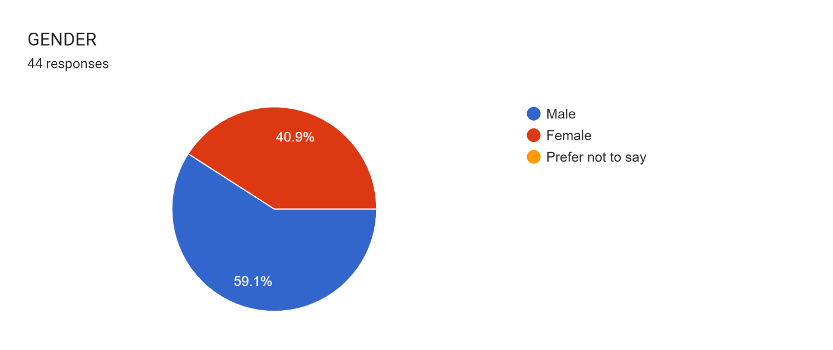

# Chart 6.1.2 Classification of respondents based on their gender.

# INTERPRETATION:

##### In this questionnaire, there are 59.1% of male and 40.9% of female employee’s respondent for the gender common question.

3) I am satisfied with my salary.

|  |  |  |
| --- | --- | --- |
|  | No of responses | Percentage |
| Strongly Agree | 8 | 17.8 |
| Agree | 20 | 44.4 |
| Neutral | 12 | 26.7 |
| Disagree | 5 | 11.1 |
| Strongly Disagree | 0 | 0 |
| Total (45) | 45 | 100 |

Table 6.1.3 Classification of respondents based on their salary.

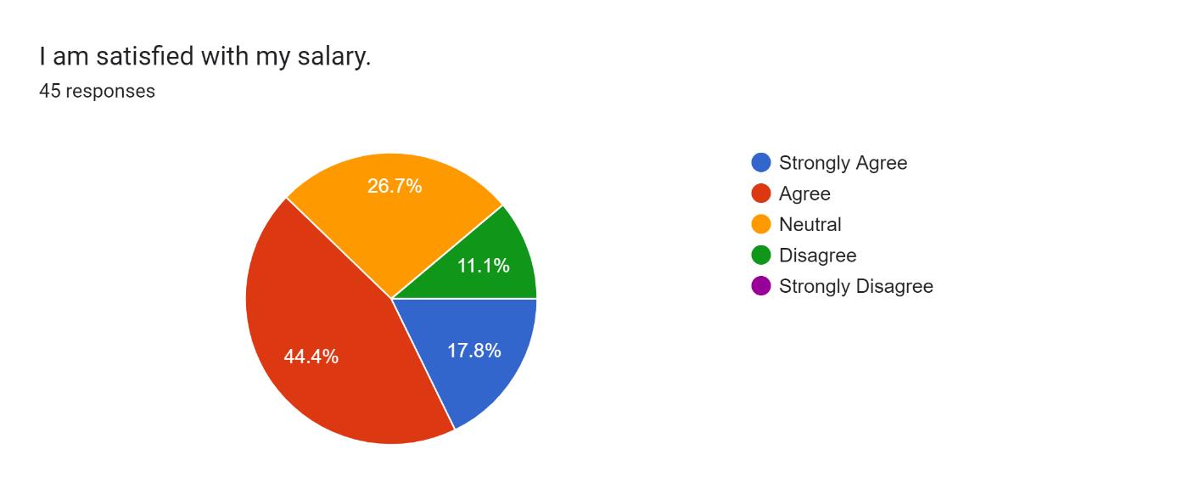

# Chart 6.1.3 Classification of respondents based on their salary.

# INTERPRETATION:

From this questionnaire, above response is maximum number of employees 44.4% agree the salaries satisfied and 26.7% employees in neutral state and 17.8% strongly agree the salaries are satisfied and only 11.1% disagree their salary not satisfied.

4) I am satisfied with my retirement plan.

|  |  |  |
| --- | --- | --- |
|  | No of responses | Percentage |
| Strongly Agree | 05 | 11.1 |
| Agree | 12 | 26.7 |
| Neutral | 17 | 37.8 |
| Disagree | 10 | 22.2 |
| Strongly Disagree | 01 | 02.2 |
| Total (45) | 45 | 100 |

Table 6.1.4 Classification of respondents based on their retirement plan.

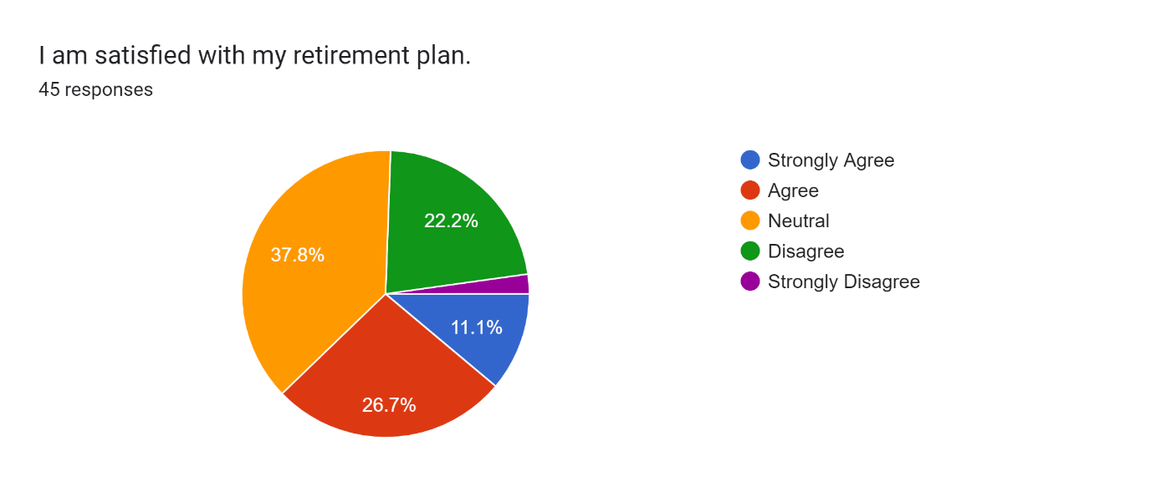

# Chart 6.1.4 Classification of respondents based on their retirement plan

**INTERPRETATION:**

From this questionnaire, above response is maximum number of employees 37.8% given neutral the satisfaction for retirement plan and 26.7% employees in agree for retirement plan and 11.1% strongly agree the retirement plan are satisfied and only 22.2% disagree their retirement plan not satisfied, 2.2% strongly disagree the retirement plan.

5) I am satisfied with my opportunities for promotion, raises, and bonuses.

|  |  |  |
| --- | --- | --- |
|  | No of responses | Percentage |
| Strongly Agree | 07 | 15.6 |
| Agree | 15 | 33.3 |
| Neutral | 16 | 35.6 |
| Disagree | 06 | 13.3 |
| Strongly Disagree | 01 | 02.2 |
| Total (45) | 45 | 100 |

Table 6.1.5 Classification of respondents based on their opportunities for promotion, raises, and bonuses.

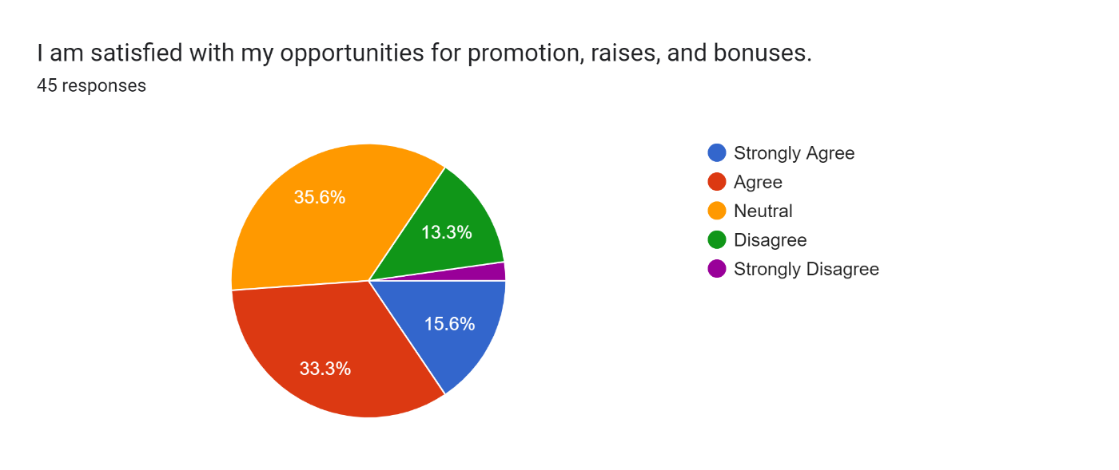

Chart 6.1.5Classification of respondents based on their opportunities for promotion, raises, and bonuses.

# INTERPRETATION:

From this questionnaire, above response is maximum number of employees 35.6% given neutral the satisfaction for opportunities and 33.3% employees in agree for opportunities and 15.6% strongly agree opportunities are satisfied and only 13.3% disagree their opportunities not satisfied, 2.2% strongly disagree the opportunities.

6) Overall, I am satisfied with my financial benefits.

|  |  |  |
| --- | --- | --- |
|  | No of responses | Percentage |
| Strongly Agree | 07 | 15.6 |
| Agree | 15 | 33.3 |
| Neutral | 20 | 44.4 |
| Disagree | 03 | 06.7 |
| Strongly Disagree | 00 | 00 |
| Total (45) | 45 | 100 |

Table 6.1.6 Classification of respondents based on their financial benefits.

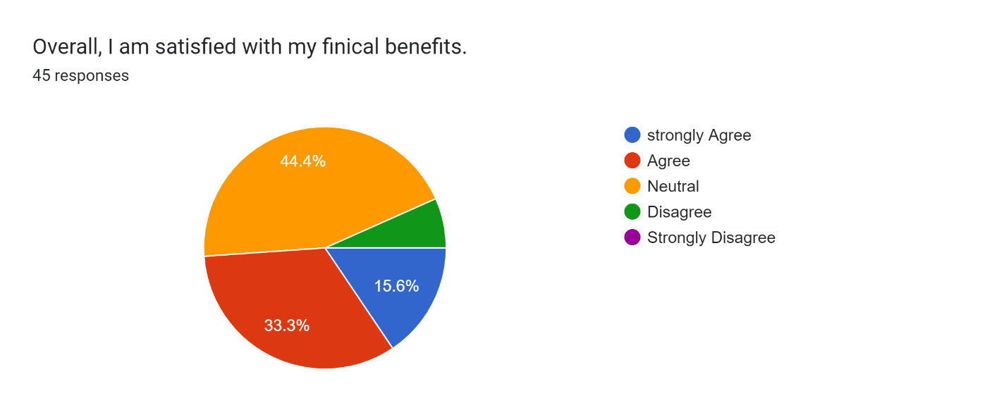

# Chart 6.1.6 Classification of respondents based on their financial benefits.

# INTERPRETATION:

From this questionnaire, above response is maximum number of employees 44.4% given neutral the satisfaction for financial benefits and 33.3% employees in agree for financial benefits and 15.6% strongly agree financial benefits are satisfied and only 6.7% disagree their financial benefits not satisfied.

# 7) I am satisfied with my health plan options.

|  |  |  |
| --- | --- | --- |
|  | No of responses | Percentage |
| Strongly Agree | 10 | 22.2 |
| Agree | 19 | 42.2 |
| Neutral | 10 | 22.2 |
| Disagree | 06 | 13.3 |
| Strongly Disagree | 00 | 00 |
| Total (45) | 45 | 100 |

Table 6.1.7 Classification of respondents based on their health plan.

# 

# Chart 6.1.7 Classification of respondents based on their health plan.

# INTERPRETATION:

From this questionnaire, above response is maximum number of employees 42.2% agree the satisfaction for health plan and 22.2% employees given neutral for health plan and 22.2% strongly agree health plan are satisfied and only 13.3% disagree their health plan not satisfied.

# 8) I am satisfied with my long-term disability insurance.

|  |  |  |
| --- | --- | --- |
|  | No of responses | Percentage |
| Strongly Agree | 10 | 22.2 |
| Agree | 12 | 26.7 |
| Neutral | 17 | 37.8 |
| Disagree | 04 | 08.9 |
| Strongly Disagree | 02 | 04.4 |
| Total (45) | 45 | 100 |

Table 6.1.8 Classification of respondents based on their long-term disability insurance.

# 

# Chart 6.1.8 Classification of respondents based on their long-term disability insurance.

# INTERPRETATION:

From this questionnaire, above response is maximum number of employees 37.8% given neutral the satisfaction for long-term disability insurance and 26.7% employees in agree for long-term disability insurance and 22.2% strongly agree the long-term disability insurance are satisfied and only 8.9% disagree their long-term disability insurance not satisfied, 4.4% strongly disagree the long-term disability insurance.

# 9) I am satisfied with my short-term disability insurance.

|  |  |  |
| --- | --- | --- |
|  | No of responses | Percentage |
| Strongly Agree | 09 | 20 |
| Agree | 11 | 24.4 |
| Neutral | 18 | 40 |
| Disagree | 04 | 08.9 |
| Strongly Disagree | 03 | 06.7 |
| Total (45) | 45 | 100 |

Table 6.1.9 Classification of respondents based on their short-term disability insurance.

# 

# Chart 6.1.9 Classification of respondents based on their short-term disability insurance.

# INTERPRETATION:

From this questionnaire, above response is maximum number of employees 40% given neutral the satisfaction for short-term disability insurance and 24.4% employees in agree for short-term disability insurance and 20% strongly agree the short-term disability insurance are satisfied and only 8.9% disagree their short-term disability insurance not satisfied, 6.7% strongly disagree the short-term disability insurance.

# 10) I am satisfied with my dental/vision plan options.

|  |  |  |
| --- | --- | --- |
|  | No of responses | Percentage |
| Strongly Agree | 08 | 18.2 |
| Agree | 16 | 36.4 |
| Neutral | 13 | 29.5 |
| Disagree | 06 | 13.6 |
| Strongly Disagree | 01 | 02.2 |
| Total (45) | 44 | 99.9 |

Table 6.1.10 Classification of respondents based on their dental/vision plan.

# 

# Chart 6.1.10 Classification of respondents based on their dental/vision plan.

# INTERPRETATION:

From this questionnaire, above response is maximum number of employees 36.4% agree the satisfaction for dental/vision plan and 29.5% employees given neutral for insurance and 18.2% strongly agree the dental/vision plan are satisfied and only 13.6% disagree their dental/vision plan not satisfied, 2.2% strongly disagree the dental/vision plan.

# 11) I am overall satisfied with my health benefits.

|  |  |  |
| --- | --- | --- |
|  | No of responses | Percentage |
| Strongly Agree | 08 | 17.8 |
| Agree | 21 | 46.7 |
| Neutral | 12 | 26.7 |
| Disagree | 04 | 08.9 |
| Strongly Disagree | 00 | 00 |
| Total (45) | 45 | 100 |

Table 6.1.11 Classification of respondents based on their health benefits.

# 

# Chart 6.1.11 Classification of respondents based on their health benefits.

# INTERPRETATION:

From this questionnaire, above response is maximum number of employees 46.7% agree the satisfaction for health benefits and 26.7% employees given neutral for health benefits and 17.8% strongly agree health benefits are satisfied and only 8.9% disagree their health benefits not satisfied.

12) I am overall satisfied with travel and expenditures.

|  |  |  |
| --- | --- | --- |
|  | No of responses | Percentage |
| Strongly Agree | 10 | 22.2 |
| Agree | 14 | 31.1 |
| Neutral | 16 | 35.6 |
| Disagree | 04 | 08.9 |
| Strongly Disagree | 01 | 02.2 |
| Total (45) | 45 | 100 |

Table 6.1.12 Classification of respondents based on their travel and expenditures.

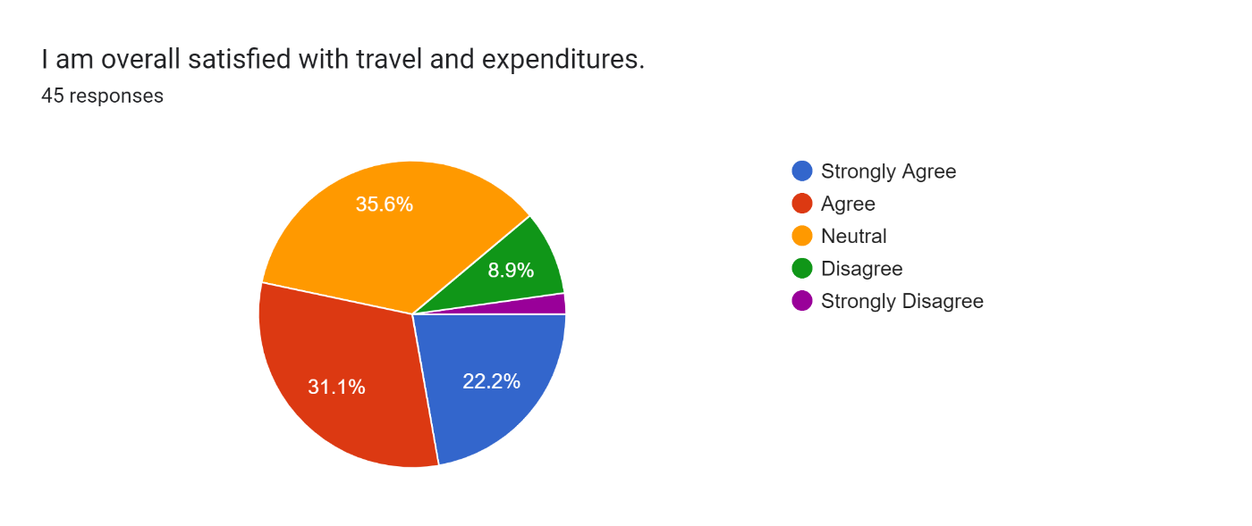

# Chart 6.1.12 Classification of respondents based on their travel and expenditures.

# INTERPRETATION:

From this questionnaire, above response is maximum number of employees 35.6% given neutral the satisfaction for travel and expenditures and 31.1% employees in agree for travel and expenditures 22.2% strongly agree the travel and expenditures are satisfied and only 8.9% disagree their travel and expenditures not satisfied, 2.2% strongly disagree the travel and expenditures.

13) I am satisfied with the number of vacation, sick and personal days that I receive.

|  |  |  |
| --- | --- | --- |
|  | No of responses | Percentage |
| Strongly Agree | 10 | 22.2 |
| Agree | 18 | 40 |
| Neutral | 13 | 28.9 |
| Disagree | 04 | 08.9 |
| Strongly Disagree | 00 | 00 |
| Total (45) | 45 | 100 |

Table 6.1.13 Classification of respondents based on their number of vacation, sick and personal days.

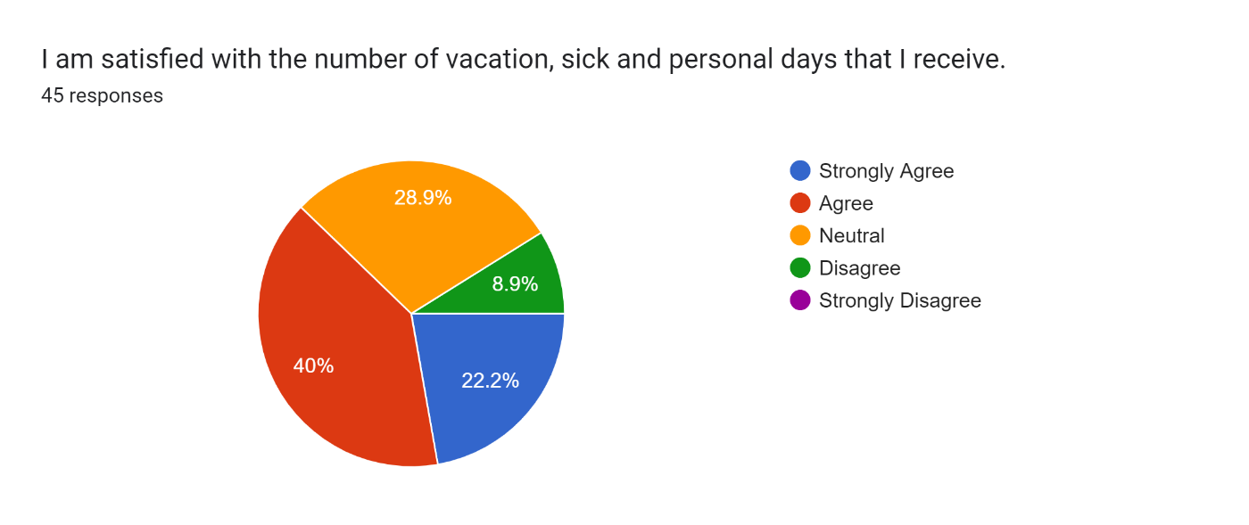

# Chart 6.1.13 Classification of respondents based on their number of vacation, sick and personal days.

# INTERPRETATION:

From this questionnaire, above response is maximum number of employees 40% agree the satisfaction for number of vacation, sick and personal days and 28.8% employees given neutral for number of vacation, sick and personal days and 22.2% strongly agree number of vacation, sick and personal days are satisfied and only 8.9% disagree their number of vacation, sick and personal days not satisfied.

14) Overall, I am satisfied with my paid time off.

|  |  |  |
| --- | --- | --- |
|  | No of responses | Percentage |
| Strongly Agree | 11 | 24.4 |
| Agree | 19 | 42.2 |
| Neutral | 12 | 26.7 |
| Disagree | 03 | 06.7 |
| Strongly Disagree | 00 | 00 |
| Total (45) | 45 | 100 |

Table 6.1.14 Classification of respondents based on their paid time off.

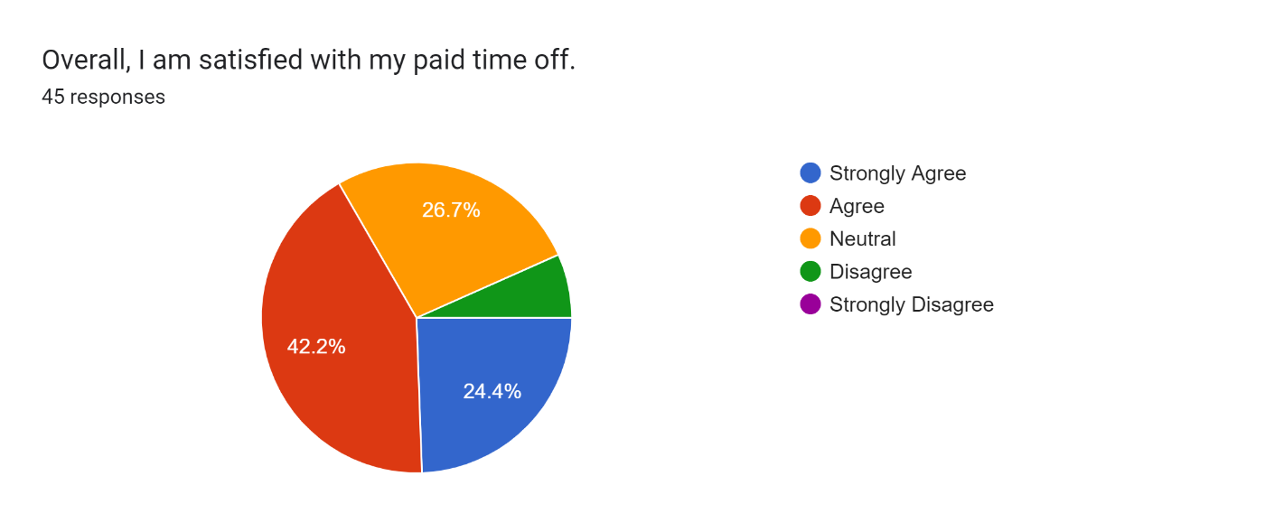

# Chart 6.1.14 Classification of respondents based on their paid time off.

# INTERPRETATION:

From this questionnaire, above response is maximum number of employees 42.2% agree the satisfaction for paid time off and 26.7% employees given neutral for paid time off and 24.4% strongly agree paid time off are satisfied and only 6.7% disagree their paid time off not satisfied.

15) How would you rate the professionalism of the payroll staff?

|  |  |  |
| --- | --- | --- |
|  | No of responses | Percentage |
| Exceptional | 08 | 17.4 |
| Good | 22 | 50 |
| Average | 11 | 23.9 |
| Needs Improvement | 04 | 08.7 |
| Unacceptable | 00 | 00 |
| Total (45) | 45 | 100 |

# Table 6.1.15 Classification of respondents based on their professionalism of pay roll staff.

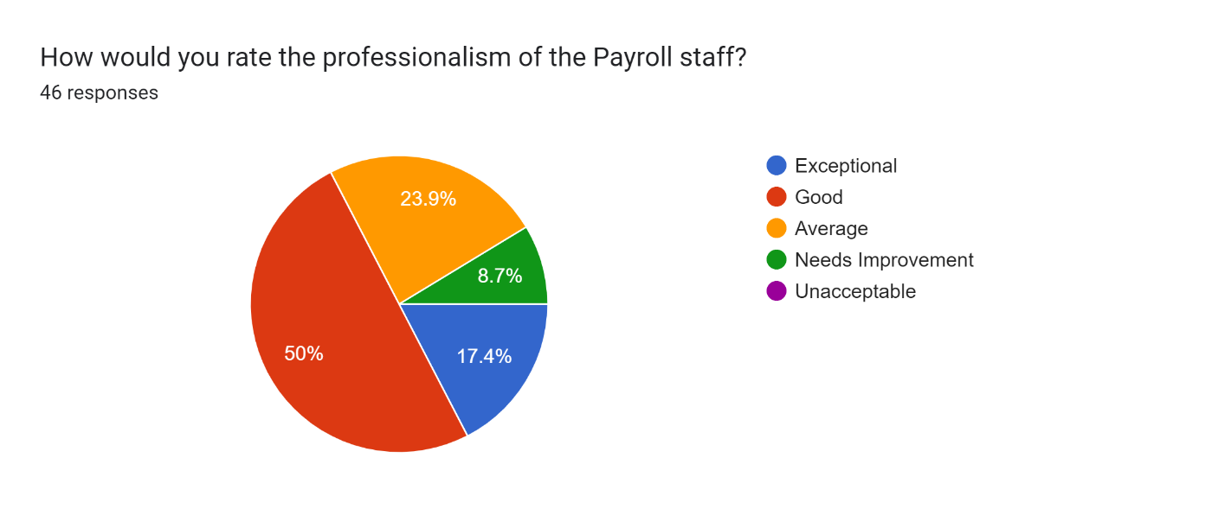

# Chart 6.1.15 Classification of respondents based on their professionalism of payroll staff.

# INTERPRETATION:

From this questionnaire, above response is maximum number of employees 50% marked good the satisfaction for payroll staff and 23.9% employees given average for payroll staff and 17.4% given exceptional payroll staff and only 8.7% marked needs improvement to their payroll staff.

16) When you contacted or visited the Payroll Office, did you get the information that you needed or your issue resolved?

|  |  |  |
| --- | --- | --- |
|  | No of responses | Percentage |
| Yes | 23 | 51.1 |
| No | 12 | 26.7 |
| Maybe | 10 | 22.2 |
| Total (45) | 45 | 100 |

Table 6.1.16 Classification of respondents based on their contacted or visited the Payroll Office.

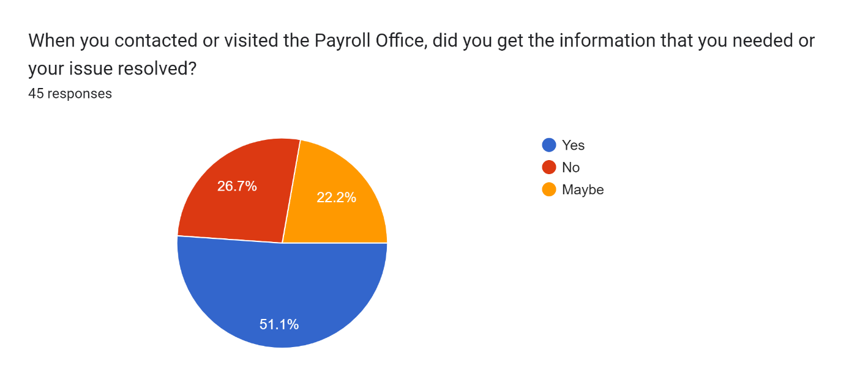

# Chart 6.1.16 Classification of respondents based on their contacted or visited the Payroll Office.

# INTERPRETATION:

From this questionnaire, above response is maximum number of employees 51.1% said yes to the satisfaction for contact or visit payroll office and 26.7% employees given no for contact or visit payroll office and 22.2% maybe contact or visit payroll office.

17) Did any one person make a difference in your experience with the Payroll Office?

|  |  |  |
| --- | --- | --- |
|  | No of responses | Percentage |
| Yes | 23 | 51.1 |
| No | 13 | 28.9 |
| Maybe | 09 | 20 |
| Total (45) | 45 | 100 |

Table 6.1.17 Classification of respondents based on their make a in your experience with the Payroll Office.

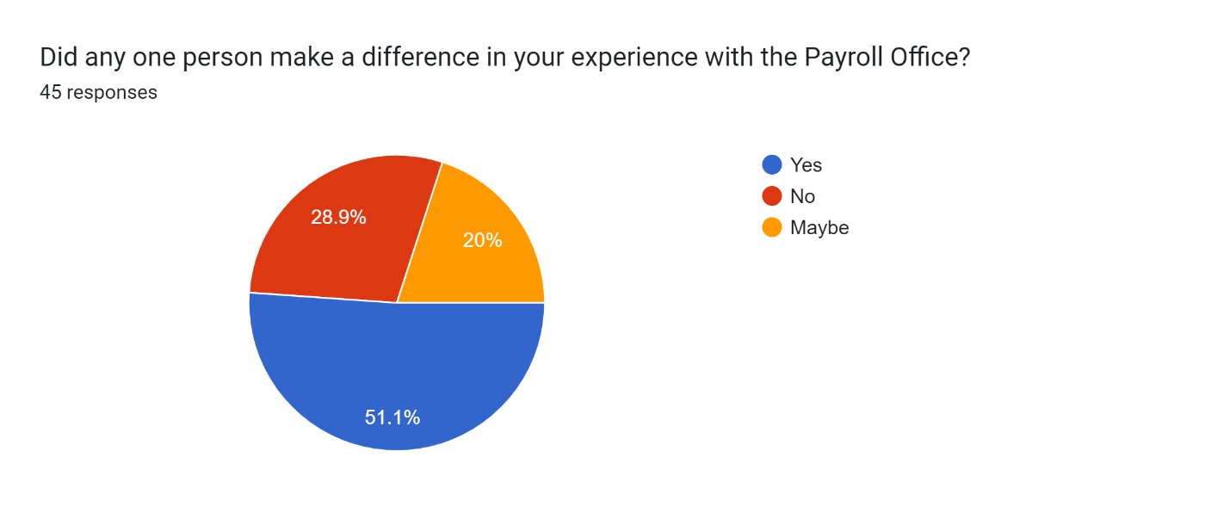

# Chart 6.1.17 Classification of respondents based on their make a difference in your experience with the Payroll Office.

# INTERPRETATION:

From this questionnaire, above response is maximum number of employees 51.1% said yes to the satisfaction for make a difference in your experience with the Payroll Office and 28.9% employees make a difference in your experience with the Payroll Office and 20% maybe make a difference in your experience with the Payroll Office.

18) Are all payments made to your employees processed through the payroll-system?

|  |  |  |
| --- | --- | --- |
|  | No of responses | Percentage |
| Yes | 36 | 80 |
| No | 04 | 08.9 |
| Maybe | 05 | 11.1 |
| Total (45) | 45 | 100 |

Table 6.1.18 Classification of respondents based on their payment passes through payroll system.

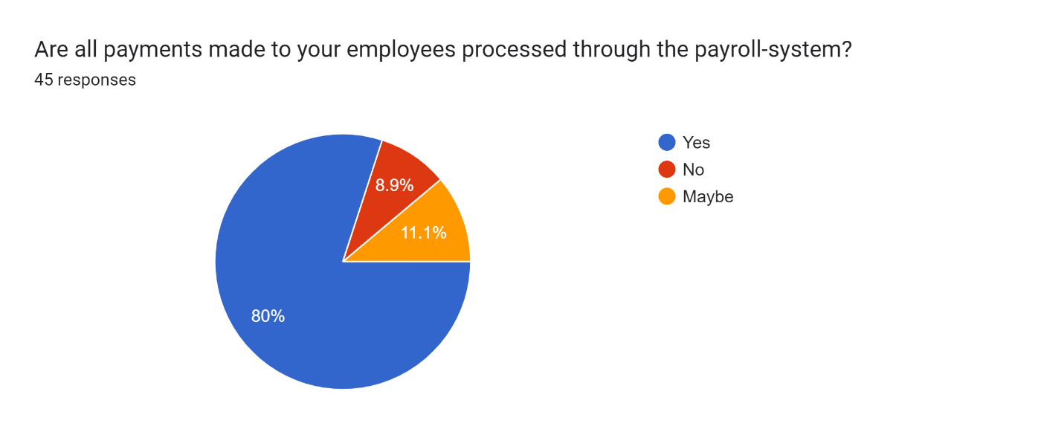

# Chart 6.1.18 Classification of respondents based on their payment passes through payroll system.

# INTERPRETATION:

From this questionnaire, above response is maximum number of employees 80% said yes to the all payments processed through the payroll system and 11.7% employees given may be for all payments processed through the payroll system and 8.9% said no all payments processed through the payroll system.

19) Does the company reimburse entertainment expenditure laid out on behalf of the company?

|  |  |  |
| --- | --- | --- |
|  | No of responses | Percentage |
| Yes | 17 | 37.8 |
| No | 16 | 35.6 |
| Maybe | 12 | 26.7 |
| Total (45) | 45 | 100 |

Table 6.1.19 Classification of respondents based on their reimbursement expenditure.

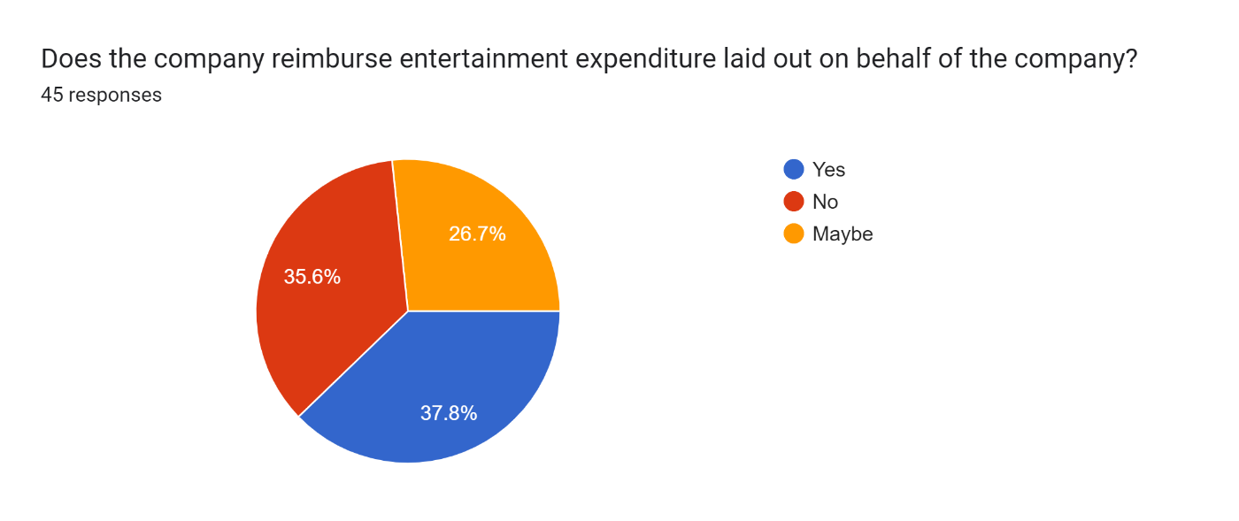

# Chart 6.1.19 Classification of respondents based on their reimbursement expenditure.

# INTERPRETATION:

From this questionnaire, above response is maximum number of employees 37.8% said yes to the satisfaction for reimburse entertainment expenditure and 35.6% employees given no for reimburse entertainment expenditure and 26.7% given maybe to reimburse entertainment expenditure.

20) How satisfied are you with the accuracy of your payroll?

|  |  |  |
| --- | --- | --- |
|  | No of responses | Percentage |
| Very Satisfied | 09 | 20 |
| Completely Satisfied | 14 | 31.1 |
| Slightly Satisfied | 09 | 20 |
| Somewhat Satisfied | 08 | 17.8 |
| Not at all Satisfied | 05 | 11.1 |
| Total (45) | 45 | 100 |

Table 6.1.20 Classification of respondents based on their accuracy of payroll

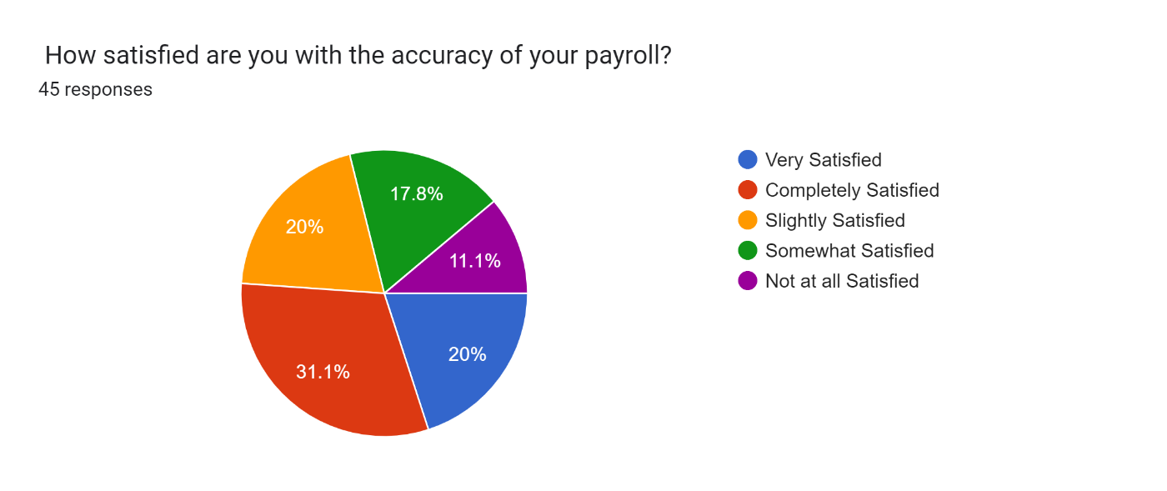

# Chart 6.1.3 Classification of respondents based on their accuracy of payroll.

# INTERPRETATION:

From this questionnaire, above response is maximum number of employees 31.1% given completely satisfied for accuracy of payroll and 20% employees are very satisfied and slightly satisfied for accuracy of payroll,17.8% somewhat satisfied accuracy of payroll and only 11.1% not at all satisfied for accuracy of payroll.

21) How satisfied with your overtime pay?

|  |  |  |
| --- | --- | --- |
|  | No of Responses | Percentage |
| Very Satisfied | 07 | 15.6 |
| Satisfied | 12 | 26.7 |
| Neutral | 14 | 31.1 |
| Dissatisfied | 09 | 20 |
| Very Dissatisfied | 03 | 06.6 |
| Total (45) | 45 | 100 |

Table 6.1.21 Classification of respondents based on their overtime pay.

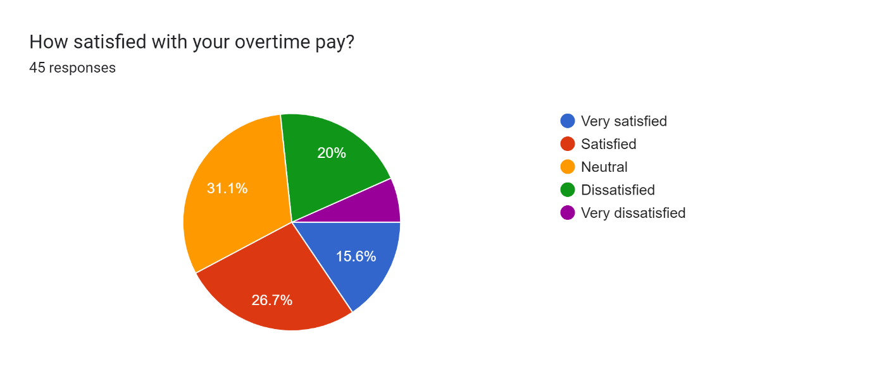

# Chart 6.1.21 Classification of respondents based on their overtime pay.

**INTERPRETATION:**

From this questionnaire, above response is maximum number of employees 31.1% given neutral for overtime pay and 26.7% employees given satisfied for overtime pay and 20% dissatisfied for overtime pay and only 6.6% dissatisfied to their overtime pay.

**CHAPTER - 7**

**FINDINGS, SUGGESTIONS, AND CONCLUSION.**

**7.Findings, Suggestions, and Conclusion.**

**7.1 Findings**

* 44.4% of the respondents agree to salaries are satisfied in the Air Filters Industry.
* 37.8% of the respondents given neutral for the retirement plan in the organisation.
* 35.6% of the respondents given neutral for promotions, raises and bonuses in the industry.
* 44.4% of the respondents given neutral for over all financial benefits of organisation.
* 42.2% of the respondents are satisfied to the health plan of organisation.
* 37.8% of the respondents given neutral to long-term disability insurance of the organisation.
* 40% of the respondents given neutral to short-term disability insurance of the organisation.
* 36.4% of the respondents agree to vision/dental plan of the industry.
* 46.7% of the respondents agree for the overall health benefits of the industry.
* 35.6% of the respondents given neutral to the travel and expenditure are satisfied.
* 40% of the respondents agree to the number vacation, sick, and personal days leave getting from organisation is satisfied.
* 42.2% of the respondents agree to paid time off in the industry is satisfied.
* 50% of the respondents are satisfied with the professionalism of payroll staff in the organisation.
* 51.1% of the respondents are satisfied with the information that they needed or problem resolved by the payroll office in the organisation.
* 51.1% of the respondents are satisfied with one person make a difference in your experience with the Payroll Office.
* 80% of the respondents are agreed that their payments pass through payroll-system.
* 37.8% of the respondents are satisfied to the company reimburse entertainment expenditure laid out on behalf of the company.
* 31.1% of the respondents are satisfied to the accuracy of payroll in industry.
* 31.1% of the respondents given neutral to the overtime pay of the company.
  1. **Suggestions**
* Organisation should concentrate on their retirement plan for the future of the employees.
* Health benefits of the industry looks weak so try to improve the plan on the health plan for the employees.
* We need to improve the overtime pay of employees based on suggestion details.
* We need to increase the reimbursement expenditure of the employees.
* Need to invest on employee basic benefits for the improvement of organisation.

So, to motivate the employees, management should take into consideration some suggestions given by the employees. It will help to increase the motivation and ultimately the job satisfaction of the employees of Instromed Medical Devices and Solutions.

* 1. **Conclusion**

As the world moves faster and competition becomes more intense due to globalization, human talent will determine which organizations will be successful in the future.

Training helps to achieve this aim. Training is an important tool in the hands of organization.

Employees are enjoying their work; they are satisfied with the resources provided to them, also happy with the trust shown by the CEO, Manager towards their employees.

Company should give focus on their needs of employees. It should give sufficient opportunities to improve employee’s skills.

**CHAPTER - 8**

**ANNEXURE AND REFERENCES**

**8. Annexure and References**

**8.1 Annexure**

AGE

* + 18-24
  + 25-35
  + 36-45
  + 45 and above

GENDER

* Male
* Female
* Prefer not to say

I am satisfied with my salary.

* Strongly Agree
* Agree
* Neutral
* Disagree
* Strongly Disagree

I am satisfied with my retirement plan.

* Strongly Agree
* Agree
* Neutral
* Disagree
* Strongly Disagree

I am satisfied with my opportunities for promotion, raises, and bonuses.

* Strongly Agree
* Agree
* Neutral
* Disagree
* Strongly Disagree

Overall, I am satisfied with my finical benefits.

* strongly Agree
* Agree
* Neutral
* Disagree
* Strongly Disagree

I am satisfied with my health plan options.

* Strongly Agree
* Agree
* Neutral
* Disagree
* Strongly Disagree

I am satisfied with my long-term disability insurance

* Strongly Agree
* Agree
* Neutral
* Disagree
* Strongly Disagree

I am satisfied with my short-term disability insurance.

* Strongly Agree
* Agree
* Neutral
* Disagree
* Strongly Disagree

I am satisfied with my dental/vision plan options.

* Strongly Agree
* Agree
* Neutral
* Disagree
* Strongly Disagree

I am overall satisfied with my health benefits.

* Strongly Agree
* Agree
* Neutral
* Disagree
* Strongly Disagree

I am overall satisfied with travel and expenditures.

* Strongly Agree
* Agree
* Neutral
* Disagree
* Strongly Disagree

I am satisfied with the number of vacation, sick and personal days that I receive.

* Strongly Agree
* Agree
* Neutral
* Disagree
* Strongly Disagree

Overall, I am satisfied with my paid time off.

* Strongly Agree
* Agree
* Neutral
* Disagree
* Strongly Disagree

How would you rate the professionalism of the payroll staff?

* Exceptional
* Good
* Average
* Needs Improvement
* Unacceptable

When you contacted or visited the Payroll Office, did you get the information that you needed or your issue resolved?

* Yes
* No
* Maybe

Did any one person make a difference in your experience with the Payroll Office?

* Yes
* No
* Maybe

Are all payments made to your employees processed through the payroll-system?

* Yes
* No
* Maybe

Does the company reimburse entertainment expenditure laid out on behalf of the company?

* Yes
* No
* Maybe

How satisfied are you with the accuracy of your payroll?

* Very Satisfied
* Completely Satisfied
* Slightly Satisfied
* Somewhat Satisfied
* Not at all Satisfied

How satisfied with your overtime pay?

* Very satisfied
* Satisfied
* Neutral
* Dissatisfied
* Very dissatisfied

**8.2 References**

[1]"How to motivate everyone on the payroll - Smart Payroll", Smart Payroll, 2018. [Online]. Available: <https://www.smartpayroll.co.nz/motivate-everyone-payroll/>.

[2]"Payroll Processing Features and Objectives of PR System", Legler.com, 2018. [Online]. Available: <http://www.legler.com/probj.html>.

[3]"Features of a Payroll System", Smallbusiness.chron.com, 2018. [Online]. Available: <https://smallbusiness.chron.com/features-payroll-system-60900.html>.

[4]2018. [Online]. Available: https://www.coursehero.com/file/p6flr8p/11-Conclusion-PayrollManagement-System-software-developed-for-a-company-has/.

[5] P. Prakash, "The 52 Best Payroll Services for Small Business Owners", Fundera Ledger, 2018. [Online]. Available: <https://www.fundera.com/blog/payroll-services-for-small-business>.

[6]"Explaining the Different Types of Feasibility Studies", Brighthub Project Management, 2018. [Online]. Available: https://www.brighthubpm.com/project-planning/56372-types-offeasibility-studies/.

[7]"NonFunctional Requirements — SRS for AakashTechSupport 1.0.1 documentation", Aakashtechsupportdocs.readthedocs.io, 2018. [Online]. Available: https://aakashtechsupportdocs.readthedocs.io/en/latest/nonfunc.html.

[8]"What is entity relationship diagram (ERD)? - Definition from WhatIs.com", SearchDataManagement, 2018. [Online]. Available: <https://searchdatamanagement.techtarget.com/definition/entity-relationship-diagram-ERD>.

[9] A. Hillsberg, "List of Payroll Software Companies in 2018 - Financesonline.com", Financesonline.com, 2018. [Online]. Available: https://financesonline.com/list-of-payrollsoftware-companies/.

[10]"Gusto Reviews: Overview, Pricing and Features", Financesonline.com, 2018. [Online]. Available: <https://reviews.financesonline.com/p/gusto/>.

[11]"OnPay Reviews: Overview, Pricing and Features", Financesonline.com, 2018. [Online]. Available: <https://reviews.financesonline.com/p/onpay/>.

[12]"ADP Workforce Now Reviews: Overview, Pricing and Features", Financesonline.com, 2018. [Online]. Available: <https://reviews.financesonline.com/p/adp-workforce-now/>.

[13]"Xero Reviews: Overview, Pricing and Features", Financesonline.com, 2018. [Online]. Available: https://reviews.financesonline.com/p/xero/.

[14]"Dayforce HCM - Financesonline.com", Financesonline.com, 2018. [Online]. Available: https://reviews.financesonline.com/p/dayforce-hcm/.

[15]"Wave Reviews: Overview, Pricing and Features", Financesonline.com, 2018. [Online]. Available: <https://reviews.financesonline.com/p/wave-apps/>.

[16]"Zenefits Reviews: Overview, Pricing and Features", Financesonline.com, 2018. [Online]. Available: <https://reviews.financesonline.com/p/zenefits/>.

[17]"Intuit Payroll Reviews: Overview, Pricing and Features", Financesonline.com, 2018. [Online]. Available: <https://reviews.financesonline.com/p/intuit-payroll/>.

[18]2018. [Online]. Available: https://www.business2community.com/human-resources/top-10- benefits-using-payroll-software-0760968.

[19]"Advantages and disadvantages of payroll software", nibusinessinfo.co.uk, 2018. [Online]. Available: https://www.nibusinessinfo.co.uk/content/advantages-and-disadvantages-payroll-software.

[20]"Introduction of Payroll Management System", FreeProjectz, 2018. [Online]. Available: https://www.freeprojectz.com/project-synopsis/synopsis-payroll-management-system/introduction-payroll-management-system.

[21]"An Introduction to Payroll Systems", Smallbusiness.chron.com, 2018. [Online]. Available: <https://smallbusiness.chron.com/introduction-payroll-systems-67550.html>.

[22] Meenakshi S. Nair, *"A Study on Employee Retention Strategies",* 2007, pp. 41-56.

[23] Dr. Shikha N. Khera1, Ms. Karishma Gulati, Human Resource Information System and its impact on Human Resource Planning: A perceptual analysis of Information Technology companies, IOSR Journal of Business and Management (IOSRJBM) ISSN: 2278- 487X Volume 3, Issue 6 (Sep, -Oct. 2012).

[24] N. H. Abdulah, E. Wahab, A. Shamsuddin, and N. A. Abdul Hamid, “Acceptance of Computerized Payroll System among SMEs‟ Managers using Technology Acceptance Model,” in 2nd International Conference on Technology Management, Business and Entrepreneurship, 2013, pp. 301–307.

[25] F. H. Rusly, A. Ahmi, Y. Y. Abdul Talib, and K. Rosli, “Payroll system: A bibliometric analysis of the literature,” in AIP Conference Proceedings, 2018, vol. 2016, p. 020124.

[26] N. Khairudin, K. Rosli, and Y. Y. Abdul Talib, “SQL Payroll Training Module,” Sintok, Malaysia: Institute for Strategic and Sustainable Accounting Development (ISSAD), 2018.

[27] S. Q. Batool, D. M. A. Sajid, and D. S. H. Raza., “Benefits and Barriers of Human Resource Information System in Accounts Office & Azad Jammu & Kashmir Community Development Program,” Int. J. Humanit. Soc. Sci., vol. 2, no. 3, pp. 211–217, 2012.