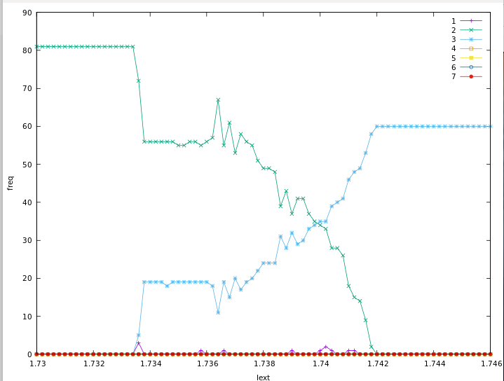
Gnuplot code
gnuplot> set xlabel "Iext"
gnuplot> set ylabel "freq"
gnuplot> set key font ",10"
gnuplot> plot "Freq_of_Spike_per_grp2_vs_Iext0.txt" index 0 using 1:2 w lp title"1", "Freq_of_Spike_per_grp2_vs_Iext0.txt" index 1 using 1:2 w lp title "2","Freq_of_Spike_per_grp2_vs_Iext0.txt" index 2 using 1:2 w lp title "3","Freq_of_Spike_per_grp2_vs_Iext0.txt" index 3 using 1:2 w lp title"4", "Freq_of_Spike_per_grp2_vs_Iext0.txt" index 4 using 1:2 w lp title "5","Freq_of_Spike_per_grp2_vs_Iext0.txt" index 5 using 1:2 w lp title "6","Freq_of_Spike_per_grp2_vs_Iext0.txt" index 6 using 1:2 w lp title "7"

