Trial
Iext= 1.6
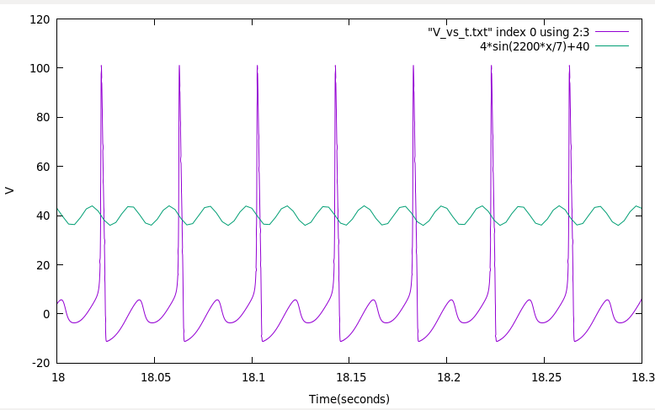
Gnu plot code:
gnuplot> set xlabel "Time(seconds)"
gnuplot> set ylabel "V"
gnuplot> set xrange[18:18.3]
gnuplot> plot "V_vs_t.txt" index 0 using 2:3 w lines,4*sin(2200*x/7)+40

Step: 0.001
Iextmin:1.600
Iextmax: 1.650

Trial 2
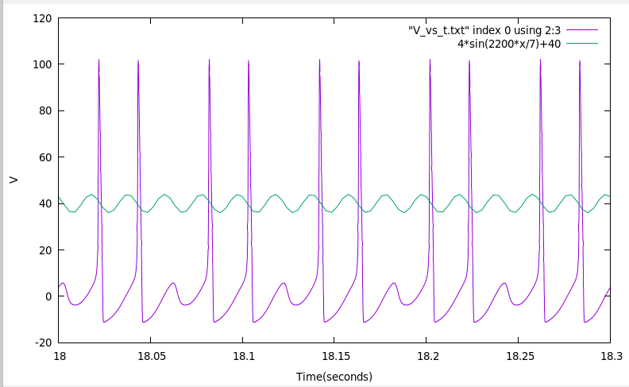
Iext = 1.7

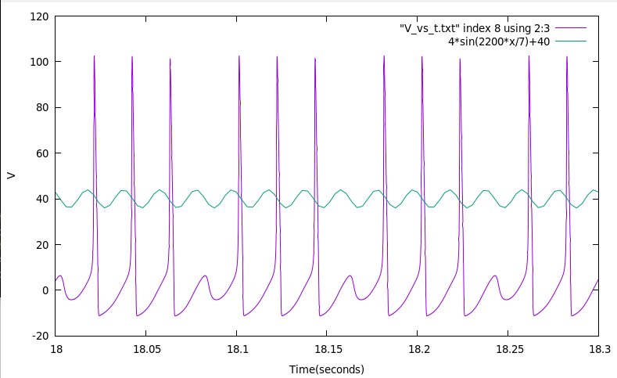
Iext = 1.78

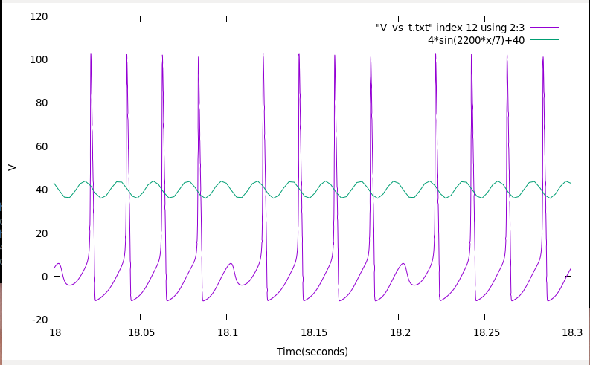
Iext = 1.82

Step: 0.01
Iextmin:1.7
Iextmax:1.83

Trial 3
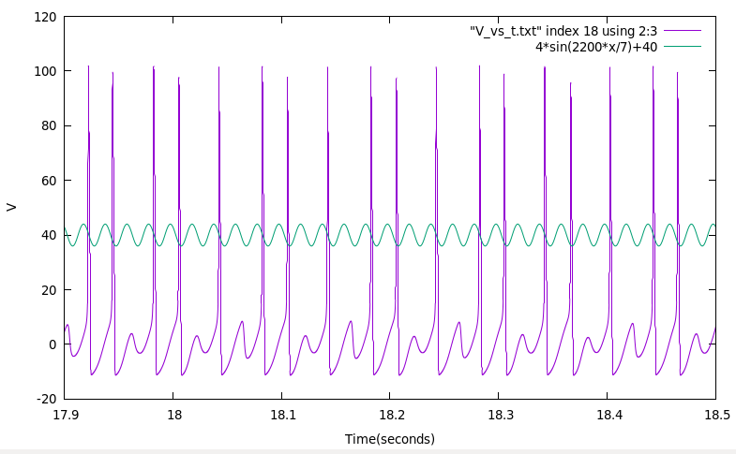
Iext = 1.6518
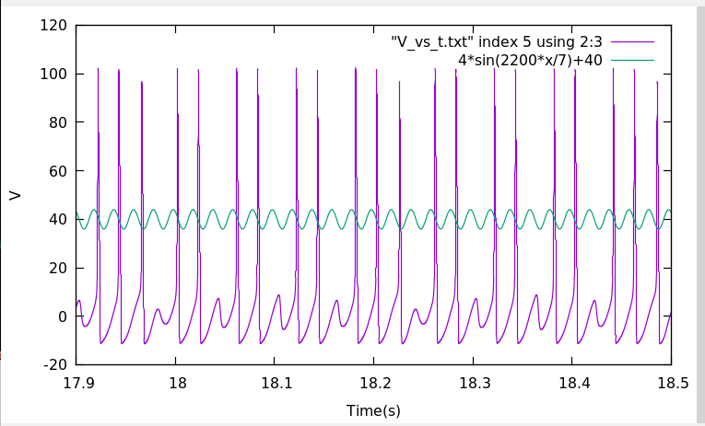
Iext=1.7345
Gnuplot code:
gnuplot> set xrange[17.9:18.5]
gnuplot> set samples 10000
gnuplot> plot "V_vs_t.txt" index 18 using 2:3 w lines,4*sin(2200*x/7)+40
Trial 3
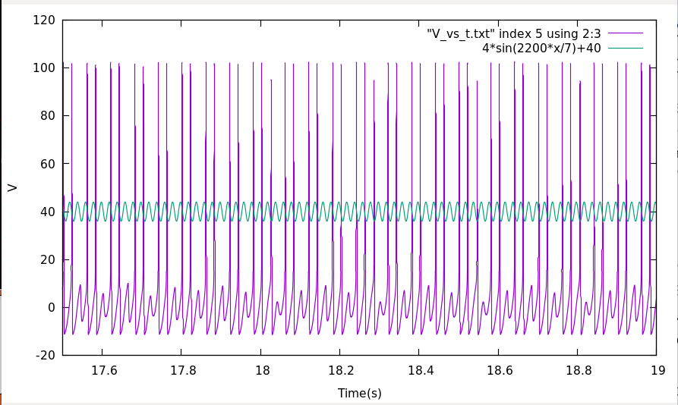
Iext=1.73365
gnuplot> set xrange[17.5:19]
gnuplot> plot "V_vs_t.txt" index 5 using 2:3 w lines,4*sin(2200*x/7)+40
Trial 3
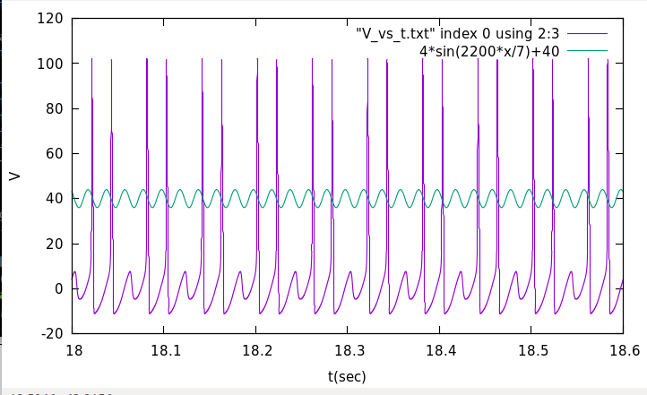
Iext=1.731
gnuplot> set xrange[18:18.6]
gnuplot> plot "V_vs_t.txt" index 0 using 2:3 w lines,4*sin(2200*x/7)+40
Trial 4
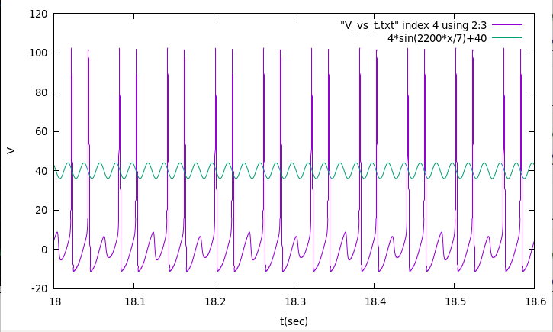
Iext=1.7324
Trial 5
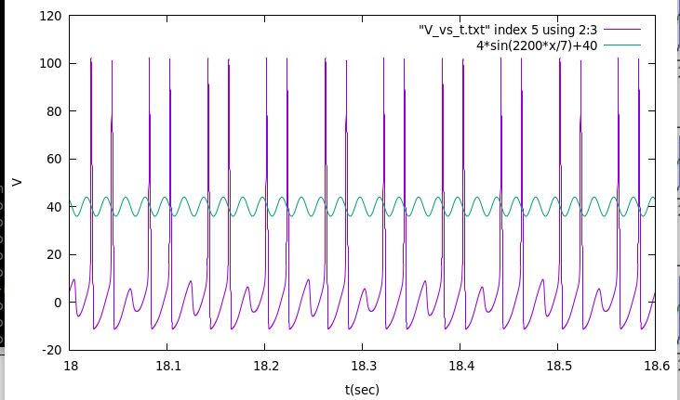
Iext=1.73315

