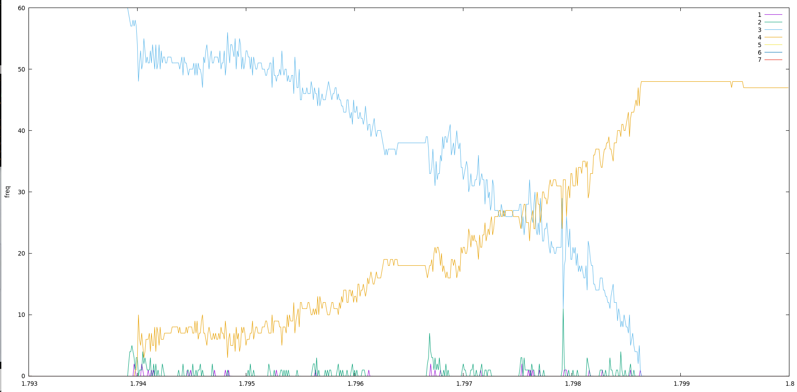
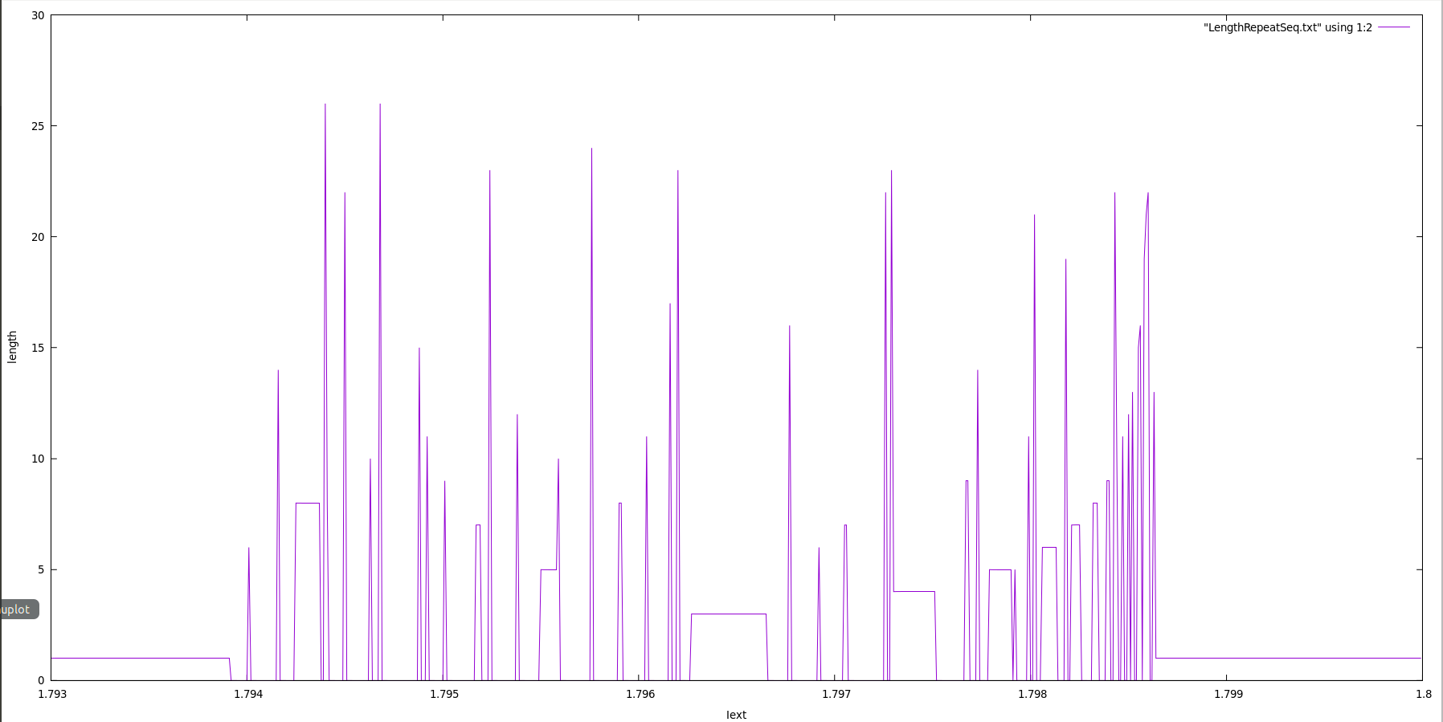
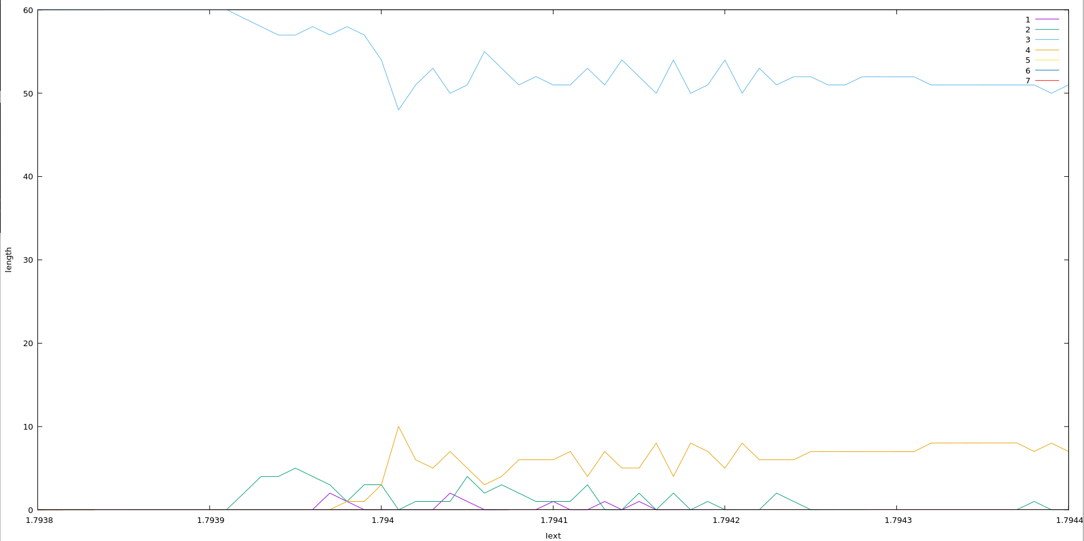
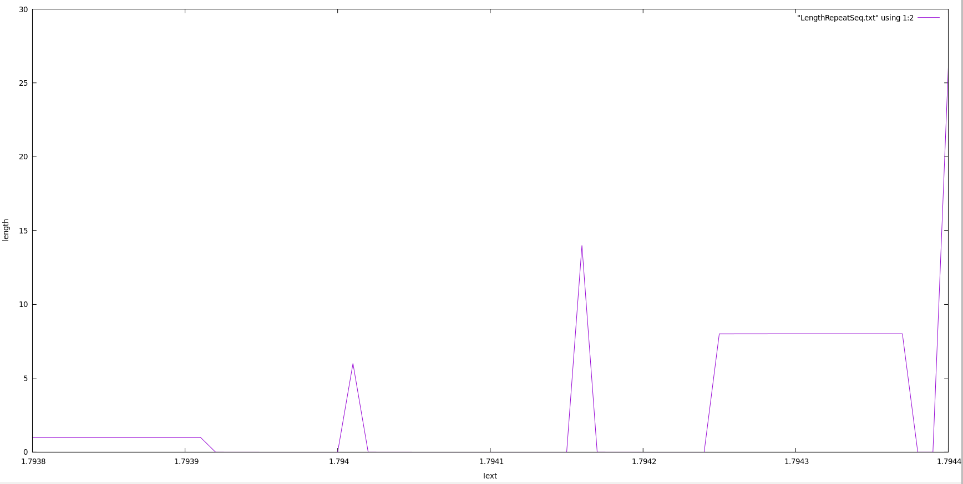
1.7939-1.7941
81
10
1
0
0
0
0
1
0
1
0
0
0
1
0
0
0
0
0
0
0
1
1
0
1
0
1
0
1
0
0
0
0
0
0
0
0
0
0
0
0
0

