Link : https://github.com/agasusantooo/Pemrograman_Desktop

Latihan Pengamatan 11

1. Flip Horizontal tanpa fungsi bawaan :

Private Sub FlipHorizontalToolStripMenuItem_Click(sender As Object, e As EventArgs) Handles FlipHorizontalToolStripMenuItem.Click

If PictureBox1.Image Is Nothing Then

MessageBox.Show("Silakan buka gambar terlebih dahulu.", "Peringatan", MessageBoxButtons.OK, MessageBoxIcon.Warning)

Exit Sub

End If

Dim bmp As New Bitmap(PictureBox1.Image)

Dim width As Integer = bmp.Width

Dim height As Integer = bmp.Height

Dim flippedBmp As New Bitmap(width, height)

For y As Integer = 0 To height - 1

For x As Integer = 0 To width - 1

' Salin piksel dari sisi kiri ke sisi kanan (horizontal flip)

flippedBmp.SetPixel(width - 1 - x, y, bmp.GetPixel(x, y))

Next

Next

1. Error handling pada grayscale :

Private Sub GreyscaleToolStripMenuItem_Click(sender As Object, e As EventArgs) Handles GreyscaleToolStripMenuItem.Click

Dim r, g, b, gray As Integer

If PictureBox1.Image Is Nothing Then

MessageBox.Show("Silakan buka gambar terlebih dahulu.", "Peringatan", MessageBoxButtons.OK, MessageBoxIcon.Warning)

Exit Sub

End If

Dim bmp = New Bitmap(PictureBox1.Image)

For bar As Integer = 0 To PictureBox1.Image.Height - 1

For kol As Integer = 0 To PictureBox1.Image.Width - 1

r = bmp.GetPixel(kol, bar).R

g = bmp.GetPixel(kol, bar).G

b = bmp.GetPixel(kol, bar).B

gray = Math.Round(0.2126 * r + 0.7152 * g + 0.0722 * b)

bmp.SetPixel(kol, bar, Color.FromArgb(gray, gray, gray))

Next

Next

'Dim img As Image

'img = CType(bmp, Image)

'PictureBox1.Image = img

PictureBox1.Image = bmp

End Sub

PictureBox1.Image = flippedBmp

End Sub

1. Saya menambahkan gaussian blur

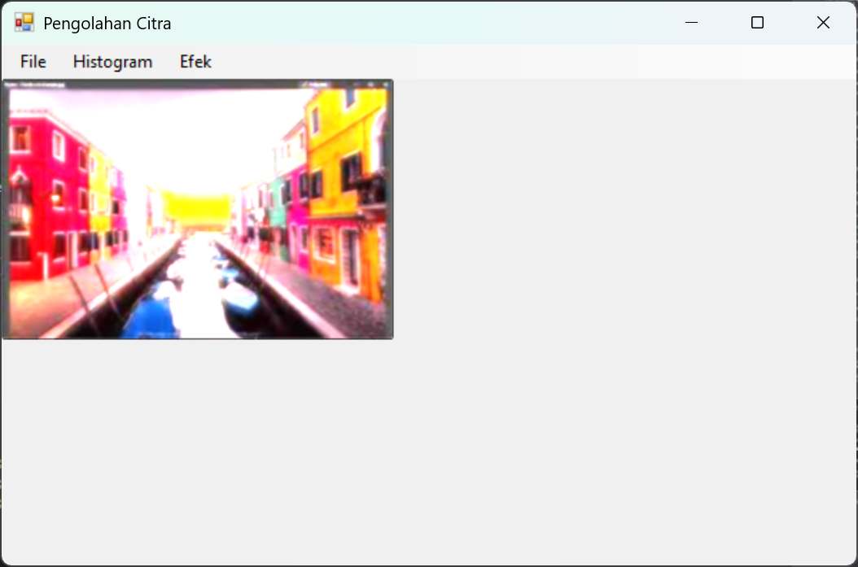 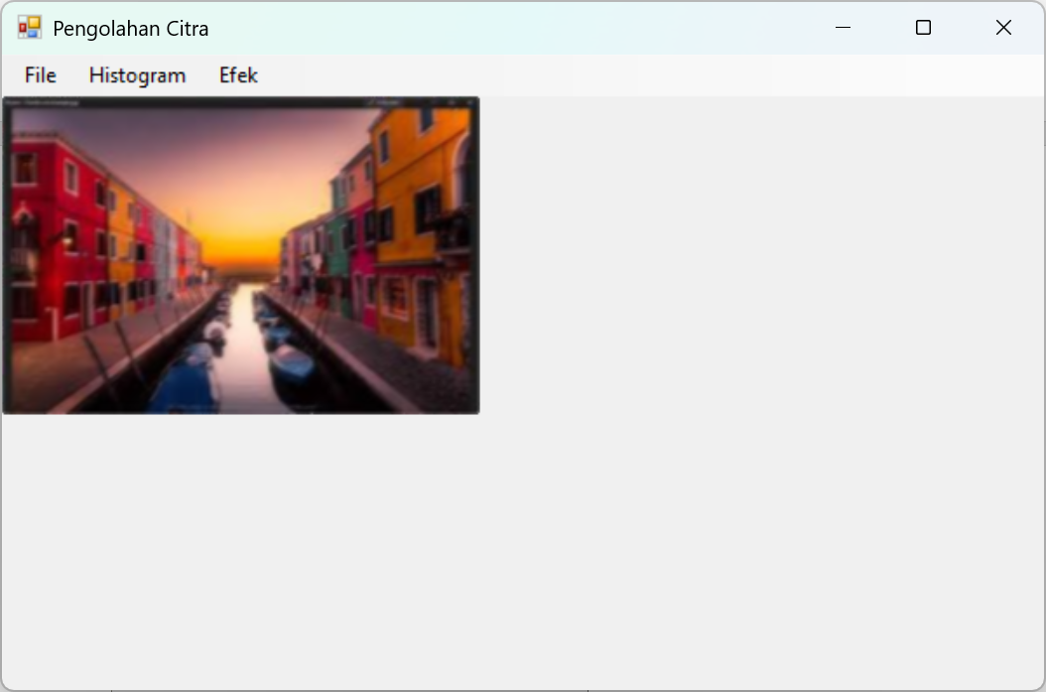

Gaussian blur yang kiri dan blur biasa sebelah kanan. Terdapat perbedaan di intensitas cahayanya. Gaussian blur lebih terang daripada blur biasa

1. Histogram awal

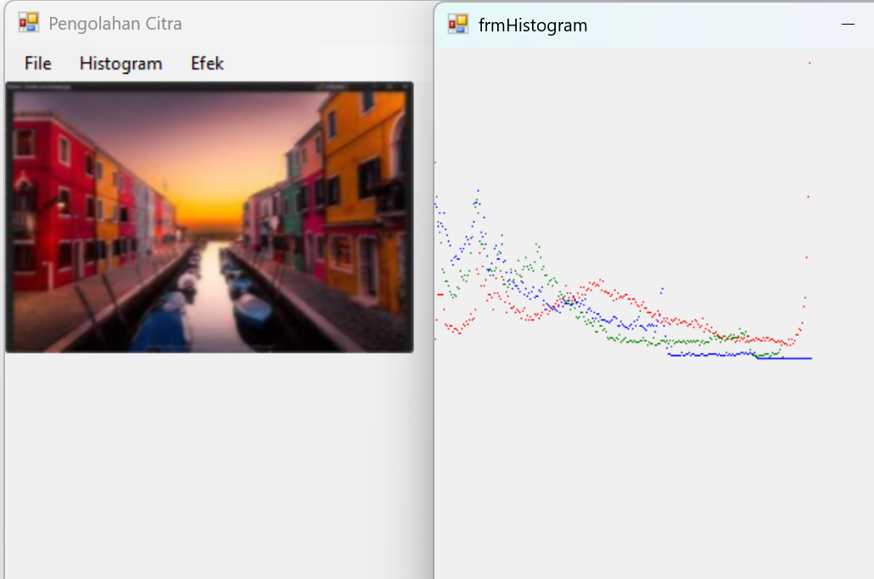

Histogram 8 kali pengurangan kontras

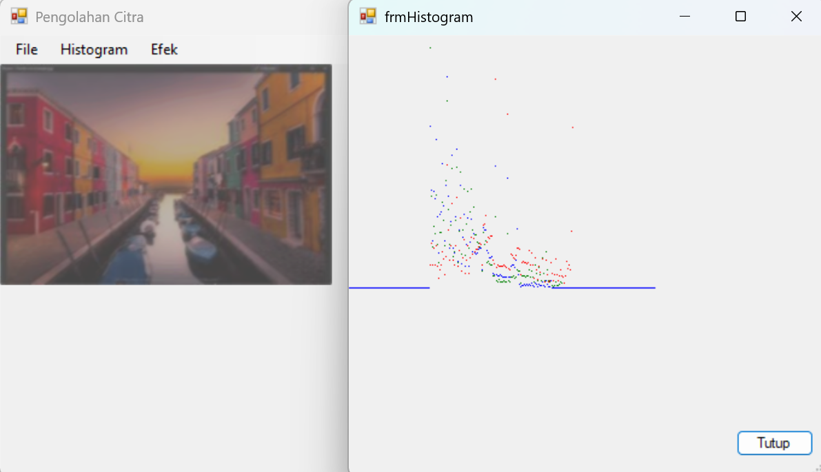

Perbedaannya bahwa intensitas warnanya berkurang drastis ditunjukkan oleh histogram yang jauh lebih sedikit menampilkan spectrum warnanya karena banyak yang berada di tepi bawah