Flask REST API
- Zainstaluj odpowiednie moduły z poziomu File->Settings:
flask
connexion
flask-sqlalchemy
flask-marshmallow
flask-Bootstrap
marshmallow-sqlalchemy
marshmallow
swagger-ui-bundle
- W folderze Day13 załóż nowy folder o nazwie server, utwórz w nim plik o nazwie app.py
- Uzupełnij kod pliku app.py:

import os
import connexion
from flask_sqlalchemy import SQLAlchemy
from flask_marshmallow import Marshmallow
from flask_bootstrap import Bootstrap
main_directory = os.path.abspath(os.path.dirname(__file__))
app_connexion = connexion.App(__name__, specification_dir=main_directory)
app = app_connexion.app
Bootstrap(app)
# database path
sqlite_path = "sqlite:///" + os.path.join(main_directory, "music_store.db")
# Configure the SqlAlchemy part of the app instance
app.config["SQLALCHEMY_ECHO"] = True
app.config["SQLALCHEMY_DATABASE_URI"] = sqlite_path
app.config["SQLALCHEMY_TRACK_MODIFICATIONS"] = False
# sql alchemy orm to communicate with sqlite db
db = SQLAlchemy(app)
# marshmallow init
ma = Marshmallow(app)

Plik app.py będzie służył jako plik z główną konfiguracją aplikacji, jak aplikacja serwera – flask/connection oraz dostep do bazy danych

- Utwórz plik index.py w folderze server – plik ten będzie służyl jako glówny skrypt uruchamiający naszą aplikację. Poniżej kod, który należy umieścić w pliku:

from flask import render_template
from Day13.server.app import app_connexion
from Day13.server.models import Album, AlbumSchema
# Get the application instance
connex_app = app_connexion
# create a URL route in our application for "/"
@connex_app.route("/")
def home():
"""
This function just responds to the browser URL
localhost:8080/
:return: the rendered template
"""
return "<h1>Hello, iSA Python World!</h1>"
if __name__ == "__main__":
connex_app.run(port=8080, debug=True)

- Uruchom plik index.py, otwórz przeglądarkę i otwórz adres http://localhost:8080/
- Zmień kod w pliku index.py, aby w przeglądarce wyświetlił się napis: „That is REST API example” – zapisz plik index.py po zmianach, przejrzyj logi konsoli i odśwież stronę przeglądarki – czy tekst się zmienił?
- Zatrzymaj uruchomiony skrypt. W folderze server dodaj plik swagger.yml, zawartość pliku:

swagger: "2.0"
info:
description: This is the swagger file with our REST API spec
version: "1.0.0"
title: Swagger Rest Documentation
consumes:
- application/json
produces:
- application/json
basePath: /api
# Paths supported by the server application
paths:
/album:
get:
operationId: album.read_all
tags:
- Albums
summary: Gets all the albums, sorted by artist
description: Gets all the albums, sorted by artist
responses:
200:
description: Successfully returned albyms
schema:
type: array
items:
properties:
album_id:
type: string
description: Id of the albym
artist:
type: string
description: Title of the album
title:
type: string
description: Title of the album
image_url:
type: string
description: Image URL of the album
last_edited_at:
type: string
description: Creation/Update timestamp of the album

- W folderze server stwórz plik album.py:

import json
from flask import jsonify
albums = [
{
"album_id": 1,
"artist": "Michael Jackson",
"title": "Thriller",
"image_url": "https://upload.wikimedia.org/wikipedia/en/thumb/5/55/Michael_Jackson_-_Thriller.png/220px-Michael_Jackson_-_Thriller.png"
},
{
"album_id": 2,
"artist": "Metallica",
"title": "Kill'em all",
"image_url": "https://upload.wikimedia.org/wikipedia/en/thumb/5/55/Michael_Jackson_-_Thriller.png/220px-Michael_Jackson_-_Thriller.png"
}
]
def read_all():
"""
This function responds to a request for /api/album
with the lists of available albums
:return: json string of list of albums
"""
# Create the list of albums from our data
return jsonify(albums)

- W kodzie pliku index.py za linią 6 dodaj konfiguracje servera z wczesniej stworzonego pliku YAML:
# Read the swagger.yml file to configure the endpoints
connex_app.add_api("swagger.yml")

- Uruchom plik index.py, a następnie przejdź w przeglądarce do adresu
http://localhost:8080/api/ui
Rozwiń dokumentację do sekcji Albums i wypróbuj wywołanie metody GET /album
- Uzupełnij konfigurację pliku swagger.yml o pozostałe metody do sekcji Albums:
Plik powinien wyglądać następująco:
swagger: "2.0"
info:
description: This is the swagger file with our REST API spec
version: "1.0.0"
title: Swagger Rest Documentation
consumes:
- application/json
produces:
- application/json
basePath: /api
# Paths supported by the server application
paths:
/album:
get:
operationId: album.read_all
tags:
- Albums
summary: Gets all the albums, sorted by artist
description: Gets all the albums, sorted by artist
responses:
200:
description: Successfully returned albyms
schema:
type: array
items:
properties:
album_id:
type: string
description: Id of the albym
artist:
type: string
description: Title of the album
title:
type: string
description: Title of the album
image_url:
type: string
description: Image URL of the album
last_edited_at:
type: string
description: Creation/Update timestamp of the album
post:
operationId: album.create
tags:
- Albums
summary: Create an album
description: Create an new album
parameters:
- name: album
in: body
description: Album to create
required: True
schema:
type: object
properties:
artist:
type: string
description: Artist of album to create
title:
type: string
description: Title of album to create
image_url:
type: string
description: Image URL of album to create
responses:
201:
description: Successfully created album
schema:
properties:
album_id:
type: string
description: Id of the album
artist:
type: string
description: Artist of album to create
title:
type: string
description: Title of album to create
image_url:
type: string
description: Image URL of album to create
timestamp:
type: string
description: Creation/Update timestamp of the album record
/album/{album_id}:
get:
operationId: album.read_one
tags:
- Albums
summary: Read one album data
description: Get one album
parameters:
- name: album_id
in: path
description: Id of the album
type: integer
required: True
responses:
200:
description: Successfully read album
schema:
type: object
properties:
album_id:
type: string
description: Id of the album
artist:
type: string
description: Artist of album
title:
type: string
description: Title of album
image_url:
type: string
description: Image URL of album
timestamp:
type: string
description: Creation/Update timestamp of the album record
put:
operationId: album.update
tags:
- Albums
summary: Update an album
description: Update an album
parameters:
- name: album_id
in: path
description: Id of the album to update
type: integer
required: True
- name: album
in: body
schema:
type: object
properties:
artist:
type: string
description: Artist of album
title:
type: string
description: Title of album
image_url:
type: string
description: Image URL of album
responses:
200:
description: Successfully updated album
schema:
properties:
album_id:
type: string
description: Id of the album
artist:
type: string
description: Artist of album
title:
type: string
description: Title of album
image_url:
type: string
description: Image URL of album
timestamp:
type: string
description: Creation/Update timestamp of the album record
delete:
operationId: album.delete
tags:
- Albums
summary: Delete an album from the db
description: Delete an album
parameters:
- name: album_id
in: path
type: integer
description: Id of the album to delete
required: true
responses:
200:
description: Successfully deleted an album!

- Po uzupełnieniu sekcji konfiguracji, należy dodać właściwy kod do obsługi albumów – najpierw jednak skorzystamy z biblioteki SQLAlchemy i stworzymy model naszego albumu, przystosowany do przechowywania w bazie danych. W folderze server stwórz plik models.py:

from Day13.server.app import db, ma
import datetime
class Album(db.Model):
__tablename__ = "album"
album_id = db.Column(db.Integer, primary_key=True)
artist = db.Column(db.String(64))
title = db.Column(db.String(128))
image_url = db.Column(db.String(255))
last_edited_at = db.Column(
db.DateTime, default=datetime.datetime.utcnow, onupdate=datetime.datetime.utcnow
)
class AlbumSchema(ma.Schema):
class Meta:
# model = Album,
fields = ("album_id", "artist", "title", "image_url", "last_edited_at")
sqla_session = db.session

- Następnie zmień kod pliku album.py, tak aby korzystać tym razem z danych dostępnych w bazie danych:

from Day13.server.app import db
from Day13.server.models import Album, AlbumSchema
from flask import make_response, abort
def read_all():
"""
This function responds to a request for /api/album
with the lists of available albums
:return: json string of list of albums
"""
# Create the list of people from our data
albums = Album.query.order_by(Album.artist).all()
# Serialize the data for the response
album_schema = AlbumSchema(many=True)
dump = album_schema.dump(albums)
data = dump.data
return data
def read_one(album_id):
"""
This function responds to a request for /api/album/{album_id}
with one matching album from albums
:param album_id: Id of album to find
:return: album with passed id (if founded)
"""
# Get the album from db
album = Album.query.filter(Album.album_id == album_id).one_or_none()
if album is not None:
# Serialize the data for the response
album_schema = AlbumSchema()
data = album_schema.dump(album).data
return data
# Otherwise, nope, didn't find that album
else:
abort(
404,
"Album not found for Id: {album_id}".format(album_id=album_id),
)
def create(album):
"""
This function creates a new album
based on the passed data
:param album: album to create in people structure
:return: 201 on success, 406 on album exists
"""
artist = album.get("artist")
title = album.get("title")
image_url = album.get("image_url")
existing_album = (
Album.query.filter(Album.artist == artist)
.filter(Album.title == title)
.one_or_none()
)
if existing_album is None:
# Create a album instance using the schema
schema = AlbumSchema()
new_album = Album(artist=album["artist"], title=album["title"], image_url=album["image_url"])
# Add the album to the database
db.session.add(new_album)
db.session.commit()
# Serialize and return the newly created album in the response
data = schema.dump(new_album).data
return data, 201
# Album exists already
else:
abort(
409,
f"Album {artist}: {title} exists already"
)
def update(album_id, album):
"""
This function updates an existing album
Throws an error if an album
already exists in the database.
:param album_id: Id of the album to update
:param album: new data of album
:return: updated album data
"""
album_to_update = Album.query.filter(
Album.album_id == album_id
).one_or_none()
# Check if we're trying to create duplicates in db
artist = album.get("artist")
title = album.get("title")
image_url = album.get("image_url")
existing_album = (
Album.query.filter(Album.artist == artist)
.filter(Album.title == title)
.one_or_none()
)
if album_to_update is None:
abort(
404,
"Album not found for Id: {album_id}".format(album_id=album_id),
)
# Would our update create a duplicate?
elif (
existing_album is not None and existing_album.album_id != album_id
):
abort(
409,
f"Album {artist}: {title} exists already"
)
# Otherwise go ahead and update!
else:
# turn the passed data into a db object
schema = AlbumSchema()
update_album_data = Album(artist=artist, title=title, image_url=image_url)
# Set the id to the album we want to update
update_album_data.album_id = album_to_update.album_id
# merge the new object into the old and commit it to the db
db.session.merge(update_album_data)
db.session.commit()
# return updated album
data = schema.dump(update_album_data).data
return data, 200
def delete(album_id):
"""
This function deletes an album
:param album_id: Id of the album to delete
:return: 200 on successful delete, 404 if not found
"""
# Get the album from db
album = Album.query.filter(Album.album_id == album_id).one_or_none()
if album is not None:
db.session.delete(album)
db.session.commit()
return make_response(
f"Album with id {album_id} deleted", 200
)
# Didn't find that album
else:
abort(
404,
f"Album with id {album_id} not found"
)

- Aby aplikacja działała prawidłowo, należy jeszcze zainijować naszą bazę danych SQLite – stwórz plik init_database.py:

import os
from Day13.server.app import db
from Day13.server.models import Album
# Data to initialize database with
Albums = [
{"artist": "Michael Jackson", "title": "Thriller", "image_url": "https://upload.wikimedia.org/wikipedia/en/thumb/5/55/Michael_Jackson_-_Thriller.png/220px-Michael_Jackson_-_Thriller.png"},
{"artist": "Linkin Park", "title": "Meteora", "image_url": "https://image.ceneostatic.pl/data/products/48665992/i-linkin-park-meteora-album-cover-sticker.jpg"},
]
# Delete database file if it exists currently
if os.path.exists("music_store.db"):
os.remove("music_store.db")
# Create the database
db.create_all()
# populate the database
for album in Albums:
a = Album(artist=album.get("artist"), title=album.get("title"), image_url=album.get("image_url"))
db.session.add(a)
db.session.commit()

- Uruchom plik index.py, przejdź do strony http://localhost:8080/api/ui/#/ i przetestuj działanie API – spróbuj dodać nowe albumy, zaktualizować istniejące:
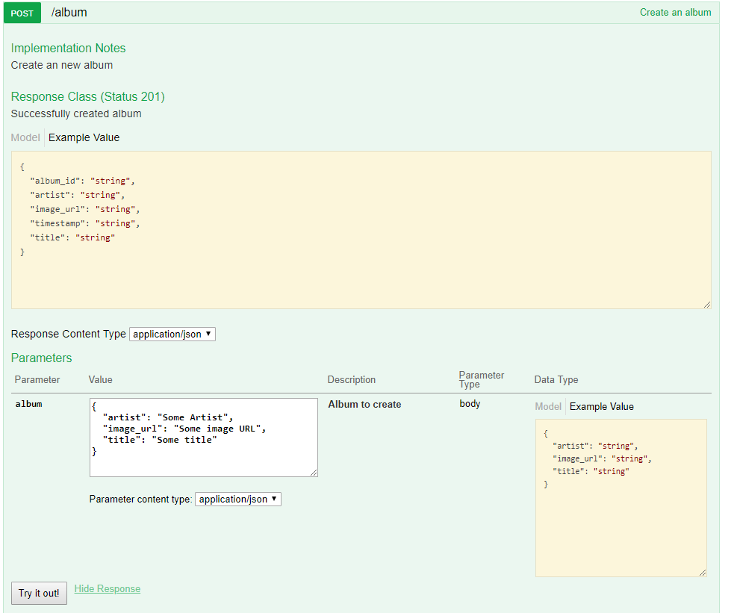
- Stwórz folder templates w folderze server i umieść w nowo utworzonym folderze templates plik base.html:

{# ``base.html`` is the template all our other templates derive from. While
Flask-Bootstrap ships with its own base, it is good form to create a custom
one for our app, as it allows customizing some aspects.
Deriving from bootstap/base.html gives us a basic page scaffoling.
You can find additional information about template inheritance at
http://jinja.pocoo.org/docs/templates/#template-inheritance
#}
{%- extends "bootstrap/base.html" %}
{# We also set a default title, usually because we might forget to set one.
In our sample app, we will most likely just opt not to change it #}
{% block title %}Music Store{% endblock %}
{# While we are at it, we also enable fixes for legacy browsers. First we
import the necessary macros: #}
{% import "bootstrap/fixes.html" as fixes %}
{# Then, inside the head block, we apply these. To not replace the header,
``super()`` is used: #}
{% block head %}
{{super()}}
{#- Docs: http://pythonhosted.org/Flask-Bootstrap/macros.html#fixes
The sample application already contains the required static files. #}
{{fixes.ie8()}}
{%- endblock %}
{# Adding our own CSS files is also done here. Check the documentation at
http://pythonhosted.org/Flask-Bootstrap/basic-usage.html#available-blocks
for an overview. #}
{% block styles -%}
{{super()}} {# do not forget to call super or Bootstrap's own stylesheets
will disappear! #}
<link rel="stylesheet" type="text/css"
href="{{url_for('static', filename='main.css')}}">
{% endblock %}

- Do folderu templates dodaj jeszcze plik index.html:

{# This simple template derives from ``base.html``. See ``base.html`` for
more information about template inheritance. #}
{%- extends "base.html" %}
{# Loads some of the macros included with Flask-Bootstrap. We are using the
utils module here to automatically render Flask's flashed messages in a
bootstrap friendly manner #}
{% import "bootstrap/utils.html" as utils %}
{# Inside the ``content`` is where you should place most of your own stuff.
This will keep scripts at the page end and a navbar you add on later
intact. #}
{% block content %}
<div class="container">
{%- with messages = get_flashed_messages(with_categories=True) %}
{%- if messages %}
<div class="row">
<div class="col-md-12">
{{utils.flashed_messages(messages)}}
</div>
</div>
{%- endif %}
{%- endwith %}
<div class="jumbotron">
<h1>Welcome to iSA Music Store</h1>
<p>This example application demonstrates some of the
features of <a href="http://pythonhosted.org/Flask-Bootstrap">
Flask-Bootstrap</a>.</p>
<p>
<a class="btn btn-lg btn-default" href="http://pythonhosted.org/Flask-Bootstrap"
role="button" >Show docs</a>
</p>
</div>
<div class="row">
<div class ="col-md-4">
<div class="thumbnail">
<img src="https://i.iplsc.com/-/000712WJNHHX8EBF-C122.jpg">
<div class="caption">
<h3>Thriller</h3>
<p>
This is album of Michael Jackson - Thriller
</p>
</div>
</div>
</div>
<div class ="col-md-4">
<div class="thumbnail">
<img src="https://image.ceneostatic.pl/data/products/48665992/i-linkin-park-meteora-album-cover-sticker.jpg">
<div class="caption">
<h3>Meteora</h3>
<p>
This is album of Linkin Park Band
</p>
</div>
</div>
</div>
<div class ="col-md-4">
<div class="thumbnail">
<img src="https://i.iplsc.com/-/000712WJNHHX8EBF-C122.jpg">
<div class="caption">
<h3>Thriller</h3>
<p>
This is album of Michael Jackson - Thriller
</p>
</div>
</div>
</div>
<ul>
{% for album in albums %}
<li>{{ album.artist }} {{ album.title }}</li>
{% endfor %}
</ul>
</div>
</div>
{%- endblock %}

- Zaktualizuj plik index.py:

from flask import render_template
from Day13.server.app import app_connexion
from Day13.server.models import Album, AlbumSchema
# Get the application instance
connex_app = app_connexion
# Read the swagger.yml file to configure the endpoints
connex_app.add_api("swagger.yml")
# create a URL route in our application for "/"
@connex_app.route("/")
def home():
"""
This function just responds to the browser URL
localhost:5000/
:return: the rendered template "index.html"
"""
albums = Album.query.order_by(Album.artist).all()
# Serialize the data for the response
# album_schema = AlbumSchema(many=True)
# dump = album_schema.dump(albums)
# data = dump.data
return render_template("index.html", albums=albums)
if __name__ == "__main__":
connex_app.run(port=8080, debug=True)
- Uruchom plik index.py I przejdz do strony http://localhost:8080/
- Zmien kod w pliku index.htm, aby albumy nie były wyświetlane jako prosta lista, ale jako „karty” – uzyj istniejącego kodu z elementem

<div class ="col-md-4">
<div class="thumbnail">

