Agathe Benichou
CS150
Due: Sunday October 3rd

Project 1: Class Diagrams

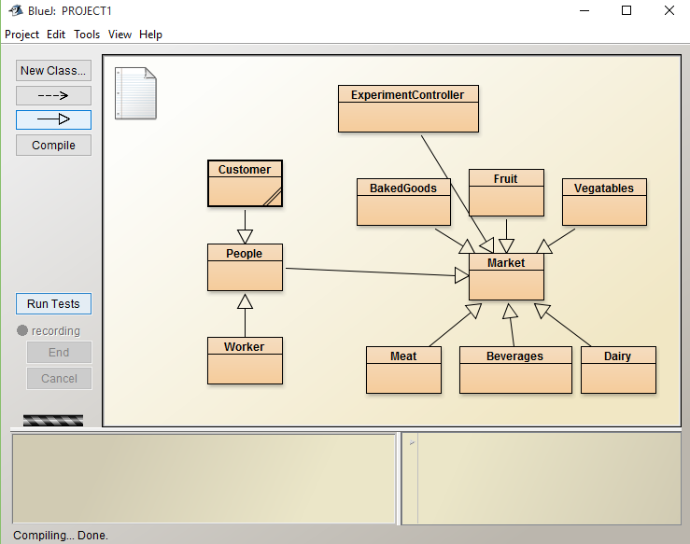

Every class is controlled within the market. The stalls are inside the market, the people are inside the market. The workers of the stalls and the customers of the market are both people and the people are at the market. The experiment controller class controls the entire experiment. The market is the most important class because that is where everything I screated and run.

