Agathe Benichou
CS150: Data Structures and Algorithms
Due: October 17th 2015

Project #1 – The Easton's Farmers Market

1. Introduction

This project was to simulate Eastons Farmers Market, which is the oldest continuously operating outdoor farmers market. The most important task of this project, as a market manager, was to determine the number and type of stalls that should be in the market. The goals of the simulation are to minimize the time spent in line for each customer, to satisfy as many requirements for each customer as possible, to try to ensure that the market meet at least 50% of every customer's needs and to maximize the number of people going through the market. Some of the assumptions I made for this project was that there would be no time spent walking from stall to stall and that once the customer gets to the front of the queue, they are automatically “served” so there is no wait time once they get to the front of the queue. In my simulation, I decided that each stall should only have one booth and each booth should only have one line. I think that my simulation can ensure that the market meets at least 50% of every customer's needs, properly work the given mean and standard deviation numbers for times spent waiting in line while still minimizing the time spent in line, and maximize the number of people going through the market.

2. Approach

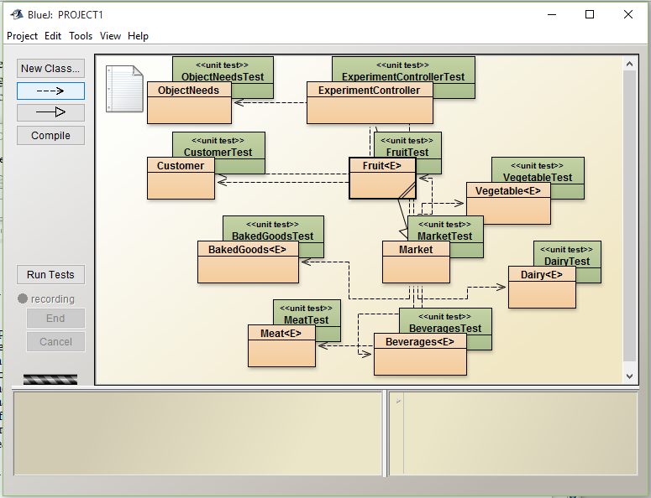

This is the final layout of my classes for this project. The ObjectNeeds class is my most basic class, it is there just to be able to create an object in the Market class. The ObjectNeeds class has 12 instances in the Market class, these 12 instances are for the 12 items available at the market ( 2 items per each stall). The Customer class is the class that the customers in the market are created from. There are six classes for the six stalls: Fruit class, Vegetable class, Baked Goods class, Meat class, Beverages class and Dairy class. Each of these classes all extend abstract Queue and implement Queue, they are all the same classes with different names. All of these classes, or stalls, are created in the Market class. The Market class is where all the stalls and all of the items available at each stall are created. It is also where the list of needs is randomly generated based on percentages given in class. Most importantly, the Market class is where the methods are that control which stalls the customers goes to, depending on their needs, and how long they stay at those stalls depending on the numbers given in class. My project is run and controlled in the ExperimentController class. This is where the open and close time of the market are monitored, where the customers and their needs are generated based on their arrival time that is also generated in this class and there the customers go through each stall. This class puts together the Market class and the Customer class to create the simulation.

3. Methods

I decided to run both of my simulation a total of 7 times. In those 7 simulations, I collected enough data to create plots (as shown in the Data and Analysis section) to see which parts of my hypothesis were fulfilled. I thought that 7 simulations was enough simulations to generate enough data points and it was enough simulations to show that my project properly works. My first simulation was the one where each kind of good had one stall and one line per stall, these graphs are shown first and in red. I calculated the average time for customers that was spent at the market, regardless of their number of needs. I calculated the average number of customers that came to the market and the average time they arrived in, compared to the mean time and standard deviation time that was given. I calculated the average time spent at each stall and compared that to the mean time and standard deviation time that was given. I also calculated the amount of money made during each simulation by adding a money increment to my code, I made each item worth one dollar. I also looked at whether 50% of each customers needs was being satisfied for each simulation.

4. Data and Analysis

I ran 7 simulations and took the average of the times of all the customers in each simulation. Those averages are the times that are plotted below. With the exception of one high average of 430 seconds, most of the other averages from the simulations were around 400 seconds. The average of the simulations averages is 402 seconds which is 6.7 minutes. The average time spent at the market for customers, regardless of their number of needs, was 6.7 minutes. I think that 7 minutes is a reasonable amount of time for someone to spend at a farmers market that only have 6 kinds of stalls.

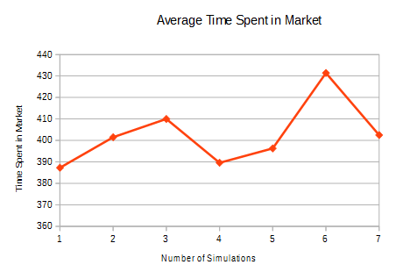

One of the goals of the project was to maximize the amount of customers who entered the market. Below is a graph of of the number of customers who entered the market for each simulation. The average number of customers that entered the market was 239.8 customers.
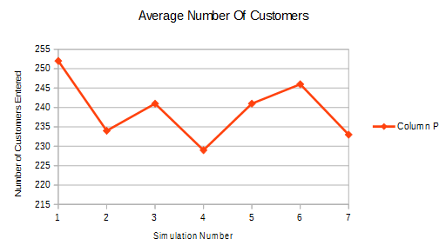

This is a plot of the averages of the times that each customer entered the market in intervals of. Given a mean of 61 second intervals with a standard deviation of 31 seconds, most customer arrival times were around 60 seconds. The average of interval times was 65 seconds which is a good interval time. This means that one customer arrived around every minute, which kept the market very busy.

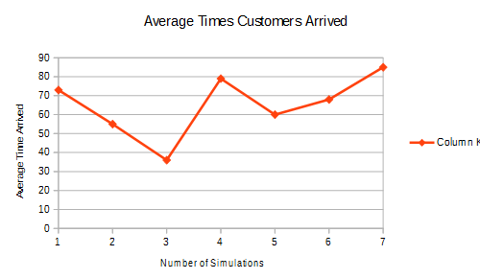

The Baked Goods, or Bakery, Queue has a mean wait time of 29 seconds. According to the given numbers, 37% of customers want an item from this stall. Below is a graph of the average time customers who went to the Baked Goods queue spent there, per simulation. The average of the time spent on queue is 28.4 seconds. This number is below the mean wait time which means that most customers received their item from the stall before they should have, according to the mean. This helps minimize the amount of time spent at the market per customer.

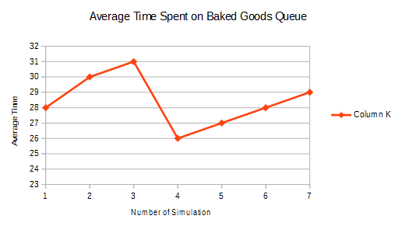

The Dairy Queue has a mean wait time of 59 seconds. According to the given numbers, 59% of customers want an item from this stall, which means a lot of customer will be on queue for an item. Below is a graph of the average time customers who went on the Dairy Queue spent there, per simulation. The average of the time spent on queue is 59.3 seconds. This number is just a little above the mean wait time so most customers got their item from this queue after the same time.
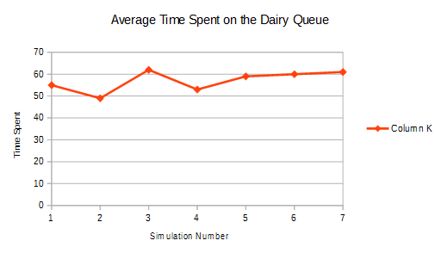

The Meat Queue has a mean wait time of 101 seconds, which is a pretty high wait time compared to other stalls. According to the given numbers, 53% of customers want an item from this stall. Below is a graph of the average time customers who went on the Dairy Queue spent there, per simulation. The average time spent on queue is 103 seconds, which is above the mean time.

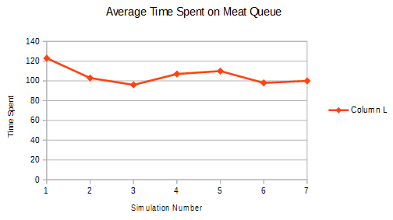

The Beverages Queue has a mean wait time of 19 seconds. According to the given numbers, only 43% of customers want an item from this stall. Below is a graph of the average time customers who went to the Beverages Queue spent there, per simulation. The average time spent on queue is 19.5 seconds.

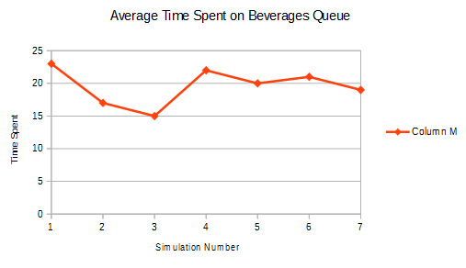

The Vegetable Queue has a mean wait time of 119 seconds, which is a lot especially considering that according to the numbers given, the mean number of customers who want an item from the Vegetable Queue is 71% of customers. Below is a graph of the average time customers who went on the Vegetable Queue spent there, per simulation. The average time is 118 seconds.

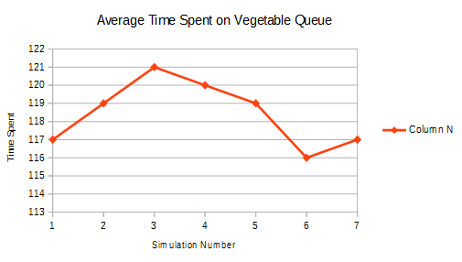

The Fruit Queue had a mean wait time of 83 seconds. According to the numbers given, about 47% of customers wanted an item from the Fruit Queue. Below is a graph of the average time customers who went on the Fruit Queue spent there, per simulation. The average time is 82.57 seconds.

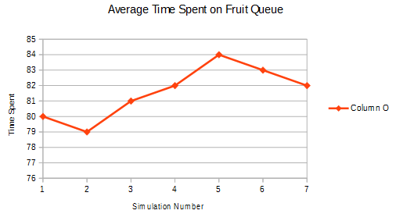

To test how much the market made in one simulation, or in one day of being open, I added a money counter to my simulation and made each item worth 1 dollar. In 7 simulations, I found the average amount of money made to be 696.2 dollars.
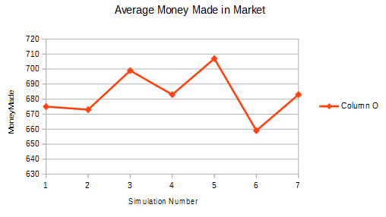

Below is a sample of the last two customers that entered the market from one of my simulations. The first customer entered the market at 14242 seconds, a couple minutes before the market closed, got on line for the baked goods, fruit, vegetable and got their baked goods and fruit before the market closed. However, they got on line to the vegetables before the market closed and were unable to get their vegetable item because the market closed while they were on line. The second customers ended the market 1 minute before the market closed and got on the fruit line immediately but the market closed before the wait time was over.
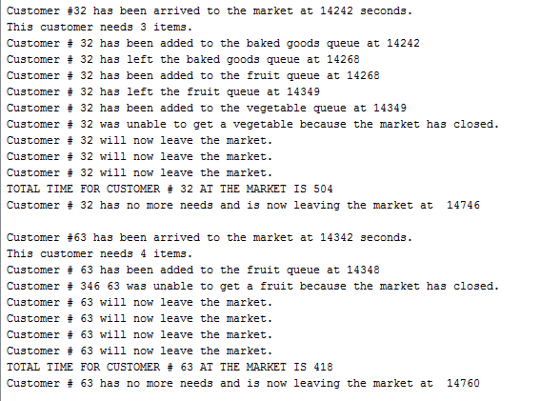
Below is a graph of the amount of customers per simulation who did not have at least 50% of their needs satisfied. As you can see, most customers did have all or 50% of their needs satisfied. The customers who did not have 50% of their needs satisfied are the ones who entered the market several minutes or seconds before closing time. An average of 2 customers per simulation did not have 50% of their needs satisfied. 2 customers out of an average of 240 customers, that means that 99% of the customers got 50% of their needs satisfied, which is very high.
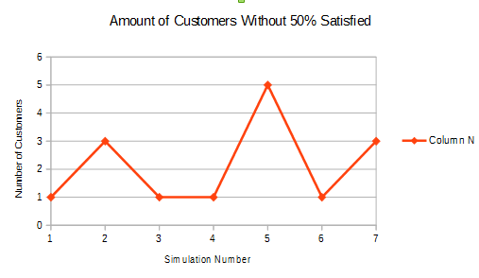

5. Conclusion

The most critical type of stall in the market are the stalls that have the highest percentages of customers who want those items. The vegetable stall is the most critical as it has a mean of 71% of customers who want items from the vegetable stall and a mean queue wait time of 119 seconds. The next most critical stall is the dairy stall which has a mean of 59% of customers who want items from the dairy stall and a mean queue wait time of 59 seconds. The last most critical stall is the meat stall as it has a mean of 53% who want items from the meat stall and a mean queue wait time of 101 seconds. If the amount of customers were to increase by 10% these are the stalls that would need to expand these stalls because they would be heavily desired. If the market wanted to make more money, they could stay open a couple extra hours. If I run my simulation for 2 more hours, the amount of money made is over 1000 dollars. Another way to increase the amount of money made in the market is to increase the amount of customers allowed into the market. This can be achieved by either decreasing the mean and standard deviation of the intervals in which the customers enter the market in. More realistically, customers do not come alone. They are usually with their families or with friends, they are mostly in groups. If you change the simulation so that groups of people come in with more items, then the amount of money made will also increase. My simulation shows that 99% of customers who entered the market had 50% of their needs satisfied by the time they left the market. My simulation does properly work the given mean and standard deviation values of the stalls and customers while still minimizing the time spent in line. Most of the average wait times calculated per stall were at or below the mean value. Only some average wait times were above the mean value and even those are not that much above the mean value. In conclusion, my simulation was efficient and it accomplished the goals that the market had.

6. References

"ArrayList (Java Platform SE 7 )." ArrayList (Java Platform SE 7 ). Oracle, 1994. Web. 11 Oct. 2015.

"Beginner Java - How to Check If Integer Is in a given Range?" - Stack Overflow. N.p., n.d. Web. 11 Oct. 2015.

Dirani, Bill. "Java Practices - Generate Random Numbers." Java Practices - Generate Random Numbers. Hirondelle Systems, 21 Sept. 2013. Web. 11 Oct. 2015.

"EFM Website." EFM Website. N.p., n.d. Web. 14 Oct. 2015.

"LinkedList (Java Platform SE 7 )." LinkedList (Java Platform SE 7 ). N.p., n.d. Web. 13 Oct. 2015.

"Percentage Chance of Saying Something?" Java. N.p., n.d. Web. 11 Oct. 2015.

"Queue (Java Platform SE 7 )." Queue (Java Platform SE 7 ). N.p., n.d. Web. 14 Oct. 2015.

Weiss, Mark Allen. Data Structures and Algorithm Analysis. Redwood City, CA: Benjamin/Cummings Pub., 1995. Print.

