Timothée SCHMODERER  15 rue de Sotteville,  76100 Rouen,  France.  +33 6 24 74 57 53       |  | PhD Student in  Theoretical and Applied Mathematics | 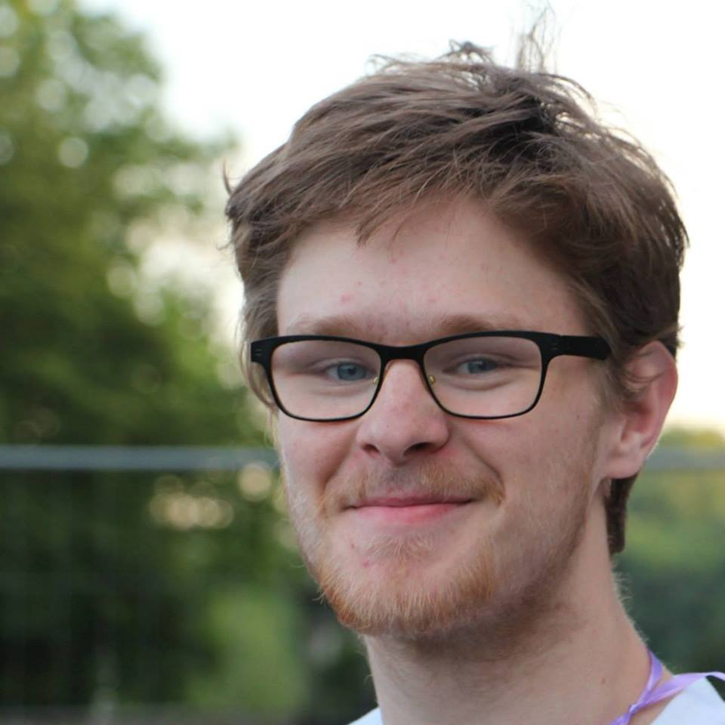

+ SCHOLARSHIP
2018 – 2022  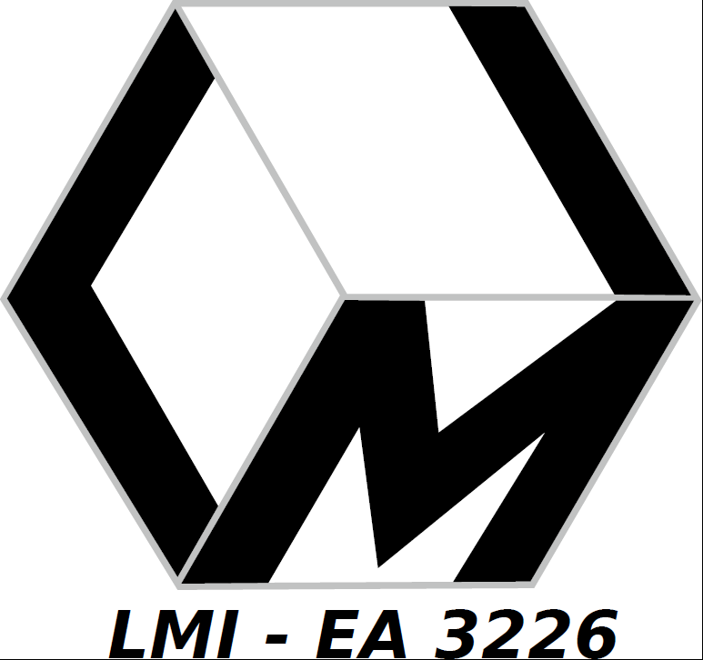  PhD | PhD in control theory at the Mathematic Laboratory of INSA of Rouen (FR),  - Advisor: Witold RESPONDEK (LMI - Rouen), Co-Advisor: Emmanuel TRELAT (LJLL - Paris)  - Funding: Ministerial grant.  - Themes: nonlinear dynamical systems,optimal control, motion planing, differential geometry,  - Teachings:  - 2021 / 2022 : Numerical Analysis, direct and iterative methods for solving systems of linear equations, for graduated students.  - 2019 / 2022 : Sequences, Real variable functions analysis, differentiability, integration for undergraduates students.  - Administrative functions:  - 2021 / 2023: Elected member representative of PhD students for the laboratory.  - 2020 / 2022: Elected member representative of PhD students for the Doctoral School.
2013 - 2018  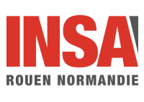  Engineer Degree | Preparatory Cycle and Specialization Cycle in Mathematical Engineering at INSA Rouen  - Generalist training in physics, chemistry, engineering sciences, mathematics, then in-depth training in theoretical and applied mathematics, computer science.  - Training in theoretical and numerical analysis of PDEs, control theory, Hamilton-Jacobi equations, introduction to high performance computing  - Development of an instant messaging software (JAVA). Mathematical research on the basis of Lagrangian physics. Theoretical and numerical analysis of optimal transport problems with applications towards imaging science.
2017 – 2018    Master Degree | Research Master in Mathematics and Applications at the University of Rouen (co-accredited with INSA)  - Introduction to research in an academic environment  - In-depth training in PDE analysis and control theory. Introduction to stochastic processes.  - Realization of a Finite Element project applied to biology.
2016 – 2018    Master Degree | Double degree in Mathematics and Applications at the Pierre and Marie Curie University (Paris VI)  - Complementary training in theoretical and applied mathematics.  - First year: Galois theory, differential geometry, Lie groups and algebras, number theory.  - Second year: specialisation in theoretical and numerical analysis of partial differential equations

+ RESEARCH
- Schmoderer T. & Respondek W. (2021). Conic nonholonomic constraints on surfaces and control systems, Submitted at Journal of Dynamical and Control Systems.
This paper addresses the equivalence problem of conic submanifolds in the tangent bundle of a smooth 2-dimensional manifold. Those are treated as nonholonomic constraints whose admissible curves are trajectories of the corresponding control systems. We deal with this problem under the prism of feedback equivalence of control systems, both control-affine and fully nonlinear. The first main result of this work is a complete description of regular conic submanifolds. We also give equivalence results for a special class of conic submanifolds via the study of the Lie algebra of infinitesimal symmetries of the corresponding control systems. Then, we consider the classification problem of conic submanifolds, which is achieved via feedback classification of nonlinear control system. Our results describe and completely characterise quadratic systems, and include several normal and canonical forms.
- Schmoderer T., Aviles-Rivero A. I., Corona V., Debroux N. & Schönlieb C-B. (2021) “Learning Optical Flow for Fast MRI Reconstruction“. Accepted at Inverse Problems.
Reconstructing high-quality magnetic resonance images (MRIs) from undersampled raw data is of great interest from both technical and clinical point of views. To this date, however, it is still a mathematically and computationally challenging problem due to its severe ill-posedness, resulting from the highly undersampled data. Whilst a number of techniques have been presented to improve image reconstruction, they only account for spatio-temporal regularisation, which shows its limitations in several relevant scenarios including dynamic data. In this work, we propose a new mathematical model for the reconstruction of high-quality medical MRI from few measurements. Our proposed approach combines—in a multi-task and hybrid model—the traditional compressed sensing formulation for the reconstruction of dynamic MRI with motion compensation by learning an optical flow approximation. More precisely, we propose to encode the dynamics in the form of an optical flow model that is sparsely represented over a learned dictionary. This has the advantage that ground truth data is not required in the training of the optical flow term. Furthermore, we present an efficient optimisation scheme to tackle the non-convex problem based on an alternating splitting method. We demonstrate the potentials of our approach through an extensive set of numerical results using different datasets and acceleration factors. Our combined approach reaches and outperforms several state-of-the-art techniques for multi-tasking reconstruction and other classic variational reconstruction schemes. Finally, we show the ability of our technique to transfer phantom based knowledge to real datasets.
- Debroux N., Le Guyader C., Schmoderer T., Rouxelin N., Quesnel E. & Bousquet-Melou P. (2018, June). "A Second Order Free Discontinuity Model for Bituminous Surfacing Crack recovery, Analysis of a Nonlocal Version of it and MPI Implementation". SIAM Conference on Imaging Science, Bologna
We consider a second order variational model dedicated to crack detection on bituminous surfacing. It is based on a variant of the weak formulation of the Blake-Zisserman functional that involves the discontinuity set of the gradient of the unknown, set that encodes the geometrical thin structures we aim to recover. Following Ambrosio, Faina and March, an approximation of this cost function by elliptic functionals is provided. Theoretical results including existence of minimizers, existence of a unique viscosity solution to the derived evolution problem, and a Gamma-convergence result relating the elliptic functionals to the initial weak formulation are given. Extending then the ideas developed in the case of first order nonlocal regularization to higher order derivatives, we provide and analyze a nonlocal version of the model and an MPI implementation.

+ EXPERIENCES
Final year project  2017 – 2018 | Master thesis on the problem of optimal transport, supervised by Carole Le Guyader (INSA) & Vincent Duval (INRIA - Mokaplan)  - Analysis of the founding article of Benamou and Brenier  - Implementation of the optimal transport algorithm, following the method of Papadakis, Peyré and Oudet  - Application to image processing
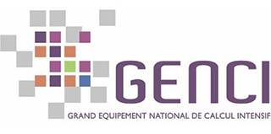  Hackathon  October 2017 | Participation in the GENCI (Grand équipement national de calcul intensif) 10th anniversary competition  - Parallelization of a crack detection code in bitumen images in MPI.  - Acquisition of skills in high performance computing on 2D finite difference codes with non-local term.
Technician Internship    Summer 2017 | Numerical analysis for partial differential equations at the Laboratory for Applied Mathematics of the University of Cologne  - Implementation of a finite difference method on irregular meshes for the Euler gas equation.  - Extension of a discontinuous Galerkin method with shock wave treatment for the equations of fluid mechanics (publication possibility).  - Discovery of the world of university research and appropriation of its methods. Introduction to scientific publication.

+ SKILLS
Languages | English C1 (fluent reading, writing and speaking (TOEIC : 935)  German B2 (fluent in reading, writing and speaking, stays of several months with a family)
Coding languages | C, C++, Fortran, Matlab, R, Latex

+ SOFTWARE
IATHENA | Chess IA software. Build from scratch with a traditional alpha-beta search.  - C++, docker, python, Github integration CI-CD
MPP Toolbox | Motion planing toolbox. Full software for the efficient computing control systems trajectories.  - C++, python, Github integration CI-CD

+ ASSOCIATIVE EXPERIENCES
2014 – 2016   | Treasurer (2014/2015) then President (2015/2016) of the INSA Rouen students' office  - Management of teams for the realization of more than twenty annual events. Development and management of an associative budget of about 200k€.  - Organization of the INSA Rouen GALA 2016, over 1100 participants, 65k€ budget.  - Management of the daily life of an association under the law of 1901: running meetings, communicating about projects with management and partners.
2013 –   | Active member of the Scouts et Guides de France.  - Realization of a self-financed solidarity project in Bulgaria with 6 team members. Obtained the Scout of the World certificate.  - Preparation and animation of activities for young children and then for teenagers. Obtained the Brevet d'Aptitude aux Fonctions d'Animateur (BAFA).  - Trainer on several occasions for junior scout leaders.

