Live Session Unit 9

Adam Baca

November 14, 2016

## CHL

# This is my submission for live session Unit 9 homework. It goes in the proper order, shows code and solutions. Let me know if there are any issues.

#Read the file with headers  
CHF<-read.csv("C:\\Users\\adamg_000\\OneDrive\\Public\\Doing Data Science\\CHF\\CHF.csv",header=TRUE)  
#get mean paid by medicare under the vector name meanpaid.medicare  
meanpaid.medicare<-mean(CHF$AmtReim)  
#get mean total accommodation  
meanaccom<-mean(CHF$TotAccomChg)  
#Get mean departmental charges  
meandep<-mean(CHF$TotDeptChg)  
#standard dev for amount paid by medicare  
devpaid.medicare<-sd(CHF$AmtReim)  
#SD for accommodation  
devaccom<-sd(CHF$TotAccomChg)  
#for dept charges  
devdep<-sd(CHF$TotDeptChg)  
#Use tapply to find mean medicare payments by gender  
tapply(CHF$AmtReim,CHF$Sex,mean)

## 1 2   
## 8213.662 8439.620

#By accomodation charges  
tapply(CHF$TotAccomChg,CHF$Sex,mean)

## 1 2   
## 18724.69 18625.29

#By Department Charges  
tapply(CHF$TotDeptChg,CHF$Sex,mean)

## 1 2   
## 19429.24 18007.78

#Boxplot for Mdeicare payments by Gender  
boxplot(CHF$AmtReim,CHF$Sex)

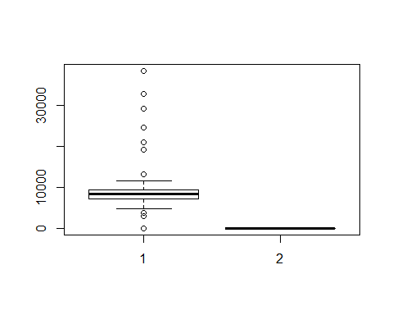

#For total Accommodation charges  
boxplot(CHF$TotAccomChg,CHF$Sex)

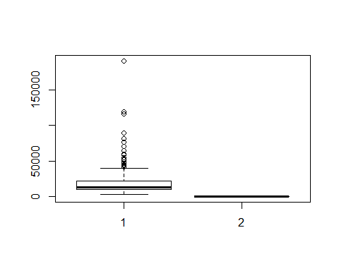

#For dept charges  
boxplot(CHF$TotDeptChg,CHF$Sex)

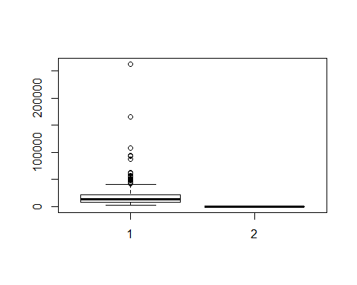

#hist for accomodation charges  
hist(CHF$TotAccomChg)

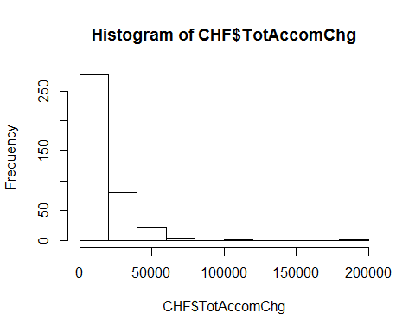

#hist for gender  
hist(CHF$Sex)

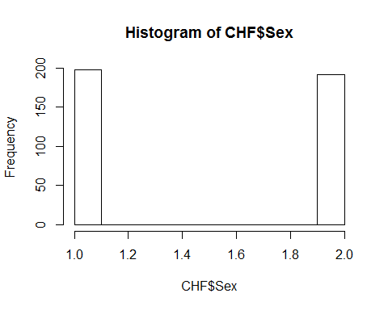

#hist for age  
hist(CHF$Age)

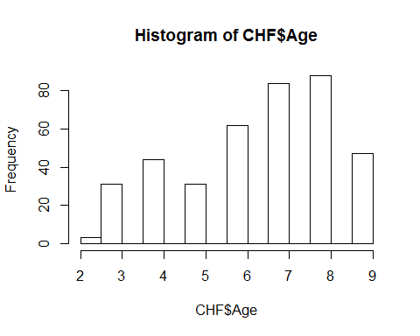

#barplot of sex by admission source, need to clean up  
barplot(CHF$admsrc,CHF$Sex)

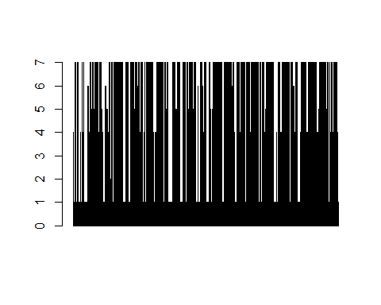

#Find mortality rates when   
#DRG=292 and DRG=293  
#discharge destination=20  
mortrate<-CHF[c(10,11)]  
#Total values for drg 292 = 144  
mortratea<-mortrate[!(mortrate$drgcode!=292),]  
#Total values for drg 293=81  
mortrateb<-mortrate[!(mortrate$drgcode!=293),]  
mortrate2<-mortrate[!(mortrate$dischdest!=20),]  
mortrate3<-mortrate2[!(mortrate2$drgcode<=291),]  
#The data shows 3 expirations with a DRG code of 292  
#The data shows 2 expirations with a DRG code of 293  
#The entire dataset has 390 visits  
mortrate292<-3/144  
mortrate293<-2/81  
#Plot the rate with the total observations by drg  
#The following is the code to create a subsetted dataset with Patient# LOS and DRG Code  
#Then a 1 sample ttest is run to see if LOS significantly different than 6 for drg 291  
los291<-CHF[!(CHF$drgcode!=291),]  
los291b<-CHF[c(1,2,11)]  
los291b<-los291[c(1,2,11)]  
mean(los291b$LOS)

## [1] 8.830303

t.test(los291b$LOS,mu=6,conf.level=0.95)

##   
## One Sample t-test  
##   
## data: los291b$LOS  
## t = 5.2706, df = 164, p-value = 4.233e-07  
## alternative hypothesis: true mean is not equal to 6  
## 95 percent confidence interval:  
## 7.769979 9.890627  
## sample estimates:  
## mean of x   
## 8.830303