LOCATE: main analysis

Adrian Barnett

25 July, 2023

The methods used here are based on the published protocol (Brain et al. 2020). Any changes to the protocol will be noted in the paper. The trial registration on ANZCTR is available [here](https://www.anzctr.org.au/Trial/Registration/TrialReview.aspx?id=378779&isReview=true).

Changes to protocol:

* The protocol used 8.0 kpa whereas the trial registration used 8.0 and 8.2 kpa to define high-risk. We used 8.0 kpa for the analysis.
* The protocol specified that outcomes would be examined using time since GP referral. However, we instead used time since randomisation. This is because the intervention can only have an impact after randomisation, and using time from GP referral would include a period of ‘immortal time’.
* Reduced time to additional screening/testing for liver disease was a planned outcome that was not included. We included time to first appointment at the hepatology clinic, which was not in the protocol.
* Our protocol stated we would use data from the MBS and PBS. However, getting the necessary approvals for this data took much longer than anticipated. Rather than delay the start of the trial, we decided not to use the MBS/PBS data. We also removed the following planned inclusion criteria: “Consent to access of their data from Queensland Health and MBS and PBS”.
* Multiple outcomes in the protocol used a time point of “12 months post-baseline”. However, because of delays in recruitment, we delayed the final follow-up until all patients had completed at least 12 months since randomisation. Hence the time-point used is “at least 12 months post-baseline.” This decision was made on logistical grounds, as it was easier to do all follow-ups at the same time, and it had the added benefit of increasing the overall follow-up time and hence the statistical power.

All these changes were made before the final analyses were run.

# Statistical methods

We used descriptive statistics to compare the randomised groups at baseline.

Our primary outcome and some secondary outcomes were time to event outcomes. We therefore used a survival analysis approach, modelling the time to the outcome or right-censoring when data collection ended (Dobson and Barnett 2018). We used a Kaplan–Meier plot to graphically examine the difference between randomised groups. To estimate the difference between groups we used a Weibull regression model with randomised group as a predictor variable. We included other predictors that were likely to explain variance in the outcome, which were: age, gender and centre. The estimates from the Weibull model are hazard ratios and we include estimates of the median times for the usual care and new model of care groups, and the difference in these medians.

We used a generalised linear model for the outcomes that were continuous (quality of life), counts (number of GP visits), and binary (using Statins). When available, we included the participants’ baseline as a predictor, for example, including baseline EQ-5D in the quality of life model.

We used Bayesian methods for the regression models, and hence the results are presented as the mean differences with 95% credible intervals. We checked the convergence of the Bayesian models by plotting the chains for the intercept.

We used multiple imputation when predictors were missing, using 10 imputations and combining the imputed estimates to give an overall result (Sterne et al. 2009). We did not impute results when the outcome was missing and instead excluded participants with missing outcomes.

We used the CONSORT guidelines to report the results (Schulz, Altman, and and 2010).

# Time to diagnosis of high-risk NAFLD (primary clinical outcome)

This outcome was listed in the published protocol as the primary clinical outcome.

The start date is the date of GP referral, the end date is the date of high-risk diagnosis, and the censoring date is the date the patients’ notes were examined by the study nurse.

### Kaplan-Meier plot (primary clinical outcome)

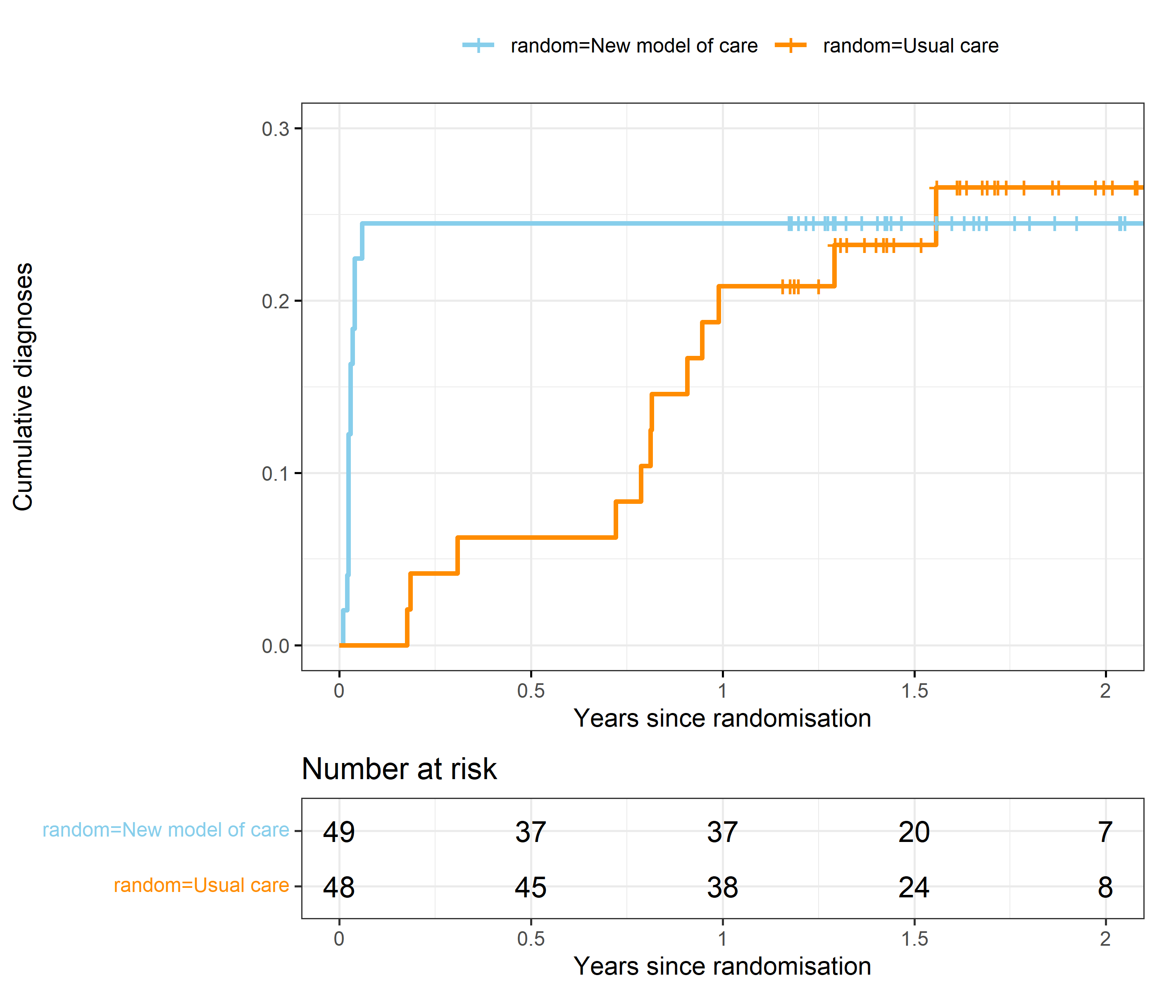

There were 1 participants excluded from this analysis due to negative or missing times. The total follow-up time is 129 years. The total number of events is 24 with 73 censored.

The plot shows the estimated accumulation over time of participants diagnosed as high-risk. The vertical notches on the lines show when participants were right-censored as the follow-up time ended. The table below the graph shows the participants “at risk”, meaning those who were yet to be diagnosed as high-risk.

The plot shows an interesting pattern. There were some participants rapidly diagnosed in the new model care in the first few months, followed by no change for the next 2 years. In the usual care arm, the high-risk diagnoses accumulated steadily in the first year.

### Weibull survival model (primary clinical outcome)

| **variable** | **mean** | **lower** | **upper** |
| --- | --- | --- | --- |
| New model of care | 1.28 | 0.59 | 2.79 |
| Male | 1.06 | 0.47 | 2.30 |
| Age (+10 years) | 1.38 | 1.05 | 1.85 |
| Sunshine Coast | 2.00 | 0.92 | 4.32 |
| Median time (usual care) | 46.39 | 7.36 | 167.30 |
| Median time (new model of care) | 28.44 | 4.80 | 105.77 |
| Median difference (usual care minus new model) | 17.95 | -44.17 | 119.21 |
| Weibull shape | 0.51 | 0.39 | 0.66 |

Despite the strong separation in the Kaplan-Meier plot, the hazard ratio for the new model of care was wide and included an increased time to diagnosis. The estimated median times reflect the small number of events, with estimates of many years before half the sample will be diagnosed.

Age was associated with an increased hazard of the primary outcome. Every 10 year increase in age increased the hazard by 1.38, 95% confidence interval 1.05 to 1.85. This means that older patients had a shorter time to high-risk NAFLD.

The Weibull shape controls the parametric hazard function over time. It is reported here for completeness and will not be included in the journal article.

# Time to first successful fibrosis assessment with Fibroscan

This outcome was listed in the published protocol as a secondary clinical outcome.

There were 1 participants excluded from this analysis due to negative or missing times. The total follow-up time is 46 years.

### Kaplan-Meier plot (time to successful Fibroscan)

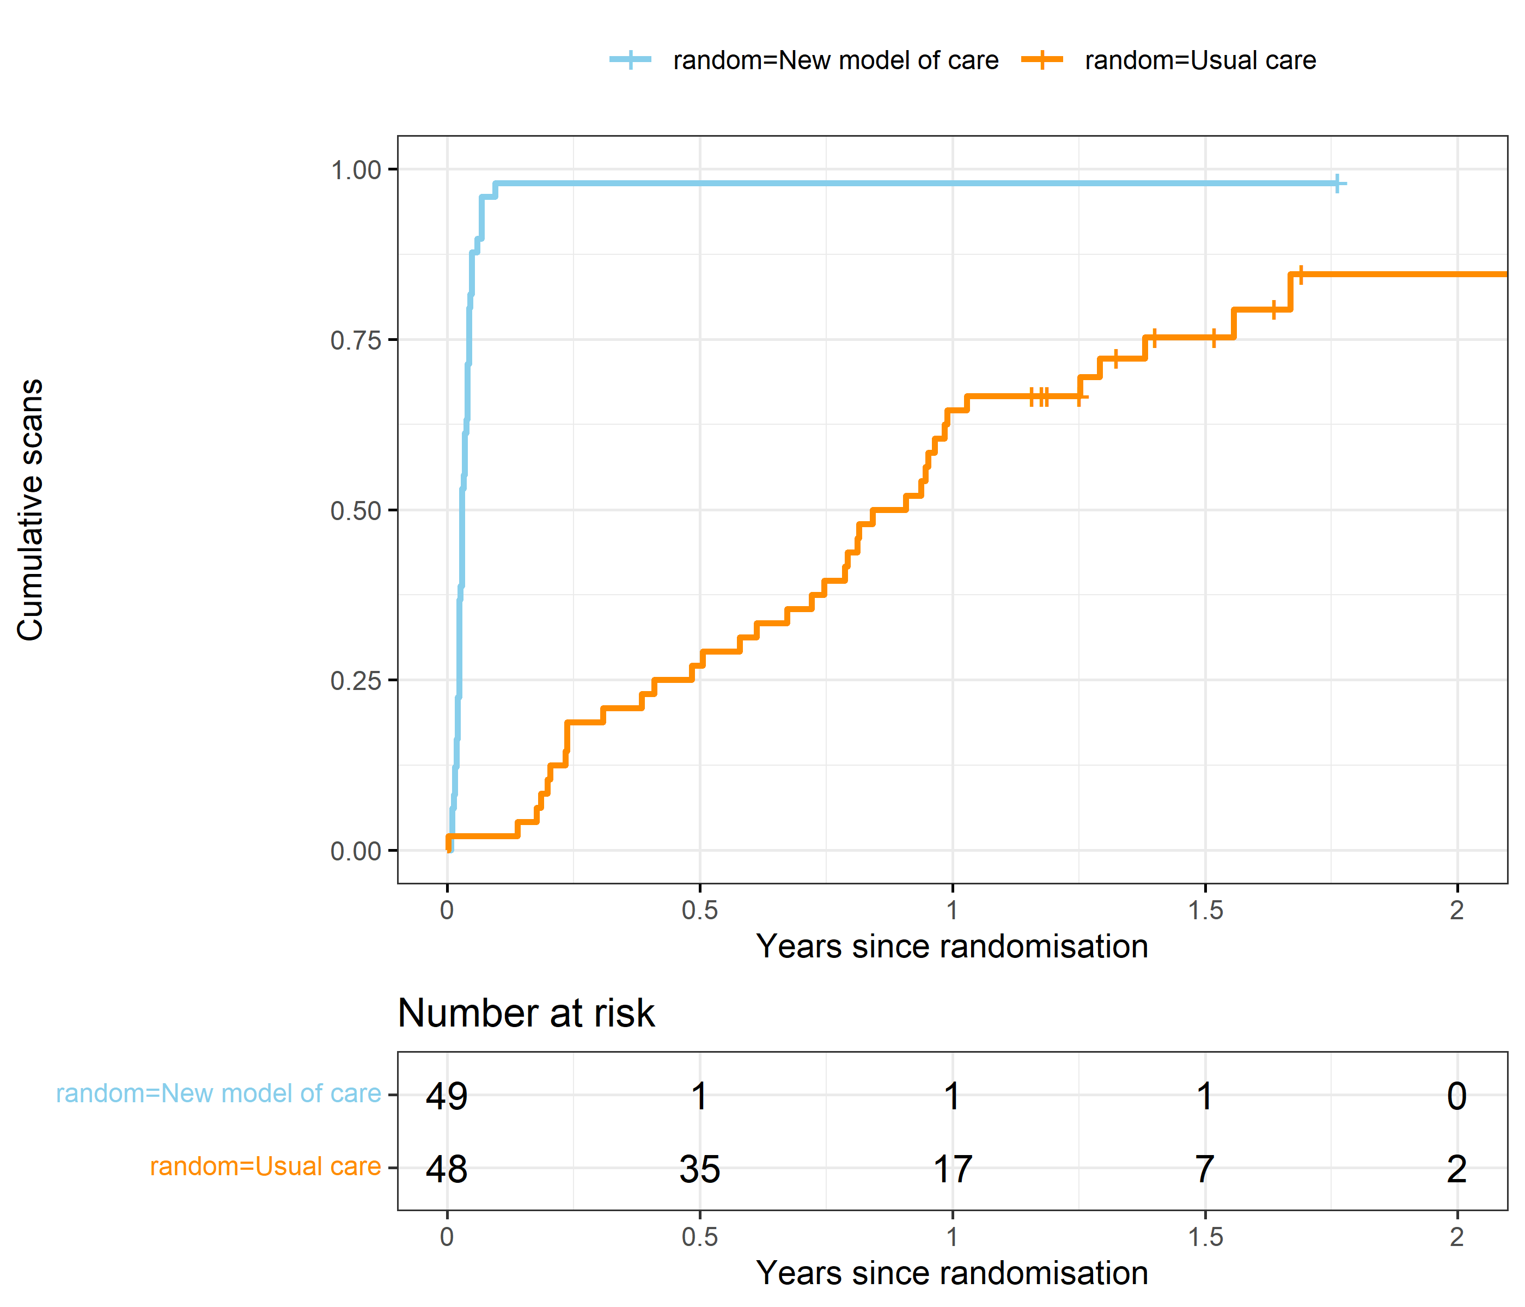

The plot shows the estimated accumulation over time of successful scans. The vertical notches on the lines show when participants were right-censored as the follow-up time ended. The table below the graph shows the participants “at risk”, meaning those who are yet to have a Fibroscan. The total number of participants with a scan is 85, with 12 censored.

Almost everyone in the new model of care had their scan in a few months. In contrast, the usual care group slowly accumulated scans over time.

### Weibull survival model (time to successful Fibroscan)

| **variable** | **mean** | **lower** | **upper** |
| --- | --- | --- | --- |
| New model of care | 16.13 | 9.07 | 29.21 |
| Male | 1.53 | 0.96 | 2.44 |
| Age (+10 years) | 1.12 | 0.96 | 1.31 |
| Sunshine Coast | 0.71 | 0.40 | 1.21 |
| Median time (usual care) | 0.96 | 0.60 | 1.51 |
| Median time (new model of care) | 0.04 | 0.03 | 0.07 |
| Median difference (usual care minus new model) | 0.92 | 0.56 | 1.45 |
| Weibull shape | 0.90 | 0.77 | 1.03 |

We used a Weibull regression model to estimate the time to Fibroscan. We included the randomised group and the potential predictors of gender, age and centre.

The mean hazard ratio for the new model of care was well above one and the median reduction in time to scan was close to one year.

# Time to first appointment at the hepatology clinic

This outcome **was not** in the published protocol.

There were 1 participants excluded from this analysis due to negative or missing times. The total follow-up time is 88 years.

### Kaplan-Meier plot (time to first appointment)

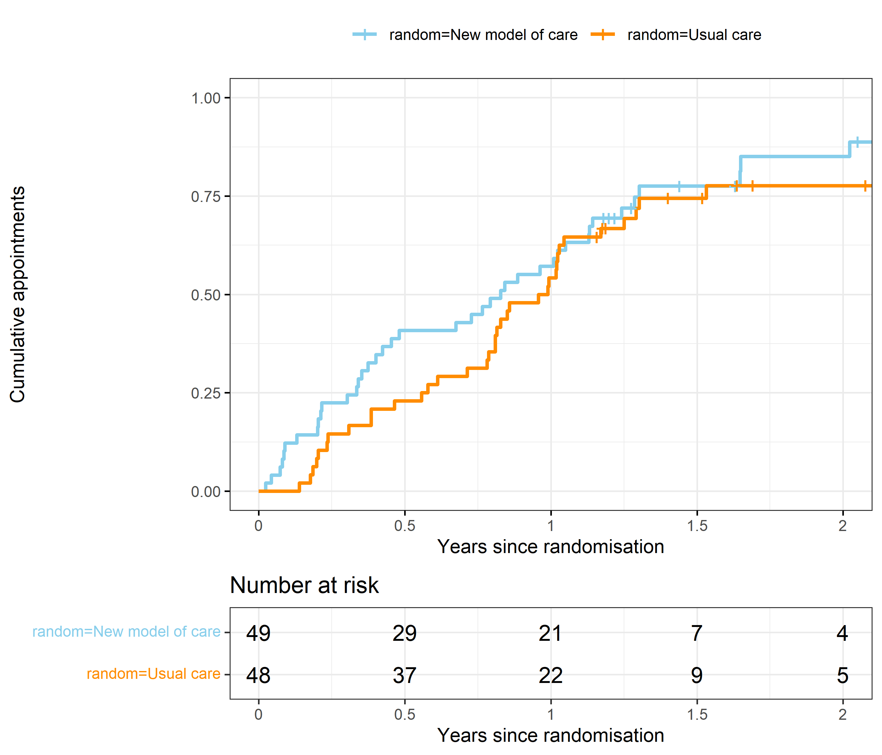

The total number of appointments is 76, with 21 censored.

### Weibull survival model (time to first appointment)

| **variable** | **mean** | **lower** | **upper** |
| --- | --- | --- | --- |
| New model of care | 1.18 | 0.75 | 1.85 |
| Male | 1.46 | 0.87 | 2.44 |
| Age (+10 years) | 1.09 | 0.93 | 1.28 |
| Sunshine Coast | 5.10 | 3.02 | 8.60 |
| Median time (usual care) | 1.51 | 1.06 | 2.13 |
| Median time (new model of care) | 1.33 | 0.91 | 1.89 |
| Median difference (usual care minus new model) | 0.18 | -0.32 | 0.71 |
| Weibull shape | 1.33 | 1.10 | 1.57 |

Similarly to the previous primary outcome, the new model of care decreased the average time, but the 95% credible intervals were wide and included the potential for longer times with the new model of care.

# Reduction in hospital admissions

There were no admissions to hospital for any LOCATE participants, so we have not analysed this outcome.

This outcome was listed in the published protocol as a secondary clinical outcome.

# Reduction in emergency department presentations

In this section we examine the time from randomisation to first emergency department presentation.

This outcome was listed in the published protocol as a secondary clinical outcome.

There were 1 participants excluded from this analysis due to negative or missing times. The total follow-up time is 133 years.

### Kaplan-Meier plot (time to ED presentation)

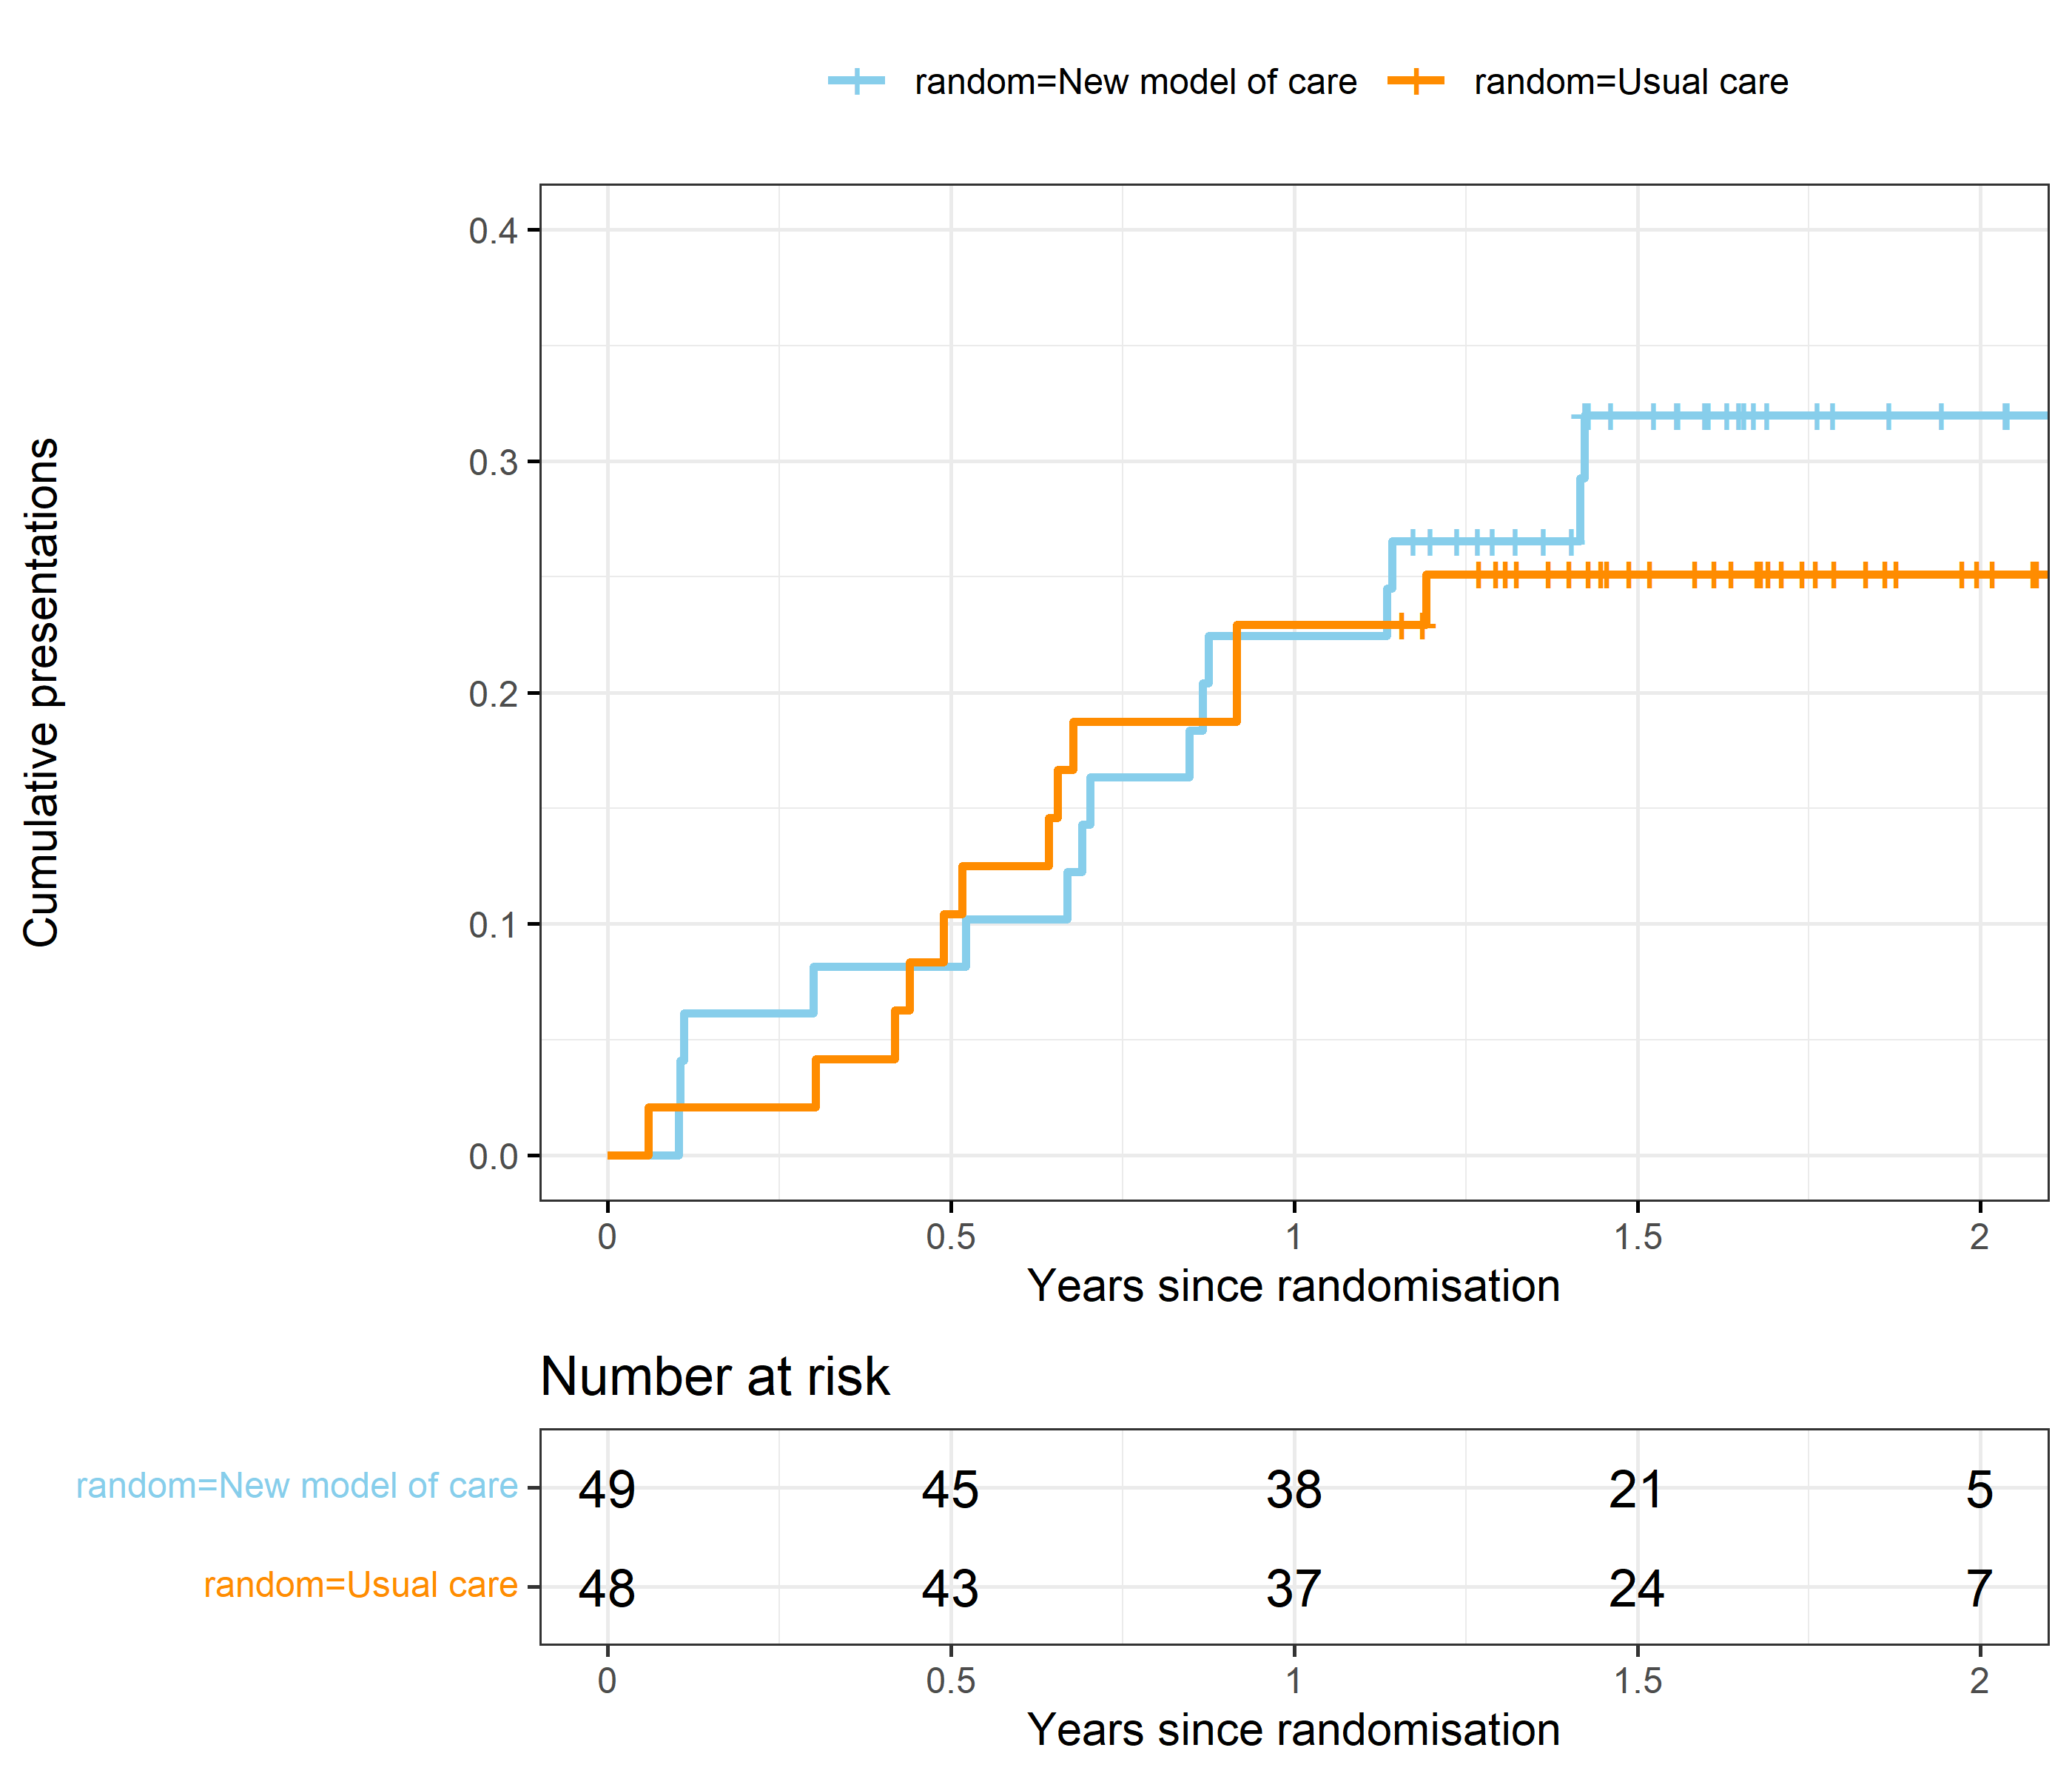

We use a survival model to examine the time to ED presentation. Participants with no ED presentations were censored at their follow-up date.

The two cumulative incidence curves are very similar.

### Weibull survival model (time to ED presentation)

| **variable** | **mean** | **lower** | **upper** |
| --- | --- | --- | --- |
| New model of care | 1.32 | 0.60 | 2.92 |
| Male | 0.69 | 0.30 | 1.54 |
| Age (+10 years) | 0.94 | 0.73 | 1.20 |
| Sunshine Coast | 0.29 | 0.09 | 0.80 |
| Median time (usual care) | 2.91 | 1.51 | 5.84 |
| Median time (new model of care) | 2.21 | 1.08 | 4.44 |
| Median difference (usual care minus new model) | 0.70 | -1.47 | 3.43 |
| Weibull shape | 1.01 | 0.70 | 1.38 |

The results show hazard ratios and 95% credible intervals (the model was fitted using a Bayesian method). A hazard ratio over 1 indicates an increased hazard, meaning a faster time to ED presentation. The model adjusted for gender, age and centre.

The Sunshine Coast had a greatly reduced hazard ratio, meaning longer times to ED presentation.

There was no apparent difference in median time between the new model of care and usual care.

# Improved health-related quality of life

This outcome was listed in the published protocol as a secondary clinical outcome.

### Boxplot (quality of life)

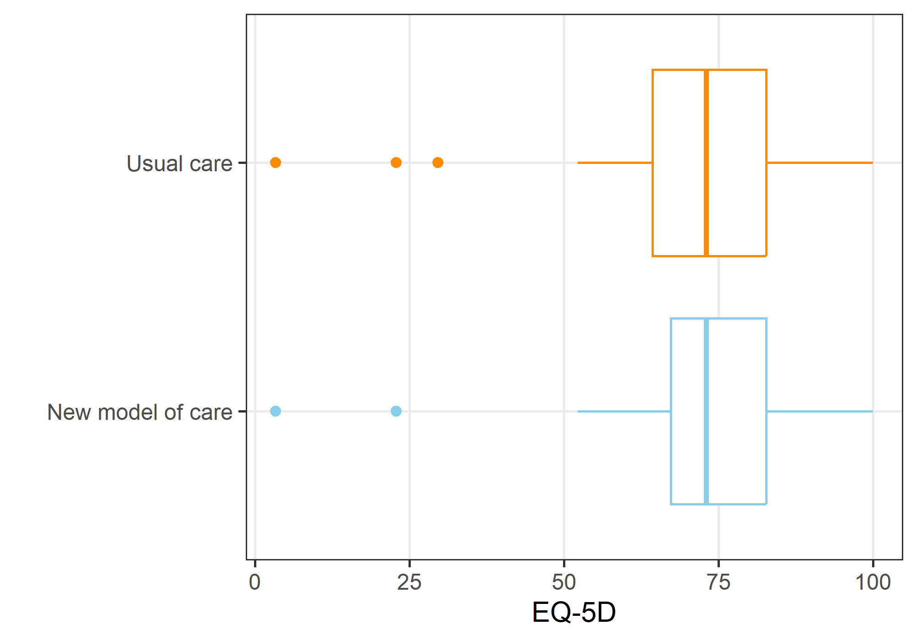

The higher the score, the better the quality of life. The highest possible score is 100, and the lowest 0. A few participants were close to zero.

### Statistical model (quality of life)

| **variable** | **mean** | **lower** | **upper** |
| --- | --- | --- | --- |
| Intercept | 65.9 | 57.3 | 74.4 |
| EQ-5D at baseline | 0.7 | 0.5 | 0.9 |
| New model of care | -3.6 | -12.6 | 5.5 |
| Age (+10 years) | 1.3 | -1.8 | 4.5 |
| Male | 6.3 | -3.2 | 15.8 |
| Time since randomisation (months) | 5.3 | -0.5 | 11.1 |
| Sunshine Coast | -5.8 | -15.9 | 4.4 |
| Standard deviation | 17.1 | 14.1 | 20.8 |

The results are on the scale of EQ-5D from 0 to 100. The model adjusted for baseline EQ-5D, age, gender, time since randomisation, and centre. Time since randomisation was added because there was some variance in when the participants were called, although most were close to the 12-month time.

Because of missing follow-up data, there were 61 participants available for this analysis.

There was little difference in quality of life between the usual care and new model of care groups.

Baseline quality of life was strongly predictive of follow-up quality of life, which is as expected.

### Residual check (quality of life)

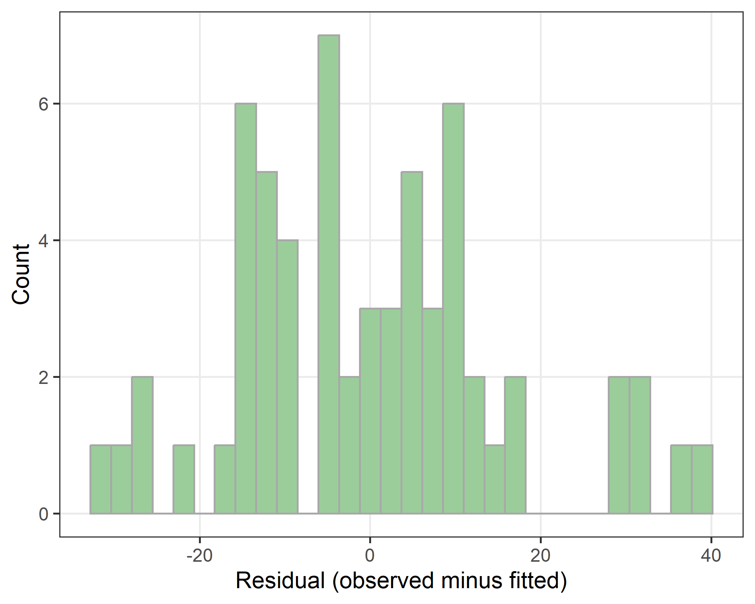

There are no clear concerns in the residual plot.

# Reduced hepatocellular carcinoma (HCC) detected outside specific surveillance

There was only one diagnosis of HCC for any LOCATE participants, so we have not analysed this outcome.

This outcome was listed in the published protocol as a secondary clinical outcome.

# Reduced variceal bleeding occurring without variceal surveillance

There were only two diagnoses of variceal bleeding for any LOCATE participants, so we have not analysed this outcome.

This outcome was listed in the published protocol as a secondary clinical outcome.

# Increased statin use

This outcome was listed in the published protocol as a secondary clinical outcome.

From the protocol: “Statin use will be compared between groups by examining the number of participants given a new statin script during the follow-up period. The denominator will be the number of patients not on statins at the time of their referral letter to the hepatology clinic.”

### Table (statin use)

|  | **New model of care** | **Usual care** |
| --- | --- | --- |
| Already on cholesterol lowering drugs 12 months ago | 11 (36.7%) | 5 (16.1%) |
| No drugs | 15 (50.0%) | 23 (74.2%) |
| Yes, started cholesterol lowering drug (not a statin) | 1 (3.3%) | 1 (3.2%) |
| Yes, started statin | 3 (10.0%) | 2 (6.5%) |

The table shows the number of participants and column percentages. This table is for all available participants, regardless of their statin use at baseline.

### Statistical model (statin use)

| **variable** | **mean** | **lower** | **upper** |
| --- | --- | --- | --- |
| New model of care | 4.02 | 0.40 | 55.58 |
| Age (+10 years) | 0.50 | 0.19 | 1.14 |
| Male | 0.07 | 0.00 | 0.68 |
| Sunshine Coast | 2.83 | 0.22 | 36.05 |

The dependent variable is starting a statin. We excluded those patients who were already on a statin at baseline. The number of participants included was 45. We used a logistic regression model so the table above shows the odds ratios and 95% credible intervals.

The model adjusted for age, gender and centre. There were no men who started a statin, hence the estimate for men was extremely variable. To account for this, we used a relatively tight Bayesian prior for gender, which helped give a more realistic estimate for this variable.

The new model of care was associated with a much higher odds of new statin use, but the 95% credible intervals were wide and included a reduced use of new statins relative to the usual care group.

# Increased referrals to a specialist, other than a hepatologist: dietician/nutritionist or psychologist

This outcome was listed in the published protocol as a secondary clinical outcome.

### Table (dietician/nutritionist or psychologist)

#### Dietician or Nutritionist

| **Dietician/Nutritionist** | **New model of care** | **Usual care** |
| --- | --- | --- |
| No | 17 (56.7%) | 22 (71.0%) |
| Yes | 13 (43.3%) | 9 (29.0%) |

#### Psychologist

| **Psychologist** | **New model of care** | **Usual care** |
| --- | --- | --- |
| No | 23 (76.7%) | 22 (71.0%) |
| Yes, accredited counsellor | 3 (10.0%) | 1 (3.2%) |
| Yes, psychologist | 4 (13.3%) | 8 (25.8%) |

### Statistical model (Dietician or nutritionist)

There were 37 participants who were missing this outcome and so were excluded from this analysis.

There were 3 participants with missing data for whether they had seen a dietician or nutritionist at baseline. We used multiple imputation to impute their missing values before running the model.

We used a logistic regression model so the table above shows the odds ratios and 95% credible intervals. The mean odds was much higher for the new model of care group, but the 95% credible interval included a higher odds for usual care. Participants who had seen a dietician or nutritionist at baseline were far more likely to see one at follow-up, which is as expected. Older participants were less likely to see a dietician or nutritionist.

| **variable** | **mean** | **lower** | **upper** |
| --- | --- | --- | --- |
| New model of care | 4.29 | 0.87 | 21.01 |
| Saw nutritionist/dietician at baseline | 13.77 | 2.56 | 73.93 |
| Age (+10 years) | 0.50 | 0.28 | 0.90 |
| Male | 0.34 | 0.06 | 1.84 |
| Sunshine Coast | 0.05 | 0.00 | 0.95 |

### Statistical model (Psychologist)

There were 37 participants who were missing this outcome and so were excluded from this analysis.

| **variable** | **mean** | **lower** | **upper** |
| --- | --- | --- | --- |
| New model of care | 0.65 | 0.18 | 2.28 |
| Age (+10 years) | 1.14 | 0.73 | 1.80 |
| Male | 0.57 | 0.13 | 2.31 |
| Sunshine Coast | 0.05 | 0.00 | 0.41 |

We used a logistic regression model so the table above shows the odds ratios and 95% credible intervals. The mean odds ratio was under 1 for the new model of care, but the credible intervals were wide.

None of the participants on the Sunshine Coast saw a psychologist in the last 12 months. We used a tighter Bayesian prior for centre to account for this.

# Increased GP use

This outcome **was not** listed in the published protocol or trial registration.

### Boxplot (GP use)

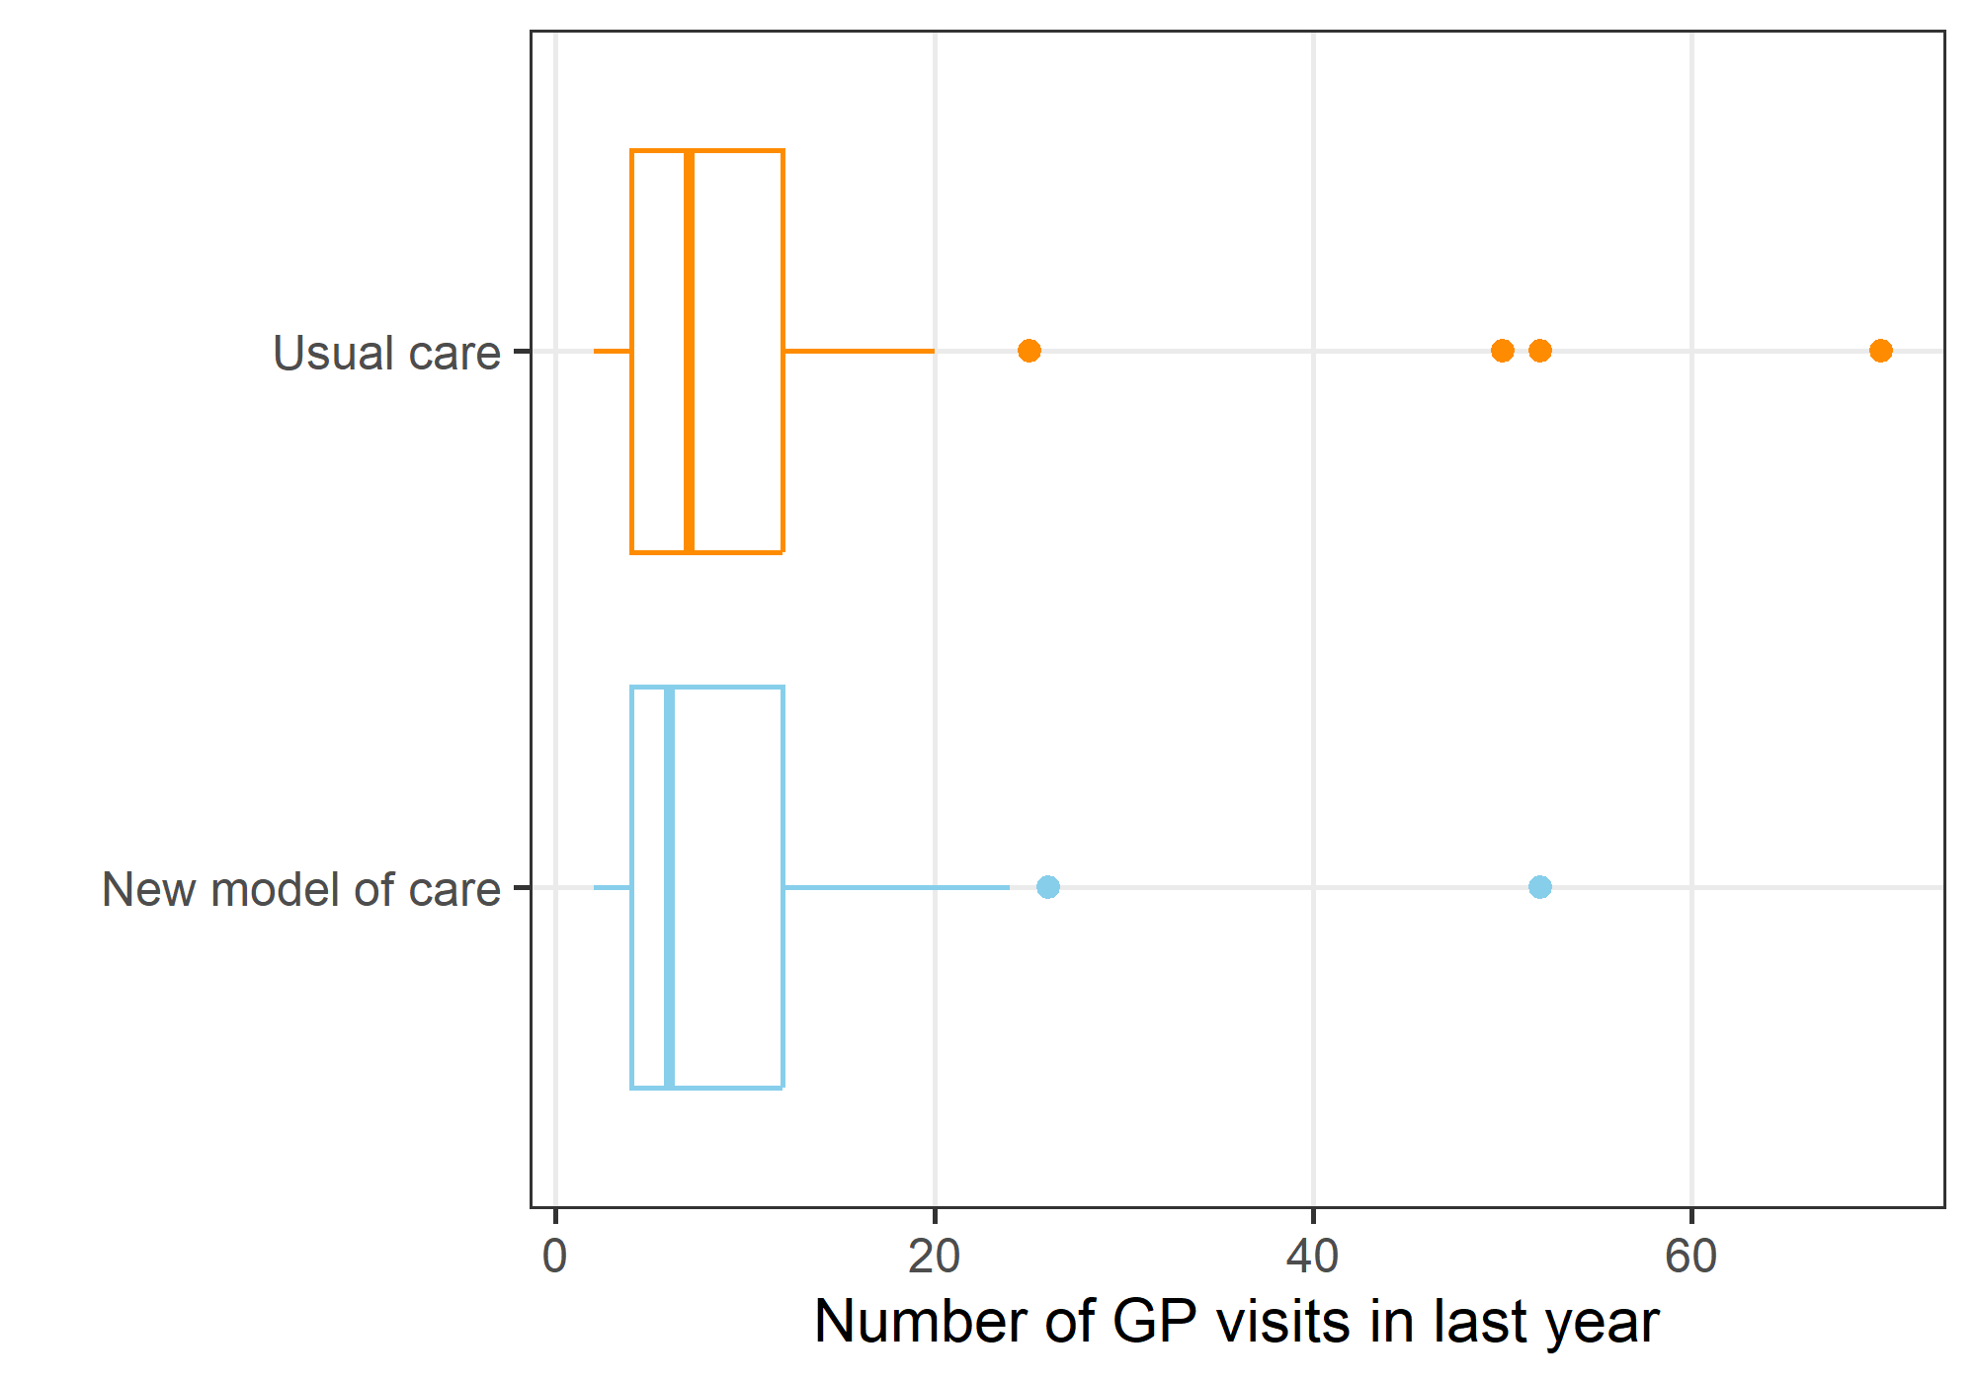

The number of GP visits in the last year has a strong positive skew and four outliers of over 40 visits.

### Statistical model (GP use)

There were 37 participants who were missing this outcome and so were excluded from this analysis.

There were 4 participants with missing data for their number of GP visits at baseline. We used multiple imputation to impute their missing values before running the model.

| **variable** | **mean** | **lower** | **upper** |
| --- | --- | --- | --- |
| New model of care | 0.81 | 0.69 | 0.94 |
| GP visits at baseline (log-transformed) | 3.58 | 2.78 | 4.60 |
| Age (+10 years) | 1.08 | 1.01 | 1.14 |
| Male | 1.10 | 0.75 | 1.62 |
| Sunshine Coast | 0.57 | 0.45 | 0.72 |

The model used a Poisson distribution, so the results are presented as rate ratios. We adjust for GP use at baseline and, not surprisingly, there was a strong positive association between baseline GP usage and follow-up usage. We also adjust for age and sex.

The new model of care was associated with a decrease in GP usage.

Older participants were more likely to visit the GP. Participants at the Sunshine Coast had a reduced rate of GP use.

### Residual check (GP use)

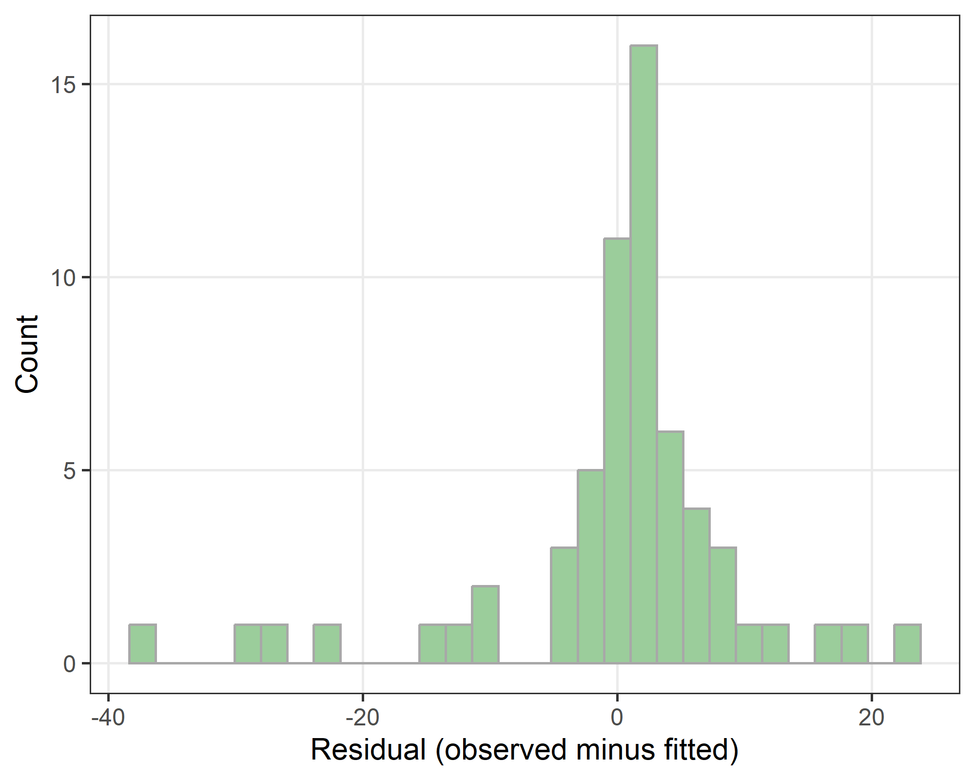

There are no clear concerns in the residual plot.

# Reduced mortality

There were no deaths for any LOCATE participants during the follow-up, so we have not analysed this outcome.

This outcome was listed in the published protocol as a secondary clinical outcome.

# Per protocol analysis

| **Per protocol** | **New model of care** | **Usual care** |
| --- | --- | --- |
| FALSE | 2 | 0 |
| TRUE | 48 | 48 |

The table above shows the number of participants by randomised group that followed the per protocol definition. Only 2 patients did not follow the protocol. Given this small difference we will not run a separate per protocol analysis.

# Appendices

The appendices contain technical details. Some may be included as appendices in the paper.

### Bayesian models

The models were fitted using a Bayesian paradigm, so the results are given as means and 95% credible intervals, which have a more intuitive interpretation that standard 95% confidence intervals.

We used the nimble package to fit the Bayesian models. We used 2 chains, with a burn-in of 20,000 followed by a sample of 20,000 thinned by 10.

### Bayesian model convergence

In this section we show the graphical estimates of model convergence.

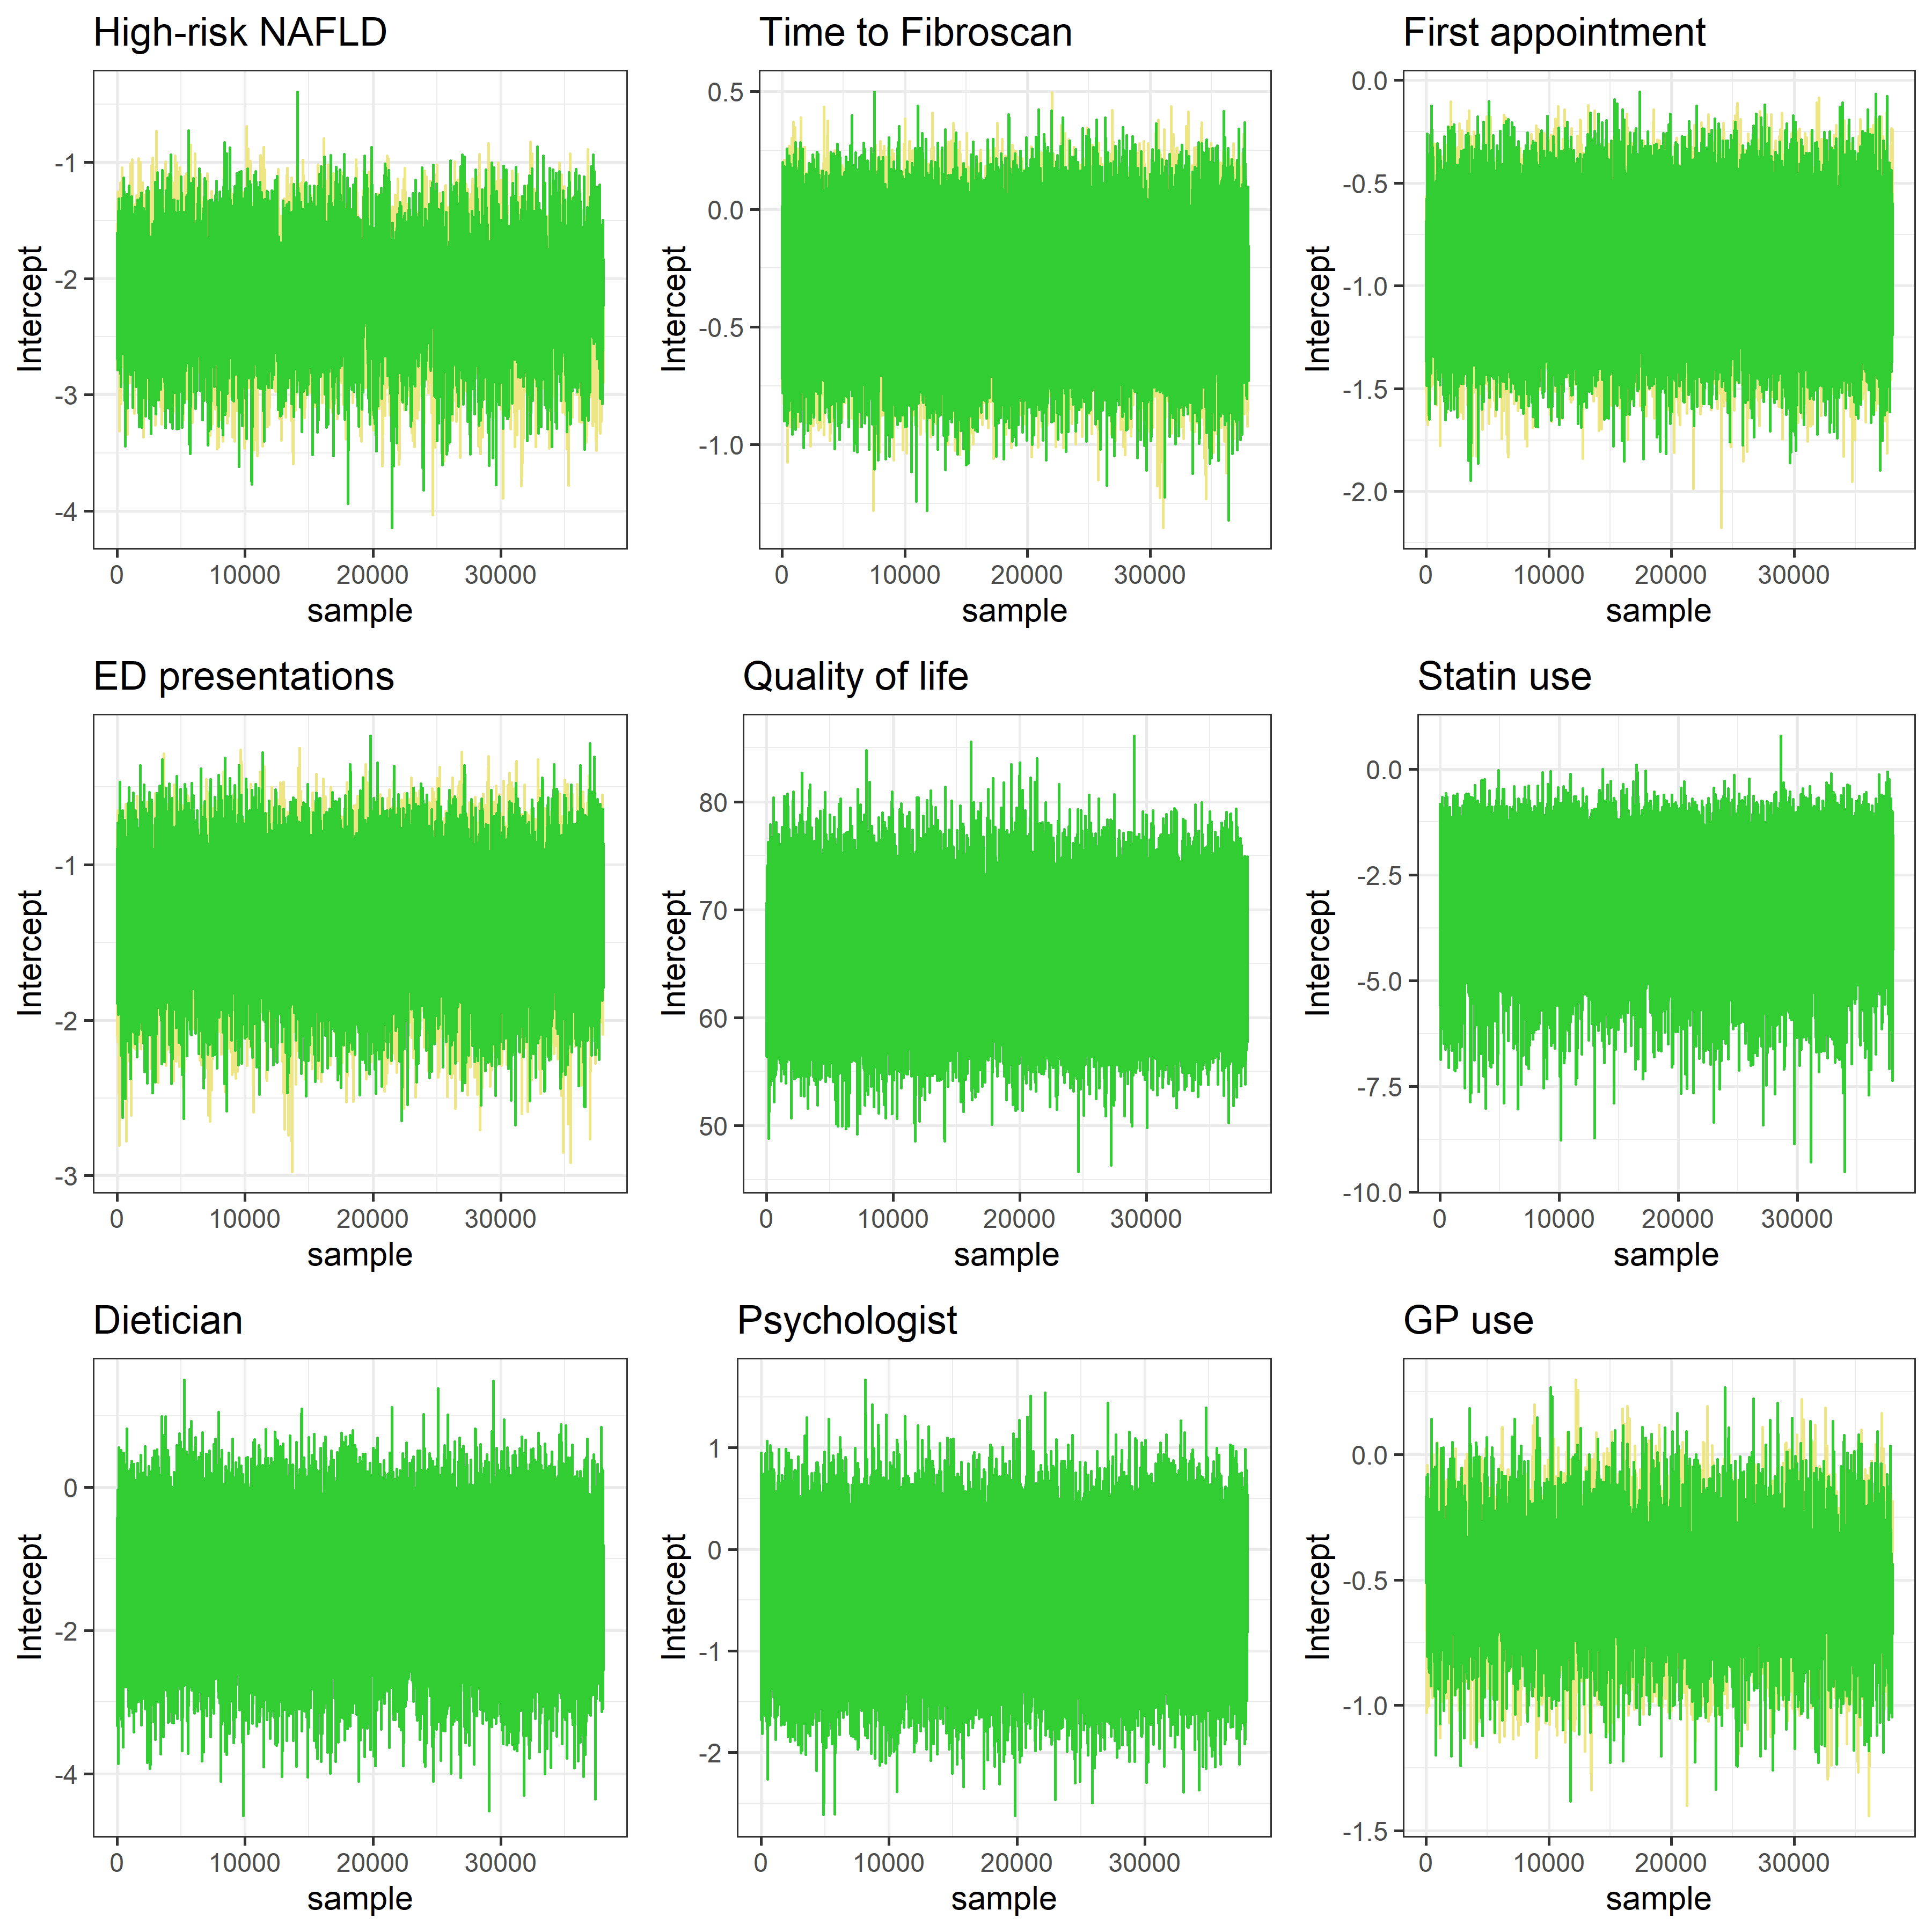

All the chains appear to show good mixing and convergence, so there are no concerns for any of the models.

### R and package versions

We used the following version of R and packages.

R version 4.3.1 (2023-06-16 ucrt)  
Platform: x86_64-w64-mingw32/x64 (64-bit)  
Running under: Windows 10 x64 (build 19045)  
  
Matrix products: default  
  
  
locale:  
[1] LC_COLLATE=English_Australia.utf8 LC_CTYPE=English_Australia.utf8 LC_MONETARY=English_Australia.utf8 LC_NUMERIC=C LC_TIME=English_Australia.utf8   
  
time zone: Australia/Brisbane  
tzcode source: internal  
  
attached base packages:  
[1] stats graphics grDevices utils datasets methods base   
  
other attached packages:  
 [1] gridExtra_2.3 mitools_2.4 nimble_1.0.1 broom_1.0.5 survminer_0.4.9 ggpubr_0.6.0 ggplot2_3.4.2 survival_3.5-5 stringr_1.5.0 janitor_2.2.0 flextable_0.9.2 tidyr_1.3.0 dplyr_1.1.2 knitr_1.43   
  
loaded via a namespace (and not attached):  
 [1] tidyselect_1.2.0 farver_2.1.1 fastmap_1.1.1 pracma_2.4.2 fontquiver_0.2.1 promises_1.2.0.1 digest_0.6.31 timechange_0.2.0 mime_0.12 lifecycle_1.0.3 ellipsis_0.3.2 gfonts_0.2.0 magrittr_2.0.3 compiler_4.3.1 rlang_1.1.1 tools_4.3.1 igraph_1.5.0 utf8_1.2.3 yaml_2.3.7 data.table_1.14.8 ggsignif_0.6.4 labeling_0.4.2 askpass_1.1 curl_5.0.1 xml2_1.3.4 abind_1.4-5 httpcode_0.3.0 numDeriv_2016.8-1.1 withr_2.5.0 purrr_1.0.1 grid_4.3.1 fansi_1.0.4 gdtools_0.3.3 xtable_1.8-4 colorspace_2.1-0 scales_1.2.1 crul_1.4.0 cli_3.6.1 rmarkdown_2.22 crayon_1.5.2 ragg_1.2.5   
[42] generics_0.1.3 rstudioapi_0.14 km.ci_0.5-6 commonmark_1.9.0 DBI_1.1.3 splines_4.3.1 parallel_4.3.1 survMisc_0.5.6 vctrs_0.6.3 Matrix_1.5-4.1 jsonlite_1.8.5 fontBitstreamVera_0.1.1 carData_3.0-5 car_3.1-2 rstatix_0.7.2 systemfonts_1.0.4 glue_1.6.2 codetools_0.2-19 ggtext_0.1.2 lubridate_1.9.2 stringi_1.7.12 gtable_0.3.3 later_1.3.1 munsell_0.5.0 tibble_3.2.1 pillar_1.9.0 htmltools_0.5.5 openssl_2.0.6 R6_2.5.1 KMsurv_0.1-5 textshaping_0.3.6 evaluate_0.21 shiny_1.7.4 lattice_0.21-8 highr_0.10 markdown_1.7 backports_1.4.1 gridtext_0.1.5 snakecase_0.11.0 fontLiberation_0.1.0 httpuv_1.6.11   
[83] TeachingDemos_2.12 Rcpp_1.0.10 zip_2.3.0 uuid_1.1-0 coda_0.19-4 officer_0.6.2 xfun_0.39 zoo_1.8-12 pkgconfig_2.0.3

# References

Brain, David, James O’Beirne, Ingrid J. Hickman, Elizabeth E. Powell, Patricia C. Valery, Sanjeewa Kularatna, Ruth Tulleners, Alison Farrington, Leigh Horsfall, and Adrian Barnett. 2020. “Protocol for a Randomised Trial Testing a Community Fibrosis Assessment Service for Patients with Suspected Non-Alcoholic Fatty Liver Disease: LOCal Assessment and Triage Evaluation of Non-Alcoholic Fatty Liver Disease (LOCATE-NAFLD).” *BMC Health Services Research* 20 (1). <https://doi.org/10.1186/s12913-020-05233-2>.

Dobson, A. J., and A. G. Barnett. 2018. *An Introduction to Generalized Linear Models*. 4th ed. Chapman & Hall/CRC Texts in Statistical Science. CRC Press.

Schulz, K. F, D. G Altman, and D. Moher and. 2010. “CONSORT 2010 Statement: Updated Guidelines for Reporting Parallel Group Randomised Trials.” *BMJ* 340 (mar23 1): c332–32. <https://doi.org/10.1136/bmj.c332>.

Sterne, J. A C, I. R White, J. B Carlin, M. Spratt, P. Royston, M. G Kenward, A. M Wood, and J. R Carpenter. 2009. “Multiple Imputation for Missing Data in Epidemiological and Clinical Research: Potential and Pitfalls.” *BMJ* 338 (jun29 1): b2393–93. <https://doi.org/10.1136/bmj.b2393>.