**Automatically detecting issues with randomised controlled trials**

Adrian Barnett[1]

Word count: ?

# Abstract

*Objectives*:

*Design*: Observational study.

*Setting*: Published RCTs.

*Participants*:

*Main outcome measures*:

*Results*:

*Conclusion*:

*Key words*: randomised controlled trials;

# Introduction

# Methods

The observed differences ($d$) in groups were modelled using a t-distribution.

$$d_{i,j}∼N(Δ_{i,j},σ_{i,j}^{2},{\text{df}}_{i}), i=1,…,M, j=1,…,n_{i},$$

where $i$ is the study index and $j$ is the row index. The degrees of freedom (df) for study $i$ is the total sample size minus ($N_{i}−2$).

The pooled inverse-variance was modelled as

$$σ_{i,j}^{−2}=s_{i,j}^{−2}+γ_{i}$$

where $s$ is the observed pooled variance. The study-level random variable $γ_{i}$ was used to model an additional precision for study $i$ using a spike-and-slab approach

$$γ_{i}=(1−I_{i}^{γ})×0+I_{i}^{γ}×ϵ_{i},$$

$$I_{i}^{γ}∼\text{Bernoulli}(p_{1}),$$

$$ϵ_{i}∼\text{N}(0,{10}^{3})I(0,)$$

So the additional precision is zero with probability ($1−I_{i}^{γ}$) which is the “spike” that models studies where the differences between randomised groups are as expected. The switch for each study is modelled using a Bernoulli distribution. The probability $p_{1}$ is the expected proportion of papers with an issue. This can be specified as a constant or given its own hyper-parameter. The additional precision (“slab”) was modelled using a truncated normal distribution where the estimate must be positive. This is because we were interested in studies with a higher than expected precision.

The mean was also modelled using a spike-and-slab approach.

$$Δ_{i,j}=(1−I_{i}^{Δ})×0+I_{i}^{Δ}×ν_{i}$$

$$I_{i}^{Δ}∼\text{Bernoulli}(p_{2}),$$

$$ν_{i}∼\text{N}(0,{10}^{3})$$

So here the spike is at zero for studies where the mean difference is as expected for randomised controlled trials. The slab here includes a wide range of positive and negative values.

### Graphical description of the model

Here we give a graphical description of the model.

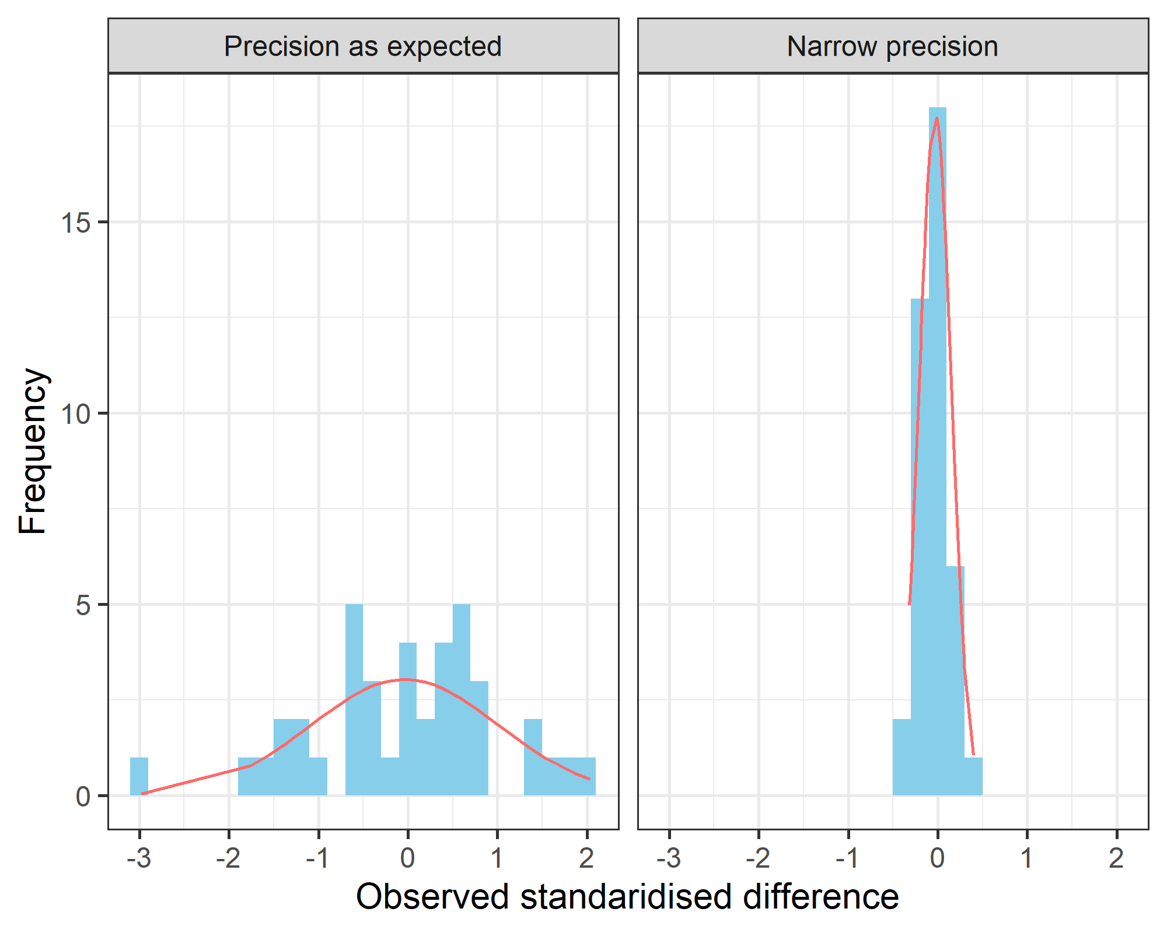

In the example, both studies have a mean difference of zero, but the observed differences from one study are much narrower and closer to zero. Our approach models the precision (inverse-variance) and aims to detect when studies have an unexpectedly narrow precision.

# Conclusion

## Acknowledgements

## Competing interests

The authors have declared that no competing interests exist.

## Funding

This work was supported by National Health and Medical Research Council (<https://www.nhmrc.gov.au/>) grant number APP1117784. The funders had no role in study design, data collection and analysis, decision to publish, or preparation of the manuscript.

## Authors’ contributions

## Data sharing

# References

1. Australian Centre for Health Services Innovation & Centre for Healthcare Transformation, Queensland University of Technology, Queensland, Australia, [a.barnett@qut.edu.au](mailto:a.barnett@qut.edu.au)