Random manual checks of the analysis data

Adrian Barnett

12 June, 2025

The results below are manual checks for randomly selected articles and reviewers. The aim is to manually verify the accuracy of the automated data collection. We use a Bayesian approach to give an upper limit on the error rates.

The first results show the frequency table of errors.

## Articles where reviewer is not cited in the paper’s references

| **checked** | **n** | **percent** |
| --- | --- | --- |
| fail | 2 | 2 |
| pass | 98 | 98 |

This check examined reviewers where our data algorithm said there was no citation to the reviewer, which we then verified by searching the article’s reference list. The errors were for references to a book and a conference paper that did not have a DOI.

## Where reviewer is cited in the articles’s references

| **checked** | **n** | **percent** |
| --- | --- | --- |
| fail | 1 | 1 |
| pass | 99 | 99 |

This check examined reviewers where our data algorithm said there was one or more citations to the reviewer, which we then verified by searching the article’s reference list. The error was where our data algorithm only captured one citation, but there should have been two.

## Reviewers who used self-citations

| **checked** | **n** | **percent** |
| --- | --- | --- |
| fail | 4 | 5 |
| pass | 76 | 95 |

This check examined reviewers where our data algorithm said there were one or more self-citations, which we then verified by searching the review text. For all four failures of our algorithm, we did capture a self-citation, but the number captured was one fewer than the true number.

### Plot of the prior and posterior probabilities

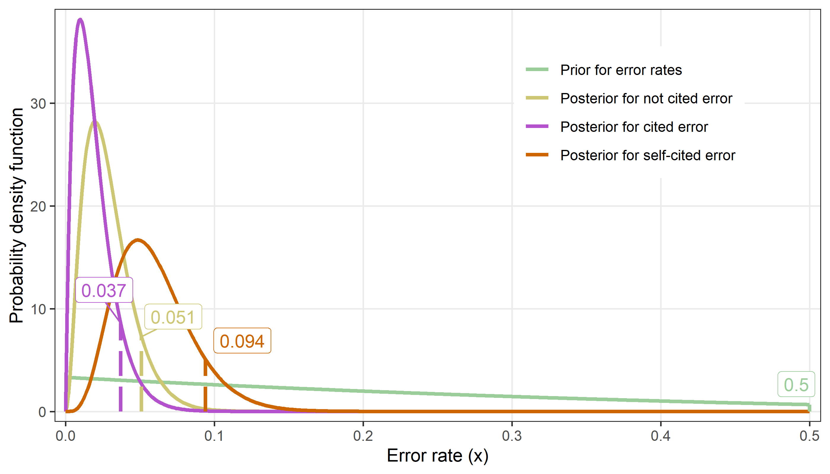

The plot shows the beta distributions for the prior and the posteriors. The highlighted rates are the error rates at the 90% limit. So there is a 90% probability that the error rate is less than the highlighted rate.

| **labels** | **fails** | **error** |
| --- | --- | --- |
| Prior for error rates |  | 0.500 |
| Posterior for not cited error | 2 | 0.051 |
| Posterior for cited error | 1 | 0.037 |
| Posterior for self-cited error | 4 | 0.094 |

The table shows the error rates. The vaguely informative prior had a 90% probability that the error rate was under 0.5.