Plots

Adrian Barnett

17 July, 2025

## Reviewers’ recommendations

#### For all versions combined

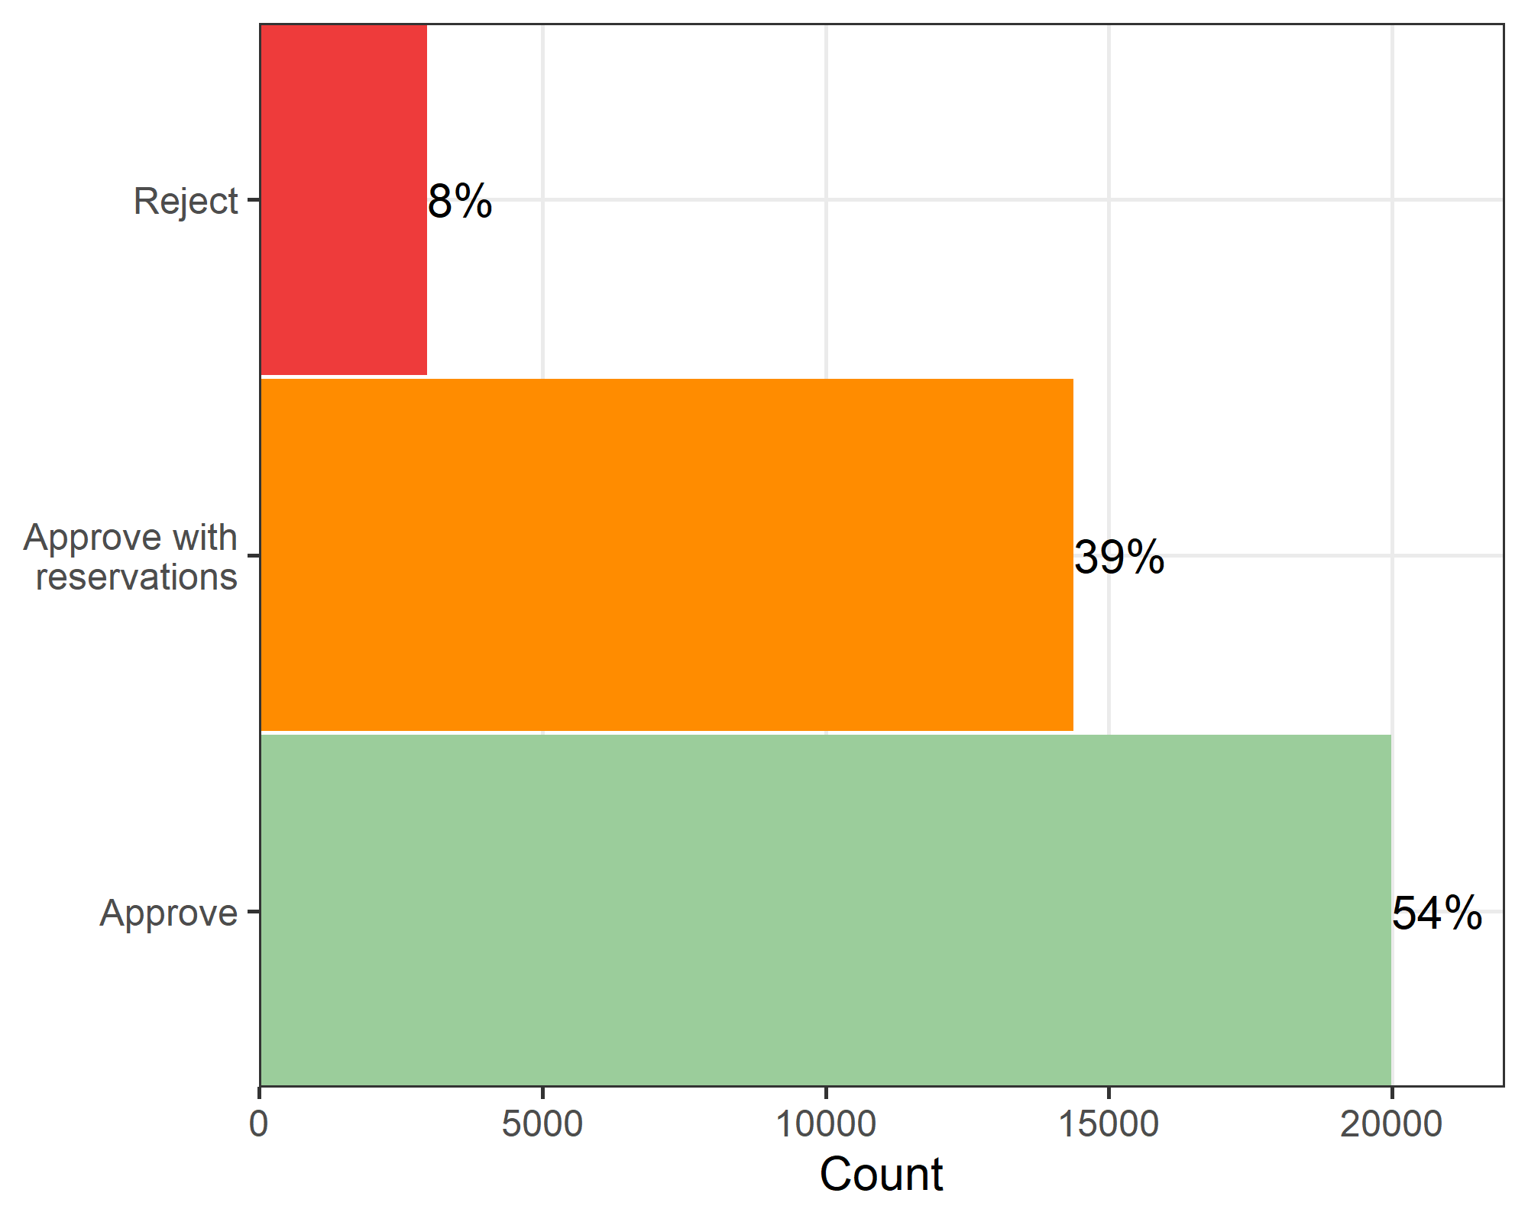

#### By version

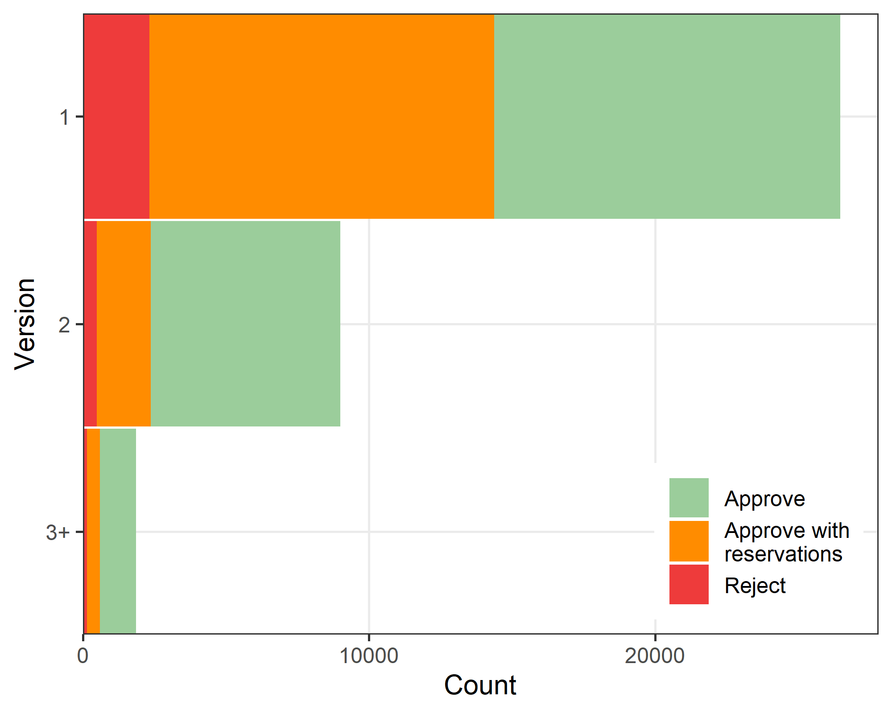

## Number of papers the reviewer cited

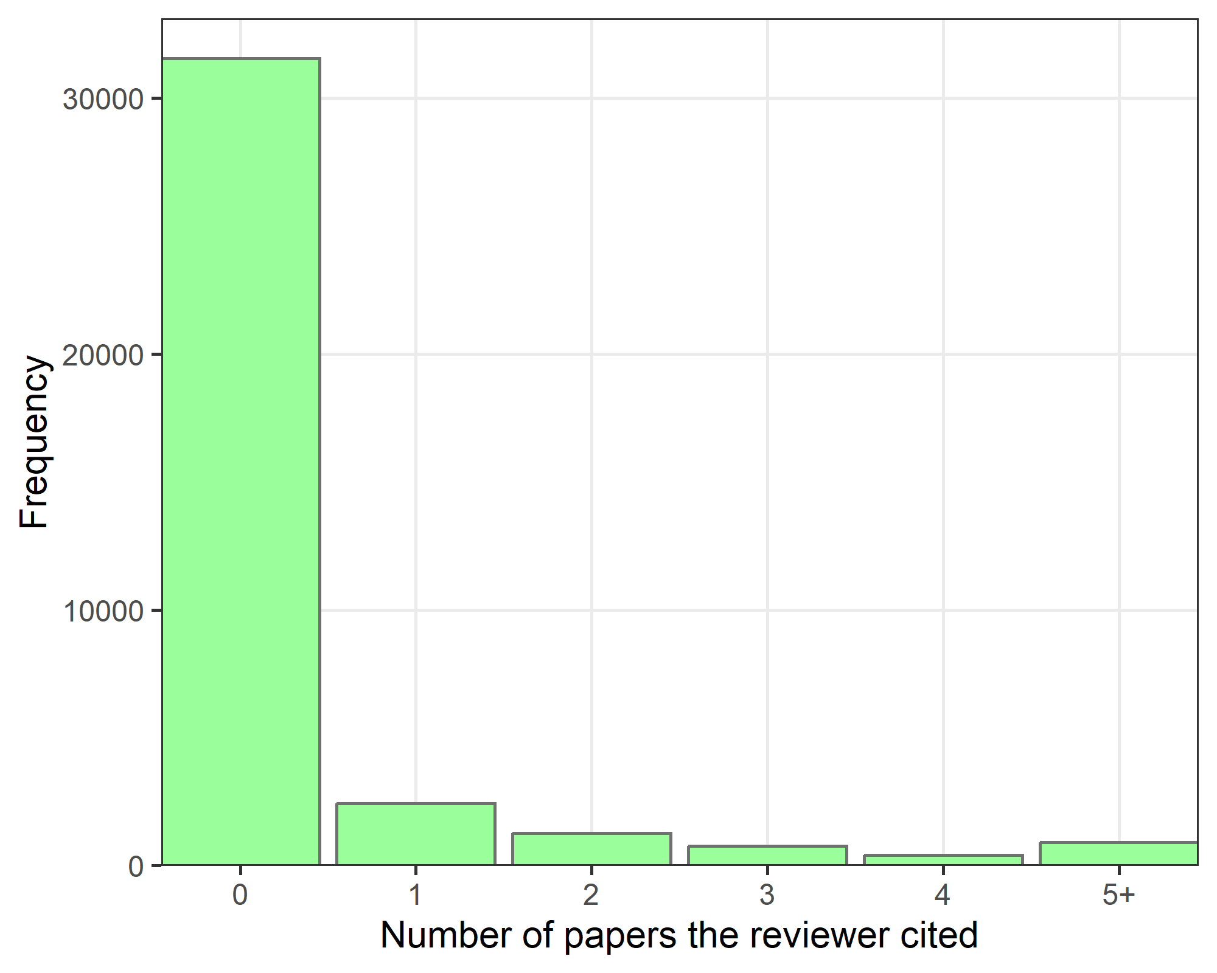

## Number of self-citations

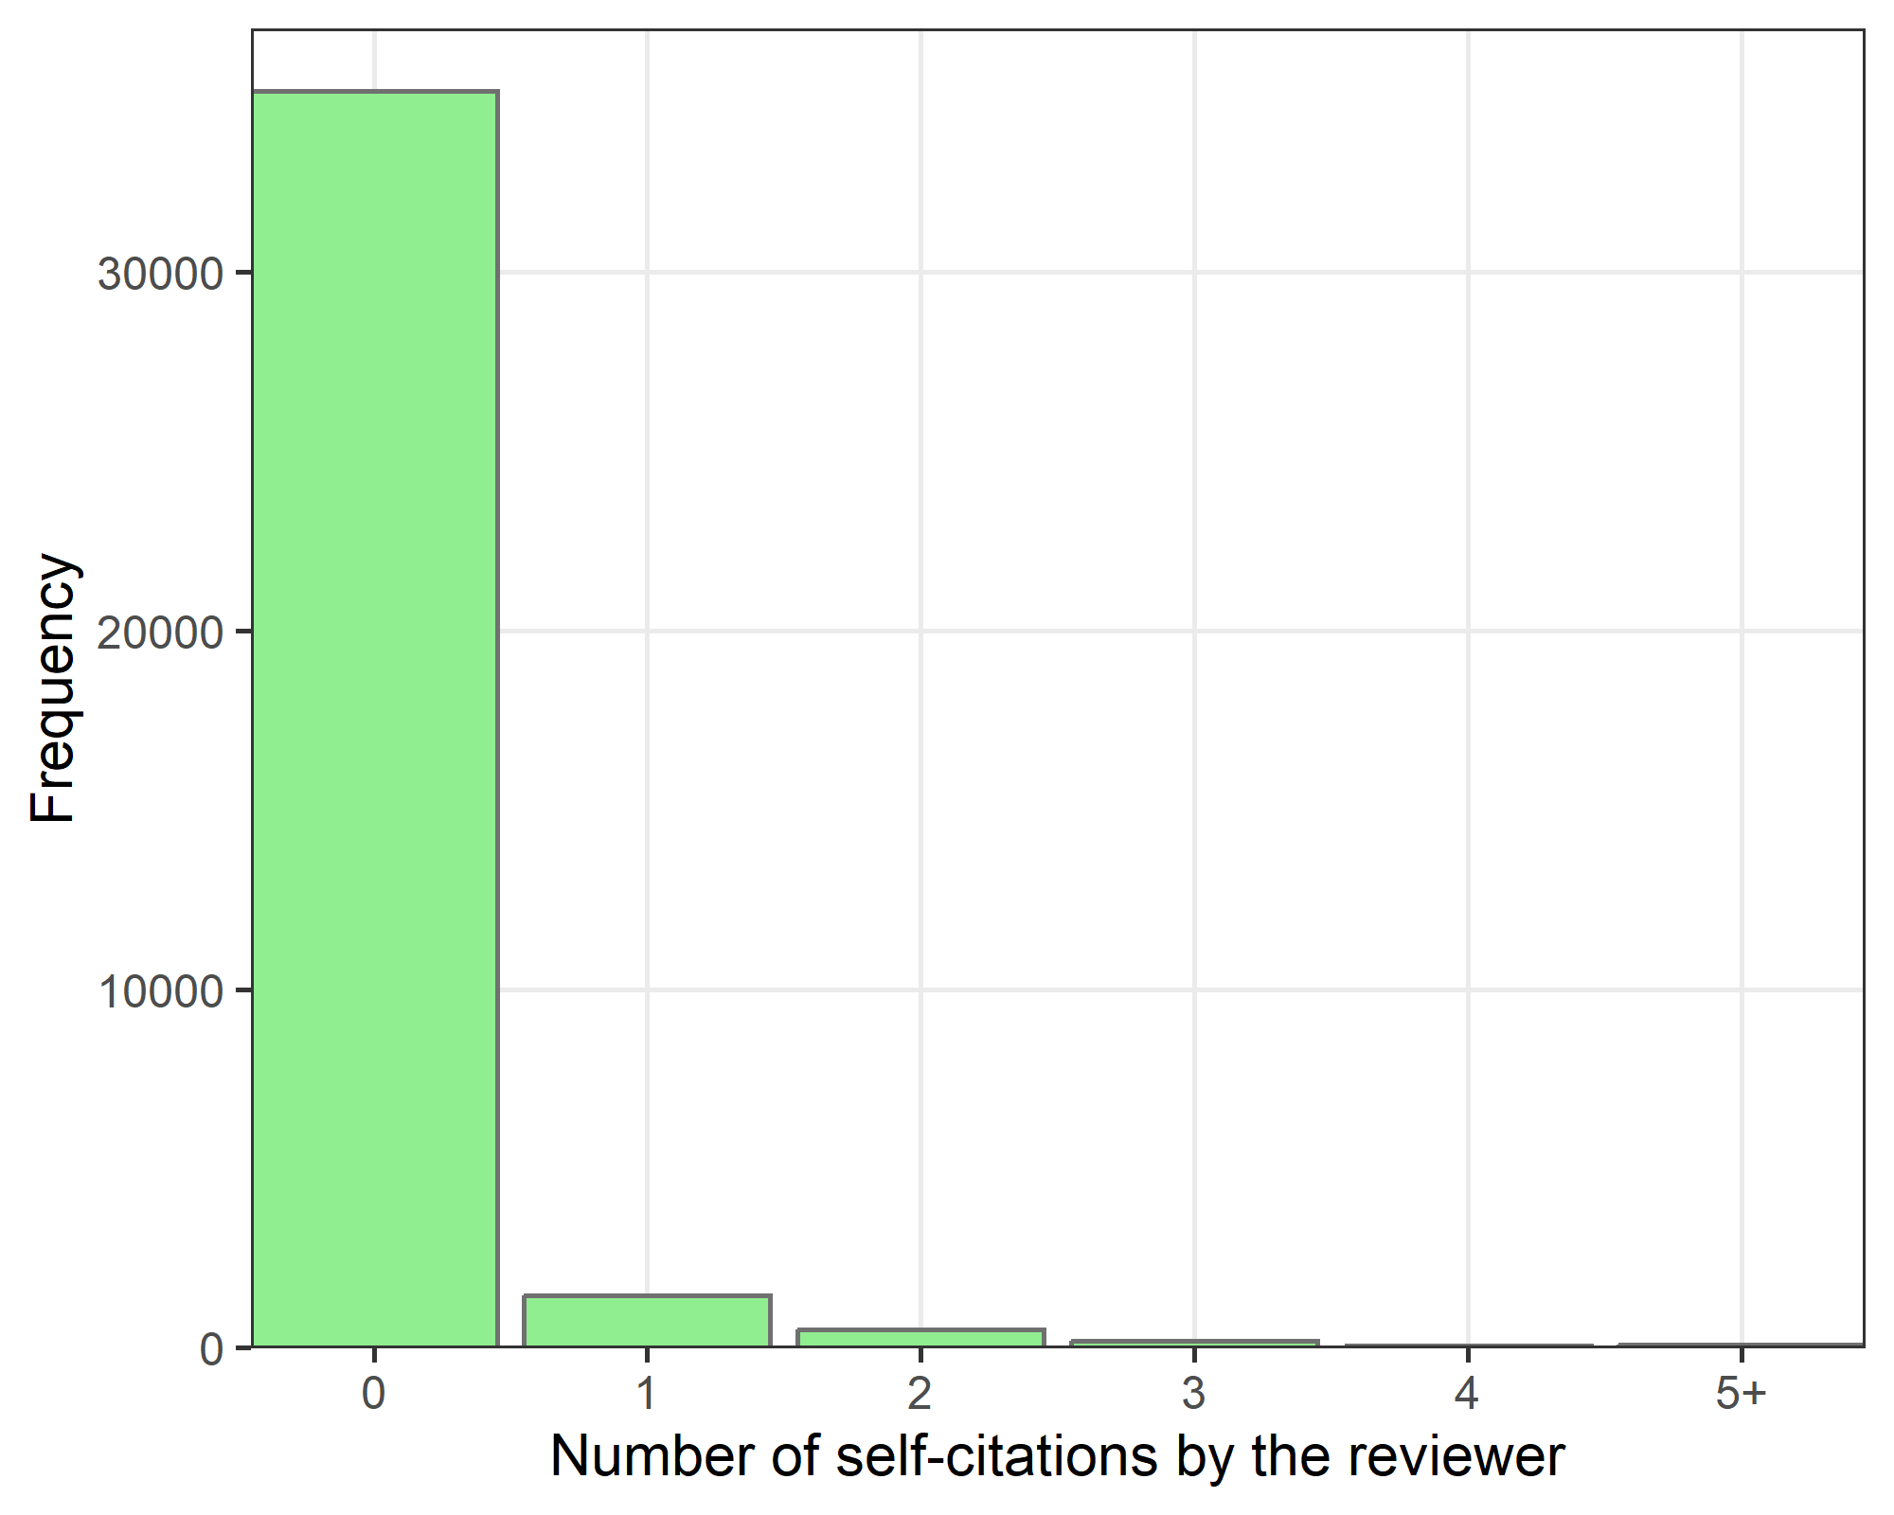

## Reviewers’ publication counts

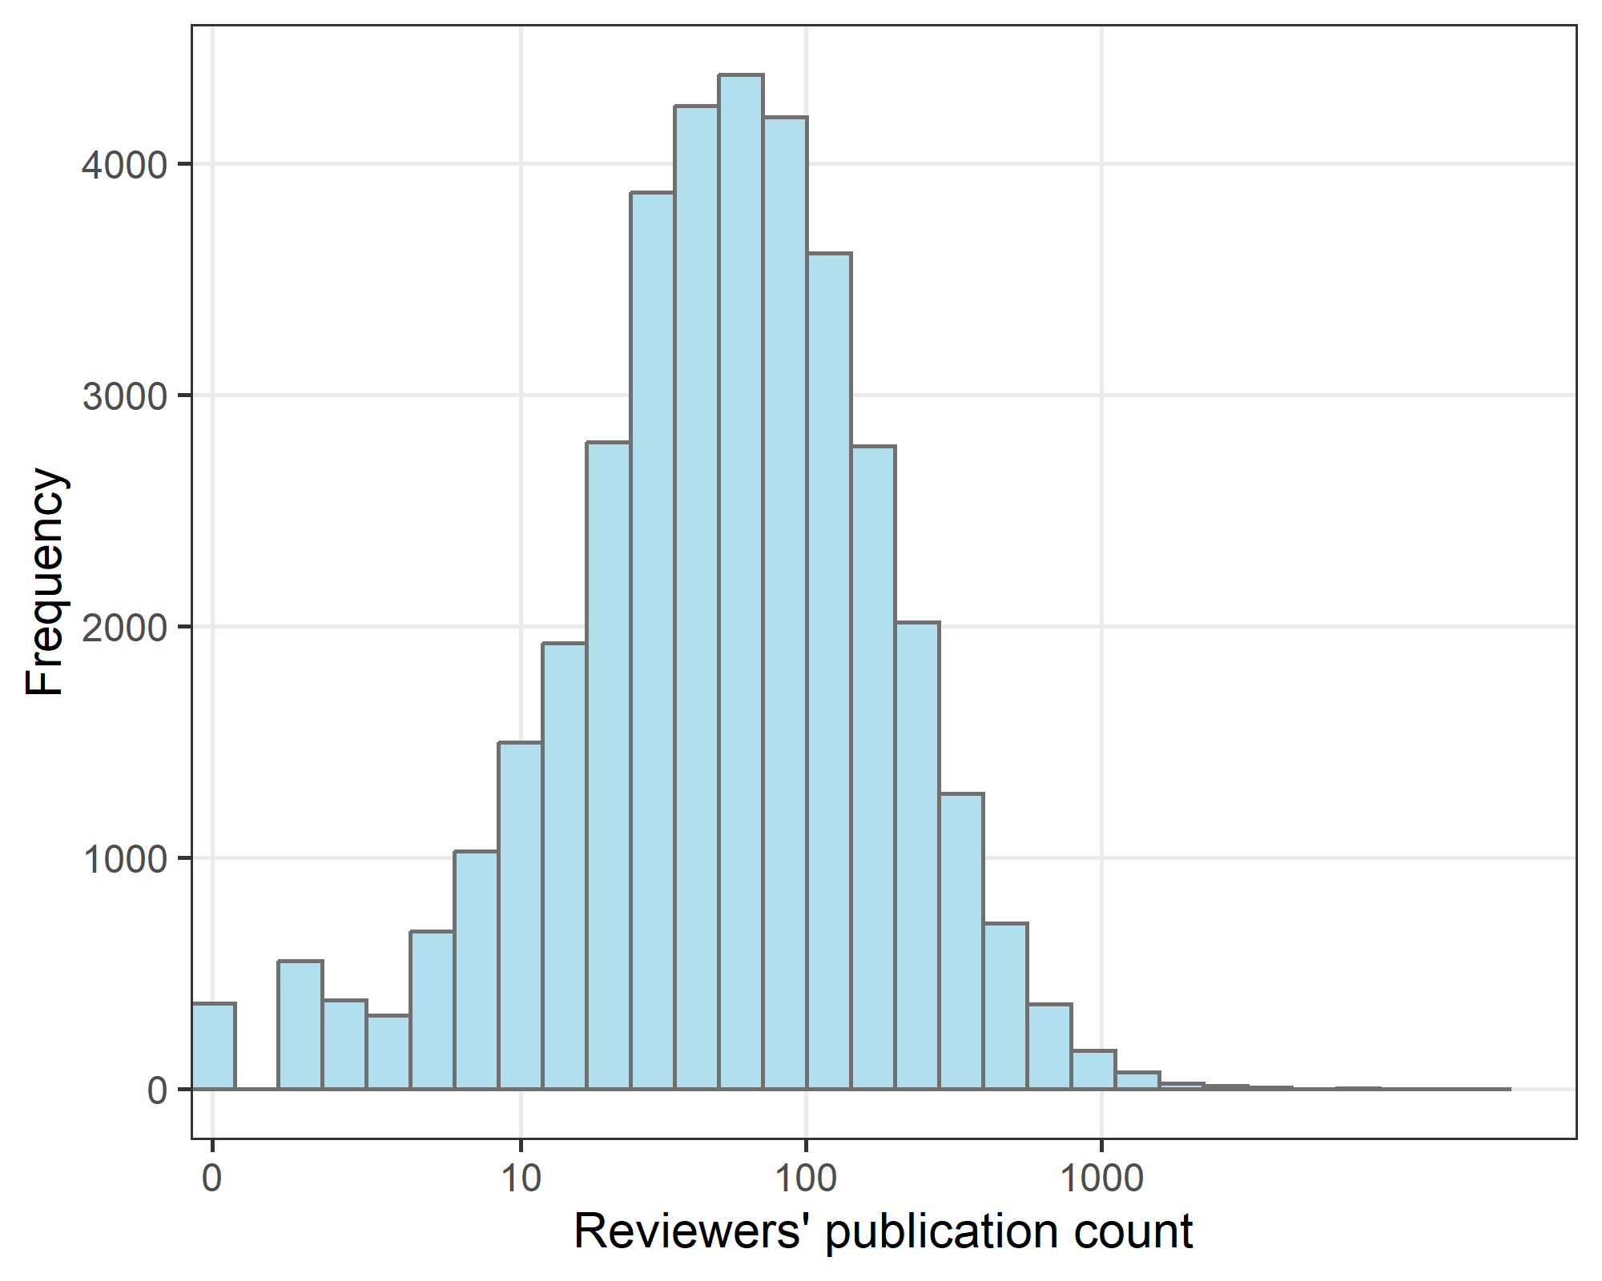

The x-axis is log-transformed (base 10). The number of papers is an indicator of the reviewer’s experience.

## Self-citations by version

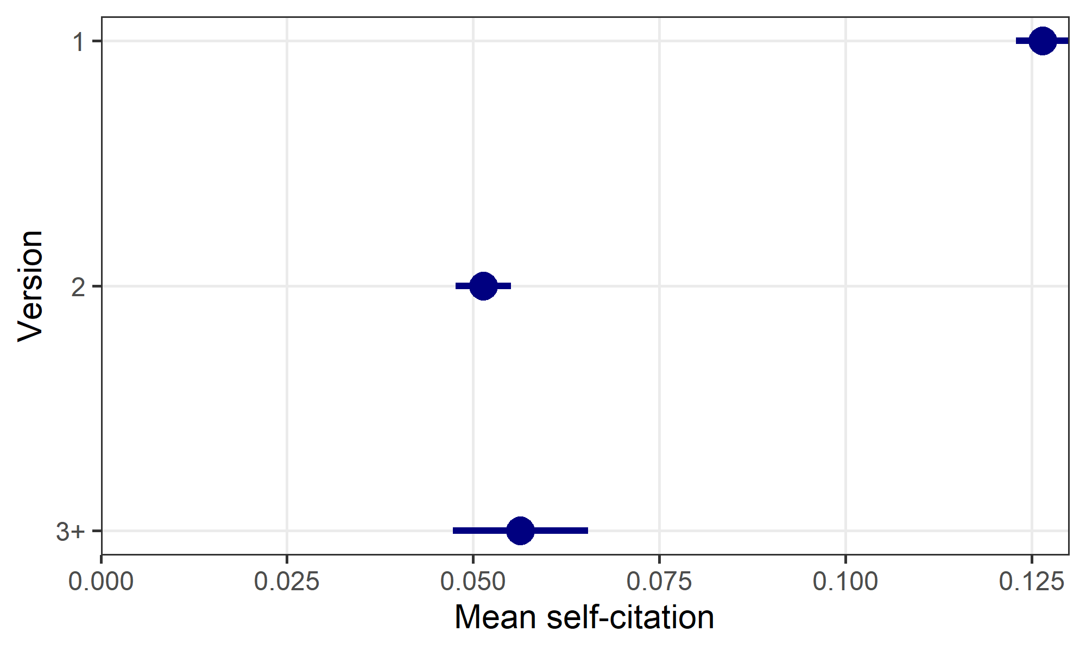

## Self-citations by country

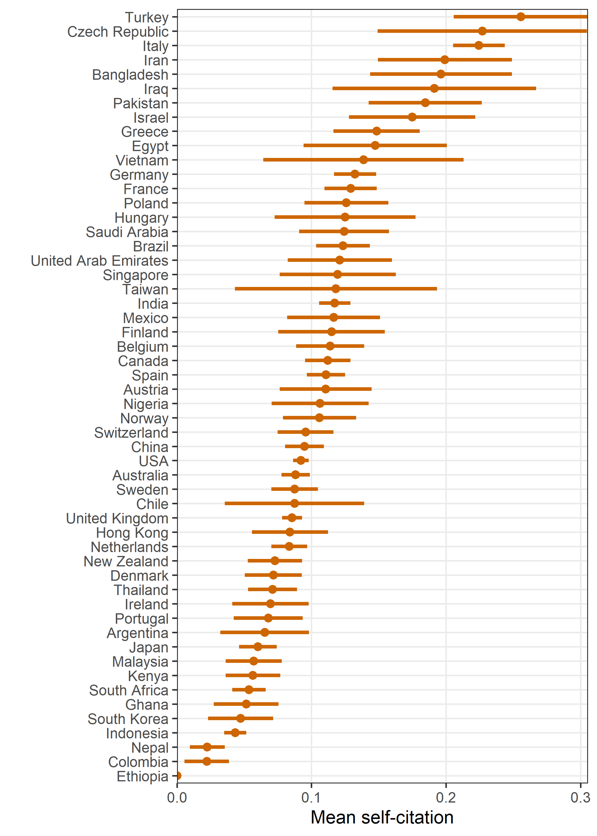

Limited to countries with at least 100 reviews.

## Model of self citation counts

|-------------|-------------|-------------|-------------|  
|-------------------------------------------------------|  
|-------------|-------------|-------------|-------------|  
|-------------------------------------------------------|

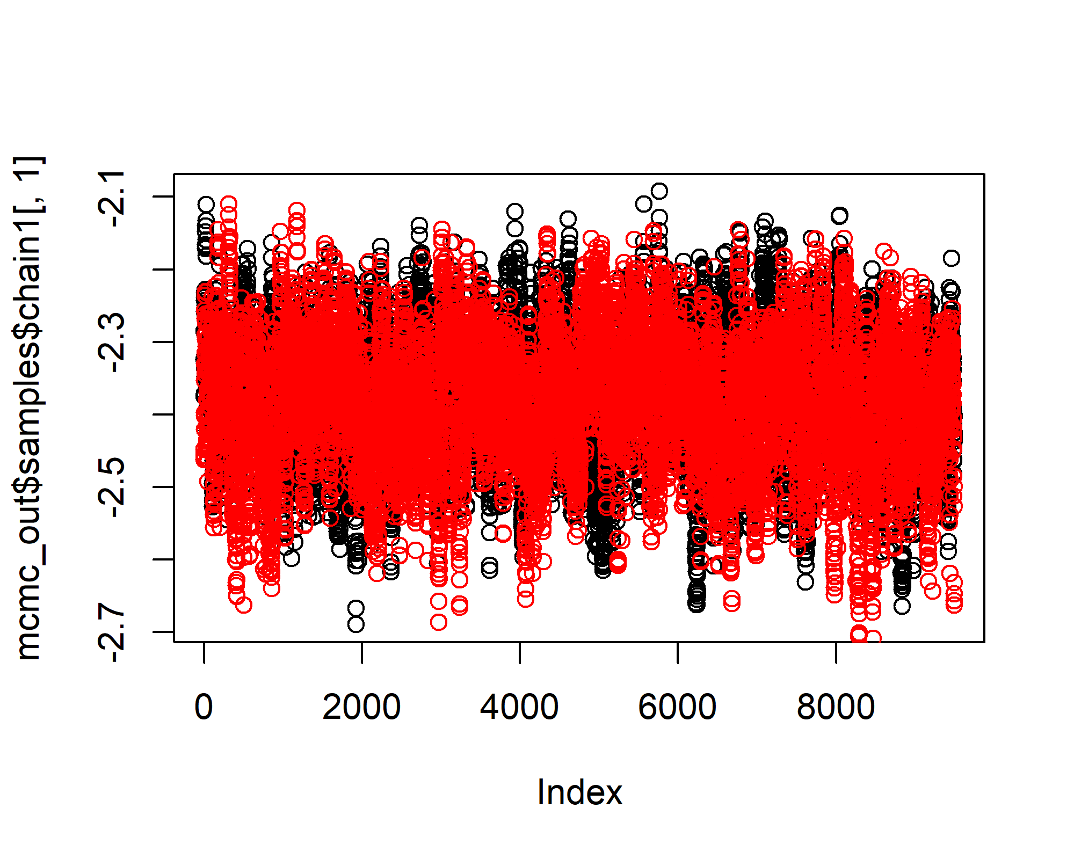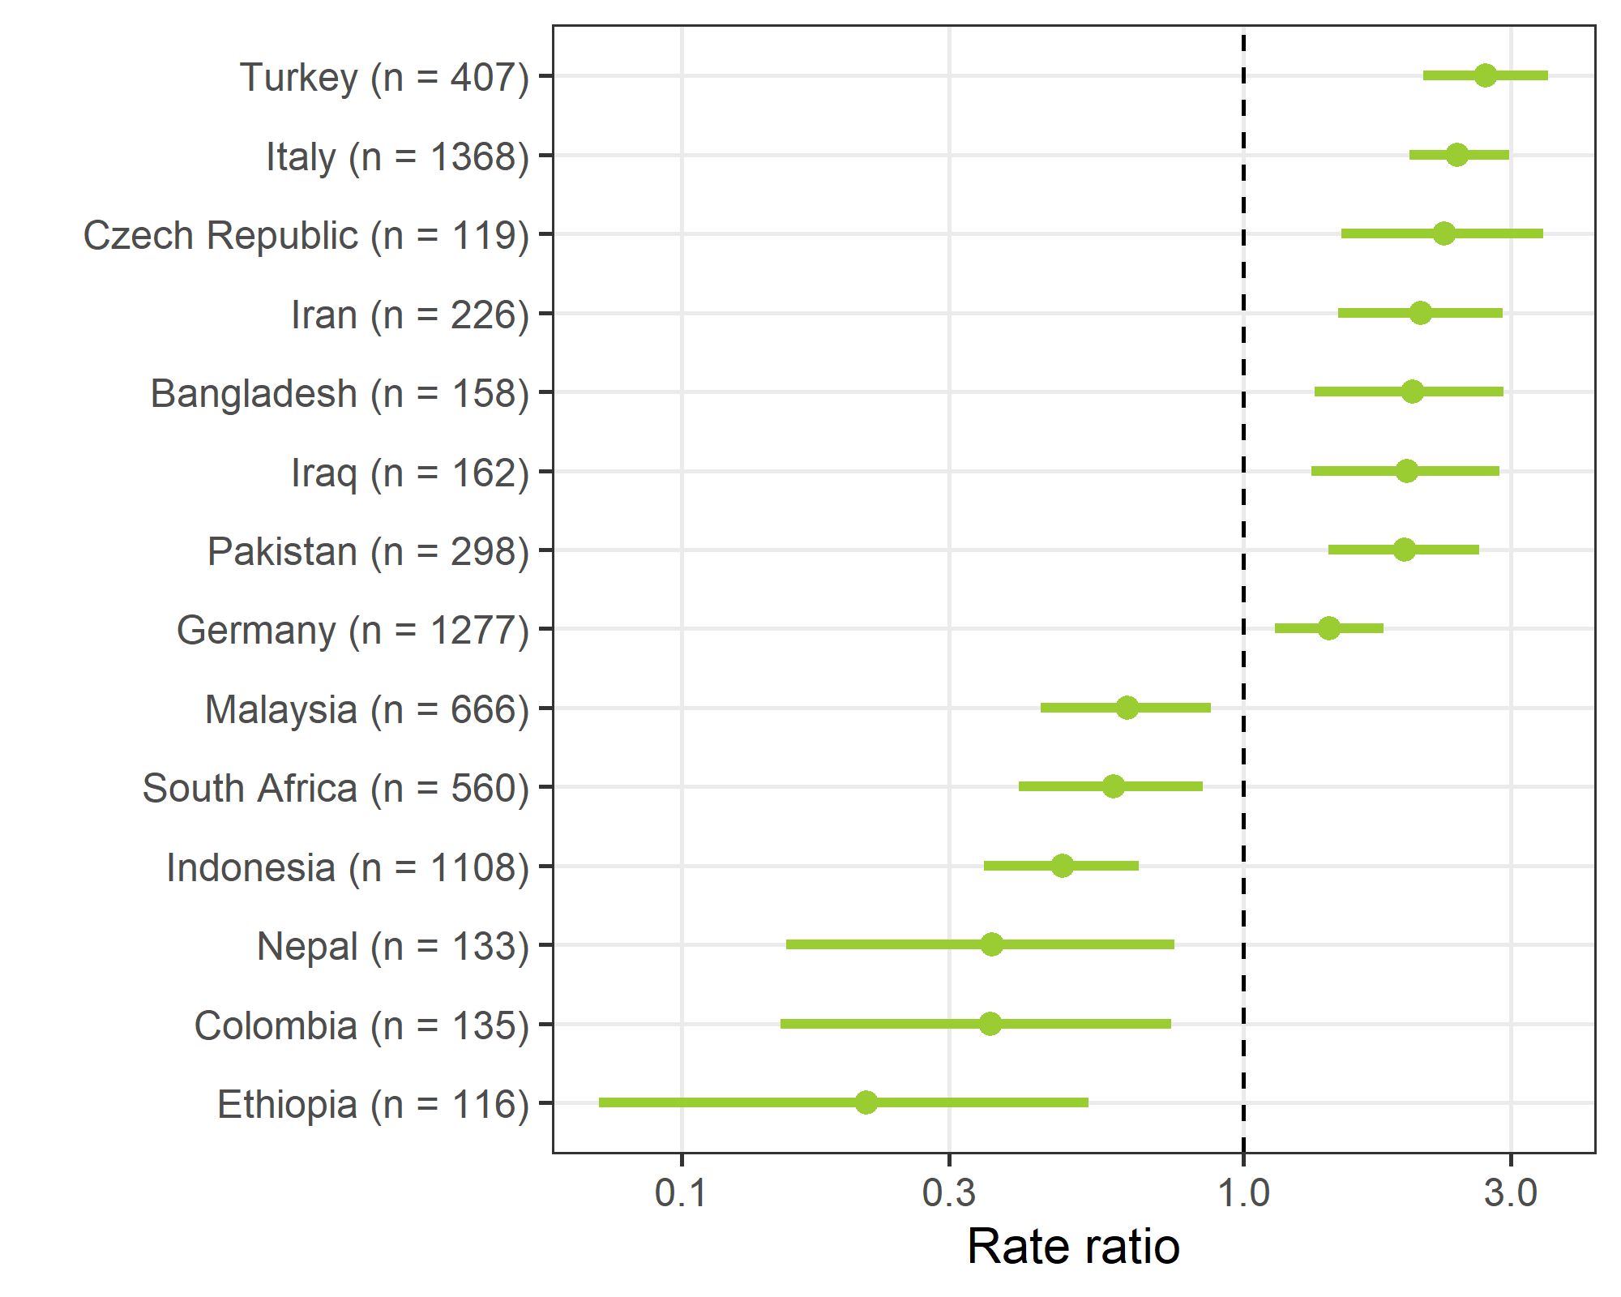

We used a Poisson model with a dependent variable of the number of self-citations and independent variable of country, which was fitted as a random effect. The plot shows those estimates where the posterior probability is less than 0.01 and there are more than 100 reviews. The country labels include the number of reviews, which is small for some countries.