Simulate time saved nationally by a simplified ethics/site-specific approval system

Adrian Barnett

05 September 2019

# 1. Approvals requiring ethics and SSA

We model the national number of applications requiring ethics and site-specific approvals and estimate: 1) the time spent currently and, 2) how much time could be saved in a streamlined system.

## 1.1 Time spent in the current ethics/SSA system

We estimate number of applications requiring ethics and SSA from four sources:

1. The number of trials in the NHMRC report on HREC activity was 2155.
2. The number of committee and administrative reviews at QUT in 2018 was 180 out of 672 applications, which gives a number of 577 if extrapolated to the national number of applications reported in the NHMRC report.
3. Searching on ANZCTR for studies registered in 2018 that included sites in Australia gives 1472.
4. Searching on pubmed for clinical trials (of all types) with an Affiliation of “Australia” published in 2018 gives 2942 papers.

We average these four numbers to give 1786 applications requiring ethics and SSA per year.

## 1.2 Simulated number of ethics committees and sites per proposal

We simulate the number of ethics committees and site-specific approvals needed per study using Poisson distributions, with a minimum of one ethics and one SSA approval. The site-specific approval needs a long right tail to cover those studies that recruit across multiple states. We therefore used a mixture of Poisson distributions to capture this, assuming 80% of studies are small and 20% are large.

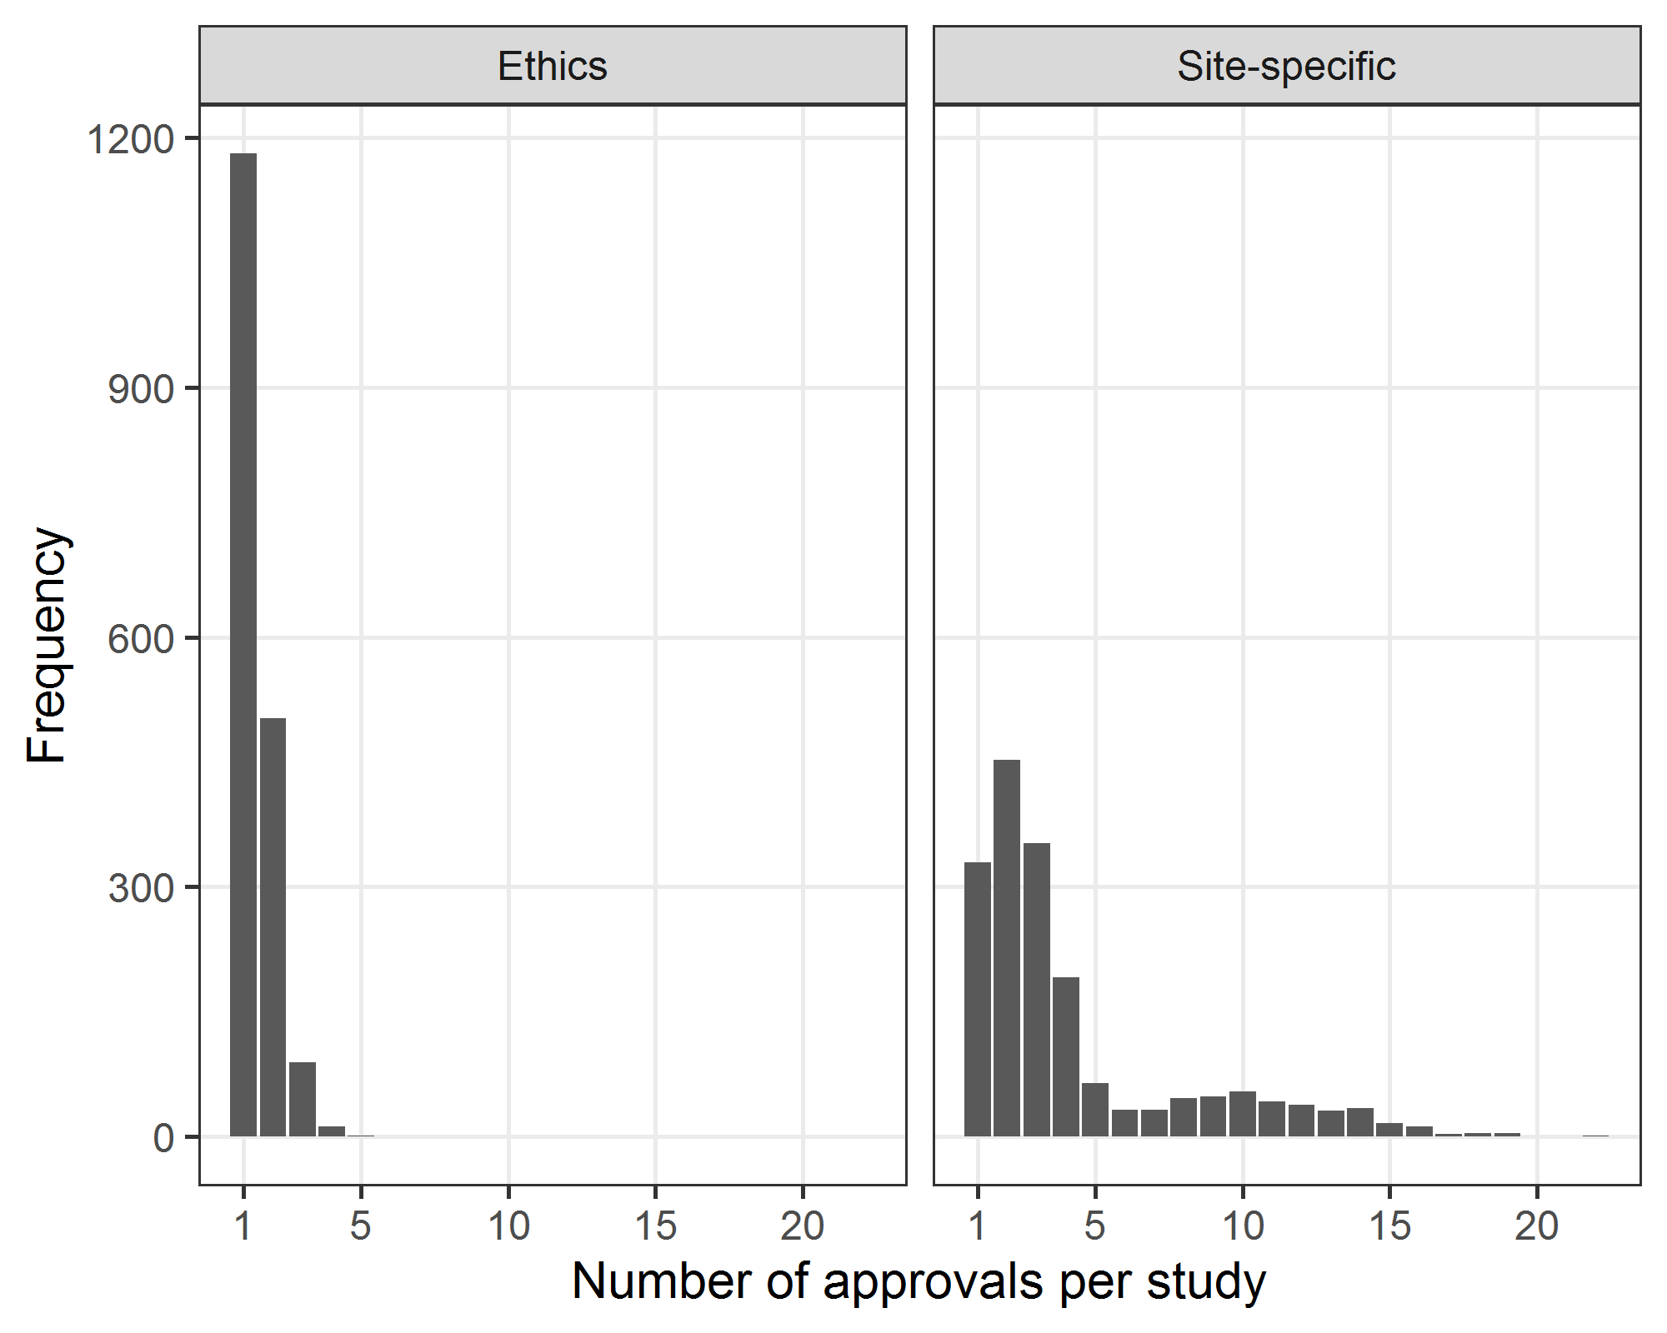

## 1.3 Time spent per approval in the current ethics/SSA system

For the times per approval, we use data from Barnett et al (2016) and Duplancic et al (2019) from their studies that required an ethics and site-specific approval. We simulate times from these studies using an empirical distribution. The observed times for ethics and SSA are shown below, each bar is an individual HREC or site.

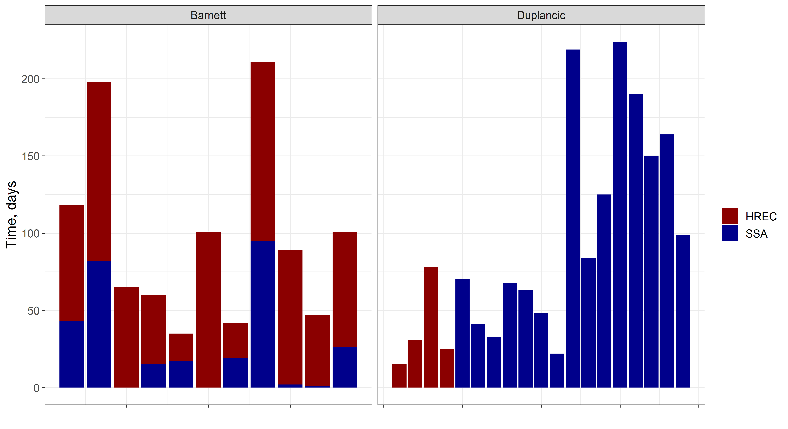

## 1.4 Simulated approval times in the current ethics/SSA system

The plot below shows the simulated times in days for studies to get ethics and SSA approval. The dotted vertical line is at six months. The approval times are calculated using the longest HREC and longest SSA per study.

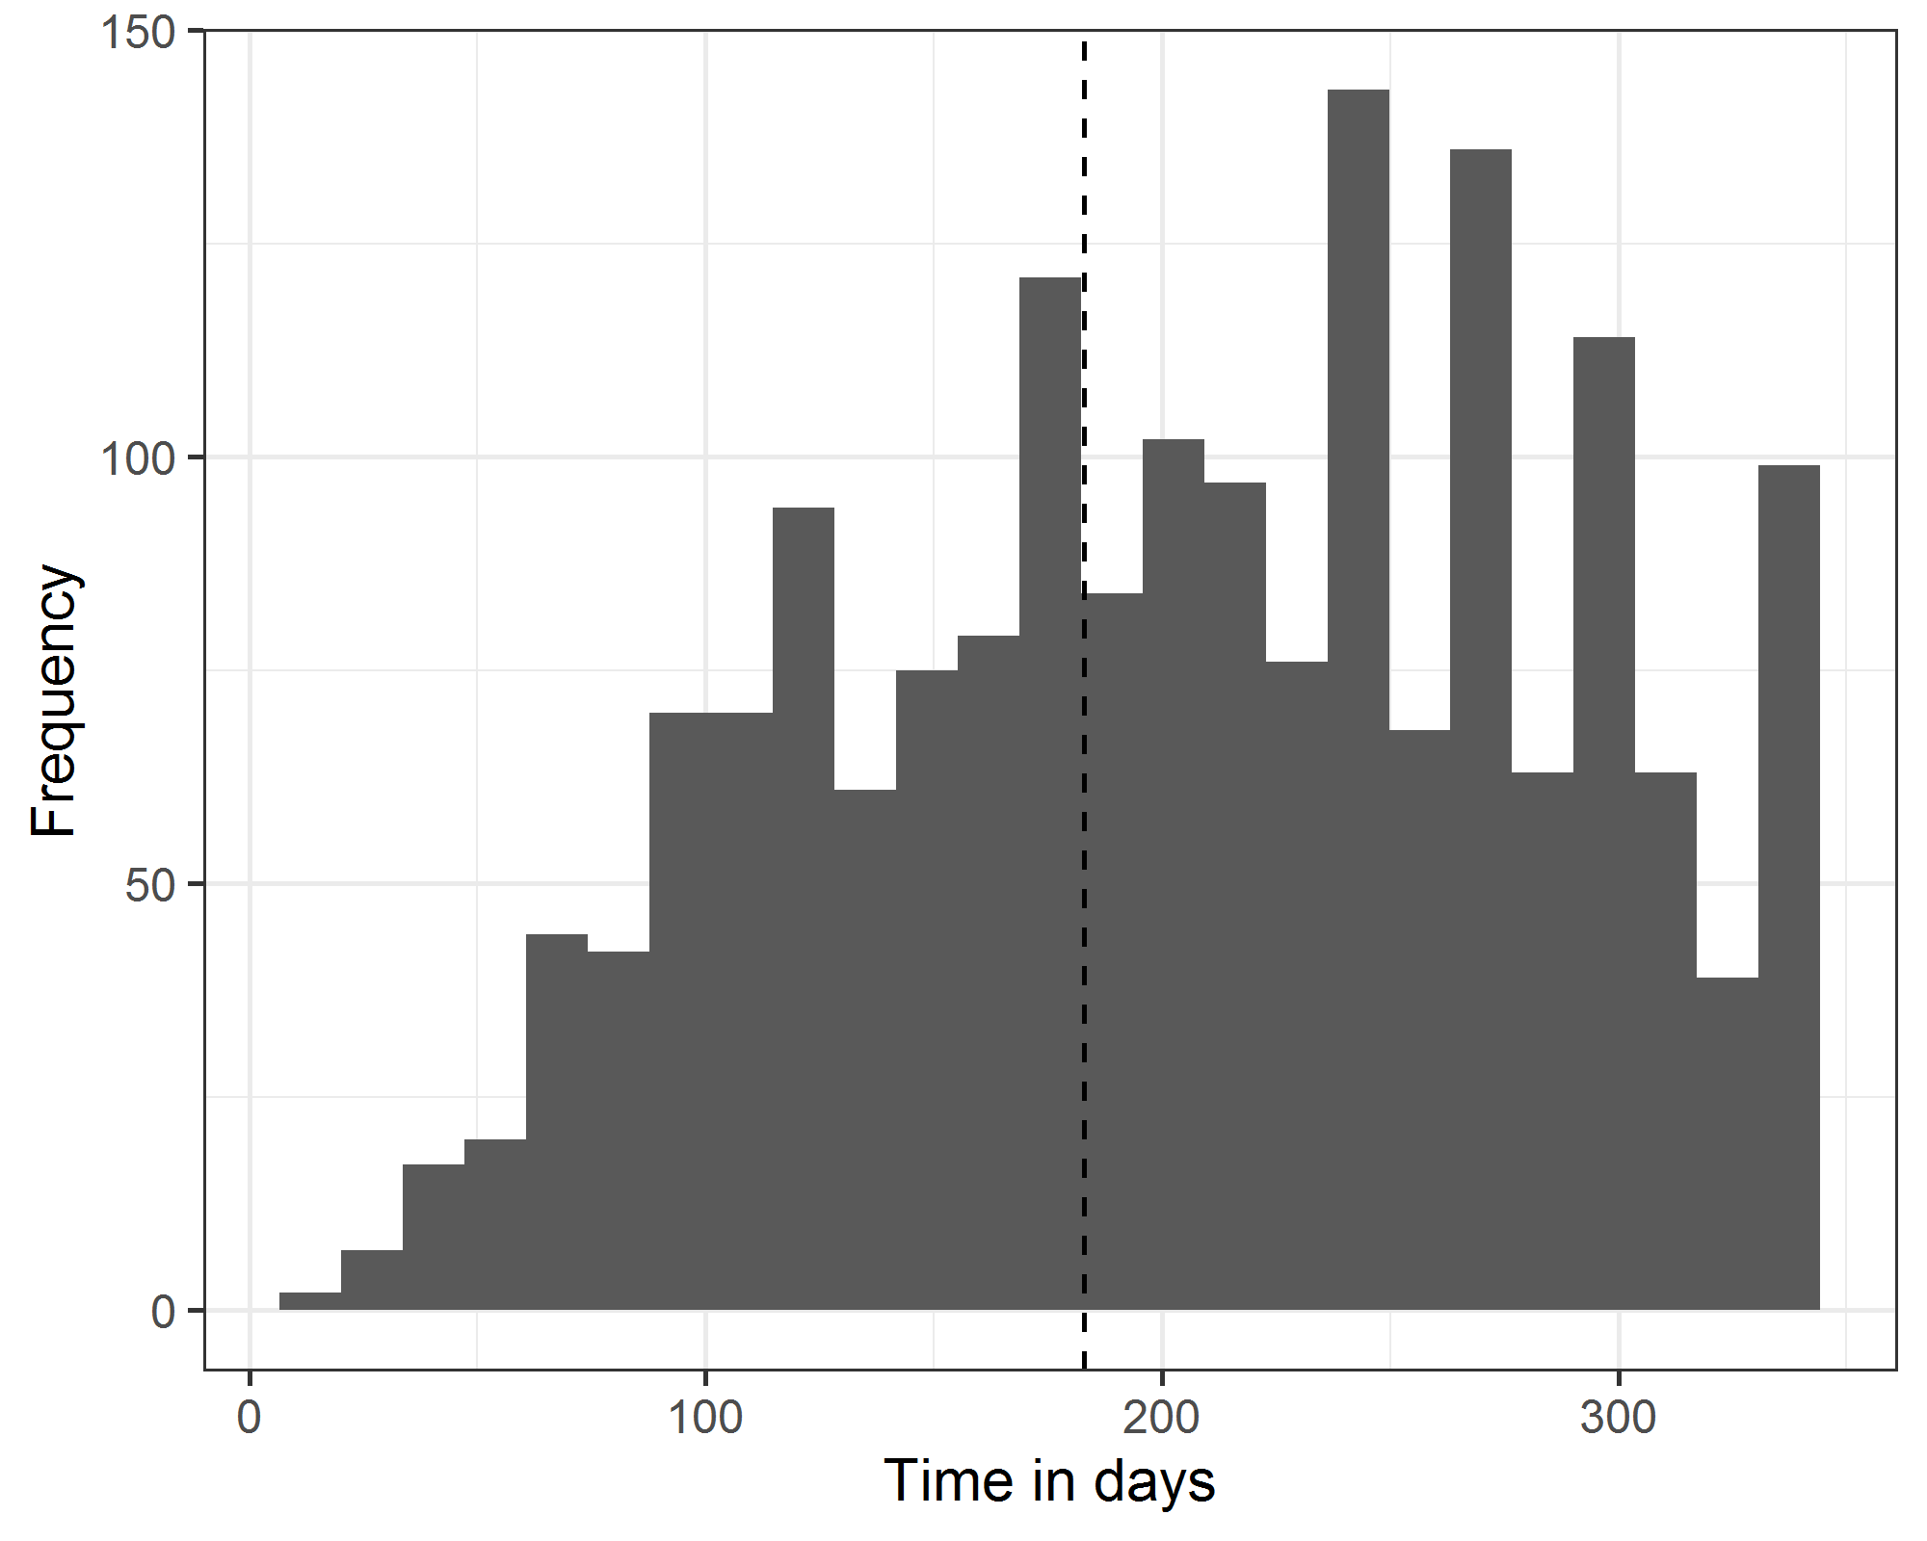

## 1.5 Time in the simplified ethics/SSA system

In the simplified system we assume all applications take no longer than six months, which is based on the system proposed by Clay-Williams et al (2019). Hence we expect the tail of the distribution to be at six months as per the plot below. This is the same distribution as above squeezed into a shorter span.

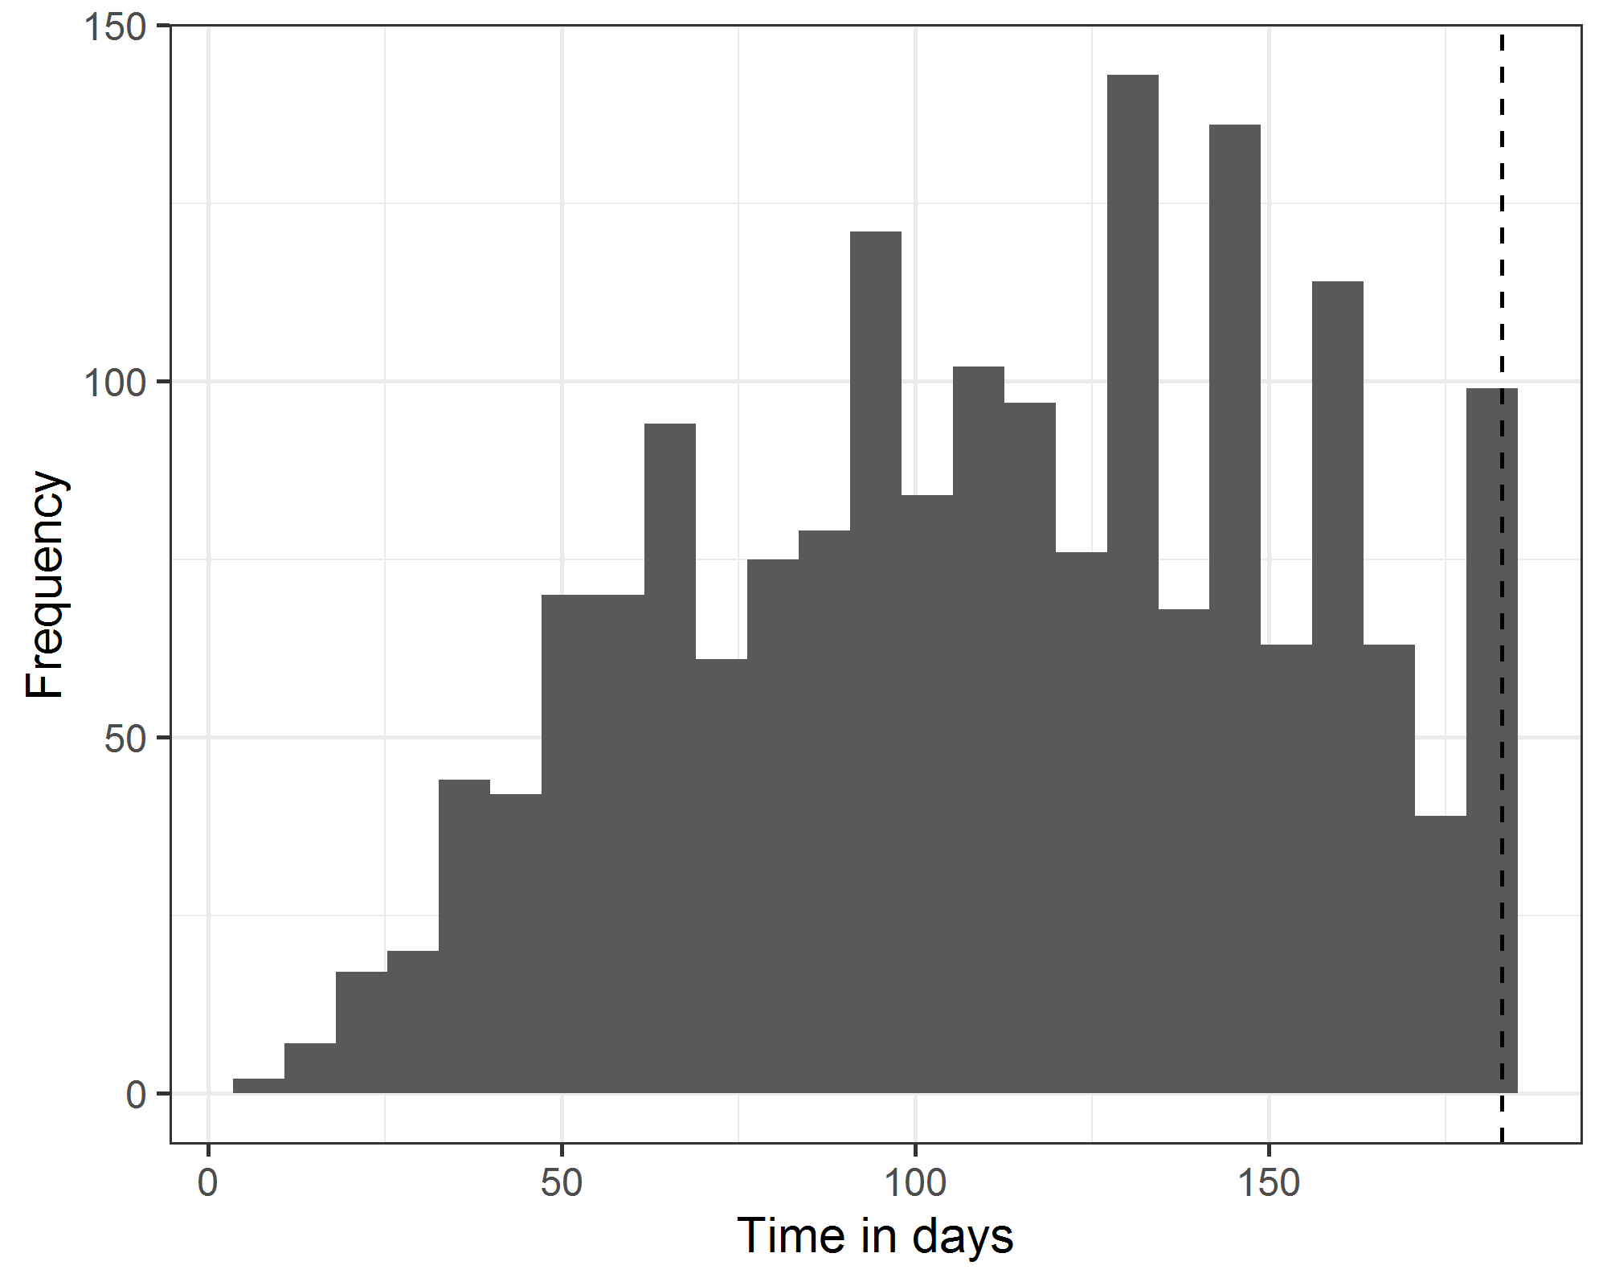

## 1.6 Total time and potential time saved in the ethics/SSA system

The estimated total time spent in the current system is 1,004 years. The estimated total time spent in the streamlined system is 463 years. The number of years that could be saved is 541 years.

If we apply a full-time researchers assistant’s time at an annual salary of $56,000, then we have a salary cost of $30 million per year.

# 2. Low and negligible risk proposals

Here were examine the potential savings for using an US-style self-certification system in place of the current low and negligible risks system.

We estimate the national number of low and negligible risk proposals in two ways.

1. By multiplying the national number of HREC applications (18,039) by the proportion of low and negligible risk applications from QUT’s HREC (0.73). This gives a total national number of low and negligible risk applications of 13,207.
2. Using Pubmed, the proportional of journal articles contributed by QUT in 2018 of the total number of articles with Australian affiliations is 0.032. Using the inverse of this proportion applied to the number of low risk ethics applications at QUT in 2018 gives an estimated national number of 15,285.

Averaging the two estimates gives a national estimate of 14,246.

## 2.1 Simulating the current approval times for low and negligible risk proposals

We simulate the current times spent by researchers on low and negligible risk proposals using the empirical data on ethics proposals from the Barnett and Duplancic studies.

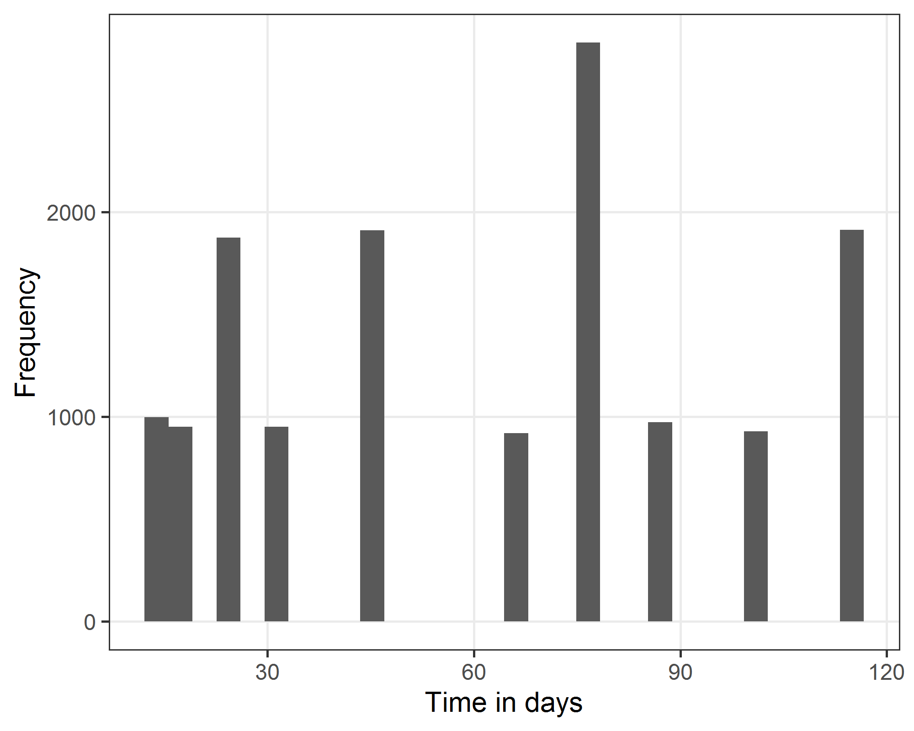

The median time is 65 days, and the inter-quartile range is 25 to 87 days.

## 2.2 Time in the low and negligible risk proposals

We assume that a self-certification system would take researchers 2 days per proposal.

The estimated total time spent in the current system is 2,378 years. The estimated total time spent in the streamlined system is 78 years. The number of years that could be saved is 2,300 years.

If we apply a full-time researchers assistant’s time at an annual salary of $56,000, then we have a salary cost of $129 million per year.

# References

* Duplancic, C. , Crough, T. and Bell, S. C (2019) Multi‐centre ethics and research governance review can impede non‐interventional clinical research. *Intern Med J*, **49**: 722-728. <doi:10.1111/imj.14158>
* Robyn Clay-Williams, Natalie Taylor and Jeffrey Braithwaite (2019) Potential solutions to improve the governance of multicentre health services research. *Med J Aust* **208** (4). <doi:10.5694/mja16.01268>
* National Health and Medical Research Council. Report on the Activity of Human Research Ethics Committees and Certified Institutions for the period: 1 January 2016 to 31 December 2016
* Adrian G. Barnett, Megan J. Campbell, Carla Shield, Alison Farrington, Lisa Hall, Katie Page, Anne Gardner, Brett G. Mitchell & Nicholas Graves (2016) The high costs of getting ethical and site-specific approvals for multi-centre research. *Research Integrity and Peer Review* **1** 16