Results for the census of statisticians on ethics committees

Adrian Barnett

16 January, 2025

# Broken and incorrect links

There were many hyper links in the sampling frame that were broken or did not resolve to HREC’s web page.

| **Link resolved** | **n** | **percent** |
| --- | --- | --- |
| no | 40 | 21 |
| yes | 147 | 79 |

# CONSORT flow chart

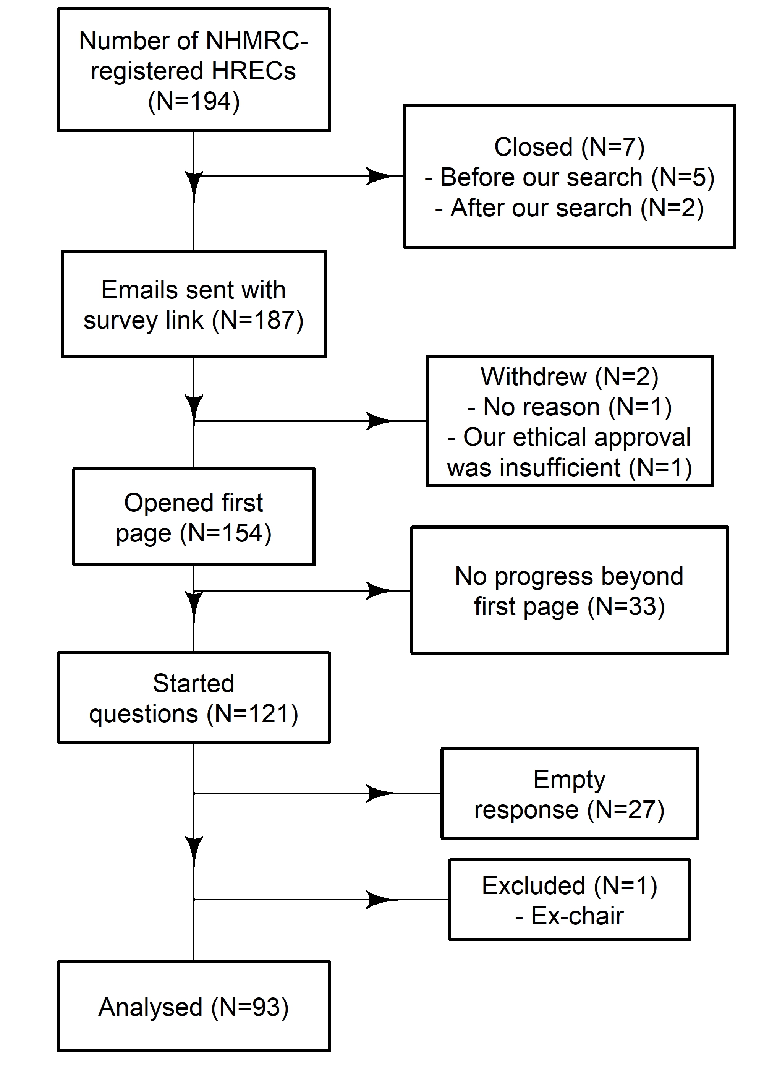

The diagram shows the progress from the sampling frame to the number analysed.

# Recruitment

Plot of recruitment over time.

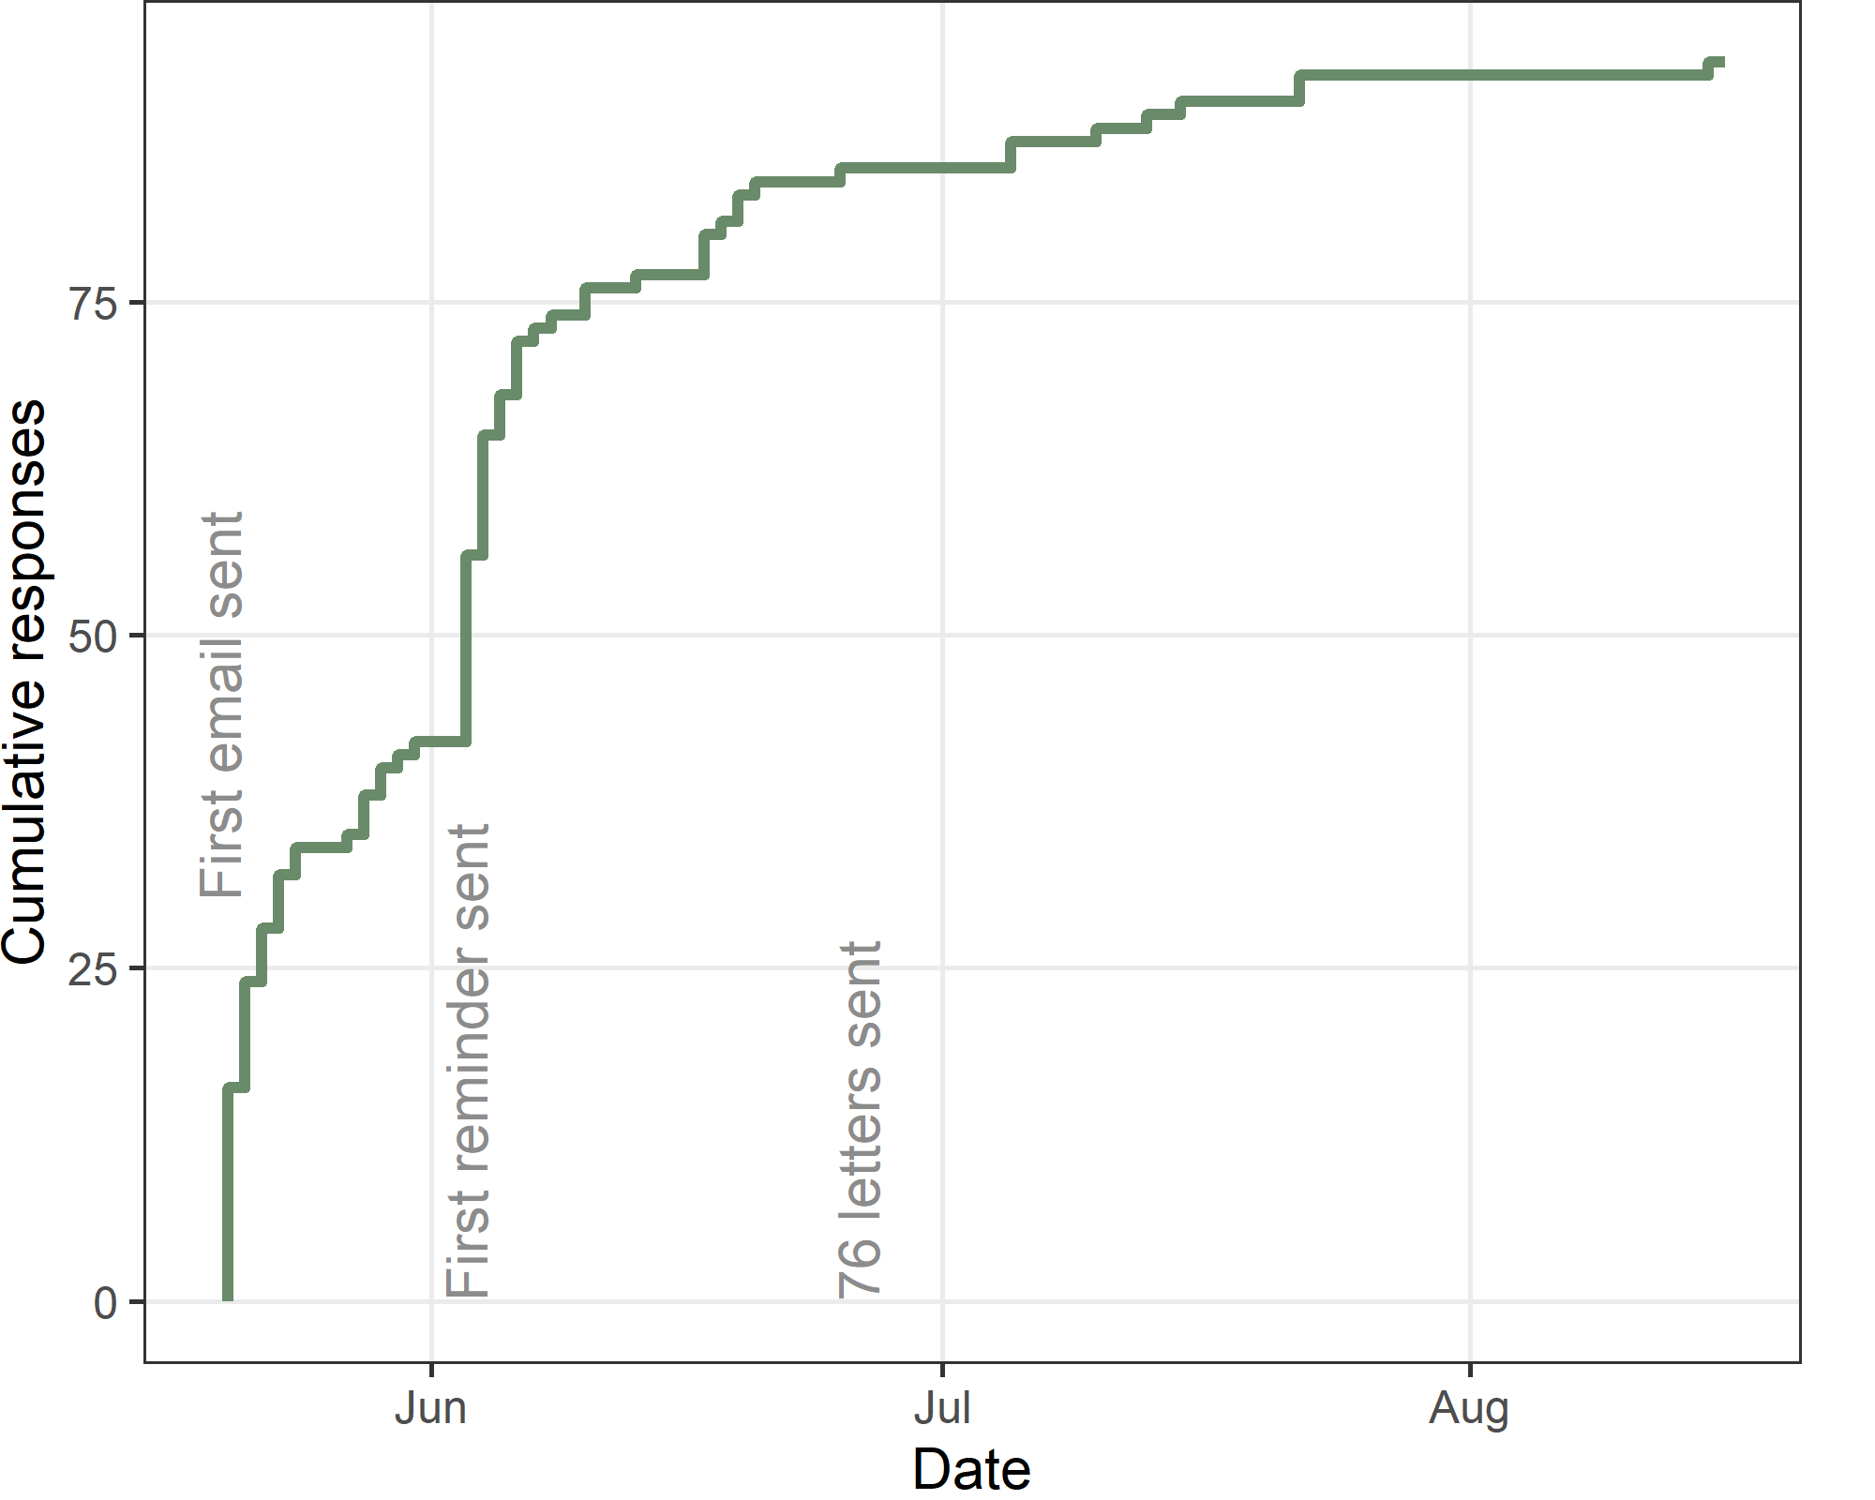

The total number recruited is 93. The first participant was recruited on 20 May 2024 and the last on 15 Aug 2024, which is 88 days.

There were 0 respondents who did not consent to participate according to the yes/no consent question in the form.

The total number of questionnaires sent was 187 so the response rate is 50%.

# Meta-data on questions

## Time taken to answer questions

| **Q10** | **Q25** | **median** | **Q75** | **Q90** |
| --- | --- | --- | --- | --- |
| 4 | 11 | 32 | 1,689 | 22,726 |

These results are only for those who answered some of the questions and exclude the “click through” respondents. The summary statistics show the time in minutes to complete the online questions. Q[x] is the *x*th percentile.

The very long times are almost certainly due to respondents leaving the browser window open and returning to complete the questionnaire. This is possibly because they had to gather further information.

## Questionnaire progress as a percent

The table below shows the questionnaire progress as a percent, with the results grouped into four categories.

| **Progress %** | **n** | **percent** |
| --- | --- | --- |
| (-0.001,5] | 0 | 0 |
| (5,50] | 4 | 4 |
| (50,75] | 2 | 2 |
| (75,100] | 87 | 94 |

Most respondents completed most of the questions.

# Questions

### What is your current role(s) on the committee?

Respondents could tick multiple boxes.

| **Role** | **n (%)** |
| --- | --- |
| Chair | 62 (67%) |
| Coordinator or Officer | 23 (25%) |
| Other | 4 (4%) |
| Full member | 2 (2%) |
| Co-chair | 2 (2%) |
| Deputy chair or Associate chair | 2 (2%) |
| Statistician | 1 (1%) |
| Lay person | 1 (1%) |
| Lawyer | 0 (0%) |
| No answer | 0 (0%) |

The percent for “No answer” is for all participants who could have answered the question. The other percents use a denominator of respondents who gave at least one answer.

### How many full members are on the current committee including the chair?

| **n** | **missing** | **Q1** | **Median** | **Q3** |
| --- | --- | --- | --- | --- |
| 89 | 4 | 12 | 14 | 21 |

The summary statistics above are the median and first to third quartile. n is the number answered.

#### Barplot of committee size

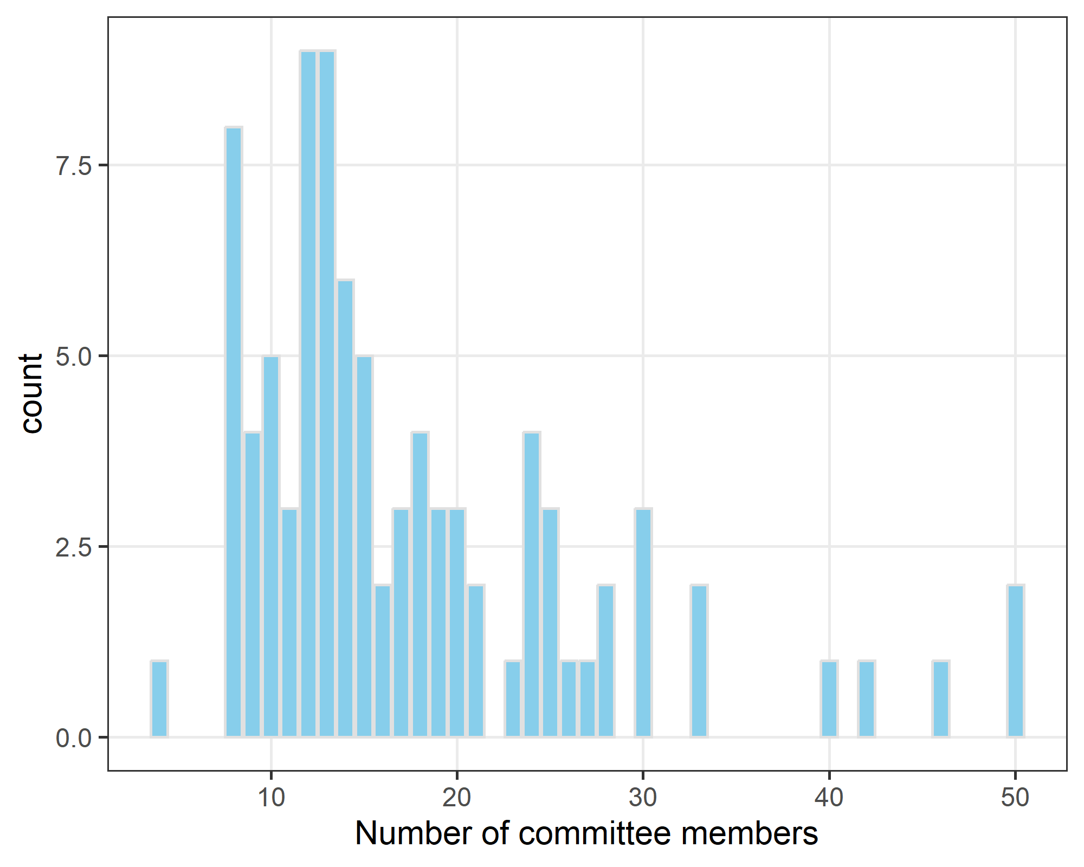

Australian HREC committees have a minimum of 8 members.

## Application numbers

The next set of questions examine the number of applications the committee considered in one year (2023). We are only interested in applications that included quantitative data and/or analysis. Our aim is to estimate the total number of applications considered across Australia in one year, hence we also impute the numbers for committees that did not respond to our questionnaire.

There were two different options for answering the question.

### Option 1: How many applications did the committee consider in 2023 that included quantitative data and/or analysis? Give your best estimate, and a lower and upper range if you are uncertain.

| **Applications with data and/or analysis** | **n** | **missing** | **Q1** | **Median** | **Q3** |
| --- | --- | --- | --- | --- | --- |
| Mean | 62 | 31 | 12 | 42 | 75 |
| Lower | 24 | 69 | 10 | 40 | 81 |
| Upper | 24 | 69 | 18 | 55 | 101 |

This is the total number of applications with data and/or analysis and the optional lower and upper range. The summary statistics show the median and first to third quartile.

#### Results where the mean number was outside the lower to upper range

| **id** | **lower** | **mean** | **upper** |
| --- | --- | --- | --- |

The above table is a check that respondents understood the purpose of the lower and upper range. As there are no rows in the table, it appears that respondents understood the question.

### How many respondents included some uncertainty for option 1

| **Some uncertainty** | **n** | **percent** |
| --- | --- | --- |
| No | 39 | 63 |
| Yes | 23 | 37 |

### Option 2 part a: How many applications did the committee consider in 2023?

| **n** | **missing** | **Q1** | **Median** | **Q3** |
| --- | --- | --- | --- | --- |
| 56 | 37 | 25 | 56 | 122 |

This is the total number of applications and the optional lower and upper range.

### Option 2 part b: What percentage of these applications included quantitative data and/or analysis? Give your best estimate, and a lower and upper range if you are uncertain.

| **Percent with data and/or analysis** | **n** | **missing** | **Q1** | **Median** | **Q3** |
| --- | --- | --- | --- | --- | --- |
| Mean | 48 | 45 | 33 | 60 | 78 |
| Lower | 17 | 76 | 40 | 50 | 60 |
| Upper | 16 | 77 | 60 | 70 | 84 |

#### Results where the mean percentage was outside the lower to upper range

| **id** | **lower** | **mean** | **upper** |
| --- | --- | --- | --- |

The above table is a check that respondents understood the purpose of the lower and upper range.

### How many respondents included some uncertainty for option 2

| **Some uncertainty** | **n** | **percent** |
| --- | --- | --- |
| No | 33 | 69 |
| Yes | 15 | 31 |

### Total number of applications

We combined the results from options 1 and 2 to give an overall estimate of the total number of applications and the uncertainty. We imputed the results for HRECs who did not respond to give a national estimate.

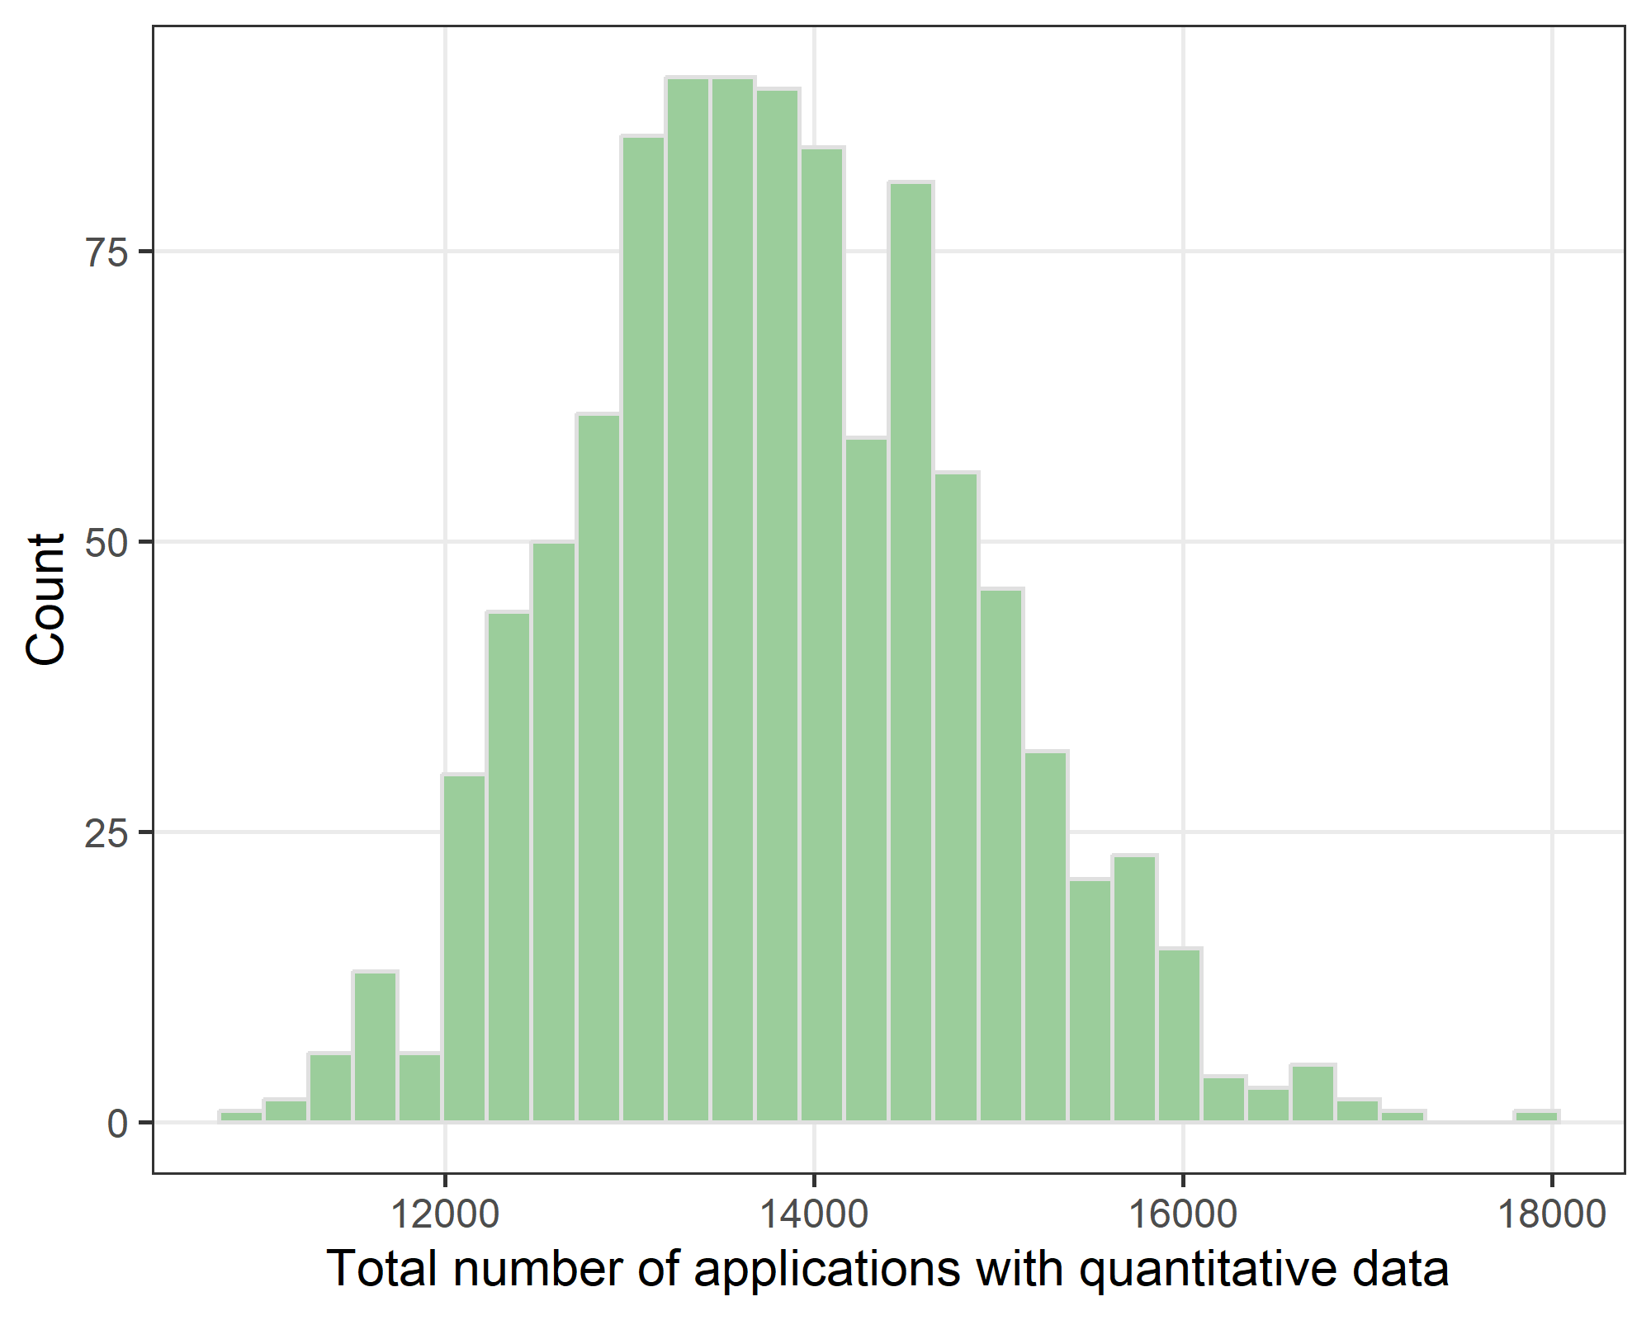

We estimated the number of annual applications with quantitative data and/or analysis using a bootstrap approach using 1000 samples. This allowed us to model the uncertainty in respondents’ answers. We used a triangular distribution based on the respondents’ lower and upper limits and mean.

The mean number of applications is 13,794 with a 95% confidence interval from 11,886 to 15,968.

### Does the committee currently have a statistician

| **Question** | **Response** | **n (%)** | **95% CI** |
| --- | --- | --- | --- |
| Either a full member or who can be consulted | No | 31 (33%) | 29 to 38 |
| Yes | 56 (60%) | 55 to 65 |
|  | 6 (6%) | 4 to 9 |
| As a full member of the committee? | No | 52 (56%) | 51 to 61 |
| Yes | 31 (33%) | 29 to 38 |
|  | 10 (11%) | 8 to 14 |
| As a non-member but who can be consulted on statistical issues? | No | 39 (42%) | 37 to 47 |
| Yes | 33 (35%) | 31 to 40 |
|  | 21 (23%) | 19 to 27 |

The above table shows the frequencies of the two key questions on statisticians. The empty responses are missing.

We used bootstrap confidence intervals to estimate the percentages accounting for non-response using 10,000 bootstrap resamples.

The main outcome is the number and percentage of statisticians who are full committee members.

### Accounting for statistical qualifications

| **Question** | **Response** | **n (%)** | **95% CI** |
| --- | --- | --- | --- |
| Either a full member or who can be consulted | No | 54 (58%) | 53 to 63 |
| Yes | 33 (35%) | 31 to 40 |
|  | 6 (6%) | 4 to 9 |
| As a qualified full member of the committee? | No | 60 (65%) | 59 to 69 |
| Yes | 23 (25%) | 20 to 29 |
|  | 10 (11%) | 8 to 14 |
| As a qualified non-member but who can be consulted on statistical issues? | No | 57 (61%) | 56 to 66 |
| Yes | 15 (16%) | 12 to 20 |
|  | 21 (23%) | 19 to 27 |

This table is as per the previous table but after accounting for where the respondents provided the statistician’s qualifications. So to be classed as “Yes” the respondents had to respond “Yes” to the question and also provide some statistical qualifications.

Our secondary outcome is access to statistical expertise (either as a full member or non-member) from a qualified statistician.

### What are the statistician’s qualifications in statistics?

Only for those who answered that they have a statistician on the committee or have access to one.

Respondents could tick multiple boxes.

| **Role** | **n (%)** |
| --- | --- |
| PhD Statistics | 18 (35%) |
| Don`t know | 12 (23%) |
| BSc Statistics | 9 (17%) |
| MBiostat | 8 (15%) |
| Other | 8 (15%) |
| Accredited statistician | 7 (13%) |
| MSc Statistics | 5 (10%) |
| No formal qualifications | 3 (6%) |
| Diploma Statistics | 0 (0%) |
| No answer | 4 (7%) |

The percent for “No answer” is for all participants who could have answered the question. The other percents use a denominator of respondents who gave at least one answer.

### Are they currently employed as a statistician?

| **Response** | **n** | **percent** | **valid_percent** |
| --- | --- | --- | --- |
| Yes, full-time | 23 | 41 | 0.43396226 |
| No | 10 | 18 | 0.18867925 |
| Other | 10 | 18 | 0.18867925 |
| Yes, part-time | 8 | 14 | 0.15094340 |
|  | 3 | 5 |  |
| Retired statistician | 2 | 4 | 0.03773585 |

### How do you decide when to consult the statistician?

Only for respondents who answered that they have access to a statistician.

| **Response** | **n** | **percent** |
| --- | --- | --- |
| When the committee and/or chair feels unable to assess the statistical methods | 14 | 42 |
| Missing | 8 | 24 |
| Other, please specify | 7 | 21 |
| For selected applications that include quantitative data and/or analysis | 4 | 12 |

### When did your committee last have a statistician as a full member?

Only for respondents who answered that they do not have a statistician on the committee.

| **Response** | **n** | **percent** | **valid_percent** |
| --- | --- | --- | --- |
| Never had one | 35 | 67 | 0.83333333 |
| 0 to 1 years ago | 1 | 2 | 0.02380952 |
| 2 to 3 years ago | 1 | 2 | 0.02380952 |
| 3 or more years ago | 5 | 10 | 0.11904762 |
|  | 10 | 19 |  |

### How are statistical aspects of studies dealt with?

Only for respondents who answered that they do not have a statistician on the committee.

| **Response** | **n** | **percent** | **valid_percent** |
| --- | --- | --- | --- |
| Within committee | 17 | 33 | 0.3617021 |
| Applications are reviewed outside the committee by a qualified statistician | 5 | 10 | 0.1063830 |
| Applications are reviewed outside the committee by a methods review panel or scientific sub-committee | 6 | 12 | 0.1276596 |
| Researchers must consult a qualified statistician before submitting their application | 1 | 2 | 0.0212766 |
| Researchers are expected to consult a qualified statistician before submitting their application | 10 | 19 | 0.2127660 |
| Other | 8 | 15 | 0.1702128 |
|  | 5 | 10 |  |

### Why don’t you have a statistician on the committee?

Only for respondents who answered that they do not have a statistician on the committee.

Respondents could tick multiple boxes.

| **Reason** | **n (%)** |
| --- | --- |
| Other committee members are able to cover statistical questions | 20 (43%) |
| We have access to statistical expertise outside the committee | 18 (38%) |
| Only need occasional statistical expertise | 14 (30%) |
| Other | 10 (21%) |
| Statisticians` expertise is not necessary for the decision-making process | 7 (15%) |
| Cannot recruit one | 5 (11%) |
| No answer | 5 (10%) |

### Do you consider that the committee needs a statistician as a full member?

Only for respondents who answered that they do not have a statistician on the committee.

| **Response** | **n** | **percent** | **valid_percent** |
| --- | --- | --- | --- |
| No | 39 | 75 | 0.8125 |
| Yes | 9 | 17 | 0.1875 |
|  | 4 | 8 |  |

### National Statement wording

Only for respondents who answered that they do not consider that a committee needs a statistician.

| **Response** | **n** | **percent** | **valid_percent** |
| --- | --- | --- | --- |
| No | 32 | 82 | 0.88888889 |
| Don't know | 3 | 8 | 0.08333333 |
|  | 3 | 8 |  |
| Yes | 1 | 3 | 0.02777778 |

## How are statistical concerns handled?

Question wording: ``Consider a hypothetical application. If the statistician advised the committee that the proposed method of data collection and/or analysis were not appropriate to answer the research question(s) then what actions are taken.’’

#### The statistician’s concerns are discussed amongst the committee

| **Response** | **n** | **percent** | **valid_percent** |
| --- | --- | --- | --- |
| Always | 47 | 84 | 0.88679245 |
| Usually | 3 | 5 | 0.05660377 |
| Sometimes | 2 | 4 | 0.03773585 |
| Rarely | 1 | 2 | 0.01886792 |
|  | 3 | 5 |  |

#### The application is sent back to the researchers and they are asked to address the statistician’s concerns

| **Response** | **n** | **percent** | **valid_percent** |
| --- | --- | --- | --- |
| Always | 40 | 71 | 0.75471698 |
| Usually | 7 | 12 | 0.13207547 |
| Sometimes | 5 | 9 | 0.09433962 |
| Never | 1 | 2 | 0.01886792 |
|  | 3 | 5 |  |

#### Summary plot

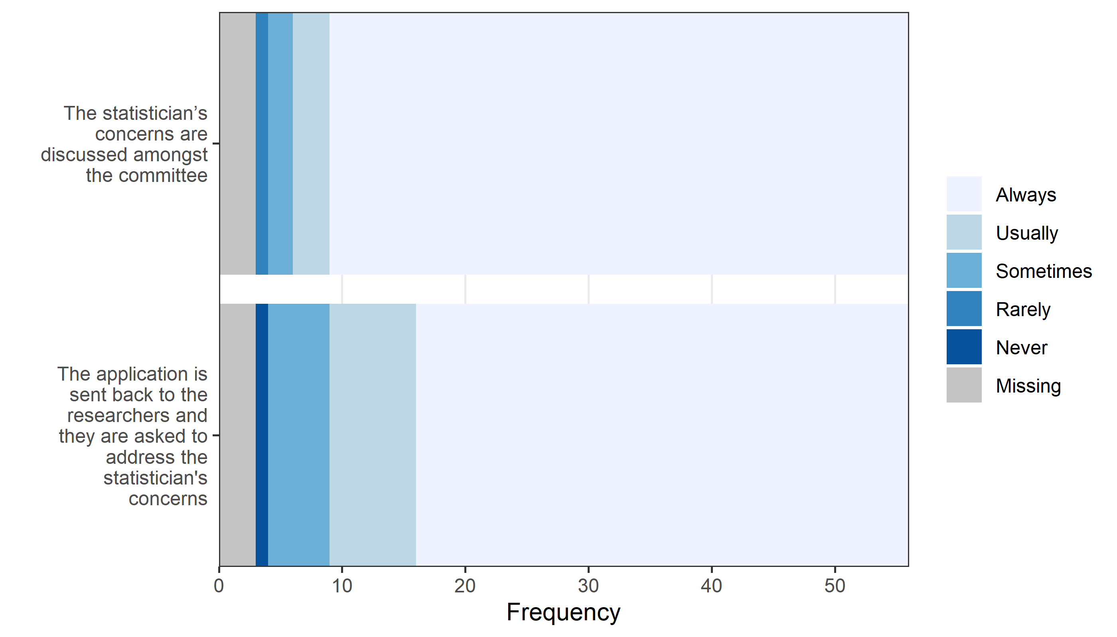

## Committees with access to a statistician

Here we estimate the number and percentage of committees that have access to a qualified statistician. This is those committees with a statistician as a member, or where there is a statistician as a non-member who can be consulted. For both cases, we verified that the statistician had qualifications in statistics. The unknown response is where these questions were not answered.

| **Access to statistician** | **n** | **percent** |
| --- | --- | --- |
| No | 54 | 58 |
| Unknown | 6 | 6 |
| Yes | 33 | 35 |

### Estimated national application numbers by access to statistician

Here we stratify the estimated total number of applications according to whether the committee has access to a statistician. We only use applications that included quantitative data. We include the uncertainty due to: the ranges provided by the respondents, the results from committees that did not respond. The estimates are national annual totals and are the mean and a 90% bootstrap interval.

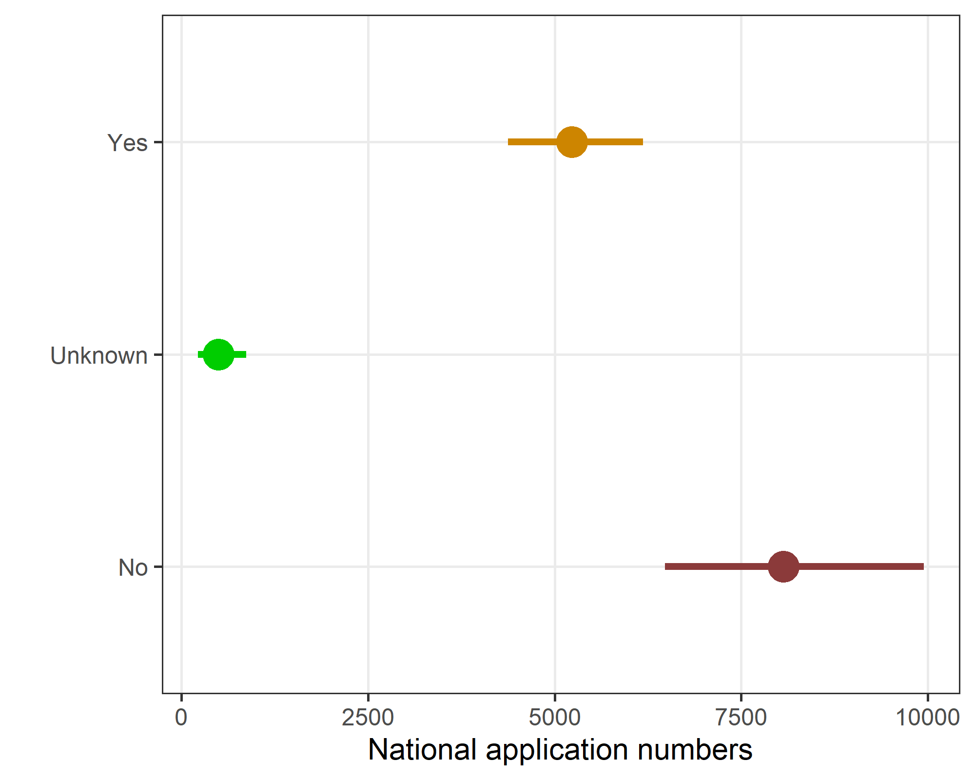

##### Table of the plotted data

| any_adequate | mean | lower | upper |
| --- | --- | --- | --- |
| No | 8,064 | 6,481 | 9,946 |
| Unknown | 496 | 219 | 868 |
| Yes | 5,233 | 4,377 | 6,186 |

Results show the mean and lower and upper limit from the bootstrap confidence interval.

# Item-missing data

The table below show item-missing data with panels that match the questionnaire logic. This avoids data being wrongly flagged as missing when the respondent never saw that question.

| **Question** | **Max response** | **Missing, n (%)** |
| --- | --- | --- |
| Option 2 part a: How many applications did the committee consider in 2023? | 93 | 37 (40) |
| Option 1: How many applications did the committee consider in 2023 that included quantitative data and/or analysis? | 93 | 31 (33) |
| Is there currently a qualified statistician: - As a non-member but who can be consulted on statistical issues? | 93 | 21 (23) |
| Is there currently a qualified statistician: - As a full member of the committee? | 93 | 10 (11) |
| How many full members are on the current committee including the chair? | 93 | 4 (4) |
| What is your current role(s) on the committee? | 93 | 0 (0) |
| Are they currently employed as a statistician? | 56 | 3 (5) |
| The statistician's concerns are discussed amongst the committee | 56 | 3 (5) |
| The application is sent back to the researchers and they are asked to address the statistician's concerns | 56 | 3 (5) |
| What are the statistician’s qualifications in statistics? | 56 | 0 (0) |
| When did your committee last have a statistician as a full member? | 52 | 10 (19) |
| How are statistical aspects of studies dealt with? | 52 | 5 (10) |
| Do you consider that the committee needs a statistician as a full member? | 52 | 4 (8) |
| Why don't you have a statistician on the committee? | 52 | 0 (0) |
| Does this change in wording alter your opinion about having a qualified statistician member of the committee? | 39 | 3 (8) |
| How do you decide when to consult the statistician? | 33 | 8 (24) |