A census of Australian Research integrity advisors: results

Adrian Barnett

17 April 2023

## Flow diagram

The diagram below shows how we first approached institutions and then advisors.

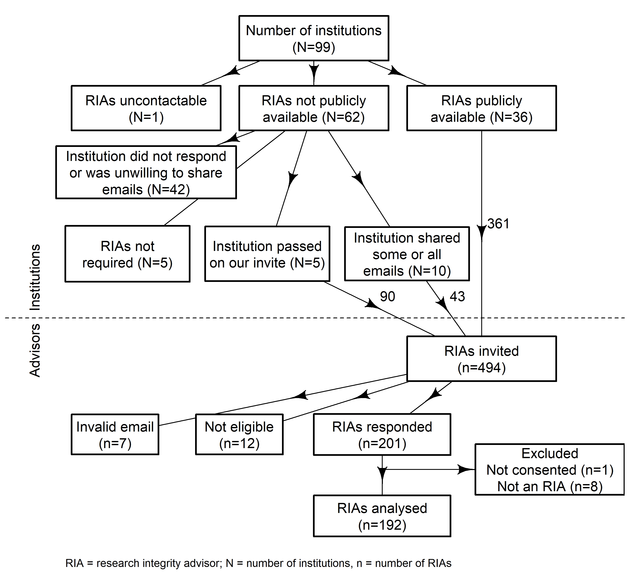

Most institutions (N = 63) did not make the contact details of their Research Integrity Advisors publicly available. One institution had a separate approvals process for conducting research, and we were not able to complete this process.

## Number of research integrity advisors

The bar plot below shows the number of advisors from the 61 institutions where this information was publicly available or that provided it on request. The modal number of advisors was 1, the median was 6 and the maximum 42. The first to third quartile was 3 to 10. The between-institution variation in advisor numbers is large.

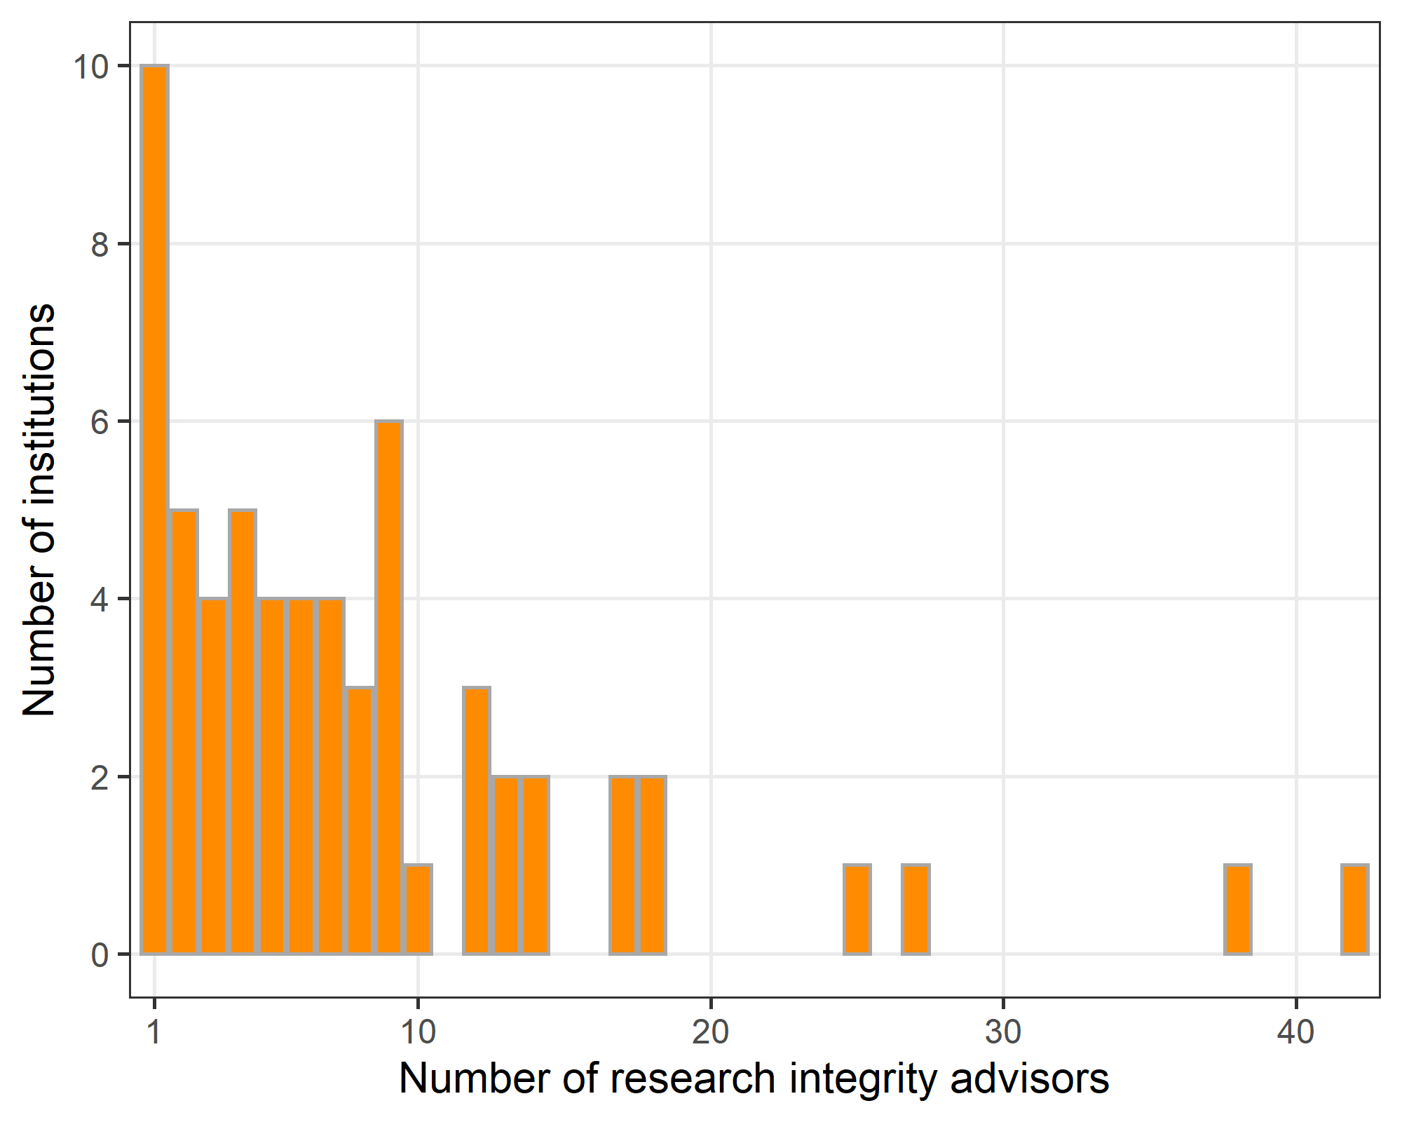

We used a bootstrap approach to estimate the total national number of advisors and the uncertainty in this estimate. We randomly imputed the number of RIAs for the 29 institutions where we did not know the number of advisors, based on the observed numbers shown above. We then calculated the total number of advisors using the observed and imputed numbers. We repeated this imputation and calculation 1,000 times. The plot below shows the 1,000 bootstrap estimates of the national total.

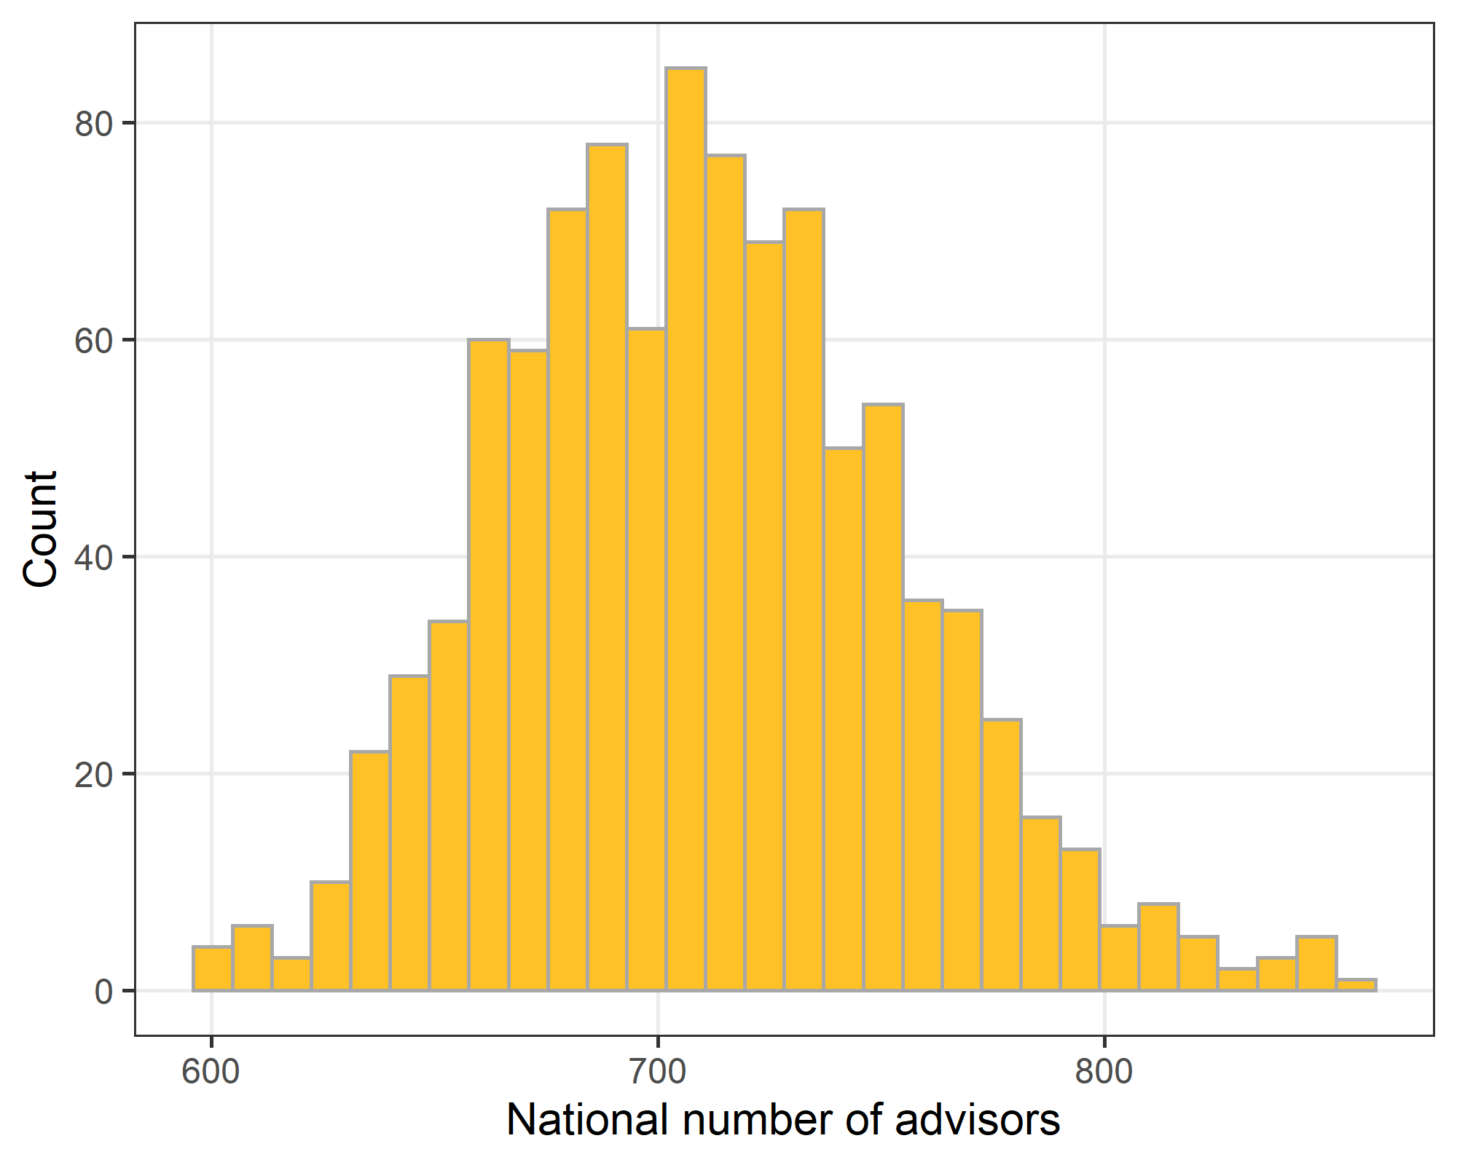

The estimated median number of national advisors is 709 with 1st quartile of 678 and 3rd quartile of 740. A 95% bootstrap interval is 632 to 806.

## Questionnaire

The total number of responses was 201. The overall response percentage was 41% with 201 responses from 494 emails. The response percentage from the direct invite from our team was 46%, whereas the response percentage from the five institutions that passed on our invite was much lower at 17%.

Text *in italics* below is the wording used in the questionnaire.

## *I consent to participate.*

| **Response** | **n (%)** |
| --- | --- |
| No | 1 (0) |
| Yes | 200 (100) |

The results below exclude the participant who did not consent.

## *I am a current Research Integrity Advisor and/or was a Research Integrity Advisor this time last year.*

| **Response** | **n (%)** |
| --- | --- |
| No | 8 (4) |
| Yes, I am a current or recent Research Integrity Advisor | 190 (96) |

The results below exclude the participants who were not research integrity advisors.

## *When did you role as a Research Integrity Advisor start?*

Respondents were asked to give their start year and date. There were 5 missing responses. The earliest year in the questionnaire was 2016, but this was an error as the policy started before then. A number of respondents gave their starting year as an optional comment.

| **Median (1st to 3rd quartile)** |
| --- |
| 2019.4 (2018.1 to 2021.4) |

### Histogram of start date

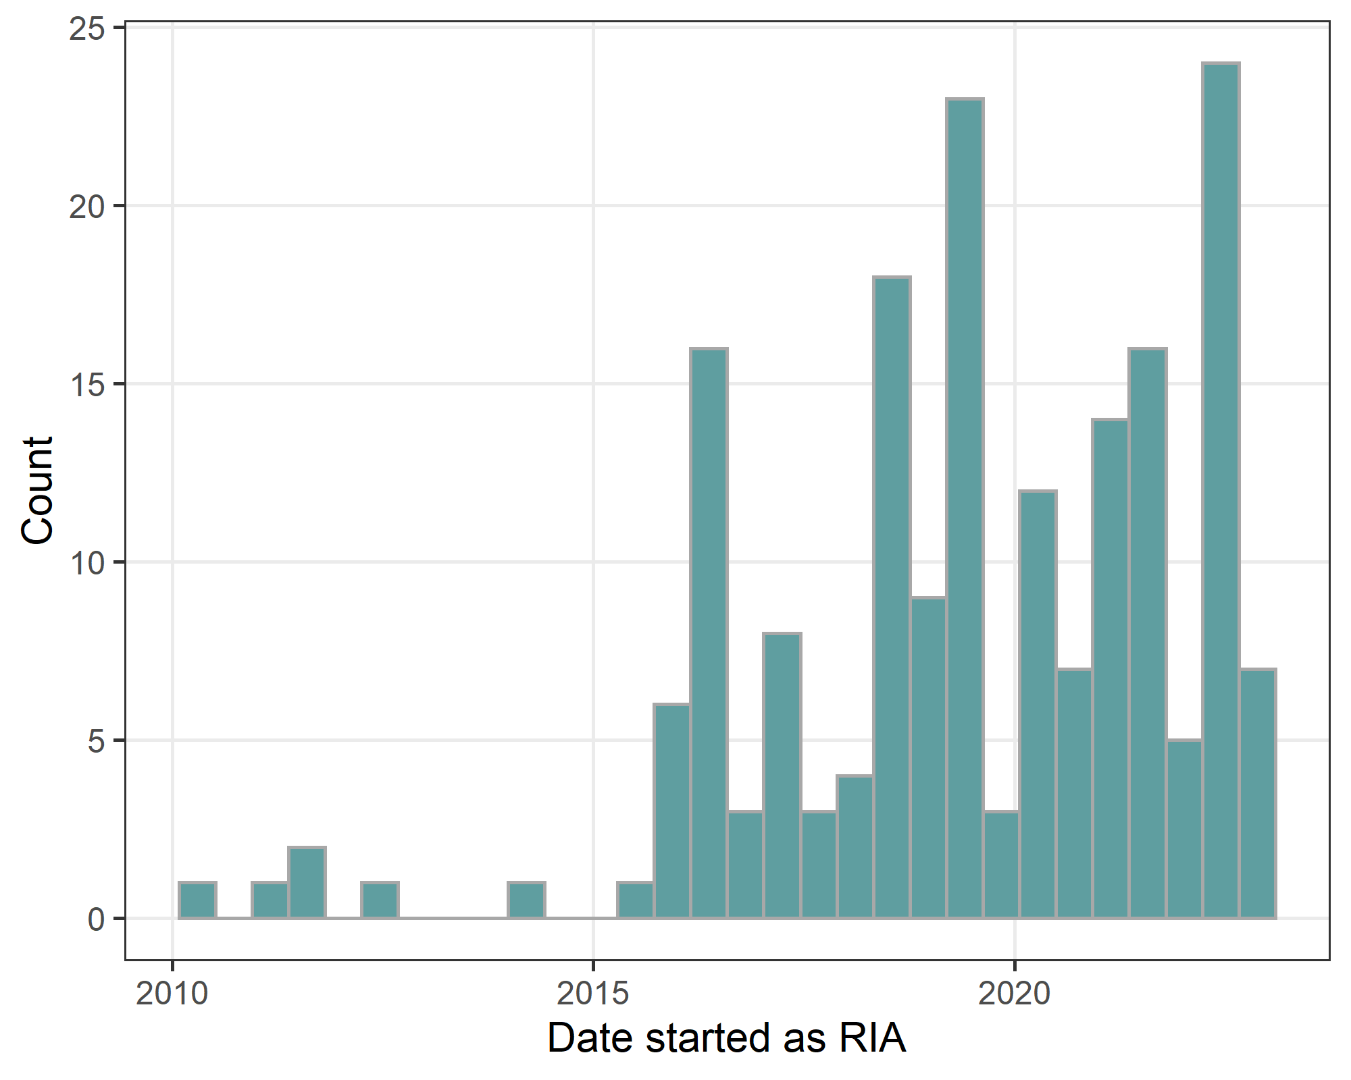

## *Are you still a Research Integrity Advisor?*

| **Response** | **n (%)** |
| --- | --- |
| Missing | 3 (2) |
| No | 17 (9) |
| Yes | 170 (89) |

## Number of years in role

| **Median (1st to 3rd quartile)** |
| --- |
| 4 (2 to 5) |

#### Boxplot

The results are split by those who have left the role and those ongoing.

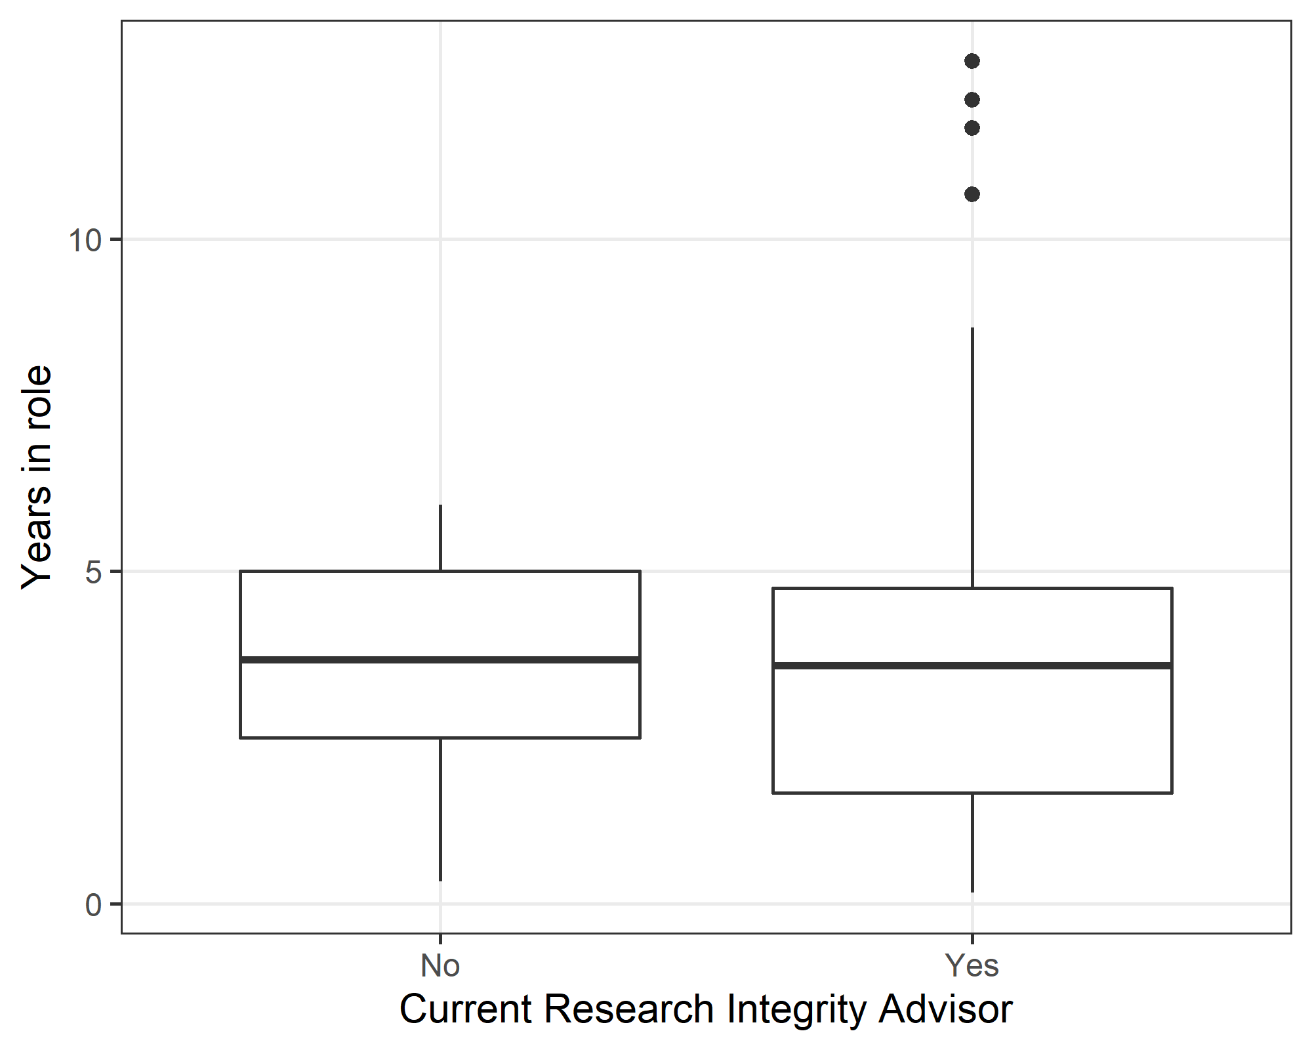

# Training and workload

## *Have you received training for your role as a Research Integrity Advisor?*

### Initial training when starting the role

| **Response** | **n (%)** |
| --- | --- |
| No | 38 (21) |
| Yes | 144 (79) |

### Ongoing training during the role

| **Response** | **n (%)** |
| --- | --- |
| No | 55 (31) |
| Yes | 122 (69) |

### Cross-tabulation of initial and ongoing training

|  | **Ongoing training** | | |
| --- | --- | --- | --- |
| **Initial training** | **No** | **Yes** | **Missing** |
| No | 25 (13%) | 13 (7%) | 0 (0%) |
| Yes | 30 (16%) | 108 (57%) | 6 (3%) |
| Missing | 0 (0%) | 1 (1%) | 7 (4%) |

Thirteen percent of respondents did not receive initial or ongoing training.

## *In your opinion, has the amount of training for your role as a Research Integrity Advisory been …*

| **Response** | **n (%)** |
| --- | --- |
| Too little | 52 (29) |
| About right | 128 (70) |
| Too much | 2 (1) |

## *How much time have you spent in your role as a Research Integrity Advisor? Include the time spent providing advice, attending meetings, reading policies/guidelines, giving presentations and attending courses.*

| **Median (1st to 3rd quartile)** |
| --- |
| 0.5 (0.1 to 1.0) |

This is the number of days per month that the respondents work in their advisory role. We asked respondents to give an estimate of the average number of days per month spent giving advice. Respondents were also able to answer in terms of working days or full-time equivalent, and these estimates were converted to the monthly average.

#### Histogram

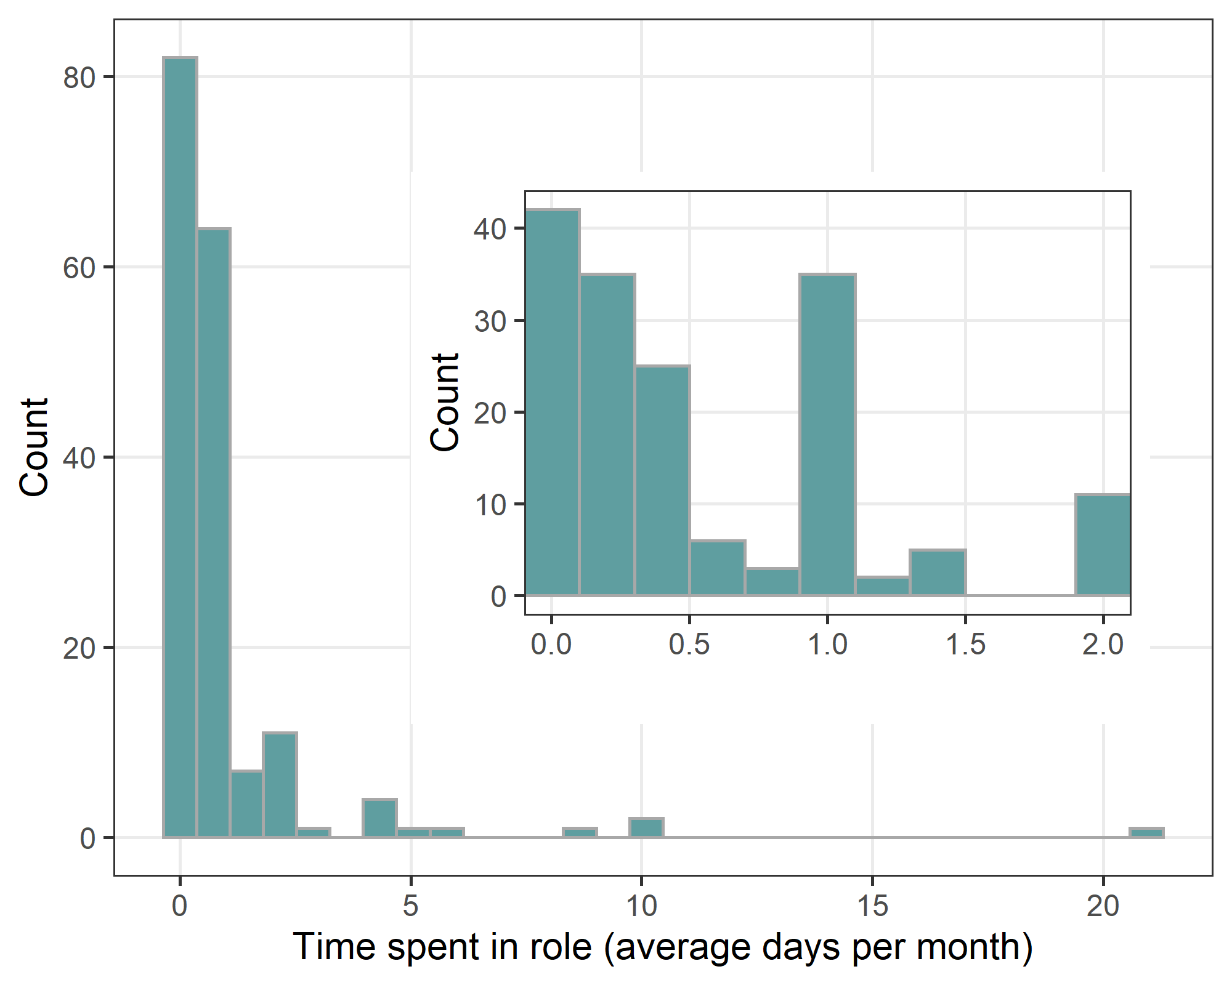

There was a strong positive skew in the time as a few respondents indicated that all or most of their time is spent as an advisor. To examine the majority of responses in more detail, we used an inset plot that was truncated at 2 days. The inset shows a relatively large number of responses of 1 day per month.

The number of advisors reporting no time was 8 (5%).

#### Average time

Here we estimate the average time spent in the role and account for uncertainty from non-responders and the uncertainty given by some respondents, e.g. “2 to 4 days”.

| **statistic** | **mean** | **lower** | **upper** |
| --- | --- | --- | --- |
| Mean | 1.0 | 0.9 | 1.2 |
| Median | 0.5 | 0.4 | 0.5 |
| None (%) | 4.0 | 2.7 | 5.5 |

The table shows the estimated mean and median with the uncertainty (lower to upper 95% confidence interval). The mean is relatively high compared to the median because of the large outliers. Both estimates are still a small amount of time. It also shows the estimated percent who have spent no time.

### Time spent in role - answer option

| **Response** | **n (%)** |
| --- | --- |
| Average per month | 66 (35) |
| Days | 100 (53) |
| FTE | 14 (7) |
| Missing | 10 (5) |

The table shows which of the three options was most often used to estimate their time spent in the role. FTE = full-time equivalent. The “Days” answer is their total working days.

### Time spent in role - uncertainty

| **Response** | **n (%)** |
| --- | --- |
| FALSE | 170 (89) |
| TRUE | 20 (11) |

The table shows the number of respondents who indicated some uncertainty in their time spent in the role.

## *In your role as a Research Integrity Advisor, how many times have you provided advice for staff and students?*

#### Staff (average per month)

| **Median (1st to 3rd quartile)** |
| --- |
| 0.1 (0.0 to 0.3) |

There were 41 (22%) respondents who said they had not provided any help to staff.

##### Histogram

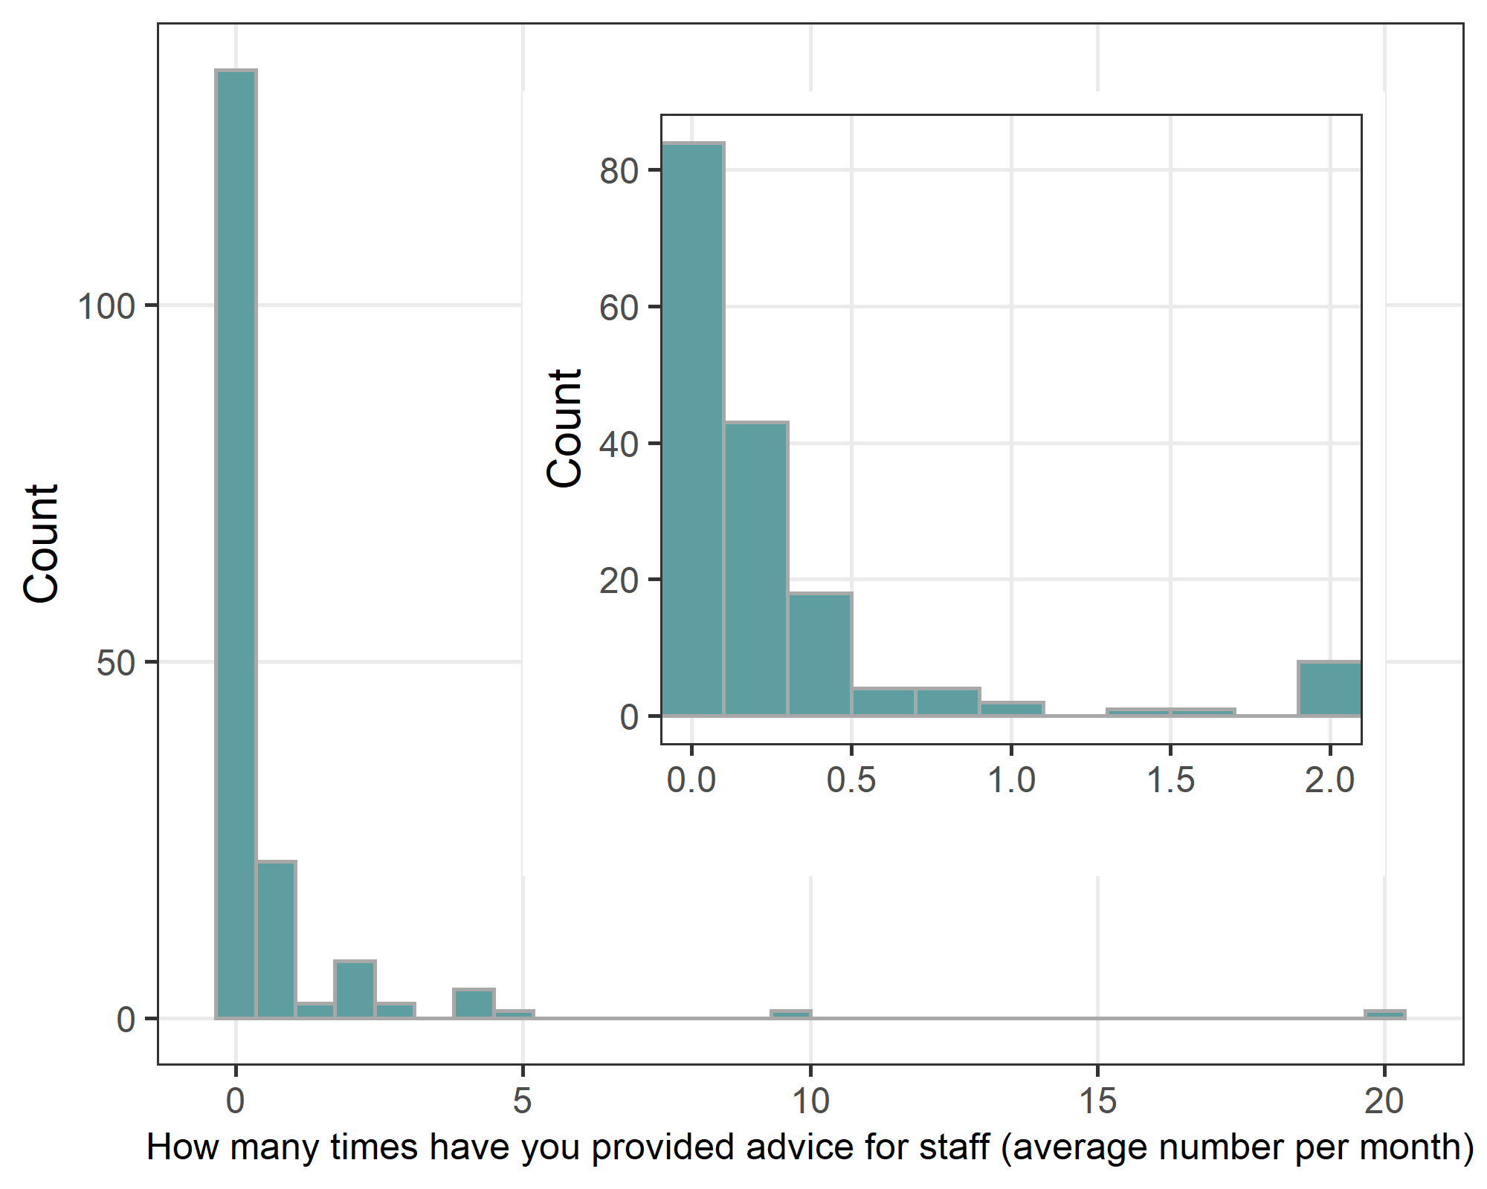

#### Students (average per month)

| **Median (1st to 3rd quartile)** |
| --- |
| 0.1 (0.0 to 0.2) |

There were 60 (32%) respondents who said they had not provided any help to students.

##### Histogram

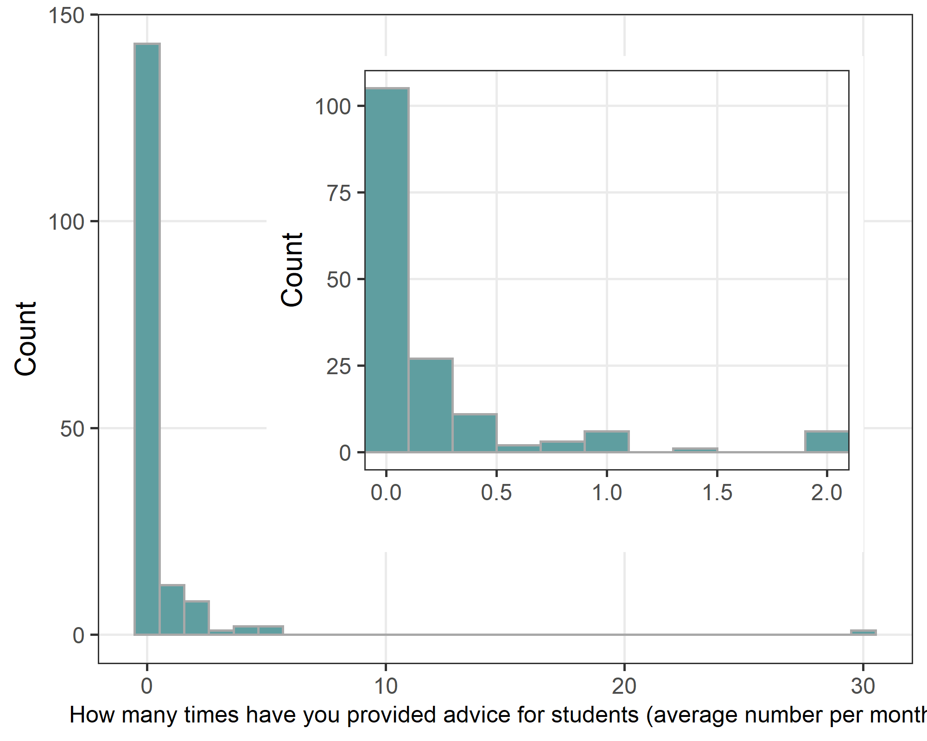

We use an inset because the one outlier means most of the data is squashed in a narrow space.

#### Average help

Here we estimate the amount of help provided to students and staff, and account for uncertainty from non-responders and the uncertainty indicated by some respondents, e.g. “2 to 4 times”.

| **group** | **statistic** | **mean** | **lower** | **upper** |
| --- | --- | --- | --- | --- |
| Students | Mean | 0.5 | 0.4 | 0.7 |
| Median | 0.1 | 0.0 | 0.1 |
| None (%) | 35.5 | 32.0 | 38.9 |
| Staff | Mean | 0.6 | 0.5 | 0.7 |
| Median | 0.1 | 0.1 | 0.1 |
| None (%) | 23.6 | 20.8 | 26.7 |

The table shows the estimated mean and median with the uncertainty (lower to upper 95% confidence interval). It also shows the estimated percent who have not helped staff or students.

### Times provided advice - answer option

The tables below show which of the four options was most often used by respondents to estimate their times providing advice.

#### Staff

| **Response** | **n (%)** |
| --- | --- |
| None | 37 (19) |
| Total number | 95 (50) |
| Average per month | 17 (9) |
| Average per year | 27 (14) |
| Missing | 14 (7) |

#### Students

| **Response** | **n (%)** |
| --- | --- |
| Average per month | 17 (9) |
| Average per year | 25 (13) |
| Missing | 20 (11) |
| None | 47 (25) |
| Total number | 81 (43) |

## *Have you provided advice about*

| **Question** | **Response** | **n (%)** |
| --- | --- | --- |
| Authorship | No | 25 (17) |
| Yes | 126 (83) |
| Bullying | No | 94 (69) |
| Yes | 43 (31) |
| Challenges in collaborations | No | 44 (31) |
| Yes | 98 (69) |
| Conflicts of interest | No | 61 (43) |
| Yes | 82 (57) |
| Data integrity | No | 68 (50) |
| Yes | 69 (50) |
| Data management and sharing | No | 68 (49) |
| Yes | 72 (51) |
| Data usage without the consent of the original researchers | No | 83 (60) |
| Yes | 56 (40) |
| Inadequate supervision | No | 61 (43) |
| Yes | 81 (57) |
| Other, please specify | No | 44 (80) |
| Yes | 11 (20) |
| Questionable research practices | No | 57 (39) |
| Yes | 88 (61) |
| Recognition of Aboriginal and Torres Strait Islander Peoples | No | 116 (87) |
| Yes | 18 (13) |
| Research conducted without adequate ethical clearances | No | 78 (56) |
| Yes | 61 (44) |
| Respect for participants, animals and the environment | No | 103 (77) |
| Yes | 30 (23) |
| Sexual harassment | No | 127 (95) |
| Yes | 6 (5) |
| Training and resources | No | 81 (60) |
| Yes | 53 (40) |

These results do not include those advisors who said they have never provided any advice to staff or students.

#### Bar plot

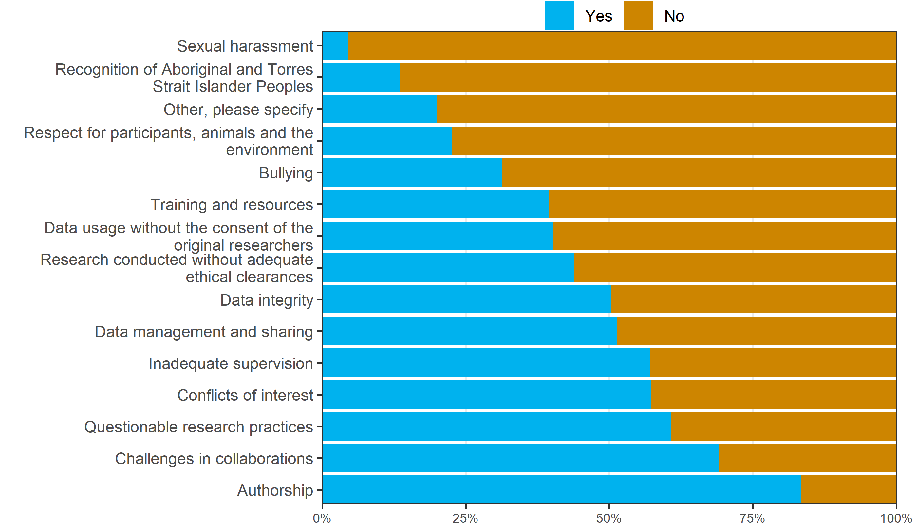

The rows in the bar plot are ordered by the percent of “Yes” answers. The issue that came top was Authorship.

## *Thinking about all the research integrity issues that you given advice on as part of your role. Do you think you were able to help the person who needed advice?*

| **Response** | **n (%)** |
| --- | --- |
| All of the time | 25 (15) |
| Most of the time | 97 (58) |
| About half the time | 10 (6) |
| Some of the time | 8 (5) |
| None of the time | 3 (2) |
| Unsure | 25 (15) |

These results do not include those advisors who said they have never provided any advice to staff or students.

#### Bar plot

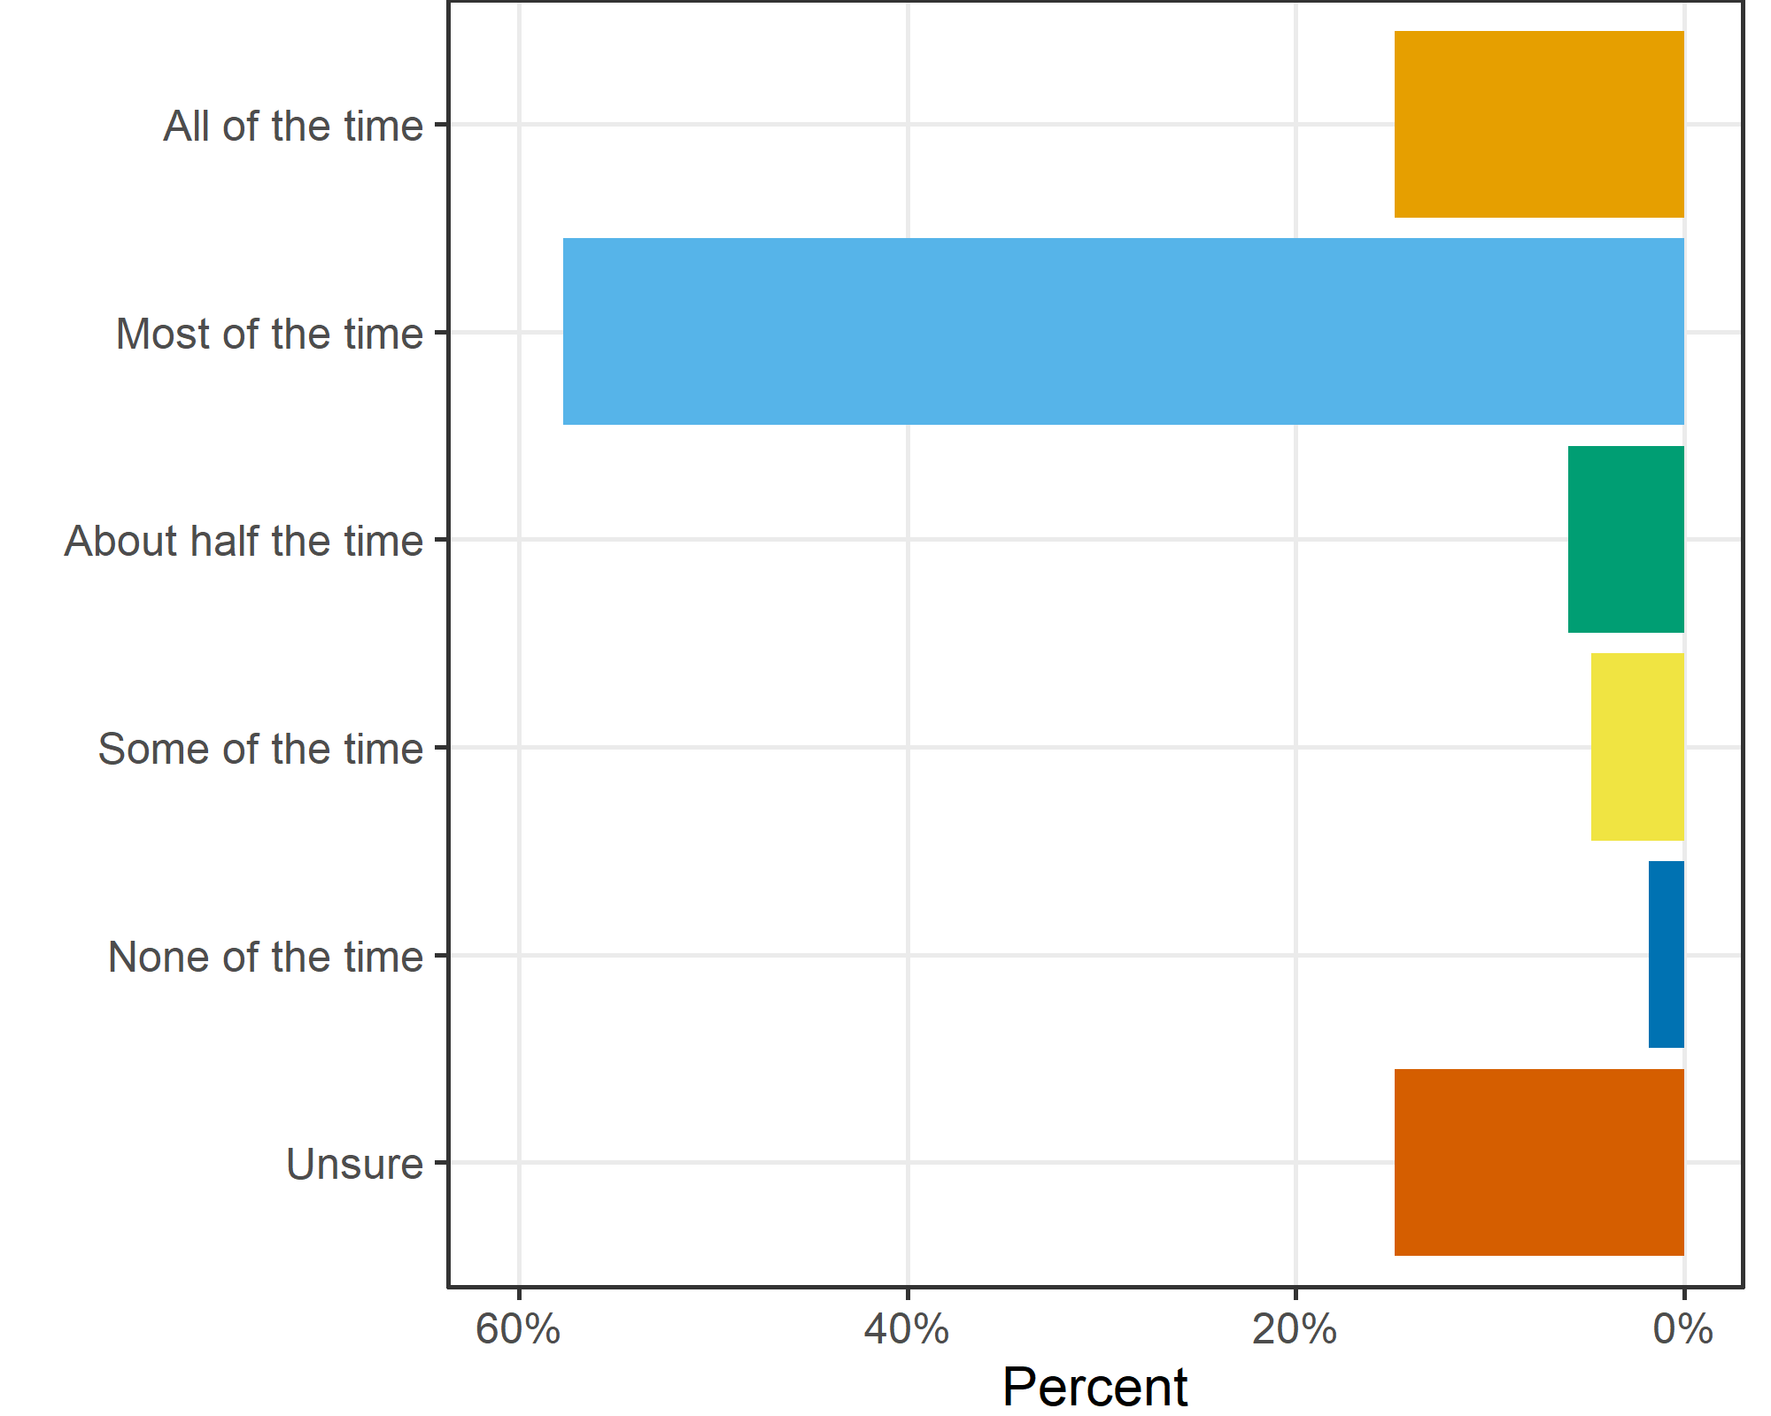

# Thoughts on role

## *Do you agree or disagree with the following statements concerning your role as research integrity advisor:*

| **Question** | **Response** | **n (%)** |
| --- | --- | --- |
| I feel my role has promoted research integrity | Agree | 106 (65) |
| Neither agree nor disagree | 40 (25) |
| Disagree | 16 (10) |
| I would like more contact with other Research Integrity Advisors at my institution or at other institutions | Agree | 68 (38) |
| Neither agree nor disagree | 77 (43) |
| Disagree | 34 (19) |
| My institution needs to have more Research Integrity Advisors | Agree | 24 (14) |
| Neither agree nor disagree | 73 (44) |
| Disagree | 69 (42) |
| My institution needs to take the role more seriously | Agree | 53 (29) |
| Neither agree nor disagree | 60 (33) |
| Disagree | 67 (37) |
| Other, please specify | Agree | 8 (57) |
| Neither agree nor disagree | 5 (36) |
| Disagree | 1 (7) |
| The role should include promoting good practice and not just supporting potential issues | Agree | 151 (85) |
| Neither agree nor disagree | 22 (12) |
| Disagree | 5 (3) |
| There should be greater recognition of the role, e.g., in annual appraisals, promotion | Agree | 92 (53) |
| Neither agree nor disagree | 69 (40) |
| Disagree | 13 (7) |
| There should be more internal advertising about my role to staff and students | Agree | 120 (67) |
| Neither agree nor disagree | 38 (21) |
| Disagree | 22 (12) |
| There should be more training for Research Integrity Advisors | Agree | 85 (47) |
| Neither agree nor disagree | 63 (35) |
| Disagree | 32 (18) |

#### Bar plot

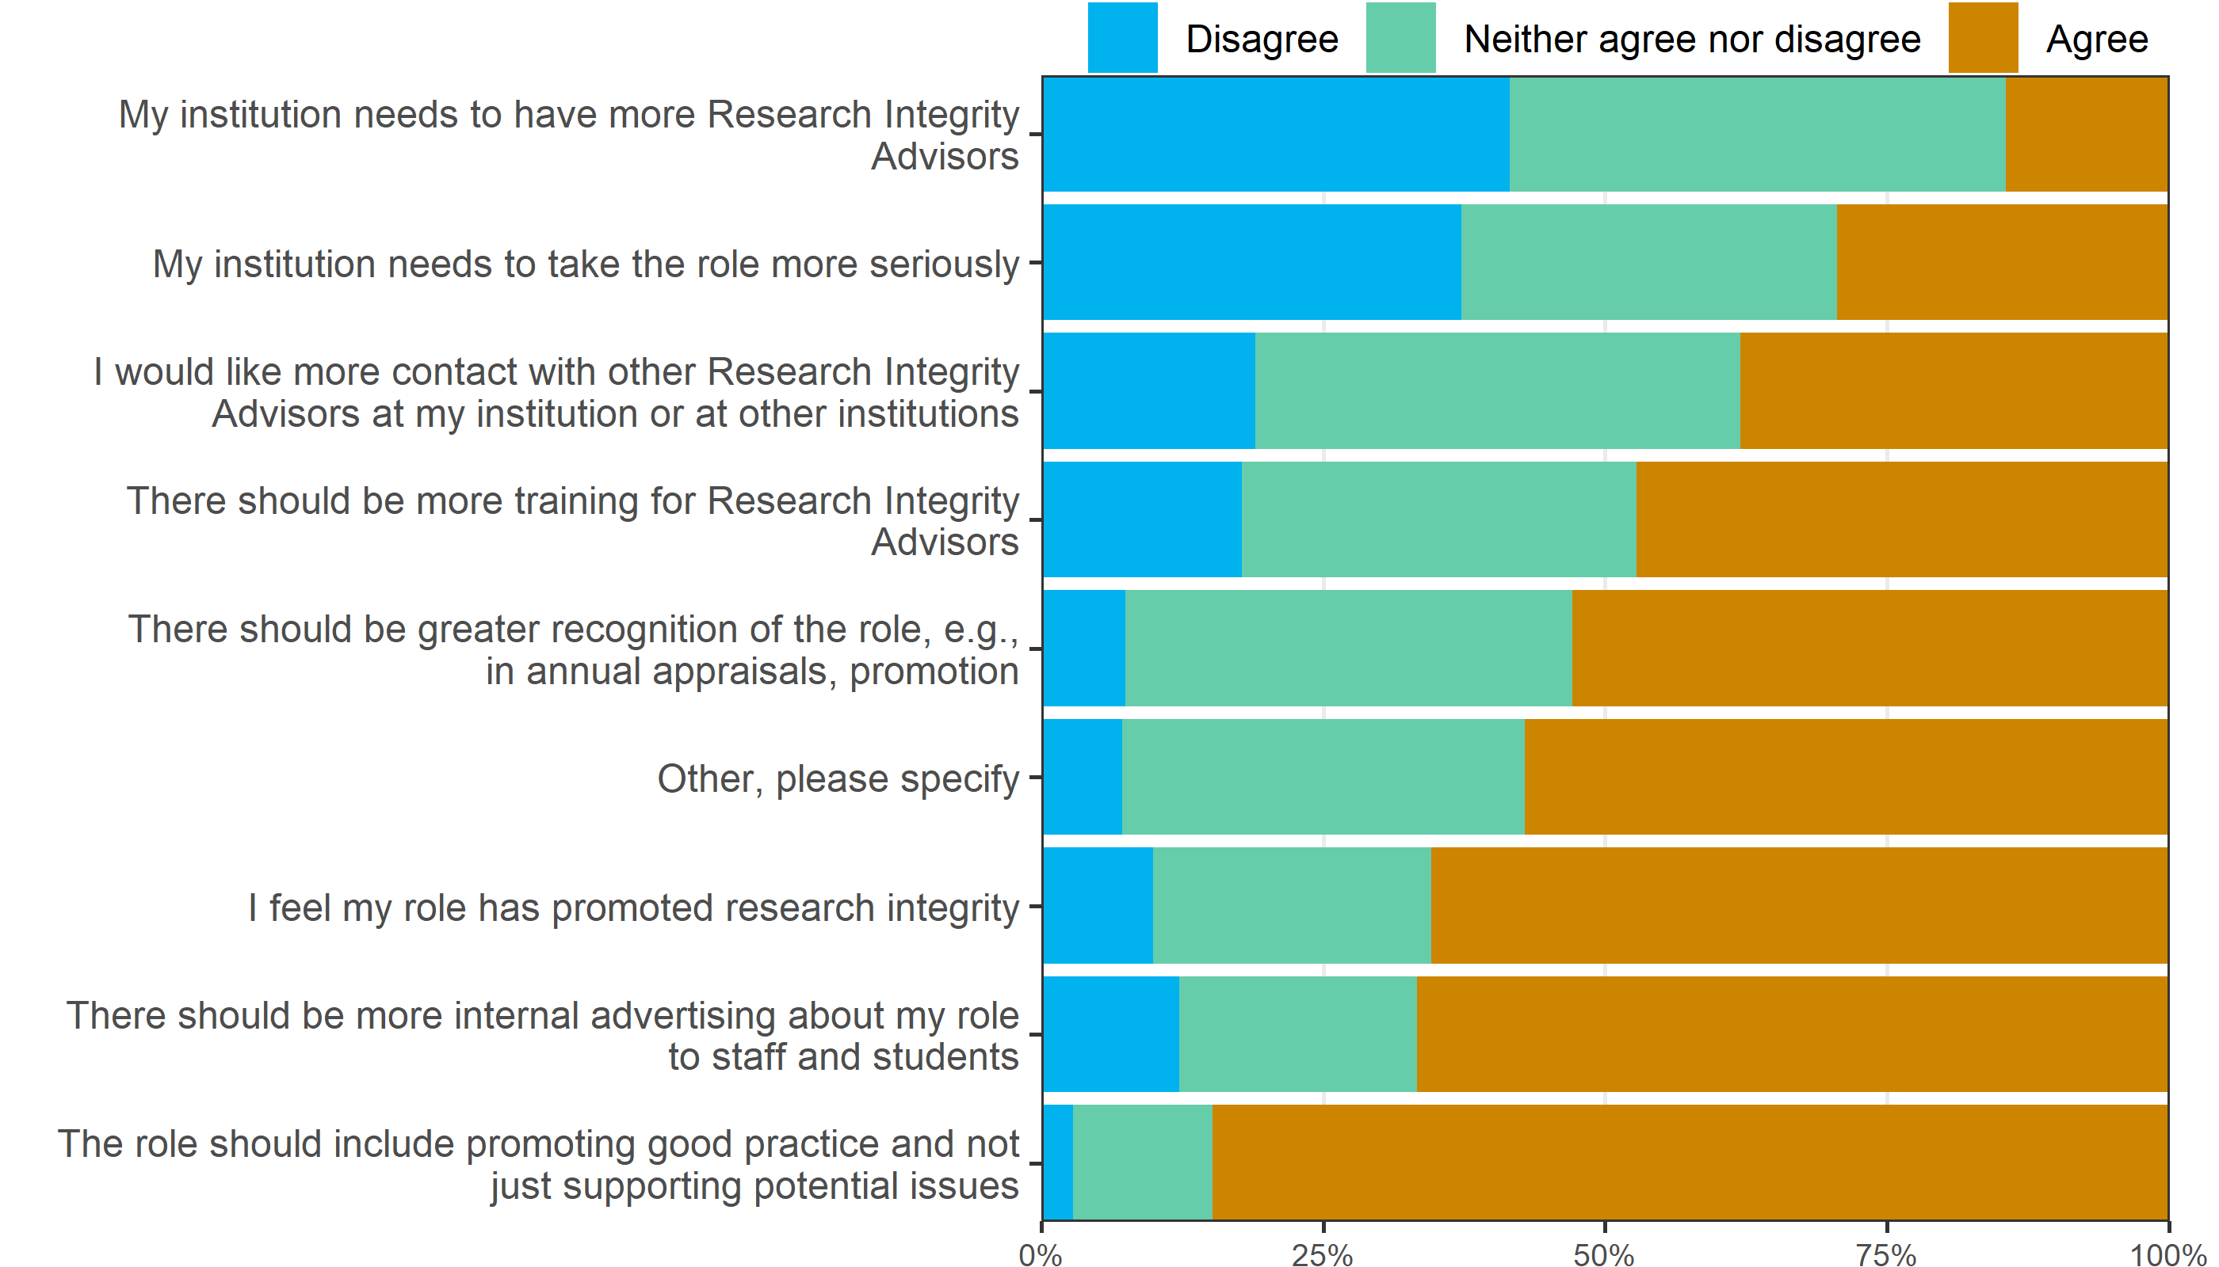

The rows in the bar plot are ordered by the percent of “Agree” answers.

# Demographics

## *Approximately how many years have you worked in research?*

| **Response** | **n (%)** |
| --- | --- |
| 0 years (I am not a researcher) | 2 (1) |
| Less than 3 years | 1 (1) |
| 3 to 10 years | 20 (11) |
| 11 years or more | 158 (87) |

Almost all of the advisors were senior researchers.

RIAs are supposed to have research experience, so the 2 respondents who are not researchers may be not be aligned with the policy, however, they might still provide good advice.

## Bar plot

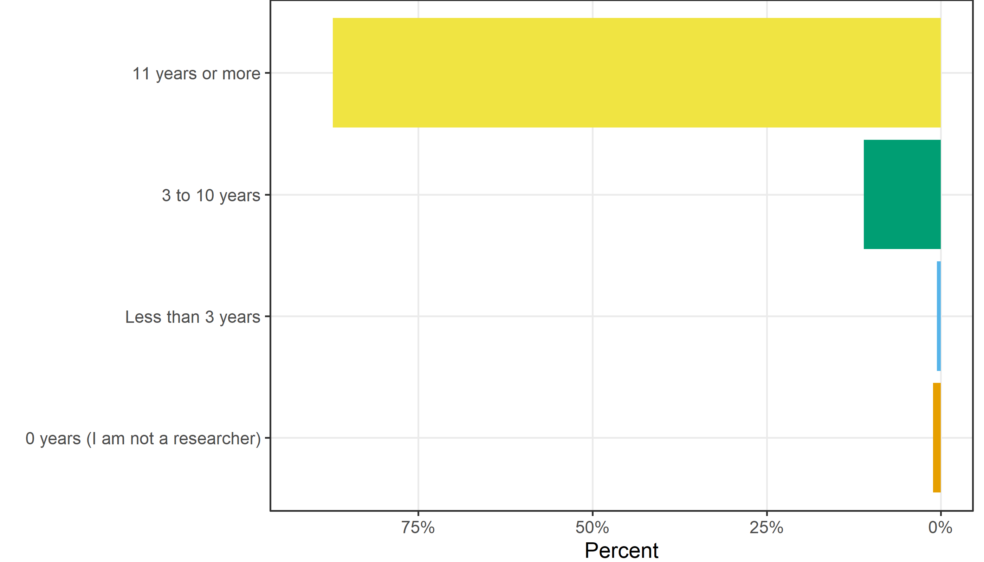

# Survey response results

In this section we examine meta-data on the survey including the completeness and time taken.

## Numbers not eligible, withdrawn and out-of-office

There were 39 out-of-office emails and 7 emails bounced as the address was no longer valid. The number who withdrew was 22. The number not eligible was 12.

## Response dates

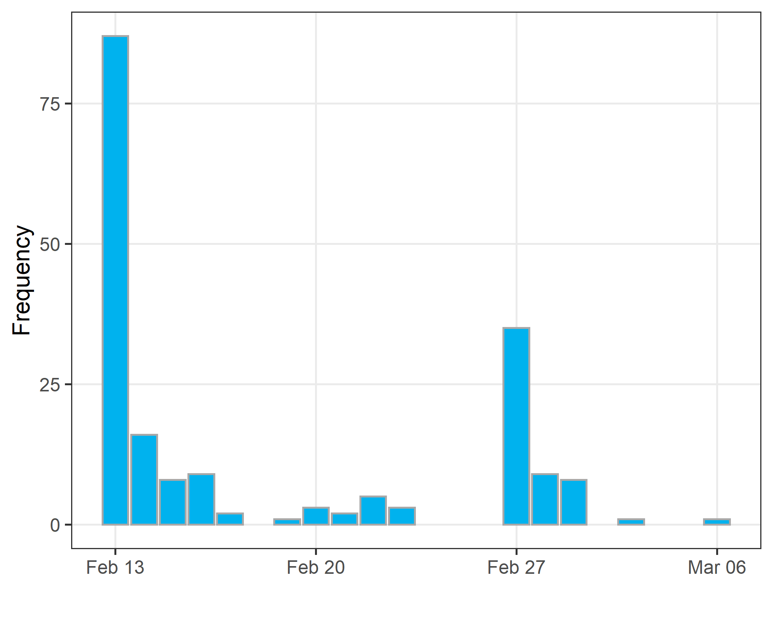

The survey was launched on Monday 13 February 2023. Reminders were sent 2 weeks later (27 February) to non-responders and incomplete responders. The survey was closed on 13 March.

## Questionnaire progress as a percent

The table below shows the questionnaire progress as a percent, with the results grouped into three categories.

| **Response** | **n (%)** |
| --- | --- |
| (5,50] | 7 (4) |
| (50,75] | 2 (1) |
| (75,100] | 181 (95) |

Most respondents completed most of the questions.

## Time taken

Time taken in minutes to complete the questions.

| **Median (1st to 3rd quartile)** |
| --- |
| 7 (5 to 12) |

The survey did not take long to complete.

## Numerical summary of optional text comments

| **question** | **Number of comments / median words** |
| --- | --- |
| Any comments about when your role started or ended? (optional) | 59 / 12 |
| Do you have any comments on your training or time spent as a Research Integrity Advisor? (optional) | 99 / 18 |
| Do you have any comments on the advice you have provided or situations you have encountered? (optional) | 59 / 24 |
| Do you agree or disagree with the following statements concerning your role as a Research Integrity Advisor: - Other, please specify - Text | 14 / 18 |
| Lastly, do you have comments about your role as a Research Integrity Advisor or about this research? (optional) | 72 / 27 |

The table shows the number of comments and the median number of words.

The total number of comments was 303.

## Did they provide their email for further study?

| **Response** | **n (%)** |
| --- | --- |
| No | 165 (87) |
| Yes | 25 (13) |

Respondents were asked about their interest to take part in a further qualitative study about their role as a Research Integrity Advisor.

## Missing data

This section examines the item-missing data of missing responses to each question. The plot below shows what responses were missing (shown in grey), excluding optional comments. The questions are ordered according to the survey.

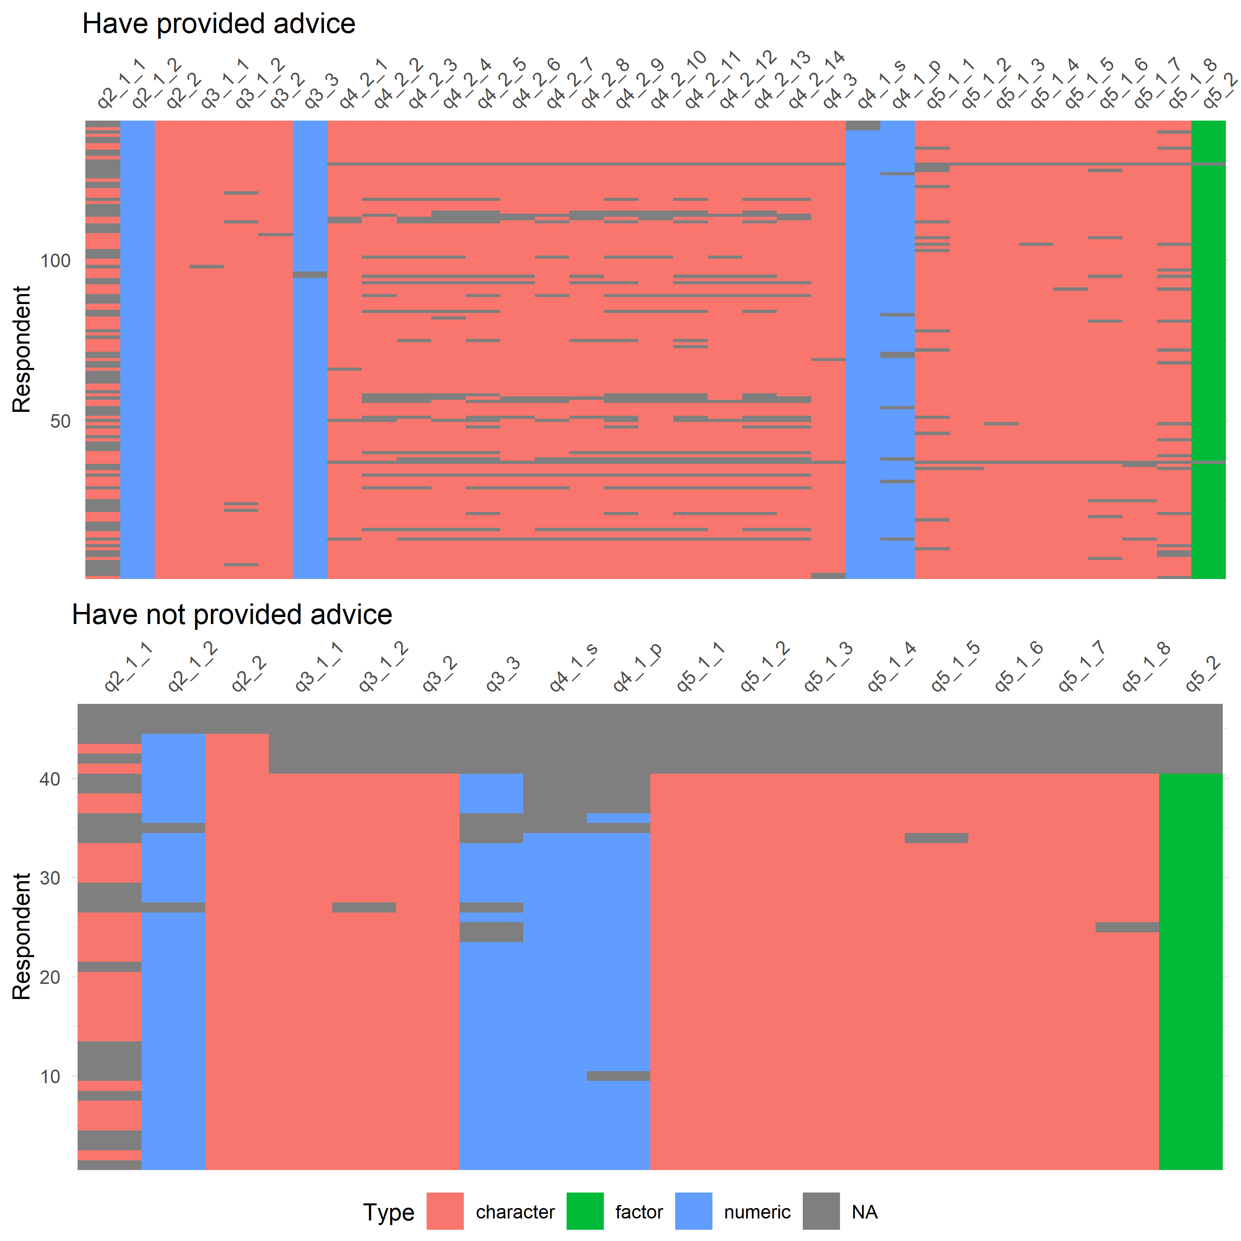

### Counts of missing data by question

| **Question** | **Number missing** | **Maximum possible** | **Percent missing** |
| --- | --- | --- | --- |
| Are you still a Research Integrity Advisor? | 3 | 190 | 2 |
| When did you role as a Research Integrity Advisor start? - Year | 5 | 190 | 3 |
| Thinking about all the research integrity issues that you given advice on as part of your role. Do you think you were able to help the person who needed advice? | 5 | 143 | 3 |
| Have you received training for your role as a Research Integrity Advisor? - Initial training when starting the role | 8 | 190 | 4 |
| In your opinion, has the amount of training for your role as a Research Integrity Advisory been … | 8 | 190 | 4 |
| Approximately how many years have you worked in research? Answer in terms of working years, e.g., if 3 years of working half-time then answer 2 years ("Less than 3 years"). | 9 | 190 | 5 |
| Have you provided advice about - Authorship | 7 | 143 | 5 |
| Do you agree or disagree with the following statements concerning your role as a Research Integrity Advisor: - There should be more training for Research Integrity Advisors | 10 | 190 | 5 |
| Do you agree or disagree with the following statements concerning your role as a Research Integrity Advisor: - My institution needs to take the role more seriously | 10 | 190 | 5 |
| Do you agree or disagree with the following statements concerning your role as a Research Integrity Advisor: - There should be more internal advertising about my role to staff and students | 10 | 190 | 5 |
| Do you agree or disagree with the following statements concerning your role as a Research Integrity Advisor: - I would like more contact with other Research Integrity Advisors at my institution or at other institutions | 11 | 190 | 6 |
| Do you agree or disagree with the following statements concerning your role as a Research Integrity Advisor: - The role should include promoting good practice and not just supporting potential issues | 12 | 190 | 6 |
| Have you received training for your role as a Research Integrity Advisor? - Ongoing training during the role | 13 | 190 | 7 |
| Time spent in role (average days per month) | 15 | 190 | 8 |
| Have you provided advice about - Questionable research practices | 12 | 143 | 8 |
| How many times have you provided advice for staff (average number per month) | 16 | 190 | 8 |
| Do you agree or disagree with the following statements concerning your role as a Research Integrity Advisor: - There should be greater recognition of the role, e.g., in annual appraisals, promotion | 16 | 190 | 8 |
| Have you provided advice about - Conflicts of interest | 14 | 143 | 10 |
| Have you provided advice about - Challenges in collaborations | 15 | 143 | 10 |
| Have you provided advice about - Inadequate supervision | 15 | 143 | 10 |
| How many times have you provided advice for students (average number per month) | 21 | 190 | 11 |
| Have you provided advice about - Data management and sharing | 17 | 143 | 12 |
| Have you provided advice about - Research conducted without adequate ethical clearances | 18 | 143 | 13 |
| Have you provided advice about - Data usage without the consent of the original researchers | 18 | 143 | 13 |
| Do you agree or disagree with the following statements concerning your role as a Research Integrity Advisor: - My institution needs to have more Research Integrity Advisors | 24 | 190 | 13 |
| Have you provided advice about - Data integrity | 20 | 143 | 14 |
| Have you provided advice about - Bullying | 20 | 143 | 14 |
| Do you agree or disagree with the following statements concerning your role as a Research Integrity Advisor: - I feel my role has promoted research integrity | 28 | 190 | 15 |
| Have you provided advice about - Training and resources | 23 | 143 | 16 |
| Have you provided advice about - Respect for participants, animals and the environment | 24 | 143 | 17 |
| Have you provided advice about - Sexual harassment | 24 | 143 | 17 |
| Have you provided advice about - Recognition of Aboriginal and Torres Strait Islander Peoples | 24 | 143 | 17 |
| When did you role as a Research Integrity Advisor start? - Month (leave blank if unsure) | 97 | 190 | 51 |

The table rows are ordered by the variables with the most to least amount of missing. Most questions were reasonably well completed.

The question with the most amount of missing was the month they started in the role, which they were instructed to leave blank if they were unsure. Some of the questions on what advice they provided were also often blank, including Recognition of Aboriginal and Torres Strait Islander Peoples and Sexual harassment.

## Response randomisation

To reduce potential bias from response ordering, we randomised the order of response categories where possible. For example, the question on whether advisors thought they could help, was sometimes presented as “All to the time” to “None of the time”, and at other times presenting in the reverse order. Here we test whether this ordering influenced the responses.

| **outcome** | **Mean** | **CI** |
| --- | --- | --- |
| Training | 0.83 | 0.43 to 1.56 |
| Helped | 0.77 | 0.39 to 1.52 |

The table shows the odds ratios and 95% credible interval for the association between the randomised order the responses, and the probability of giving a more positive response. There is no strong association, indicating that respondents were not simply ticking the first or last responses.