Analysis of confidence intervals in journal abstracts and full-text.

Adrian Barnett

10 June 2019

# Summary table

The table below shows the number of confidence limits from abstracts and full-texts, together with the total number of unique journals, and the number with a zero lower limit (which are excluded from the plots below).

|  |  |  |  |
| --- | --- | --- | --- |
| source | n | journals | zero |
| Abstract | 968,278 | 5,949 | 1,159 |
| Full-text | 351,937 | 2,754 | 439 |

## Table of mistakes

How many intervals were excluded because of a mistake where the mean was not within the interval.

|  |  |  |  |  |
| --- | --- | --- | --- | --- |
| Mistake | Abstract n | Percent | Full-text n | Percent |
| *FALSE* | 961862 | 99.3 | 348809 | 99.1 |
| *TRUE* | 6416 | 0.7 | 3128 | 0.9 |
| *All* | 968278 | 100.0 | 351937 | 100.0 |

## Table of CI level

### Numbers with missing CI level

|  |  |  |  |  |  |  |
| --- | --- | --- | --- | --- | --- | --- |
| Missing | factor(source) Abstract n | Percent | Full-text n | Percent | All n | Percent |
| *FALSE* | 855212 | 89 | 309538 | 89 | 1164750 | 89 |
| *TRUE* | 105512 | 11 | 38851 | 11 | 144363 | 11 |
| *All* | 960724 | 100 | 348389 | 100 | 1309113 | 100 |

### Numbers with missing CI level

For the table below we excluded the intervals where the CI level was not given.

|  |  |  |  |  |  |  |
| --- | --- | --- | --- | --- | --- | --- |
| 95% CI | factor(source) Abstract n | Percent | Full-text n | Percent | All n | Percent |
| *FALSE* | 2879 | 0.3 | 787 | 0.3 | 3666 | 0.3 |
| *TRUE* | 852333 | 99.7 | 308751 | 99.7 | 1161084 | 99.7 |
| *All* | 855212 | 100.0 | 309538 | 100.0 | 1164750 | 100.0 |

# Lower confidence interval (log-scale)

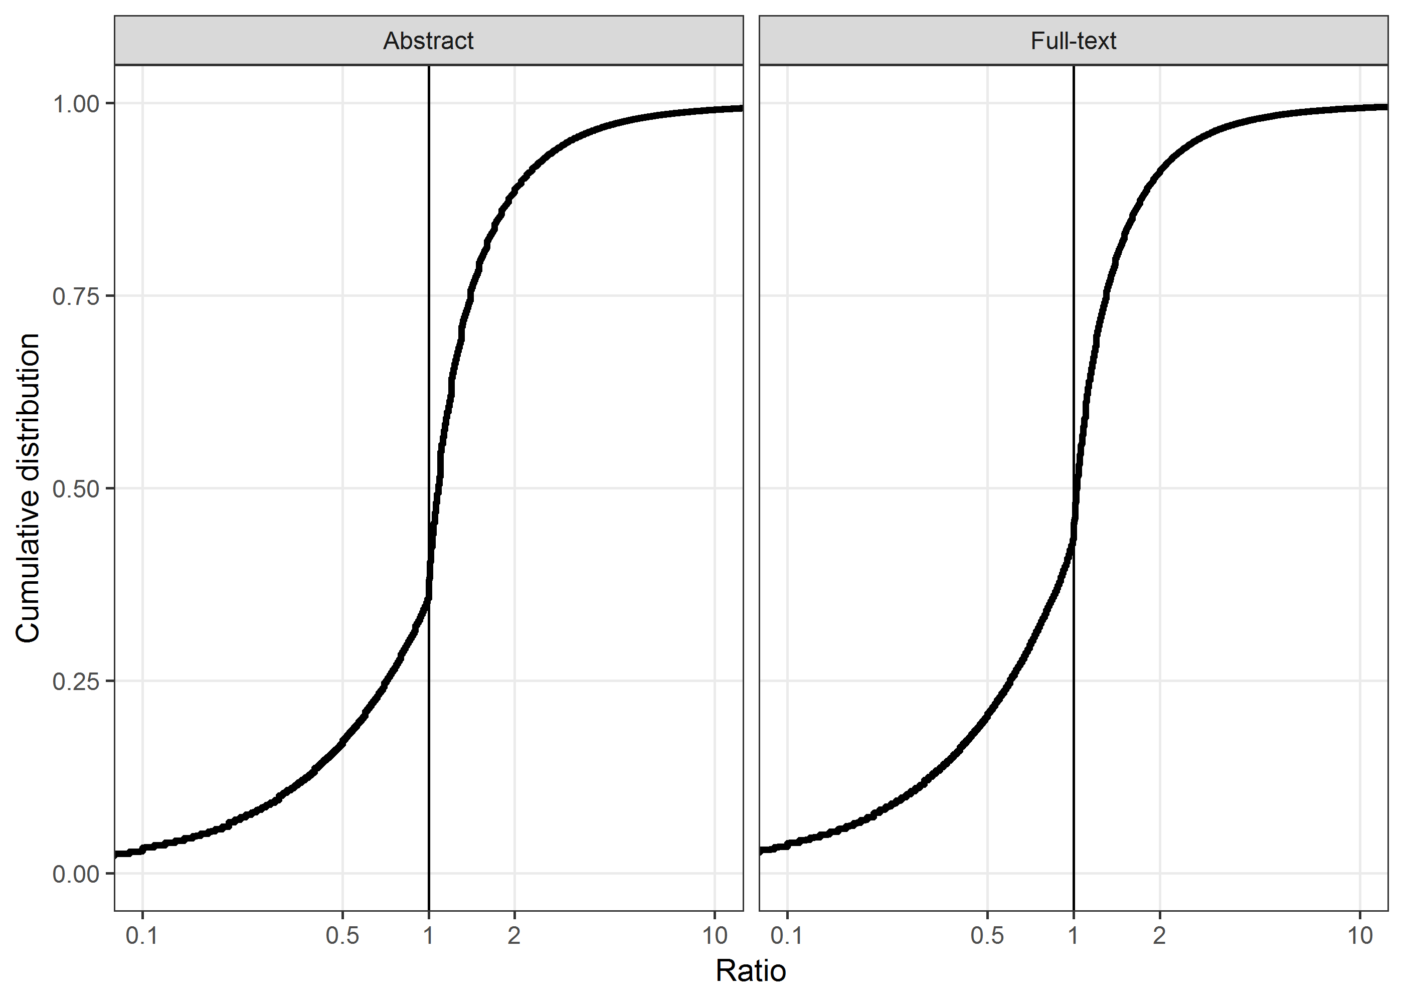

There were 3% limits excluded from the plot that were less than 0.1, and 0.8% limits excluded that were above 10.

## Number and percent of lower intervals above 1 and less than or equal to 1.1

|  |  |  |  |  |
| --- | --- | --- | --- | --- |
| (1, 1.1] | Abstract n | Percent | Full-text n | Percent |
| *No* | 804367 | 83 | 295829 | 84 |
| *Yes* | 162752 | 17 | 55669 | 16 |
| *All* | 967119 | 100 | 351498 | 100 |

## Number and percent of lower intervals above 1 and less than or equal to 1.2

|  |  |  |  |  |
| --- | --- | --- | --- | --- |
| (1, 1.2] | Abstract n | Percent | Full-text n | Percent |
| *No* | 711603 | 74 | 265104 | 75 |
| *Yes* | 255516 | 26 | 86394 | 25 |
| *All* | 967119 | 100 | 351498 | 100 |

# Upper confidence interval (log scale)

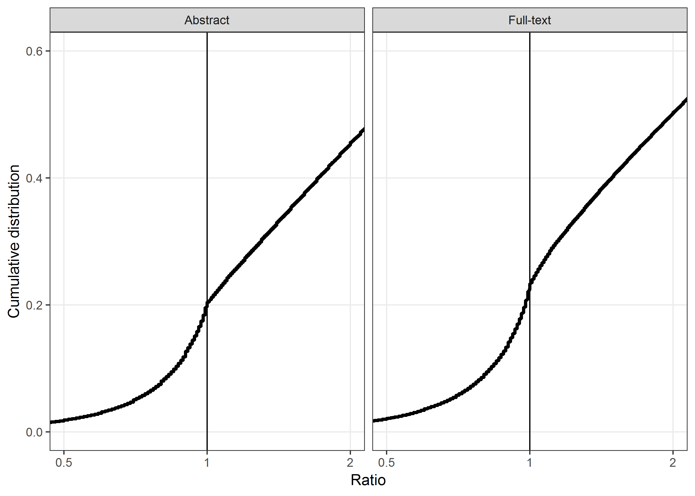

# Plot of lower and upper intervals side by side (log scale)

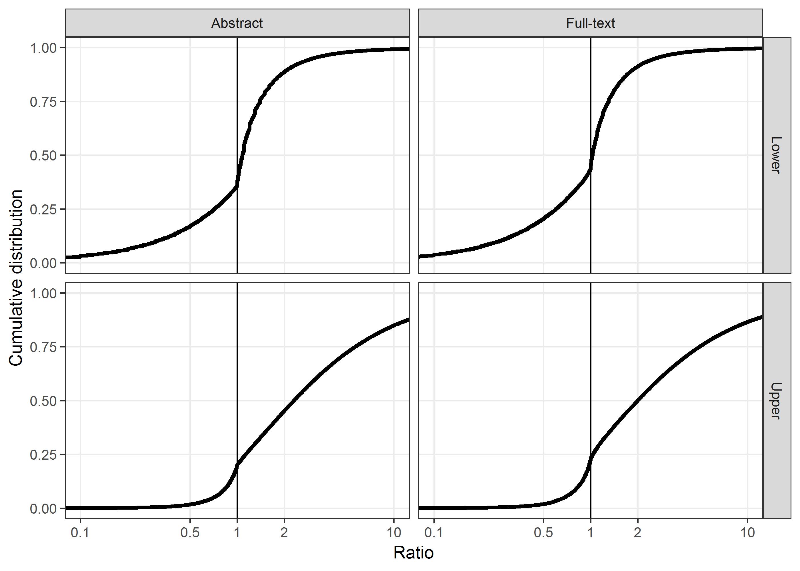

# Alternative plot on same panel (log scale)

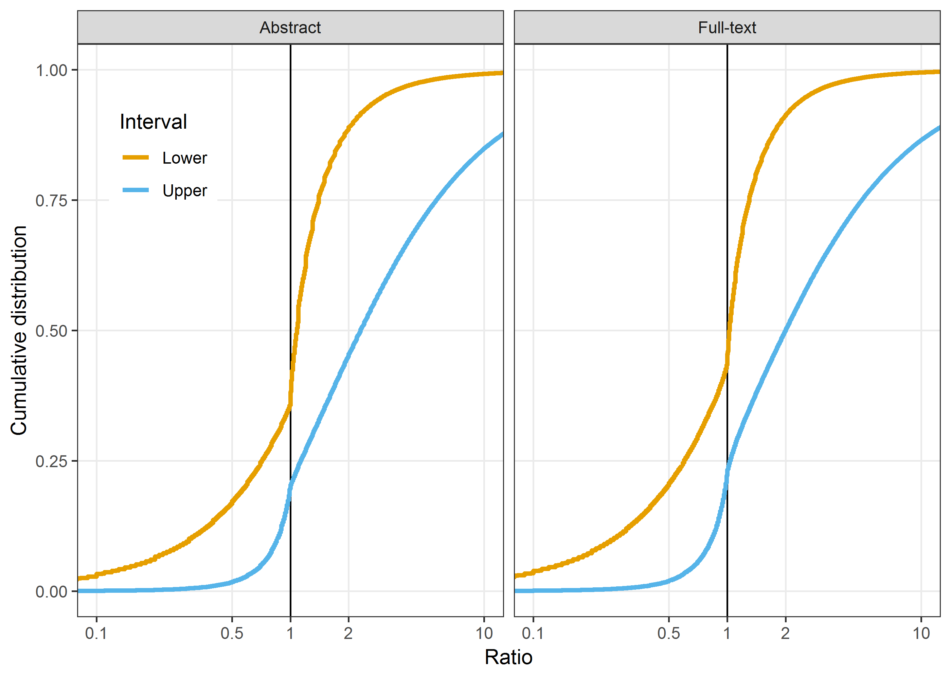

The plot above includes 96% of all lower intervals and 85% of all upper intervals.

# Alternative plot on non-log scale

This plot was suggested by a reviewer who said that “log-scales are difficult to process intuitively”. The x-axis is restricted to 0.25 (1/4) to 4.

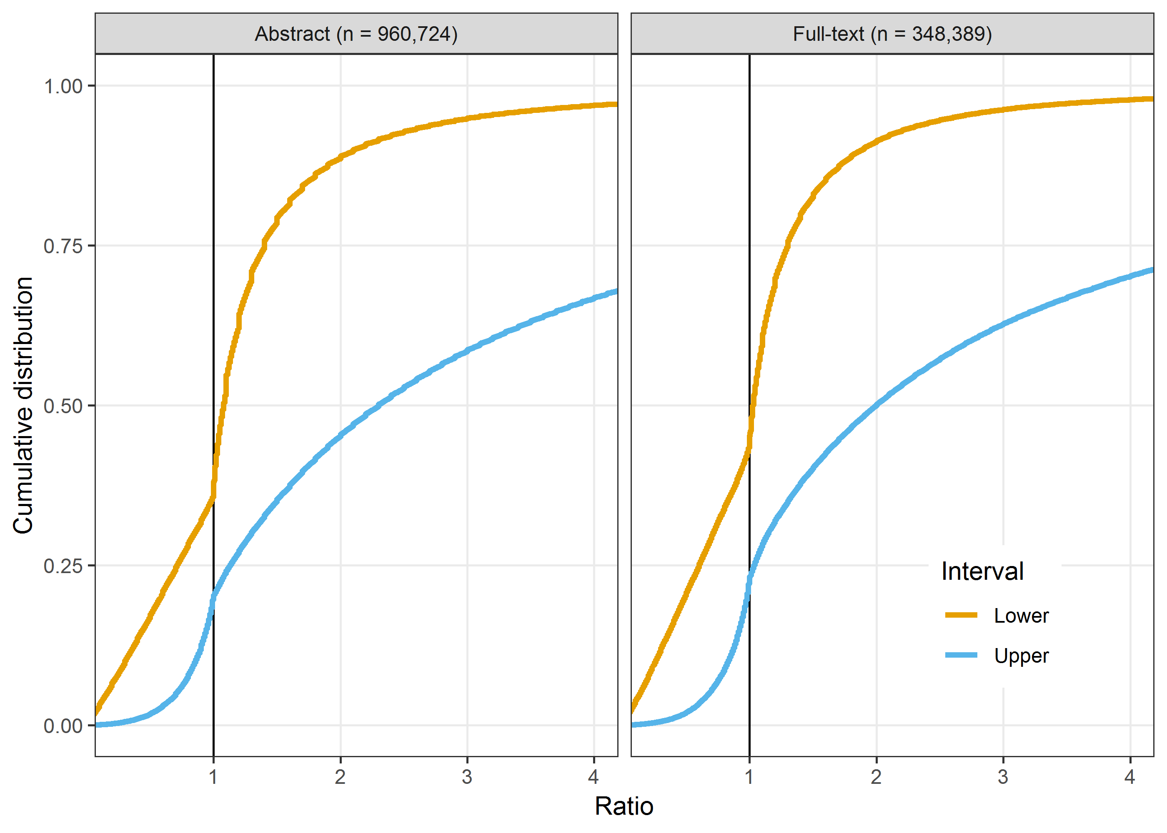

The plot above includes 89% of all lower intervals and 67% of all upper intervals.

# Alternative plot on zoomed in scale

This plot was suggested by a reviewer who asked if we could zoom in on the area closest to 1. The x-axis is restricted to 0.83 to 1.2 and the y-axis is restricted to reduce white space. We also plot this on a non-log scale.

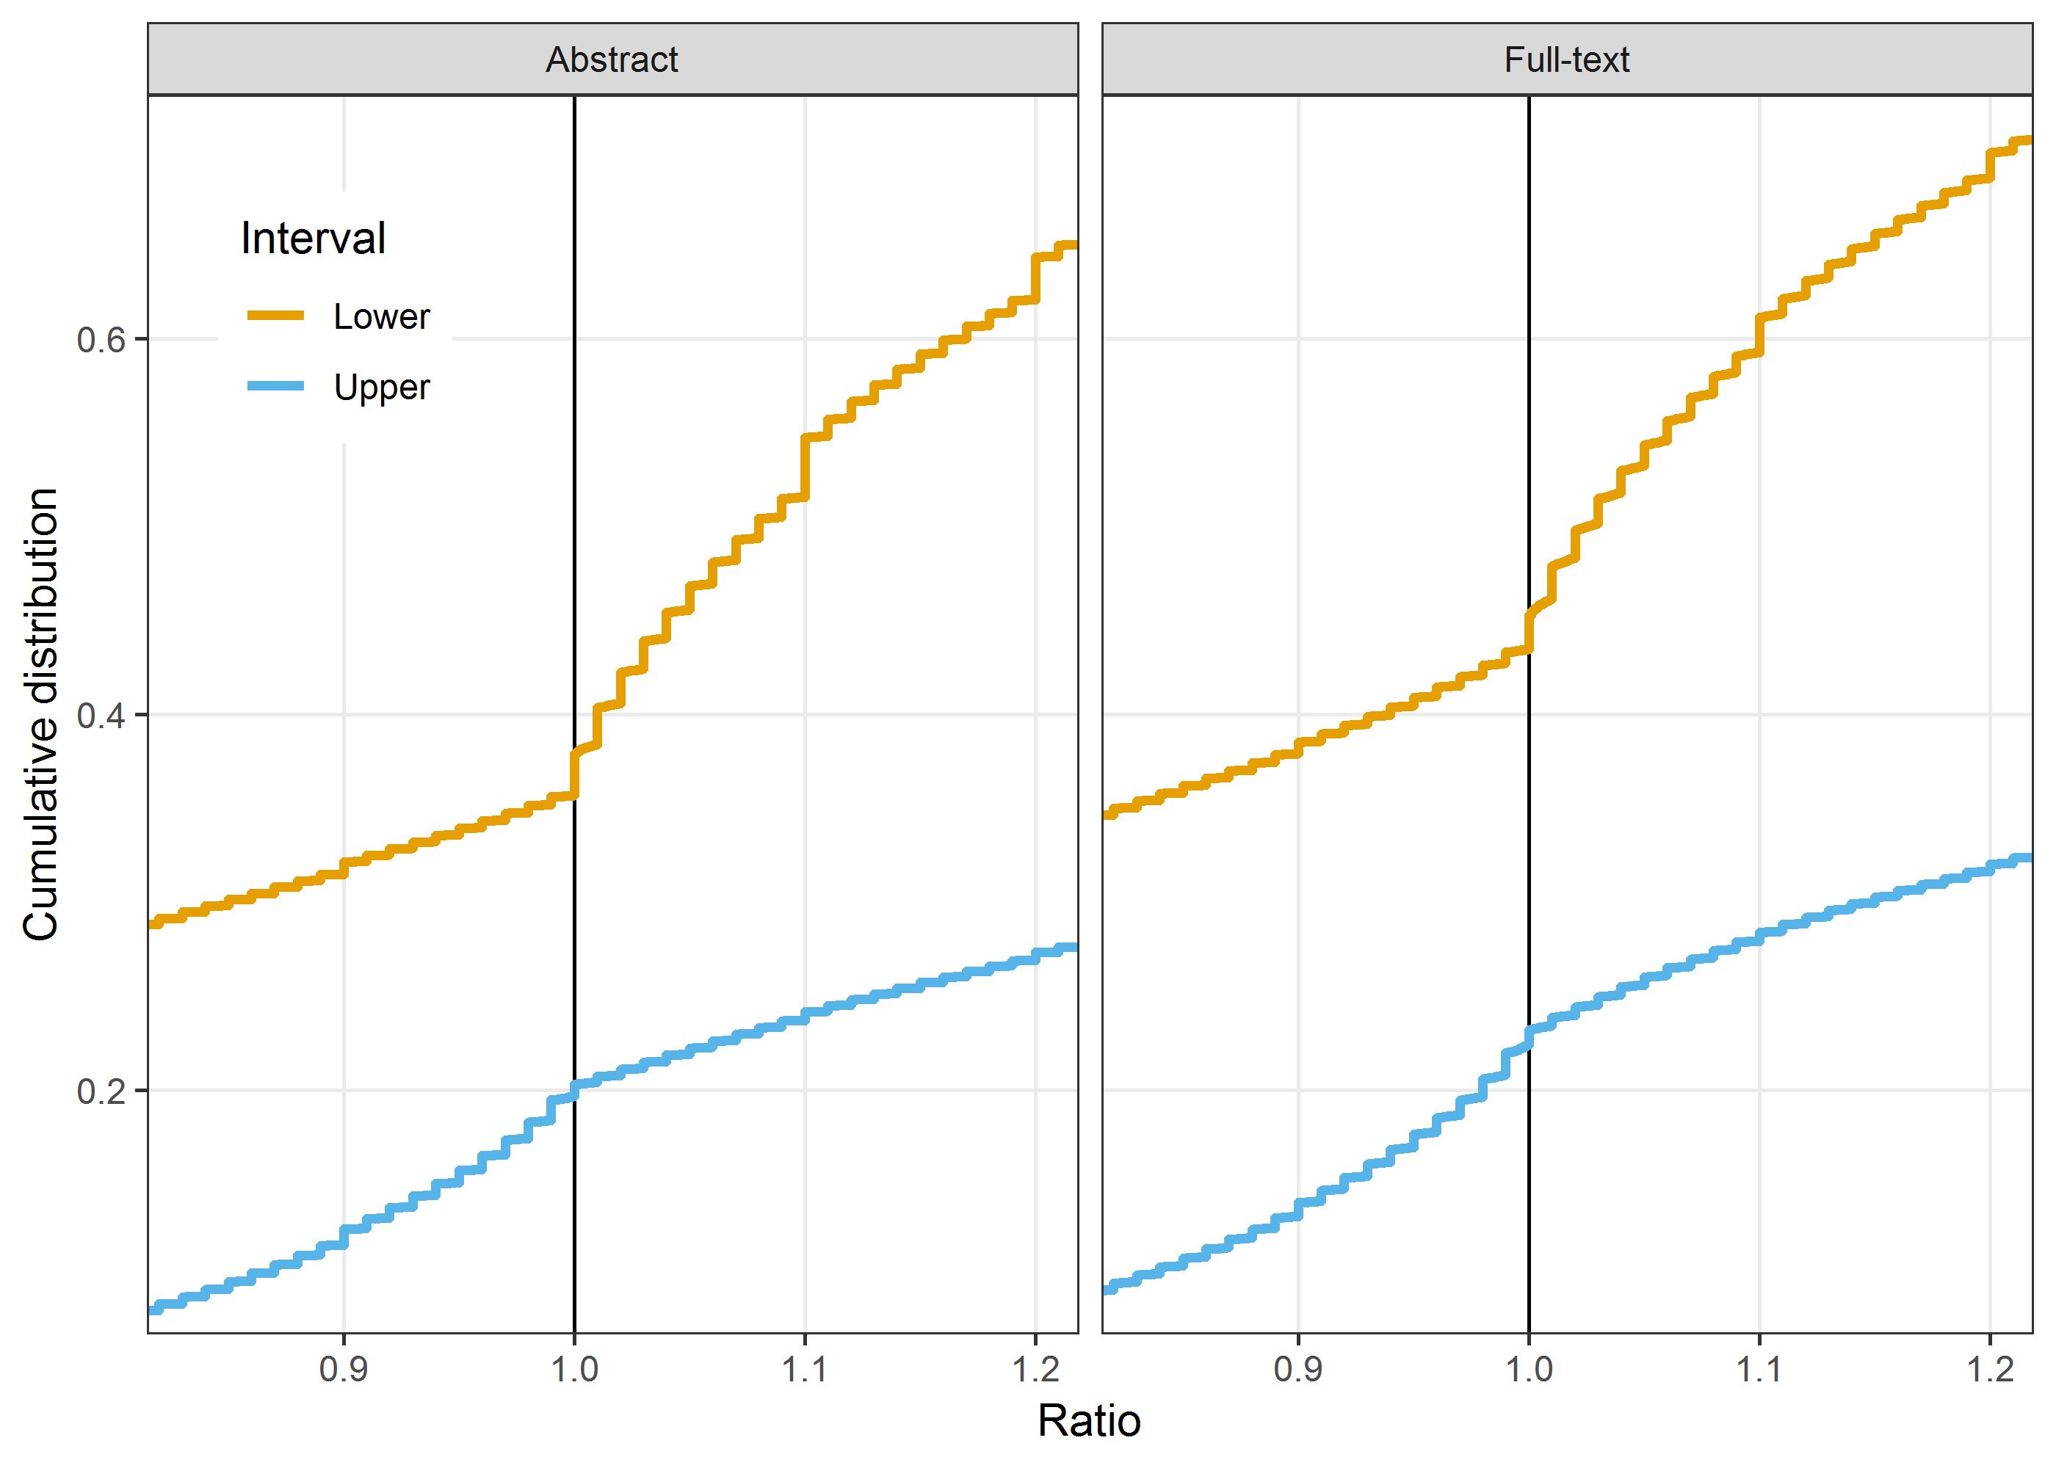

This zoomed in plot shows the clear steps in the data due to rounding.

The plot above includes 35% of all lower intervals and 20% of all upper intervals.

# Non-cumulative plots

## Wider bin-width

This plot is in bin-widths of 0.1. The x-axis range is from 0.2 to 4.

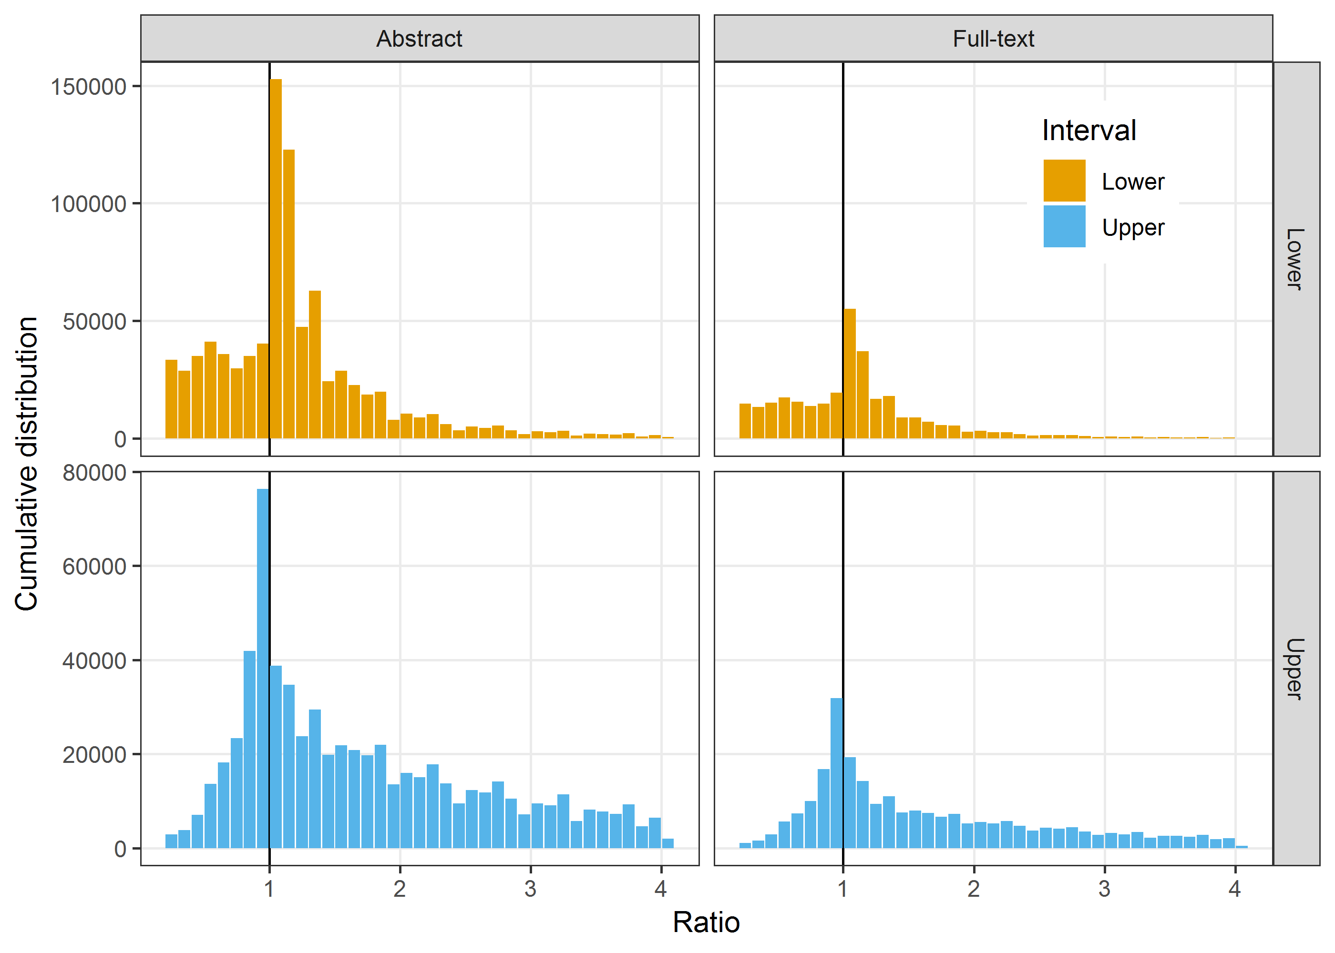

## Narrower bin width

This plot is in bin-widths of 0.05. The x-axis range is from 0.2 to 4.

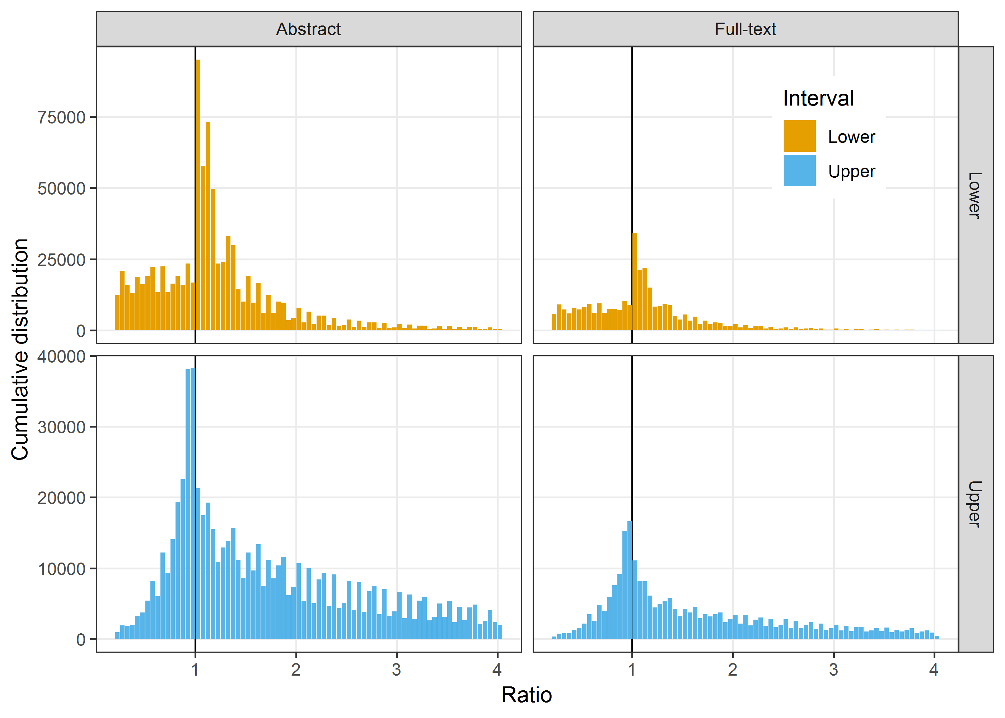

# Intervals over time

We examine the cumulative plots over time to see whether things have worsened or improved. We plot the empirical cumulative distribution function in five year bands. We excluded the data prior to 1990 because of the relatively small numbers.

## Abstracts

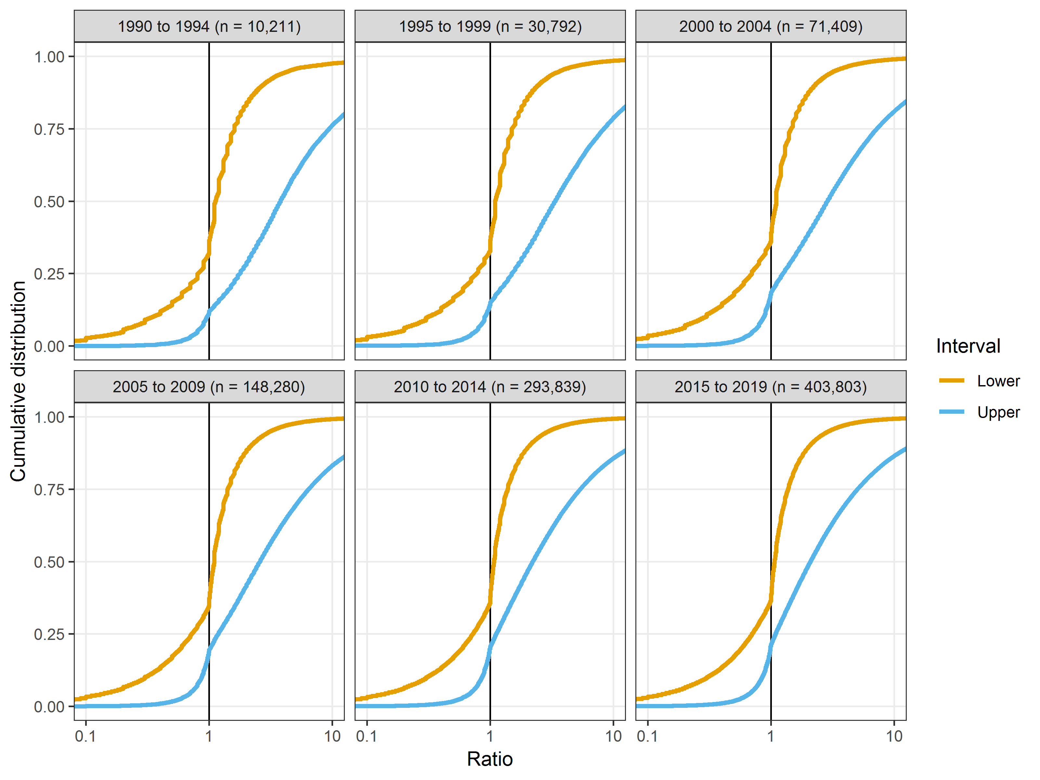

The plot shows a near identical cumulative distribution functions for each five year period.

This plot excludes 43 intervals that were missing the year.

### Abstract intervals over time on non-log scale

Here we show the same plot but on a non-log scale restricted to the ratios of 0.25 to 4.

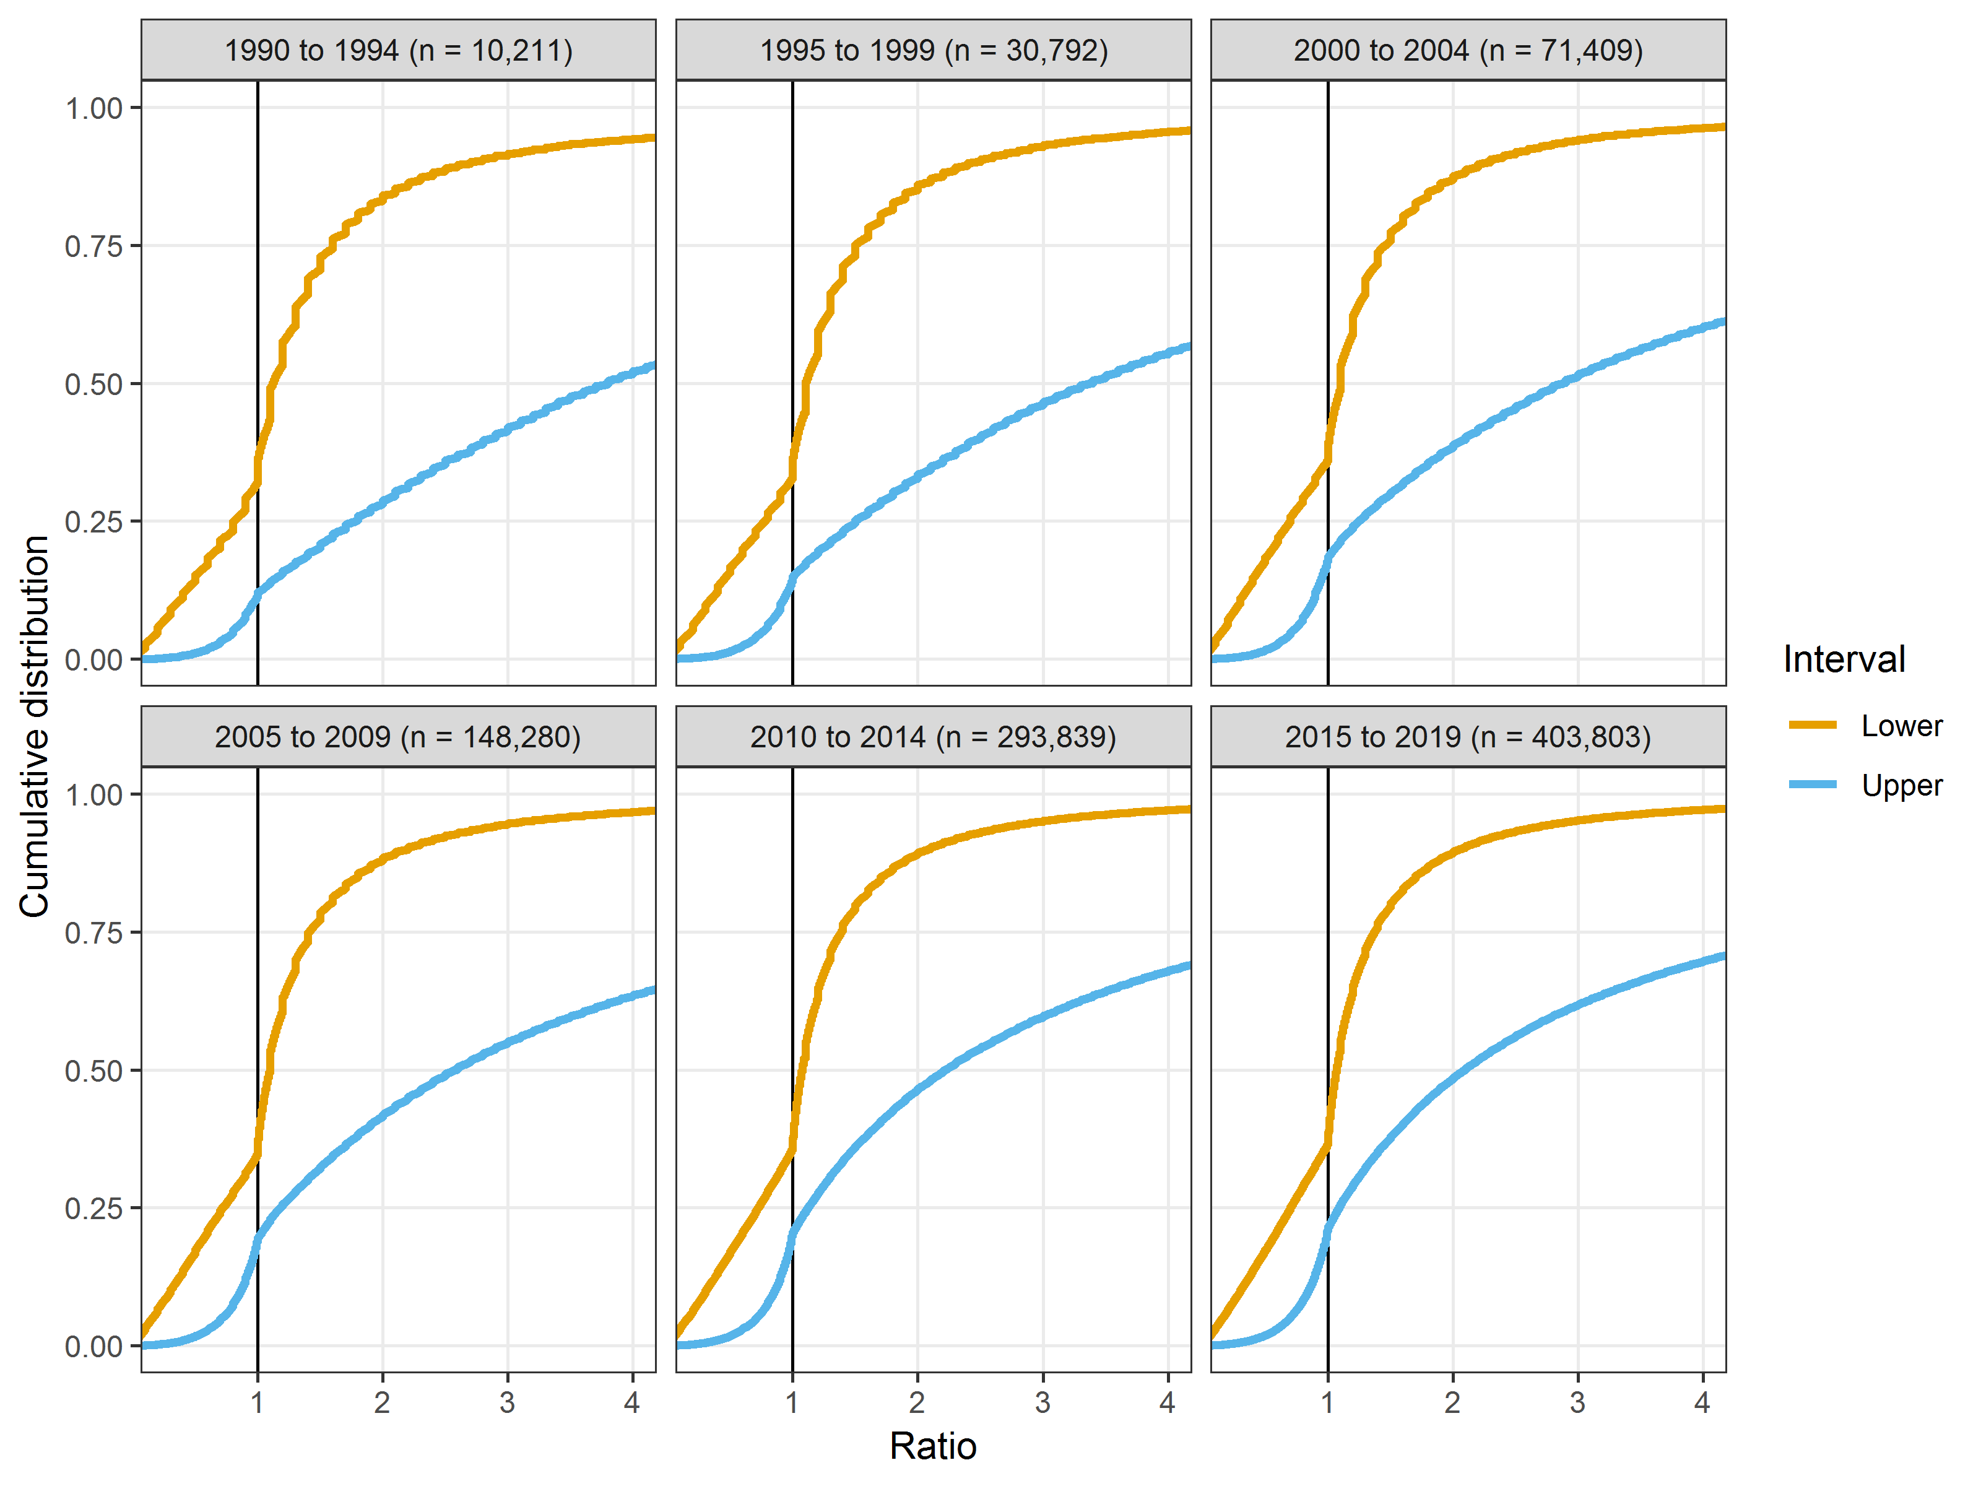

## Full-text

For the full-text data we start from the year 2000 because there are few papers available before then.

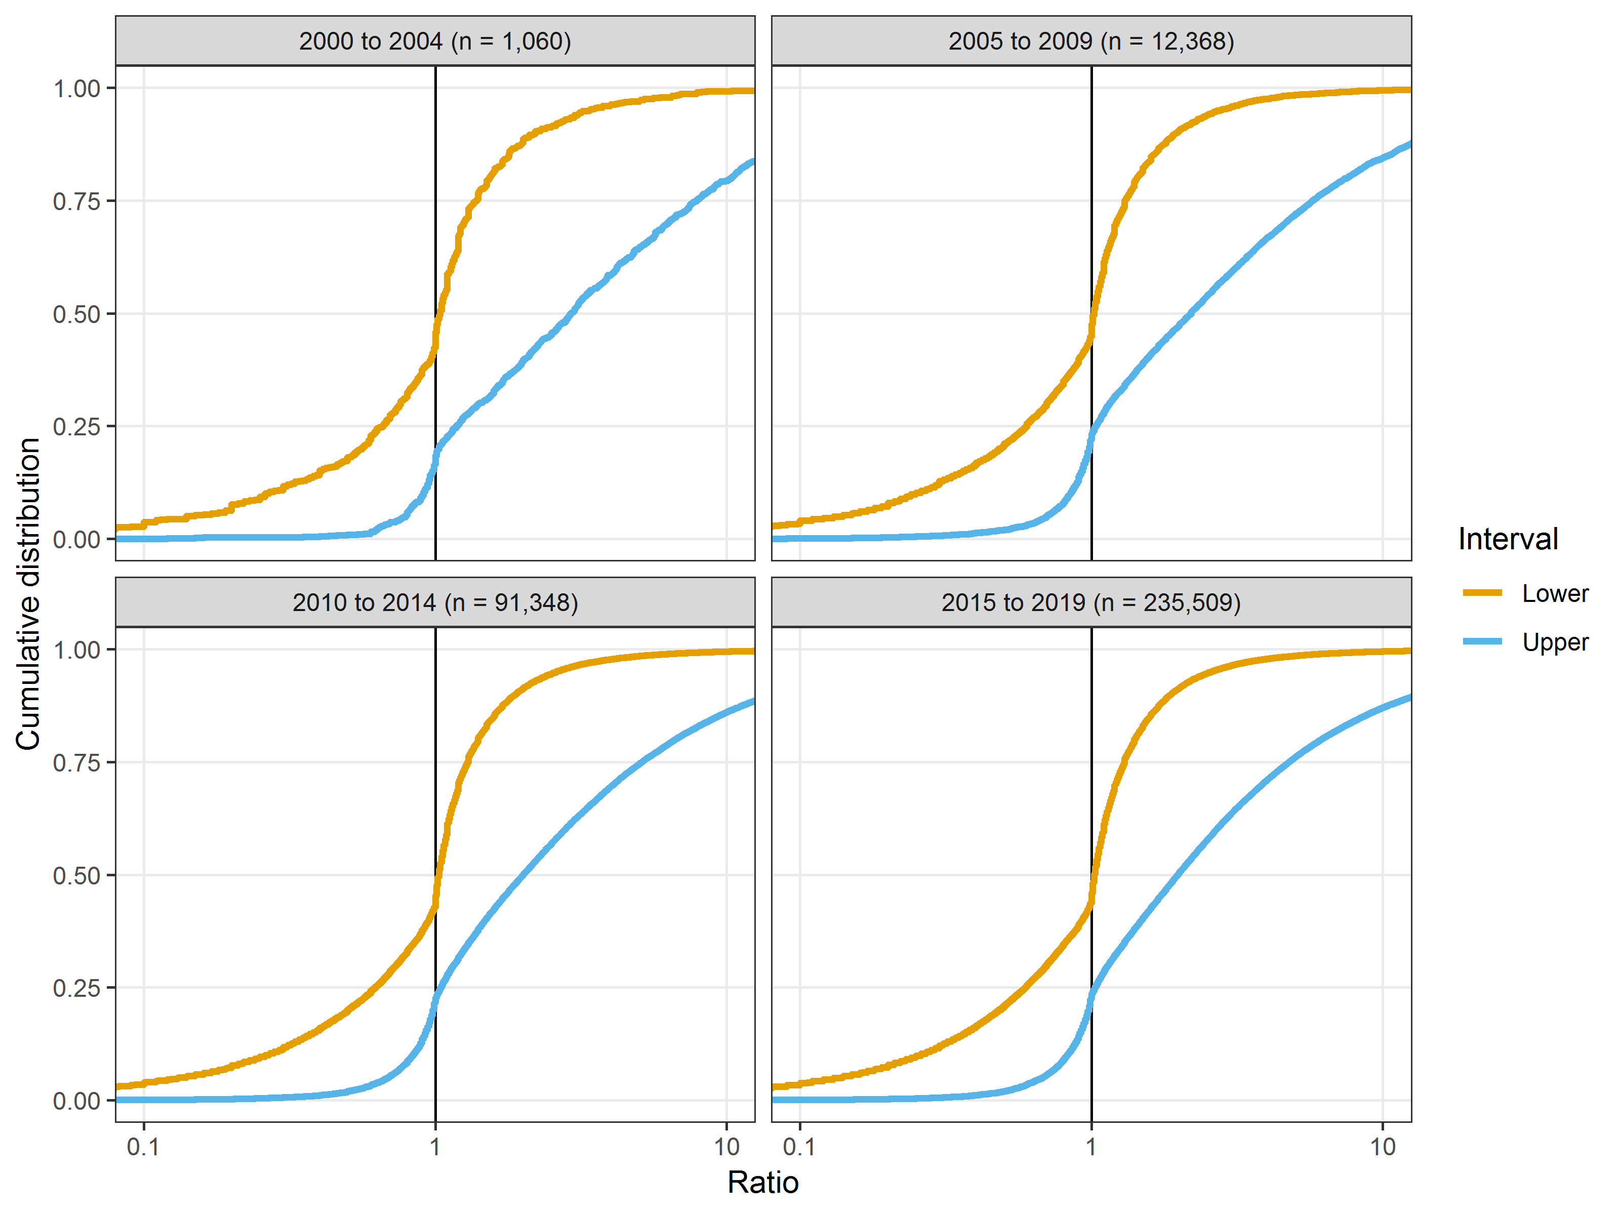

The plot shows a near identical cumulative distribution functions for each five year period.

This plot excludes 3031 intervals that were missing the year.

### Full-text intervals over time on non-log scale

Here we show the same plot but on a non-log scale restricted to the ratios of 0.25 to 4.

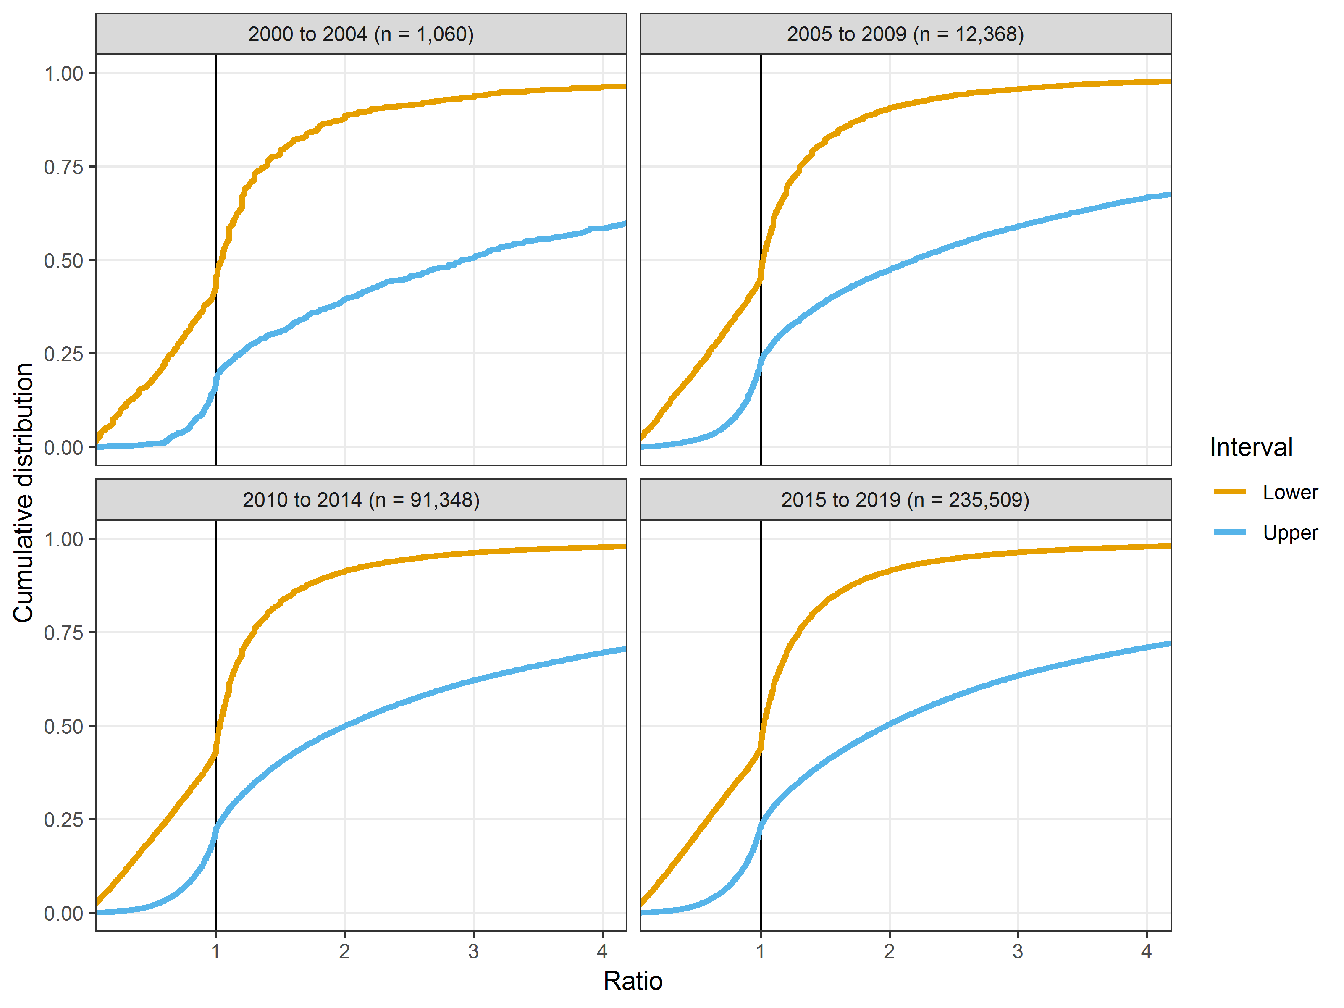

The plot shows a near identical cumulative distribution function for each five year period. The plot also shows more rounding in earlier abstracts as the more recent cumulative plots are smoother.

# Sensitivity analysis using one result per abstract

The above results make no adjustment for using repeated data from the same abstract. Here we use a sensitivity analysis to check whehter this dependence is influencing the results. We do this by randomly selecting one interval per abstract and re-creaing the plot.

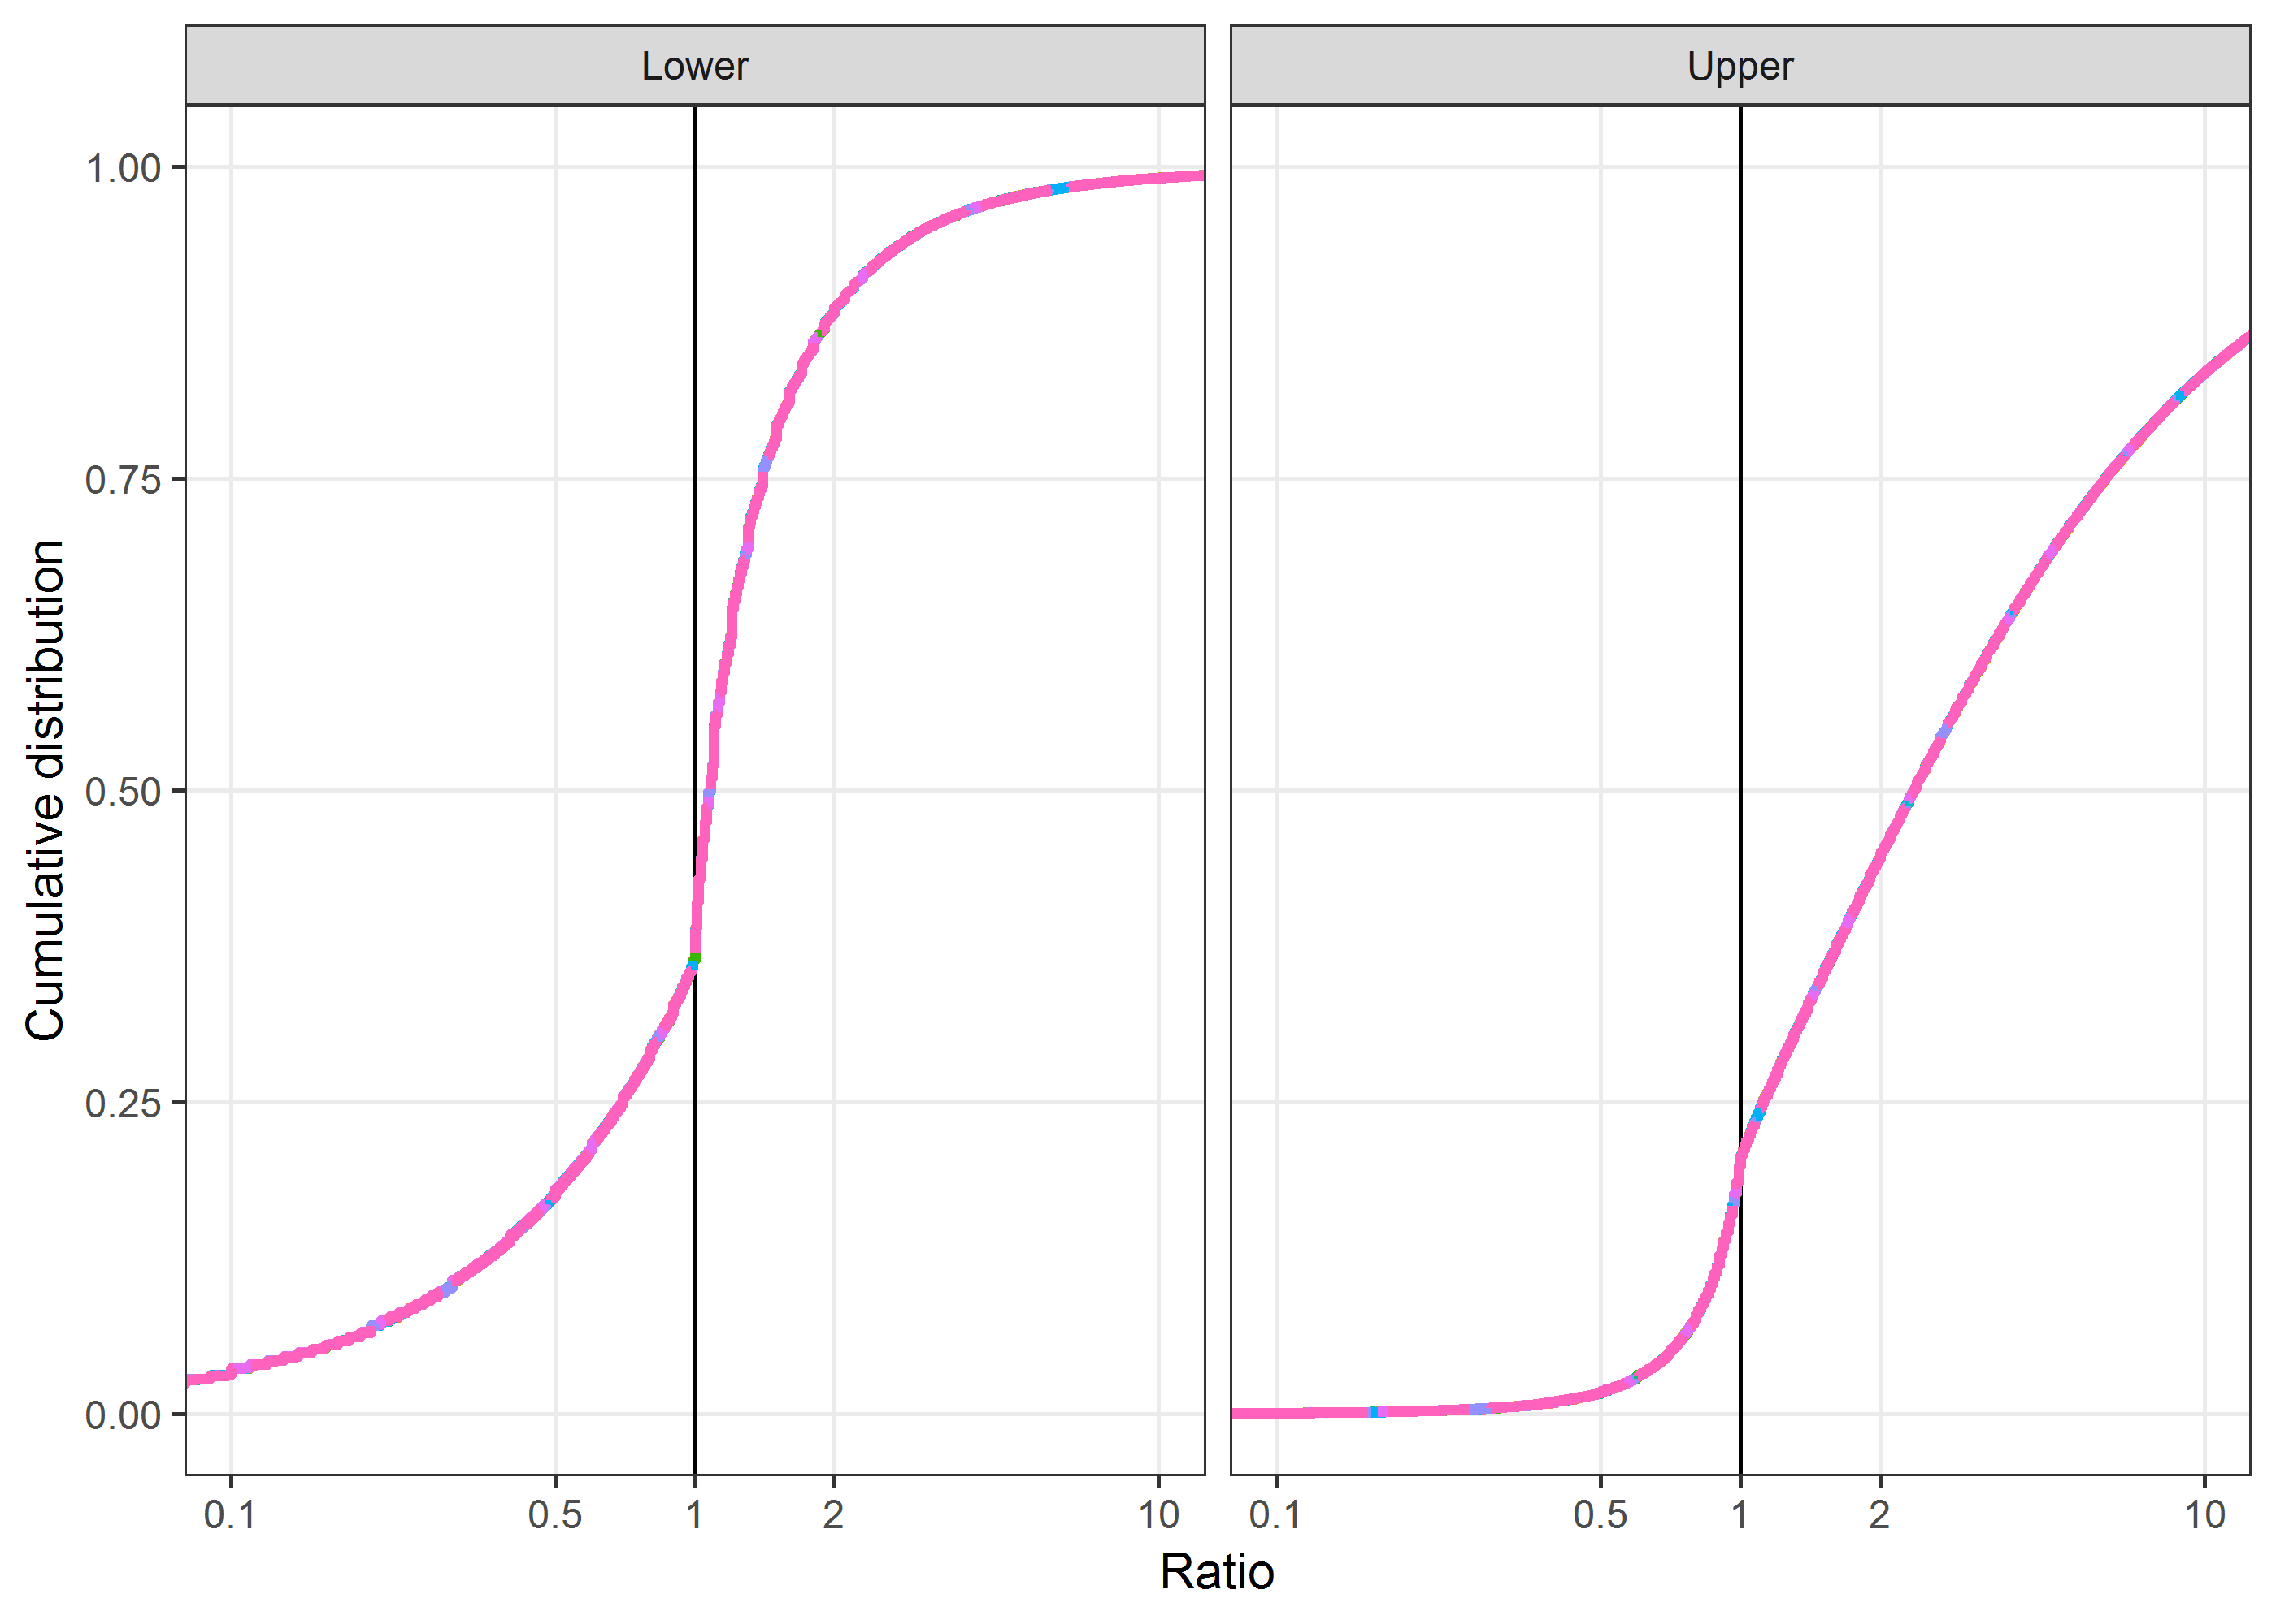

The lines were completely overlapping, showing no impact of the repeated results.

# Unbiased data from Schuemie et al

Here we examine the data from Schuemie et al which is a large unbiased sample of hazard ratios from an observational analysis of insurance data. We use 138,472 hazard ratios.

