Long-term mortality of judges: summary statistics and plots

22 March 2022

# Lexis diagram

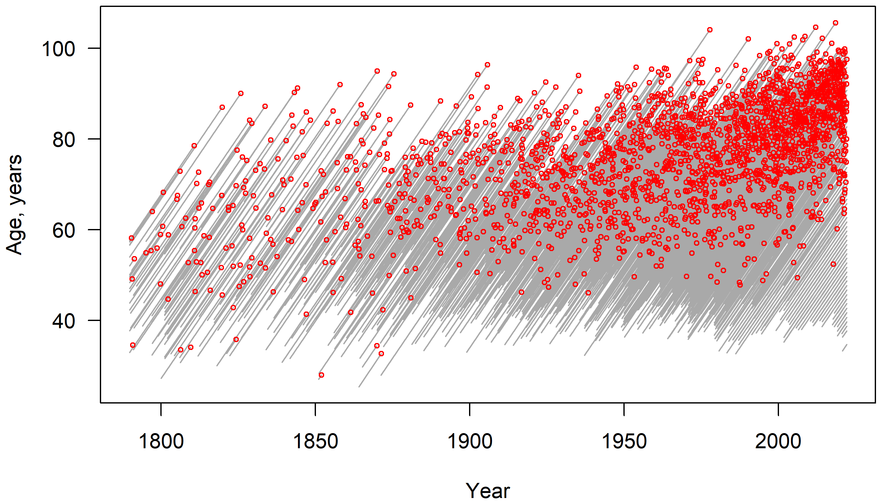

The Lexis diagram uses all the available data on judges (1789 to 2022), so including data before the life tables were available in 1850.

# Number of new judges per year

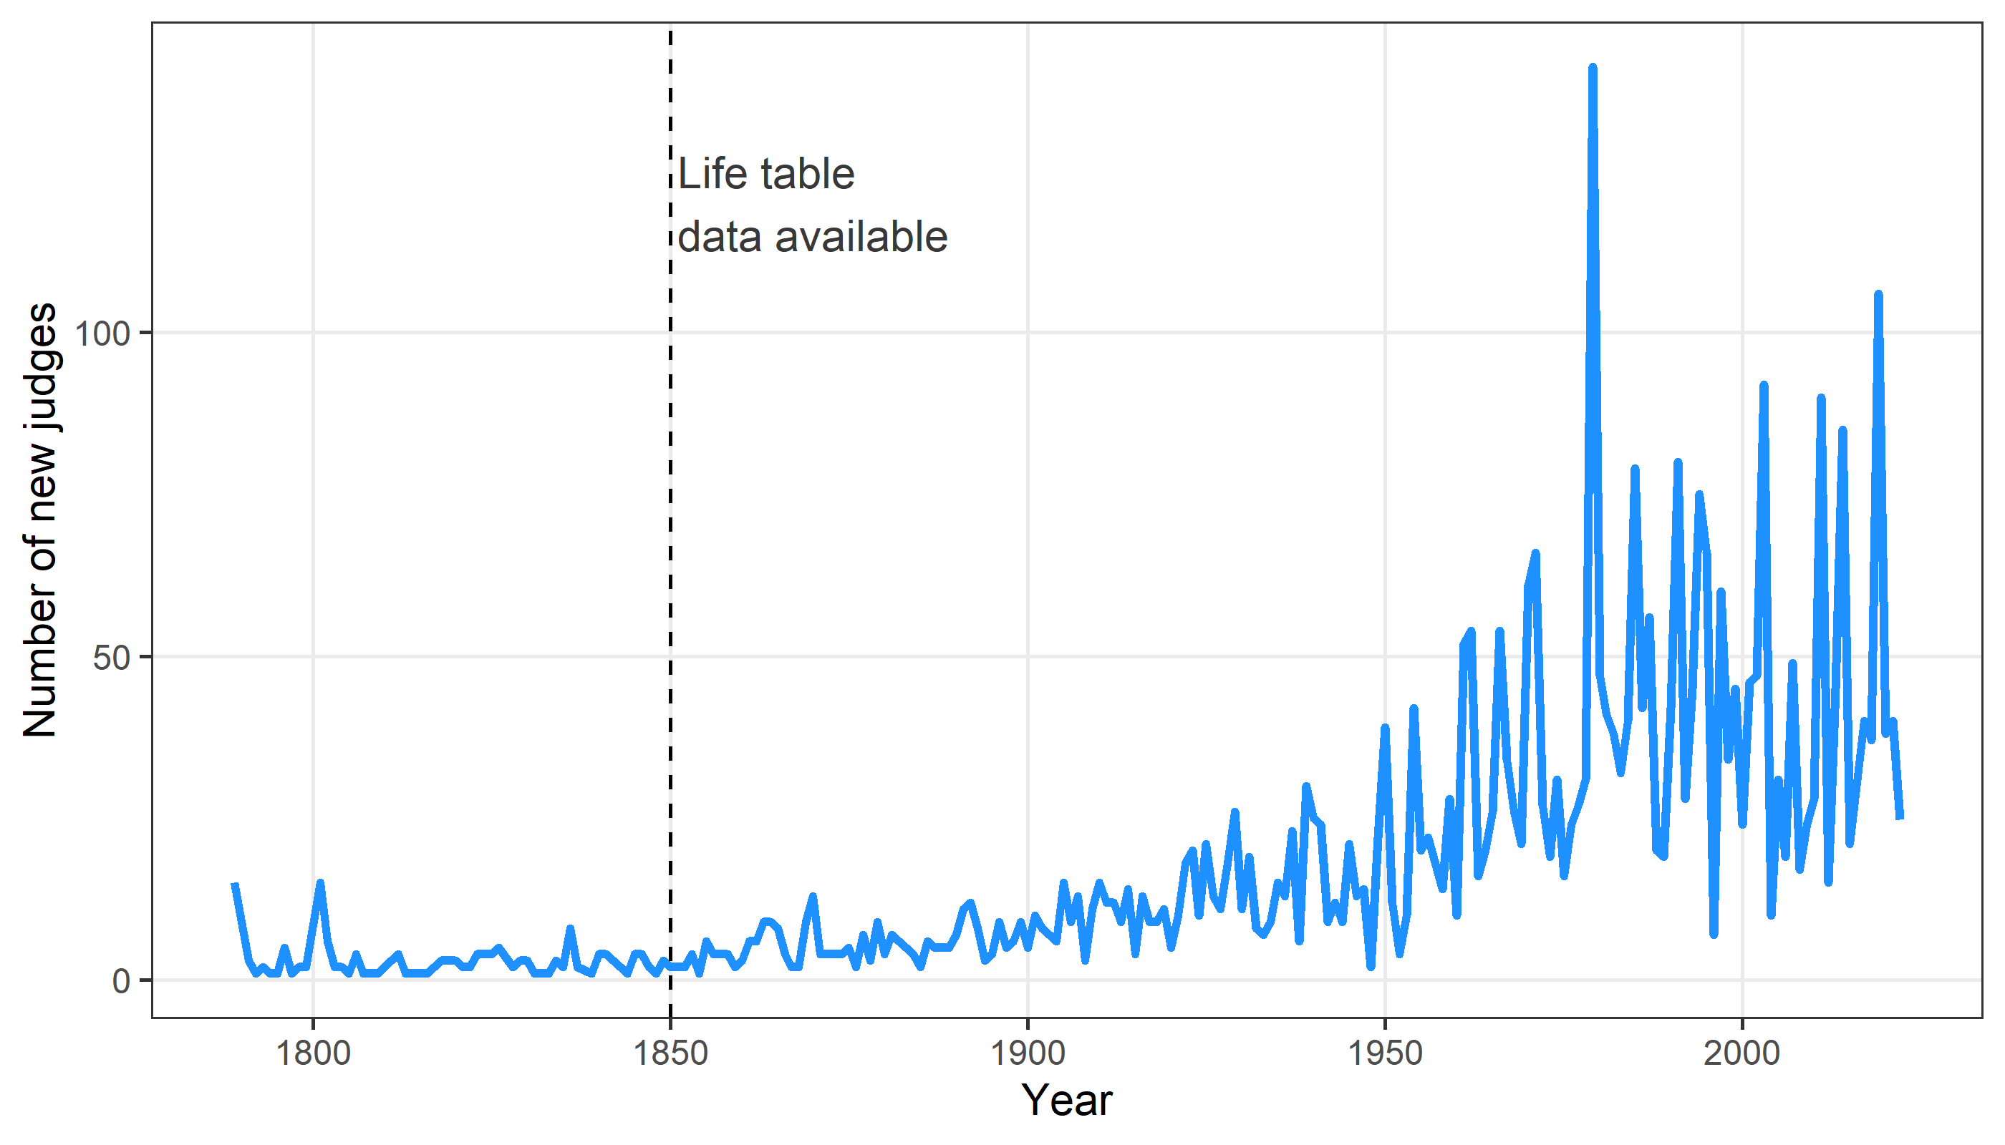

The final year (2022) is adjusted for only being a fraction of a full year.

# Age at nomination over time

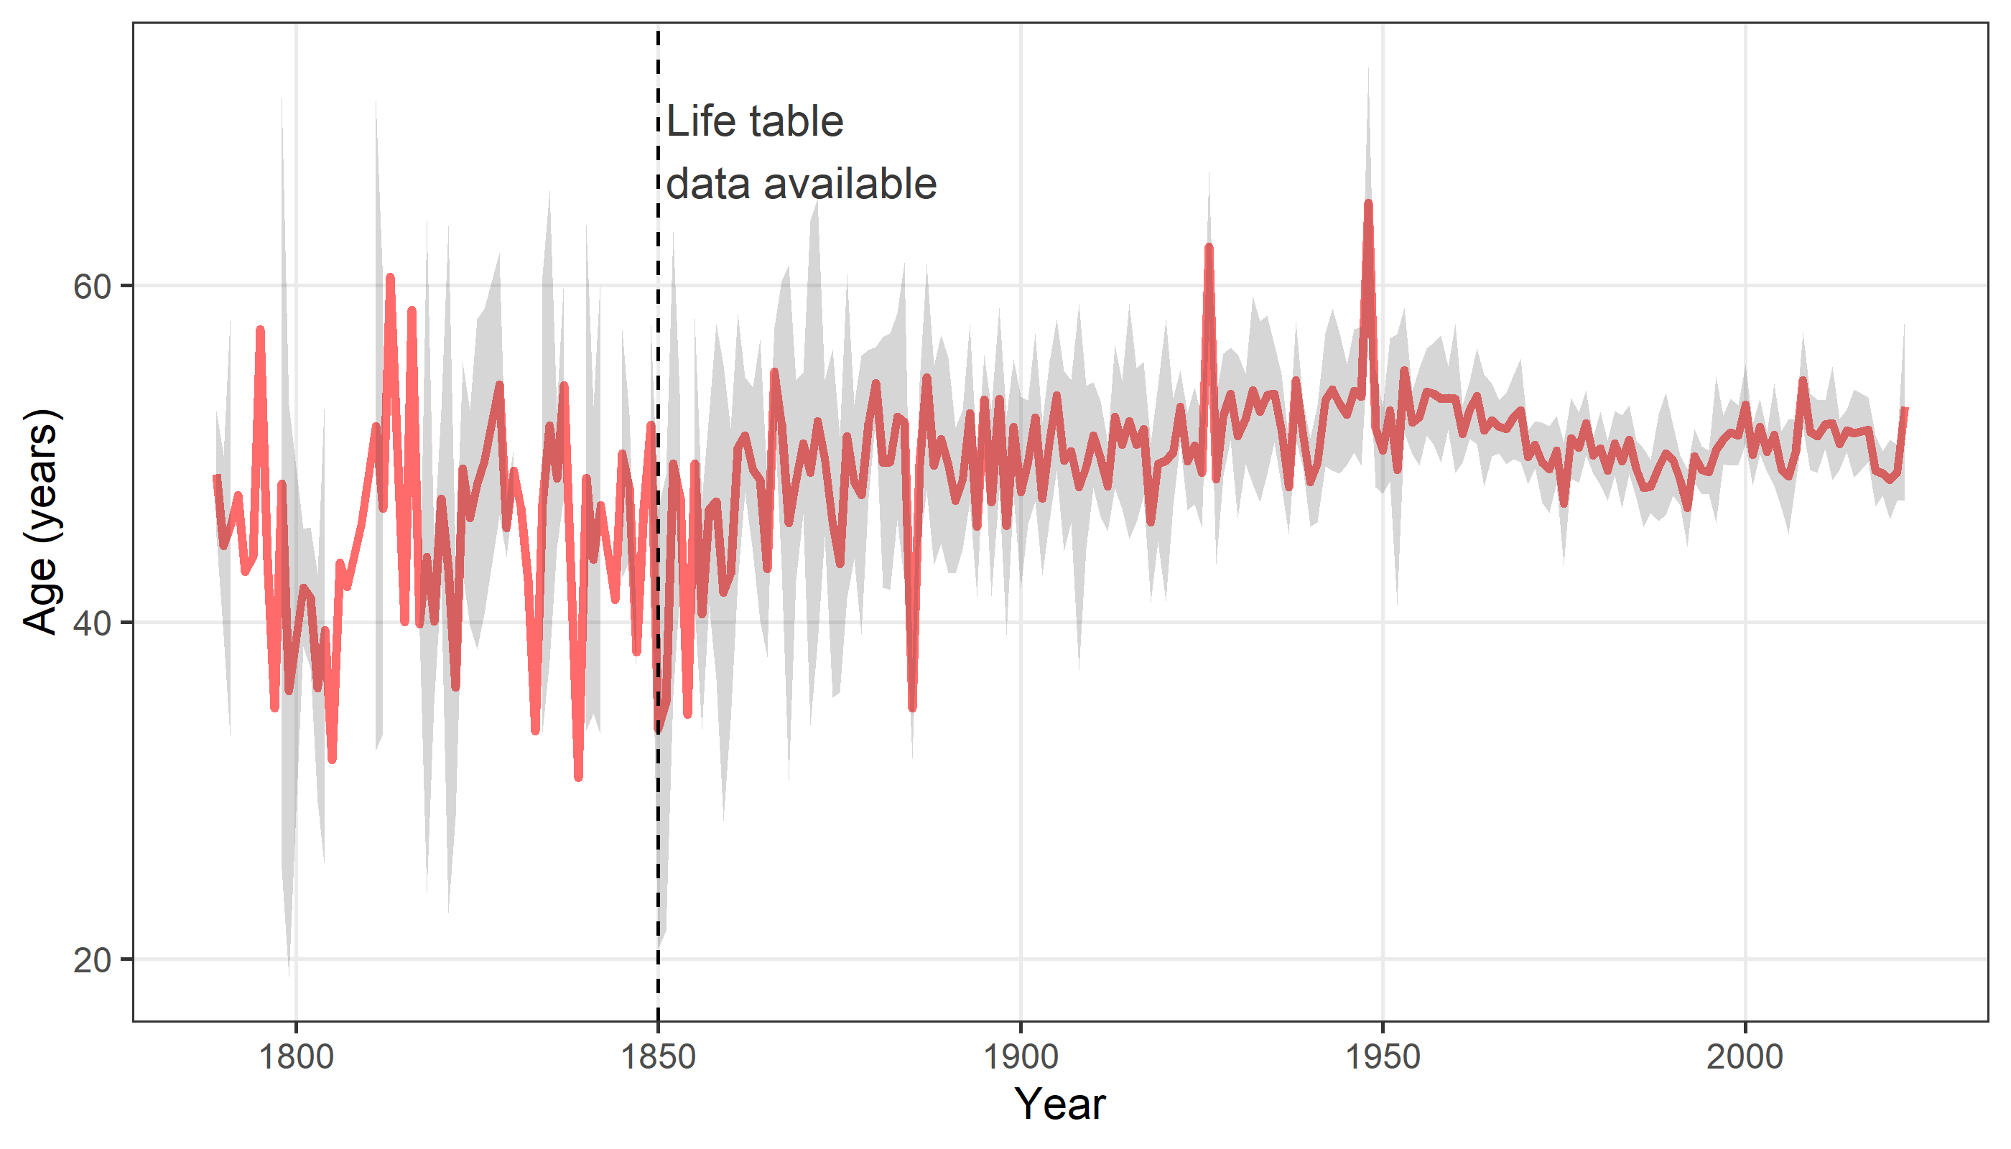

The plot shows the mean age at nomination (red line) and a 95% confidence interval for the mean (shaded area). The confindence interval does not exist in some years as there were no judges appointed.

# Death counts per year

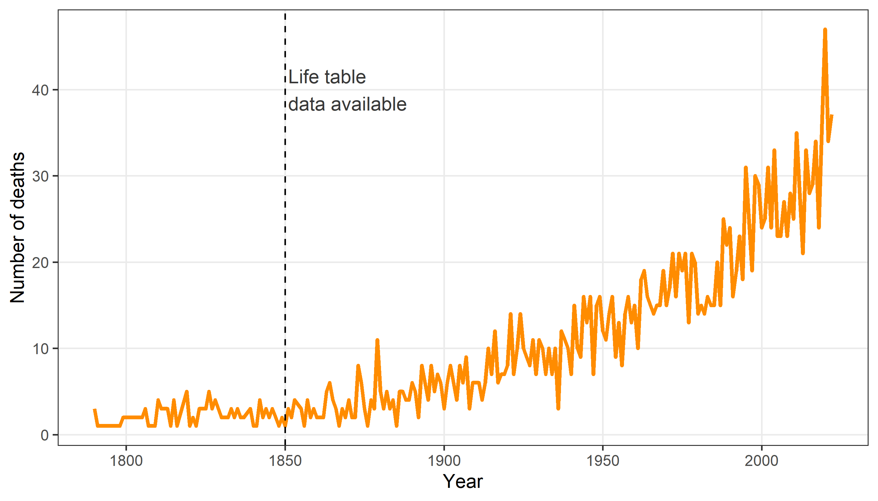

The final year (2022) is adjusted for only being a fraction of a full year.

# Age at death over time

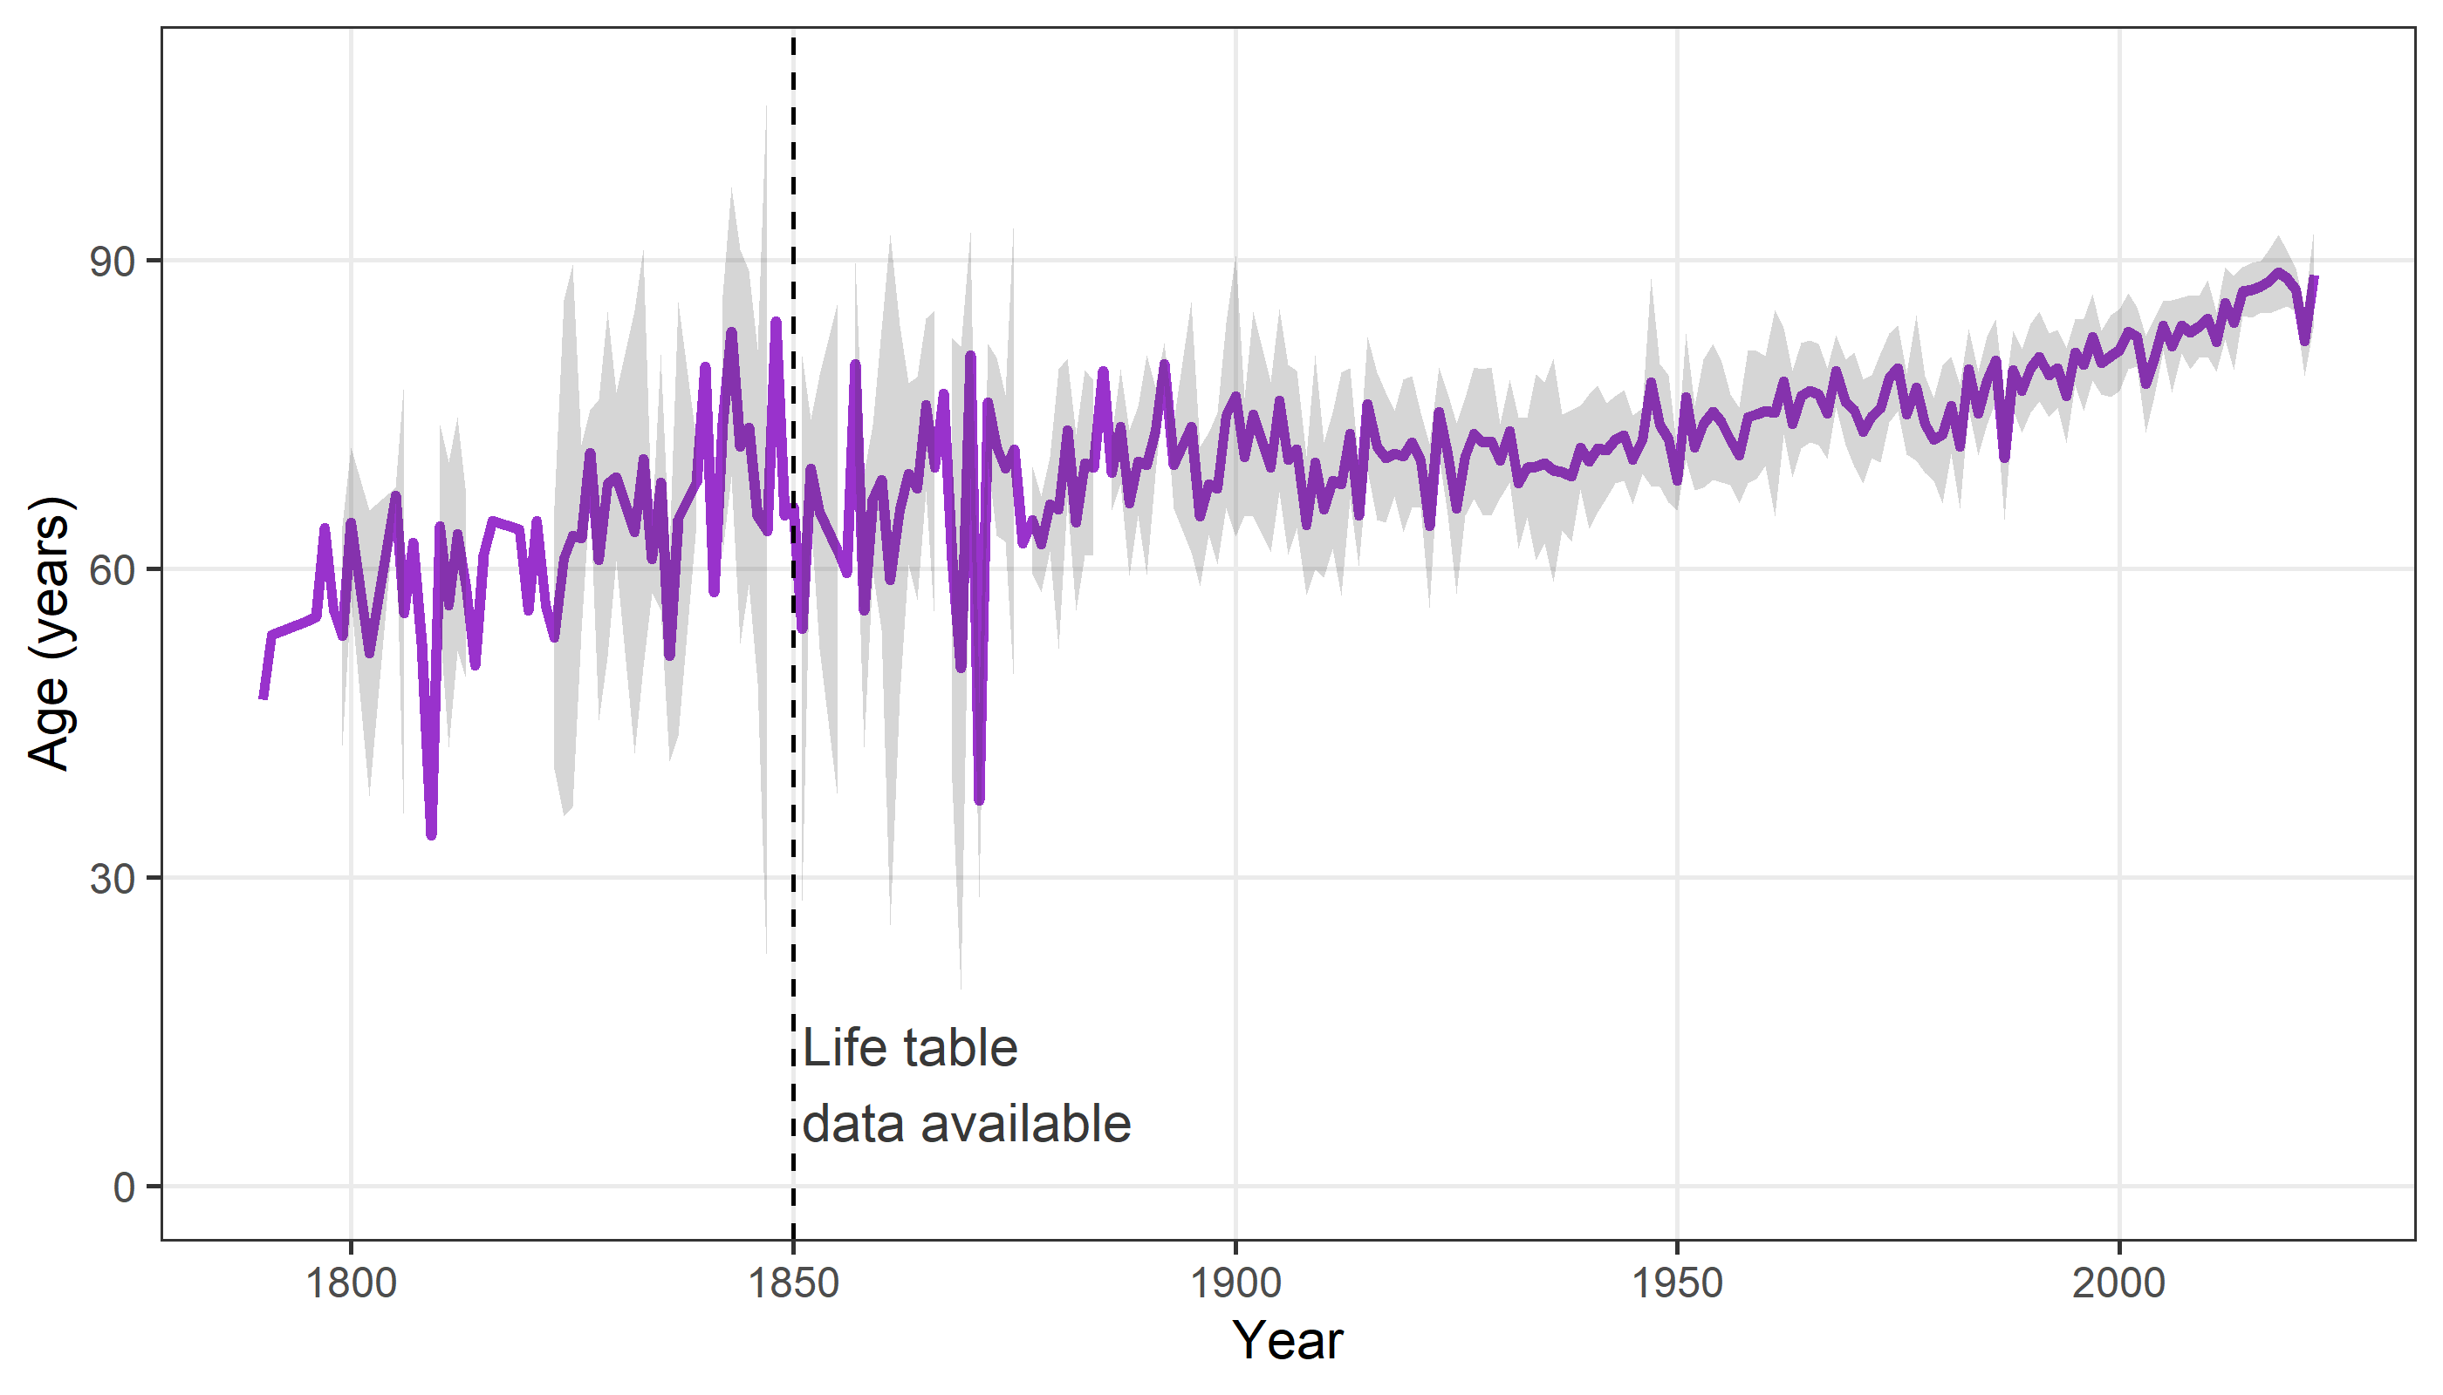

The plot shows the mean age at death (red line) and a 95% confidence interval for the mean (shaded area). The confindence interval does not exist in some years as there were no judges appointed.

# Summary statistics

For the summary statistics below, we only use judges who were at risk from 1850.

| **variable** | **min** | **q1** | **q2** | **q3** | **max** |
| --- | --- | --- | --- | --- | --- |
| Age at nomination (years) | 25 | 45 | 51 | 55 | 74 |
| Follow-up in years | 0 | 13 | 24 | 33 | 62 |
| Year of nomination | 1850 | 1950 | 1979 | 1999 | 2022 |

The total years of follow up is 86,055. There were 2081 deaths.

| **gender** | **n** | **percent** |
| --- | --- | --- |
| Female | 496 | 13 |
| Male | 3,179 | 87 |

# Average age over time

Here we examine the average age of the cohort over time.

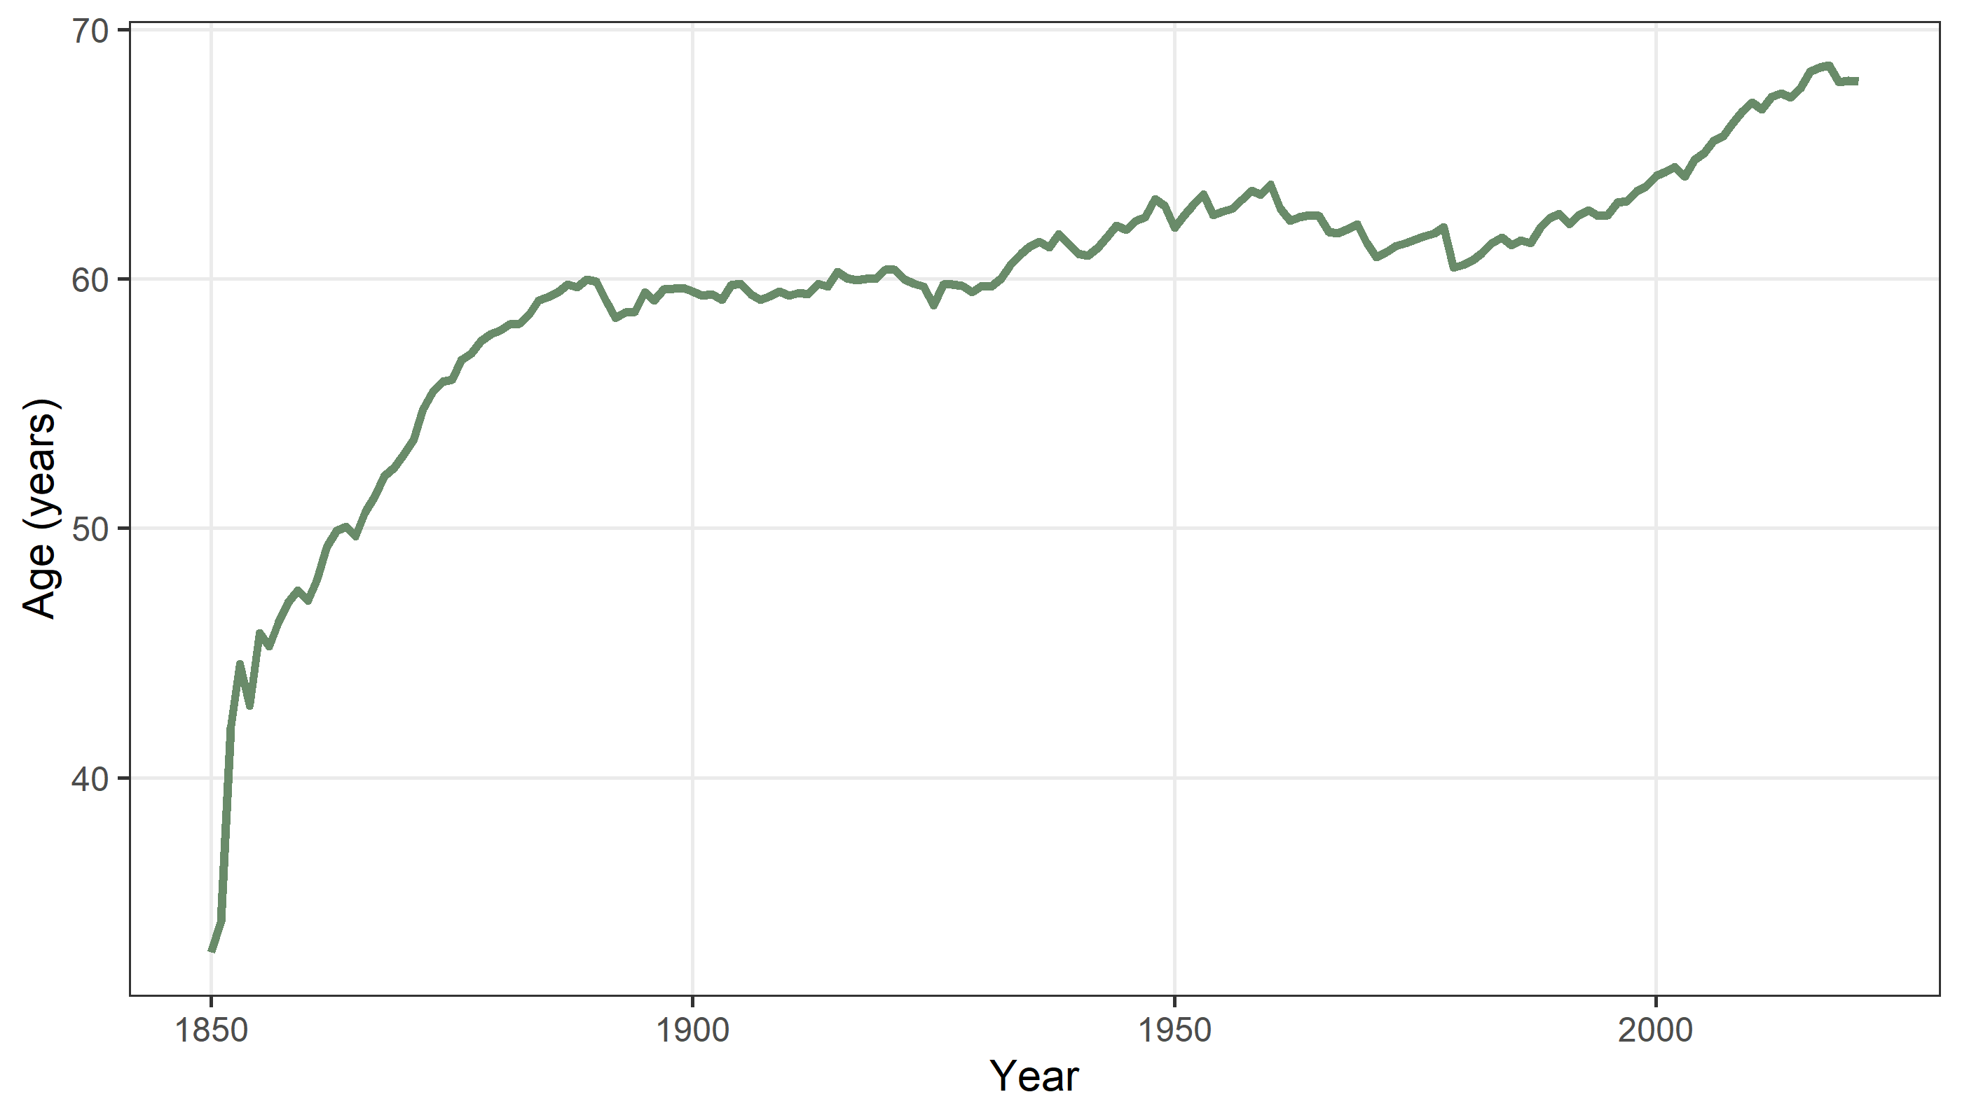

# Observed and expected deaths

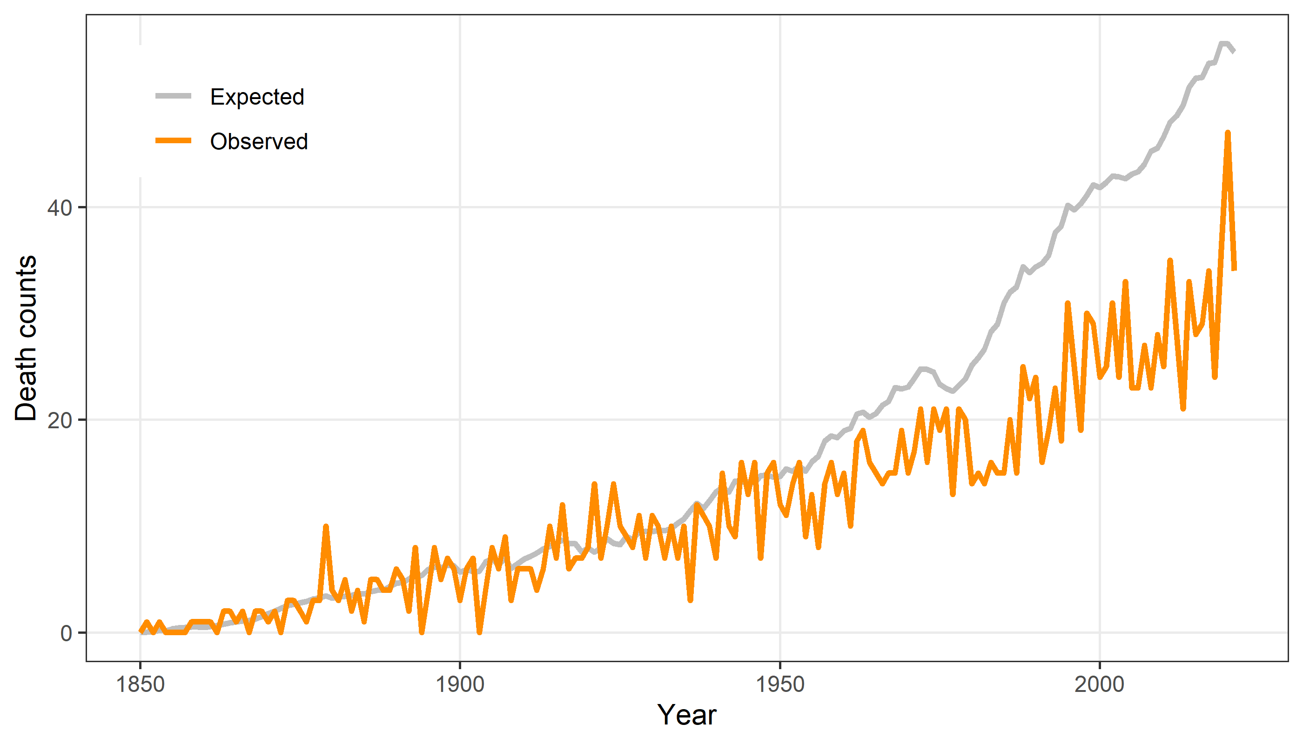

# Standardised mortality ratio

