Can we use EQUATOR citations to make a league table of good research practice?

Adrian Barnett & David Moher

29 December 2018

Our overall aim is to examine if international league tables of institutions could be updated to include a metric of good research practice, and we consider citing an EQUATOR guideline to indicate good practice. We used the CONSORT (randomised trials), PRISMA (systematic reviews) and STROBE (observational) checklists.

We used 34 papers from the journals below.

##### CONSORT

* The revised CONSORT statement for reporting randomized trials: explanation and elaboration., *Annals of internal medicine* (2001)
* The CONSORT statement: revised recommendations for improving the quality of reports of parallel-group randomized trials., *JAMA* (2001)
* The CONSORT statement: revised recommendations for improving the quality of reports of parallel-group randomised trials., *Lancet (London, England)* (2001)
* The CONSORT statement: revised recommendations for improving the quality of reports of parallel group randomized trials., *BMC medical research methodology* (2001)
* The CONSORT statement: revised recommendations for improving the quality of reports of parallel-group randomized trials., *Journal of the American Podiatric Medical Association* (2001)
* The CONSORT statement: revised recommendations for improving the quality of reports of parallel-group randomised trials., *Clinical oral investigations* (2003)
* The CONSORT Statement: revised recommendations for improving the quality of reports of parallel-group randomized trials 2001., *Explore (New York, N.Y.)* (2005)
* CONSORT 2010 statement: updated guidelines for reporting parallel group randomised trials., *BMJ (Clinical research ed.)* (2010)
* CONSORT 2010 explanation and elaboration: updated guidelines for reporting parallel group randomised trials., *BMJ (Clinical research ed.)* (2010)
* CONSORT 2010 Statement: updated guidelines for reporting parallel group randomised trials., *Trials* (2010)
* CONSORT 2010 Statement: updated guidelines for reporting parallel group randomised trials., *BMC medicine* (2010)
* CONSORT 2010 statement: updated guidelines for reporting parallel group randomized trials., *Annals of internal medicine* (2010)
* CONSORT 2010 changes and testing blindness in RCTs., *Lancet (London, England)* (2010)
* CONSORT 2010 Explanation and Elaboration: Updated guidelines for reporting parallel group randomised trials., *Journal of clinical epidemiology* (2010)
* CONSORT 2010 Statement: Updated guidelines for reporting parallel group randomised trials., *Journal of clinical epidemiology* (2010)
* CONSORT 2010 statement: updated guidelines for reporting parallel group randomised trials., *PLoS medicine* (2010)
* CONSORT 2010 statement: updated guidelines for reporting parallel group randomized trials., *Obstetrics and gynecology* (2010)
* [CONSORT 2010 Statement: updated guidelines for reporting parallel group randomised trials (Chinese version)]., *Zhong xi yi jie he xue bao : Journal of Chinese integrative medicine* (2010)
* CONSORT 2010 Statement: updated guidelines for reporting parallel group randomized trials., *Open medicine : a peer-reviewed, independent, open-access journal* (2010)
* CONSORT 2010 explanation and elaboration: updated guidelines for reporting parallel group randomised trials., *International journal of surgery (London, England)* (2012)
* CONSORT 2010 Statement: Updated guidelines for reporting parallel group randomised trials, *Italian Journal of Public Health* (2010)

##### PRISMA

* The PRISMA statement for reporting systematic reviews and meta-analyses of studies that evaluate health care interventions: explanation and elaboration., *PLoS medicine* (2009)
* The PRISMA statement for reporting systematic reviews and meta-analyses of studies that evaluate health care interventions: explanation and elaboration., *Annals of internal medicine* (2009)
* The PRISMA statement for reporting systematic reviews and meta-analyses of studies that evaluate healthcare interventions: explanation and elaboration., *BMJ (Clinical research ed.)* (2009)
* The PRISMA statement for reporting systematic reviews and meta-analyses of studies that evaluate health care interventions: explanation and elaboration., *Journal of clinical epidemiology* (2009)
* Preferred reporting items for systematic reviews and meta-analyses: the PRISMA statement., *Journal of clinical epidemiology* (2009)
* Reprint–preferred reporting items for systematic reviews and meta-analyses: the PRISMA statement., *Physical therapy* (2009)
* Preferred reporting items for systematic reviews and meta-analyses: the PRISMA statement., *International journal of surgery (London, England)* (2010)

##### STROBE

* Strengthening the Reporting of Observational Studies in Epidemiology (STROBE) statement: guidelines for reporting observational studies., *BMJ (Clinical research ed.)* (2007)
* The Strengthening the Reporting of Observational Studies in Epidemiology (STROBE) statement: guidelines for reporting observational studies., *Bulletin of the World Health Organization* (2007)
* The Strengthening the Reporting of Observational Studies in Epidemiology (STROBE) statement: guidelines for reporting observational studies., *Epidemiology (Cambridge, Mass.)* (2007)
* Strengthening the Reporting of Observational Studies in Epidemiology (STROBE): explanation and elaboration., *Epidemiology (Cambridge, Mass.)* (2007)
* The Strengthening the Reporting of Observational Studies in Epidemiology (STROBE) statement: guidelines for reporting observational studies., *Journal of clinical epidemiology* (2008)
* [The Strengthening the Reporting of Observational Studies in Epidemiology (STROBE) statement: guidelines for reporting observational studies]., *Revista espanola de salud publica* (2008)

#### Inclusion criteria

The inclusion criteria for our citing papers were:

* Articles or Reviews, in order to remove editorials, commentaries, corrections, etc.
* Published in 2016 or 2017 because league tables are based on annual data

To only include papers that adhered to the first item on the PRIMSA and CONOSRT checklists, which is to include the study design in the title, we only included:

* For PRISMA papers: “systematic search”, “systematic review”, “systematic literature review”, “scoping review”, “meta-analyses” or “meta-analysis” in the title (including versions without hyphens)
* For CONSORT papers: “randomised trial”, “randomized trial” or “RCT”.

The *Scopus* citation data were searched on 11-Dec-2018.

We use a fractional count of citations. So, for example, if a paper had two authors from universities Y and Z, then each university would get a 0.5 weight.

## Summary stats

There were 14408 papers giving a total of 47876 author affiliations that could be counted. The average number of affiliations per paper was 3.3.

### Missing data

A small number of results were missing the affiliation and/or the country. These missing results were excluded before calculating the statistics.

##### Missing affiliation

year   
 2016 2017 All   
 n n n   
 All Percent All Percent All Percent  
 Missing 121 0.5776 138 0.5125 259 0.541  
 All 20948 100.0000 26928 100.0000 47876 100.000

##### Missing country

year   
 2016 2017 All   
 n n n   
 All Percent All Percent All Percent   
 Missing 54 0.2578 73 0.2711 127 0.2653  
 All 20948 100.0000 26928 100.0000 47876 100.0000

##### Missing affiliation by country (rows ordered by number missing)

|  |  |  |  |
| --- | --- | --- | --- |
|  | Complete | Missing | Percent missing |
| Missing | 72 | 55 | 43 |
| United States | 8,064 | 39 | 0 |
| Italy | 2,644 | 22 | 1 |
| United Kingdom | 5,223 | 16 | 0 |
| Australia | 4,187 | 14 | 0 |
| Brazil | 1,609 | 12 | 1 |
| Canada | 3,817 | 12 | 0 |
| Germany | 1,606 | 12 | 1 |
| Spain | 1,306 | 10 | 1 |
| China | 4,098 | 8 | 0 |
| Other | 14,991 | 59 | 0 |
|  | 47,617 | 259 | 48 |

Here we examine whether some countries had more missing affilations than others. This could indicate a disadvantage for some countries.

## Regions by year (excluding missing regions)

The tables show the weighted counts by regions. It excludes missing regions, but includes data where the region was not missing but the affiliation was missing.

##### 2016

|  |  |
| --- | --- |
| Region | Weighted sum |
| WESTERN EUROPE | 2,459 |
| NORTHERN AMERICA | 1,521 |
| ASIA (EX. NEAR EAST) | 1,279 |
| OCEANIA | 593 |
| LATIN AMER. & CARIB | 325 |
| NEAR EAST | 86 |
| SUB-SAHARAN AFRICA | 61 |
| EASTERN EUROPE | 46 |
| NORTHERN AFRICA | 35 |
| BALTICS | 5 |

##### 2017

|  |  |
| --- | --- |
| Region | Weighted sum |
| WESTERN EUROPE | 2,986 |
| NORTHERN AMERICA | 1,807 |
| ASIA (EX. NEAR EAST) | 1,658 |
| OCEANIA | 727 |
| LATIN AMER. & CARIB | 424 |
| NEAR EAST | 109 |
| SUB-SAHARAN AFRICA | 89 |
| EASTERN EUROPE | 71 |
| NORTHERN AFRICA | 38 |
| BALTICS | 7 |

## Top ten countries by year (excluding missing countries)

The tables show the weighted counts by countries. It excludes data where the country was missing, but includes data where the country was not missing but the affiliation was missing.

##### 2016

|  |  |
| --- | --- |
| Country | Weighted sum |
| United States | 1,074 |
| China | 871 |
| United Kingdom | 719 |
| Australia | 553 |
| Canada | 440 |
| Italy | 319 |
| Netherlands | 296 |
| Brazil | 266 |
| Germany | 220 |
| Denmark | 136 |

##### 2017

|  |  |
| --- | --- |
| Country | Weighted sum |
| United States | 1,269 |
| China | 1,064 |
| United Kingdom | 827 |
| Australia | 668 |
| Canada | 526 |
| Italy | 358 |
| Netherlands | 349 |
| Brazil | 345 |
| Germany | 277 |
| Spain | 190 |

## Top 50 universities by year (including missing affiliation data)

##### 2016

|  |  |  |  |  |
| --- | --- | --- | --- | --- |
| rank | affiliation | n | wsum | standard |
| 1 | University of Toronto | 349 | 82.8 | 2 |
| 2 | University of Sydney | 234 | 75.8 | 5 |
| 3 | Missing | 121 | 47.3 | NA |
| 4 | King’s College London | 184 | 46.5 | 16 |
| 5 | Zhejiang University | 66 | 42.0 | 176 |
| 6 | University College London | 152 | 40.7 | 7 |
| 7 | Mayo Clinic | 105 | 39.7 | 38 |
| 8 | West China Hospital of Sichuan University | 73 | 39.1 | 239 |
| 9 | Erasmus University Rotterdam | 91 | 38.1 | 92 |
| 10 | University of Melbourne | 149 | 37.6 | 13 |
| 11 | Monash University | 118 | 36.8 | 20 |
| 12 | University of São Paulo | 93 | 36.4 | 1 |
| 13 | University of Ottawa | 140 | 35.8 | 68 |
| 14 | University of Oxford | 121 | 35.7 | 48 |
| 15 | University of Amsterdam | 103 | 35.7 | 35 |
| 16 | Harvard University | 150 | 35.4 | 8 |
| 17 | University Medical Center Utrecht | 82 | 34.8 | 136 |
| 18 | Københavns Universitet | 87 | 33.6 | 45 |
| 19 | University of Birmingham | 104 | 33.4 | 89 |
| 20 | University of Copenhagen | 86 | 31.1 | 76 |
| 21 | McMaster University | 131 | 31.1 | 34 |
| 22 | Imperial College London | 111 | 29.4 | 62 |
| 23 | VU University Amsterdam | 92 | 27.0 | 24 |
| 24 | University of Manchester | 83 | 26.3 | 52 |
| 25 | University of Queensland | 90 | 25.6 | 14 |
| 26 | McGill University | 81 | 25.0 | 39 |
| 27 | University of Alberta | 92 | 24.9 | 31 |
| 28 | Johns Hopkins University | 94 | 24.4 | 21 |
| 29 | Sun Yat-sen University | 47 | 24.2 | 162 |
| 30 | University of Calgary | 68 | 24.1 | 94 |
| 31 | Radboud University | 67 | 23.8 | 69 |
| 32 | Shanghai Jiao Tong University | 43 | 22.7 | 96 |
| 33 | Chongqing Medical University | 31 | 22.1 | 633 |
| 34 | Università degli Studi di Roma La Sapienza | 61 | 22.1 | 130 |
| 35 | University of British Columbia | 62 | 20.3 | 29 |
| 36 | Katholieke Universiteit Leuven | 92 | 19.8 | 33 |
| 37 | La Trobe University | 47 | 19.8 | 128 |
| 38 | University of Newcastle, Australia | 55 | 19.7 | 42 |
| 39 | Nanjing Medical University | 35 | 19.6 | 327 |
| 40 | Stanford University | 73 | 19.2 | 46 |
| 41 | Huazhong University of Science and Technology | 27 | 18.9 | 439 |
| 42 | Maastricht University | 64 | 18.9 | 58 |
| 43 | University of Nottingham | 51 | 18.9 | 144 |
| 44 | Columbia University | 56 | 18.9 | 26 |
| 45 | University of Bristol | 63 | 18.2 | 119 |
| 46 | University of New South Wales | 78 | 17.9 | 134 |
| 47 | University of Athens | 47 | 17.9 | 73 |
| 48 | University of Sheffield | 48 | 17.6 | 101 |
| 49 | Guangxi Medical University | 26 | 17.5 | 1,123 |
| 50 | University of Wollongong | 31 | 17.4 | 216 |

##### 2017

|  |  |  |  |  |
| --- | --- | --- | --- | --- |
| rank | affiliation | n | wsum | standard |
| 1 | University of Toronto | 414 | 97.4 | 1 |
| 2 | University of Sydney | 197 | 67.2 | 5 |
| 3 | West China Hospital of Sichuan University | 96 | 56.7 | 206 |
| 4 | Missing | 138 | 56.6 | NA |
| 5 | University College London | 185 | 53.8 | 8 |
| 6 | King’s College London | 188 | 50.3 | 12 |
| 7 | Harvard University | 221 | 50.1 | 8 |
| 8 | University of Ottawa | 218 | 47.4 | 95 |
| 9 | Monash University | 170 | 47.2 | 25 |
| 10 | University of Oxford | 146 | 46.8 | 64 |
| 11 | University of Melbourne | 167 | 43.7 | 11 |
| 12 | University of Queensland | 129 | 41.5 | 16 |
| 13 | University of Amsterdam | 123 | 40.0 | 34 |
| 14 | University of São Paulo | 83 | 39.5 | 2 |
| 15 | Mayo Clinic | 107 | 37.8 | 31 |
| 16 | University of British Columbia | 104 | 36.3 | 34 |
| 17 | Zhejiang University | 64 | 36.1 | 256 |
| 18 | McMaster University | 174 | 35.7 | 42 |
| 19 | University of New South Wales | 118 | 34.4 | 92 |
| 20 | Johns Hopkins University | 115 | 34.0 | 22 |
| 21 | VU University Amsterdam | 109 | 32.1 | 23 |
| 22 | Sun Yat-sen University | 64 | 31.6 | 148 |
| 23 | University of Groningen | 92 | 30.4 | 20 |
| 24 | Imperial College London | 116 | 30.1 | 60 |
| 25 | University of Copenhagen | 102 | 29.9 | 68 |
| 26 | University of Birmingham | 79 | 29.2 | 99 |
| 27 | Erasmus University Rotterdam | 88 | 29.0 | 111 |
| 28 | University of North Carolina, Chapel Hill | 78 | 28.5 | 4 |
| 29 | University of Manchester | 96 | 28.3 | 72 |
| 30 | Københavns Universitet | 68 | 27.6 | 41 |
| 31 | University Medical Center Utrecht | 67 | 27.1 | 143 |
| 32 | University of Calgary | 72 | 26.8 | 111 |
| 33 | University of Alberta | 74 | 25.6 | 39 |
| 34 | Maastricht University | 81 | 25.3 | 52 |
| 35 | Huazhong University of Science and Technology | 38 | 25.2 | 452 |
| 36 | London School of Hygiene & Tropical Medicine | 86 | 25.0 | 411 |
| 37 | McGill University | 93 | 24.6 | 40 |
| 38 | Radboud University | 76 | 23.5 | 58 |
| 39 | Western University | 69 | 23.2 | 104 |
| 40 | University of Newcastle, Australia | 81 | 23.0 | 44 |
| 41 | University of Adelaide | 65 | 21.9 | 124 |
| 42 | Guangxi Medical University | 40 | 21.5 | 1,806 |
| 43 | University of Sheffield | 61 | 21.5 | 89 |
| 44 | Federal University of Rio Grande do Sul - UFRGS | 54 | 21.3 | 77 |
| 45 | Wuhan University | 36 | 20.9 | 390 |
| 46 | Università degli Studi di Roma La Sapienza | 63 | 20.7 | 139 |
| 47 | University of Bristol | 72 | 20.7 | 116 |
| 48 | Katholieke Universiteit Leuven | 79 | 20.6 | 30 |
| 49 | Nanjing Medical University | 43 | 20.5 | 374 |
| 50 | Peking University | 48 | 20.3 | 92 |

### Correlation of good practice and standard ranks

This is restricted to universities with a standard rank below 2000.

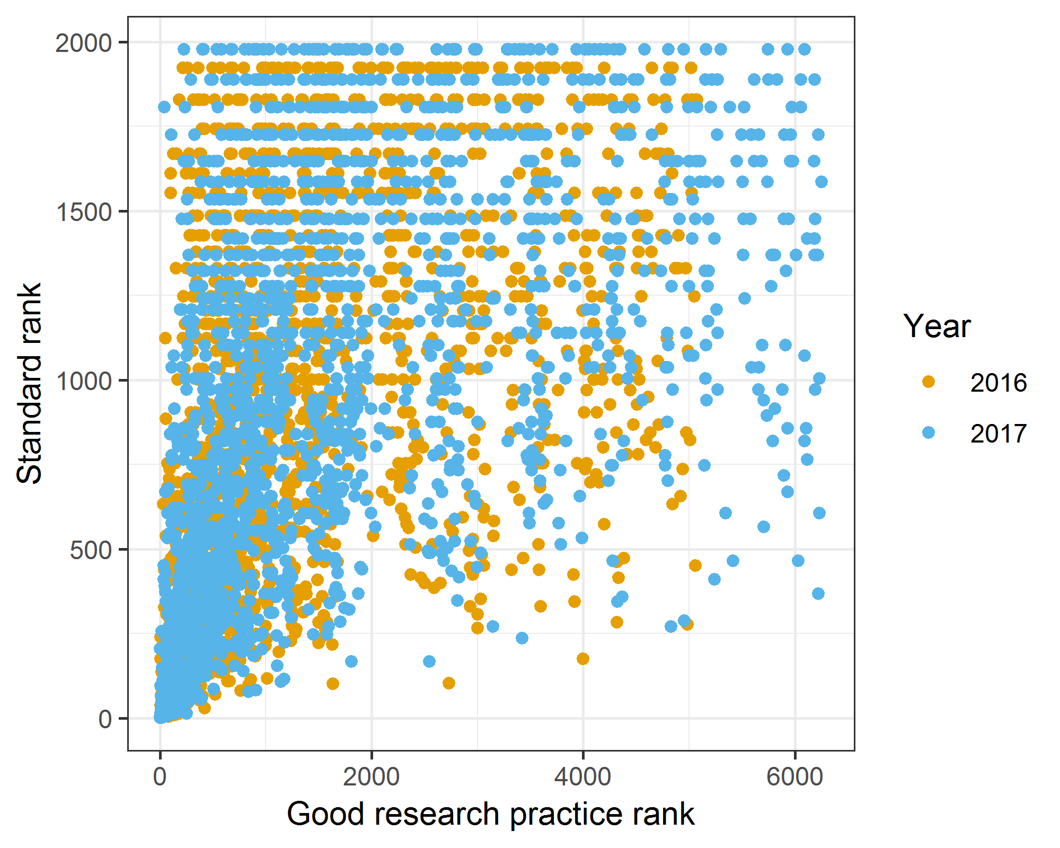

The Spearman’s correlation is 0.59.

##### Bland-Altman plot of the university rank

The plot looks at institution ranking only for those in the top 200.

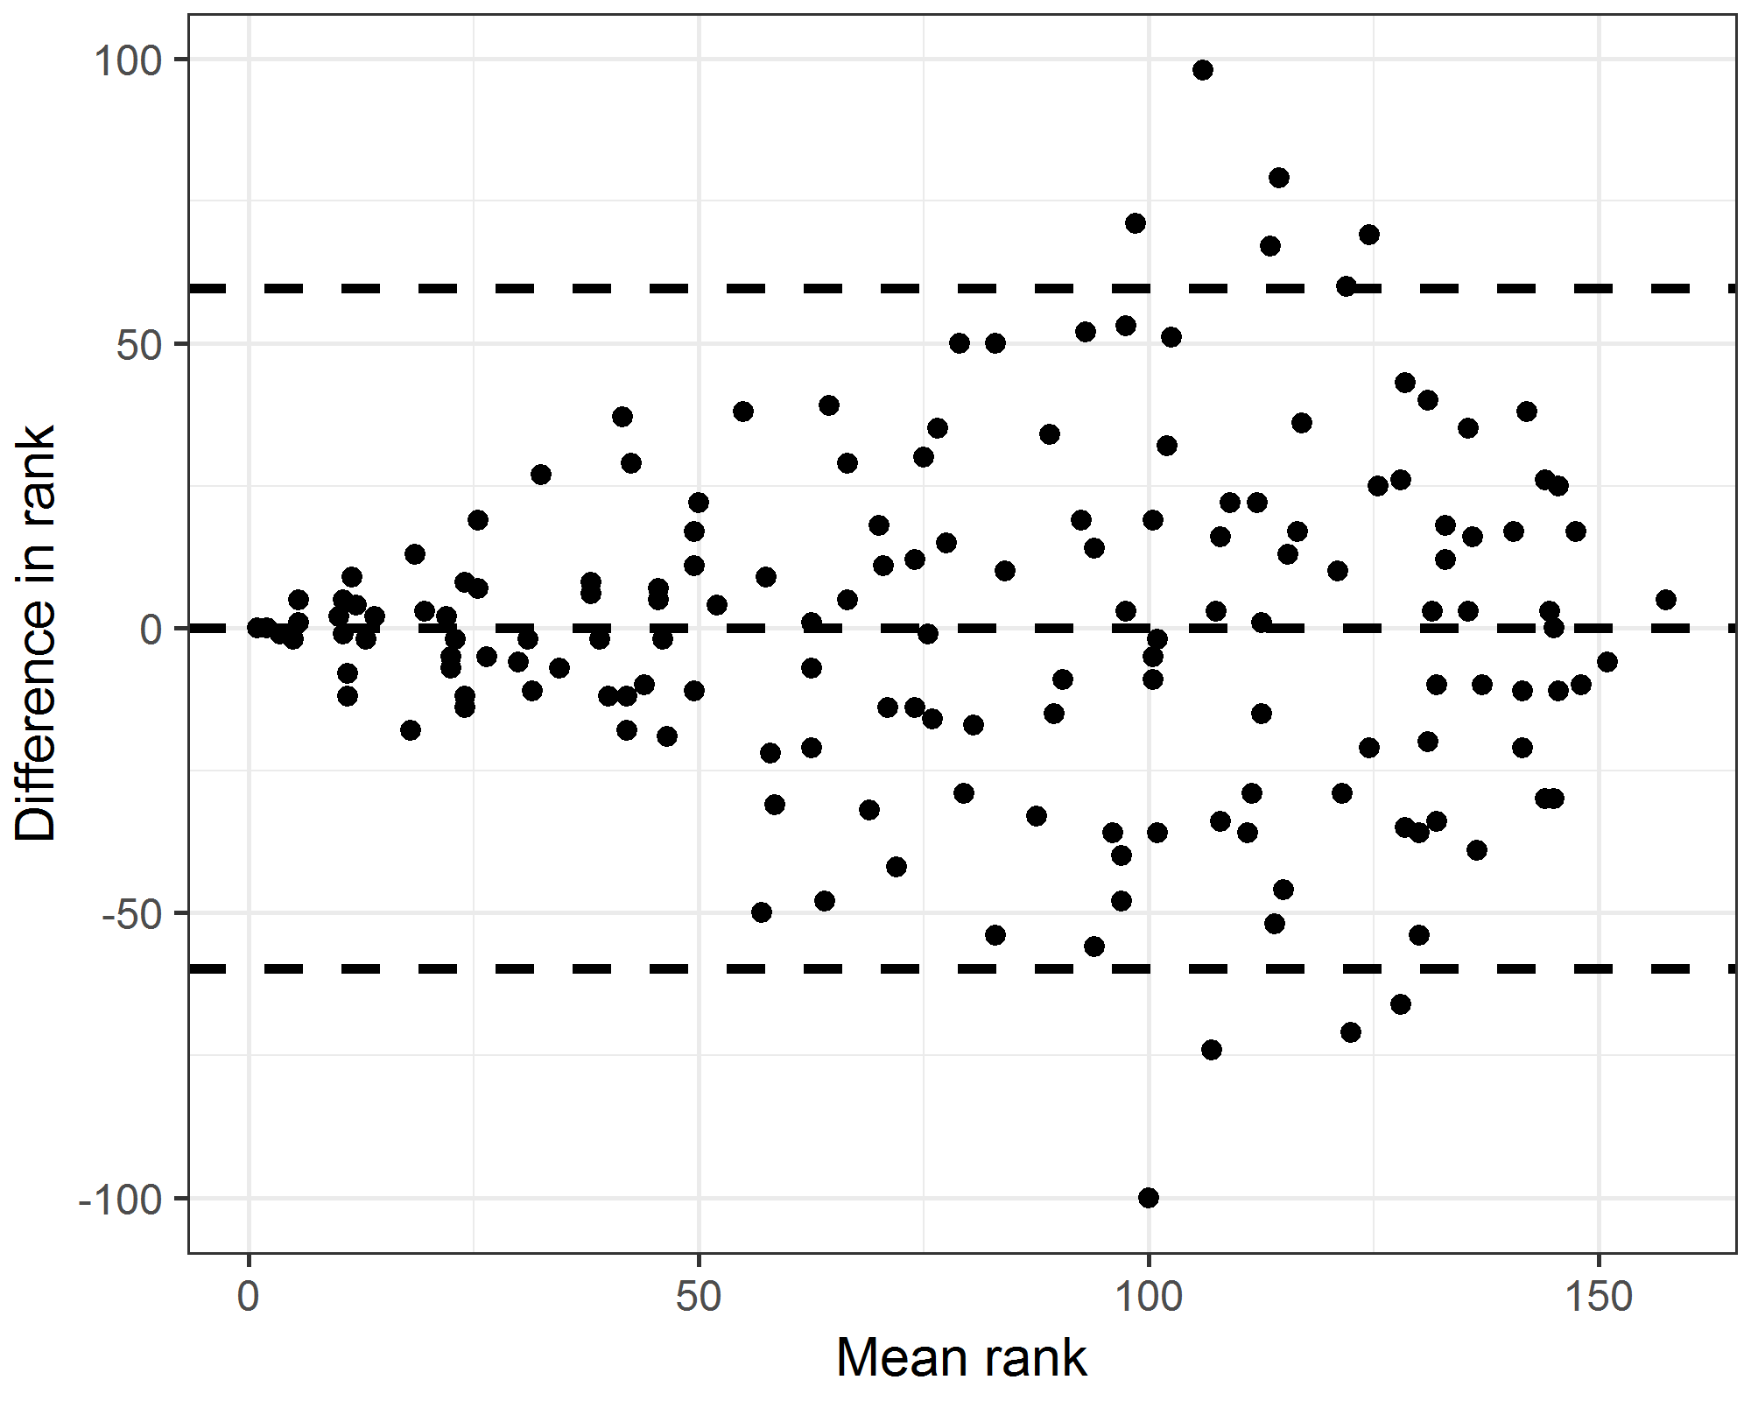

There were 161 universities in the top 200 in both years. The plot includes the limits of agreement which are -60 to 60.

##### Examine those insitutions with a very large change (over 90)

|  |  |  |  |  |  |  |  |  |  |  |  |  |
| --- | --- | --- | --- | --- | --- | --- | --- | --- | --- | --- | --- | --- |
| affiliation | wsum.x | n.x | rank.x | sum.x | standard.x | wsum.y | n.y | rank.y | sum.y | standard.y | diff | mean |
| University of Liverpool | 7 | 23 | 155 | 81 | 366 | 19 | 54 | 57 | 92 | 345 | 98 | 106 |
| University of Wollongong | 17 | 31 | 50 | 123 | 216 | 9 | 19 | 150 | 140 | 194 | -100 | 100 |

The table shows those institutions that had a change in rank of over 90. The first three columns are for 2016 and the next three for 2017.

##### List the papers from insitutions with a very large change

### Score distributions for universities

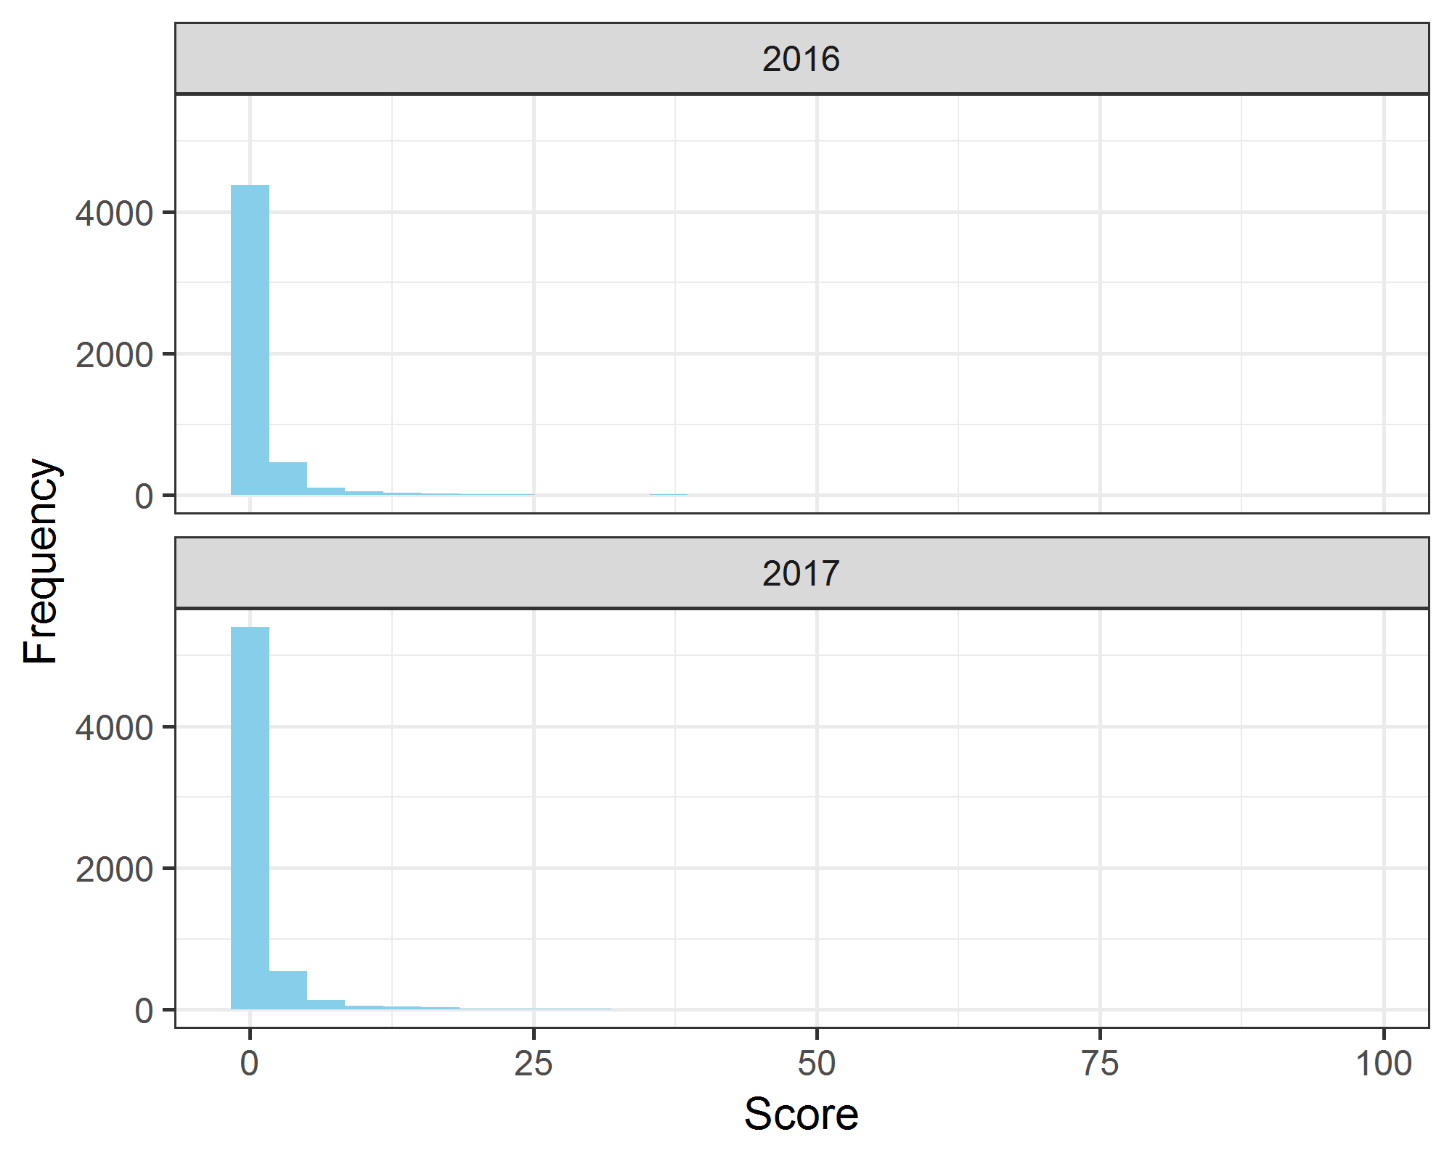

These histrograms use 11,345 scores across 2016 and 2017.

##### Boxplot of scores by year

The y-axis is on a log base-2 scale.

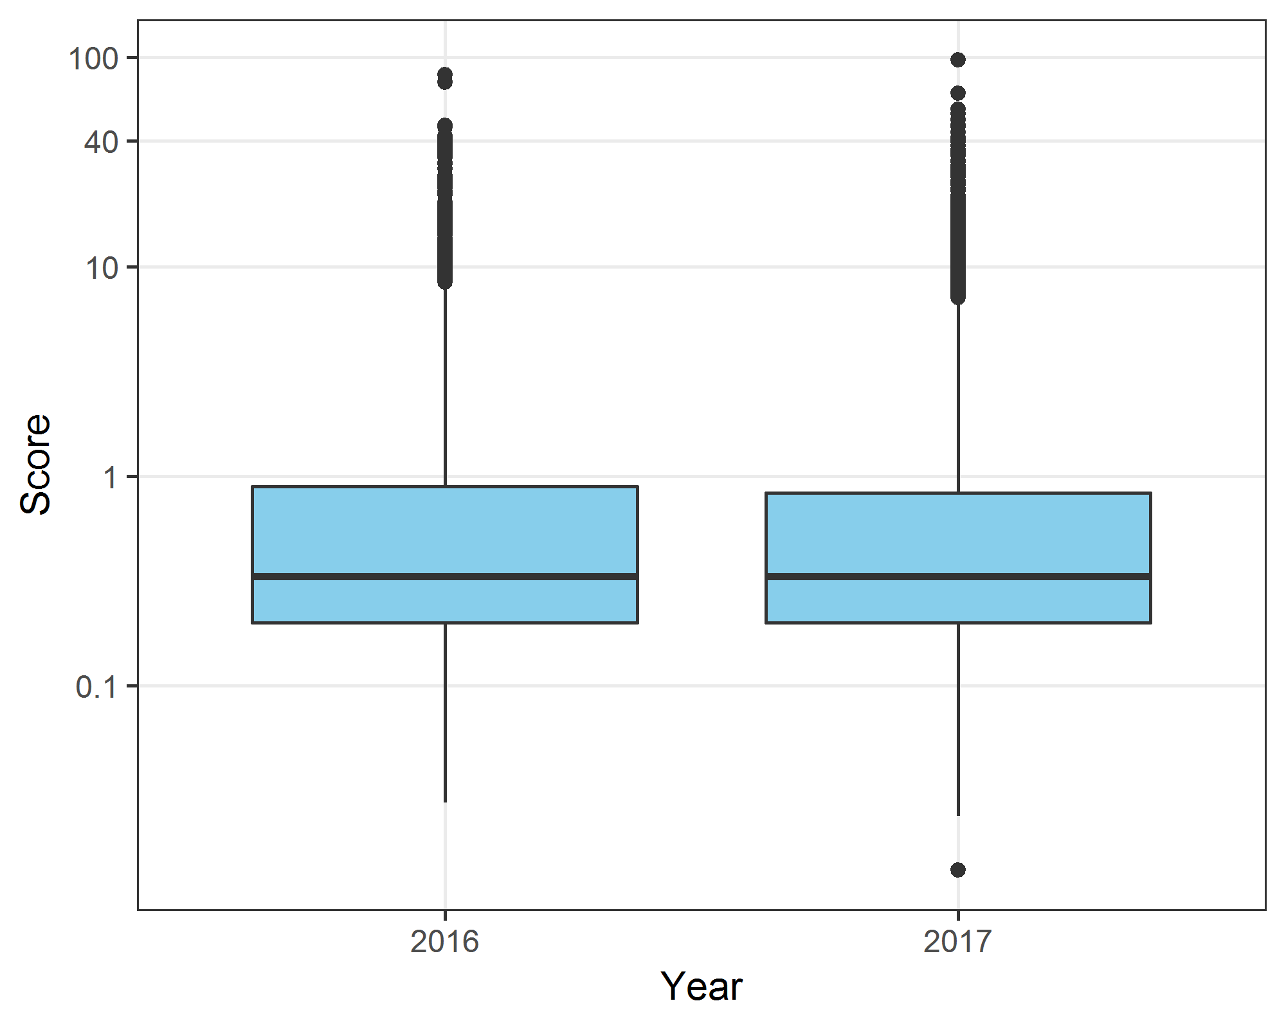

These boxplots use 11,345 scores across 2016 and 2017.

## Times Higher Education

Here we examine the Times Higher Education (THE) data for 2016 and 2017. The league table is called the “THE World University Rankings”.

##### Bland-Altman plot of the institute rank for THE World University Rankings data

The plot looks at institution ranking only for those in the top 200. A higher rank indicates higher prestige. There is a clear “funnel” to the plot, with less movement at higher ranks.

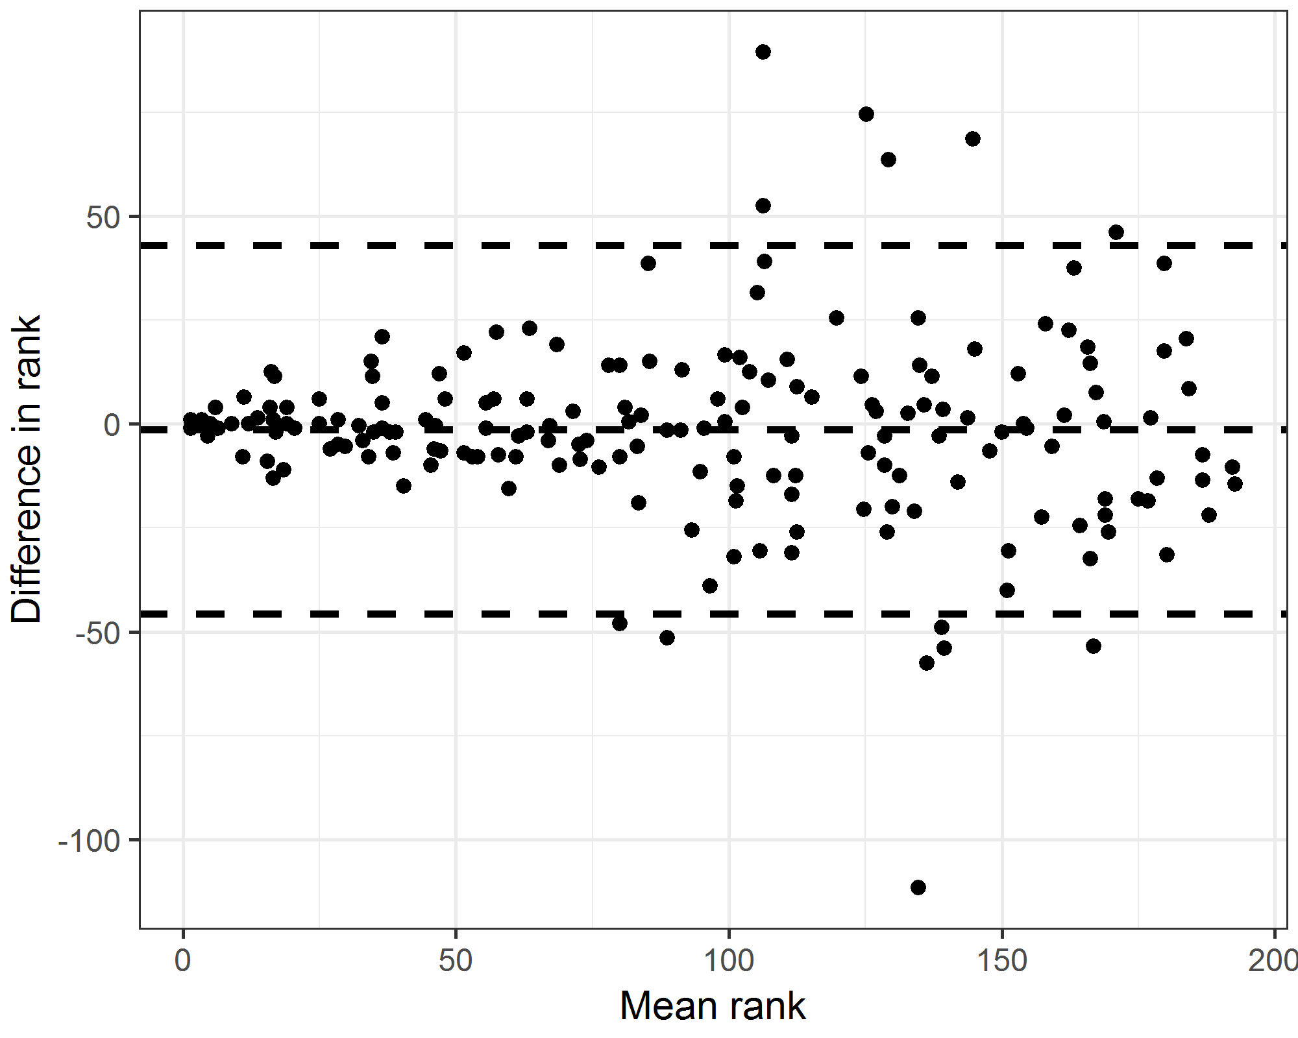

There were 184 universities in the top 200 in both years. The plot includes the limits of agreement which are -46 to 43.

## Bootstrap to get uncertainty in university ranks

Includes ‘missing’ affiliation as a category. The results are sorted according to the probability of being in the top 10.

|  |  |  |  |  |
| --- | --- | --- | --- | --- |
| Affiliation | Pr top 10 | Median rank | Lower rank | Upper rank |
| University of Toronto | 1.000 | 1 | 1 | 2 |
| University of Sydney | 1.000 | 2 | 1 | 2 |
| King’s College London | 0.977 | 4 | 3 | 10 |
| Missing | 0.957 | 4 | 3 | 12 |
| Zhejiang University | 0.748 | 7 | 3 | 19 |
| University College London | 0.744 | 8 | 3 | 17 |
| Mayo Clinic | 0.641 | 9 | 3 | 20 |
| West China Hospital of Sichuan University | 0.579 | 9 | 3 | 22 |
| Erasmus University Rotterdam | 0.529 | 10 | 4 | 21 |
| University of Melbourne | 0.432 | 11 | 4 | 20 |
| Monash University | 0.365 | 12 | 4 | 23 |
| University of São Paulo | 0.358 | 13 | 5 | 22 |
| University of Amsterdam | 0.295 | 14 | 5 | 24 |
| University of Oxford | 0.276 | 14 | 5 | 24 |
| University of Ottawa | 0.253 | 14 | 6 | 23 |
| Harvard University | 0.216 | 14 | 6 | 22 |
| University Medical Center Utrecht | 0.232 | 15 | 5 | 27 |
| Københavns Universitet | 0.167 | 17 | 6 | 28 |
| University of Birmingham | 0.121 | 17 | 6 | 27 |
| University of Copenhagen | 0.058 | 20 | 9 | 30 |

#### Plot of uncertainty in rank by median rank for 2017

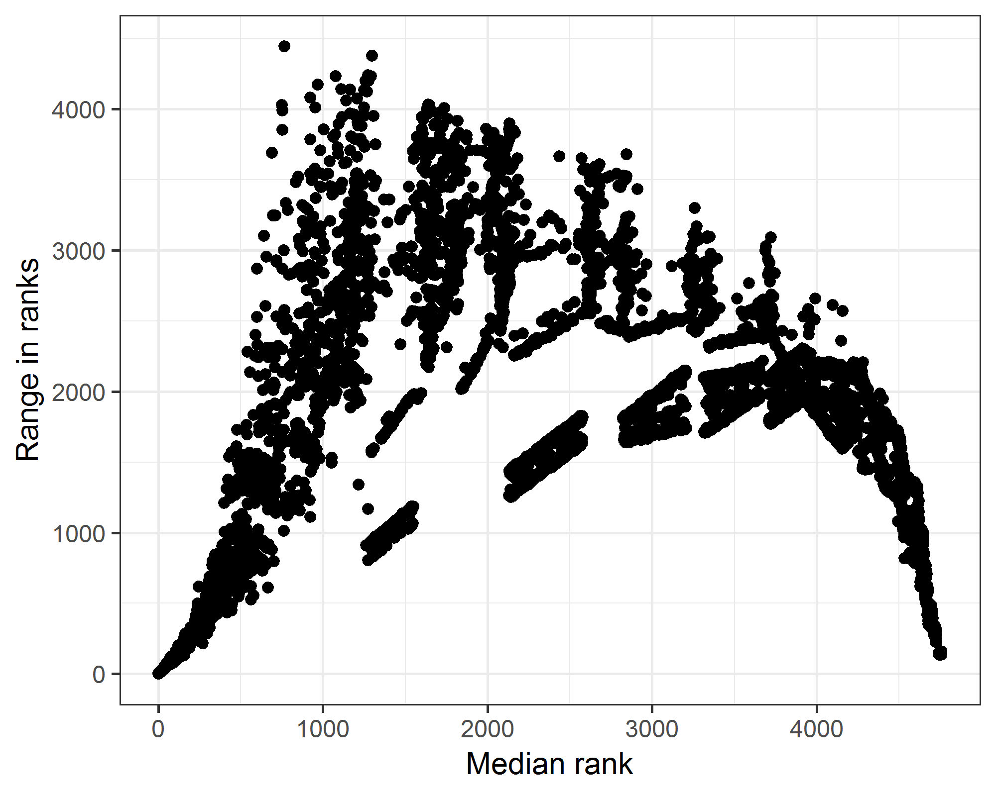

#### Plot of interval width against median rank

The plot is just for the top 200 and shows both years.

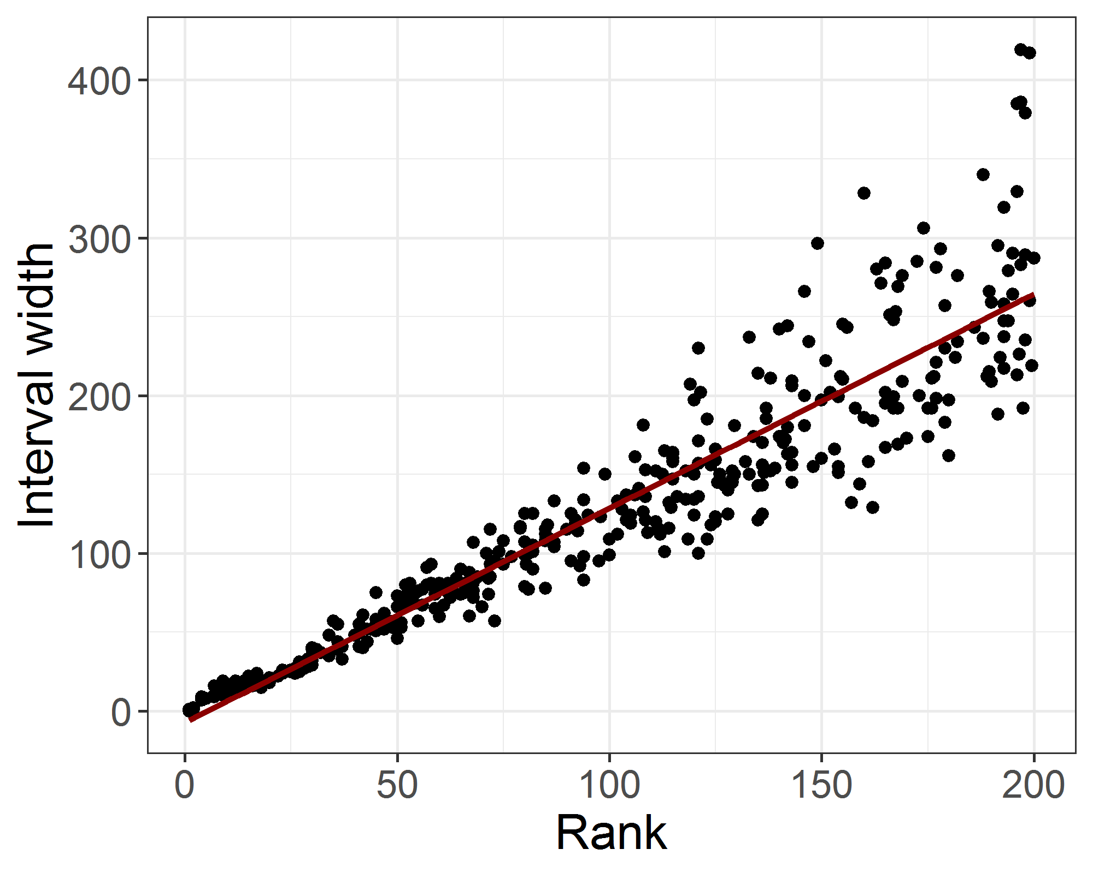

For every 10 unit increase in rank the width of the interval increases by an average of 13.6 (95% CI 13 to 14.1).

# Bayesian mixture model to estimate clusters

Here we only examine universities that had a score of two or more, which was 1386 universities, 12% of the total sample. The model includes “missing” as a university. We pre-specify the number of clusters as five, and do not try to find a more statistically optimal number as both authors agreed on this number of groups before any modelling.

We used a burn-in of 10,000 followed by a sample of 10,000 thinned by 5 to give a sample of 2,000 estimates.

### Cluster means and 95% credible intervals (alternative clustering)

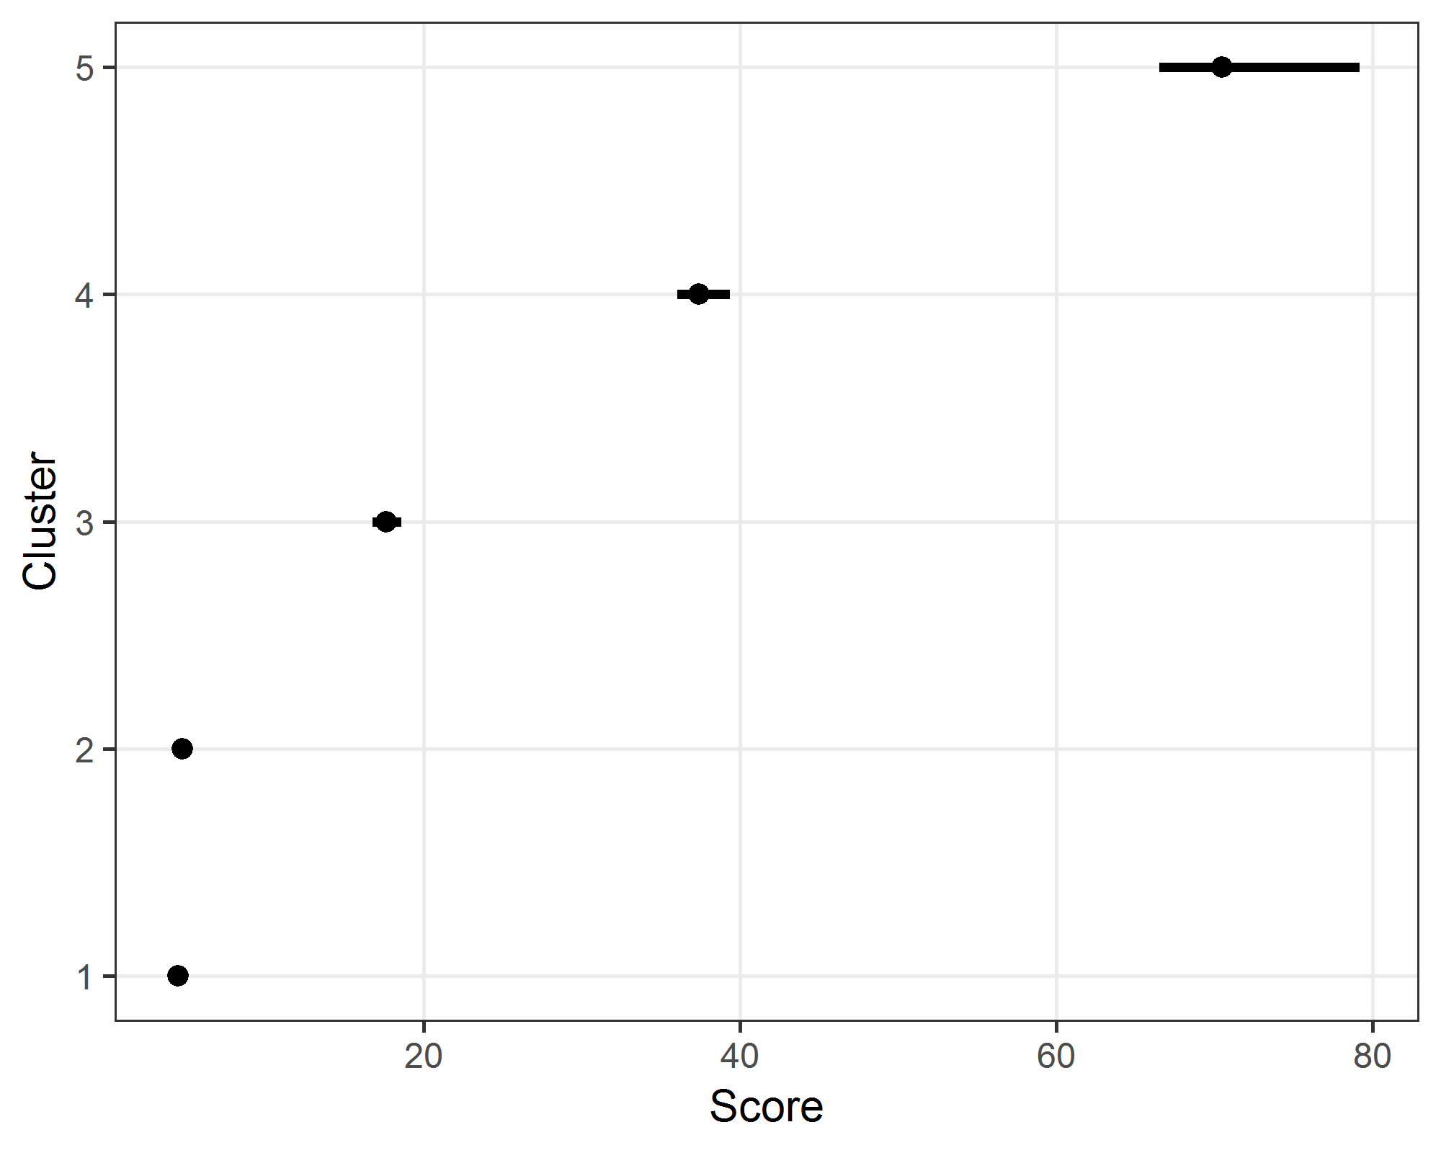

### Table of probabilities and cluster means

|  |  |  |  |
| --- | --- | --- | --- |
| cluster | P | score | CI |
| 1 | 0.42 | 4.5 | 4.2 to 4.7 |
| 2 | 0.42 | 4.7 | 4.5 to 5.1 |
| 3 | 0.11 | 17.6 | 16.8 to 18.6 |
| 4 | 0.03 | 37.4 | 36 to 39.3 |
| 5 | 0.02 | 70.5 | 66.5 to 79.2 |

#### Examine uncertainty in group membership

In the plot below we examine the difference from the modal cluster for each university. A score of zero indicates perfect membership.

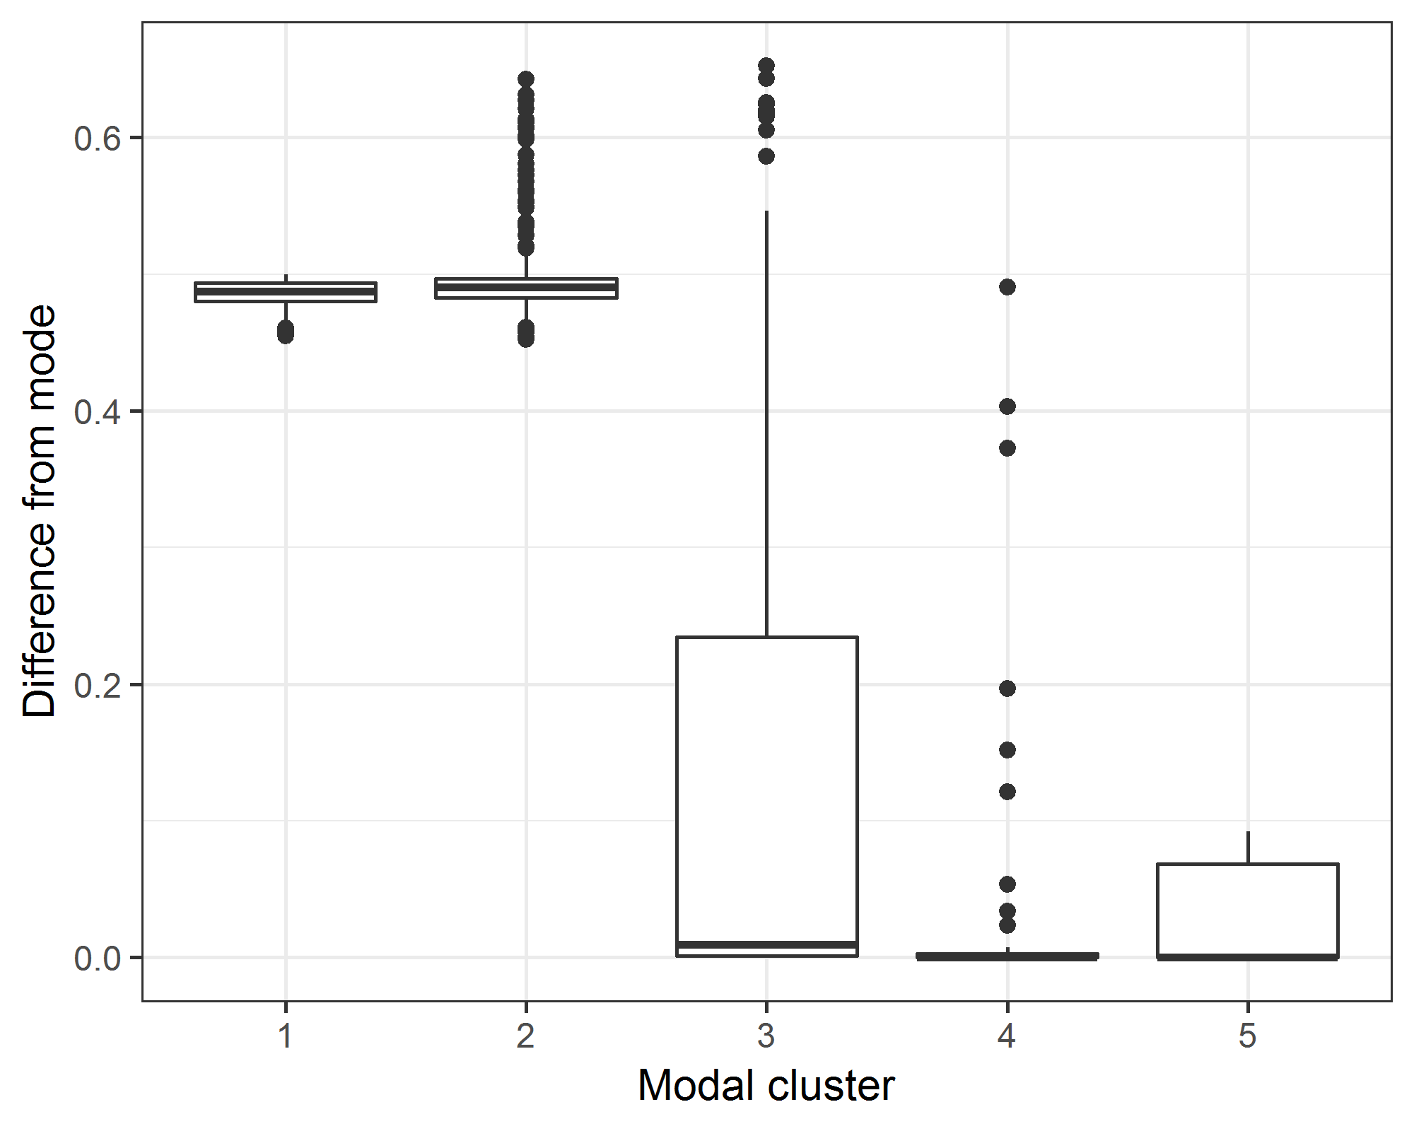

Groups 1 and 2 are very uncertain and also have a similar mean. These two groups could probably be combined to give a cluster size of four.

#### Cross-tabulation of changes in cluster membership (only those in both years)

|  |  |  |  |  |  |  |
| --- | --- | --- | --- | --- | --- | --- |
| y2016 | y2017 1 n | 2 n | 3 n | 4 n | 5 n | All n |
| *1* | 120 | 80 | 2 | 0 | 0 | 300 |
| *2* | 48 | 129 | 30 | 0 | 0 | 234 |
| *3* | 0 | 10 | 42 | 9 | 0 | 61 |
| *4* | 0 | 0 | 2 | 16 | 2 | 20 |
| *5* | 0 | 0 | 0 | 0 | 2 | 2 |
| *All* | 357 | 272 | 76 | 25 | 4 | 859 |

The number of universities that did not change cluster between 2016 and 2017 was 309 (63%).

##### Universities that went from a ‘4’ to a ‘5’

## affiliation

Missing

West China Hospital of Sichuan University

##### Universities that went from a ‘3’ to a ‘4’

## affiliation

Johns Hopkins University   
 Sun Yat-sen University   
 University of British Columbia   
 University of Groningen   
 University of Manchester   
 University of New South Wales

University of North Carolina, Chapel Hill University of Queensland  
VU University Amsterdam

### Alternative clustering #1

Here we use the same model as above, but include the sample size. This led to too few clusters, but with more membership certainty.

### Cluster means and 95% credible intervals

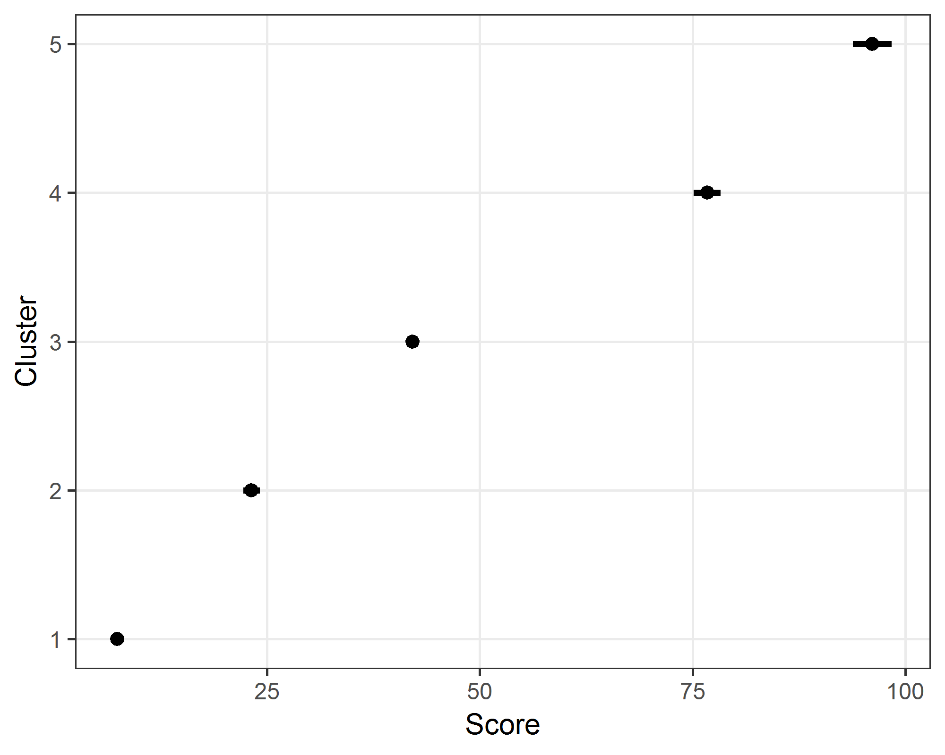

The 95% credible intervals for the means are relatively narrow.

### Table of probabilities and cluster means

|  |  |  |  |
| --- | --- | --- | --- |
| cluster | P | score | CI |
| 1 | 0.83 | 7.4 | 7 to 7.8 |
| 2 | 0.06 | 23.2 | 22.3 to 24.2 |
| 3 | 0.04 | 42.1 | 41.4 to 42.8 |
| 4 | 0.03 | 76.7 | 75.1 to 78.3 |
| 5 | 0.03 | 96.1 | 93.8 to 98.4 |

The columns are the percent probabilities ($π$) and cluster means ($\overline{x}$) and confidence intervals.

#### Examine uncertainty in group membership

In the plot below we examine the difference from the modal cluster for each university. A score of zero indicates no uncertainty in membership.

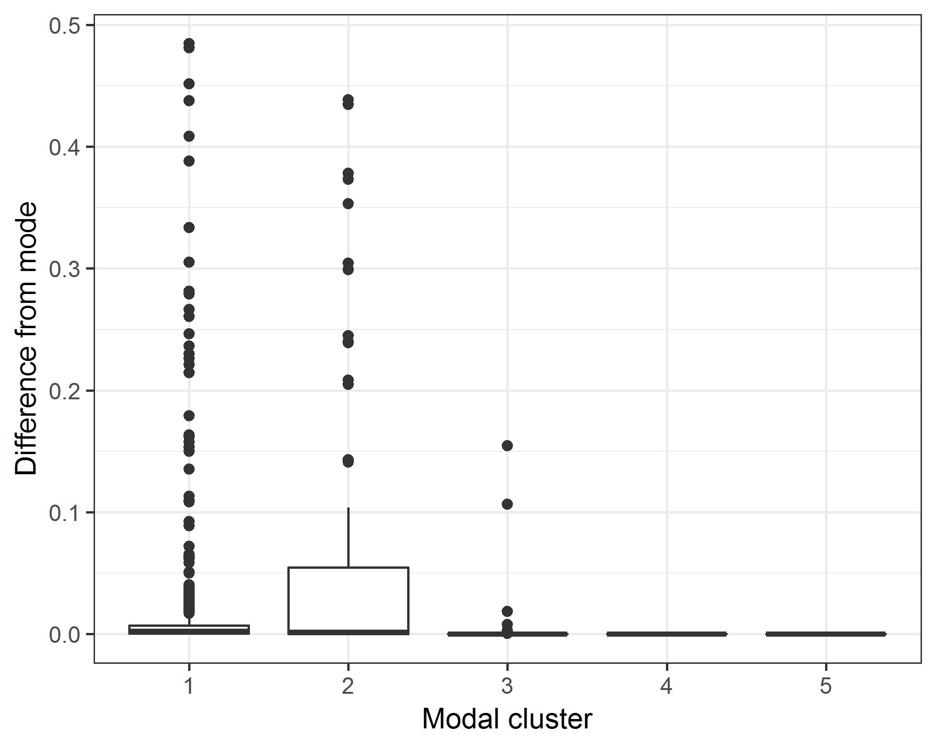

#### Cross-tabulation of changes in cluster membership (only those in both years)

|  |  |  |  |  |  |  |
| --- | --- | --- | --- | --- | --- | --- |
| y2016 | y2017 1 n | 2 n | 3 n | 4 n | 5 n | All n |
| *1* | 428 | 23 | 0 | 0 | 0 | 586 |
| *2* | 4 | 20 | 5 | 0 | 0 | 29 |
| *3* | 0 | 4 | 13 | 0 | 0 | 17 |
| *4* | 0 | 0 | 0 | 1 | 1 | 2 |
| *All* | 685 | 47 | 18 | 1 | 1 | 887 |

The number of universities that did not change cluster between 2016 and 2017 was 462 (93%).

### Alternative clustering #2

Here we use the alternative clustering assuming a Gaussian mixture model fitted using a non-Bayesian EM algorithm. This clustering does not account for the sample size.

----------------------------------------------------   
Gaussian finite mixture model fitted by EM algorithm   
----------------------------------------------------   
  
Mclust V (univariate, unequal variance) model with 5 components:   
  
 log.likelihood n df BIC ICL  
 -3547.591 1386 14 -7196.46 -7821.507  
  
Clustering table:  
 1 2 3 4 5   
329 374 341 266 76

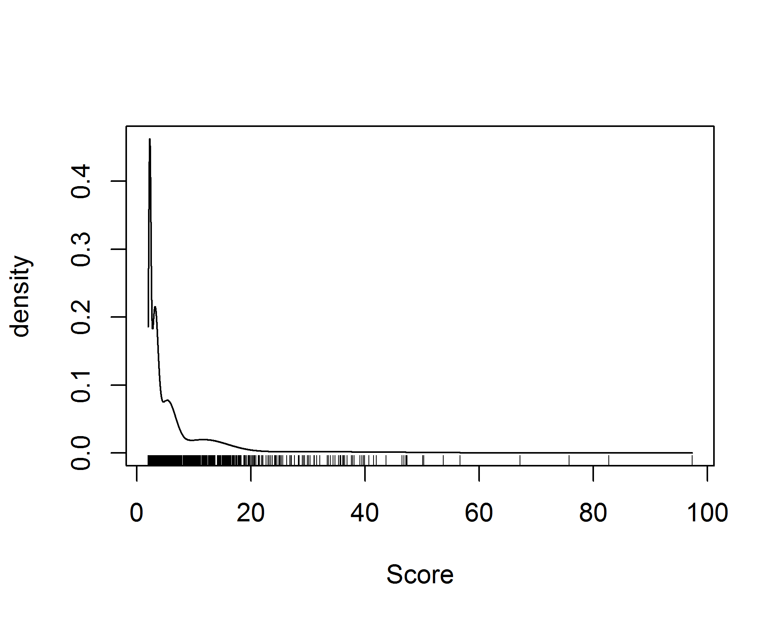

# Comparison with standard table

Here we examine how the universities in our table performed in a standard league table using publication counts. We searched for total publication counts by year in *Scopus* and only included articles (not books, book chapters, editorial or letters). To match our good practice table, we only included papers in the three subject areas of Dentistry, Health Professions and Nursing.

#### Top 10 universities in 2016 in standard table

|  |  |  |
| --- | --- | --- |
| Affiliation | sum | rank |
| University of São Paulo | 1,124 | 1 |
| University of Toronto | 1,100 | 2 |
| Harvard | 720 | 3 |
| VA Medical Center | 642 | 4 |
| University of Sydney | 593 | 5 |
| University of Washington, Seattle | 590 | 6 |
| University College London | 549 | 7 |
| Harvard University | 532 | 8 |
| University of Pittsburgh | 526 | 9 |
| University of Pennsylvania | 507 | 10 |

#### Top 10 universities in 2017 in standard table

|  |  |  |
| --- | --- | --- |
| Affiliation | sum | rank |
| University of Toronto | 1,206 | 1 |
| University of São Paulo | 1,102 | 2 |
| Harvard | 718 | 3 |
| University of North Carolina, Chapel Hill | 622 | 4 |
| University of Sydney | 607 | 5 |
| VA Medical Center | 568 | 6 |
| Harvard University | 544 | 8 |
| University College London | 544 | 8 |
| University of Washington, Seattle | 544 | 8 |
| Seoul National University | 524 | 10 |