Summary statistics, tables and plots
Adrian Barnett
09 November 2025

Top ten countries
Country | Count | percent
United States of America | 32,099 | 29
China | 16,972 | 15
United Kingdom | 12,975 | 12
Germany | 7,679 | 7
Canada | 6,262 | 6
Japan | 5,815 | 5
Australia | 5,746 | 5
France | 4,617 | 4
Brazil | 3,899 | 3
Netherlands | 3,807 | 3
There were 221 countries in total. The table shows the authors’ countries where each country is counted once per article. The percentages are over all 112,442 articles.

Top ten subjects
Subject | Count | percent
Biology and life sciences | 96,625 | 86
Medicine and health sciences | 85,809 | 76
Research and analysis methods | 55,700 | 50
Social sciences | 40,746 | 36
Physical sciences | 40,358 | 36
People and places | 36,102 | 32
Organisms | 33,625 | 30
Medical conditions | 29,973 | 27
Physiology | 25,910 | 23
Psychology | 25,548 | 23
There were 9347 subjects in total. The percentages are over all 112,442 articles.

Email domain
Domain | Count | percent
edu | 35,798 | 32
Other | 26,829 | 24
ac | 17,654 | 16
gmail | 15,533 | 14
163 | 4,568 | 4
org | 4,174 | 4
com | 3,749 | 3
yahoo | 3,023 | 3
gov | 2,131 | 2
uni | 1,976 | 2
126 | 1,825 | 2
hotmail | 1,539 | 1
qq | 1,369 | 1
net | 762 | 1
sina | 419 | 0
med | 301 | 0
bio | 286 | 0
cat | 185 | 0
phd | 83 | 0
nhs | 82 | 0
aol | 17 | 0
msn | 15 | 0
Some papers had multiple emails. The percentages are over all 112,442 articles.

Summary table
level Overall
n 112442
review_available (%) FALSE 67035 (59.6)
TRUE 45407 (40.4)
year (mean (SD)) 2022.3 (1.7)
n_authors (mean (SD)) 6.9 (5.1)
author_papers (mean (SD)) 135.3 (177.4)
time_between (mean (SD)) 177.0 (103.5)
journal (%) PLOS Biology 1815 ( 1.6)
PLOS Climate 298 ( 0.3)
PLOS Complex Systems 48 ( 0.0)
PLOS Computational Biology 4180 ( 3.7)
PLOS Digital Health 662 ( 0.6)
PLOS Genetics 2473 ( 2.2)
PLOS Global Public Health 3277 ( 2.9)
PLOS Medicine 1135 ( 1.0)
PLOS Mental Health 229 ( 0.2)
PLOS Neglected Tropical Diseases 4183 ( 3.7)
PLOS ONE 90464 (80.5)
PLOS Pathogens 3358 ( 3.0)
PLOS Sustainability and Transformation 91 ( 0.1)
PLOS Water 229 ( 0.2)
type (%) Discovery Report 42 ( 0.0)
Formal Comment 74 ( 0.1)
Lab Protocol 206 ( 0.2)
Meta-Research Article 47 ( 0.0)
Methods 131 ( 0.1)
Methods and Resources 200 ( 0.2)
Preregistered Research Article 8 ( 0.0)
Registered Report Protocol 254 ( 0.2)
Research Article 109040 (97.0)
Review 3 ( 0.0)
Short Reports 259 ( 0.2)
Software 53 ( 0.0)
Study Protocol 2100 ( 1.9)
Update Article 25 ( 0.0)
citations (mean (SD)) 12.2 (29.6)
retracted (%) FALSE 112070 (99.7)
TRUE 372 ( 0.3)

Openness over time
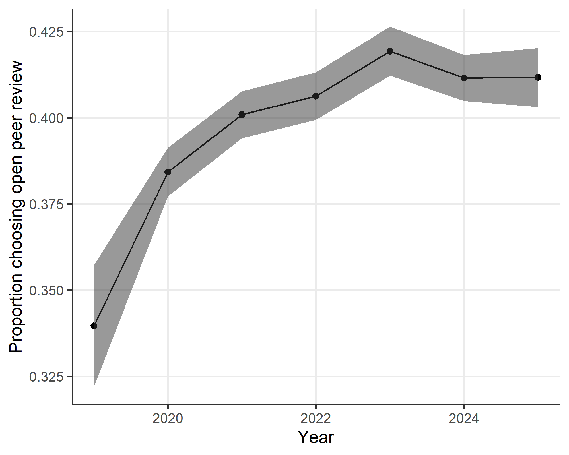
The plot shows the yearly proportion and 95% confidence interval.
There was an increase over time in the proportion of authors choosing open review.

