Summary statistics, tables and plots
Adrian Barnett
31 August 2025

Top ten countries
countries | Count | percent
United States of America | 95,894 | 21
China | 42,305 | 9
United Kingdom | 29,366 | 6
Japan | 19,315 | 4
Germany | 18,771 | 4
Canada | 18,427 | 4
Australia | 14,564 | 3
France | 12,724 | 3
Brazil | 12,632 | 3
Spain | 10,284 | 2

Top ten subjects
subjects | Count | percent
Biology and life sciences | 596,102 | 9
Medicine and health sciences | 460,355 | 7
Research and analysis methods | 109,383 | 2
Social sciences | 104,342 | 2
Psychology | 99,270 | 1
Anatomy | 92,780 | 1
Physical sciences | 89,336 | 1
Organisms | 73,358 | 1
People and places | 61,501 | 1
Neuroscience | 59,830 | 1

Summary table
level Overall
n 112650
review_available (%) FALSE 67146 (59.6)
TRUE 45504 (40.4)
year (median [IQR]) 2022.0 [2021.0, 2024.0]
n_authors (median [IQR]) 6.0 [4.0, 9.0]
time_between (median [IQR]) 154.0 [106.0, 222.0]
journal (%) PLOS Biology 1817 ( 1.6)
PLOS Climate 300 ( 0.3)
PLOS Complex Systems 48 ( 0.0)
PLOS Computational Biology 4193 ( 3.7)
PLOS Digital Health 664 ( 0.6)
PLOS Genetics 2479 ( 2.2)
PLOS Global Public Health 3285 ( 2.9)
PLOS Medicinee 1145 ( 1.0)
PLOS Mental Health 231 ( 0.2)
PLOS Neglected Tropical Diseases 4187 ( 3.7)
PLOS ONE 90616 (80.4)
PLOS Pathogens 3362 ( 3.0)
PLOS Sustainability and Transformation 93 ( 0.1)
PLOS Water 230 ( 0.2)
type (%) Discovery Report 42 ( 0.0)
Formal Comment 75 ( 0.1)
Lab Protocol 206 ( 0.2)
Meta-Research Article 47 ( 0.0)
Methods 131 ( 0.1)
Methods and Resources 200 ( 0.2)
Preregistered Research Article 8 ( 0.0)
Registered Report Protocol 254 ( 0.2)
Research Article 109246 (97.0)
Review 3 ( 0.0)
Short Reports 259 ( 0.2)
Software 53 ( 0.0)
Study Protocol 2101 ( 1.9)
Update Article 25 ( 0.0)
retracted (%) FALSE 112278 (99.7)
TRUE 372 ( 0.3)

Openness over time
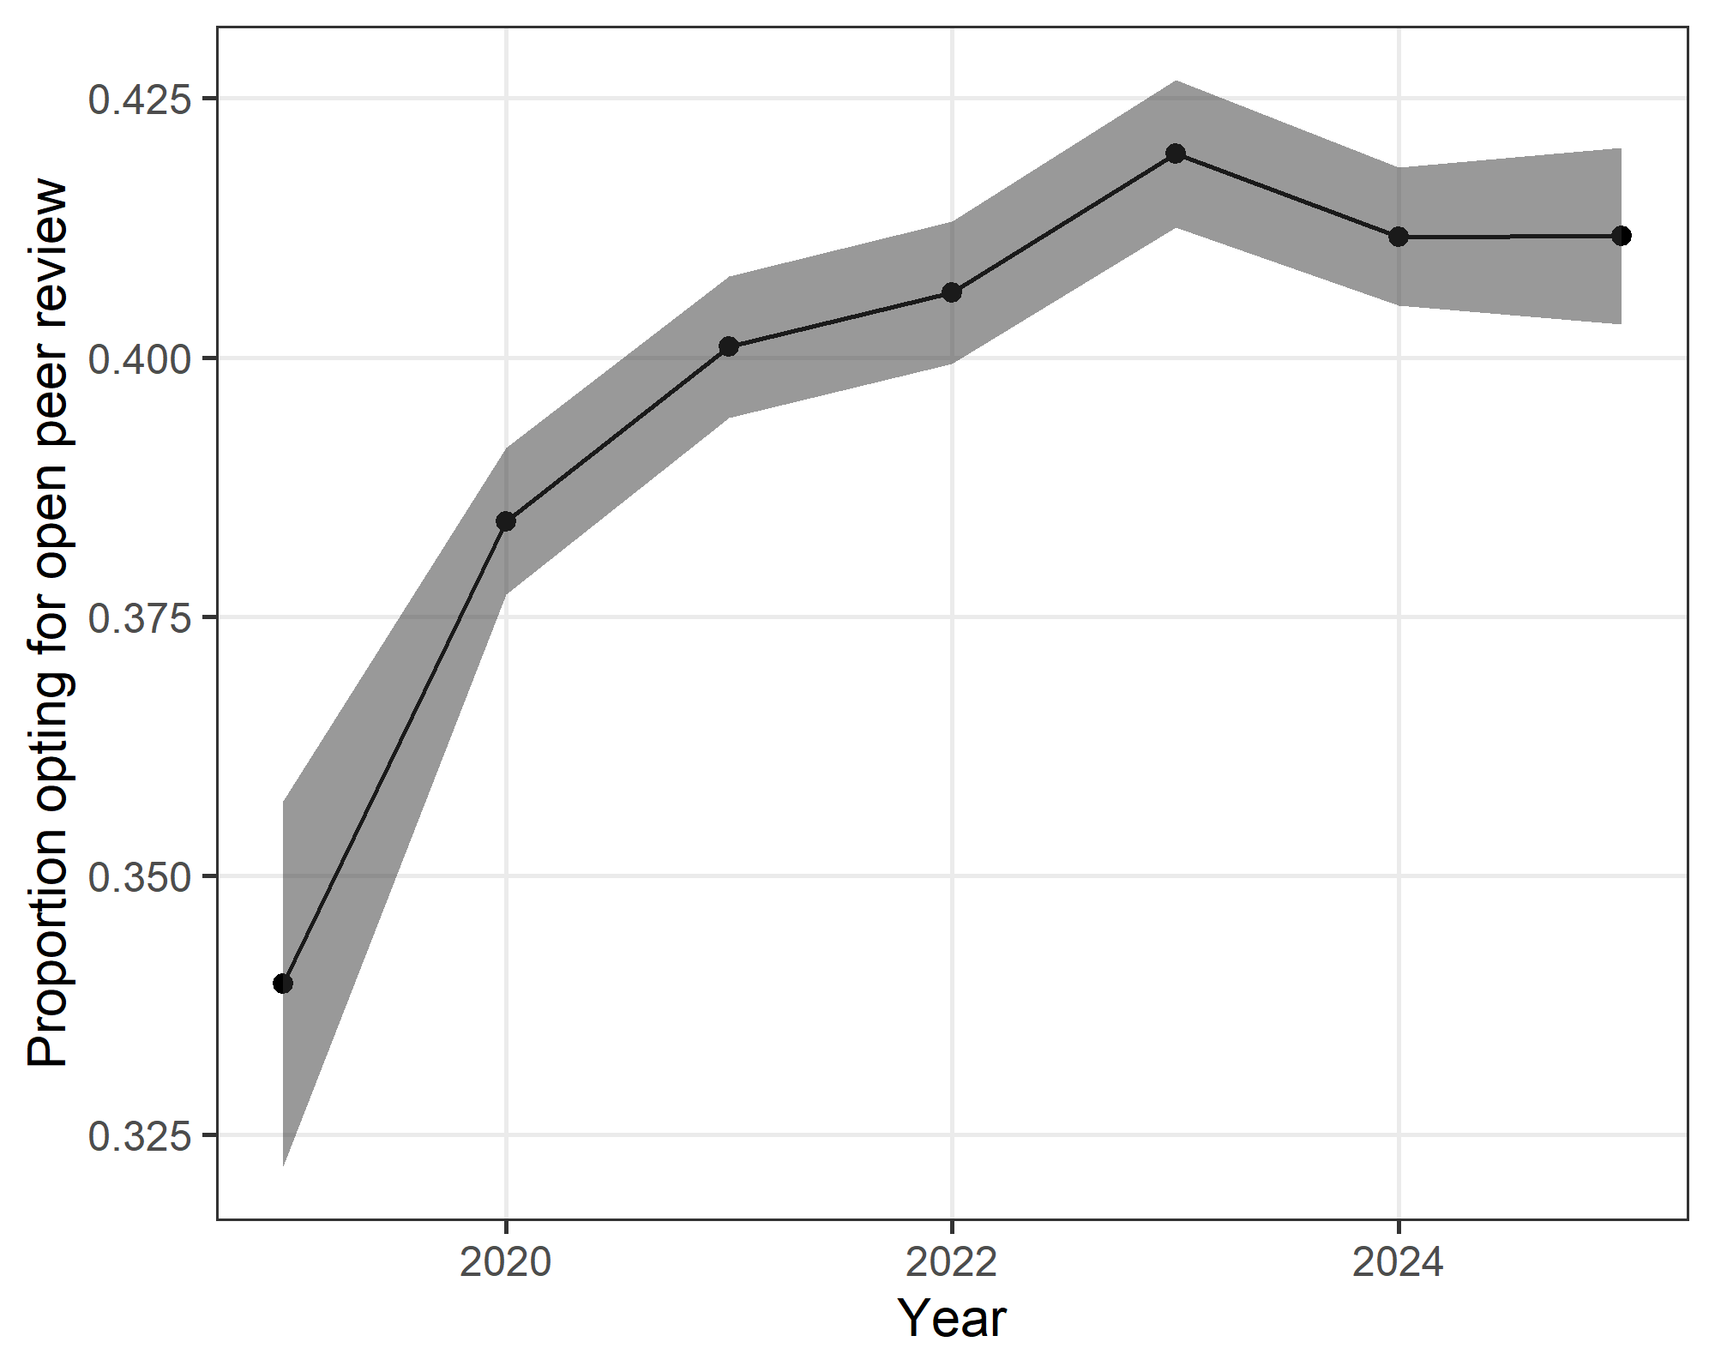
The plot shows the yearly proportion and 95% confidence interval.
There was an increase over time in the proportion of authors opting in.

