Summary statistics, tables and plots
Adrian Barnett
09 August 2026

Top ten countries
Country | no | yes
United States of America | 20067 (61) | 12853 (39)
China | 12330 (68) | 5822 (32)
United Kingdom | 6930 (52) | 6427 (48)
Germany | 4652 (59) | 3214 (41)
Canada | 3834 (59) | 2648 (41)
Japan | 3276 (55) | 2671 (45)
Australia | 3249 (55) | 2615 (45)
France | 2488 (52) | 2267 (48)
Brazil | 2431 (61) | 1549 (39)
Netherlands | 1963 (50) | 1939 (50)
There were 221 countries in total. The table shows the authors’ countries where each country is counted once per article. The row percentages are for each country.

Top ten subjects
Subject | no | yes
Biology and life sciences | 60078 (60) | 40527 (40)
Medicine and health sciences | 52342 (59) | 36939 (41)
Research and analysis methods | 34684 (60) | 23336 (40)
Physical sciences | 25925 (61) | 16274 (39)
Social sciences | 25123 (59) | 17426 (41)
People and places | 21530 (57) | 15966 (43)
Organisms | 21144 (61) | 13644 (39)
Medical conditions | 17953 (58) | 13149 (42)
Physiology | 15945 (59) | 10922 (41)
Psychology | 15666 (58) | 11117 (42)
There were 9369 subjects in total. The row percentages are per subject.

Top ten email domains
Domain | no | yes
edu | 23682 (64) | 13561 (36)
Other | 16021 (58) | 11640 (42)
ac | 10082 (55) | 8091 (45)
gmail | 8692 (54) | 7309 (46)
163 | 3308 (68) | 1592 (32)
com | 2444 (63) | 1413 (37)
org | 2433 (57) | 1834 (43)
yahoo | 1732 (56) | 1358 (44)
gov | 1418 (65) | 754 (35)
uni | 1248 (62) | 777 (38)
Some papers had multiple emails. There were 22 domains in total. The row percentages are per domain.

Top ten funders
Missing funders
Funder | no | yes
National Institutes of Health | 4628 (60) | 3126 (40)
National Natural Science Foundation of China | 3623 (69) | 1620 (31)
National Science Foundation | 2256 (57) | 1693 (43)
National Institute of Allergy and Infectious Diseases | 1396 (62) | 865 (38)
National Research Foundation, South Africa | 1169 (65) | 642 (35)
Japan Society for the Promotion of Science | 1124 (56) | 896 (44)
German Research Foundation | 992 (58) | 729 (42)
Horizon 2020 | 971 (52) | 903 (48)
Medical Research Council | 899 (47) | 1017 (53)
Some papers had multiple funders. There were 9301 funders in total, hence we only show the top ten.

Summary table
Stratified by review_available
level FALSE
n 69439
review_available (%) FALSE 69439 (100.0)
TRUE 0 ( 0.0)
year (mean (SD)) 2022.4 (1.8)
n_authors (mean (SD)) 6.8 (5.0)
author_papers (mean (SD)) 135.3 (216.4)
time_between (mean (SD)) 177.1 (103.7)
type (%) Discovery Report 20 ( 0.0)
Lab Protocol 116 ( 0.2)
Meta-Research Article 12 ( 0.0)
Methods 71 ( 0.1)
Methods and Resources 59 ( 0.1)
Preregistered Research Article 1 ( 0.0)
Registered Report Protocol 131 ( 0.2)
Research Article 67752 ( 97.6)
Review 3 ( 0.0)
Short Reports 116 ( 0.2)
Software 29 ( 0.0)
Study Protocol 1115 ( 1.6)
Update Article 14 ( 0.0)
citations (mean (SD)) 14.9 (29.2)
retracted (%) FALSE 68887 ( 99.2)
TRUE 552 ( 0.8)
ret_type (%) concern 96 ( 0.1)
retracted 456 ( 0.7)
<NA> 68887 ( 99.2)
Stratified by review_available
TRUE
n 46920
review_available (%) 0 ( 0.0)
46920 (100.0)
year (mean (SD)) 2022.5 (1.7)
n_authors (mean (SD)) 7.0 (5.1)
author_papers (mean (SD)) 150.8 (1734.8)
time_between (mean (SD)) 177.6 (103.8)
type (%) 25 ( 0.1)
98 ( 0.2)
38 ( 0.1)
81 ( 0.2)
144 ( 0.3)
7 ( 0.0)
122 ( 0.3)
45079 ( 96.1)
1 ( 0.0)
162 ( 0.3)
36 ( 0.1)
1115 ( 2.4)
12 ( 0.0)
citations (mean (SD)) 17.4 (37.4)
retracted (%) 46667 ( 99.5)
253 ( 0.5)
ret_type (%) 65 ( 0.1)
188 ( 0.4)
46667 ( 99.5)

Openness over time
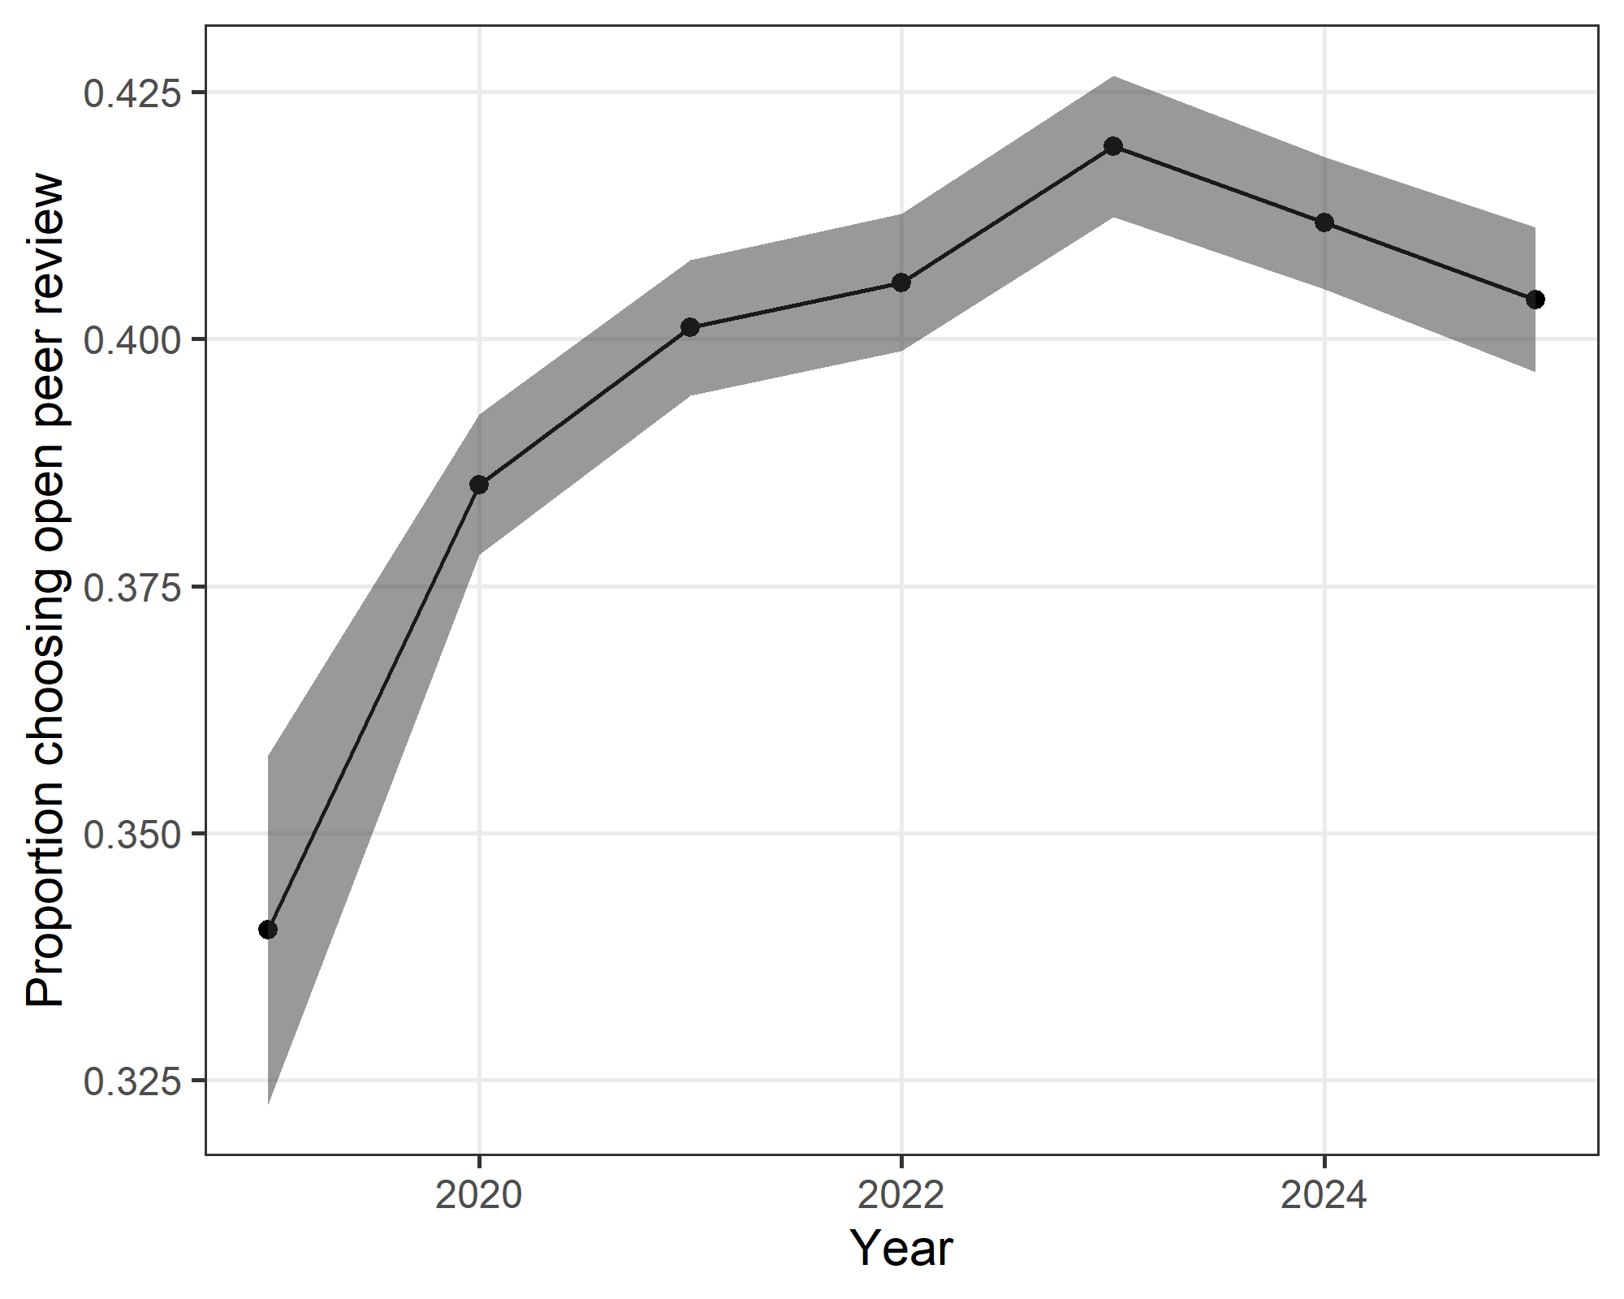
The plot shows the yearly proportion and 95% confidence interval.
There was an increase over time in the proportion of authors choosing open review.

