Summary statistics, tables and plots
Adrian Barnett
06 December 2025

Top ten countries
Country | no | yes
United States of America | 19565 (17) | 12521 (11)
China | 11528 (10) | 5442 (5)
United Kingdom | 6720 (6) | 6251 (6)
Germany | 4546 (4) | 3132 (3)
Canada | 3696 (3) | 2562 (2)
Japan | 3211 (3) | 2600 (2)
Australia | 3194 (3) | 2549 (2)
France | 2424 (2) | 2190 (2)
Brazil | 2369 (2) | 1529 (1)
Netherlands | 1919 (2) | 1887 (2)
There were 221 countries in total. The table shows the authors’ countries where each country is counted once per article. The percentages are over all 112,402 articles.

Top ten subjects
Subjects | no | yes
Biology and life sciences | 57629 (51) | 38962 (35)
Medicine and health sciences | 50239 (45) | 35536 (32)
Research and analysis methods | 33253 (30) | 22424 (20)
Physical sciences | 24758 (22) | 15586 (14)
Social sciences | 24030 (21) | 16706 (15)
People and places | 20711 (18) | 15380 (14)
Organisms | 20461 (18) | 13148 (12)
Medical conditions | 17278 (15) | 12681 (11)
Physiology | 15372 (14) | 10531 (9)
Psychology | 14914 (13) | 10626 (9)
There were 9347 subjects in total. The percentages are over all 112,402 articles.

Email domain
Domain | Count | percent
edu | 35,785 | 32
Other | 26,818 | 24
ac | 17,647 | 16
gmail | 15,525 | 14
163 | 4,568 | 4
org | 4,173 | 4
com | 3,749 | 3
yahoo | 3,021 | 3
gov | 2,129 | 2
uni | 1,976 | 2
126 | 1,825 | 2
hotmail | 1,538 | 1
qq | 1,368 | 1
net | 761 | 1
sina | 419 | 0
med | 300 | 0
bio | 286 | 0
cat | 185 | 0
phd | 83 | 0
nhs | 82 | 0
aol | 17 | 0
msn | 15 | 0
Some papers had multiple emails. The percentages are over all 112,402 articles.

Summary table
Stratified by review_available
level
n
review_available (%) FALSE
TRUE
year (mean (SD))
n_authors (mean (SD))
author_papers (mean (SD))
time_between (mean (SD))
journal (%) PLOS Biology
PLOS Climate
PLOS Complex Systems
PLOS Computational Biology
PLOS Digital Health
PLOS Genetics
PLOS Global Public Health
PLOS Medicine
PLOS Mental Health
PLOS Neglected Tropical Diseases
PLOS ONE
PLOS Pathogens
PLOS Sustainability and Transformation
PLOS Water
type (%) Discovery Report
Formal Comment
Lab Protocol
Meta-Research Article
Methods
Methods and Resources
Preregistered Research Article
Registered Report Protocol
Research Article
Review
Short Reports
Software
Study Protocol
Update Article
citations (mean (SD))
retracted (%) FALSE
TRUE
Stratified by review_available
FALSE TRUE
n 67016 45386
review_available (%) 67016 (100.0) 0 ( 0.0)
0 ( 0.0) 45386 (100.0)
year (mean (SD)) 2022.3 (1.7) 2022.4 (1.7)
n_authors (mean (SD)) 6.8 (5.0) 7.0 (5.1)
author_papers (mean (SD)) 132.7 (175.6) 139.1 (179.9)
time_between (mean (SD)) 176.8 (103.4) 177.3 (103.7)
journal (%) 684 ( 1.0) 1131 ( 2.5)
170 ( 0.3) 128 ( 0.3)
20 ( 0.0) 28 ( 0.1)
1957 ( 2.9) 2218 ( 4.9)
356 ( 0.5) 306 ( 0.7)
1278 ( 1.9) 1193 ( 2.6)
1645 ( 2.5) 1631 ( 3.6)
467 ( 0.7) 668 ( 1.5)
131 ( 0.2) 98 ( 0.2)
2717 ( 4.1) 1463 ( 3.2)
55287 ( 82.5) 35150 ( 77.4)
2111 ( 3.1) 1245 ( 2.7)
45 ( 0.1) 46 ( 0.1)
148 ( 0.2) 81 ( 0.2)
type (%) 18 ( 0.0) 24 ( 0.1)
74 ( 0.1) 0 ( 0.0)
113 ( 0.2) 93 ( 0.2)
11 ( 0.0) 36 ( 0.1)
64 ( 0.1) 67 ( 0.1)
58 ( 0.1) 142 ( 0.3)
1 ( 0.0) 7 ( 0.0)
131 ( 0.2) 122 ( 0.3)
65347 ( 97.5) 43656 ( 96.2)
2 ( 0.0) 1 ( 0.0)
110 ( 0.2) 149 ( 0.3)
23 ( 0.0) 30 ( 0.1)
1051 ( 1.6) 1047 ( 2.3)
13 ( 0.0) 12 ( 0.0)
citations (mean (SD)) 13.5 (30.6) 14.3 (35.3)
retracted (%) 66702 ( 99.5) 45298 ( 99.8)
314 ( 0.5) 88 ( 0.2)

Openness over time
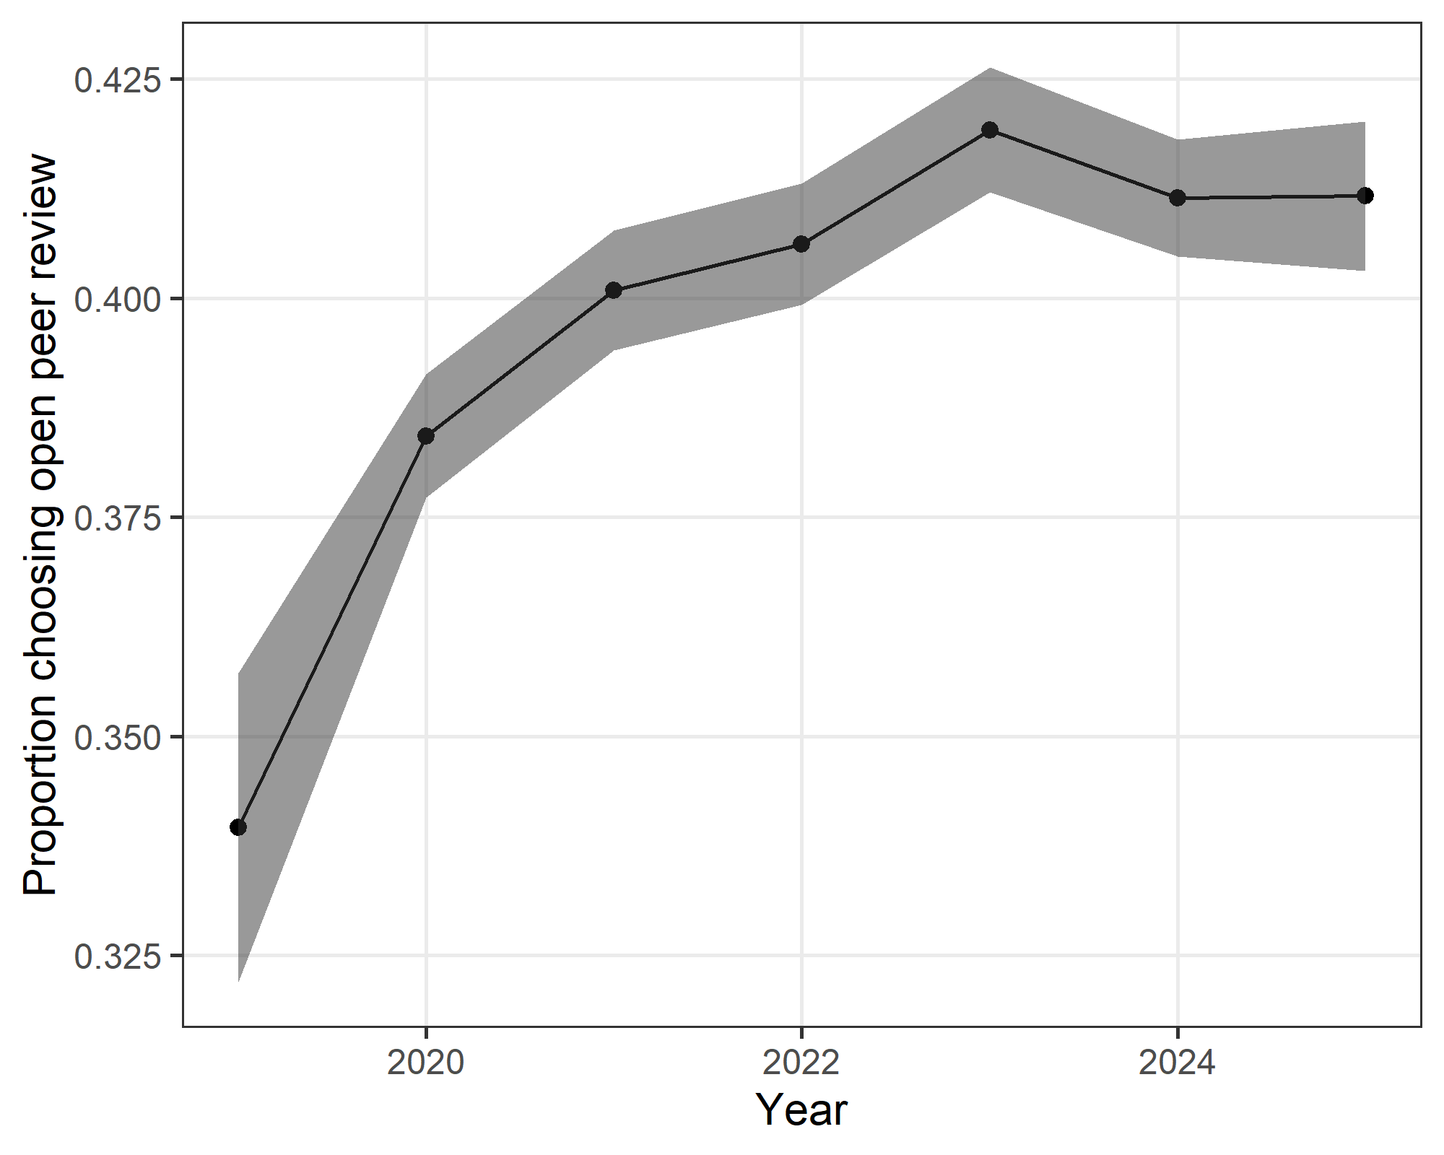
The plot shows the yearly proportion and 95% confidence interval.
There was an increase over time in the proportion of authors choosing open review.

