Summary of the focus groups (clinical)

Adrian Barnett

2023-08-01

The focus group was conducted on 1 August 2023.

The table below gives summary statistics on the time taken (in minutes) to complete the Qualtrics questions.

| **Stage** | **n** | **mean** | **min** | **max** |
| --- | --- | --- | --- | --- |
| First stage - text | 7 | 4.4 | 2.5 | 7.5 |
| Second stage - ranking | 7 | 2.8 | 1.3 | 4.5 |

## Stage 1 - attributes, free text

The table below shows the free text entered by the participants at stage 1. Rank 1 was the most important, and rank 10 the least important.

The question was: “Write an ordered list of the up to 10 attributes you consider most important when submitting a journal article.”

Most people gave 10 attributes.

| **q1** |
| --- |
| Brett Reputable journal i.e. not predatory Ability to impact policy, practice and guidelines Peer reviewed Journal that reaches the desired audience Impact factor of journal Cost of publication Timeliness of reviews Time to first decision Ease of submission Journal Publisher |
| Nina 1. Journal's suitability for topic 2. Journal's impact factor 3. Journal's reputation for peer review 4. Reputation for peer review process and speed of decisions 5. Journal's ranking 6. Prestige and recognition of journal 7. read/write agreement with university 8. Open access (goes with point 7) 9. 10. |
| Jacky 1. Journal prestige and reputation 2. Journal impact factor 3. journal has published similar type of studies in the past 4. Previous experience with journal 5. know and respect the editors 6. journal's ranking 7. quality of peer review 8. journal affiliation with official society 9. article processing fee 10. ease of submission. |
| 1. Likelihood to lead to change 2. Likelihood to reach the intended readership 3. Suitability of journal's formatting & requirements for the paper's needs eg. word/figure/reference limits 4. Reputation of journal 5. Quality of reviewer feedback 6. Other papers relevant to area previously published, or planned special issue in the area 7. Impact factor & other journal metrics 8. Likelihood of paper being accepted 9. Speed of journal response to submission 10. Previous experience in submitting to the journal |
| Pete 1. Papers overall quality 2. Paper has novel findings 3. Journal's impact factor 4. Journals prestige 5. Journal's suitability to papers topic 6. Journals article processing charges (or not) 7. Paper type 8. Journal's reputation 9. Author position 10. Journals circulation/target audience |
| Amanda 1. Topic fit with journal goals (e.g., discipline, interest area) 2. Publisher - no predatory publishers, even if they have high ranking 3. Ranking - including Q1 status 4. Cost - which varies depending on if open access funds are available via the university 5. Journal vision and mission 6. Journal editors - especially if I know and respect them 7. Journals that I read and respect 8. Quality of reviews 9. Speed of review 10. Submission requirements (e.g., submit as you like) |
| Samantha 1. Journal topic/speciality/focus 2. Journal reputation (perceived and metrics) 3. Journal reach and audience 4. Journal review process (quality and timing) 5. Publication options (green, hybrid, open access) 6. Open access charges/costs |

## Stage 2 - attribute rankings

Below we show the average ranks (dots) and the ranges (horizontal lines). There were 18 attributes to choose from.

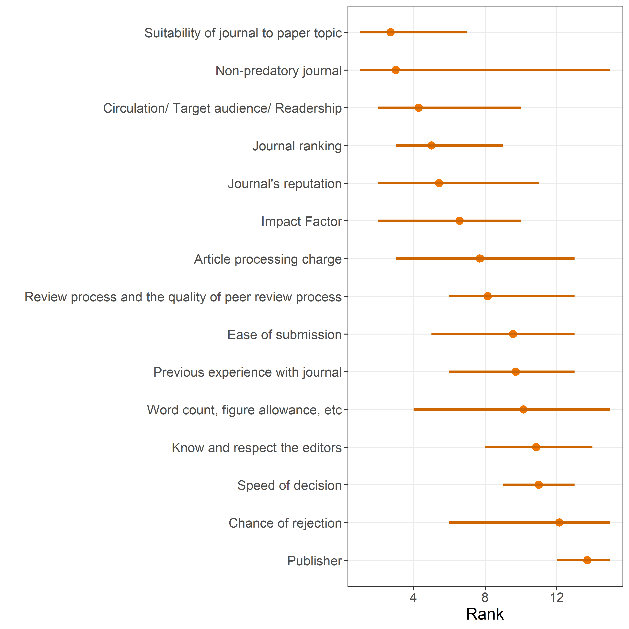

The higher the rank, the more important it was considered.