Summary of the focus groups (public health and health services)

Adrian Barnett

2023-08-11

The focus group was conducted on Friday 11 August 2023.

The table below gives summary statistics on the time taken (in minutes) to complete the Qualtrics questions.

| **Stage** | **n** | **mean** | **min** | **max** |
| --- | --- | --- | --- | --- |
| First stage - text | 9 | 4.7 | 2.0 | 7.8 |
| Second stage - ranking | 9 | 3.1 | 1.1 | 5.2 |

## Stage 1 - attributes, free text

The table below shows the free text entered by the participants at stage 1. Rank 1 was the most important, and rank 10 the least important.

The question was: “Write an ordered list of the up to 10 attributes you consider most important when submitting a journal article.”

Most people gave 10 attributes.

| **q1** |
| --- |
| academic reputation with higher impact factors important policy implications or clinical guidance not charge too much for the open access |
| Son Nghiem 1- Impact 2- Types of Audience 3- Speed of publication 4- Relevance to policy 5- Costs of pubication |
| Ting Gan 1. Speed of desicions 2. Journal impact factor 3. Journal's ranking 4. Paper is peer reviewd 5. Paper has novel findings 6. Total citation 7. Journal rejection rate |
| Ying 1. Study purpose and scope and findings 2. journal ranking 3. peer recognition 4. journal scope 5. journal audience 6. fees 7. collaborations/co-authors |
| 1. quality of the journal 2. relevance of my paper to the journal's readers 3. word limit (sometimes is very restrictive) 4. timely review 5. publication fees 6. Open access 7. my previous experience with that journal |
| Susan Jordan 1. will reach the right target audience 2. likely impact 3. clinical/health relevance with impact on research, policy or practice 4. high readership 5. likely good quality peer review 6. open access that I don't have to pay for 7. strong collaboration 8. rapid rejection (if rejected) |
| Journal scope Impact factor Published other work on topic Word count Type of article they accept - research I do not always accepted by all journals Cost Time of peer review No preference for authorship - tend to promote junior staff and I will go last |
| Yuming 1. Increase the impact of the research 2. Generalise the research findings 3. Reused by others 4. The influence of the journal 5. The publication time of the journal, the quicker the better 6. Promoting the paper by the journal 7. Open access 8. Accessed by policy makers and general population 9. Improve by peer reviewer 10. Increase the citation |
| Katharina: 1. Journal publishing charges 2. Authorship position (first or last) 3. Impact factor of journal 4. Citations 5. Open access 6. Journal response timeframe 7. Journal publishing/processing timeframe 8. Journal’s reputation 9. Journal’s prestige (including Q1) 10. Journal guidelines with suitable word count / tables / figures allowed |

## Stage 2 - attribute rankings

Below we show the average ranks (dots) and the ranges (horizontal lines). There were 18 attributes to choose from.

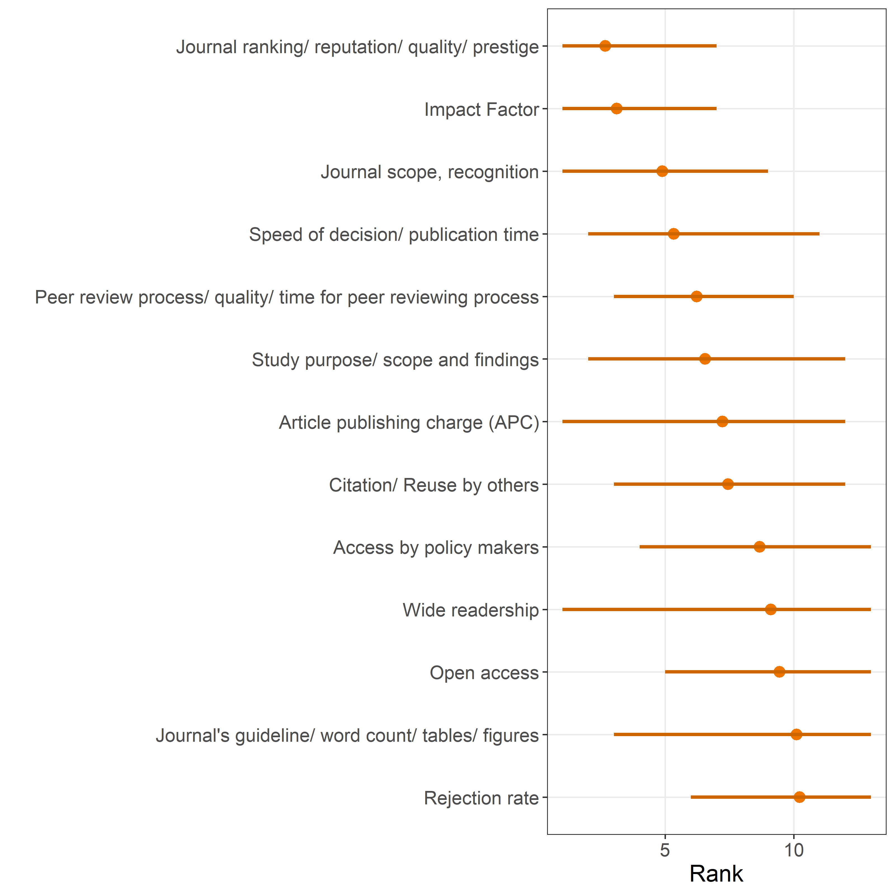

The higher the rank, the more important it was considered. The more uncertainty, the wider the ranges.