Summary of the pilot data collection

Adrian Barnett

2023-06-23

The pilot was conducted on 23 June 2023.

The table below gives summary statistics on the time taken (in minutes) to complete the Qualtrics questions.

| **Stage** | **n** | **mean** | **min** | **max** |
| --- | --- | --- | --- | --- |
| First stage - text | 10 | 6.3 | 3.5 | 7.5 |
| Second stage - ranking | 10 | 3.6 | 1.9 | 5.4 |

## Stage 1 - attributes, free text

The table below shows the free text entered by the participants at stage 1. Rank 1 was the most important, and rank 10 the least important.

The question was: “Write an ordered list of the up to 10 attributes you consider most important when submitting a journal article.”

Most people gave 10 attributes.

| **Rank 1** | **Rank 2** | **Rank 3** | **Rank 4** | **Rank 5** | **Rank 6** | **Rank 7** | **Rank 8** | **Rank 9** | **Rank 10** |
| --- | --- | --- | --- | --- | --- | --- | --- | --- | --- |
| Prestige and the recognition of the journal | Journal’s suitability to paper's topic | Quality of peer review | Journal’s impact factor | Journal’s ranking, including SCImago | Audience and Readership | Journal is open access | Journal is in your field | A journal that your institution and/or supervisor strongly supports | Speed of decisions |
| Impact on clinical care/practice | Cited in policy/clinical guideline | Availability of users to access (e.g. clinicians to read) - so open access | Journals similarity to paper's topic | Journals readership numbers | Journals download statistics | Journals rejection rate | Speed of decision | Impact factor | Journal reputation |
| A journal read by peers and/or recommended by peers | Journal is open access | Paper’s overall quality | Your author position (1st, middle, last, etc) | A journal that your institution and/or supervisor strongly supports | Paper’s total citations | Paper leads to email queries about the research | Paper is used in policy or practice | Paper’s Altmetric score (or Plum Analytics, Impact Story) | Paper wins an award |
| Paper is used in policy or practice | Paper creates health/wellbeing improvements | Paper’s overall quality | Paper leads to new/ongoing funding for research team | Journal indexation, e.g. indexed in PubMed | Paper includes new software and/or training materials | Paper’s download statistics | Paper leads to new collaborations | Paper creates economic benefits | Speed of decisions |
| Scope and aims of the journal tallies with my research paper | Journal’s article processing charge | Speed of decisions | Paper is peer reviewed | Quality of peer review | Journal’s impact factor | Journal indexation, e.g. indexed in PubMed | Paper is used in policy or practice | Paper’s overall quality | Paper has highly novel findings |
| suitability to my manuscript topic | impact factor | article processing charge | journal aims and vision | speed of decision | ease of submission | recommended by supervisors | journal ranking (such as Schimago) | other metrics | rejection rate |
| Journal's suitability to paper's topic | Impact factor | APC | Journal is indexed in pubmed | Rejection rate | Ease of submission process | Prestige and recognition of journel | Prestige and recognition of the journel's publisher | Inclusiveness of papers from other countries | Open access |
| Journal’s impact factor | Speed of decisions | Paper creates health/wellbeing improvements | Paper is used in policy or practice | Paper leads to new/ongoing funding for research team | Popular media coverage | Your author position (1st, middle, last, etc) | Paper has highly novel findings |  |  |
| Match of scope of journal with content of paper (e.g clinical field/readership, methods, etc) | Journal's ranking | Journal is read and respected by people in my field | Type of paper - e.g word limits may be too prescriptive for reviews or journal may not understand/appreciate qual research | Published there before | High quality peer review | Speed of decision | journal is good at influencing policy/practice | Ability to publish open access | APC |
| Paper creates health/wellbeing improvements | Paper creates cultural, behavioural, or social change | Paper is used in policy or practice | Paper creates knowledge about a health issue | Your author position (1st, middle, last, etc) | Paper’s overall quality | Paper leads to new/ongoing funding for research team | Paper leads to email queries about the research | Paper is open access | Paper was co-designed with patients or the public |

## Stage 2 - attribute rankings

Below we show the average ranks (dots) and the ranges (horizontal lines). There were 18 attributes to choose from.

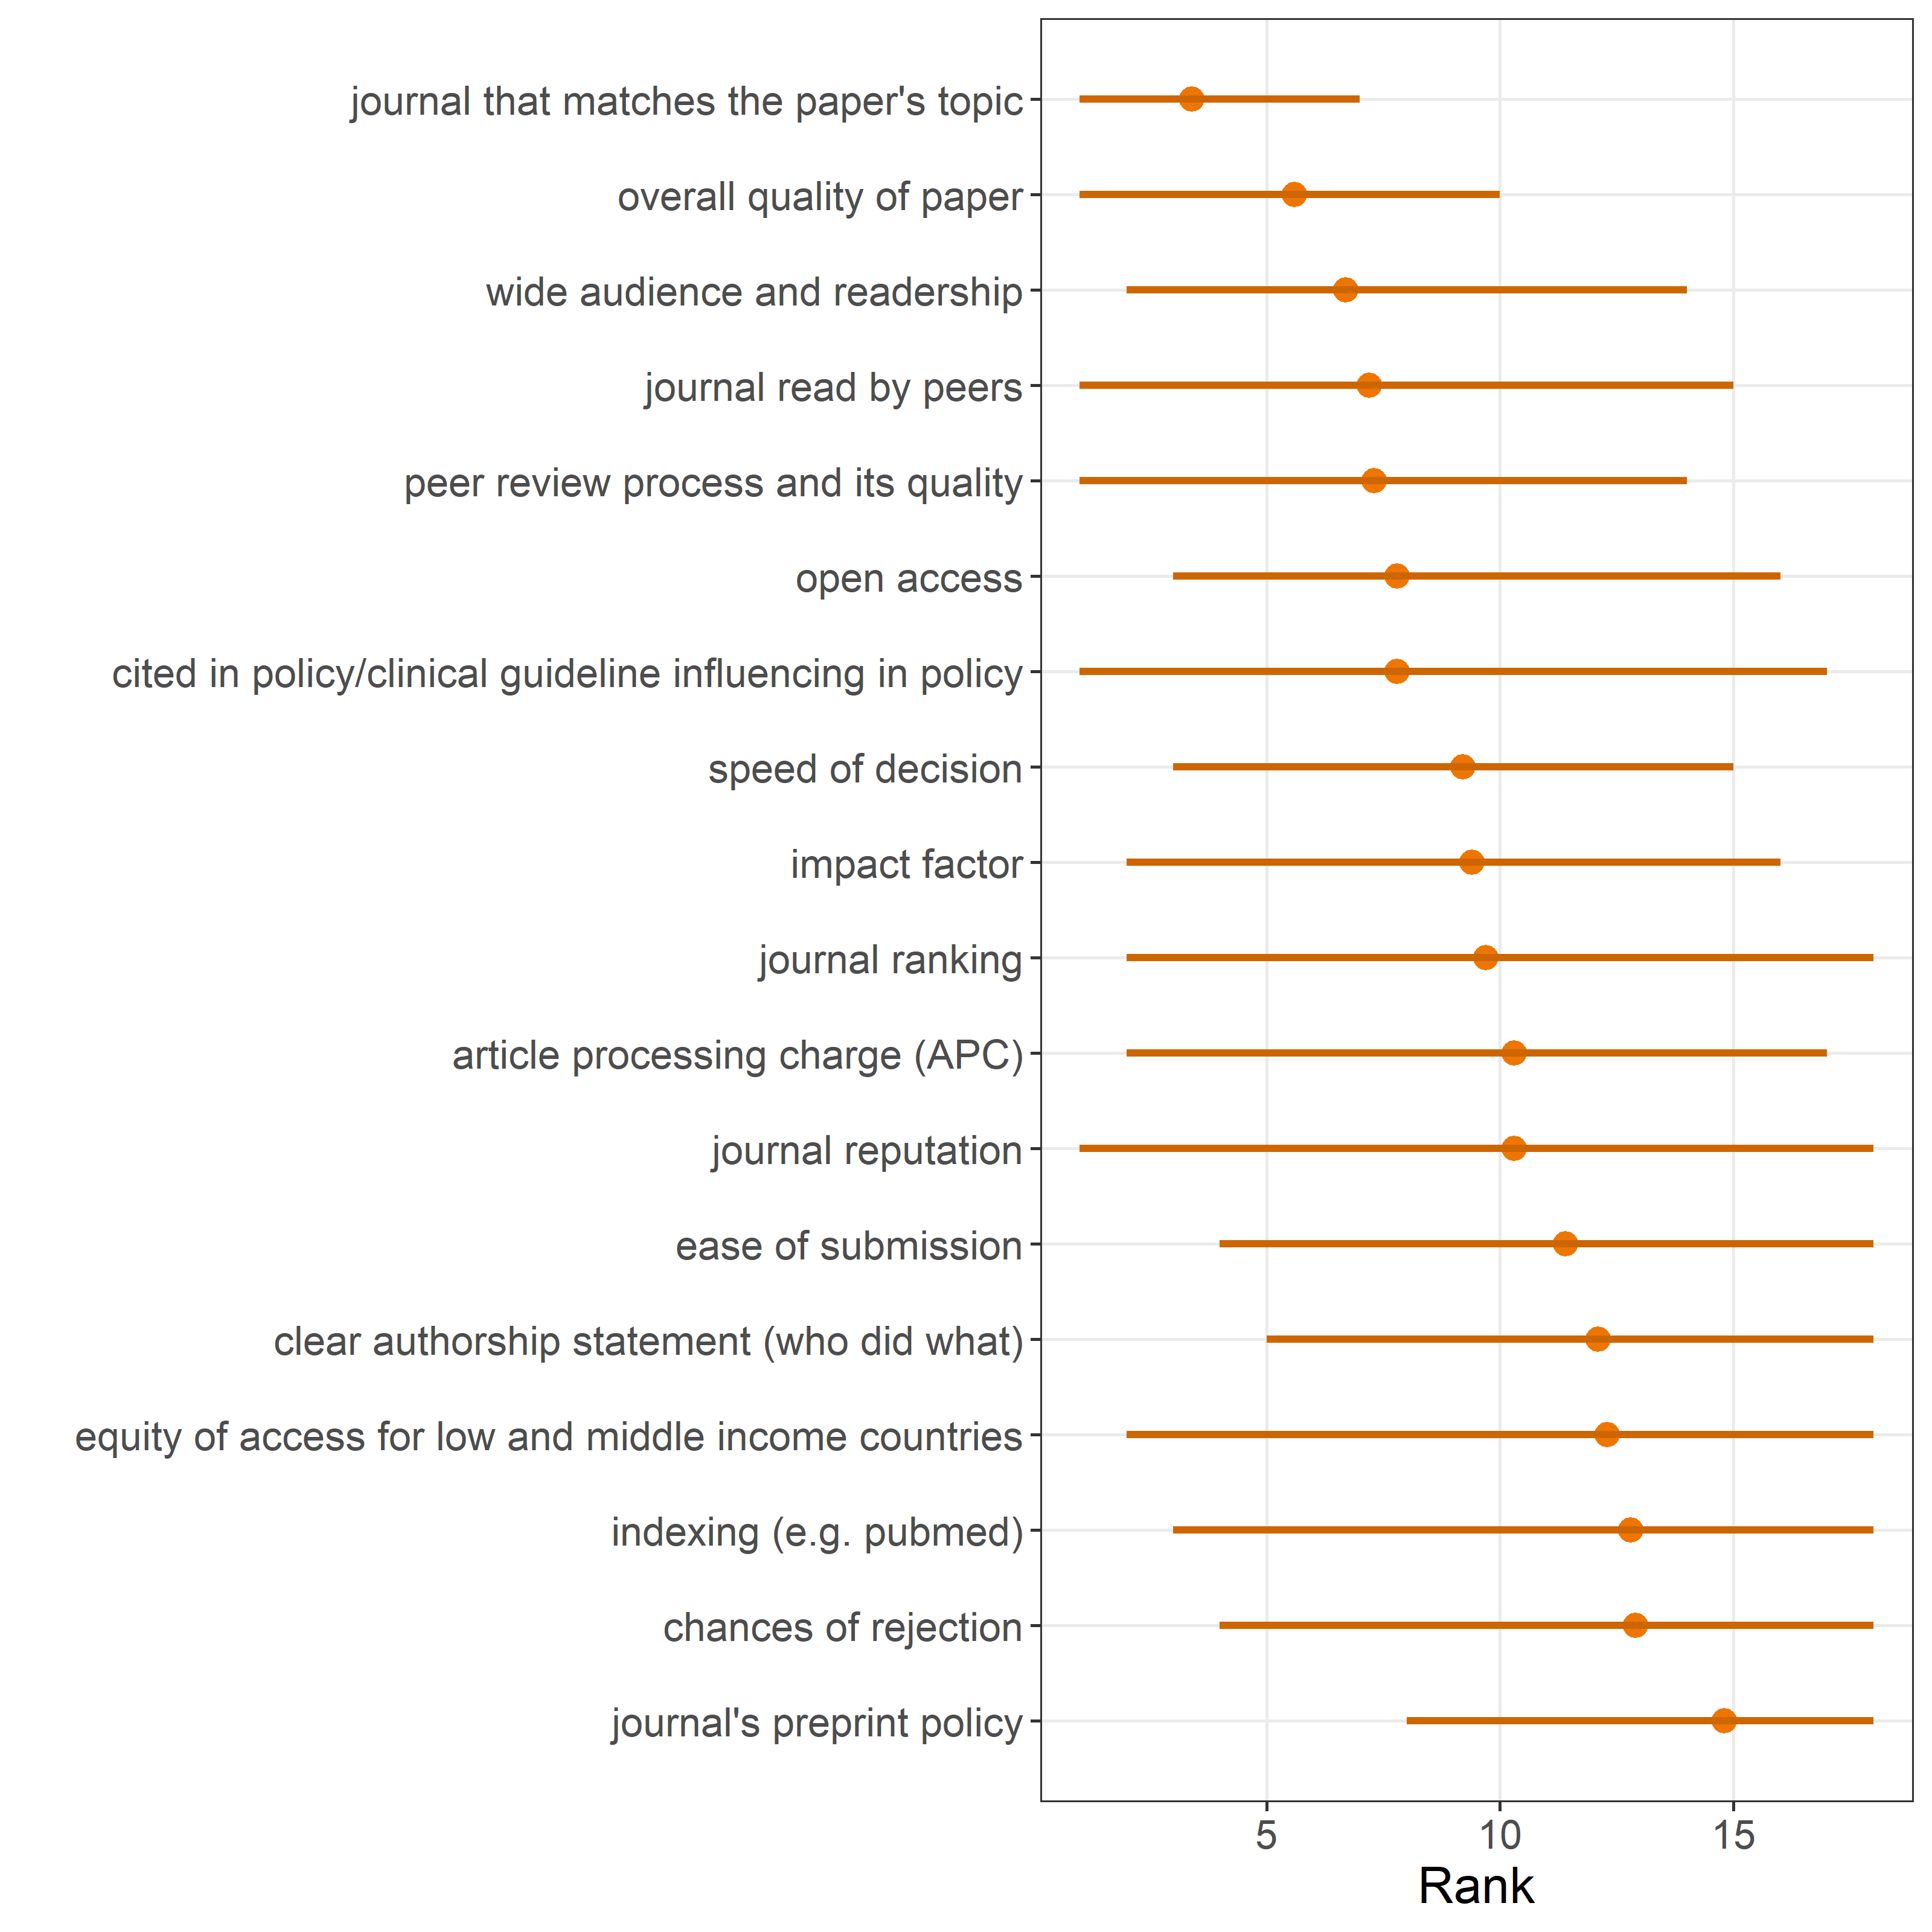

The higher the rank, the more important it was considered.