Summary of DCE responses

Adrian Barnett

12 April, 2024

## Recruitment

Plot of recruitment over time.

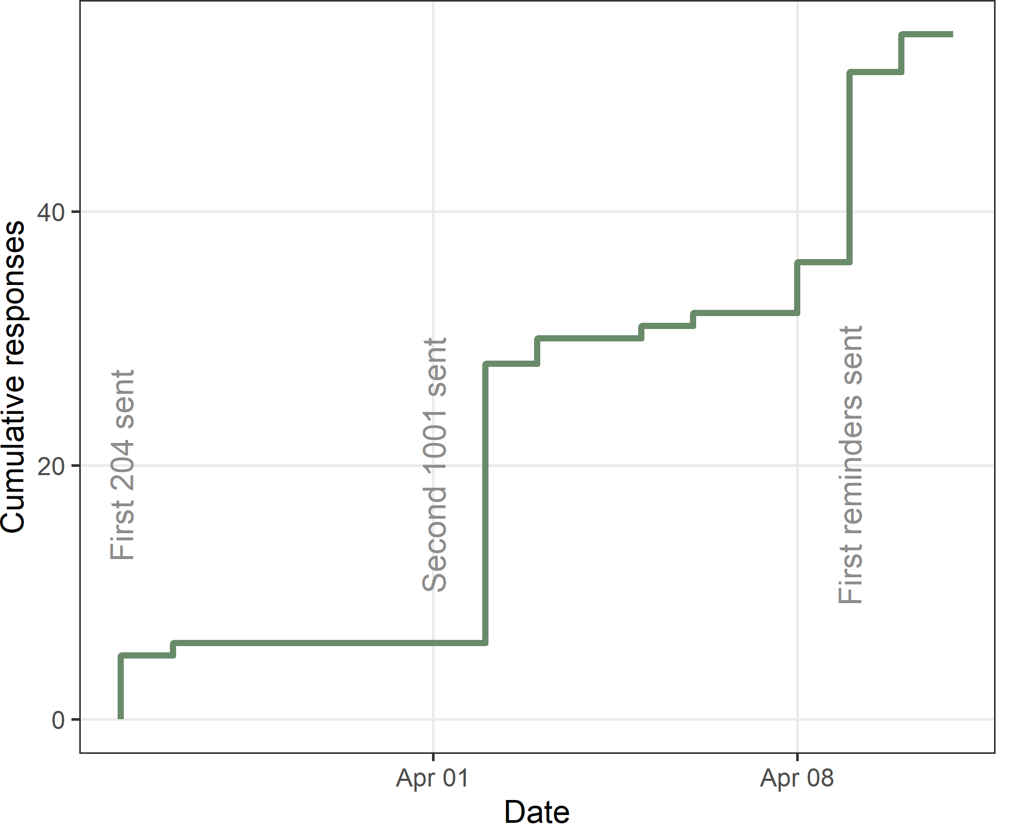

The total number recruited is 54. The first participant was recruited on 26 Mar 2024 and the last on 10 Apr 2024, which is 15 days.

## Response rate

There were 30 (2%) dead or rejected emails. There were 4 (0%) messages with an alternative email for the potential participant. There were 8 (1%) people who opted out. There were 66 (5%) out of office responses.

After excluding the dead emails, the response rate is 4.6%.

## Time taken to answer questions

| **Q10** | **Q25** | **median** | **Q75** | **Q90** |
| --- | --- | --- | --- | --- |
| 3 | 5 | 6 | 9 | 150 |

The summary statistics show the time in minutes to complete the online questions. Q[x] is the *x*th percentile.

## Questionnaire progress as a percent

The table below shows the questionnaire progress as a percent, with the results grouped into three categories.

| **Progress %** | **n** | **percent** |
| --- | --- | --- |
| (-0.001,5] | 0 | 0 |
| (5,50] | 2 | 0 |
| (50,75] | 0 | 0 |
| (75,100] | 52 | 1 |

All respondents completed most of the questions. The number and percent who finished all the questions was 51 (94%).

## How easy or difficult was it to understand the hypothetical choices between journals?

| **Difficulty** | **n** | **percent** |
| --- | --- | --- |
| Difficult | 7 | 13 |
| Moderate | 13 | 24 |
| Easy | 19 | 35 |
| Very easy | 13 | 24 |
| Missing | 2 | 4 |

## What is your broad research area?

| **Broad research area** | **n** | **percent** |
| --- | --- | --- |
| Clinical Science (including medicine, dentistry, nursing) | 29 | 54 |
| Other (please specify) | 7 | 13 |
| Public Health | 7 | 13 |
| Basic Science or Fundamental Science | 5 | 9 |
| Health Services Research | 4 | 7 |
| Missing | 2 | 4 |

### What is your broad research area? (other)

[1] "animal science and animal nutrition"   
[2] "Psychology"   
[3] "Exercise and Health Science"   
[4] "Social Science, Behavioral Science"   
[5] "engineering"   
[6] "Public Health and Health Services Research"  
[7] "Poultry Science"

## Gender

| **Gender** | **n** | **percent** |
| --- | --- | --- |
| Female | 24 | 44 |
| Male | 26 | 48 |
| Missing | 3 | 6 |
| Non-binary / third gender | 1 | 2 |

## Approximately how many years have you been working in research? Answer in terms of working years

| **missing** | **Q1** | **Median** | **Q3** |
| --- | --- | --- | --- |
| 2 | 7 | 10 | 19 |

## How many peer-reviewed publications have you published? Include all papers that you are an author on. Include all types of papers, e.g., research articles, commentaries, case reports, etc.

| **missing** | **Q1** | **Median** | **Q3** |
| --- | --- | --- | --- |
| 2 | 13 | 32 | 82 |

## Which country are you currently working in?

| **Country** | **n** | **percent** |
| --- | --- | --- |
| United States | 11 | 20 |
| Australia | 4 | 7 |
| Brazil | 4 | 7 |
| France | 4 | 7 |
| United Kingdom | 4 | 7 |
| China | 3 | 6 |
| Japan | 3 | 6 |
| Finland | 2 | 4 |
| Ireland | 2 | 4 |
| Missing | 2 | 4 |
| New Zealand | 2 | 4 |
| Türkiye | 2 | 4 |
| Denmark | 1 | 2 |
| Egypt | 1 | 2 |
| Germany | 1 | 2 |
| India | 1 | 2 |
| Mexico | 1 | 2 |
| Norway | 1 | 2 |
| Pakistan | 1 | 2 |
| South Africa | 1 | 2 |
| Spain | 1 | 2 |
| Sweden | 1 | 2 |
| Switzerland | 1 | 2 |
| Other | 0 | 0 |

## Please give your agreement with this statement: My department’s or research group’s expectations with respect to publishing are reasonable

| **Agreement** | **n** | **percent** |
| --- | --- | --- |
| Strongly disagree | 1 | 2 |
| Disagree | 2 | 4 |
| Neither agree nor disagree | 4 | 7 |
| Agree | 27 | 50 |
| Strongly agree | 15 | 28 |
| Missing | 5 | 9 |

## Do you have any comments on: our questions, or how you select journals?

The comments are ordered by the longest to shortest.

* it was difficult to interpret the “how useful/not useful” trade-off because how could something be published in a high IF journal but not be useful? Or I guess maybe if the review process might take too long that could also make an article not useful for other applications/promotion etc because it would not be published yet. It was unclear what that choice was supposed to be about because usually it’s an aggregate estimate of some of the other factors. During article submission, if I am not worried about the review process length I will select a journal that has a higher impact factor, knowing that if it gets rejected I can got down a tier. If I need something to be published quickly I will choose journals that are moderate impact factor but have a reputation for being fast and reasonable.
* I was confused when you wrote that impact factor was “not available.” Unclear if you meant that I didn’t know the impact factor (though can easily find out) or that there is no impact factor, which is a strong negative. That may have affected my responses.
* Our grant is scarce so it is difficult for us to publish open acess (regarding payment, not quality of our research). However, the university/department/ funding sources are always expecting us to publish in the highest impact factor journals.
* Nice discrete choice experiment. Not having an impact factor available was more influential than i thought, whereas I new review time was very important to me.
* I select journals by their impact factors. I refrain from submitting to open access journals or journals that don’t have any reputations in my field.
* One important point for LMI countries: open access and costs of publication! This is a main barrier in limited-resources settings.
* If an impact factor was not available for a journal, it wouldn’t be considered for our group.
* Price is big obstacle and not enough clarity within ‘predatory journals’
* Scientific work is stongly biased with the publishing track records.
* the issue of usefulness (last question brace) was a bit enigmatic
* Poor selection of questionaire
* Open access policy

The median number of words per comment was 20 with a range from 3 to 145 words.

## Dominant choice set

How many people correctly selected the dominant journal.

| **Correct answer** | **n** | **percent** |
| --- | --- | --- |
| Yes | 54 | 100 |

## Re-test

How many people gave the same answer for the re-test choice set. The rows show the original choice set and the columns the re-test.

| **Original** | **Journal A** | **Journal B** | **Missing** |
| --- | --- | --- | --- |
| Journal A | 11 | 8 | 1 |
| Journal B | 7 | 25 | 2 |

The agreement between the original and re-test is 67%.

## Missing data

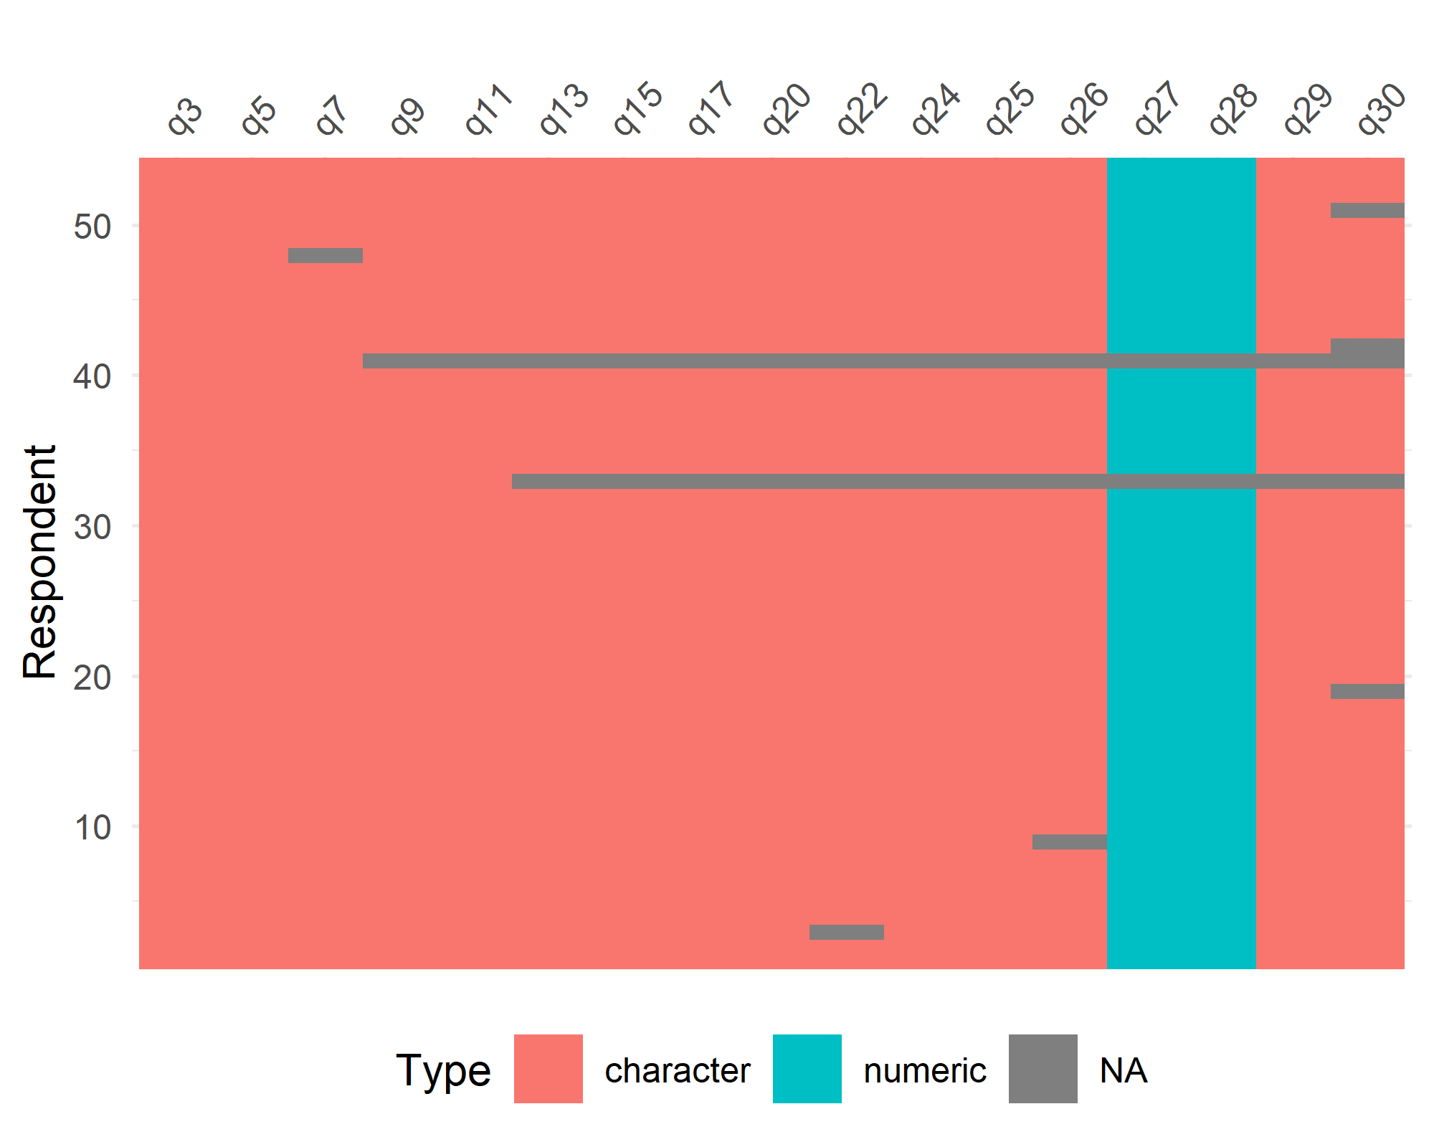

The amount of item-missing data was small. The table below shows the question labels.

| question | label |
| --- | --- |
| q3 | Choice set - dominant |
| q5 | Choice set 1 |
| q7 | Choice set 2 |
| q9 | Choice set 3 |
| q20 | Choice set 8 |
| q22 | Choice set - retest |
| q24 | DCE difficulty |
| q25 | Broad research area |
| q26 | Gender |
| q27 | Years working in research |
| q28 | Number of papers |
| q29 | Country |
| q30 | Publishing expectations |