Summary of DCE responses (pilot and final sample combined)

Adrian Barnett

25 June, 2024

## Recruitment

Plot of recruitment over time.

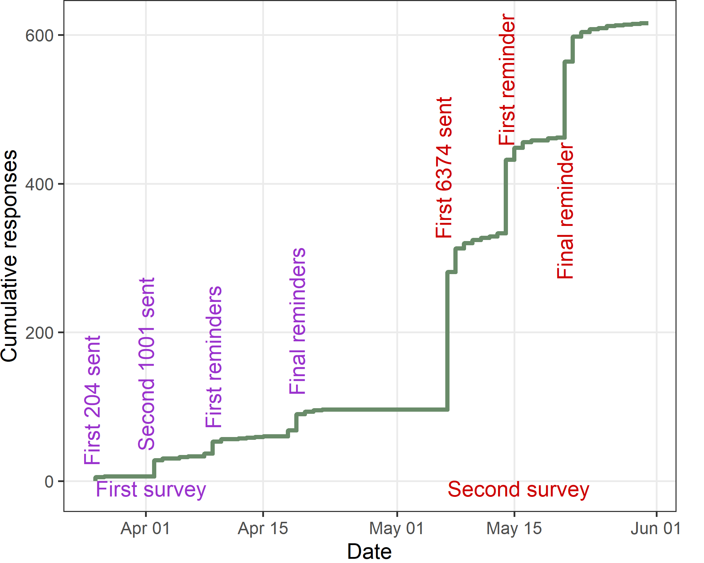

The total number recruited is 616. The first participant was recruited on 26 Mar 2024 and the last on 30 May 2024, which is 65 days.

## Response rate

There were 203 (3%) dead or rejected emails. There were 15 (0%) messages with an alternative email for the potential participant. There were 43 (1%) people who opted out. There were 432 (6%) out of office responses.

After excluding the dead emails, the response rate is 616 out of 7376, which is 8.4%.

## Time taken to answer questions

| **Q10** | **Q25** | **median** | **Q75** | **Q90** |
| --- | --- | --- | --- | --- |
| 2 | 5 | 7 | 11 | 120 |

The summary statistics show the time in minutes to complete the online questions. Q[x] is the *x*th percentile.

## Questionnaire progress as a percent

The table below shows the questionnaire progress as a percent, with the results grouped into three categories.

| **Progress %** | **n** | **percent** |
| --- | --- | --- |
| (-0.001,5] | 0 | 0 |
| (5,50] | 85 | 14 |
| (50,75] | 7 | 1 |
| (75,100] | 524 | 85 |

Most respondents completed most of the questions, but there was a second mode who started but did not progress beyond half-way. The number and percent who finished all the questions was 519 (84%).

## How easy or difficult was it to understand the hypothetical choices between journals?

| **Difficulty** | **n** | **percent** |
| --- | --- | --- |
| Very difficult | 7 | 1 |
| Difficult | 61 | 12 |
| Moderate | 165 | 31 |
| Easy | 198 | 38 |
| Very easy | 95 | 18 |

There were 90 (15%) missing responses.

## What is your broad research area?

| **Broad research area** | **n** | **percent** |
| --- | --- | --- |
| Clinical Science (including medicine, dentistry, nursing) | 297 | 57 |
| Public Health | 72 | 14 |
| Other (please specify) | 56 | 11 |
| Health Services Research | 49 | 9 |
| Basic Science or Fundamental Science | 38 | 7 |
| Medical Education | 11 | 2 |

There were 93 (15%) missing responses.

### What is your broad research area? (other)

[1] "animal science and animal nutrition"   
 [2] "Psychology"   
 [3] "Exercise and Health Science"   
 [4] "Social Science, Behavioral Science"   
 [5] "engineering"   
 [6] "APPLIED PHYSICS"   
 [7] "Public Health and Health Services Research"   
 [8] "Poultry Science"   
 [9] "Environmental sciences"   
[10] "PhD student (clinical research)"   
[11] "Neuropsychological science"   
[12] "Midwifery"   
[13] "Food science"   
[14] "Research ethics / Bioethics"   
[15] "Food Science"   
[16] "Psychology/Psychotherapy research"   
[17] "behavioural science"   
[18] "Nursing"   
[19] "sport sciences"   
[20] "Clinical psychology"   
[21] "statistics for medicine"   
[22] "Veterinary"   
[23] "Veterinary medicine"   
[24] "epidemiology; simple trials"   
[25] "psychology"   
[26] "Mental health/behavioural science"   
[27] "Sport Management"   
[28] "Engineer Biomedical (photobiomodulation, biological signal processing and rehabilitation protocol innovations in physiotherapy)"  
[29] "Nutrition"   
[30] "Veterinary Science"   
[31] "Health Psychology"   
[32] "AI in medicine"   
[33] "Environmental health and sustainability"   
[34] "Malnutrition"   
[35] "Rehabilitation"   
[36] "Biostatistics and Epidemiology"   
[37] "Dairy Science"   
[38] "Social Psychology"   
[39] "Nurse Education"   
[40] "Stuttering Intervention"   
[41] "oncology"   
[42] "Environmental engineering"   
[43] "Cardiopulmonary Rehabilitation"   
[44] "animal sciences"   
[45] "Exercise science"   
[46] "Veterinary Sciences"

## Gender

| **Gender** | **n** | **percent** |
| --- | --- | --- |
| Female | 242 | 47 |
| I use a different term (please specify) | 2 | 0 |
| Male | 264 | 51 |
| Non-binary / third gender | 4 | 1 |
| Prefer not to say | 5 | 1 |

There were 99 (16%) missing responses.

## Approximately how many years have you been working in research? Answer in terms of working years

| **missing** | **n** | **Q1** | **Median** | **Q3** |
| --- | --- | --- | --- | --- |
| 107 | 509 | 6 | 10 | 20 |

n is the number not missing.

## How many peer-reviewed publications have you published? Include all papers that you are an author on. Include all types of papers, e.g., research articles, commentaries, case reports, etc.

| **missing** | **n** | **Q1** | **Median** | **Q3** |
| --- | --- | --- | --- | --- |
| 107 | 509 | 14 | 43 | 100 |

n is the number not missing.

## Which country are you currently working in?

| **Country** | **n** | **percent** |
| --- | --- | --- |
| United States | 78 | 15 |
| United Kingdom | 55 | 11 |
| Australia | 49 | 10 |
| Italy | 20 | 4 |
| Brazil | 19 | 4 |
| Spain | 19 | 4 |
| China | 18 | 4 |
| India | 14 | 3 |
| Türkiye | 14 | 3 |
| Canada | 13 | 3 |
| France | 13 | 3 |
| Germany | 13 | 3 |
| Netherlands | 13 | 3 |
| Switzerland | 13 | 3 |
| Japan | 12 | 2 |
| Sweden | 11 | 2 |
| Ireland | 9 | 2 |
| Denmark | 8 | 2 |
| Egypt | 8 | 2 |
| Norway | 7 | 1 |
| Colombia | 6 | 1 |
| Iran | 6 | 1 |
| South Africa | 6 | 1 |
| Finland | 5 | 1 |
| Israel | 5 | 1 |
| Korea, South | 5 | 1 |
| Belgium | 4 | 1 |
| Chile | 4 | 1 |
| Malaysia | 4 | 1 |
| Mexico | 4 | 1 |
| Poland | 4 | 1 |
| Taiwan | 4 | 1 |
| Bangladesh | 3 | 1 |
| Ethiopia | 3 | 1 |
| Indonesia | 3 | 1 |
| Malawi | 3 | 1 |
| New Zealand | 3 | 1 |
| Nigeria | 3 | 1 |
| Saudi Arabia | 3 | 1 |
| Greece | 2 | 0 |
| Kenya | 2 | 0 |
| Nepal | 2 | 0 |
| Pakistan | 2 | 0 |
| Romania | 2 | 0 |
| United Arab Emirates | 2 | 0 |
| Argentina | 1 | 0 |
| Austria | 1 | 0 |
| Benin | 1 | 0 |
| Croatia | 1 | 0 |
| Cyprus | 1 | 0 |
| Estonia | 1 | 0 |
| Hungary | 1 | 0 |
| Jordan | 1 | 0 |
| Kuwait | 1 | 0 |
| Luxembourg | 1 | 0 |
| Namibia | 1 | 0 |
| Panama | 1 | 0 |
| Portugal | 1 | 0 |
| Russia | 1 | 0 |
| Singapore | 1 | 0 |
| Tanzania | 1 | 0 |
| Thailand | 1 | 0 |
| Uganda | 1 | 0 |

The total number of countries was 63. There were 102 (17%) missing responses.

## Do you have a target number of publications per year? (tick all that apply)

| **Answer** | **n (%)** |
| --- | --- |
| Yes, mandatory target from my department or research group | 26 (6%) |
| Yes, suggested target from my department or research group | 60 (14%) |
| Yes, I have a personal target | 173 (40%) |
| No | 200 (47%) |
|  | 0 (0%) |
| No answer | 90 (15%) |

This question was only in the second sample.

## What is your target number of publications per year? (skip if none)

| **missing** | **n** | **Q10** | **Q25** | **median** | **Q75** | **Q90** |
| --- | --- | --- | --- | --- | --- | --- |
| 280 | 240 | 1 | 2 | 4 | 6 | 20 |

n is the number who gave an answer.

This question was only in the second sample.

##### Histogram

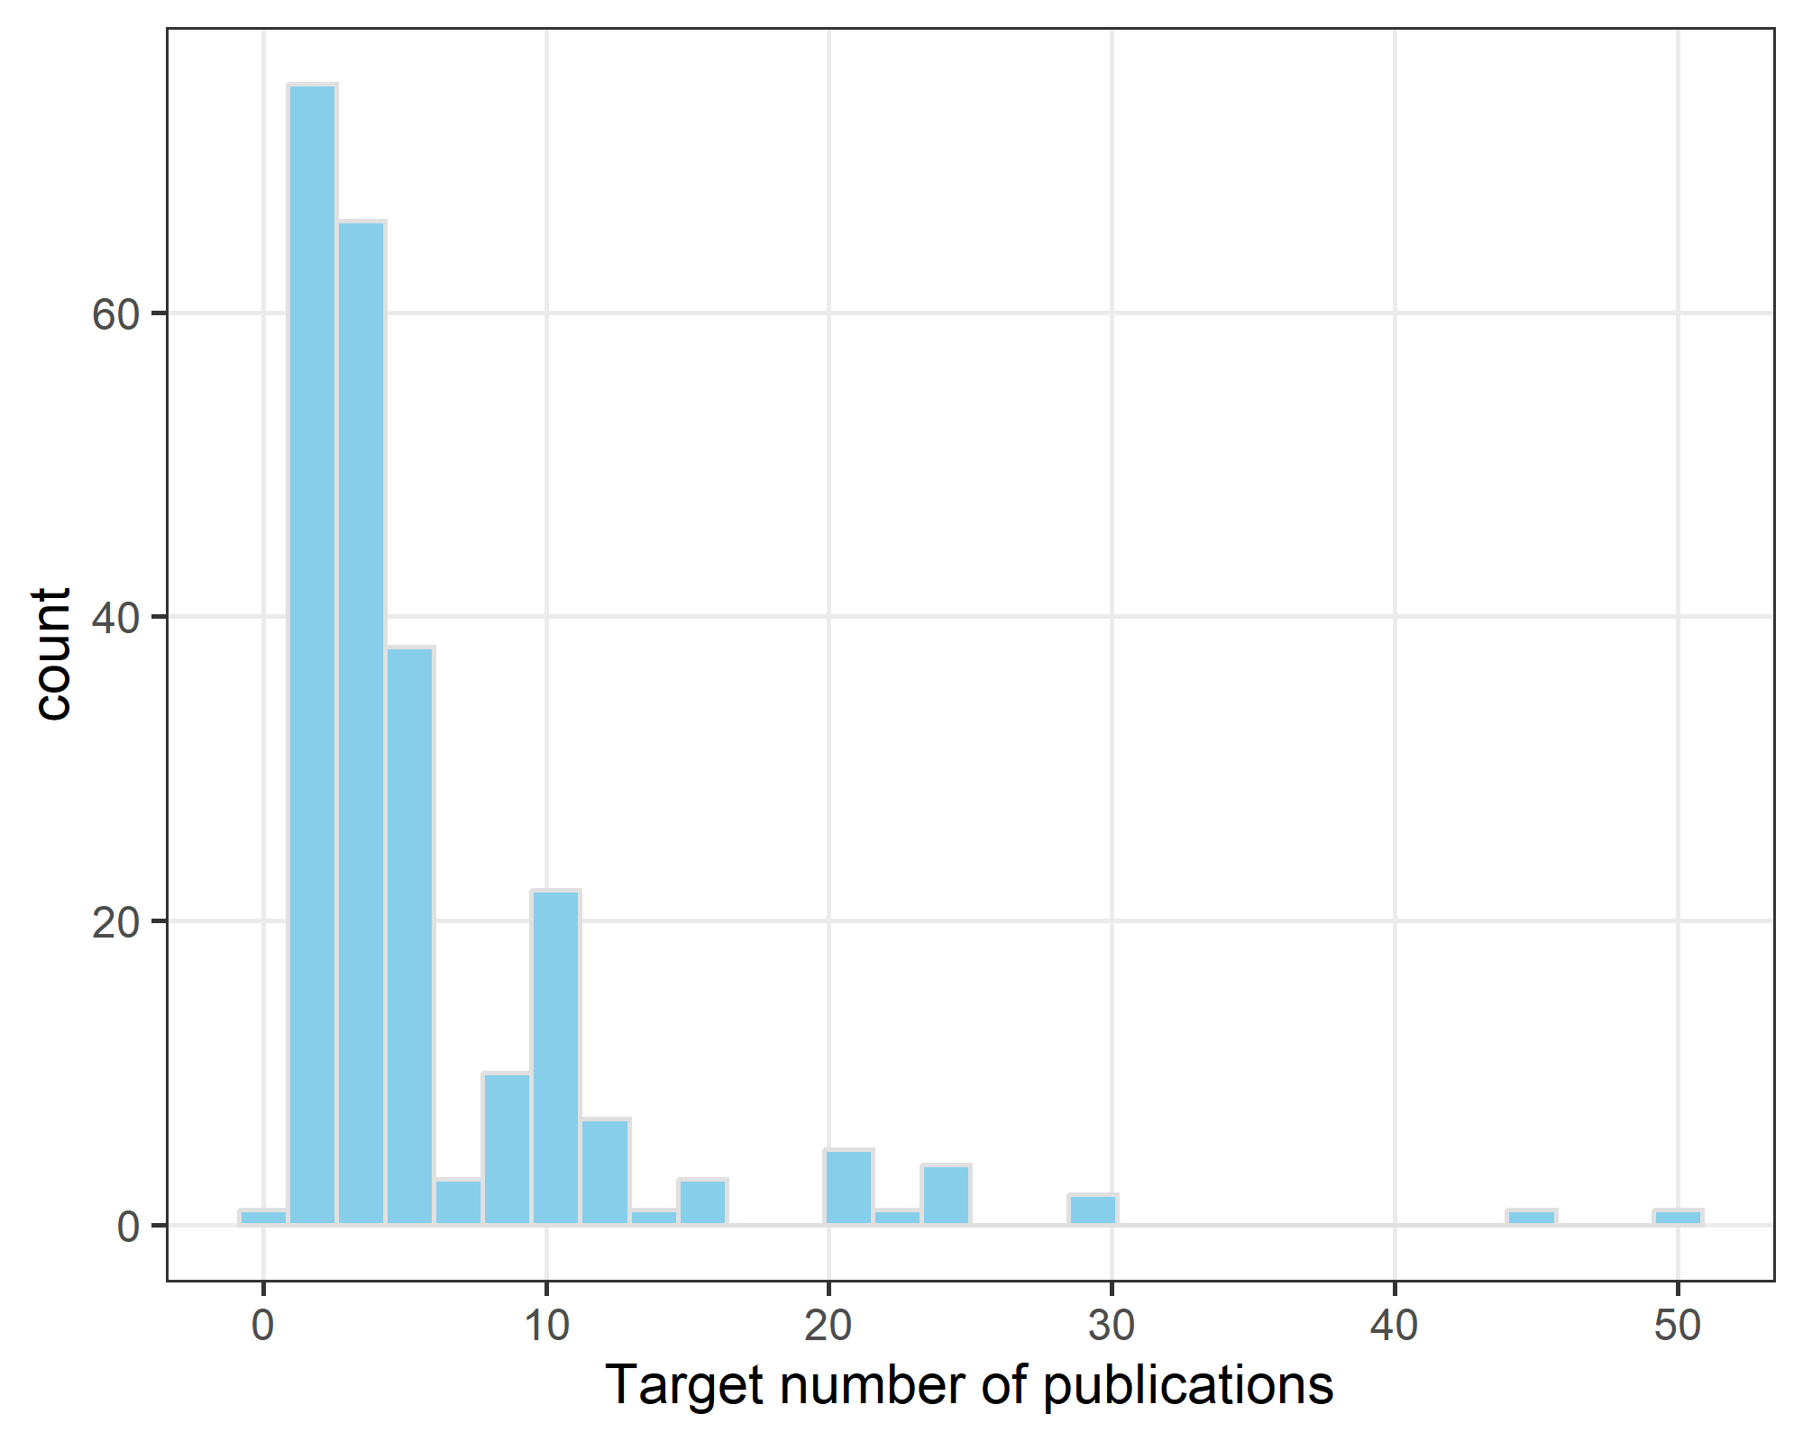

## Do you have any comments on: our questions, or how you select journals?

The comments are ordered by the longest to shortest.

* I did not quite understand the following categories in your choice of journals: 1. Impact factor - why is the impact factor not available - is it ‘not yet’ available, because it is a new open access journal, or will it likely never have an impact factor, because a. it is one of these ‘cheap, predatory’ journals that bombard you with requests to submit a paper to their journal or b. a new high-quality journal that is politically/ethically opposed to impact factors? I believe that my responses to the scenario questions are not valid, because I was lacking this background information. 2. Considering next promotion/fellowship application: It did not make sense to me why the same paper would be useful for my promotion/fellowship when submitted to one journal, but not useful when submitting it to the other journal. The only way I could think of this were true, is if the peer-review process in one journal were too slow for the paper to be published before my promotion/ fellowship application (although in this case, I would probably publish it as pre-print if possible), or if during fellowship/ promotion application only journals with impact factor are considered. However, since these factors were scenario variables themselves that did not necessarily match the given ‘useful’/ ‘not useful’ rating in the promotion category, I found it very difficult to rate the journals… By the way, I wonder if you might have selection bias in your survey, because your email was only signed with “Adrian Barnett”. Depending on country of origin and institutional culture, people who consider the sender’s title/ role/ seniority to see if an email is trustworthy or who take the time to look up the person, might be different from those who don’t and might be more or less likely to delete / ignore the email…
  1. It was confusing when the impact factor was unknown. Typically if I can’t figure this out this means the journal is new and may not pan out or that it is a very bad journal. My belief was that you were trying to get to a situation where I just didn’t know, but usually that can be solved quickly with a web search so it was hard for me to interpret. 2. Reformatting - now-a-days many things can be easily re-directed to a supplement and lesser known journals (and some even better ones) may consider your manuscript even if it is not formatted exactly as per specifications. While I usually do adhere to rules pretty strictly, many of my colleagues do not. 3. The other thing which I think about is who will read a paper depending on the case it is making. This may influence me to want to try for an atypical forum, so audience may be another parameter which you study in future iterations of your work
* it was difficult to interpret the “how useful/not useful” trade-off because how could something be published in a high IF journal but not be useful? Or I guess maybe if the review process might take too long that could also make an article not useful for other applications/promotion etc because it would not be published yet. It was unclear what that choice was supposed to be about because usually it’s an aggregate estimate of some of the other factors. During article submission, if I am not worried about the review process length I will select a journal that has a higher impact factor, knowing that if it gets rejected I can got down a tier. If I need something to be published quickly I will choose journals that are moderate impact factor but have a reputation for being fast and reasonable.
* The variable about what the Editor said would be requested after peer review was ambiguous. If this is a choice about initial submission, was it a false or inappropriate promise? I swithered about how much weight to put on colleagues’ reports about previous helpfulness of reports. The compatibility of the statements re paper being improved and paper needing to be cut by a quarter and a table was difficult to consider. I don’t think my weighting of variables that might reflect something important but it wasn’t clear how was very consistent. In practice, word count and likely openness to my sometimes edge of field approaches tend to swing submission decisions.
* Impact matters as well as journal reputation. Usually, the journals with the greatest reputation and impact attract strong reviewers, which ultimately assists to improve your work. I think the question surrounding major/minor amendments is difficult to contextualise, since most journals indicate major amendments, when in fact there is not a lot of work to do - perhaps more a provision of time to complete the task. I also feel the question related to promotion opportunities is also problematic. All research outputs should contribute to your academic reputation and therefore career trajectory.
* I’m goal orientated. If publishing in a journal is going to be “useful” for a goal (to progress in my career) compared to another that is definately “not useful” then all other variables are not important. I do not have a strick number of publications I need. Therefore I will rather not publish (or even do any research) if it will not be useful towards my goals/career growth. An important variable not discussed here is the cost of publication. If a journal is not affordable and I cannot secure funding then I cannot publish with them.
* There is a problem with your attribute about Impact Factor, in which you list “not available” as a status for the impact factor. Does that mean that the IF is not available because there isn’t one, or that I can’t access it? i.e. the journal is not listed by Pubmed and not ranked by Clarivate? I answered your questions as if there WAS no impact factor (e.g. the journal is too new), not that it wasn’t available because I didn’t have access to the internet or some other reason. This interpretation may skew your results (either way).
* I select journals based on (1) relevance / fit of my research to the scope of the journal, (2) impact factor, and (3) my own assessment of the quality of published papers in those journals. Sometimes, I may account for (4) previous experience with the journal (speed and quality and fairness of reviews), especially when time to publication is important (e.g. for a PhD student). Impact factor is always a consideration because it ‘counts’ for promotions, grand applications, and perhaps building a field reputation.
* Basically, top priority is on the topic of interest and its impact factor. For example, I submitting a paper on bolstering vaccine confidence… my top on mind is BMJ Global Health (high impact journal, has a strong stand on decolonizing global health, etc) and Vaccines (Elsevier, high impact and if my results really touch based vaccines complexities). Also, a great challenge is on the APCs, if my project do not have specific funds to cover the publication costs.. i tend to go to lower impact journals.
* I am not sure how one picks a journal knowing the post-peer-review decision will be realistic enough to find how they usually pick a journal. Also, the influence on the last question on useful for a promotion/fellowship depends on how immediate such an event is. If none of these is impending, ( or even at other times) I would look to publish papers which would add value to the field irrespective of its impact factor. I also look for society publishers, which wasn’t of interest to this study.
* Some scenarios are extremely unlikely in my experience, for example a journal with a high impact factor that would not be useful for promotion - I understand how you will use these data in assessing competing priorities, but I am afraid respondents will discount (ignore) unlikely scenarios and responses will be biased due to their personal belief that the scenario is impossible, and for example a high impact journal would count toward promotion, even if your scenario suggests it would not.
* In selecting which journal for my manuscript, we were given a list of journals in collaboration with the university, so we first chose these journals because the Article Processing Charge (APC) is directly paid by the university, although most of these journals are Q3 in Scopus. If we want to submit to other journals for Q2 and Q1, there are no specific considerations to take into account; the APC will be paid by the researchers and can be reimbursed by our university.
* I think that often there is a divergent feeling towards journals selection: somehow as a scientist and researcher, I would like to choose the journal based on personal reputation or other factors (for example, I like the papers are published there); meanwhile, research quality evaluation often is measured on other factors (e.g., IF/quartiles) and therefore it is mandatory to try to publish on those kind of journals, including those with fast responses time.
* “Considering your next application for promotion or a fellowship, this paper will be useful/not useful” This part didn’t make any sense to me, so I ignored it. If the content of the paper would be roughly the same wherever it is published, then the higher impact journal would likely be more useful for promotion etc. Also, I would never select a journal without an impact factor as I always publish in journals that I know and can trust that are not predatory.
* Currently selecting a journal is problematic: we do use the impact factor (highest that we see as realistically likely to publish our work), but want the rejection to be quick if it is not going to be reviewed. Reviewer comments need to be helpful in improving the science. We want to present all analyses so some might end up in Supplemental Materials if the journal will not publish more than 3 or so figures. I am fortunate in not needing to be promoted.
* Selection based on: topic of article in relation to topic of journal, impact factor, article type accepted at journal, article requirements of journal (such as word count, formatting), diversity of journals among already published articles (e.g. not publishing all articles at the same journal), experiences of publishing process of a journal by senior researchers/supervisors, advice from senior researchers on best fit for article of journal, etc…
* Interesting questionnaire. The main feedback on the questions is to do with ‘being useful for a future application or your next job’. I could not think of any scenarios where the nature of the journal determines this (rather than the content of the publication) apart from the impact factor putting it in a top-tier category or not. As such it felt artificial to have the highest impact factor and not being useful combined versus the contrary.
* The burden of formatting is a real issue. It massively reduces productivity. Particularly if the same paper ends up being rejected and resubmitted elsewhere. Speed is very important to me. I will avoid journals that have taken a very long time in the past. It is difficult to separate publications from professional development. By default, publications are counted highly as an academic and will help facilitate promotions.
* Some of the hypothetical situations were not realistic examples Eg if you are submitting the same paper and choosing a journal why would the paper be useful for a grant application from one but not the other - it’s the same hypothetical paper Comparison of no impact factor
* to highest isn’t realistic - most would not submit to either highest is often unattainable for majority of papers while no IF is generally avoided
* I wasn’t sure how much weight to place on the fact it had been desk rejected twice. Higher impact more useful journals are better for me. But since the paper had been desk rejected I assumed it wasn’t that novel of findings. ALso, sometimes things that would CLEARLY help my next promotion such as publicaiton in highest impact factor in my field were labeled “not useful” which made it confusing to answer.
* It depends on whether the paper is a high quality one worth putting time and effort in to get published in a high impact journal, whether it is a students or junior staff paper in which case quicker pub would be better for their careers. It depends on how many journals I have already tried as well. I tend to use quartiles and impact factors because our institution encourages us to publish in Q1 journals.
* It is a clever exercise, but too theoretical to accurately capture the real reasons for the decision. The factors identified mostly matter, but others are often more important, eg, the targeted readership for the article, the time lag for publication after the review decision, urgency of getting it published, and whether you have already taken a shot at a high IF journal and now just want it accepted.
* I sit outside academia where I don’t have the perverse publish-or-perish incentives. I find my job as a science advisor/researcher is made harder by the vast amount of articles that really didn’t need to be published, or could have been a letter/combined into another article. I support OSF and Registered Reports and would like to see more open peer-reviews and/or commentaries published with articles.
* your questions were slightly contradictory as “impact factor” and “useful for promotion” are related. So “high impact factor” and “not useful for promotion” is not a realistic scenario. Also you should have included “cost of publication”, now that the majority of journals are open access, as this is proving to be a decisive factor for those researchers who do not have funding to cover this cost.
* My decision is based mostly on a mix of factors that include sope, visibility in the field (not the same as impact factor but of course some overlap with it), and speed of reviews. I found the criterion how “helpful” reviewer comments are a bit confusing because in my experience that has zero relation to the journal. You can get helpful or unhelpful comments from reviewers at any journal…
* I see you did not address open access journals, I think that would be interesting to include as future research, for example European Grants encourage open access publications, besides they usually are fastest at every step of the process, on the other hand some of them seem too expensive for authors, they also very often require authors to support them in reviewing submitted manuscripts
* Institutionally, journal APC fee payment support is very limited. Also, economic conditions in my country are not good. For this reason, I do not prefer full open access journals. In order to be promoted, it is not enough for the journal to publish with doi. The date and number must be certain. For this reason, I prefer journals that assign dates and issues quickly.
* It was hard for me to understand what it meant for the paper to be useful or not useful in my promotion, because in my world that depends on things like the impact factor and number of publications I’ve already had that year, so it was treated as an independent variable in these scenarios but it doesn’t really track that way in my experience.
* I would never select a journal where thre was no impact factor available and would be very concerned about the quality of such a journal - other factors less important. A factor that looms large in my choices is the cost - we support open access but as African researchers thousands of pounds/dollars publication fees can be a deal breaker
* Most of your scenarios are artificial - the first consideration is does the journal charge an APC. If yes then it’s already out. Most high impact journals charge an APC which is higher than my monthly income as a government academic researcher. If there is no APC then I look at how relevant it is and what the impact factor is
* My reasoning is: I prefer a high IF, but I care the most about good research and good read worthy research article. Hence, I appreciate good and structured review, which is not contradictory. I think I have communicated exactly how I reason in your survey. This is a very clever survey. Well done. I wish you the best of luck.
* The option of whether a publication is useful or not in the next application of promotion did not feel relevant to me. Usually, as a first and/or corresponding author, all research publications count towards career progression in my set-up. This factor was not relevant to me and I had difficulty basing my decisions on this.
* Many of the combinations just don’t occur in mature. A nonexistent if is never useful for promotion. The nature of reviews is nearly always unpredictable so cannot be taken into account. The editorial preferences make more difference to whether it is worth trying a particular journal. Sad but true 8-)
* My research is aimed at promoting clinical change therefore we select the target journal based on the readership we feel will benefit most from this and most likely to use it in their practice. The quality of the research also dictates the level of the journal you may target (as reflected by the IF).
* I think the choice of promotion/ professional requirements often over rides the other factors . Often i have to restrict my answers based on this individual domain and therefore maynot be representative of the entirety of my decision making process while selecting journals.
* Target sigaps points not article number In my case the selection is biaised by the necessity of having 200 sigaps points after 4years to continue working in french universitary hospital. If there wasn’t this objective, the IF would have been less important in my selection.
* The notion that a paper would be useful for promotion when published in one journal and not another did not make sense to me in the choice task (particularly if the “not useful” option was associated with a higher impact factor). This made the task somewhat unrealistic.
* Concerning the hypothetical scenario: in my field of research, it seems quite non-existent that a high impact journal would not contribute to your profile for grant applications/fellowships. This was an aspect that I perceived as hard in the evaluation of the scenarios.
* The journal options as provided are illogical. A high impact journal is, rightly or wrongly, likely to be important in promotion/grant applications. Therefore comparing high impact-not important for promotion to low-impact-important for promotion journals makes no sense
* I am leery of journals without impact factors as I don’t want to publish in a predatory journal or one that may become predatory. Time to publish is very important. I do not like journals with poor reviewers. Open access and fees are also relevant considerations.
* It’s never like choosing between 2 because you don’t have feedback all the time. Most decisions are about impact within the field (have I read good papers in the journal ) and about publication cost (open access need to be weighed against journal reputation).
* A big part of journal selection is fit with the topic…if I’ve cited a journal a lot in my references, that will be a target journal. Impact factor is also important at my institution. I’m already a professor so promotion isn’t that big of a driver for me.
* I was confused when you wrote that impact factor was “not available.” Unclear if you meant that I didn’t know the impact factor (though can easily find out) or that there is no impact factor, which is a strong negative. That may have affected my responses.
* We are obliged to publish open access, or even prefer it, but budget to pay is very limited, so free APC under institutional agreements with publishers is paramount. I have no career progression prospects so that last row was irrelevant to me every time.
* I value fair reviews. As a woman clinician scientist I sometimes feel that I do not receive ‘impartial’ reviews. I value impact factor but also that the papers that I publish are of the best quality - recognizing that they will be in print forever.
* When selecting a journal, most important is the relevance of the journal in my research field. Very interesting survey and sometimes quite difficult to answer / Sometimes difficult to weigh up which aspects are actually more relevant. Thank you!
* Our grant is scarce so it is difficult for us to publish open acess (regarding payment, not quality of our research). However, the university/department/ funding sources are always expecting us to publish in the highest impact factor journals.
* Journals have been selected according to research type i.e. a local journal for the preliminary sections of the project. For the final, larger study, I will be submitting to a major international journal with a high impact factor in my field.
* You excluded key info that I use - previous experience publishing in certain journals, knowing the editors/editorial board (although usually not very helpful as it undergoes peer review anyway). IF of the journal usually tops decisions.
* I am now required to publish in open access journals as much as possible and we have funding available for some specific journals that meet this. This also influences choice of journal - i.e.. shaped by institutional requirements.
* The publication cost is an important factor for me because most journals charge on dollars, euros or pound sterling which is very expensive in Brazilian currency. In this way, normally I prefer journals with free publication.
* The hypothetical differences in whether publishing in Journal A/B would be useful for promotion didn’t seem realistic when combined with other factors listed, but maybe it’s just that I haven’t had this kind of experience.
* Our department requires a minimum impact factor in the field of biomedical engineering. We are also primarily looking for free or low-value journals, given the devaluation of our currency compared to the dollar or euro.
* The answers to this will depend a lot on the person’s level. Early career researchers have different priorities than established senior researchers. It will be interesting to see if this is reflected in your results.
* No mention of the reputation of the journal. I avoid predatory journals. The UK also has a set of publishers that are funded by the research councils and I always filter journals because publication fees are covered.
* We select journal based on the following: Web of Science under SCIE category, Q-ranking, JIF percentile >10 (Q4). Without formatting (authors own choice of formatting). and moderate to fast decision on first report.
* For some of the questions, I would have chosen neither journal in real life. Also, the last statement of whether the paper would be useful or not useful for future promotions of fellowships was unclear to me.
* in your survey, 2 questions were contradictory in my case: the impact factor and the question regarding the impact on the publication on my promotion (as my promotion is related to the highest impact factor)
* whether a publication is useful for promotion is very tied to impact factor - it was hard to separate those two factors when making a decision (ie high impact factor but deems not useful for promotion)
* Depends on the research and effort involved. Fast response, reasonable reviewers trump impact factor for most of my papers. However, for longer term projects, try high impact regardless of the hassle.
* My first and most important priority in selecting journals was the journal’s impact factor in my field. Second, was the helpfulness of the journal reviews. last one was its usefulness in my promotion.
* Since I am still rather new when it comes to writing/publishing articles, I select a few journals that fit the scope of the paper and then ask my co-authors for their experience and advice.
* Impact factor, Q score and cite score. Also, depends a lot on funding and the journal publisher agreements of my/co-authors institutions - this might actually be the biggest driving force.
* it all depends- if it is a powerful paper i will choose the highest impact i think i can get, but if it is a small piece of the story I will look for a smooth and efficient review process.
* Generally anything except a case report I’d generally want an impact factor or at least ESCI listing. I try to submit to a fair number of different journals depending on what is relevant
* It is required from my uni to have IF. So even if I have to cut words, make formatting, etc. I need to have the IF. I work in the US & Poland at the same time. I have 2 affiliations.
* For some hypothetical scenarios, it is hard to envision how a journal with unavailable IF, slow and useless reviews, etc., could be helpful for a promotion or fellowship.
* Lately I have been specifically seeking out calls for papers in advance to see how they best fit the projects in my lab and working within that constraint and deadline.
* Most important: Need to have an impact factor, preferable >5 The first decision should be in around 1 month (not more) There should be an option for no publication fee
* Congratulations on your interesting research. I am looking forward to the research results. I will read your article with interest when it is published. Best regards.
* Today, high impact factor journals usually have fast turnaround and are useful for promotion. That you devised questions that unlinked these factors is unrealistic.
* When I have to decide which journal I can select, the price is always very important. Sometimes, the research project has finished, and there is not enough funds.
* I believe that a minimal(Impact Factor) I.F is necessary in order to have a wide publication but other factors are very important after having the ‘Minimal’ I.F
* Nice discrete choice experiment. Not having an impact factor available was more influential than i thought, whereas I new review time was very important to me.
* Fit with journal remit; wide readership within my subfield, reach to a mixed psychology/medical audience, whether it is a paper led by myself or my students
* What should be the maximum waiting period for getting any response or review from a reputed journal with high impact factor, from the date of submission?
* I select journals by their impact factors. I refrain from submitting to open access journals or journals that don’t have any reputations in my field.
* Promotion was not tied into publications for me. Therefore, it was more important to retain the integrity of the study by not reducing the analysis.
* Impact factor is important, but I also check the quality of the published articles. Recently, article processing charges have become also relevant.
* A factor that would make a difference is whether the publication attracts a publication bonus in my organisation. That may have altered my answers.
* I select journals based on 1) APC free (subscription), 2) IF, 3) chances to be published 4) formatting rules (if changing too much, I would avoid)
* It is difficult to imagine a scenario where a journal will both 1) have impact in my field and 2) have no benefit for career/promotion decisions
* We have found it challenging to be able to adequately describe our studies with the word limits set by most journals that we investigate.
* For me the most important outcome is the quality of the article and if reviewers comments assist me in that endeavour, it takes priority
* Established guidance would be helpful, especially because some well-recognized journals use predatory practices - a lot grey areas…
* One important point for LMI countries: open access and costs of publication! This is a main barrier in limited-resources settings.
* I am not good at choosing. Tend to choose a journal which has accepted previous similar papers and I have had good experience with
* I select journals based on the impact factor, fast response from reviewers, and area of research that aligns with my paper and APC
* I felt that the responses, “useful” and “not useful” for the respective attribute could have been differently presented.
* First: What is the strength of the data (truly new, or confirmatory); if new, go to top journal (Science, Nature, etc.)
* Difficult to understand how a some choices would be considered “not useful” when most other attributes were positive.
* Usually with a lot of input from supervisors whose main priorities seem to be impact factor and speed of response.
* you did not ask about finance and open access - I rarely have funding and rarely publish in open access journals
* Agreements with my University and certain publishers do also play an important role as open access is expensive.
* Needs to be relevant to the topic of the paper, with a high impact factor. Response time is also a key factor.
* Journal that related with my research field/topic is the most important factor that I normally considered.
* Would also consider publication costs and whether there is an agreement between university and publisher
* I avoid certain journals I believe are poorly run and those that charge exorbitant publication fees
* The decision is based on how much the journal will charge and how long it will take to publish.
* I often ask to my Chief if the paper might be suitable for publication in a particular journal
* If an impact factor was not available for a journal, it wouldn’t be considered for our group.
* We’re expected to have a minimum of 4 high quality papers published within a 7 year window.
* Not just impact factor but also look for scimajo journal rankings of Q1 and Scopus top 10%
* I try not to use journals you have to pay for … this was not included in your questions.
* impact factor and helpful comments to improve the science are my most important criteria
* I do not consider journals without IF and, if possible, apply for those in Q1 or Q2.
* I use the “Find Journal” tools (ex.: <https://journalfinder.elsevier.com/>) to help.
* I struggled with this exercise because I don’t actually know how I select journals
* in the journal selection process, we avoid submitting papers to predatory journals
* I avoid journals that are proud to announce that they have a high rejection rate!
* Strange choices that the highest impact journal would not be useful for promotion
* Select journals based on relevance to subject area and reach to target audiences
* Would also look at if our library has an open access agreement with the journal
* No very high impact journals because I know it will be hard to publish in them
* Aim/scope and readership of the journal, impact factor would be most important
* I’ve been told if it isn’t in an impact factor over 10 it doesn’t matter/count
* You could have considered the publication price is some journals. Good work
* There is a contradiction between journal’s IF and it being helpful for me.
* I’d be interested to know how you chose the attributes and the categories.
* Price is big obstacle and not enough clarity within ‘predatory journals’
* I select the journal in the scopes, importance in area and impact factor
* Our specialized field is very narrow and there are only 3 main journals
* I usually select journals that publish research from my field regularly
* Include in your questions if it is necessary to pay an APC to publish.
* How can a journal have a high impact and be not useful to publish in?
* I listen to suggestions from experienced colleagues, e.g. professors.
* Scientific work is stongly biased with the publishing track records.
* Whether the journal is open access and indexed are important factors
* Prestige, IF, maybe article processing charge/read-and-publish deal
* Depends on paper Reader audience and readership Profile of journal
* Very difficult to weigh the importance of each criteria! Thank you
* the issue of usefulness (last question brace) was a bit enigmatic
* Nicely carried out survey - interesting to find out how I choose!
* Those are good questions, hope your research will be successful.
* expectations for reviewers is usually based on luck of the draw
* Your questions became a bit confusing and puzzling at the end.
* It is also a question of payment of the publication charges
* Journals which the university covers the open access fees
* TBH some of these I wouldn’t have picked either journal.
* For main paper publication impact factor would come top
* Target audience, impact factor, helpful, reaction time
* I use Jane and consider funds, IF, formatting, scope
* Quality of publication, impact factor and readership
* Quality Ranking Target audience Speed of reviews
* No, thank you and good luck for your research
* Selecting journals based on published papers.
* Everything clear. Curious to see the results
* I am afraid I lost interest in the questions
* Indexing and by cross verifying baells list
* Speed of review is very important to me.
* Helpful Journal with affordable APC
* Journals not with publication fees
* open access, cost of publication
* Poor selection of questionaire
* Do multiple basic and clinical
* based on the target audience
* Clarity of author guidelines
* impact factor, prestigious
* The crucial element is IF
* impact factor & audience
* Highest impact factor
* highest credibility
* Open access policy
* PhD Student
* Based on IF

There were 165 comments. The median number of words per comment was 24 with a range from 2 to 309 words.

## Dominant choice set

How many people correctly selected the dominant journal. Missing answers were excluded.

| **Correct answer** | **n** | **percent** |
| --- | --- | --- |
| Yes | 611 | 100 |
| No | 3 | 0 |

## Re-test

How many people gave the same answer for the re-test choice set. The rows show the original choice set and the columns the re-test. This analysis excludes missing data.

| **Original** | **Journal A** | **Journal B** |
| --- | --- | --- |
| Journal A | 76 | 61 |
| Journal B | 47 | 339 |

The agreement between the original and re-test is 79%.

## Missing data

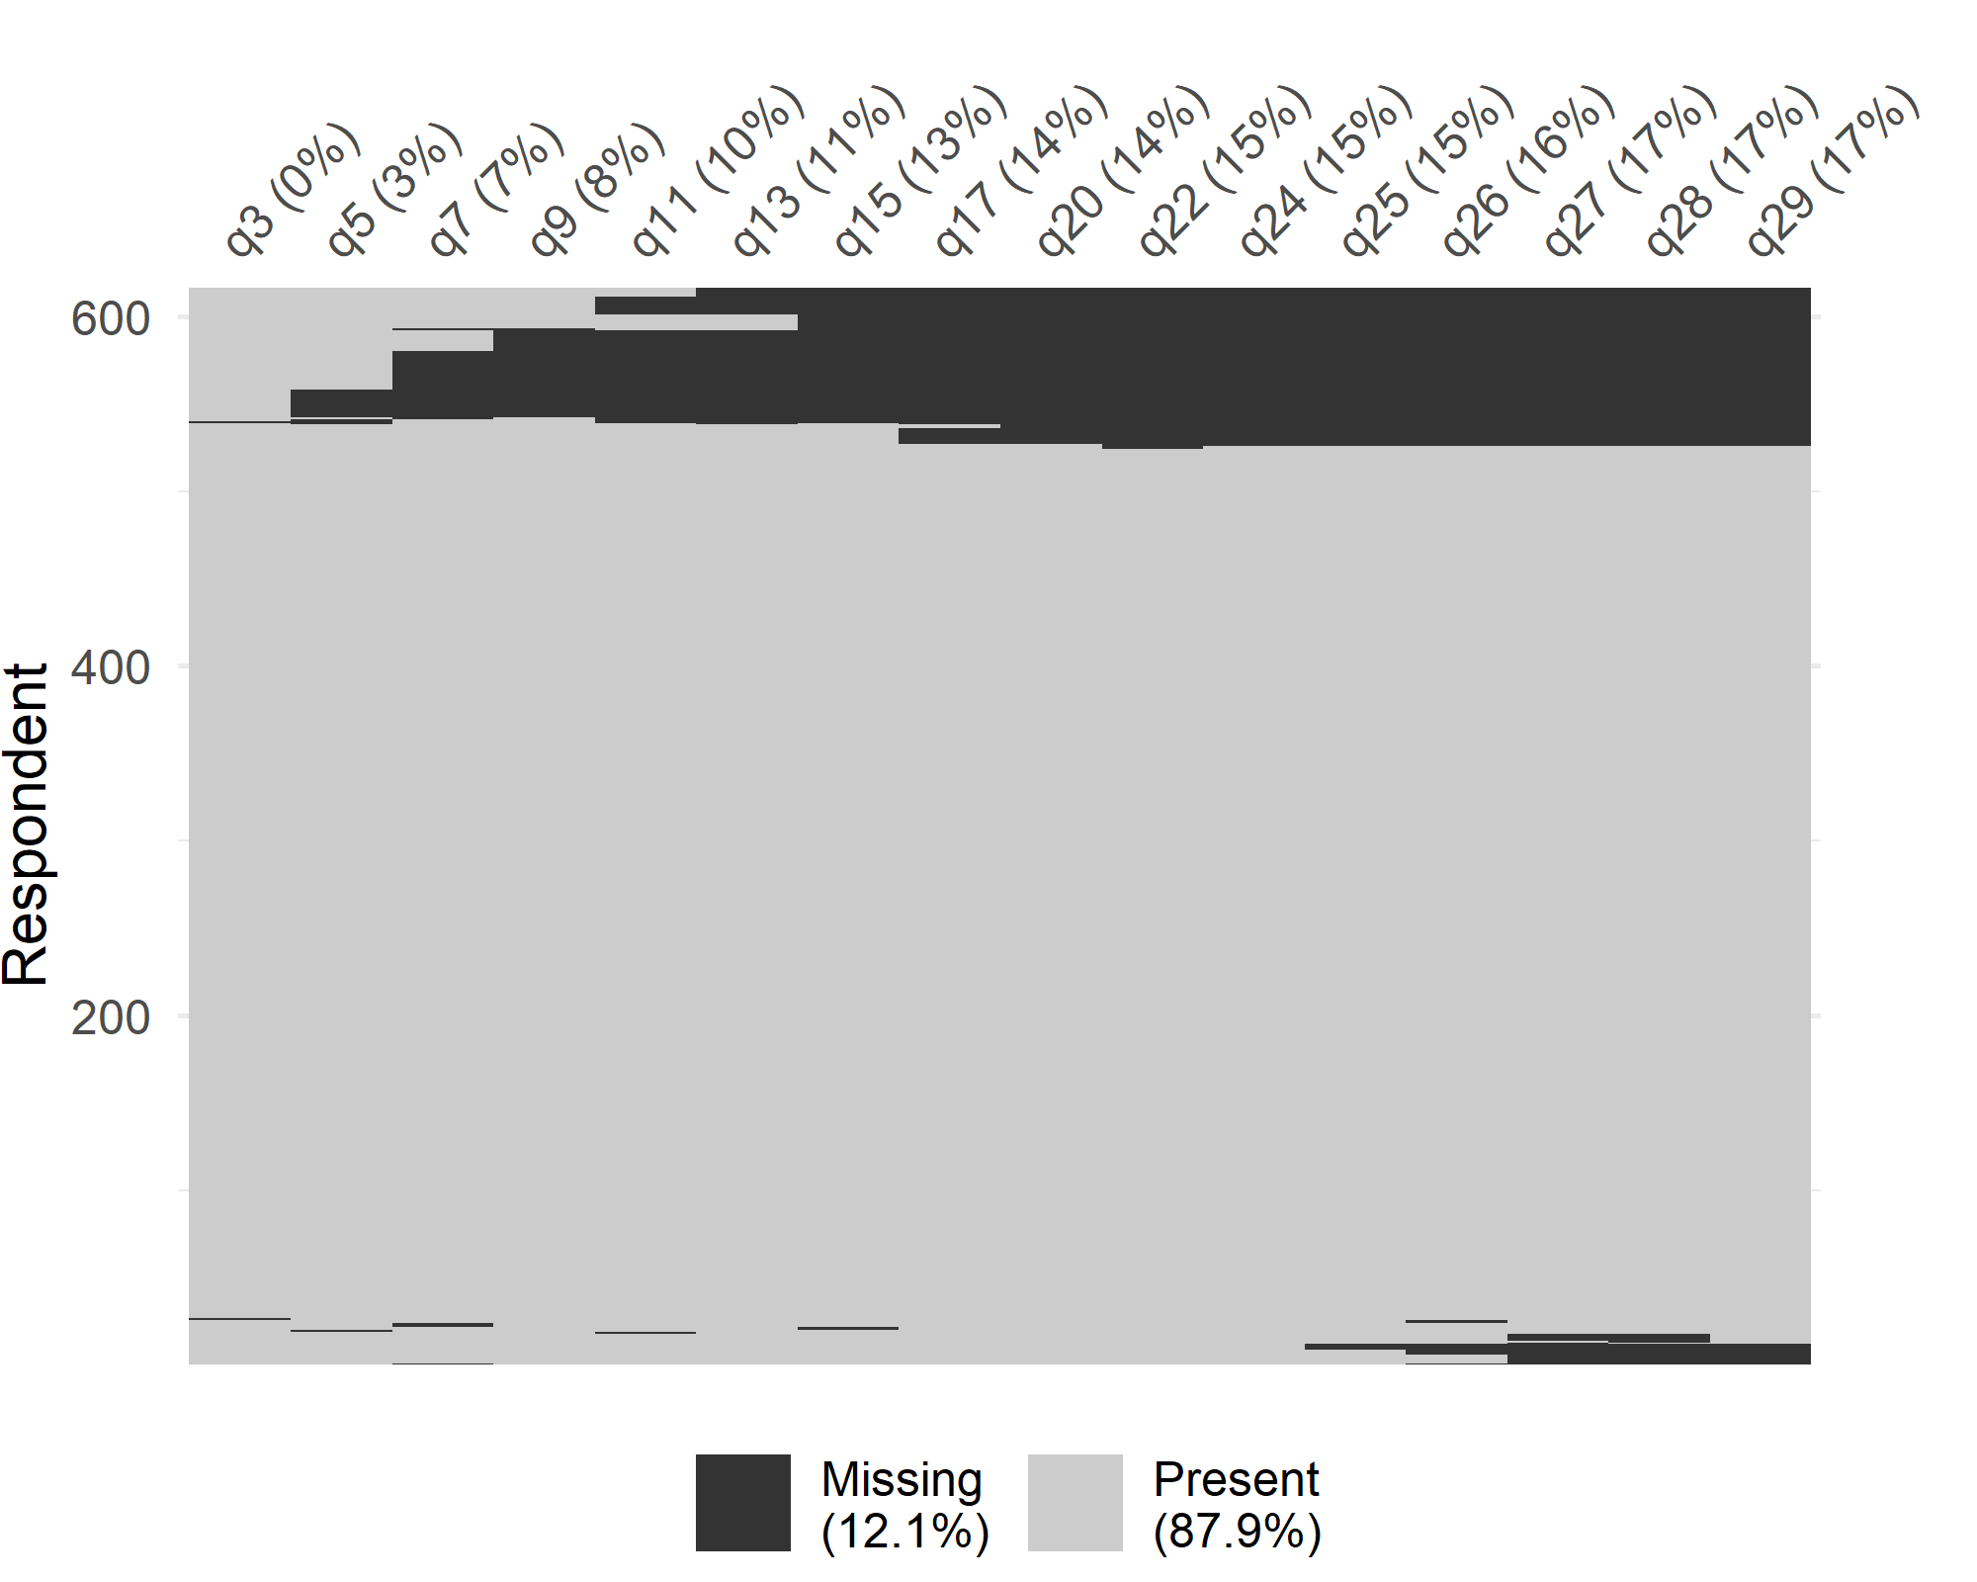

In the above plot the rows are respondents and the columns are the questions. Respondents are grouped according to the pattern in their missing data. The amount of item-missing data was small. There was a general increase as the questions increased showing some drop-out (bottom of the plot). Many people did not complete question 31 (publication target number), but this was optional.

The table below shows the question labels.

| Question number | Question |
| --- | --- |
| q3 | Choice set - dominant |
| q5 | Choice set 1 |
| q7 | Choice set 2 |
| q9 | Choice set 3 |
| q11 | Choice set 4 |
| q13 | Choice set 5 |
| q15 | Choice set 6 |
| q17 | Choice set 7 |
| q20 | Choice set 8 |
| q22 | Choice set - retest |
| q24 | DCE difficulty |
| q25 | Broad research area |
| q26 | Gender |
| q27 | Years working in research |
| q28 | Number of papers |
| q29 | Country |