Retraction Watch data for Australia

Adrian Barnett

18 May 2019

There are 284 cases from Australia in the Retraction watch database as of 15-May-2019.

# Retractions over over time

## Publication dates over time

The plot below shows the dates over time that the papers were published.

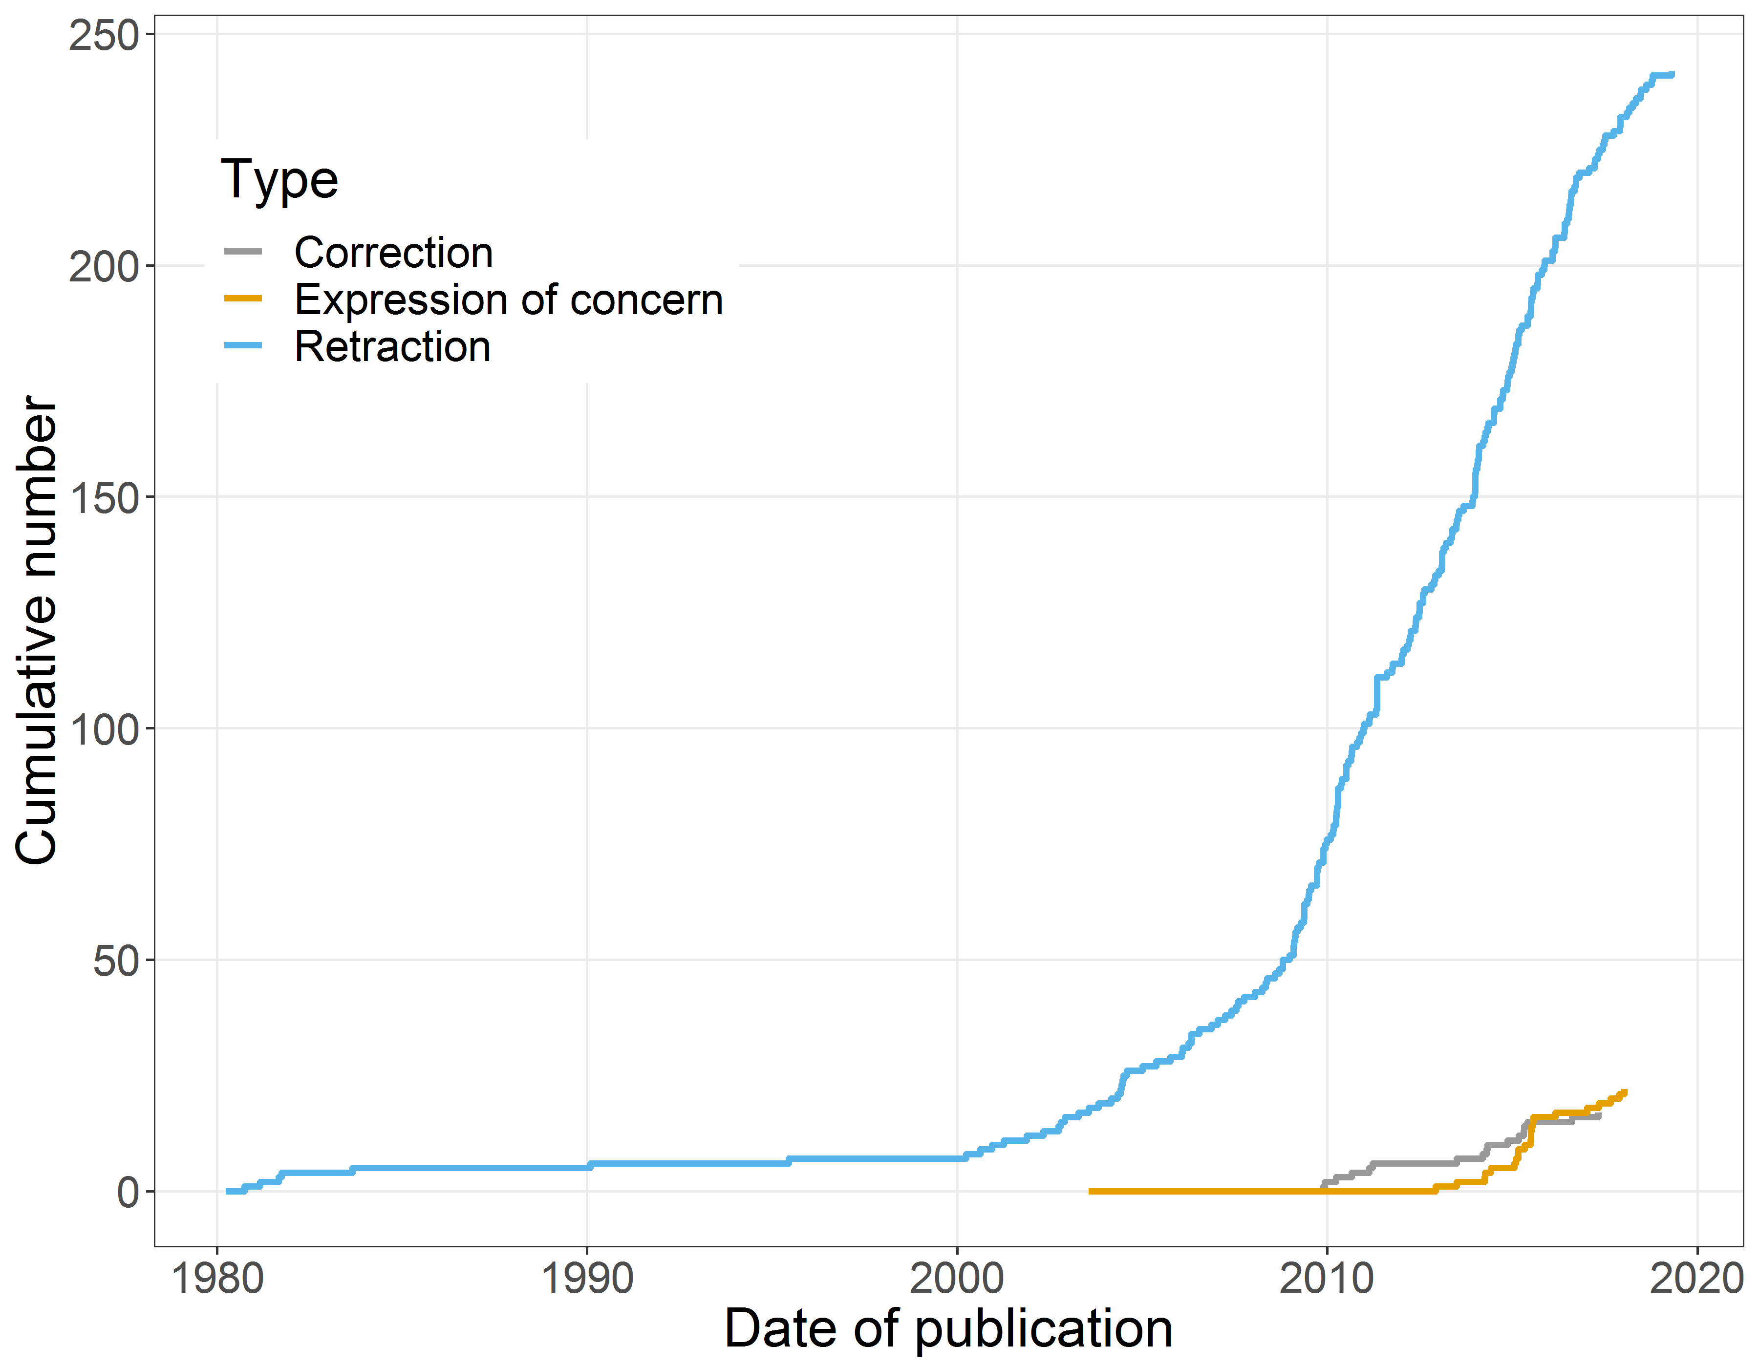

## Retraction dates over time

The plot below shows the dates over time that the papers were retracted.

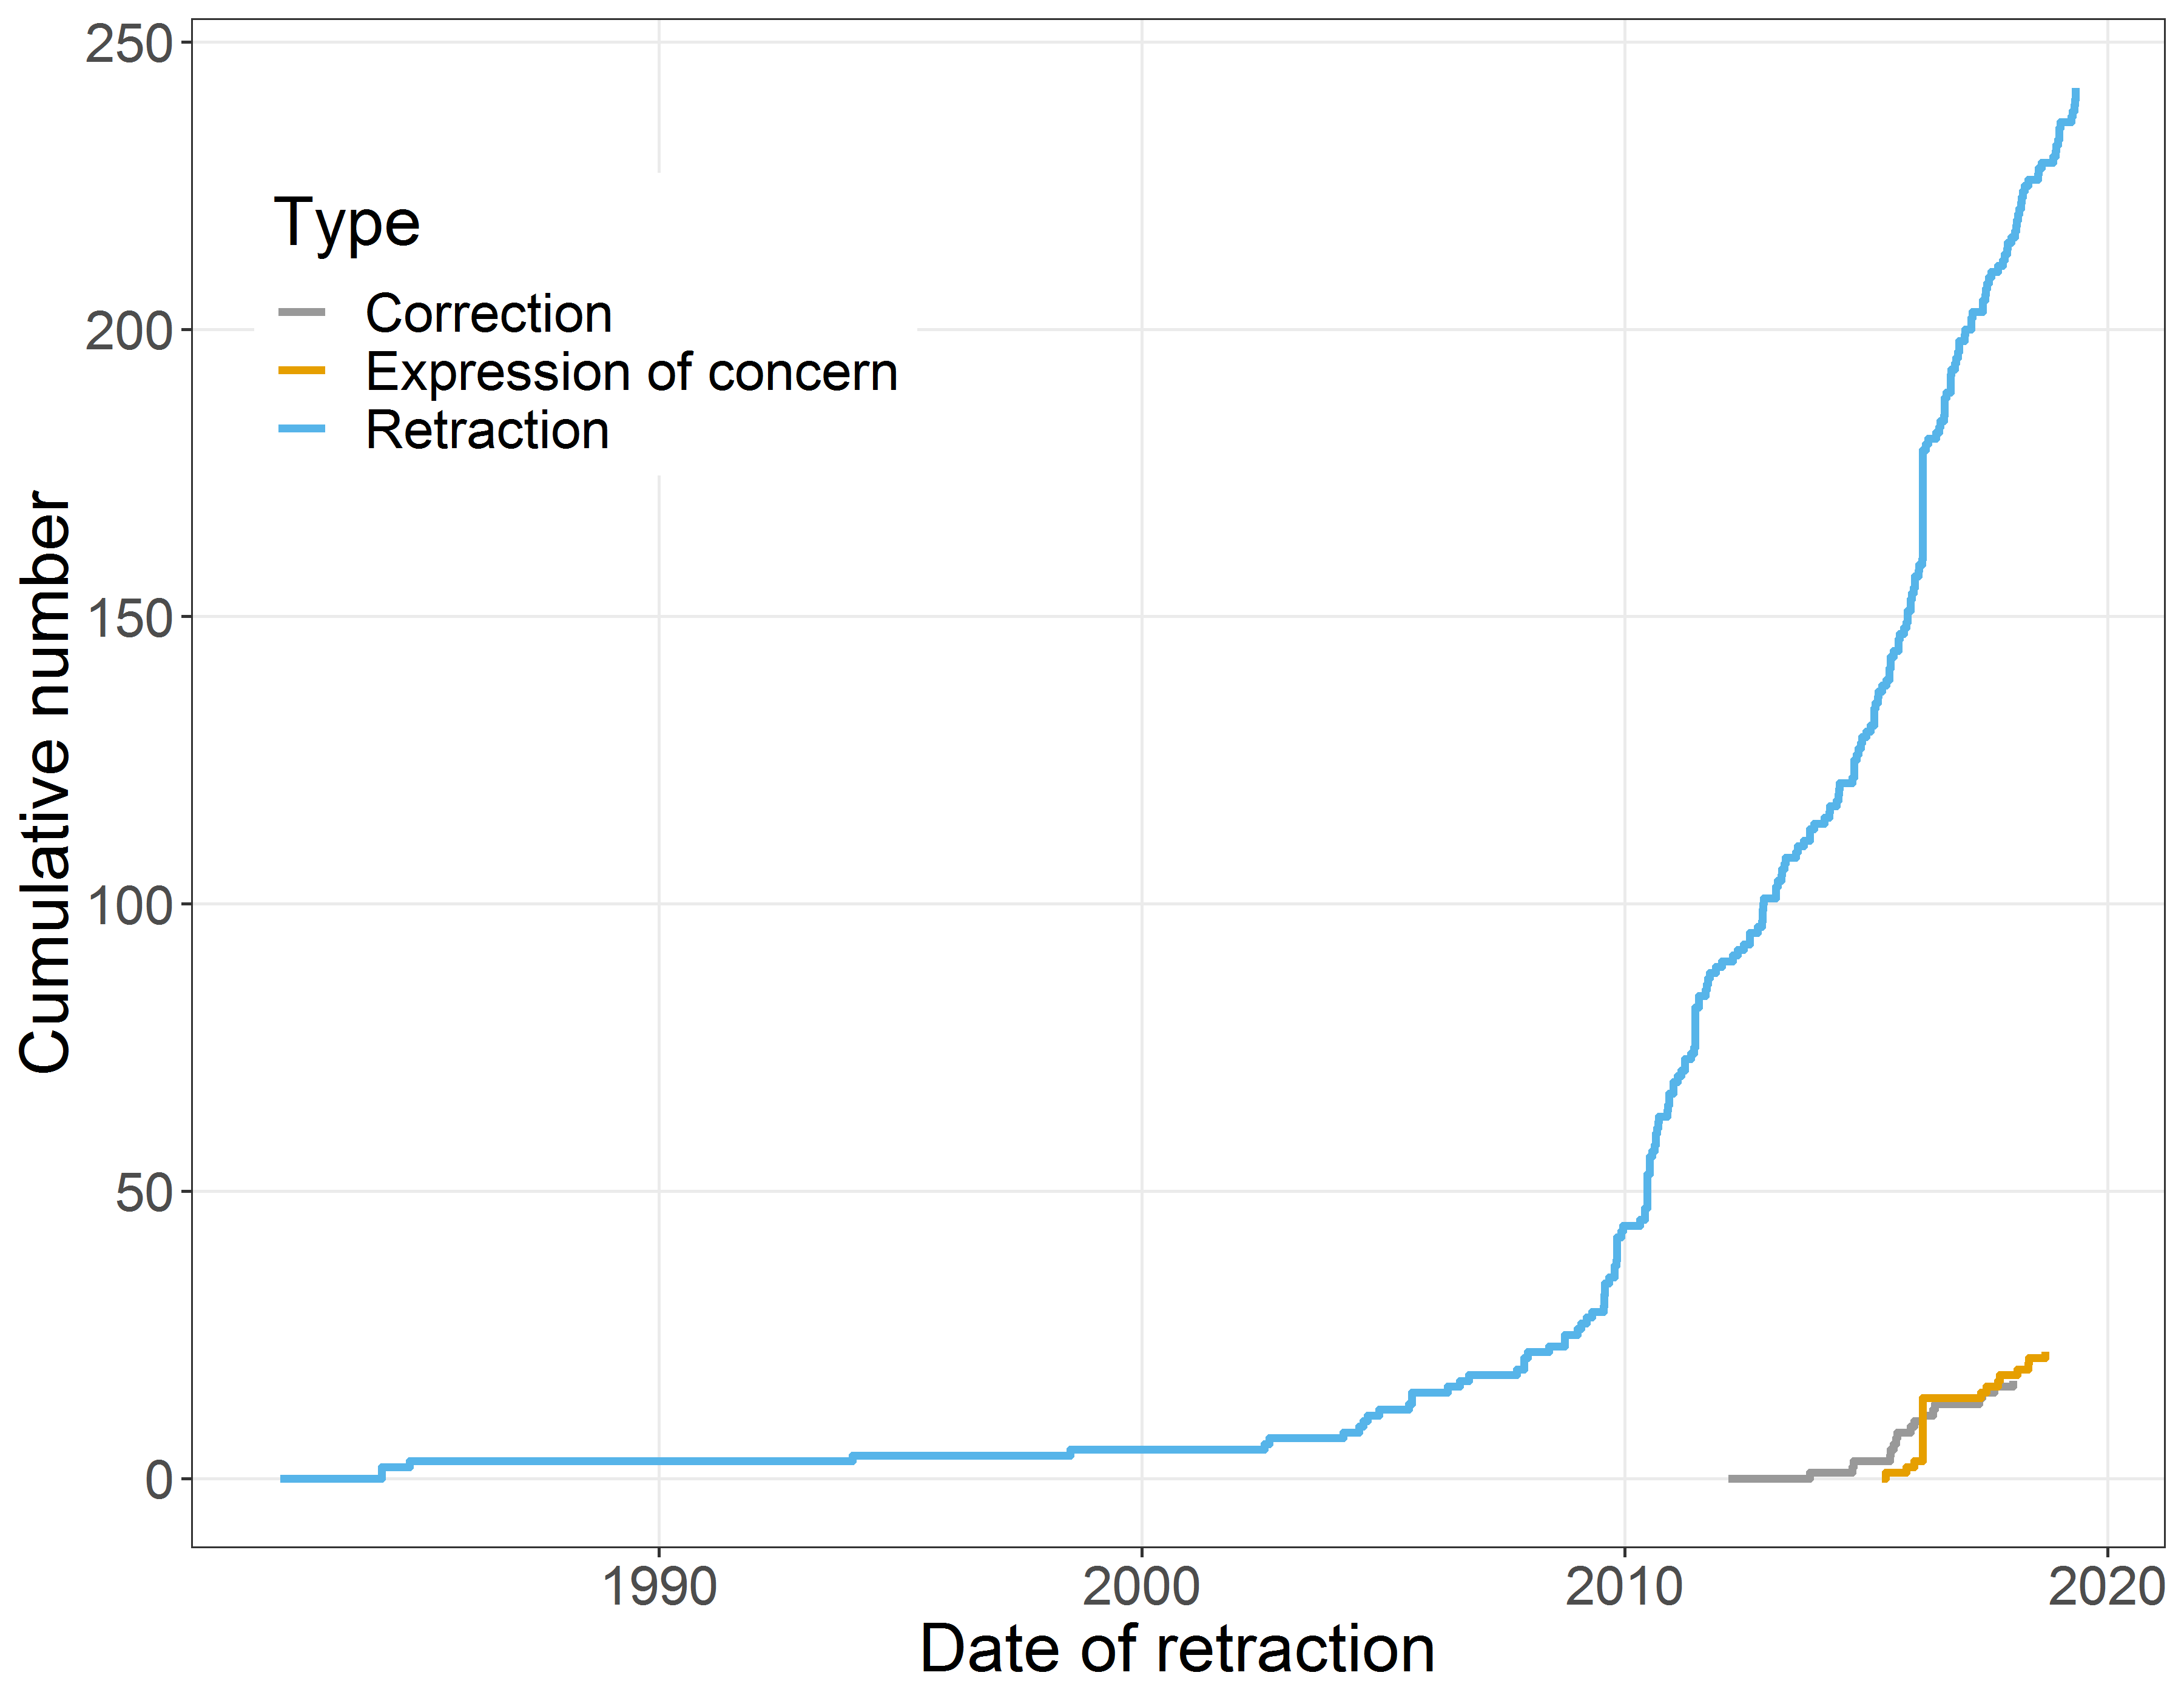

# Countries

The table below shows the top ten countries bar Australia. Australia was involved in every case. Some papers involved multiple countries so the total is greater than the total number of papers. All countries outside the top ten are grouped together as “Other”.

|  |  |  |  |
| --- | --- | --- | --- |
| rank | Country | Submissions | Percent |
| 1 | Other | 57 | 29.1 |
| 2 | China | 40 | 20.4 |
| 3 | United States | 37 | 18.9 |
| 4 | United Kingdom | 16 | 8.2 |
| 6 | Germany | 9 | 4.6 |
| 6 | Italy | 9 | 4.6 |
| 7 | Canada | 7 | 3.6 |
| 8 | Netherlands | 6 | 3.1 |
| 10 | France | 5 | 2.6 |
| 10 | Hong Kong | 5 | 2.6 |
| 10 | Sweden | 5 | 2.6 |
| NA | Total | 196 | 100.0 |

# Reasons

The table below shows the top ten reasons, with all other reasons outside the top ten being groups as “Other”. Many papers had multiple reasons so the total is greater than the total number of papers.

|  |  |  |  |
| --- | --- | --- | --- |
| rank | Reason | Count | Percent |
| 1 | Other | 376 | 59.6 |
| 2 | Notice - Limited or No Information | 46 | 7.3 |
| 3 | Error in Data | 34 | 5.4 |
| 4 | Duplication of Article | 29 | 4.6 |
| 5 | Investigation by Journal/Publisher | 28 | 4.4 |
| 6 | Investigation by Company/Institution | 27 | 4.3 |
| 7 | Concerns/Issues About Data | 25 | 4.0 |
| 8 | Fake Peer Review | 24 | 3.8 |
| 9 | Unreliable Results | 22 | 3.5 |
| 10 | Error in Methods | 20 | 3.2 |
| NA | Total | 631 | 100.0 |