Trends in spelling errors in *PubMed* from 2008 to 2023 using errors from the Wikipedia list

Adrian Barnett

21 March, 2025

The total number of errors was 48,420.

## Most common errors

| error | total |
| --- | --- |
| odd ratio | 3,426 |
| publically | 2,627 |
| demographical | 2,608 |
| principle component analysis | 1,817 |
| occured | 1,448 |
| fourty | 991 |
| indispensible | 990 |
| occuring | 965 |
| statically significant | 933 |
| Fischer's exact | 932 |
| occurence | 790 |
| binominal | 575 |
| heathy | 543 |
| inspite | 474 |
| futhermore | 432 |
| dimentional | 412 |
| Fischer exact | 399 |
| confident interval | 374 |
| comparision | 356 |
| supressed | 354 |

Top twenty errors by overall total.

## Trend in total errors over time

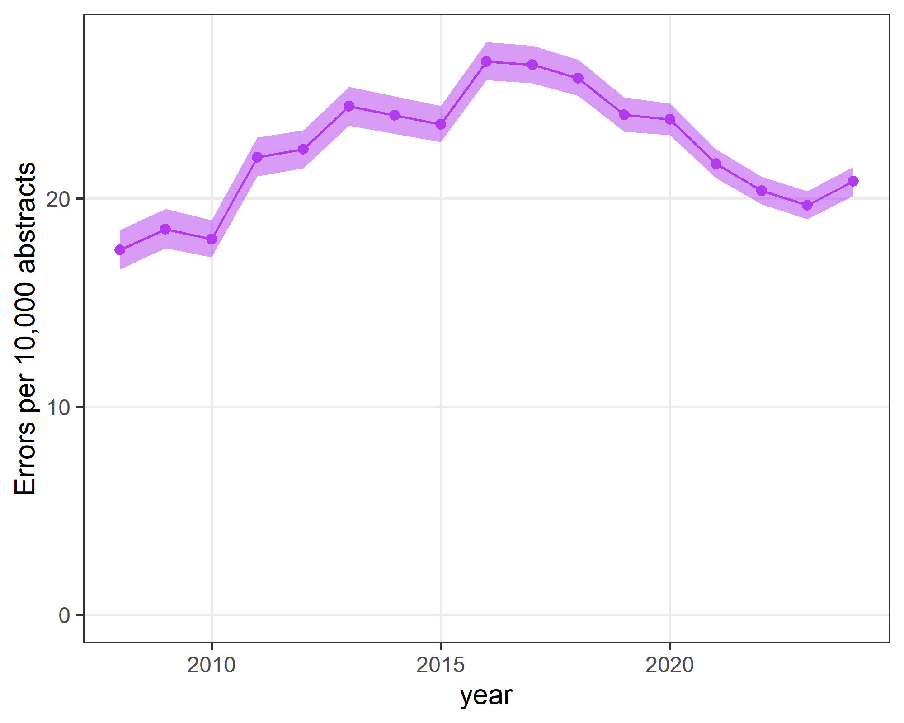

## Trend by article type

TO DO.

## Trends in top 10 errors

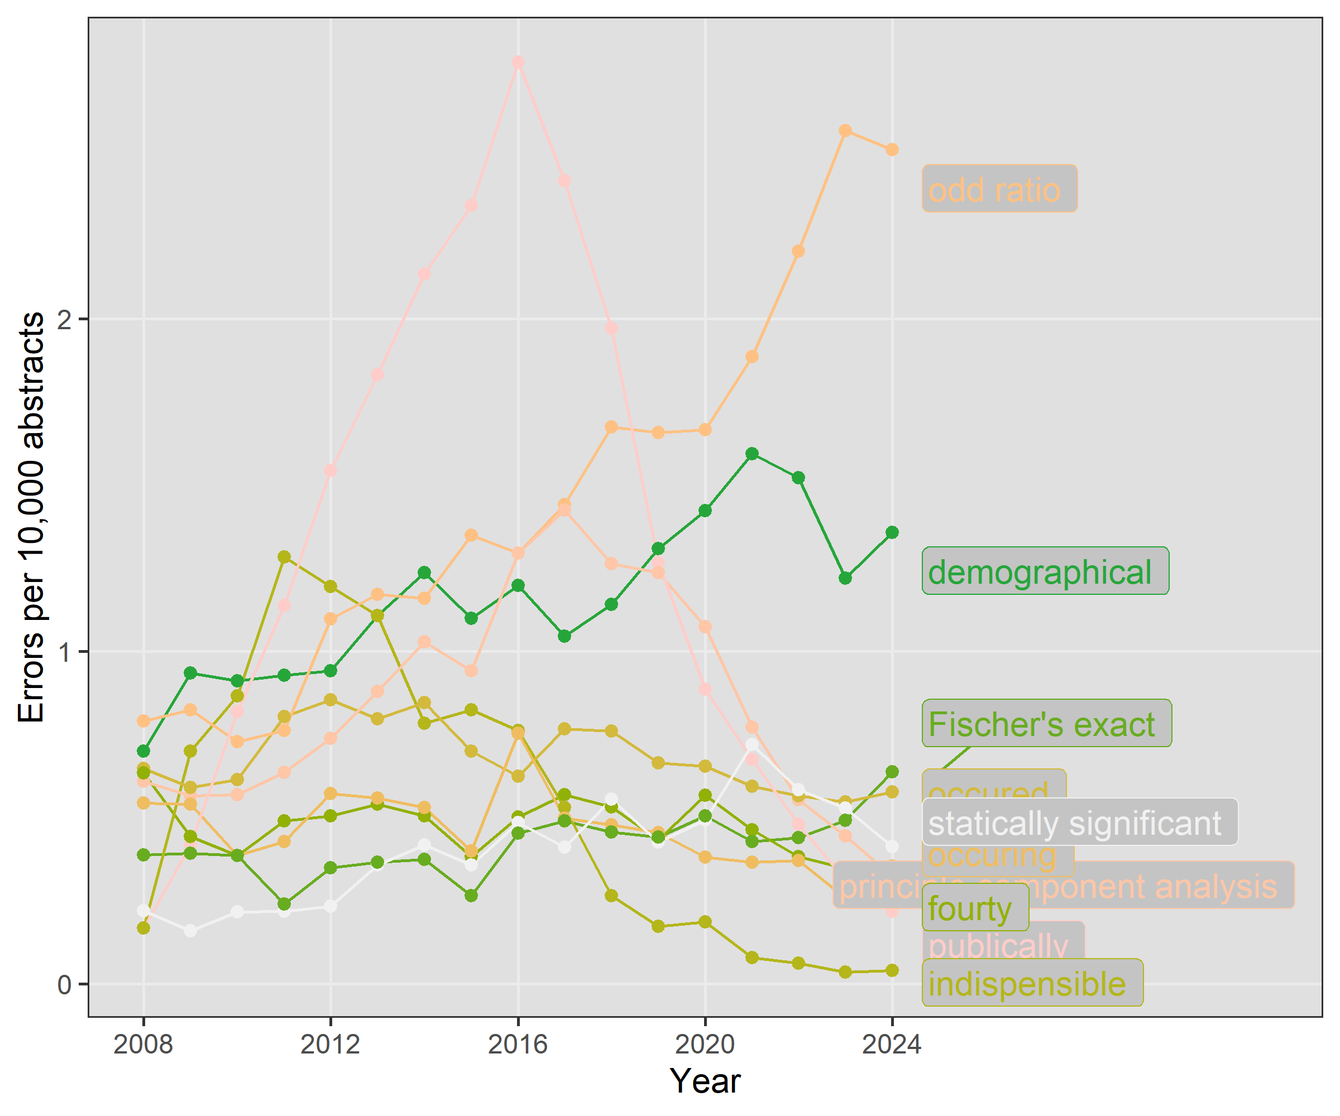

## Trends without ten most common errors

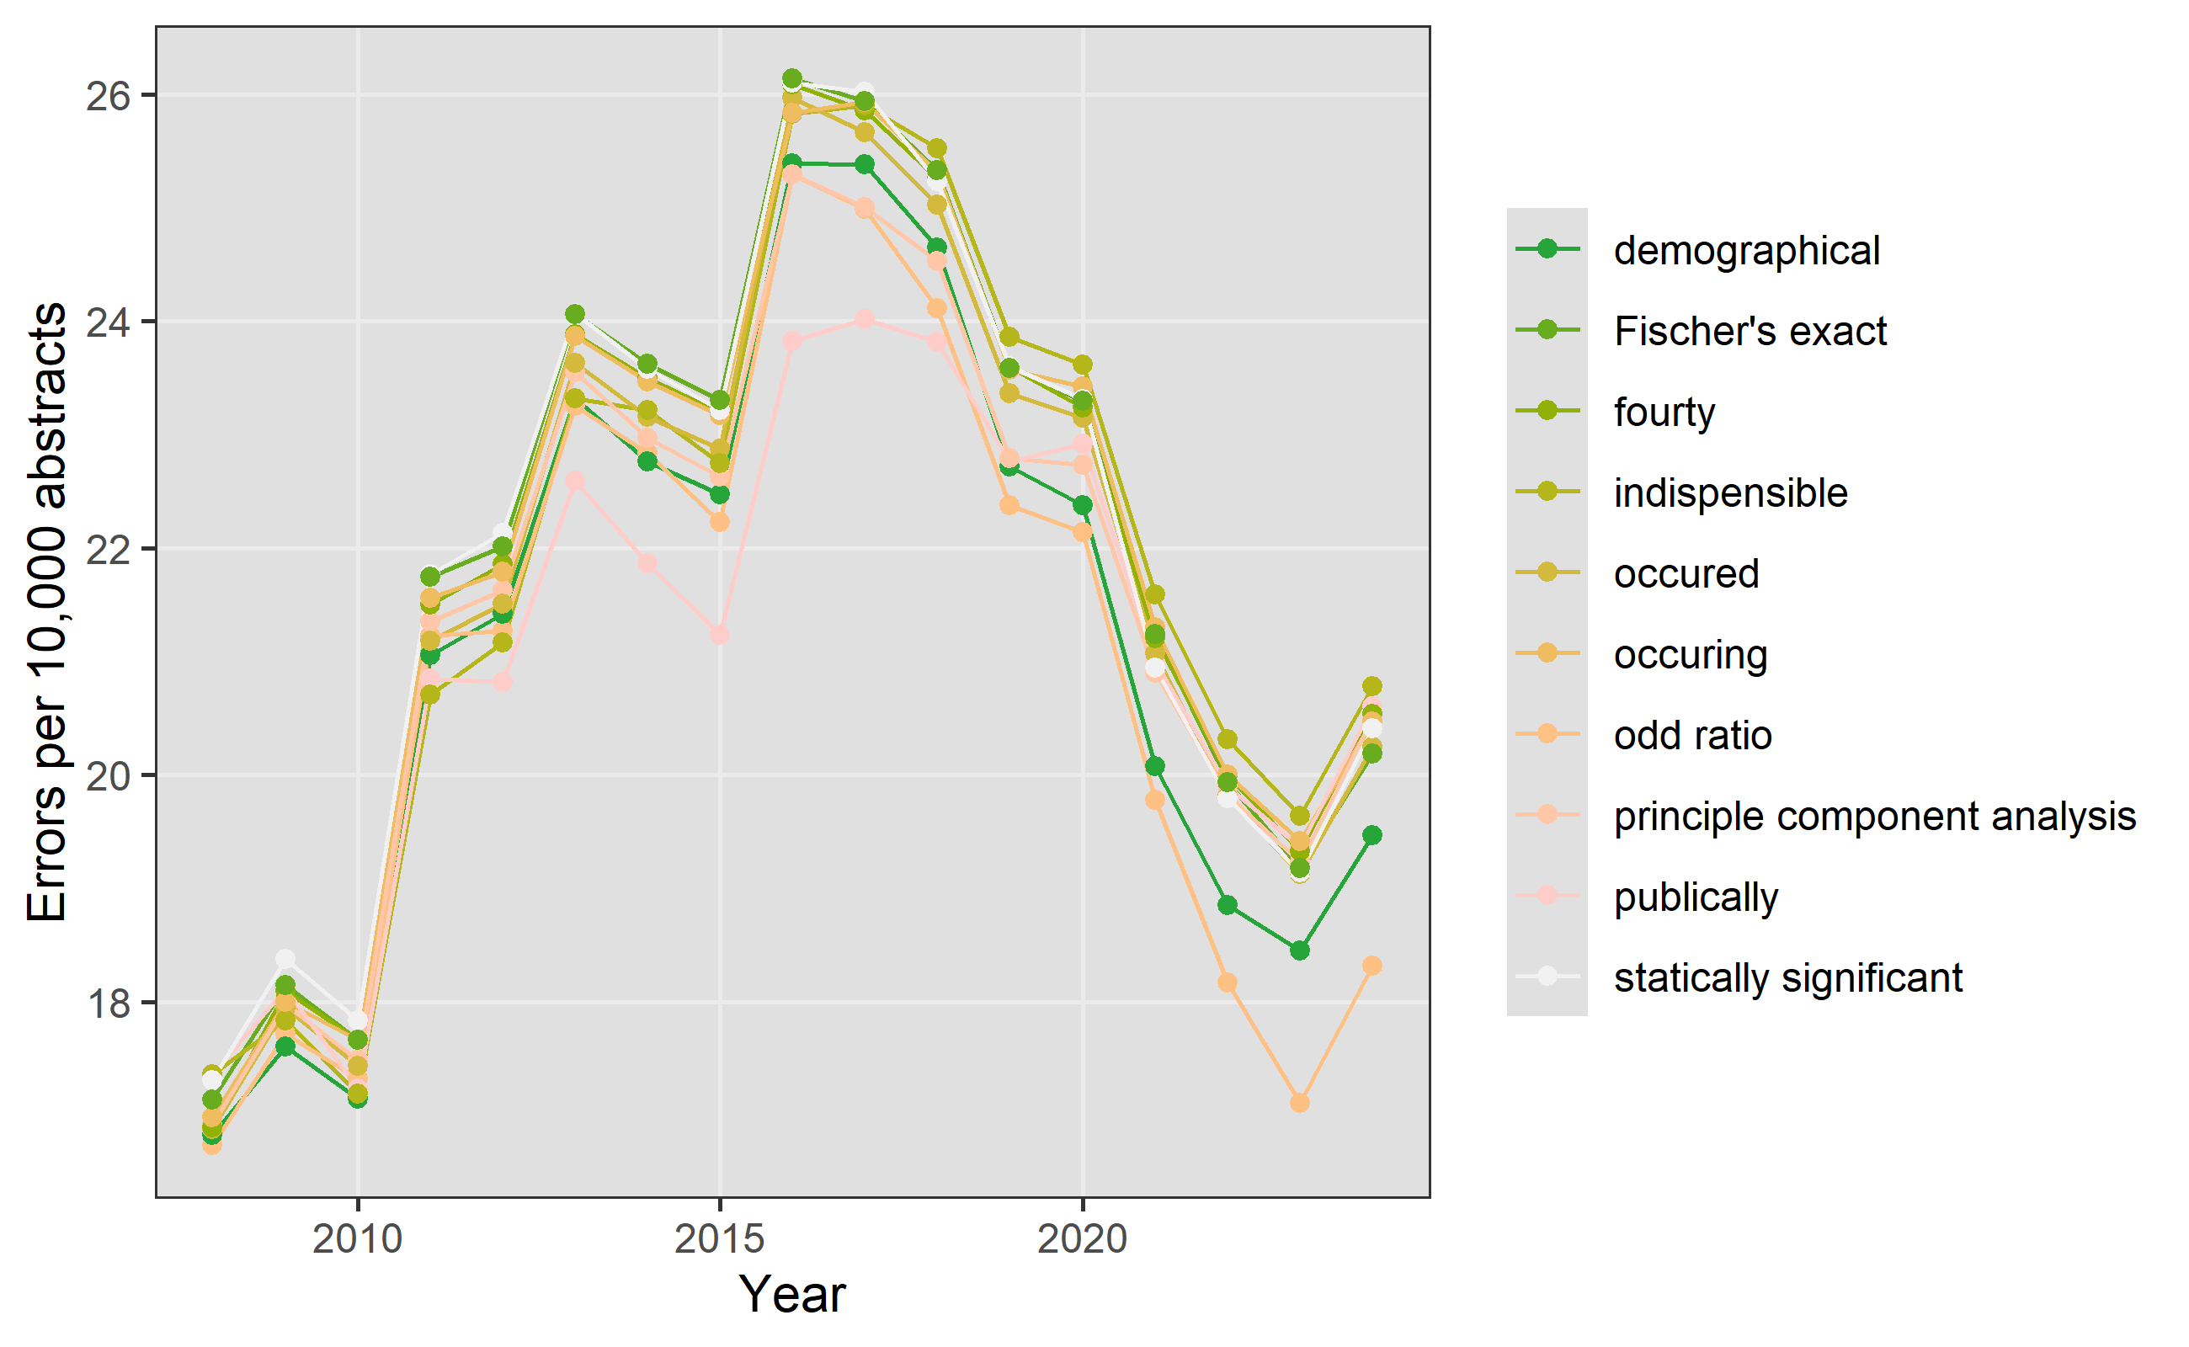

The trend does not just depend on the most common errors.

## Trend in word count over time

This trend is for the analysis data of cases and controls. The trend is for all article types combined.

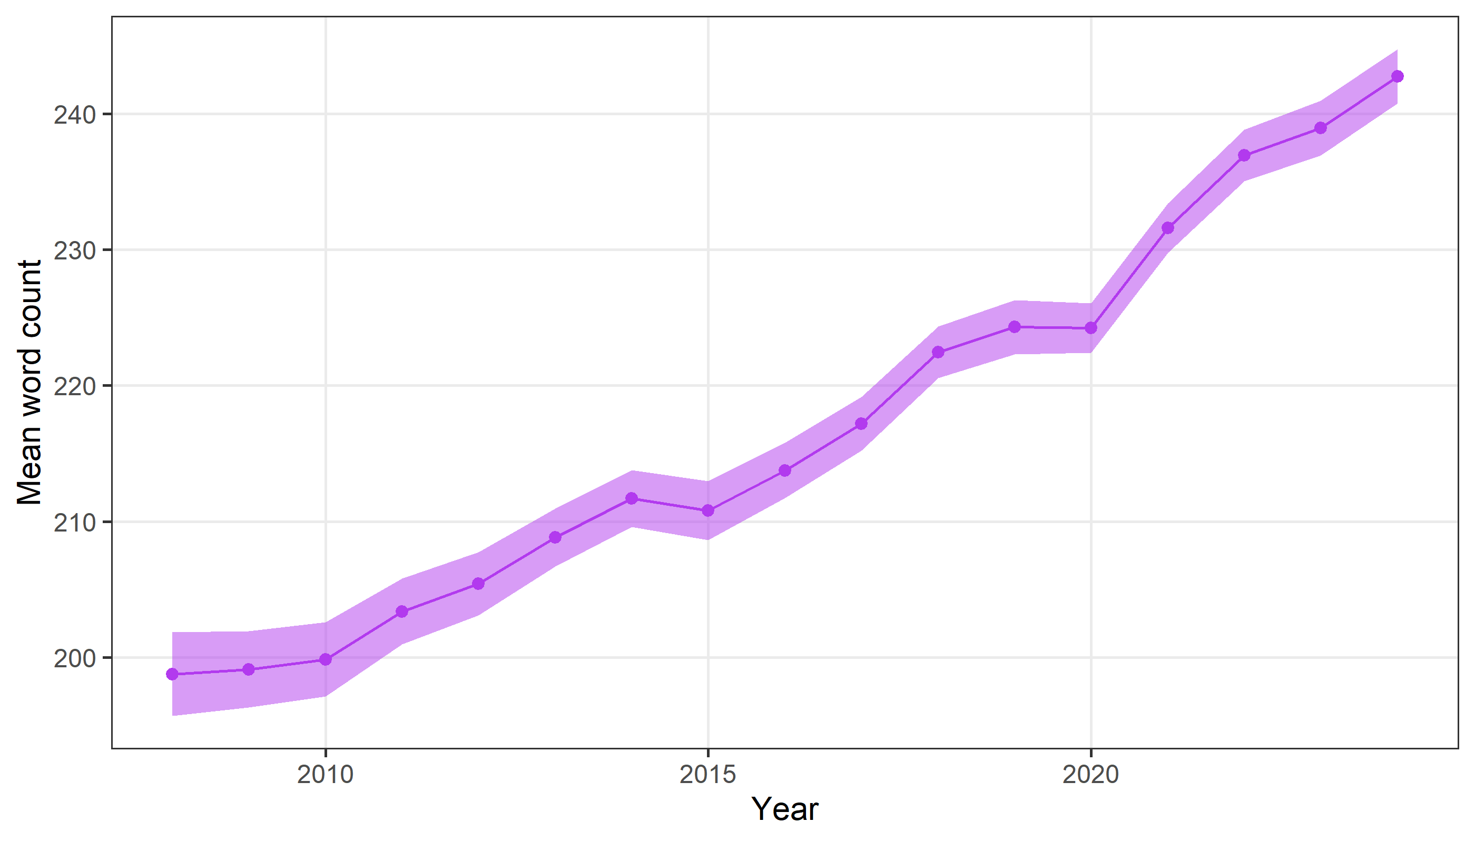

The y-axis does not start at zero.

#### Trend in word count by article type

The plot below is the mean word count by article type.

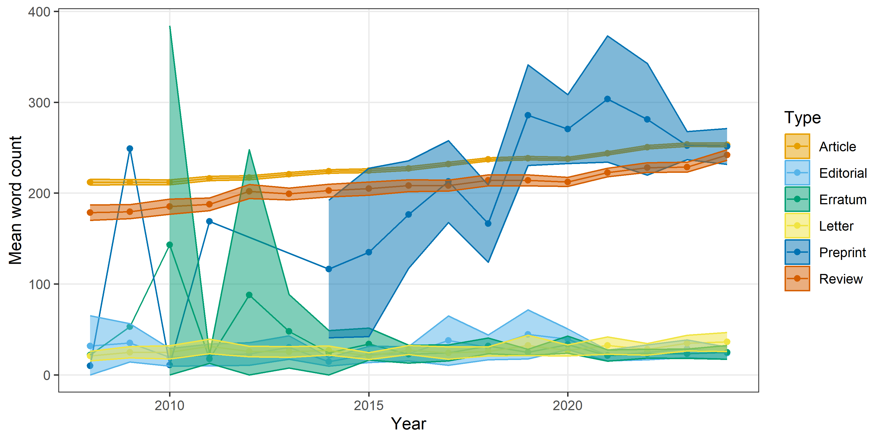

There are some missing values as we only plot years with a sample size of at least 50.

## Trend per word count

As an alternative denominator to per abstract, we now run the trend per word per abstract.

