Agreement in manually extracted data between the two research assistants
17 January 2026
This version compares Alex and Adrian with comments on the areas of disagreement.
The comparisons below are based on a random sample of 20 papers.

Q1a: Study design
 | Experimental study | Observational study | Other | Review
Experimental study | 2 | 4 | 0 | 0
Observational study | 0 | 4 | 0 | 0
Other | 0 | 5 | 3 | 1
Review | 0 | 0 | 0 | 1
Gwet’s agreement statistic was 0.35 with a confidence interval of (0.051,0.654).

Differences between research assistants
doi | comment.RA1 | RA1 | comment.RA2 | RA2
10.1002/eat.24344 | other, validation study | Other | observational, survey | Observational study
10.1038/s41598-022-21029-2 | experimental study | Experimental study | observational study, some randomisation but extremely strange | Observational study
10.1080/02640414.2020.1832735 | experimental study | Experimental study | observational study, reliability | Observational study
10.1097/jsm.0000000000000831 | other, survey | Other | observational study | Observational study
10.1111/sms.14761 | experimental study | Experimental study | observational | Observational study
10.1123/ijsnem.2020-0224 | experimental | Experimental study | observational study, non-randomised groups | Observational study
10.1123/ijspp.2021-0543 | other, qualitative | Other | observational study, survey | Observational study
10.1249/mss.0000000000003056 | other, audit | Other | review, says audit but is actually a review | Review
10.3389/fpsyg.2022.939087 | other, survey | Other | observational study, survey | Observational study
10.7717/peerj.8366 | other, reliability and validation study | Other | observational study, reliability | Observational study

Q1b: The number of authors with an AIS affiliation.
 | 1 | 2 | 3 | 4 | 6
1 | 13 | 1 | 0 | 0 | 0
2 | 0 | 0 | 0 | 0 | 0
3 | 0 | 0 | 1 | 0 | 0
4 | 0 | 0 | 0 | 3 | 0
6 | 0 | 0 | 0 | 0 | 2
Gwet’s agreement statistic was 0.94 with a confidence interval of (0.825,1).

Differences between research assistants
doi | RA1 | RA2
10.1097/jsm.0000000000000831 | 1 | 2

Q2a: Did the paper have a well-formed research question or study aim?
 | No | Not applicable | Yes
No | 2 | 1 | 0
Not applicable | 0 | 1 | 0
Yes | 0 | 0 | 16
For this question, the research assistant also split questions into whether they were a purpose, objective, etc; however, to simplify this comparison we just examine yes, no and not applicable.
Gwet’s agreement statistic was 0.94 with a confidence interval of (0.812,1).

Differences between research assistants
doi | comment.RA1 | RA1 | comment.RA2 | RA2
10.1007/s40279-020-01295-8 | no aims or research questions | No | not applicable | Not applicable

Q2b: How many research questions or aims were there?
For this comparison we compared any types of question. For example, if an RA said 2 aims and another said 2 questions then we assessed this as perfect agreement.
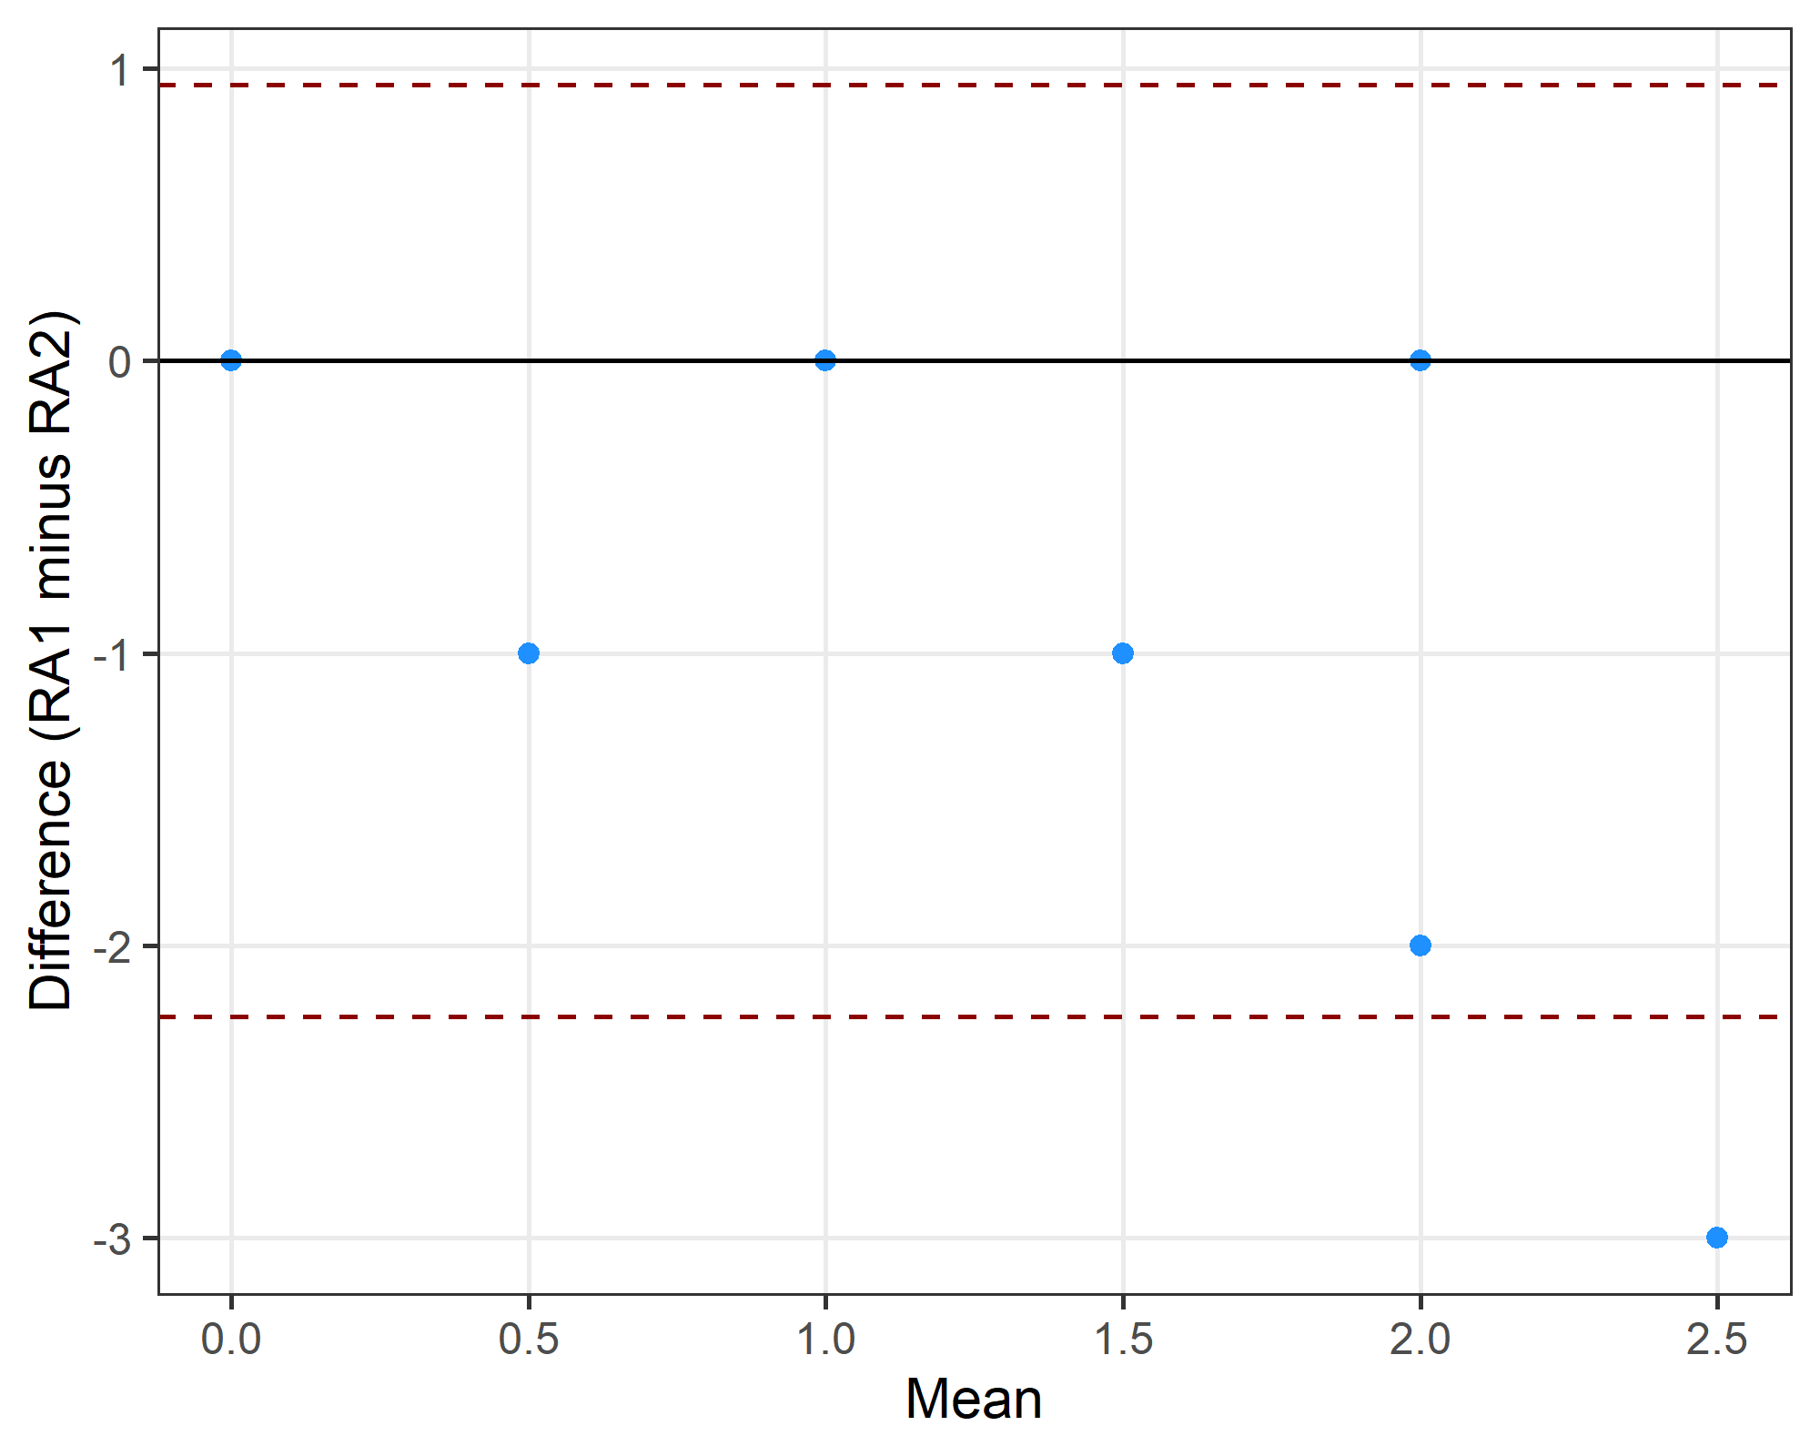
The limits of agreement were -2.24 to 0.94 .

Q2c: Can the question(s) be expressed using an established framework? For example, PICO for clinical studies or SPIDER for qualitative studies.
 | No | Not applicable | PICO | PICO, partial | SPIDER | SPIDER, partial
No | 0 | 0 | 0 | 0 | 0 | 0
Not applicable | 0 | 3 | 0 | 0 | 0 | 1
PICO | 0 | 0 | 3 | 2 | 0 | 0
PICO, partial | 2 | 1 | 0 | 5 | 0 | 0
SPIDER | 0 | 0 | 0 | 1 | 0 | 0
SPIDER, partial | 0 | 0 | 0 | 2 | 0 | 1
Gwet’s agreement statistic was 0.5 with a confidence interval of (0.233,0.764).

Differences between research assistants
doi | comment.RA1 | RA1 | comment.RA2 | RA2
10.1038/s41598-022-21029-2 | pico | PICO | ico. intervention = tights, control = placebo, outcome = recovery, p = not here. | PICO, partial
10.1097/jsm.0000000000000831 | spide | SPIDER, partial | pio. p = elite female athletes, o = pain prediction, i = model. | PICO, partial
10.1111/sms.14272 | ico | PICO, partial | no. o = landing quality? could not guess pico. | No
10.1111/sms.14761 | co | PICO, partial | no. not clear to me. | No
10.1123/ijspp.2021-0543 | not applicable | Not applicable | spie. s = athletes, e = knowledge/attitudes, pi = covid. | SPIDER, partial
10.1136/bjsports-2019-101175 | spie | SPIDER, partial | po. outcome = prescribing. p = sports medicine physicians. | PICO, partial
10.1249/mss.0000000000003056 | po | PICO, partial | not applicable, review | Not applicable
10.3389/fpsyg.2022.939087 | spider | SPIDER | po. o = mental health, p = athletes. | PICO, partial
10.7717/peerj.8366 | pico | PICO | po, population = field setting, outcome = correlation, no intervention | PICO, partial

Q3: Was there previous research on the same question(s)?
We did not use question 3 as I forgot to give the additional instructions to the second research assistant.

Q5a: Was there a sample size calculation for the research question?
 | No | Not applicable | Yes
No | 9 | 0 | 1
Not applicable | 0 | 4 | 0
Yes | 0 | 0 | 6
Gwet’s agreement statistic was 0.93 with a confidence interval of (0.779,1).

Differences between research assistants
doi | RA1 | RA2
10.1016/j.psychsport.2022.102175 | No | Yes

Q5b: Was the effect size justified in the sample size calculation?
Only where the answer to the previous question (Q5a) was “yes”.
 | No | Not applicable | Yes
No | 3 | 0 | 0
Not applicable | 0 | 13 | 1
Yes | 3 | 0 | 0
Gwet’s agreement statistic was 0.74 with a confidence interval of (0.464,1).

Differences between research assistants
doi | RA1 | RA2
10.1002/eat.24344 | Yes | No
10.1016/j.psychsport.2022.102175 | Not applicable | Yes
10.1111/sms.14761 | Yes | No
10.7717/peerj.8366 | Yes | No

Q5c: What was the target sample size?
Bland-Altman plot.
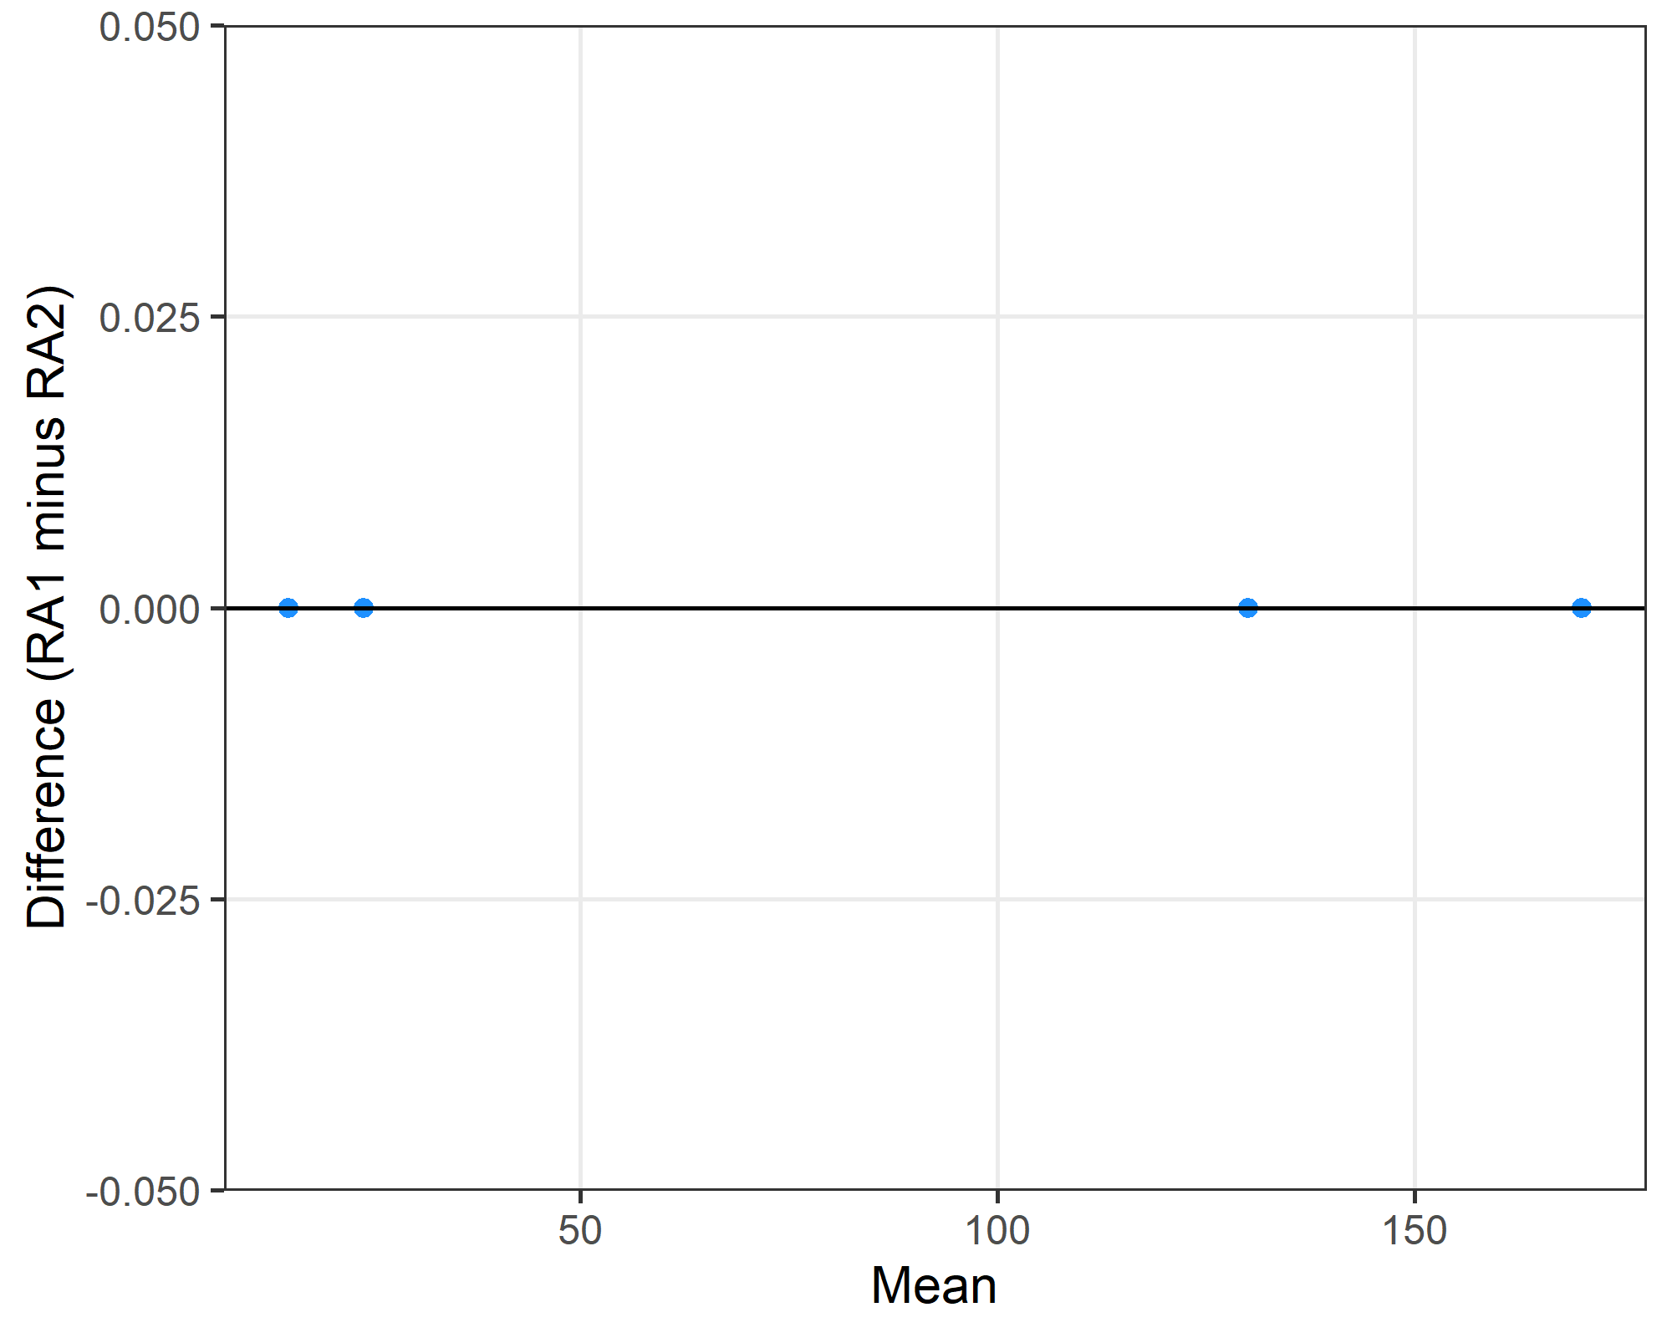
The limits of agreement were 0 to 0 .

Differences between research assistants
doi r1 r2
1 10.1016/j.psychsport.2022.102175 NA 9
2 10.1123/ijsnem.2020-0224 NA 22

Q5d: What was the actual sample size?
Bland-Altman plot with the x-axis on a log scale because of the one very large study.
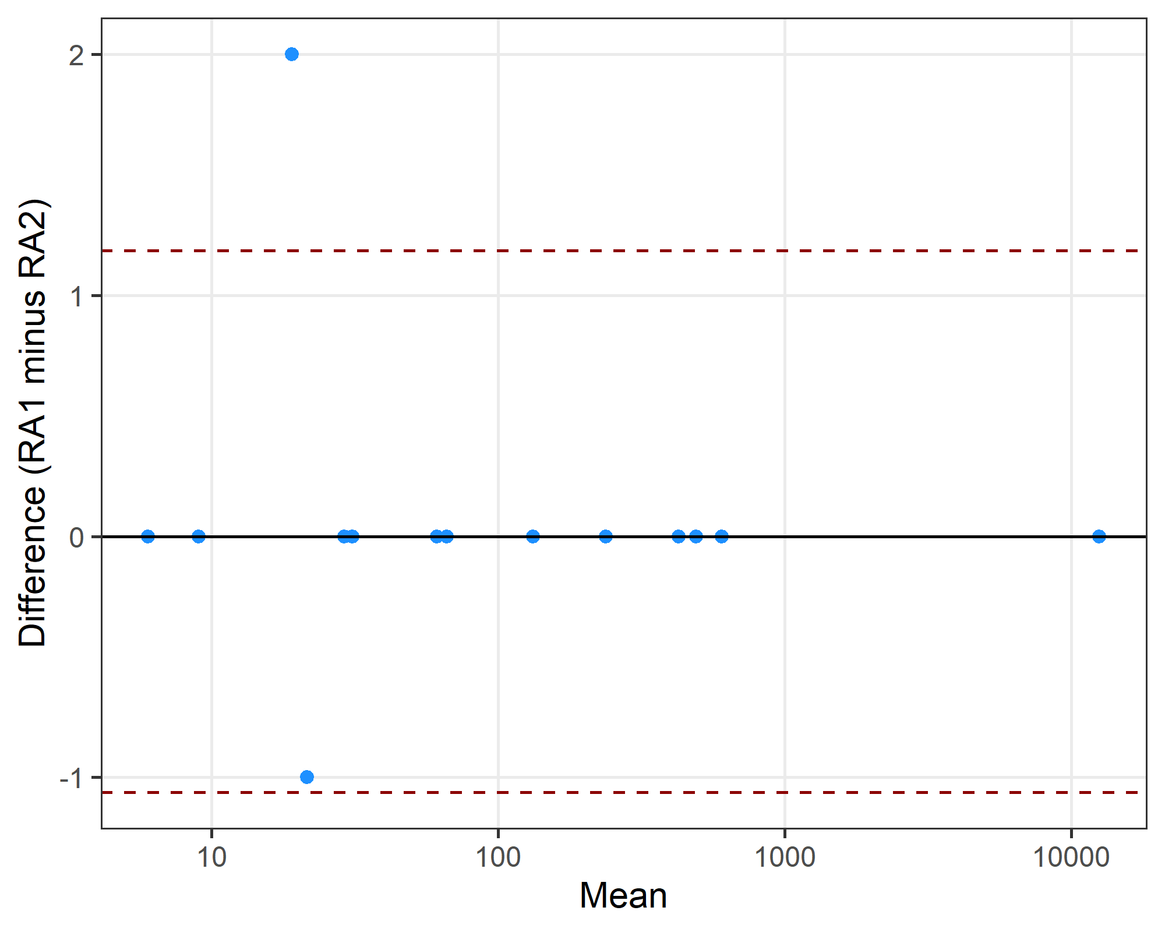
The limits of agreement were -1.06 to 1.19 .

Differences between research assistants
doi r1 r2
1 10.1038/s41598-022-21029-2 21 22
2 10.1123/ijsnem.2020-0224 20 18

Q6: number of male and female participants
Bland-Altman plots.
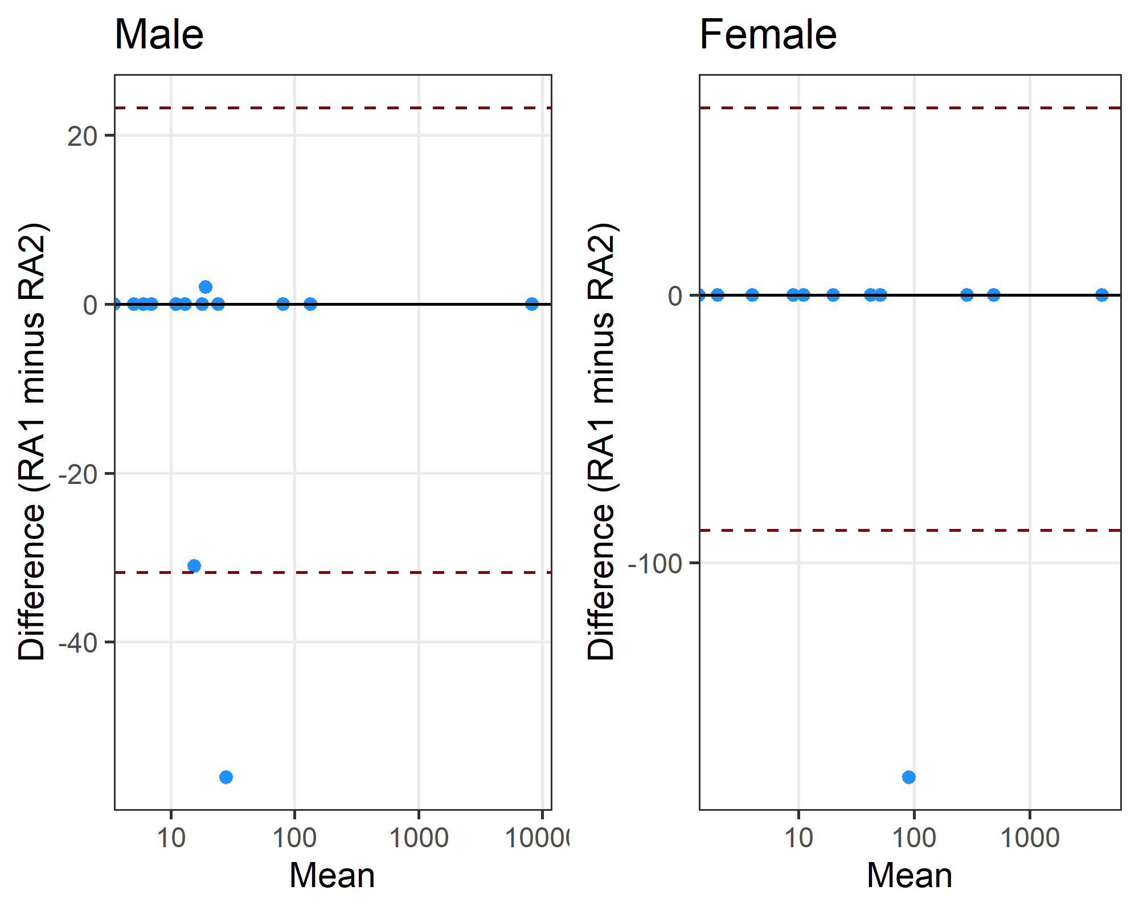

Differences between research assistants
doi r1 r2
1 10.1002/eat.24344 0 56
2 10.1007/s00421-024-05424-3 0 31
3 10.1123/ijsnem.2020-0224 20 18
doi r1 r2
1 10.1002/eat.24344 0 180

Q10: Were missing data discussed and/or correctly reported?
 | No | No data missing | Not applicable | Yes
No | 7 | 0 | 0 | 1
No data missing | 3 | 0 | 0 | 0
Not applicable | 1 | 0 | 3 | 0
Yes | 0 | 0 | 0 | 5
Gwet’s agreement statistic was 0.68 with a confidence interval of (0.416,0.942).

Differences between research assistants
doi | RA1 | RA2
10.1016/j.jsams.2022.05.011 | No data missing | No
10.1016/j.psychsport.2022.102175 | No data missing | No
10.1038/s41598-022-21029-2 | No data missing | No
10.1080/02640414.2020.1832735 | No | Yes
10.1249/mss.0000000000003056 | Not applicable | No

Q11: Were outliers removed without justification?
 | No outliers removed | Not applicable | outliers not discussed | Yes, no justification | Yes, with justification
No outliers removed | 12 | 0 | 1 | 0 | 1
Not applicable | 0 | 4 | 0 | 0 | 0
outliers not discussed | 0 | 0 | 0 | 0 | 0
Yes, no justification | 0 | 0 | 0 | 1 | 0
Yes, with justification | 1 | 0 | 0 | 0 | 1
Gwet’s agreement statistic was 0.83 with a confidence interval of (0.649,1).

Differences between research assistants
doi | RA1 | RA2
10.1007/s00421-024-05424-3 | No outliers removed | Yes, with justification
10.1016/j.jsams.2022.05.011 | Yes, with justification | No outliers removed
10.1080/14763141.2020.1820074 | No outliers removed | outliers not discussed

Q14a: Was the research question answered? (Did the authors reflect on the question)
 | Not applicable | Yes
Not applicable | 3 | 1
Yes | 0 | 16

Differences between research assistants
doi | RA1 | RA2
10.1123/ijspp.2021-0543 | Not applicable | Yes

Q14b: Was there some reflection about the practical significance of the main result/outcome.
 | No | Not applicable | Yes
No | 0 | 1 | 2
Not applicable | 0 | 0 | 0
Yes | 4 | 1 | 12
Gwet’s agreement statistic was 0.51 with a confidence interval of (0.18,0.84).

Differences between research assistants
doi | RA1 | RA2
10.1007/s40279-020-01295-8 | No | Not applicable
10.1016/j.jsams.2022.05.011 | Yes | No
10.1038/s41598-022-21029-2 | No | Yes
10.1080/14763141.2020.1820074 | Yes | No
10.1111/sms.14014 | No | Yes
10.1123/ijsnem.2020-0224 | Yes | No
10.1136/bmjsem-2024-002040 | Yes | Not applicable
10.3389/fpsyg.2022.939087 | Yes | No

