Agreement in manually extracted data between the two research assistants
19 February 2026
This version compares Alex and Ran and uses comments to resolve disagreements.
The comparisons below are based on a random sample of 20 papers.

Q1a: Study design
 | Experimental study | Observational study | Other | Review
Experimental study | 5 | 1 | 0 | 0
Observational study | 1 | 7 | 0 | 0
Other | 0 | 1 | 2 | 2
Review | 0 | 0 | 0 | 1
Gwet’s agreement statistic was 0.68 with a confidence interval of (0.408,0.943).

Differences between research assistants
doi | comment.RA1 | RA1 | comment.RA2 | RA2
10.1007/s40279-020-01295-8 | other, opinion | Other | review | Review
10.1080/02640414.2020.1832735 | experimental study | Experimental study | observational | Observational study
10.1111/sms.14272 | observational study | Observational study | experimental | Experimental study
10.1123/ijspp.2021-0543 | other, qualitative | Other | observational | Observational study
10.1249/mss.0000000000003056 | other, audit | Other | review | Review

Q1b: The number of authors with an AIS affiliation.
 | 1 | 2 | 3 | 4 | 6
1 | 13 | 1 | 0 | 0 | 0
2 | 0 | 0 | 0 | 0 | 0
3 | 0 | 1 | 0 | 0 | 0
4 | 0 | 0 | 0 | 3 | 0
6 | 0 | 0 | 0 | 0 | 2
Gwet’s agreement statistic was 0.89 with a confidence interval of (0.721,1).

Differences between research assistants
doi | RA1 | RA2
10.1097/jsm.0000000000000831 | 1 | 2
10.3389/fpsyg.2022.939087 | 3 | 2

Q2a: Did the paper have a well-formed research question or study aim?
 | No | Not applicable | Yes
No | 0 | 2 | 1
Not applicable | 0 | 0 | 1
Yes | 0 | 0 | 16
For this question, the research assistant also split questions into whether they were a purpose, objective, etc; however, to simplify this comparison we just examine yes, no and not applicable.
Gwet’s agreement statistic was 0.77 with a confidence interval of (0.524,1).

Differences between research assistants
doi | comment.RA1 | RA1 | comment.RA2 | RA2
10.1007/s40279-020-01295-8 | no aims or research questions | No | not applicable or yes - they clearly articulated what they want to do. however, this type of review should not have a research question. | Not applicable
10.1016/j.jsams.2020.05.004 | no aims or research questions | No | not applicable | Not applicable
10.1123/ijspp.2021-0543 | there was no clear aim | No | yes | Yes
10.1136/bmjsem-2024-002040 | not applicable for study type | Not applicable | yes, clear purposes | Yes

Q2b: How many research questions or aims were there?
For this comparison we compared any types of question. For example, if an RA said 2 aims and another said 2 questions then we assessed this as perfect agreement.
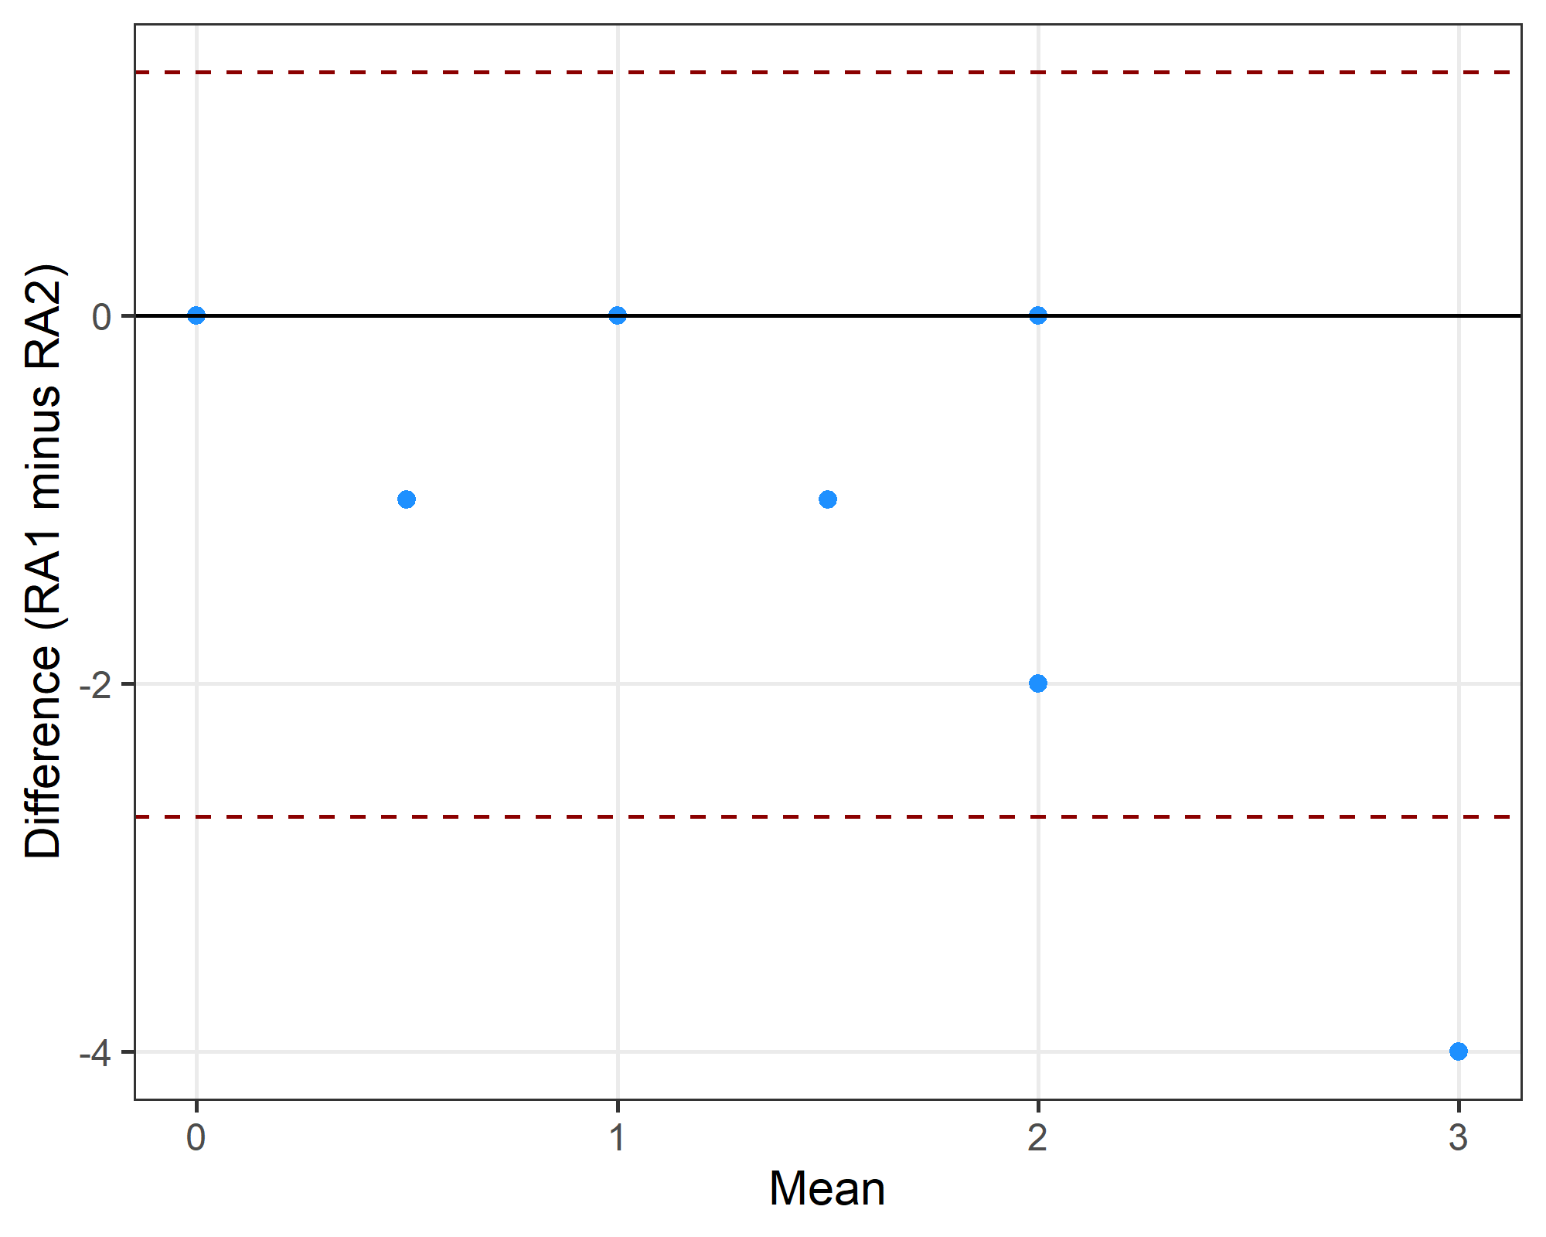
The limits of agreement were -2.72 to 1.32 .

Q2c: Can the question(s) be expressed using an established framework? For example, PICO for clinical studies or SPIDER for qualitative studies.
 | No | Not applicable | PICO | PICO, partial | SPIDER | SPIDER, partial
No | 0 | 0 | 0 | 0 | 0 | 0
Not applicable | 1 | 3 | 0 | 0 | 0 | 0
PICO | 0 | 1 | 0 | 4 | 0 | 0
PICO, partial | 1 | 2 | 1 | 4 | 0 | 0
SPIDER | 0 | 0 | 0 | 1 | 0 | 0
SPIDER, partial | 0 | 0 | 0 | 3 | 0 | 0
Gwet’s agreement statistic was 0.23 with a confidence interval of (-0.029,0.483).

Differences between research assistants
doi | comment.RA1 | RA1 | comment.RA2 | RA2
10.1007/s00421-024-05424-3 | pico | PICO | ico. population did not mentioned in the aim but mentioned previously. | PICO, partial
10.1016/j.jsams.2022.05.011 | spie | SPIDER, partial | po | PICO, partial
10.1016/j.psychsport.2022.102175 | pico | PICO | pico - p was not explicitly mentioned but overall it was clear | PICO, partial
10.1038/s41598-022-21029-2 | pico | PICO | ico | PICO, partial
10.1080/02640414.2020.1832735 | pico | PICO | not applicable to the pico framework | Not applicable
10.1080/14763141.2020.1820074 | co | PICO, partial | na | Not applicable
10.1097/jsm.0000000000000831 | spide | SPIDER, partial | po and ic are not applicable | PICO, partial
10.1111/sms.14272 | ico | PICO, partial | o | No
10.1111/sms.14761 | co | PICO, partial | na | Not applicable
10.1123/ijsnem.2020-0224 | pio | PICO, partial | pico | PICO
10.1123/ijspp.2021-0543 | not applicable | Not applicable | na or o only | No
10.1136/bjsports-2019-101175 | spie | SPIDER, partial | po, and ic are not applicable to this study | PICO, partial
10.3389/fpsyg.2022.939087 | spider | SPIDER | po and ic are not applicable to this study | PICO, partial
10.7717/peerj.8366 | pico | PICO | ico | PICO, partial

Q3: Was there previous research on the same question(s)?
We did not use question 3 as I forgot to give the additional instructions to the second research assistant.

Q5a: Was there a sample size calculation for the research question?
 | No | Not applicable | Yes
No | 9 | 0 | 1
Not applicable | 1 | 3 | 0
Yes | 1 | 0 | 5
Gwet’s agreement statistic was 0.79 with a confidence interval of (0.545,1).

Differences between research assistants
doi | RA1 | RA2
10.1002/eat.24344 | Yes | No
10.1016/j.psychsport.2022.102175 | No | Yes
10.1249/mss.0000000000003056 | Not applicable | No

Q5b: Was the effect size justified in the sample size calculation?
Only where the answer to the previous question (Q5a) was “yes”.
 | No | Not applicable | Yes
No | 2 | 0 | 1
Not applicable | 0 | 13 | 1
Yes | 1 | 1 | 1
Gwet’s agreement statistic was 0.74 with a confidence interval of (0.474,1).

Differences between research assistants
doi | RA1 | RA2
10.1002/eat.24344 | Yes | Not applicable
10.1016/j.psychsport.2022.102175 | Not applicable | Yes
10.1038/s41598-022-21029-2 | No | Yes
10.1111/sms.14761 | Yes | No

Q5c: What was the target sample size?
Bland-Altman plot.
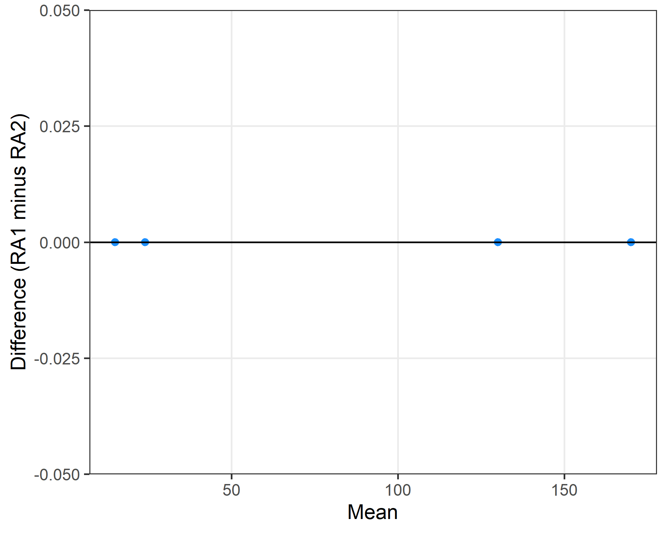
The limits of agreement were 0 to 0 .

Differences between research assistants
doi r1 r2
1 10.1016/j.psychsport.2022.102175 NA 9
2 10.1038/s41598-022-21029-2 NA 22
3 10.1136/bmjsem-2024-002040 NA 28

Q5d: What was the actual sample size?
Bland-Altman plot with the x-axis on a log scale because of the one very large study.
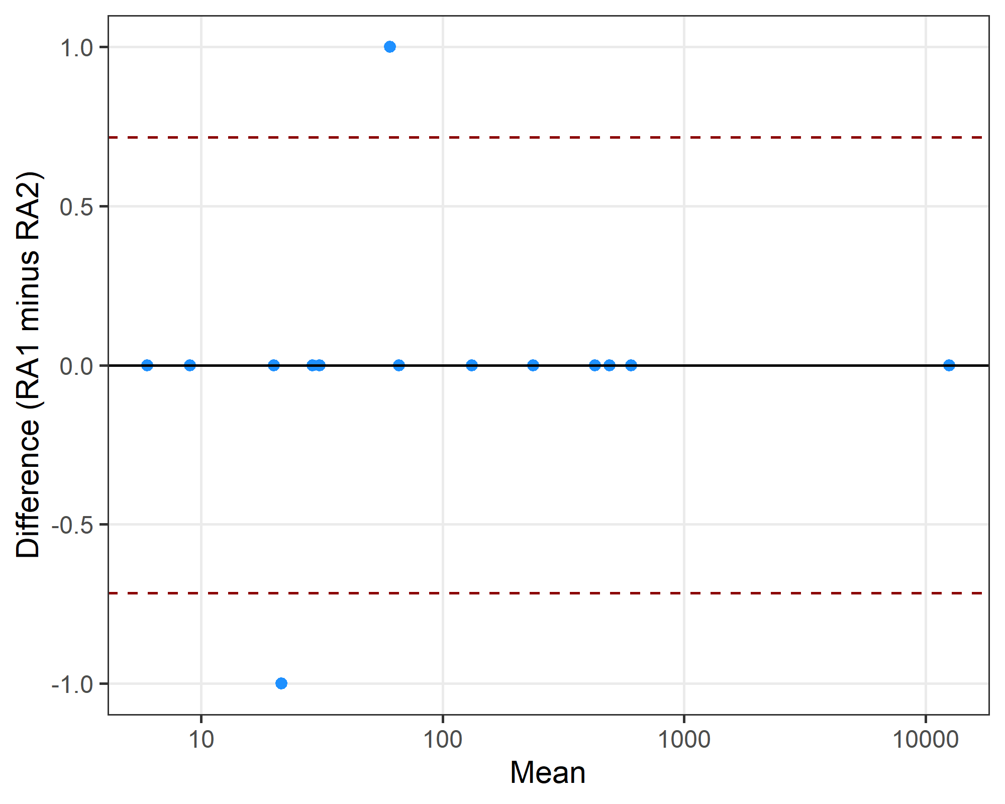
The limits of agreement were -0.72 to 0.72 .

Differences between research assistants
doi r1 r2
1 10.1016/j.jsams.2022.05.011 61 60
2 10.1038/s41598-022-21029-2 21 22
3 10.1249/mss.0000000000003056 NA 937

Q6: number of male and female participants
Bland-Altman plots.
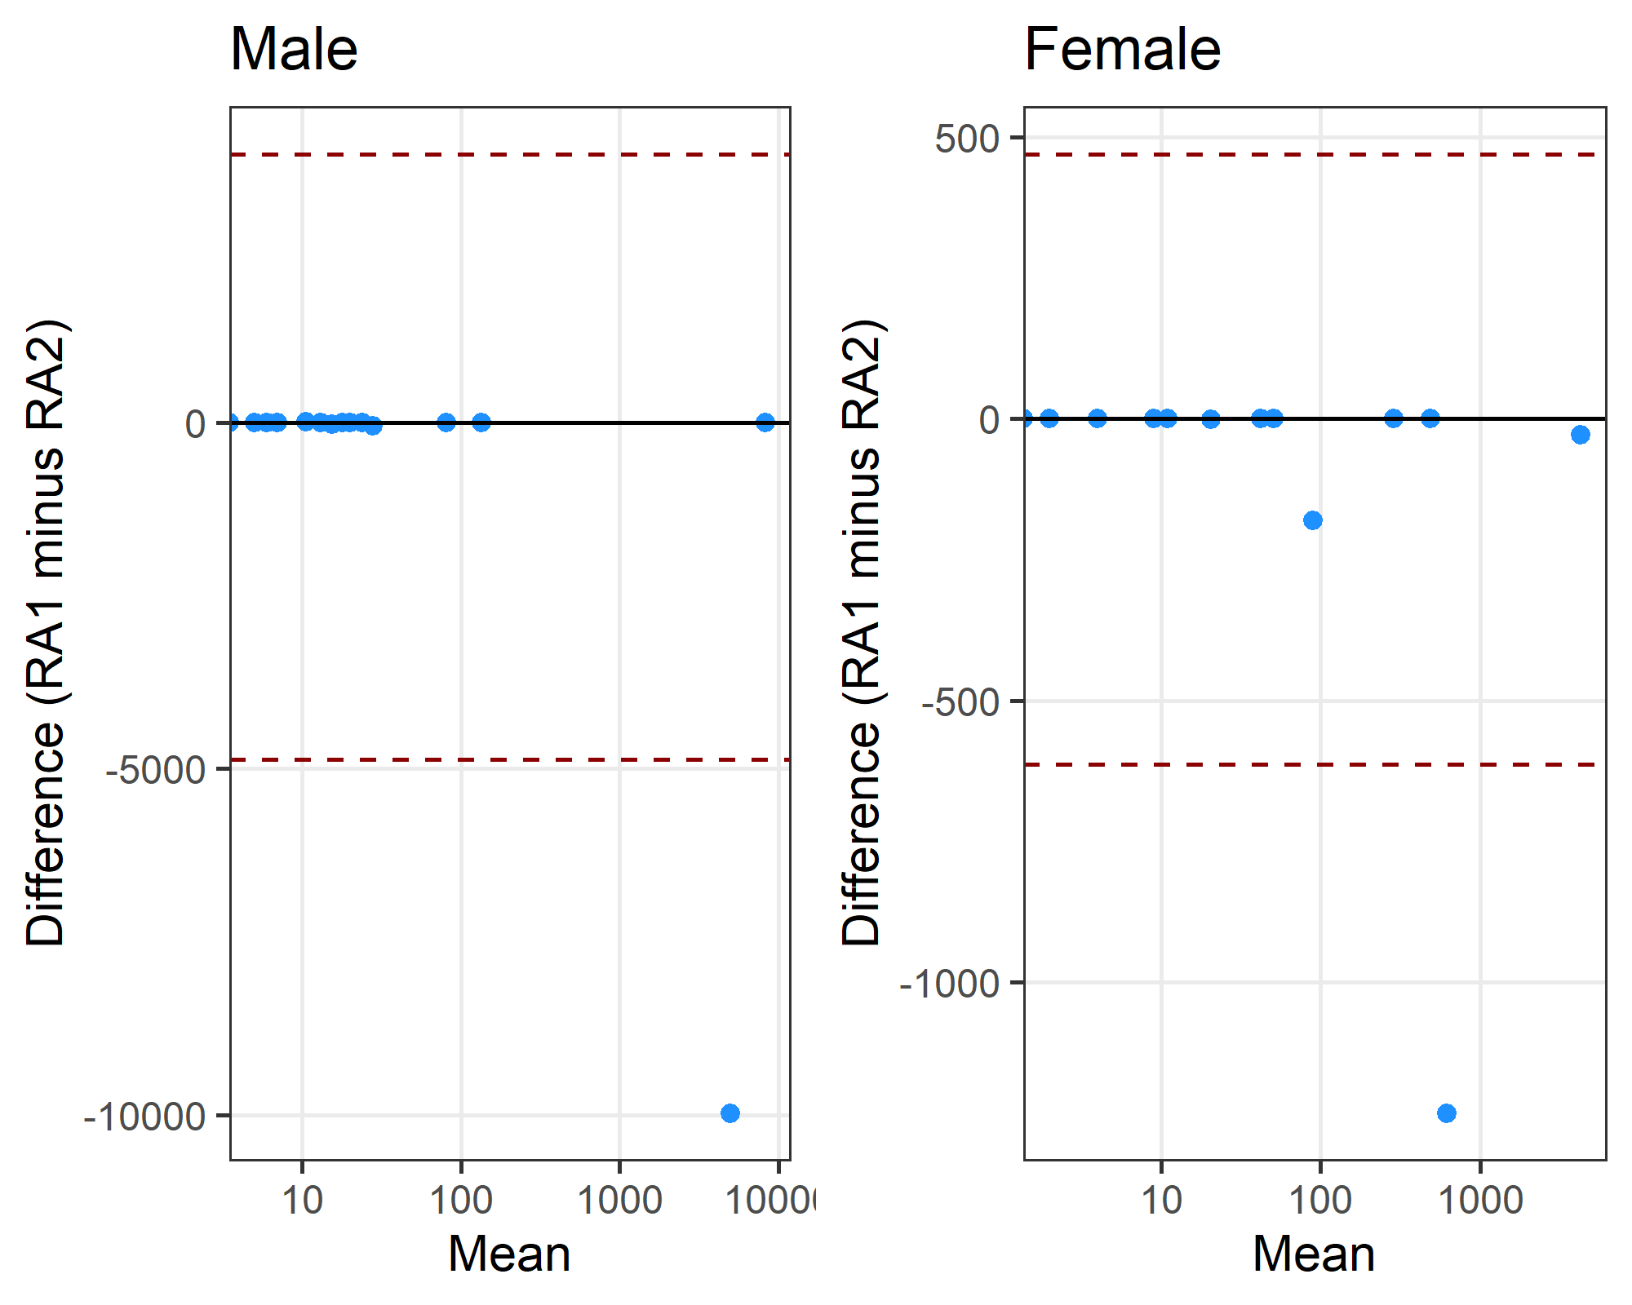

Differences between research assistants
doi r1 r2
1 10.1002/eat.24344 0 56
2 10.1007/s00421-024-05424-3 0 31
3 10.1111/sms.14272 11 10
4 10.1123/ijspp.2021-0543 8265 8267
5 10.1249/mss.0000000000003056 0 9970
doi r1 r2
1 10.1002/eat.24344 0 180
2 10.1111/sms.14272 20 21
3 10.1123/ijspp.2021-0543 4230 4259
4 10.1249/mss.0000000000003056 0 1232

Q10: Were missing data discussed and/or correctly reported?
 | No | No data missing | Not applicable | Yes
No | 8 | 0 | 0 | 0
No data missing | 2 | 0 | 1 | 0
Not applicable | 1 | 0 | 3 | 0
Yes | 2 | 0 | 0 | 3
Gwet’s agreement statistic was 0.62 with a confidence interval of (0.34,0.898).

Differences between research assistants
doi | RA1 | RA2
10.1007/s00421-024-05424-3 | Yes | No
10.1016/j.jsams.2022.05.011 | No data missing | Not applicable
10.1016/j.psychsport.2022.102175 | No data missing | No
10.1038/s41598-022-21029-2 | No data missing | No
10.1136/bjsports-2019-101175 | Yes | No
10.1249/mss.0000000000003056 | Not applicable | No

Q11: Were outliers removed without justification?
 | No outliers removed | Not applicable | Yes, no justification | Yes, with justification
No outliers removed | 8 | 4 | 0 | 1
Not applicable | 1 | 3 | 0 | 0
Yes, no justification | 0 | 0 | 1 | 0
Yes, with justification | 1 | 1 | 0 | 0
Gwet’s agreement statistic was 0.51 with a confidence interval of (0.214,0.798).

Differences between research assistants
doi | RA1 | RA2
10.1002/eat.24344 | No outliers removed | Not applicable
10.1007/s00421-024-05424-3 | No outliers removed | Yes, with justification
10.1016/j.jsams.2022.05.011 | Yes, with justification | Not applicable
10.1097/jsm.0000000000000831 | No outliers removed | Not applicable
10.1123/ijsnem.2020-0224 | Yes, with justification | No outliers removed
10.1136/bjsports-2019-101175 | No outliers removed | Not applicable
10.1249/mss.0000000000003056 | Not applicable | No outliers removed
10.7717/peerj.8366 | No outliers removed | Not applicable

Q14a: Was the research question answered? (Did the authors reflect on the question)
 | No | Not applicable | Yes
No | 0 | 0 | 0
Not applicable | 1 | 1 | 2
Yes | 1 | 0 | 15
Gwet’s agreement statistic was 0.76 with a confidence interval of (0.522,1).

Differences between research assistants
doi | RA1 | RA2
10.1016/j.jsams.2020.05.004 | Not applicable | No
10.1080/02640414.2020.1832735 | Yes | No
10.1123/ijspp.2021-0543 | Not applicable | Yes
10.1136/bmjsem-2024-002040 | Not applicable | Yes

Q14b: Was there some reflection about the practical significance of the main result/outcome.
 | No | Not applicable | Yes
No | 0 | 1 | 2
Not applicable | 0 | 0 | 0
Yes | 0 | 2 | 15
Gwet’s agreement statistic was 0.71 with a confidence interval of (0.446,0.977).

Differences between research assistants
doi | RA1 | RA2
10.1007/s40279-020-01295-8 | No | Not applicable
10.1016/j.jsams.2020.05.004 | Yes | Not applicable
10.1038/s41598-022-21029-2 | No | Yes
10.1080/14763141.2020.1820074 | Yes | Not applicable
10.1111/sms.14014 | No | Yes

