Report on Adrian’s time working on the AIS project
13 May 2026

Cumulative plot over time
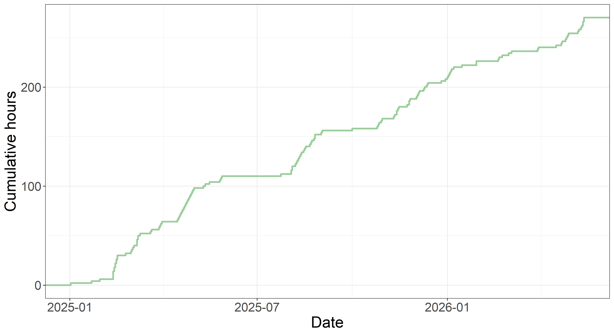

Summary of tasks
Notes | n | Total hours
Programming | 62 | 127
Slides | 19 | 47
Data entry, validation | 13 | 22
Presenting | 2 | 14
Protocol | 8 | 11
Writing paper | 8 | 9
Making slides for training course | 3 | 8
Creating and giving presentation on surveys | 1 | 7
Preliminary work on papers and topics to cover | 2 | 5
Searching for papers | 3 | 4
Data checking | 3 | 4
Data cleaning | 2 | 3
Reading | 2 | 2
Testing reading in the audited PDFs | 1 | 2
Meetings | 3 | 2
Refining audit questions | 1 | 2
Data preparation | 1 | 1
Data entry | 1 | 0
The total amount of time spent was 270 hours which is 37 working days.

