Statistical Thinking report on published Australian Institute of Sport research from 2000 to 2024
14 May 2026
Papers with AIS-supported authors were found by combining searches from papers found in PubMed and Scopus and a search provided by the AIS. The search was conducted on 11 March, 2025. The OpenAlex database was searched on 16 November, 2025.

Methods
We use descriptive statistics with plots, tables and summary statistics. For summary statistics for continuous variables, we use the median and first to third quartile (Q1 to Q3). When confidence intervals are given for binomial data, we use the Wilson score interval to avoid any problems with the normal approximation given our relatively small sample size.

Papers by publication year
We included papers for the years 2020 to 2024.
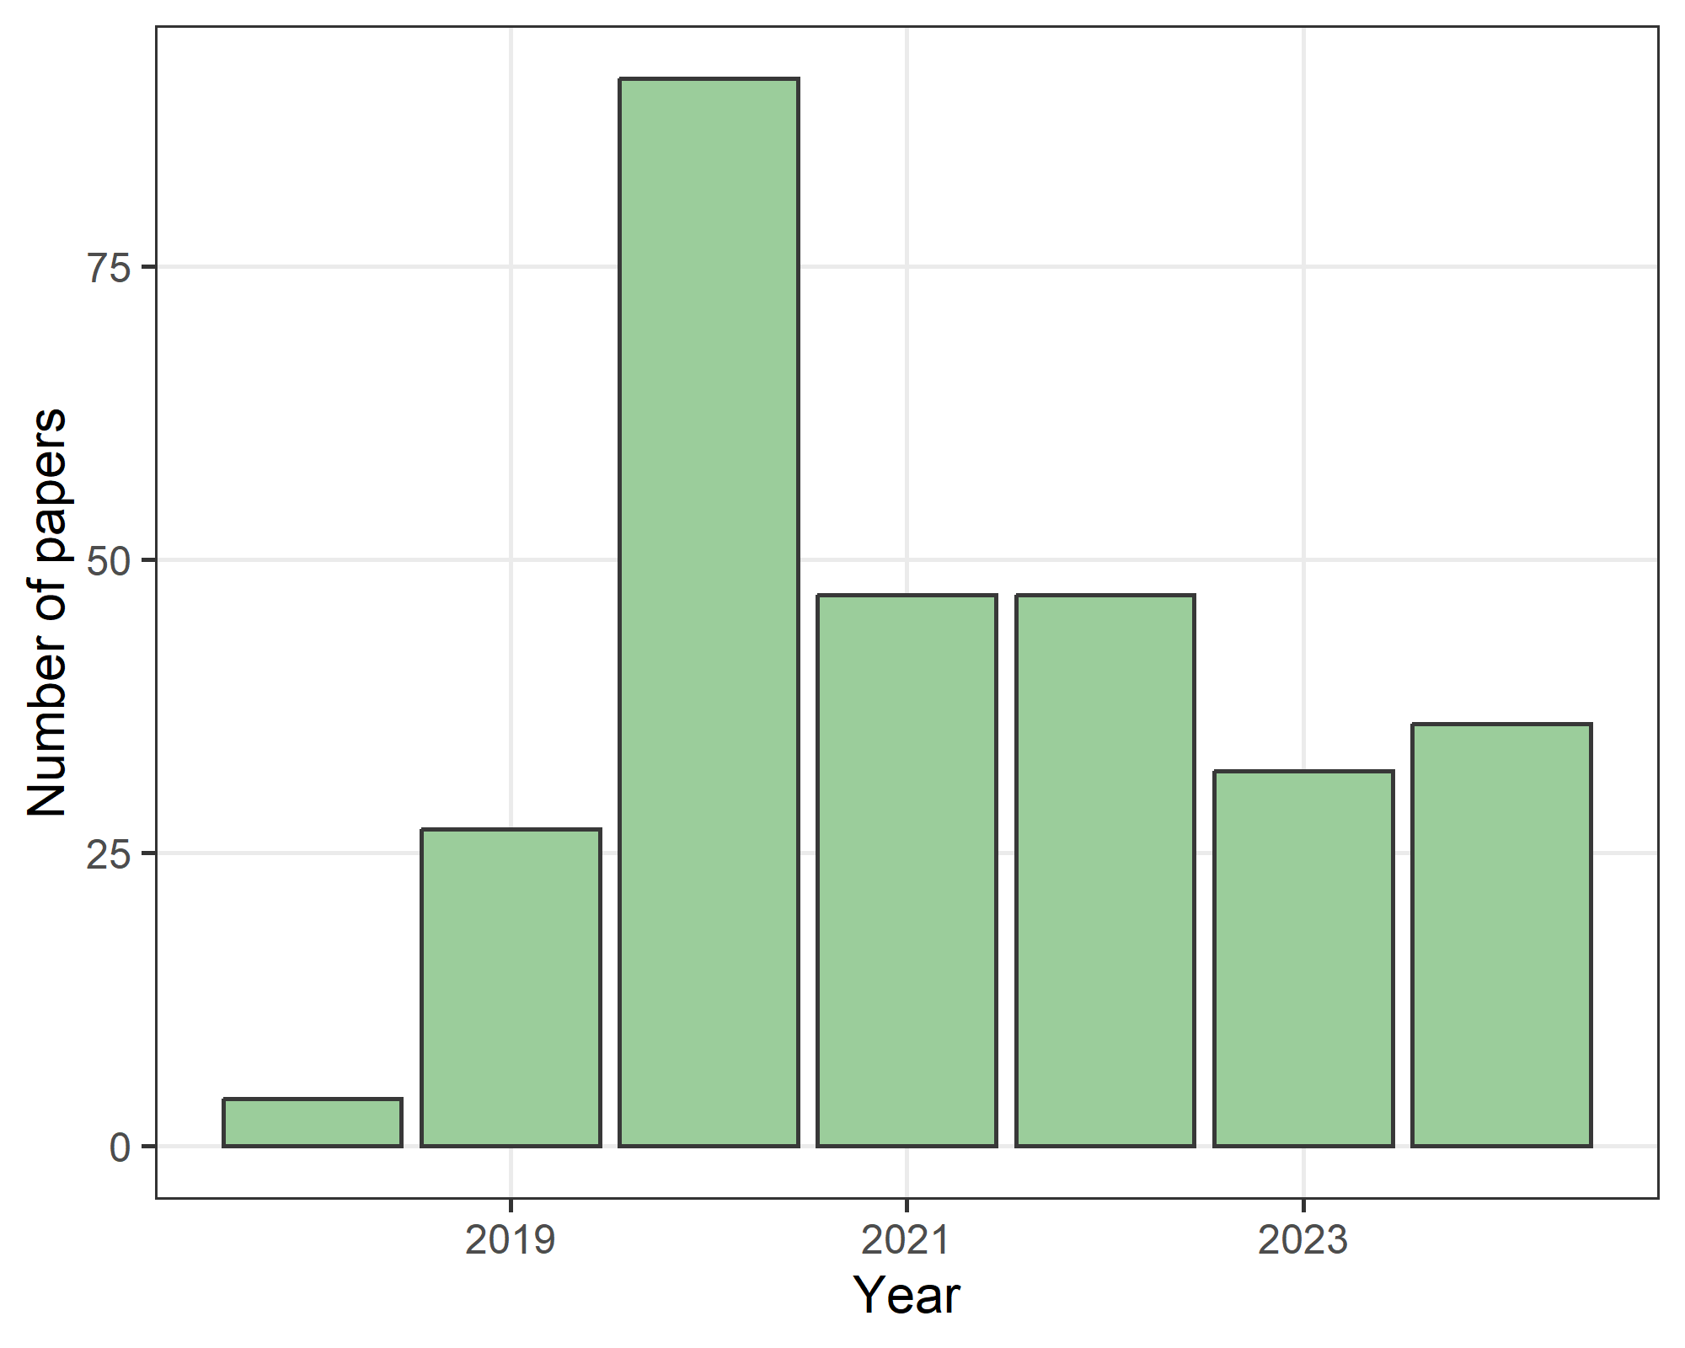
The total number of papers is 287. The most papers were in 2020. The slight left skew towards earlier years is because papers with two dates (electronic and print) are shown using the earliest date. The double-dates for all papers means that some papers above have an earliest date prior to 2020.

Section 1: Study design basics and authorship

Study design (Q1a)
This question was evaluated by the research assistant.
Study design | n | percent
Observational study | 116 | 40
Other | 69 | 24
Experimental study | 67 | 23
Review | 32 | 11
Protocol | 3 | 1
Total | 287 | 100
The “protocol” category was not in our study protocol, but was added after data collection.
The most common study design was an observational study. The “Other” category included audits, editorials, interviews, and position statements.

Author numbers per paper (Q1b)
This question was evaluated by the research assistant.
Count | N | Min | Q1 | Median | Q3 | Max
AIS authors | 287 | 1 | 1 | 1 | 2 | 10
Total authors | 287 | 1 | 4 | 6 | 8 | 113
The table shows the summary statistics for the number of authors with an AIS affiliation and the total number of authors.

Were the authors with an AIS affiliation in first or last position (Q1b)
This question was evaluated by the research assistant.
Position | Response | n | percent
First | No | 185 | 64
First | Yes | 102 | 36
Last | No | 215 | 75
Last | Yes | 72 | 25
 | Total | 287 | 100
First position is often seen as the author who has done the most work, whilst last position is often seen as the most senior author.

Was any author a statistician or methodologist? (Q1c)
This question was dropped from the analysis as we could not find a reliable automated method to identify statisticians and the manual method was too time consuming given the number of authors.

Section 2: Research question(s) and/or study aim(s)

Q2a: Did the paper have a well-formed research question or study aim?
This question was evaluated by the research assistant. We excluded 3 papers where this was not applicable: an opinion piece and an infographic.
Well formed question | n | percent | lower | upper
Yes | 200 | 70 | 65 | 75
No | 56 | 20 | 16 | 25
Purpose/Objective/Statement/Goal | 28 | 10 | 7 | 14
Total | 284 | 100
The category of “Purpose/Objective/Statement/Goal” was for papers that used a goal, objective, etc, instead of a research question. Most papers had a well-formed question or goal, although 20% without a well-formed question is still relatively large given the importance of stating a clear question.

Q2b: How many research questions or study aims were there?
This question was evaluated by the research assistant. We excluded 48 papers where the number of questions was not applicable, including those papers that did not have a well-formed question.
Number | Aims | Questions | Other
0 | 1 (0) | 1 (0) | 0
1 | 134 (56) | 1 (0) | 25 (10)
2 | 44 (18) | 6 (3) | 7 (3)
3 | 12 (5) | 7 (3) | 1 (0)
4 | 1 (0) | 1 (0) | 0
5 | 3 (1) | 0 | 0
Missing | 44 (18) | 223 (93) | 206 (86)
Total | 239 (100) | 239 (100) | 239 (100)
After data collection, we added another category of “Other” because there were many papers that used a purpose, goal or objective instead of a research question or aim. Most papers had between 1 to 2 aims or questions.
The table shows some missing for each type of question; however, there were no papers that were missing for all three types (aims, questions and other).

Q2c: Can the question(s)/aim(s) be expressed using an established framework?
This question was evaluated by the research assistant. This information was often difficult to extract and there was a low inter-rater agreement in the random sample of 30 papers. Hence, we decided not to include this question in the main paper.

Section 3: Prior research and planning

Q3: Was there previous research on the same question(s) or aim(s)? (Did they cite a review or do their own review?)
This question was evaluated by the research assistant. We excluded 3 papers where this was not applicable, e.g., an opinion piece and an infographic.
Previous research | n | percent | lower | upper
Mentioned but this research justified | 255 | 90 | 86 | 93
Mentioned but no justification was made | 24 | 8 | 6 | 12
Not mentioned at all | 5 | 2 | 1 | 4
Total | 284 | 100
Almost all papers (90%) mentioned previous research and gave a reason why this research was justified.

Q4a: Was there a study protocol and/or analysis plan?
The data for this question was extracted using an automated search of the PDFs. We excluded 20 papers that were one of: infographic, editorial, opinion, statement, commentary, protocol.
In a change to our protocol, the study protocol question was dropped because for many papers in sports science the “protocol” means the training regimen; hence, there were many false positive matches. We were able to search for analysis plans.
Analysis plan | n | percent | lower | upper
FALSE | 264 | 99 | 97 | 100
TRUE | 2 | 1 | 0 | 3
Total | 266 | 100
The results show that analysis plans were very rarely used.

Q4b: Was the study pre-registered, e.g., ANZCTR or clintrials.gov?
The data for this question was extracted using an automated search of the PDFs. We excluded 20 papers that were one of: infographic, editorial, opinion, statement, commentary, protocol.
Pre-registered | n | percent | lower | upper
FALSE | 258 | 97 | 94 | 98
TRUE | 8 | 3 | 2 | 6
Total | 266 | 100
Few studies were pre-registered.

Section 4: Sample size

Q5a: Was there a sample size calculation for the research question or study aim?
This question was evaluated by the research assistant. We excluded papers where this was not applicable, e.g., reviews.
Sample size calculation | n | percent | lower | upper
No | 193 | 87 | 82 | 91
Yes | 29 | 13 | 9 | 18
Total | 222 | 100
Many studies did not give a sample size calculation.

Q5b: Was the effect size justified in the sample size calculation?
This question was evaluated by the research assistant. This was only for papers where the response to Q5a was “Yes”.
Effect size justified | n | percent | lower | upper
Yes | 20 | 69 | 51 | 83
No | 9 | 31 | 17 | 49
Total | 29 | 100
Over half of studies with a sample size calculation provided a justification for the sample size.
Some studies cited a previous study in their sample size calculation; we took classified this as not justifying the effect size as the citation needed to be supported by some reasoning from the authors.

Q5c: What was the target sample size?
This question was evaluated by the research assistant. We only included papers that had a sample size calculation.
N | Missing | Min | Q1 | Median | Q3 | Max
29 | 4 | 7 | 10 | 17 | 24 | 170
Many target sample sizes were small with a median target sample size of just 18.

Q5d: What was the actual sample size?
This question was evaluated by the research assistant. We excluded papers where the sample size was not applicable (reviews, protocols, editorials, etc).
N | Missing | Min | Q1 | Median | Q3 | Max
234 | 20 | 1 | 14 | 28 | 76 | 12,526
Many actual sample sizes were small with a median sample size of just 30.

Sample size by study design
The actual sample size can vary greatly by study design, hence we a boxplot to show the sample sizes by study type.
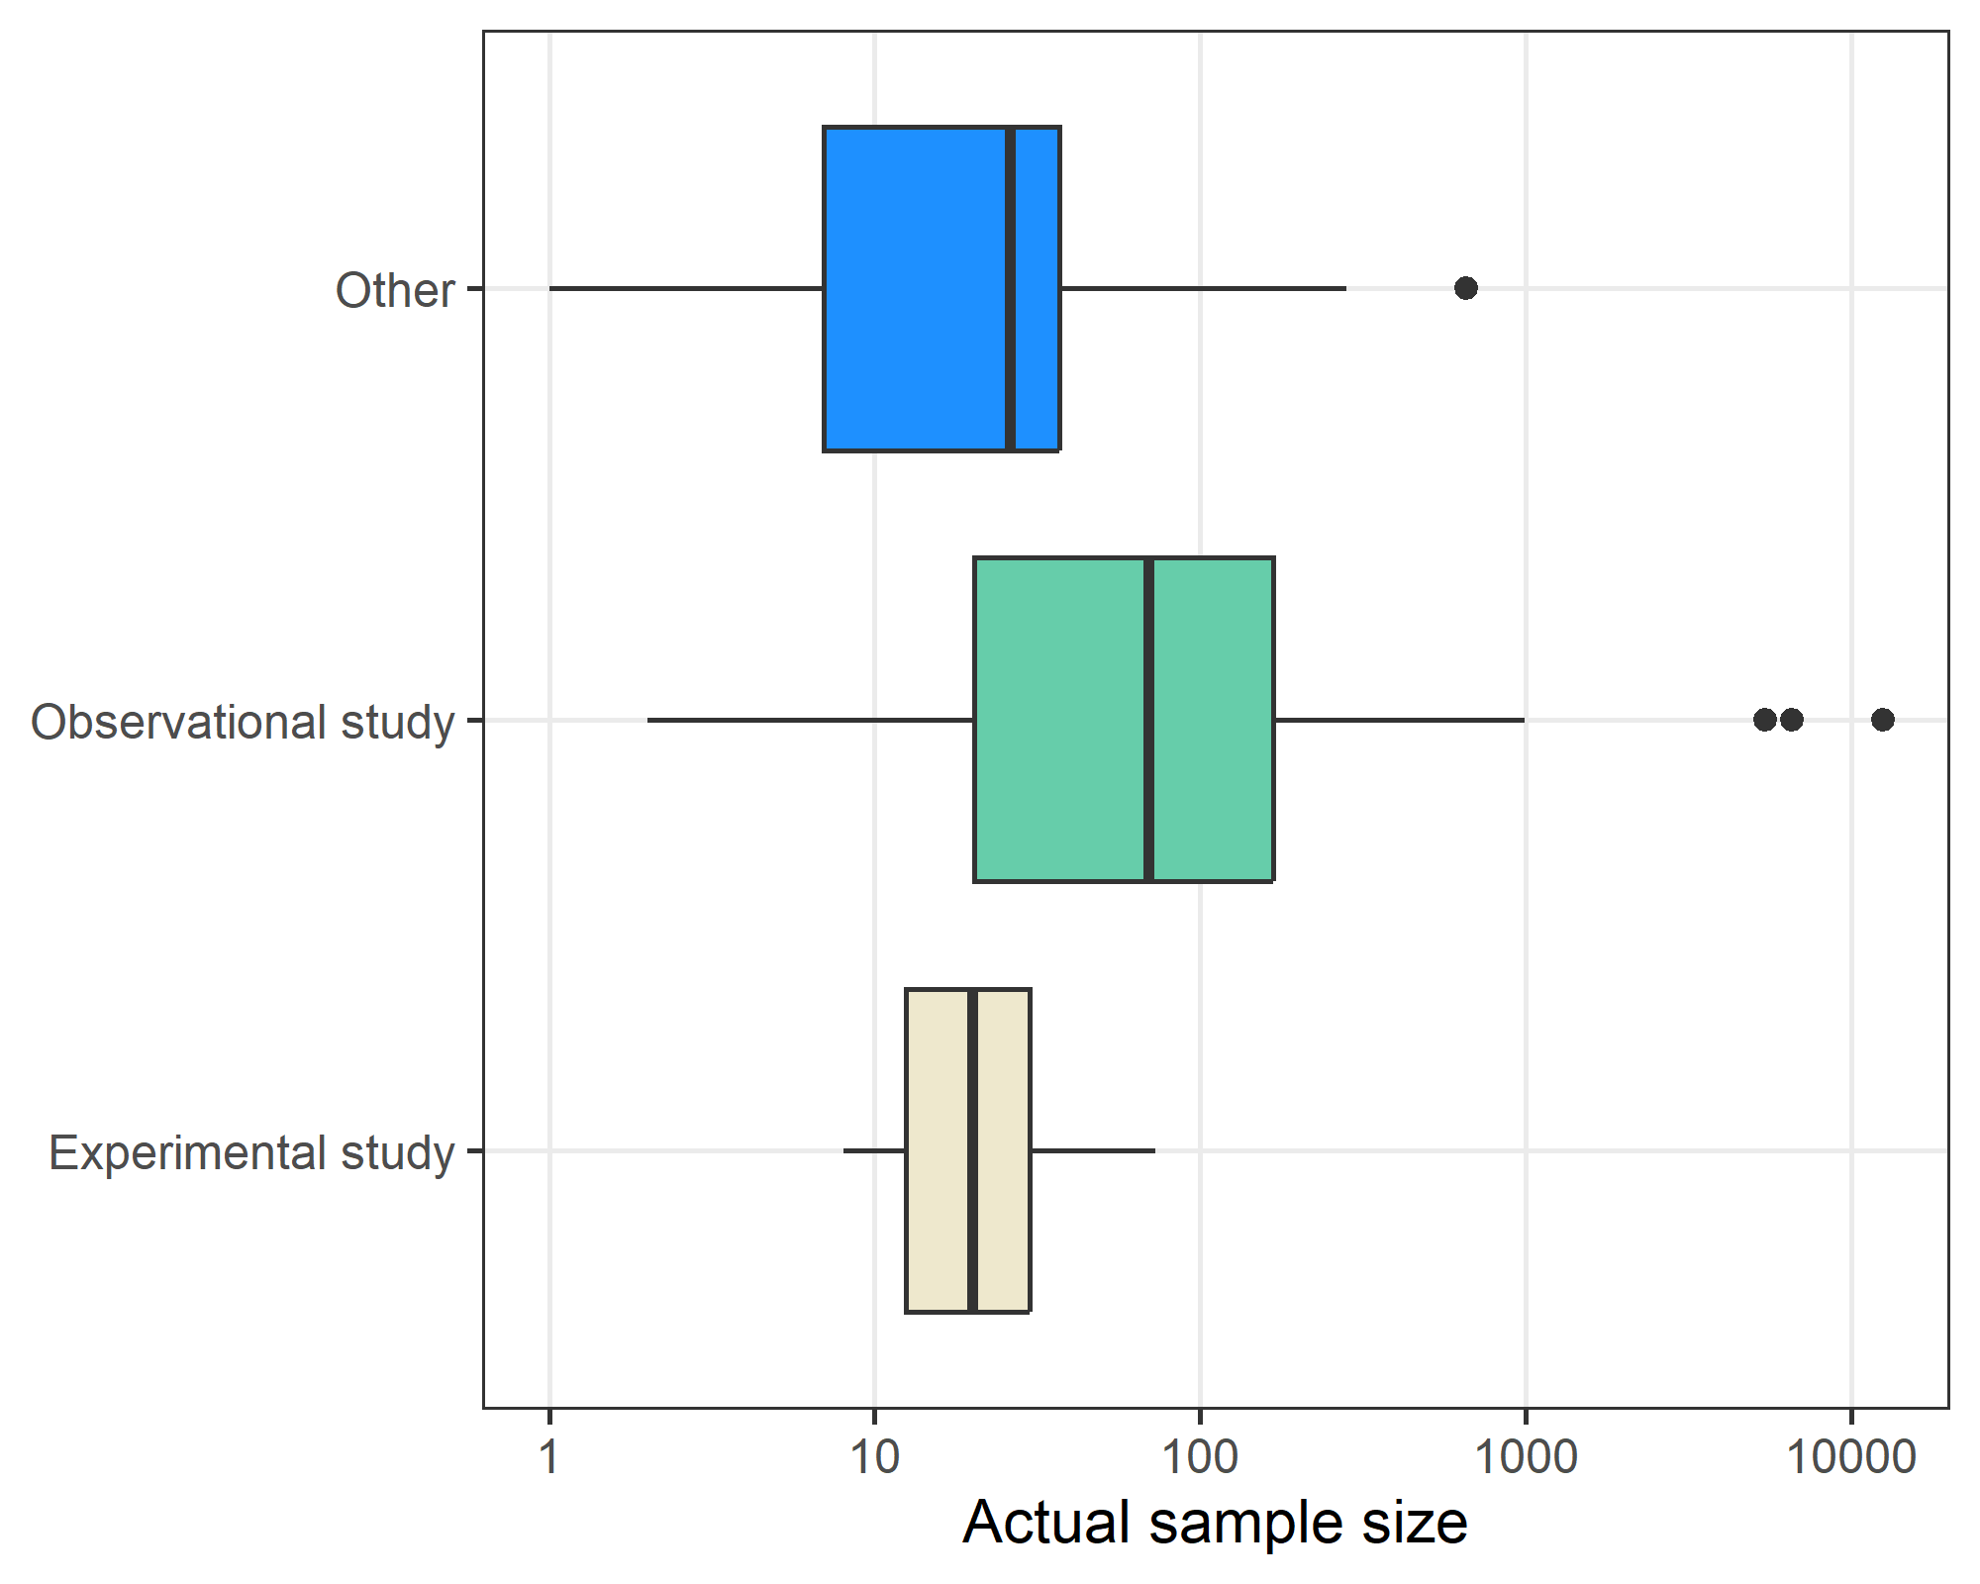
Observational studies had generally larger sample size and had most of the very large studies. The studies with a sample size of one were case studies. There were no experimental studies with a sample size over 100.

Q5c and Q5d: Comparing the target and actual sample size
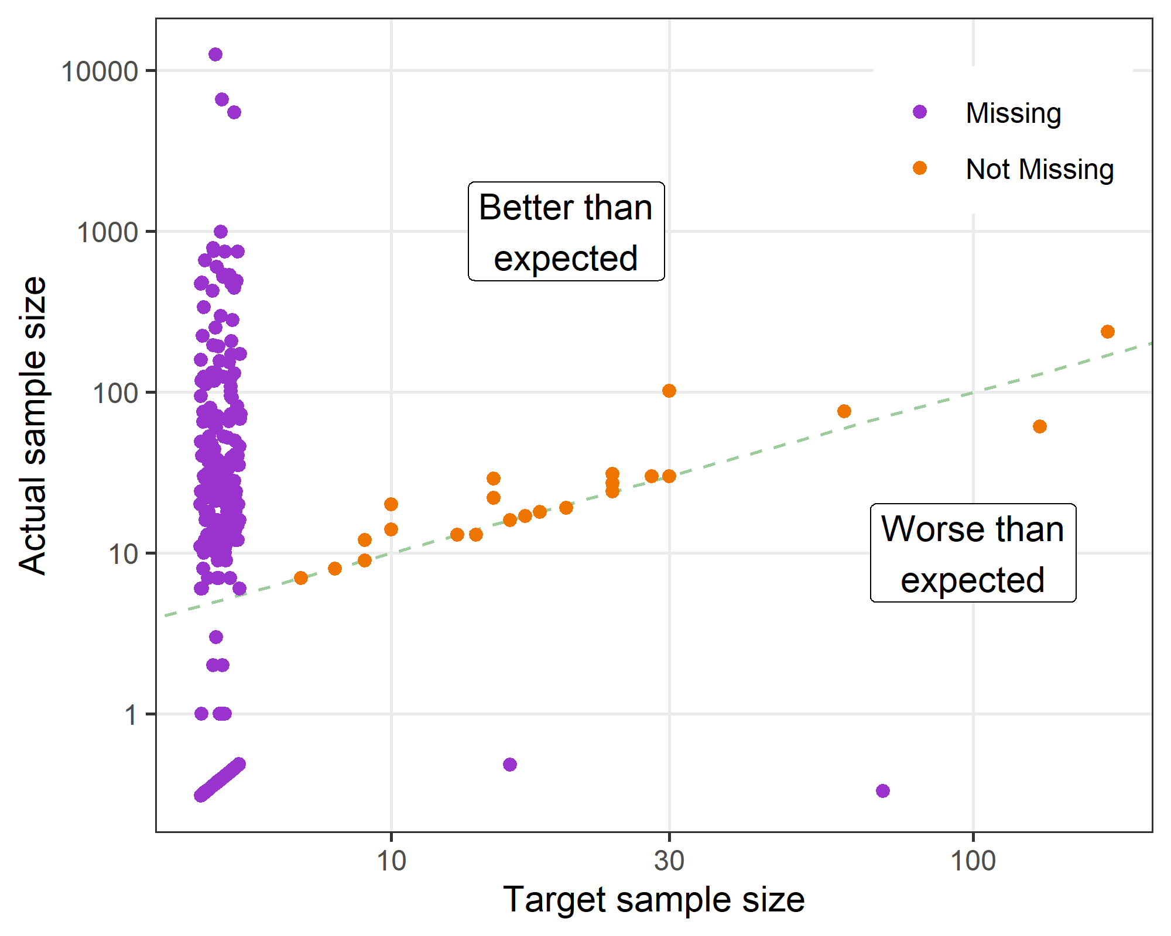
The scatter plot compares the target and actual sample sizes. The studies that were missing a target sample size are shown using the purple dots on the left margin. The plot includes a diagonal line of agreement. We have used a log scale for both axes because of the strong positive skew in sample sizes with a few very large studies. There were more studies that exceeded their sample size than were under.

Q6: How many participants were male and female?
This question was evaluated by the research assistant. All tables and graphs below exclude the papers where gender was not applicable, e.g., reviews.
gender | N | Missing | Min | Q1 | Median | Q3 | Max
female | 193 | 0 | 0 | 0 | 8 | 40 | 4,230
male | 193 | 0 | 0 | 6 | 15 | 31 | 8,265
The table above shows the summary statistics on the number of males and females. We only show the statistics for those studies where information was given on the number of males and/or females.
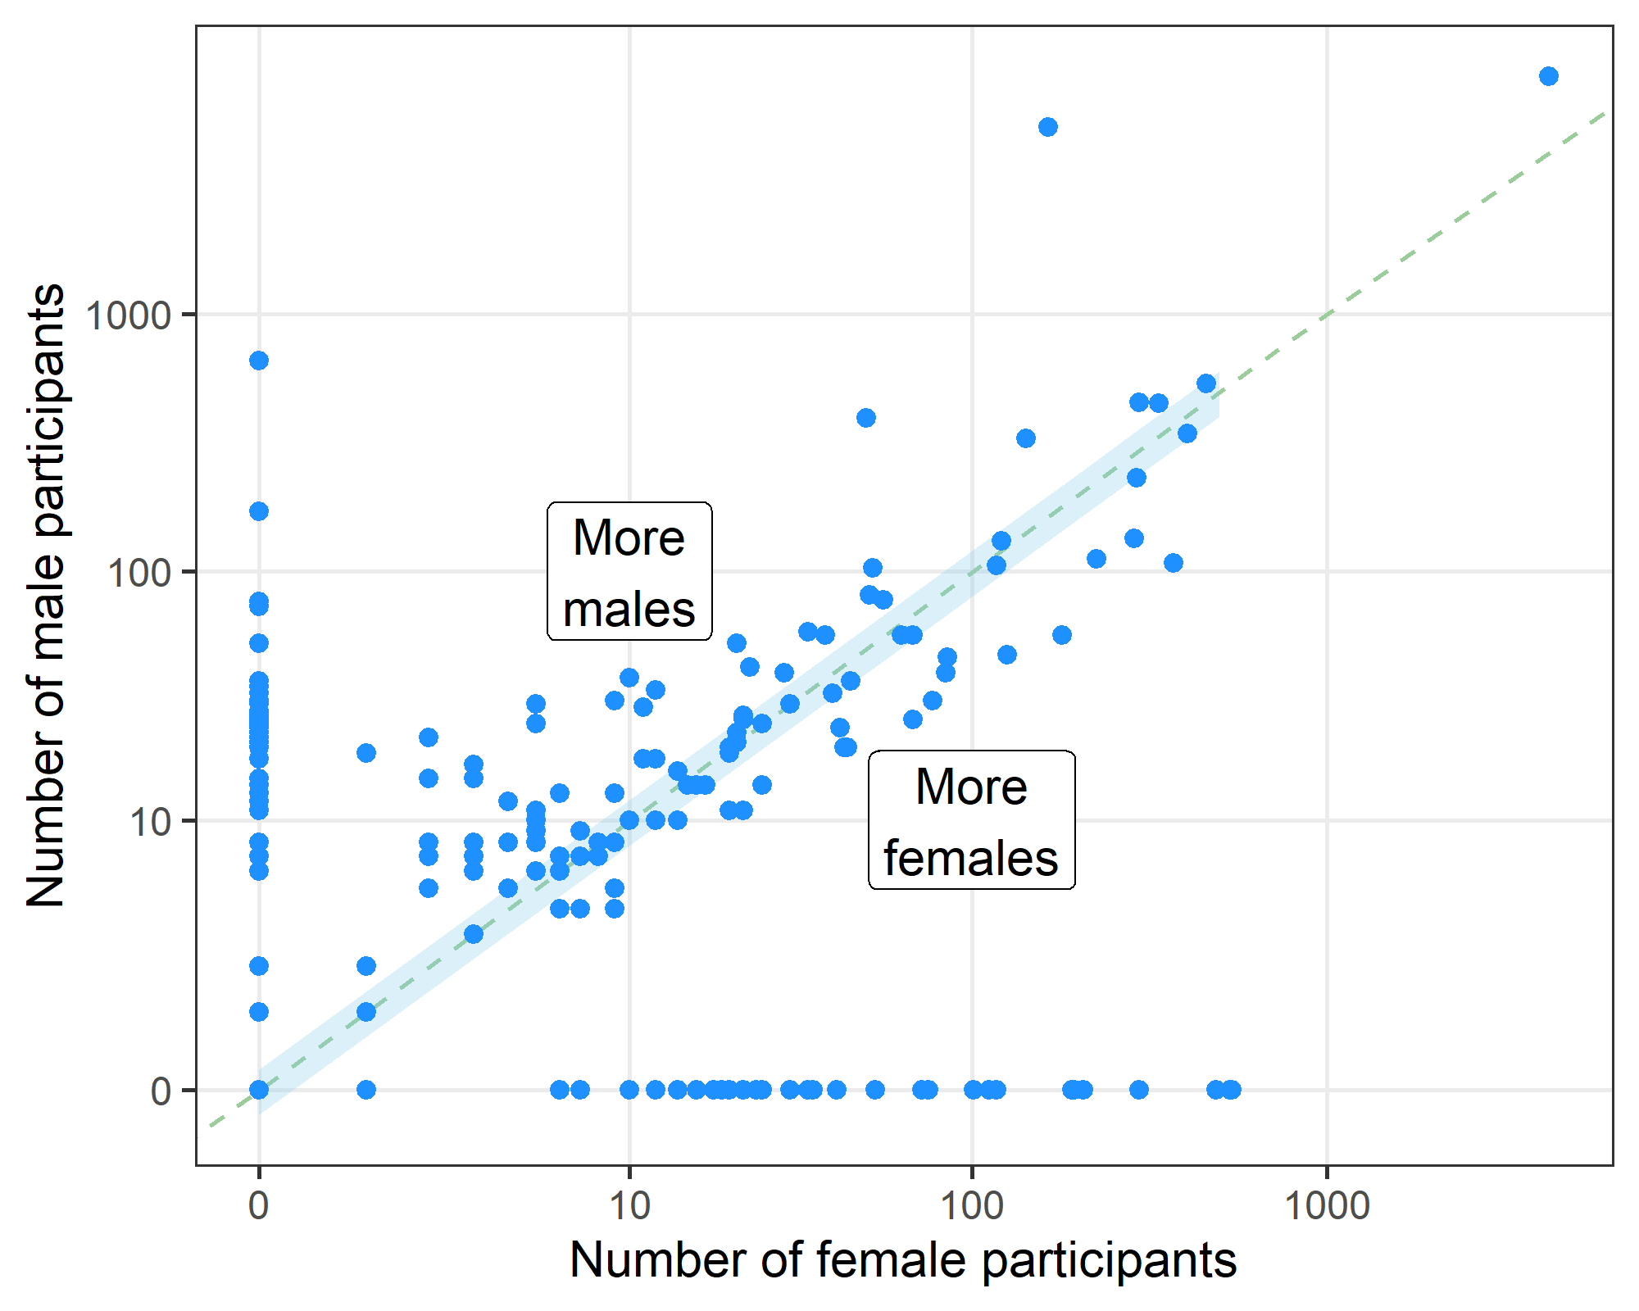
The scatter plot above aims to show the gender balance in studies. We removed 71 papers where gender was not applicable. The plot axes are on the log scale because of the positive skew in the numbers of males and females. The dotted diagonal line indicates studies with equal numbers of men and women. The blue shaded area is a 20% difference in gender. The dots along the x- and y-axes are for single sex studies (see next table).

Number of single sex studies
Gender | n | percent | lower | upper
Both | 102 | 53 | 46 | 60
Male only | 57 | 30 | 24 | 36
Female only | 34 | 18 | 13 | 24
Total | 193 | 100
Most studies were in both genders. There were slightly more studies in men only than women only.

Gender not reported
Not reported | n | percent | lower | upper
FALSE | 193 | 89 | 85 | 93
TRUE | 23 | 11 | 7 | 15
Total | 216 | 100
Some studies did not report the number of male and female participants.

Section 5: Good reporting

Q7: Was ethical clearance mentioned or was there a statement on why ethical clearance was not needed?
The data for this question was extracted using an automated search of the PDFs. We removed studies where gender was not relevant (e.g., reviews) or not reported.
Ethics statement | n | percent | lower | upper
TRUE | 205 | 81 | 75 | 85
FALSE | 49 | 19 | 15 | 25
Total | 254 | 100
Most studies included a statement regard ethics approval, which includes stating why ethical approval was not needed. Some statements on ethical approval did not include the date or approval number, but both would ideally be included to provide the most transparency. The ethics committees mentioned are shown in the appendix below.

Q8. Were the data openly shared?
The data for this question was extracted using an automated search of the PDFs. The original question in the protocol was “Was there a data availability statement?”; however, we changed this to the more strict criterion of whether the data was openly shared. This is a stronger test of transparency.
Data statement | n | percent | lower | upper
FALSE | 282 | 98 | 96 | 99
TRUE | 5 | 2 | 1 | 4
Total | 287 | 100
Very few studies openly shared data. We manually checked the five papers that assessed to have open data and there was a stated use of a data despository for every paper. However, we did not download the data and check if the data matched those used in the paper.
If the data were stated by the authors to be ‘available on request’ then this was not clased as open data.

Q9: Were there statements on funding and a conflict of interest?
The data for this question was extracted using an automated search of the PDFs.

Conflicts of interest
Conflict statement | n | percent | lower | upper
TRUE | 200 | 70 | 64 | 75
FALSE | 87 | 30 | 25 | 36
Total | 287 | 100

Funding
Funding statement | n | percent | lower | upper
TRUE | 191 | 67 | 61 | 72
FALSE | 96 | 33 | 28 | 39
Total | 287 | 100
The majority of papers did report on funding and conflicts of interest.

Q10: Were missing data discussed and/or correctly reported?
This question was evaluated by the research assistant. We excluded papers where missing data were unlikely to be relevant, e.g. protocols and reviews.
Discussed | n | percent | lower | upper
No | 128 | 56 | 50 | 63
No data missing | 55 | 24 | 19 | 30
Yes | 44 | 19 | 15 | 25
Total | 227 | 100
Missing data were often not discussed.

Q11: Were outliers removed without justification?
This question was evaluated by the research assistant. We excluded papers where outliers were unlikely to be relevant, e.g. protocols and reviews.
Outliers | n | percent | lower | upper
No outliers removed | 204 | 90 | 85 | 93
Yes, with justification | 15 | 7 | 4 | 11
Yes, no justification | 8 | 4 | 2 | 7
Total | 227 | 100
Most papers did not remove outliers. When outliers were removed, there were seven papers that did this without justification. An example quote is “one athlete was removed from the final analysis as the subject was identified as an extreme outlier”. This is not an adequate justification for exclusion as outliers can occur in real data and exclusions should only occur for data that is believed to be an error.

Q12: Was a relevant EQUATOR reporting guideline mentioned?
The data for this question was extracted using an automated search of the PDFs.
Checklist | n | percent | lower | upper
FALSE | 245 | 85 | 81 | 89
TRUE | 42 | 15 | 11 | 19
Total | 287 | 100
Most studies did not mention using a reporting guideline.

Q13. Was the publication open access?
The data for this question was extracted from Unpaywall.
Is OA | OA status | n | percent
TRUE | gold | 64 | 22
TRUE | green | 50 | 17
TRUE | hybrid | 43 | 15
TRUE | bronze | 22 | 8
FALSE | closed | 108 | 38
Total | - | 287 | 100
Over half the papers were open access.

Section 6: Research question reflection

Q14a: Was the research question or study aim answered? (Did the authors reflect on the question)
This question was evaluated by the research assistant. We excluded papers where this question was not relevant, e.g. protocols and editorials.
Answered | n | percent | lower | upper
Yes | 236 | 100 | 98 | 100
No | 1 | 0 | 0 | 2
Total | 237 | 100
Almost every paper answered their question or aim.

Q14b: Was there some reflection about the practical significance of the main result/outcome?
This question was evaluated by the research assistant. We excluded a small number of papers where this was not applicable, e.g., an infographic.
Answered | n | percent | lower | upper
Yes | 219 | 78 | 73 | 82
No | 62 | 22 | 18 | 27
Total | 281 | 100
Most papers gave some reflection on practical significance.

Q14c: Was there an over-interpretation of the study results, for example, making causal claims from a small observational study ?
This question was evaluated by the two experts in the field. Not all papers were examined.
Interpretation | n | percent | lower | upper
FALSE | 157 | 84 | 78 | 89
TRUE | 30 | 16 | 11 | 22
Total | 187 | 100
Some papers were judged to have over-interpreted the study results.

Summary diagram
The diagram below summarises the questions in an attempt to show where authors are generally doing well and where improvements could be made. The plot is ordered with the best performing questions at the top. The results are coloured in two groups, those above 60% classed as relatively good (blue) and those under 40% classed as relatively bad (red).
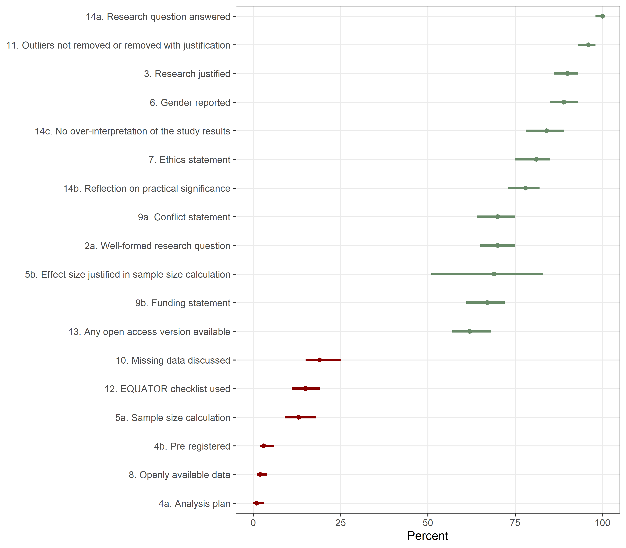

Bibliographic data
In this section we examine bibliographic data on the papers.

Word cloud of titles
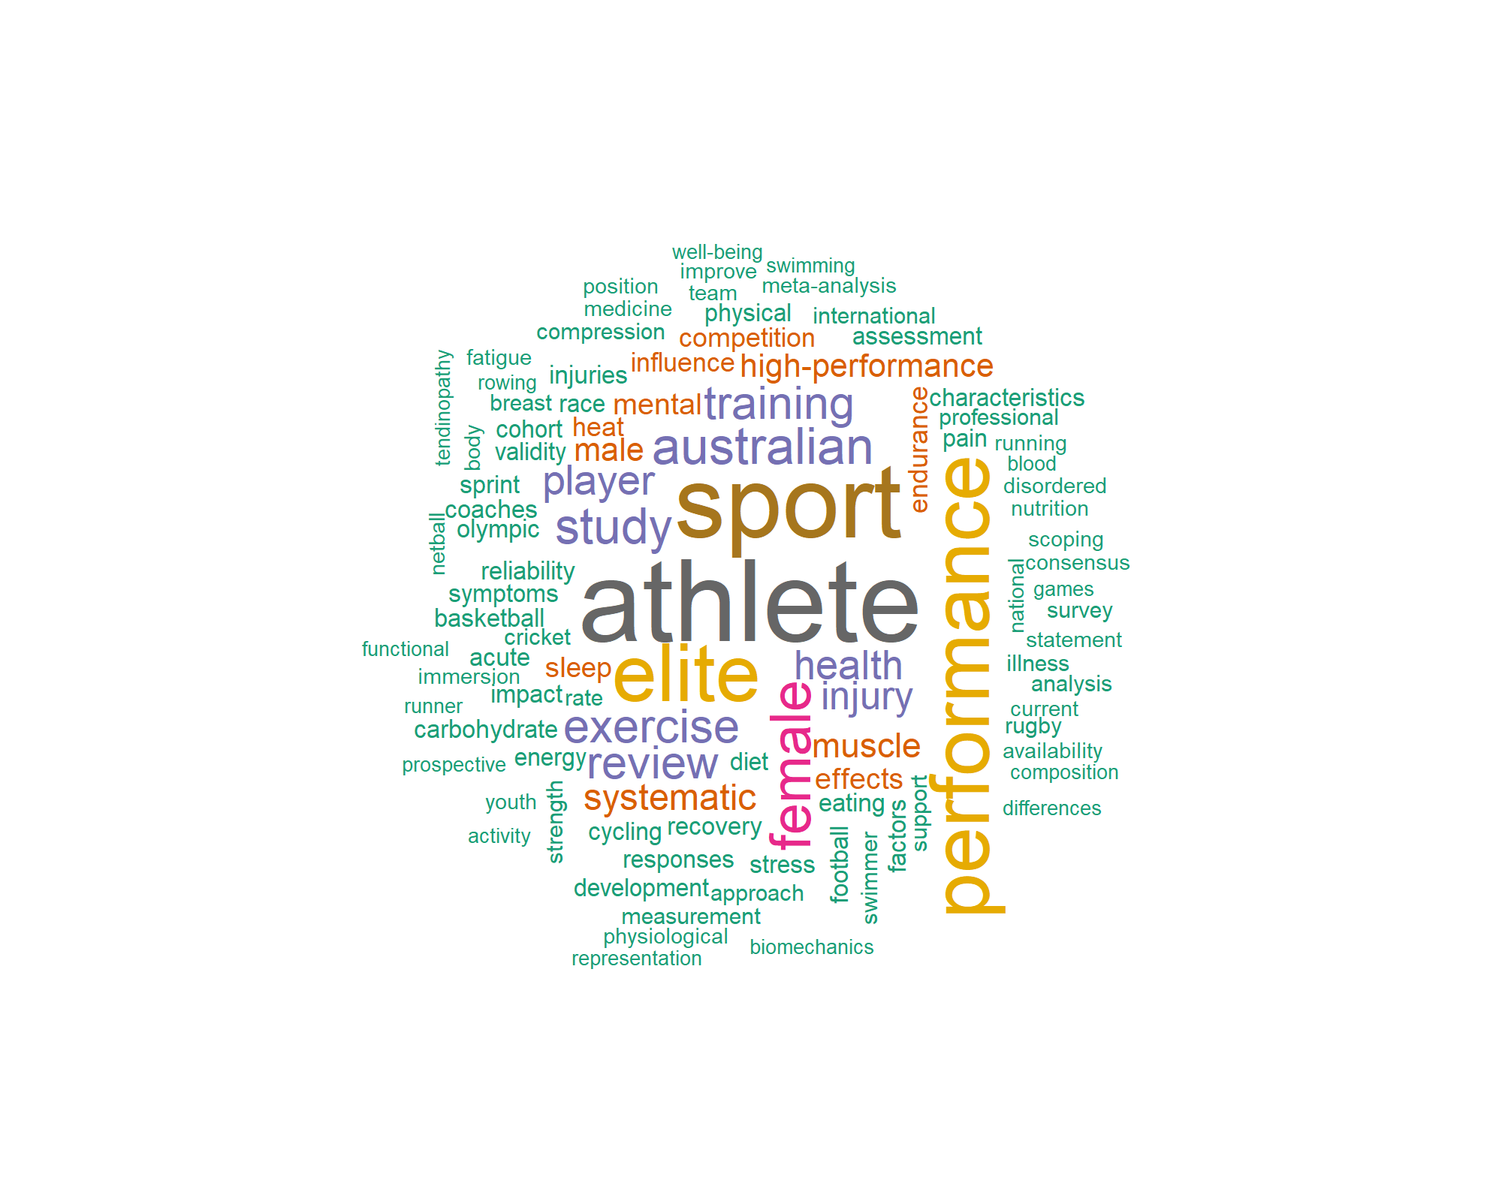
Words must have been mentioned 4 times to be in the cloud.

Most common topics (top 10)
The topics were extracted from OpenAlex. Each article includes up to three topics. The table shows the number and percent.
Topic | n
Sports injuries and prevention | 124 (44)
Sports Performance and Training | 113 (40)
Muscle metabolism and nutrition | 48 (17)
Sport Psychology and Performance | 41 (14)
Exercise and Physiological Responses | 37 (13)
Cardiovascular Effects of Exercise | 32 (11)
Thermoregulation and physiological responses | 28 (10)
Injury Epidemiology and Prevention | 25 (9)
Cardiovascular and exercise physiology | 21 (7)
Lower Extremity Biomechanics and Pathologies | 18 (6)

Most common journals (top 10)
Journal | n
Journal of Science and Medicine in Sport | 28 (10)
International Journal of Sports Physiology and Performance | 21 (7)
British Journal of Sports Medicine | 16 (6)
International Journal of Sport Nutrition and Exercise Metabolism | 16 (6)
Journal of Sports Sciences | 15 (5)
Sports Medicine | 14 (5)
European Journal of Sport Science | 11 (4)
Journal of Strength &amp; Conditioning Research | 9 (3)
Medicine &amp; Science in Sports &amp; Exercise | 9 (3)
Scandinavian Journal of Medicine &amp; Science in Sports | 9 (3)

Most common publishers (top 10)
publisher | n
Elsevier BV | 50
Taylor & Francis | 43
Human Kinetics | 38
BMJ | 26
Lippincott Williams & Wilkins | 25
Springer Science+Business Media | 21
Wiley | 18
Frontiers Media | 10
Multidisciplinary Digital Publishing Institute | 10
SAGE Publishing | 10

Most common authors (top 10)
Author | n
Michael K. Drew | 42
Louise M. Burke | 38
Shona L. Halson | 31
Gordon Waddington | 25
Alannah K. A. McKay | 23
Liam A. Toohey | 19
David Hughes | 17
Clare Minahan | 16
Rachel Harris | 16
Nicolin Tee | 15
There were 1135 unique authors.

Papers published in Frontiers or MDPI
This uses data from OpenAlex.
journal | title
Frontiers in Endocrinology | A Short-Term Ketogenic Diet Impairs Markers of Bone Health in Response to Exercise
Frontiers in Pain Research | Multimodal physiological sensing for the assessment of acute pain
Frontiers in Physiology | Concurrent Validity of Power From Three On-Water Rowing Instrumentation Systems and a Concept2 Ergometer
Frontiers in Physiology | Inflammation and Oral Contraceptive Use in Female Athletes Before the Rio Olympic Games
Frontiers in Physiology | The Free Achilles Tendon Is Shorter, Stiffer, Has Larger Cross-Sectional Area and Longer T2* Relaxation Time in Trained Middle-Distance Runners Compared to Healthy Controls
Frontiers in Psychology | Risk and protective factors for mental ill-health in elite para- and non-para athletes
Frontiers in Sports and Active Living | Comparisons of Macro-Kinematic Strategies During the Rounds of a Cross-Country Skiing Sprint Competition in Classic Technique
Frontiers in Sports and Active Living | Experiential Knowledge Affects the Visual Search Behaviors of Sprint Coaches and Sport Biomechanists
Frontiers in Sports and Active Living | Pilot Study on the Reliability of the Coach's Eye: Identifying Talent Throughout a 4-Day Cadet Judo Camp
Frontiers in Sports and Active Living | Technical Determinants of On-Water Rowing Performance
International Journal of Environmental Research and Public Health | What Contributes to Athlete Performance Health? A Concept Mapping Approach
Journal of Functional Morphology and Kinesiology | Automatic Recognition of Motor Skills in Triathlon: A Novel Tool for Measuring Movement Cadence and Cycling Tasks
Nutrients | Athlete Preferences for Nutrition Education: Development of and Findings from a Quantitative Survey
Nutrients | Auditing the Representation of Female Versus Male Athletes in Sports Science and Sports Medicine Research: Evidence-Based Performance Supplements
Nutrients | Managing Female Athlete Health: Auditing the Representation of Female versus Male Participants among Research in Supplements to Manage Diagnosed Micronutrient Issues
Nutrients | Neither Beetroot Juice Supplementation nor Increased Carbohydrate Oxidation Enhance Economy of Prolonged Exercise in Elite Race Walkers
Nutrients | Short-Term Very High Carbohydrate Diet and Gut-Training Have Minor Effects on Gastrointestinal Status and Performance in Highly Trained Endurance Athletes
Nutrients | The Validity of Ultrasound Technology in Providing an Indirect Estimate of Muscle Glycogen Concentrations Is Equivocal
Sports | Movement Competency Training Delivery: At School or Online? A Pilot Study of High-School Athletes
Sports | Using the Isometric Mid-Thigh Pull to Predict Three-Repetition Maximum Squat Values in Female Athletes
There were 20 papers published in MDPI or Frontiers journals.
MDPI and Frontiers are considered as predatory publishers by an independent group of researchers. Both publishers were clear outliers in an analysis of publication patterns over time with an enormous recent increase in output and special issues. They also have fast turn-around times, which raises concern about the rigor of their peer review.
Summary statistics on the number of authors per paper.

Citations
The citation data were from OpenAlex.

Summary statistics for citation counts
Type | N | Missing | Min | Q1 | Median | Q3 | Max
cited | 284 | 0 | 0 | 4 | 10 | 24 | 221
yearly | 284 | 0 | 0 | 1 | 3 | 7 | 39
Total citations counts and counts per year.

Histogram of adjusted citation counts
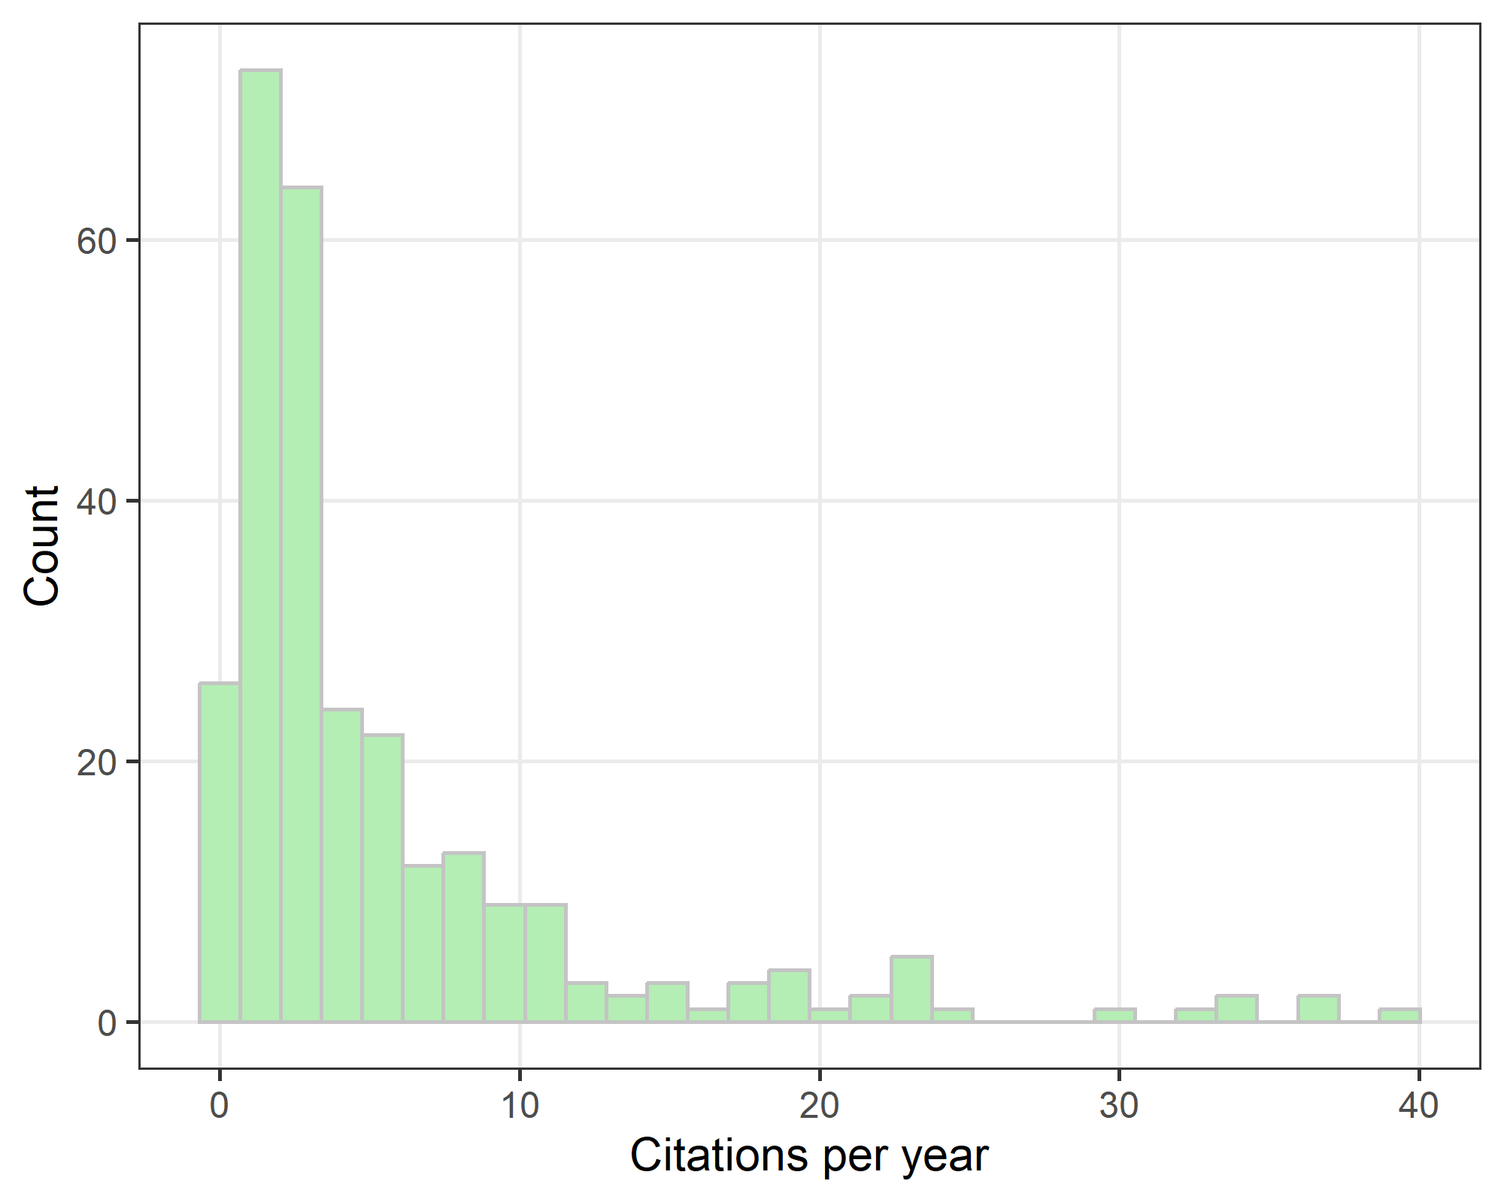
We look at the citations per year to adjust for time since publication (as papers published recently have less time to accrue citations). The distribution has a strong positive skew, with a few highly cited papers.

Altmetric
N | Missing | Min | Q1 | Median | Q3 | Max
287 | 29 | 0 | 2 | 10 | 27 | 715
Summary statistics on Altmetric scores. The highest Altmetric score was for the paper titled “A Short-Term Ketogenic Diet Impairs Markers of Bone Health in Response to Exercise.” published in Frontiers in endocrinology.

Summary tables

Descriptive statistics
group | var | stats
 | Year published | 2021 [2020 to 2022]
 | AIS authors | 1 [1 to 2]
 | Total citations | 10 [4 to 24]
 | Citations per year | 3 [1 to 7]
 | Altmetric | 10 [2 to 27]
Study design | Observational study | 116 (40)
Study design | Other | 69 (24)
Study design | Experimental study | 67 (23)
Study design | Review | 32 (11)
Study design | Protocol | 3 (1)
Topics (top 3) | Sports injuries and prevention | 124 (44)
Topics (top 3) | Sports Performance and Training | 113 (40)
Topics (top 3) | Muscle metabolism and nutrition | 48 (17)
Journals (top 3) | Journal of Science and Medicine in Sport | 28 (10)
Journals (top 3) | International Journal of Sports Physiology and Performance | 21 (7)
Journals (top 3) | British Journal of Sports Medicine | 16 (6)

Outcomes
comb_label | numbers | percent | ci
4a. Analysis plan | 2/266 | 1 | 0, 3
8. Openly available data | 5/287 | 2 | 1, 4
4b. Pre-registered | 8/266 | 3 | 2, 6
5a. Sample size calculation | 29/222 | 13 | 9, 18
12. EQUATOR checklist used | 42/287 | 15 | 11, 19
10. Missing data discussed | 44/227 | 19 | 15, 25
13. Any open access version available | 179/287 | 62 | 57, 68
9b. Funding statement | 191/287 | 67 | 61, 72
5b. Effect size justified in sample size calculation | 20/29 | 69 | 51, 83
2a. Well-formed research question | 200/284 | 70 | 65, 75
9a. Conflict statement | 200/287 | 70 | 64, 75
14b. Reflection on practical significance | 219/281 | 78 | 73, 82
7. Ethics statement | 205/254 | 81 | 75, 85
14c. No over-interpretation of the study results | 157/187 | 84 | 78, 89
6. Gender reported | 193/216 | 89 | 85, 93
3. Research justified | 255/284 | 90 | 86, 93
11. Outliers not removed or removed with justification | 219/227 | 96 | 93, 98
14a. Research question answered | 236/237 | 100 | 98, 100

Missing data
The table below reports the amount of missing data. We do not include conditional missing, for example, sample sizes were not relevant for systematic reviews.
qnum | Missing | N | percent
5c | 4 | 29 | 14
5d | 20 | 234 | 9

