Agreement in manually extracted data between the two research assistants
28 September 2026
The comparisons below are based on a random sample of 20 papers.

Q1a: Study design
 | Experimental study | Observational study | Other | Review
Experimental study | 5 | 1 | 0 | 0
Observational study | 0 | 8 | 0 | 0
Other | 0 | 1 | 3 | 1
Review | 0 | 0 | 0 | 1
Gwet’s agreement statistic was 0.81 with a confidence interval of (0.589,1).

Differences between research assistants
doi | comment.RA1 | RA1 | comment.RA2 | RA2
10.1080/02640414.2020.1832735 | experimental study | Experimental study | observational study, reliability | Observational study
10.1123/ijspp.2021-0543 | other, qualitative | Other | observational study, survey | Observational study
10.1249/mss.0000000000003056 | other, audit | Other | review, says audit but is actually a review | Review

Q1b: The number of authors with an AIS affiliation.
 | 1 | 2 | 3 | 4 | 6
1 | 13 | 1 | 0 | 0 | 0
2 | 0 | 0 | 0 | 0 | 0
3 | 0 | 0 | 1 | 0 | 0
4 | 0 | 0 | 0 | 3 | 0
6 | 0 | 0 | 0 | 0 | 2
Gwet’s agreement statistic was 0.94 with a confidence interval of (0.825,1).

Differences between research assistants
doi | RA1 | RA2
10.1097/jsm.0000000000000831 | 1 | 2

Q2a: Did the paper have a well-formed research question or study aim?
 | No | Not applicable | Yes
No | 2 | 1 | 0
Not applicable | 0 | 1 | 0
Yes | 0 | 0 | 16
For this question, the research assistant also split questions into whether they were a purpose, objective, etc; however, to simplify this comparison we just examine yes, no and not applicable.
Gwet’s agreement statistic was 0.94 with a confidence interval of (0.812,1).

Differences between research assistants
doi | comment.RA1 | RA1 | comment.RA2 | RA2
10.1007/s40279-020-01295-8 | no aims or research questions | No | not applicable | Not applicable

Q2b: How many research questions or aims were there?
For this comparison we compared any types of question. For example, if an RA said 2 aims and another said 2 questions then we assessed this as perfect agreement.
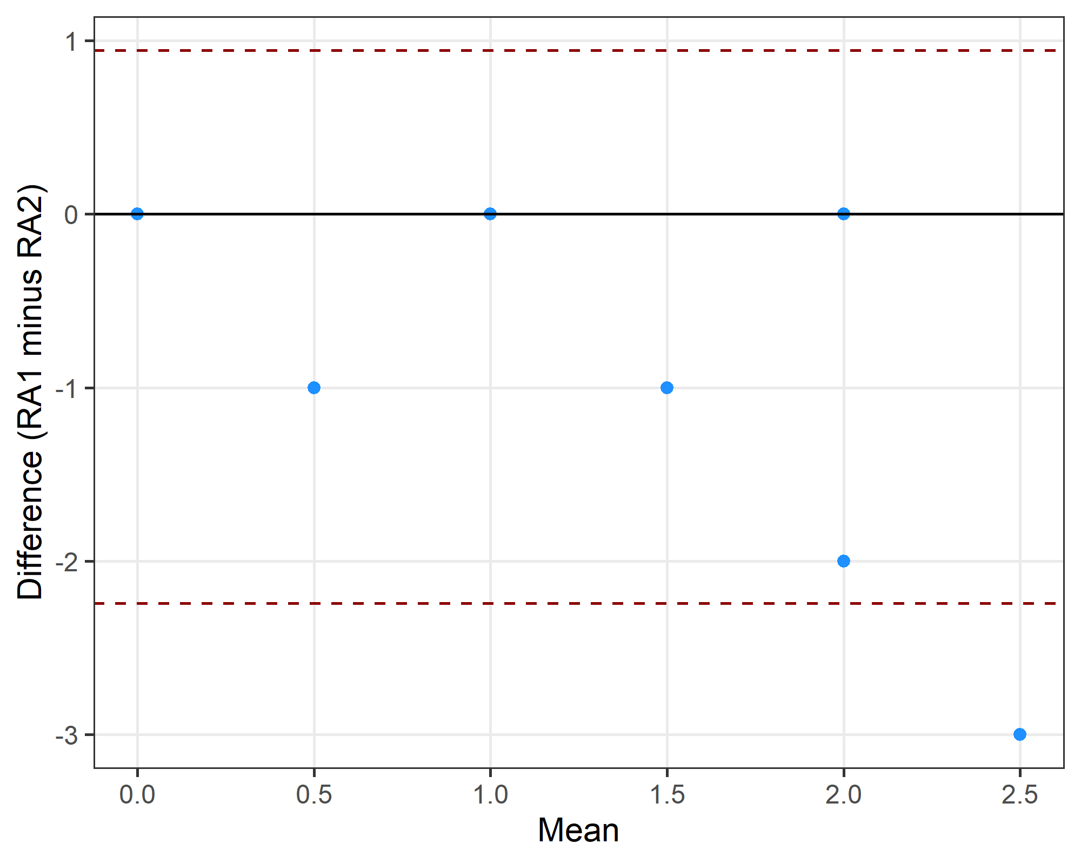
The limits of agreement were -2.24 to 0.94 .

Q2c: Can the question(s) be expressed using an established framework? For example, PICO for clinical studies or SPIDER for qualitative studies.
 | No | Not applicable | PICO | PICO, partial | SPIDER | SPIDER, partial
No | 0 | 0 | 0 | 0 | 0 | 0
Not applicable | 0 | 3 | 0 | 0 | 0 | 1
PICO | 0 | 0 | 3 | 2 | 0 | 0
PICO, partial | 2 | 0 | 1 | 5 | 0 | 0
SPIDER | 0 | 0 | 0 | 1 | 0 | 0
SPIDER, partial | 0 | 0 | 0 | 2 | 0 | 1
Gwet’s agreement statistic was 0.5 with a confidence interval of (0.234,0.764).

Differences between research assistants
doi | comment.RA1 | RA1 | comment.RA2 | RA2
10.1038/s41598-022-21029-2 | pico | PICO | ico. intervention = tights, control = placebo, outcome = recovery, p = not here. | PICO, partial
10.1097/jsm.0000000000000831 | spide | SPIDER, partial | pio. p = elite female athletes, o = pain prediction, i = model. | PICO, partial
10.1111/sms.14272 | ico | PICO, partial | no. o = landing quality? could not guess pico. | No
10.1111/sms.14761 | co | PICO, partial | no. not clear to me. | No
10.1123/ijspp.2021-0543 | not applicable | Not applicable | spie. s = athletes, e = knowledge/attitudes, pi = covid. | SPIDER, partial
10.1136/bjsports-2019-101175 | spie | SPIDER, partial | po. outcome = prescribing. p = sports medicine physicians. | PICO, partial
10.1249/mss.0000000000003056 | po | PICO, partial | pico. p = males/females, i = fueling, c = cho-based intervention, o = health outcome. | PICO
10.3389/fpsyg.2022.939087 | spider | SPIDER | po. o = mental health, p = athletes. | PICO, partial
10.7717/peerj.8366 | pico | PICO | po, population = field setting, outcome = correlation, no intervention | PICO, partial

Q3: Was there previous research on the same question(s)?
We did not use question 3 as I forgot to give the additional instructions to the second research assistant.

Q5a: Was there a sample size calculation for the research question?
 | No | Not applicable | Yes
No | 9 | 0 | 1
Not applicable | 0 | 4 | 0
Yes | 0 | 0 | 6
Gwet’s agreement statistic was 0.93 with a confidence interval of (0.779,1).

Differences between research assistants
doi | RA1 | RA2
10.1016/j.psychsport.2022.102175 | No | Yes

Q5b: Was the effect size justified in the sample size calculation?
Only where the answer to the previous question (Q5a) was “yes”.
 | No | Not applicable | Yes
No | 3 | 0 | 0
Not applicable | 0 | 13 | 1
Yes | 3 | 0 | 0
Gwet’s agreement statistic was 0.74 with a confidence interval of (0.464,1).

Differences between research assistants
doi | RA1 | RA2
10.1002/eat.24344 | Yes | No
10.1016/j.psychsport.2022.102175 | Not applicable | Yes
10.1111/sms.14761 | Yes | No
10.7717/peerj.8366 | Yes | No

Q5c: What was the target sample size?
Bland-Altman plot.
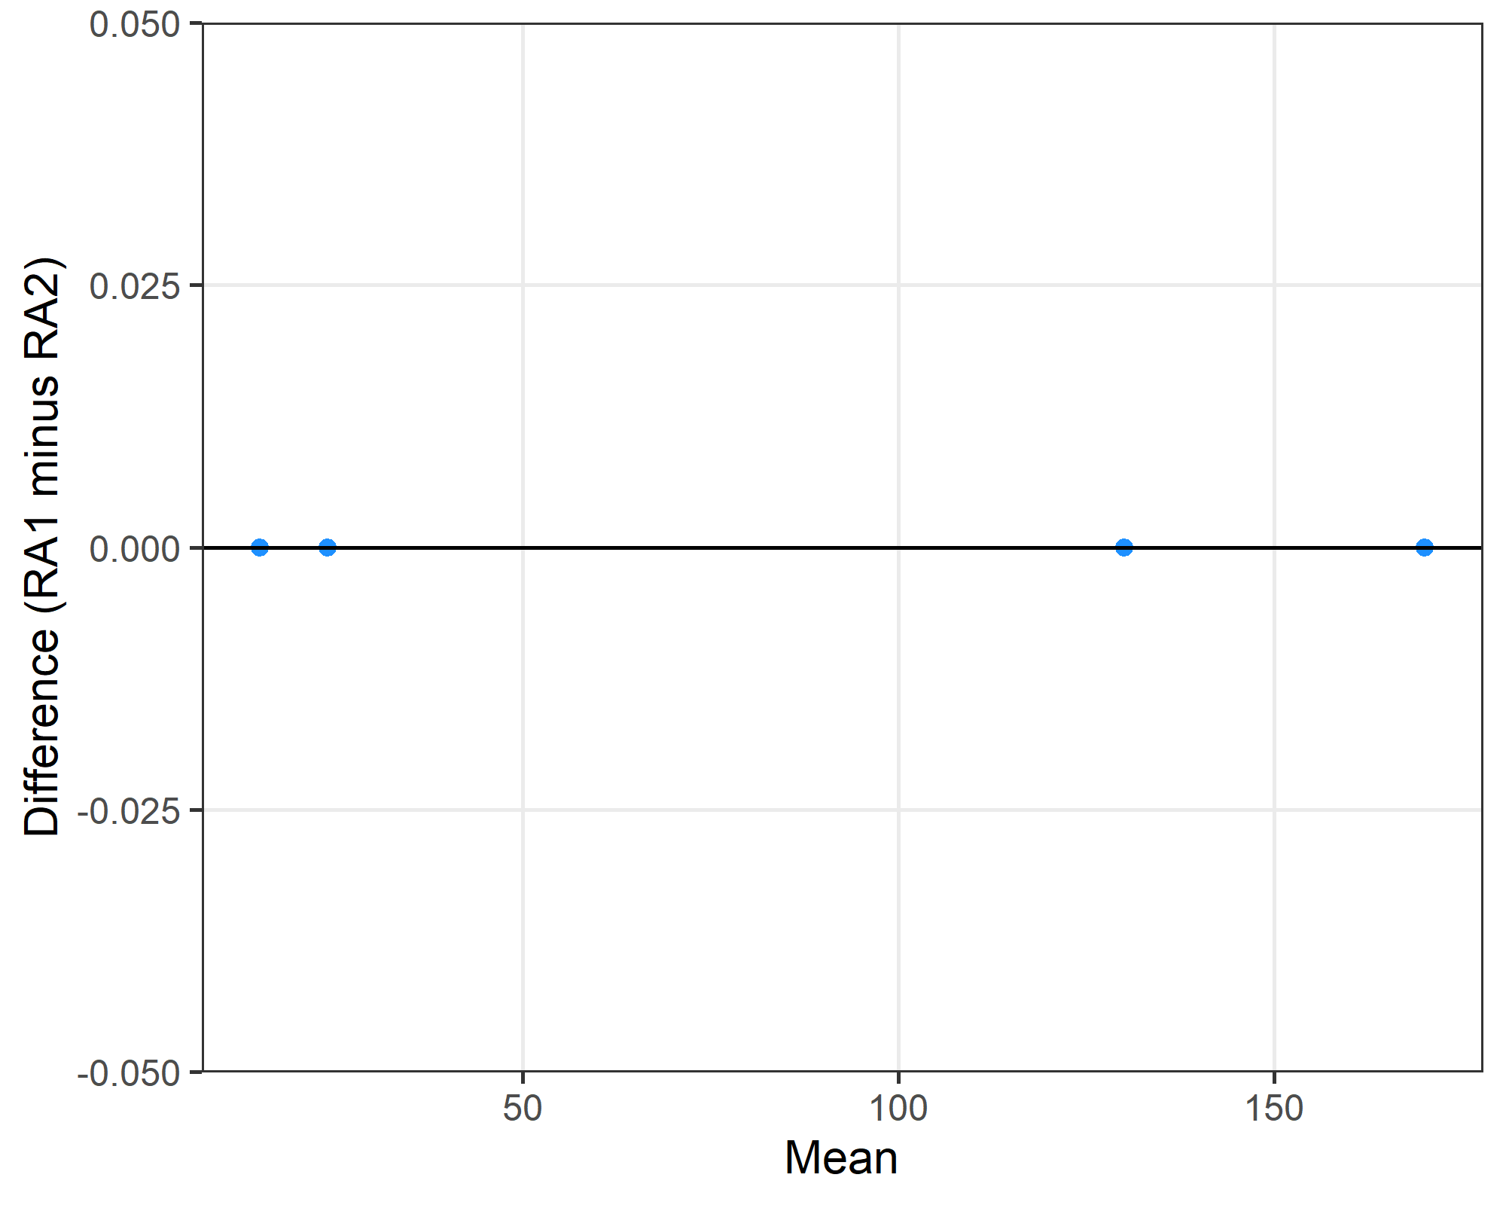
The limits of agreement were 0 to 0 .

Differences between research assistants
doi r1 r2
1 10.1016/j.psychsport.2022.102175 NA 9

Q5d: What was the actual sample size?
Bland-Altman plot with the x-axis on a log scale because of the one very large study.
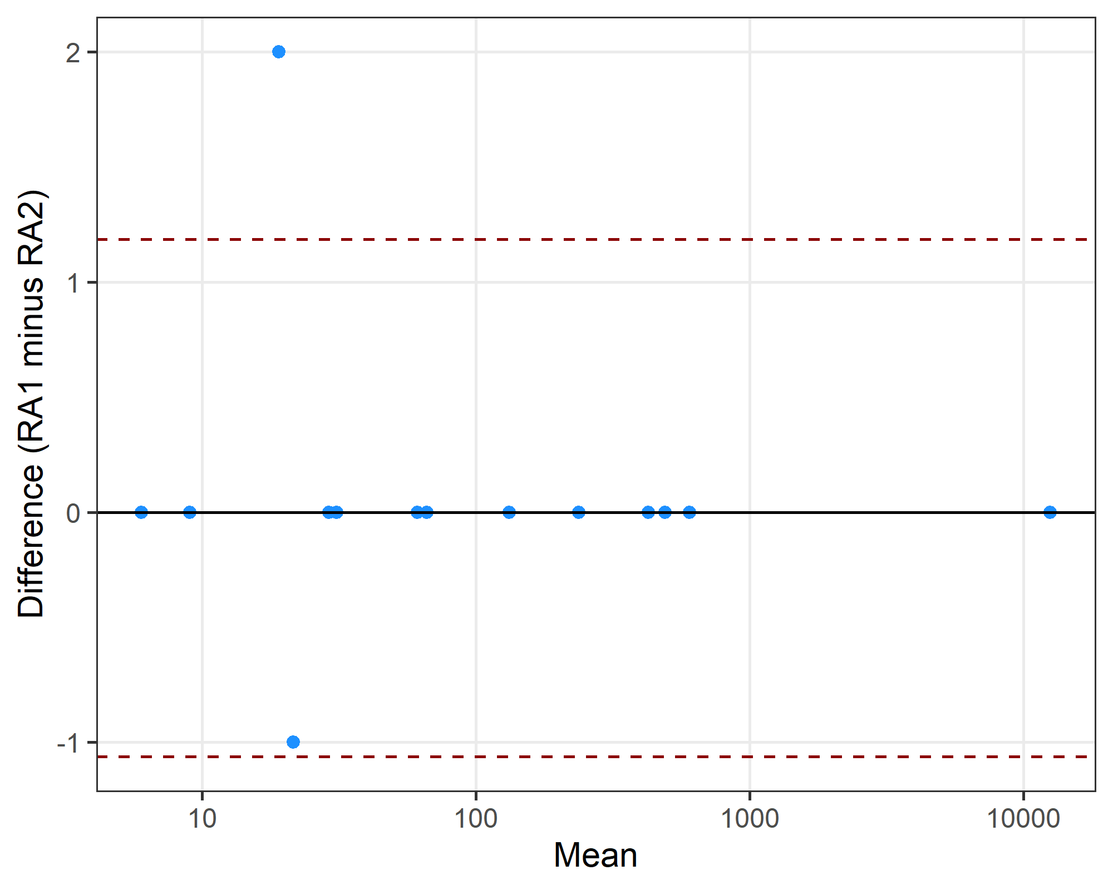
The limits of agreement were -1.06 to 1.19 .

Differences between research assistants
doi r1 r2
1 10.1038/s41598-022-21029-2 21 22
2 10.1123/ijsnem.2020-0224 20 18

Q6: number of male and female participants
Bland-Altman plots.
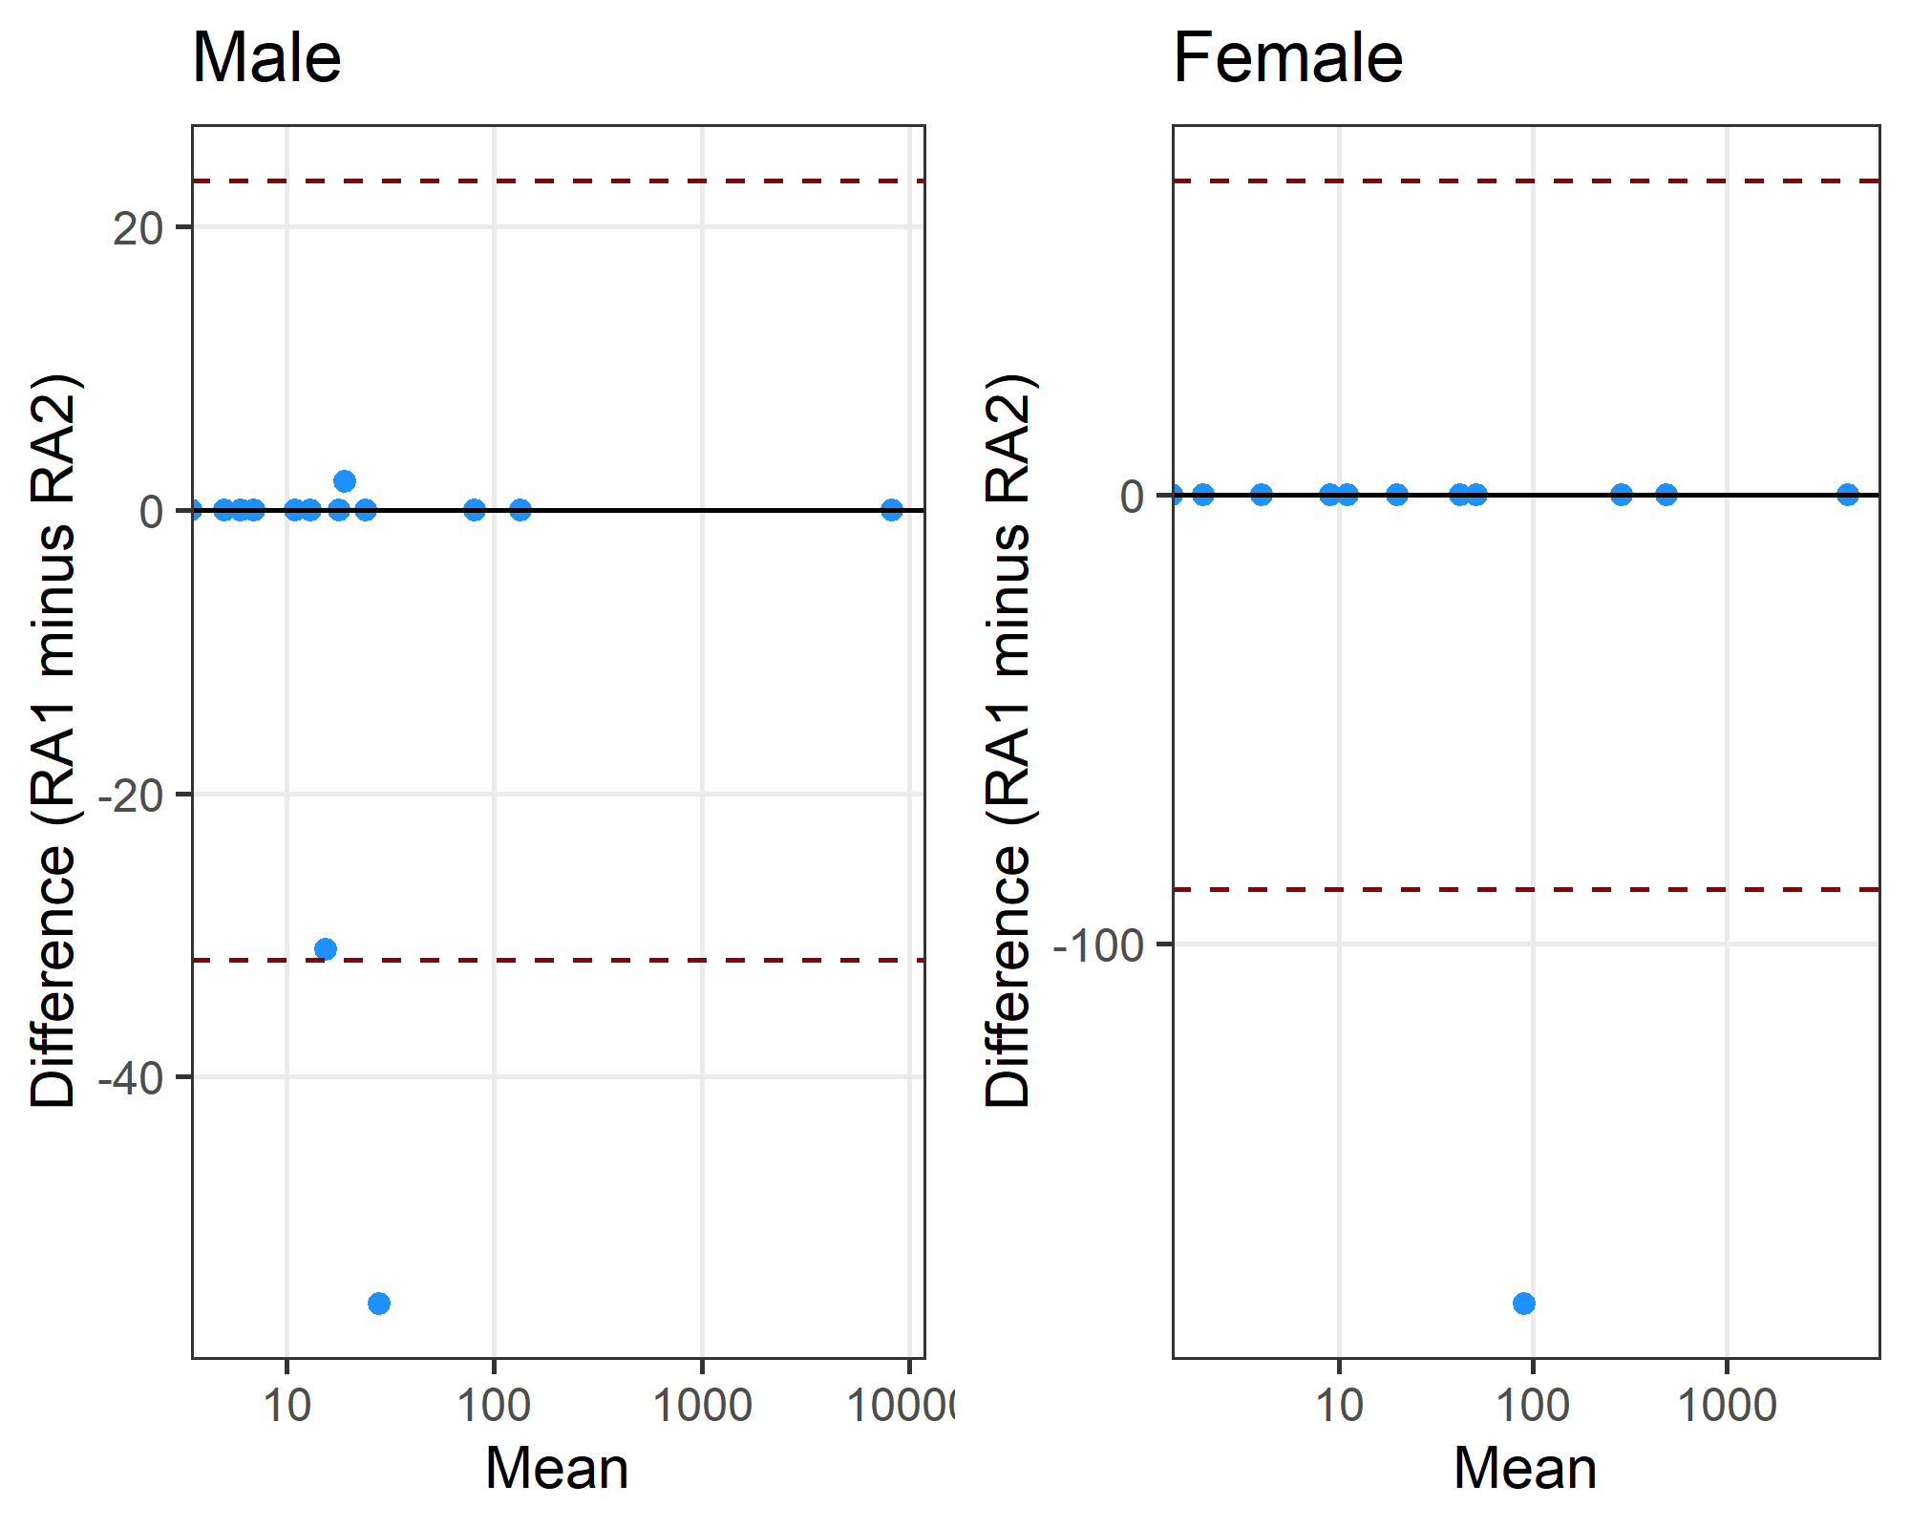

Differences between research assistants
doi r1 r2
1 10.1002/eat.24344 0 56
2 10.1007/s00421-024-05424-3 0 31
3 10.1123/ijsnem.2020-0224 20 18
doi r1 r2
1 10.1002/eat.24344 0 180

Q10: Were missing data discussed and/or correctly reported?
 | No | No data missing | Not applicable | Yes
No | 7 | 0 | 0 | 1
No data missing | 3 | 0 | 0 | 0
Not applicable | 1 | 0 | 3 | 0
Yes | 0 | 0 | 0 | 5
Gwet’s agreement statistic was 0.68 with a confidence interval of (0.416,0.942).

Differences between research assistants
doi | RA1 | RA2
10.1016/j.jsams.2022.05.011 | No data missing | No
10.1016/j.psychsport.2022.102175 | No data missing | No
10.1038/s41598-022-21029-2 | No data missing | No
10.1080/02640414.2020.1832735 | No | Yes
10.1249/mss.0000000000003056 | Not applicable | No

Q11: Were outliers removed without justification?
 | No outliers removed | Not applicable | one outlier excluded, although it's more a data error? | Yes, no justification | Yes, with justification
No outliers removed | 12 | 0 | 0 | 0 | 1
Not applicable | 0 | 4 | 0 | 0 | 0
one outlier excluded, although it's more a data error? | 0 | 0 | 0 | 0 | 0
Yes, no justification | 0 | 0 | 0 | 1 | 0
Yes, with justification | 0 | 0 | 1 | 0 | 1
Gwet’s agreement statistic was 0.88 with a confidence interval of (0.718,1).

Differences between research assistants
doi | RA1 | RA2
10.1007/s00421-024-05424-3 | No outliers removed | Yes, with justification
10.1016/j.jsams.2022.05.011 | Yes, with justification | one outlier excluded, although it's more a data error?

Q14a: Was the research question answered? (Did the authors reflect on the question)
 | Not applicable | Yes
Not applicable | 3 | 1
Yes | 0 | 16
Gwet’s agreement statistic was 0.93 with a confidence interval of (0.78,1).

Differences between research assistants
doi | RA1 | RA2
10.1123/ijspp.2021-0543 | Not applicable | Yes

Q14b: Was there some reflection about the practical significance of the main result/outcome.
 | No | Not applicable | Yes
No | 0 | 1 | 2
Not applicable | 0 | 0 | 0
Yes | 3 | 1 | 13
Gwet’s agreement statistic was 0.58 with a confidence interval of (0.267,0.892).

Differences between research assistants
doi | RA1 | RA2
10.1007/s40279-020-01295-8 | No | Not applicable
10.1038/s41598-022-21029-2 | No | Yes
10.1080/14763141.2020.1820074 | Yes | No
10.1111/sms.14014 | No | Yes
10.1123/ijsnem.2020-0224 | Yes | No
10.1136/bmjsem-2024-002040 | Yes | Not applicable
10.3389/fpsyg.2022.939087 | Yes | No

Summary of all agreement statistics

Limits of agreement summary
question | mean | lower | upper
2b | -0.6500 | -2.24 | 0.94
5c | 0.0000 | 0.00 | 0.00
5d | 0.0625 | -1.06 | 1.19

Gwet’s agreement summary
question | coeff.val | coeff.ci
1a | 0.81 | (0.589,1)
1b | 0.94 | (0.825,1)
2a | 0.94 | (0.812,1)
2c | 0.50 | (0.234,0.764)
5a | 0.93 | (0.779,1)
5b | 0.74 | (0.464,1)
10 | 0.68 | (0.416,0.942)
11 | 0.88 | (0.718,1)
14a | 0.93 | (0.78,1)
14b | 0.58 | (0.267,0.892)

