Statistical analyses for peer review uncertainty study: Appendices

Adrian Barnett

08 January, 2024

## Missing data

Here we look at item-missing data in the responses. We split by journal because *Epidemiology* has six possible decisions, whereas *BMJ Open* has four and *F1000* has only three.

### BMJ Open

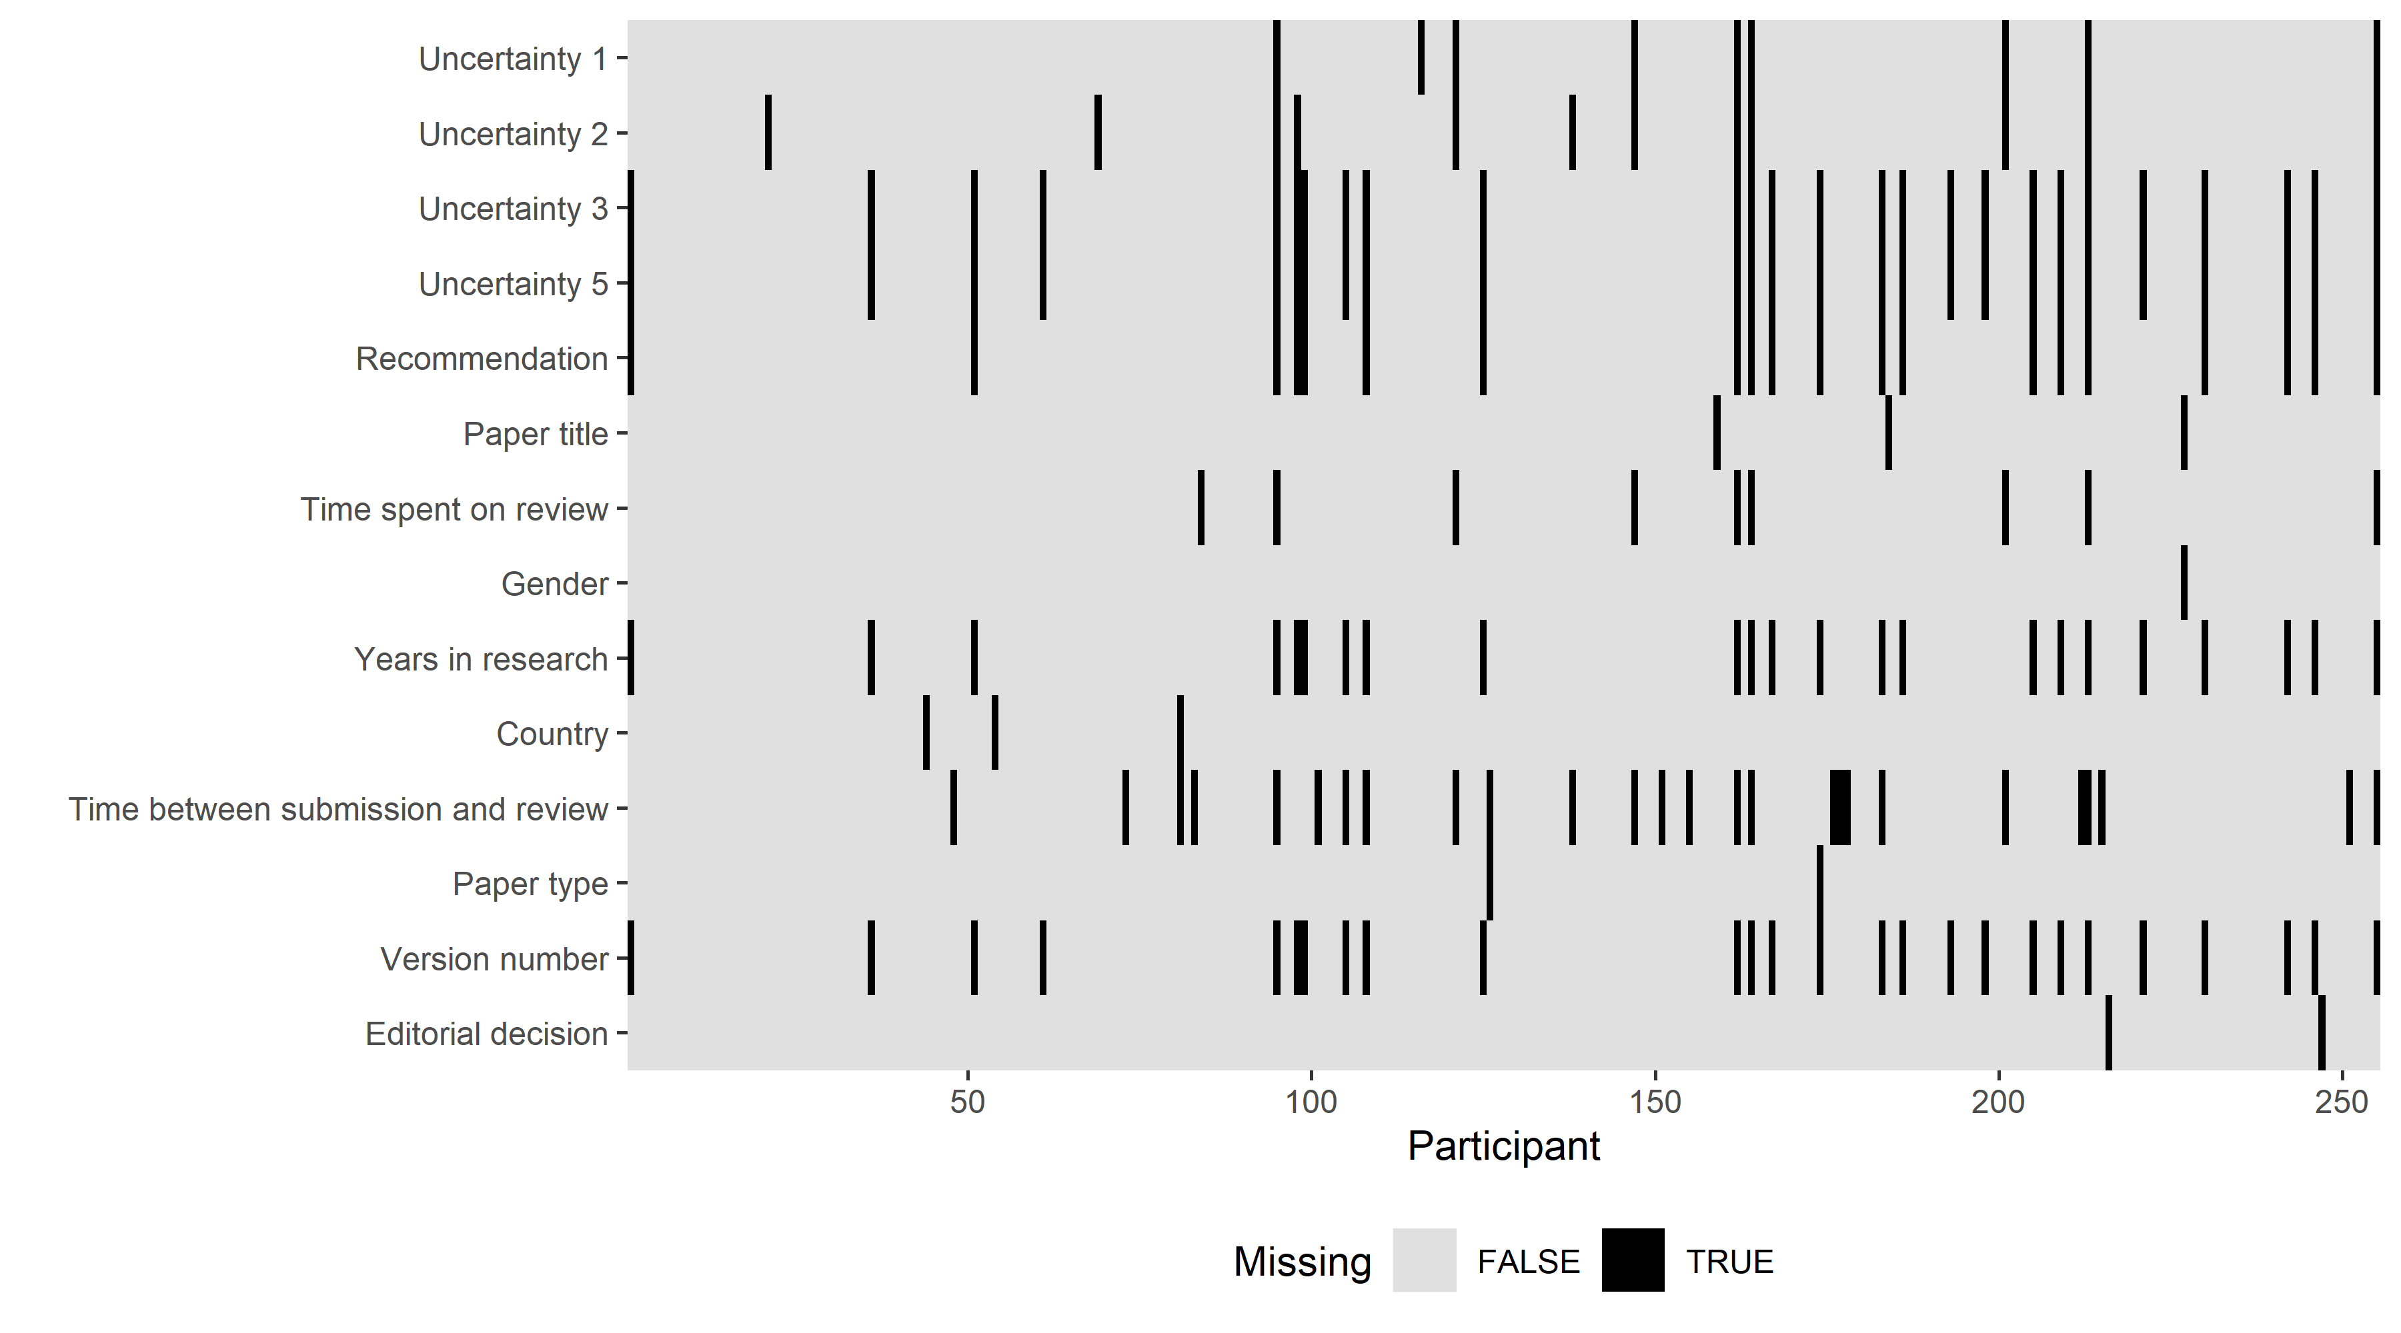

### Epidemiology

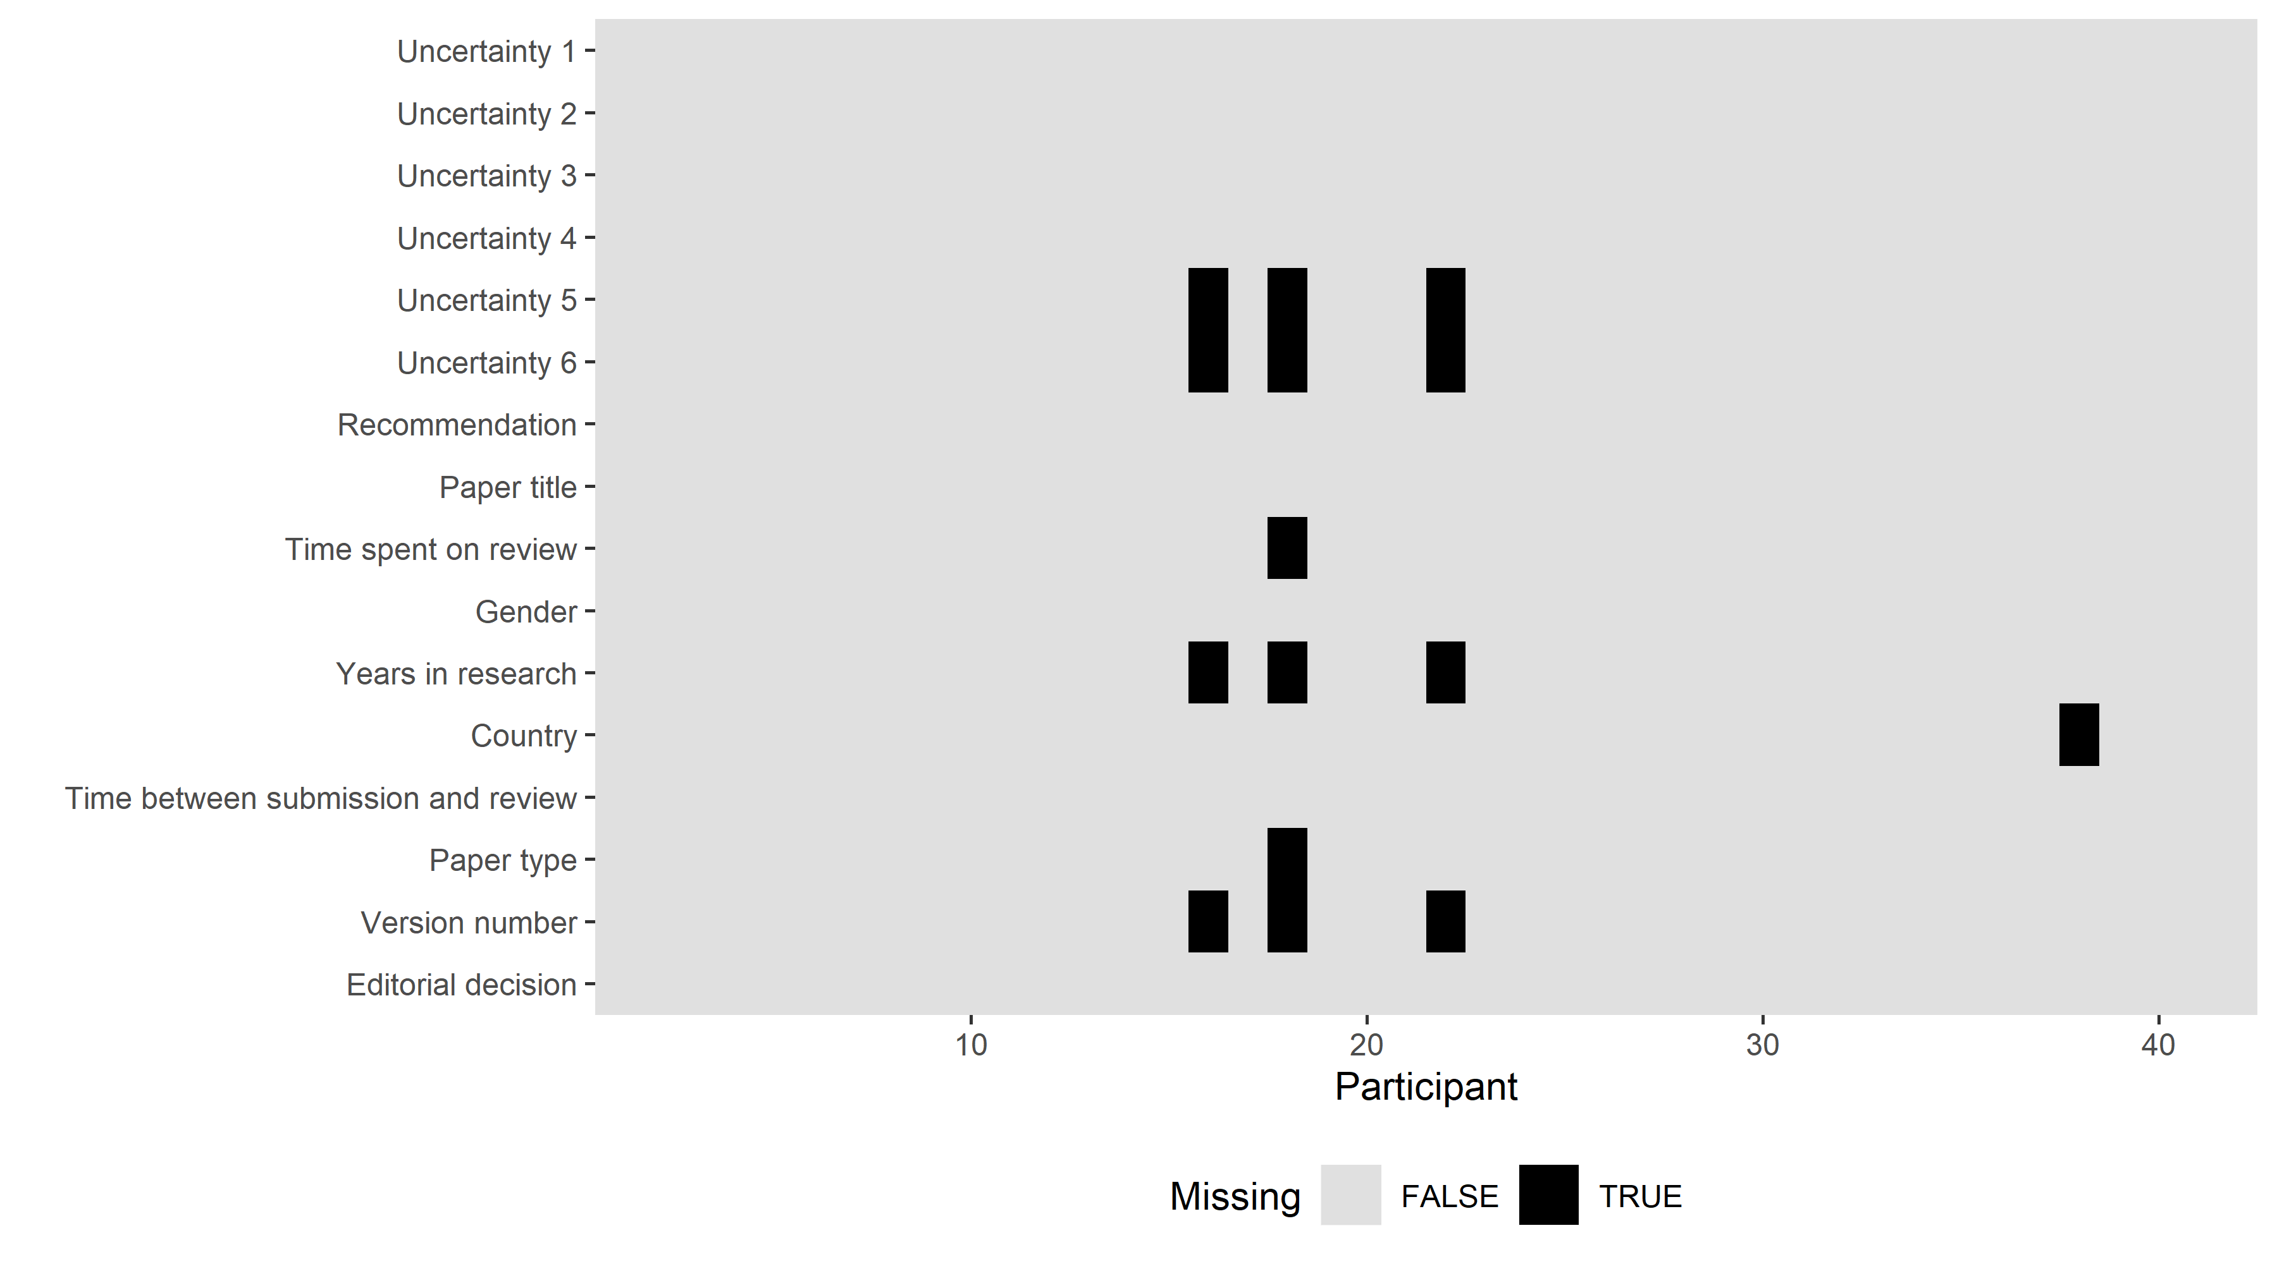

### F1000

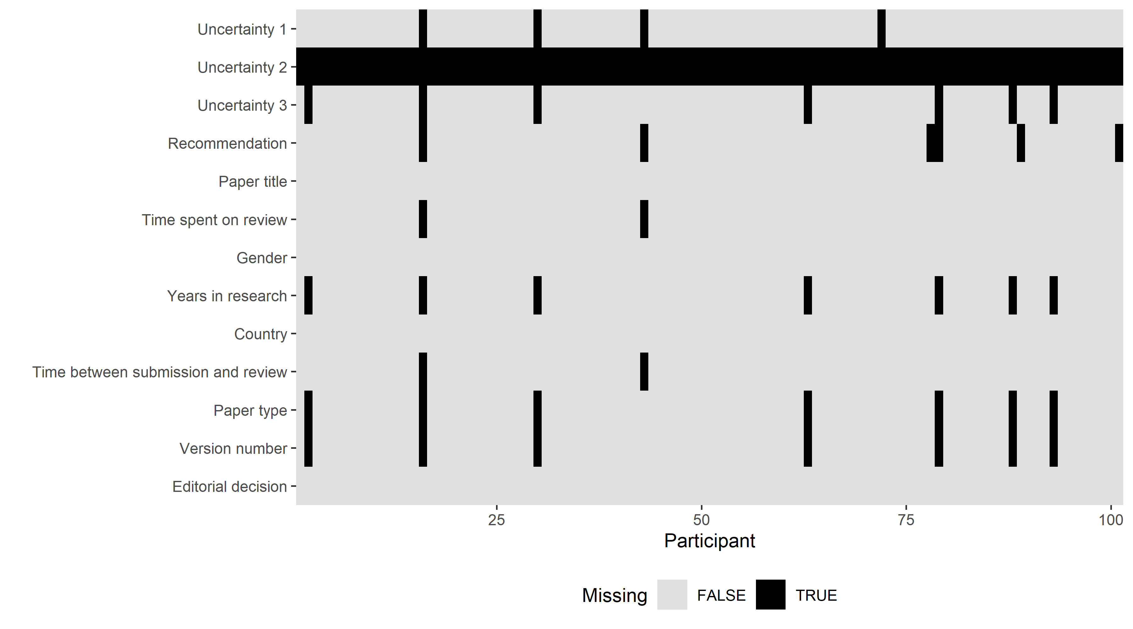

#### Overall table of missing

| **journal** | **variable** | **Not missing** | **Missing** |
| --- | --- | --- | --- |
| BMJ Open | Version number | 229 | 26 (10%) |
| Time between submission and review | 229 | 26 (10%) |
| Uncertainty 5 | 229 | 26 (10%) |
| Uncertainty 3 | 229 | 26 (10%) |
| Years in research | 232 | 23 (9%) |
| Recommendation | 235 | 20 (8%) |
| Uncertainty 2 | 243 | 12 (5%) |
| Time spent on review | 246 | 9 (4%) |
| Uncertainty 1 | 246 | 9 (4%) |
| Country | 252 | 3 (1%) |
| Paper title | 252 | 3 (1%) |
| Editorial decision | 253 | 2 (1%) |
| Paper type | 253 | 2 (1%) |
| Gender | 254 | 1 (0%) |
| Epidemiology | Version number | 39 | 3 (7%) |
| Years in research | 39 | 3 (7%) |
| Uncertainty 6 | 39 | 3 (7%) |
| Uncertainty 5 | 39 | 3 (7%) |
| Paper type | 41 | 1 (2%) |
| Country | 41 | 1 (2%) |
| Time spent on review | 41 | 1 (2%) |
| Editorial decision | 42 | 0 (0%) |
| Time between submission and review | 42 | 0 (0%) |
| Gender | 42 | 0 (0%) |
| Paper title | 42 | 0 (0%) |
| Recommendation | 42 | 0 (0%) |
| Uncertainty 4 | 42 | 0 (0%) |
| Uncertainty 3 | 42 | 0 (0%) |
| Uncertainty 2 | 42 | 0 (0%) |
| Uncertainty 1 | 42 | 0 (0%) |
| F1000 | Uncertainty 2 | 0 | 101 (100%) |
| Version number | 94 | 7 (7%) |
| Paper type | 94 | 7 (7%) |
| Years in research | 94 | 7 (7%) |
| Uncertainty 3 | 94 | 7 (7%) |
| Recommendation | 95 | 6 (6%) |
| Uncertainty 1 | 97 | 4 (4%) |
| Time between submission and review | 99 | 2 (2%) |
| Time spent on review | 99 | 2 (2%) |
| Editorial decision | 101 | 0 (0%) |
| Country | 101 | 0 (0%) |
| Gender | 101 | 0 (0%) |
| Paper title | 101 | 0 (0%) |

The table rows are ordered by the journal and the number missing.

## Optional comments

We removed short comments like “thanks” or “none”. The comments are ordered by the longest to shortest. The journal name is included.

* I highly confirm that the paper is not scientific and has no contributions in the areas of causality (F1000)
* This was a short commentary/opinion piece and therefore is not representing a typical peer review of a research paper. (Epidemiology)
* In a way this was a simple task. The authors present something new and useful (F1000)
* I was unsure whether to choose approved vs approved with reservations because I think the paper warranted publication but would have improved with some changes. However I did not eat to block plublication (F1000)
* the researcher might have used the CARS model of John Swales to have a more comprehensive analysis. The researcher can also make a comparison using various models in genre analysis of research introduction to see discrepancies on the moves and steps used (F1000)
* Self-citation in this article was excessive (F1000)
* Compliance changed to Adherence (F1000)
* I reviewed this article with a faculty mentor, though I did the majority of the review. (Epidemiology)
* No, I’m not going to give you the title of the paper, that compromises the anonymity of peer review. (Epidemiology)
* The technical sound does not appear in this paper (F1000)
* Interesting topic to review and easy to understand (F1000)
* I would like the review to remain anonymous. (Epidemiology)
* Was outside my main area of expertise, which contributed to my uncertainty (BMJ Open)
* This was a very easy review. Clear standard data set. Only the lack of discussion was irritating, but not strictly critical (F1000)
* This paper needs a lot of work to be understandable and acceptable for publication. I expect the editor will reject it but feel that decision needs to be made on the strength of more than one review. I would certainly reject the paper as it stands but it is not inconceivable that major revisions would render it publishable and, being an author myself, prefer to give the option of major revisions to an outright rejection, particularly when many of the problems are related to use of English by the Chinese authors. (BMJ Open)
* My equivocation was related to the quality of the paper overall. I considered reject in the first review but went with major revisions (BMJ Open)
* I am an early career researcher and often find it difficult to determine whether it should be minor or major. Some guidance/ training around this would be helpful! (BMJ Open)
* The methods and write up revealed that the authors were not experienced qualitative researchers. There was also a breach of ethics in terms of the potential identifiability of vulnerable participants. (BMJ Open)
* I always have 2 requests as a reviewer, which tend to be ignored! Once I emailed Kamran Abbasi when I reviewed for JRSM, but I didn’t get anywhere. My points are:1. It would be good to share the reviews between reviewers. I do this a bit at King’s College with MSc dissertation marking. Seeing others’ comments can help raise quality, get more consistency, reassure reviewers when the same comments are made ( or not ), help us to see other points of view; might be interesting to see what the authors think of reviewers’ comments. 2. I would like to be emailed when a decision is made and if published, an alert then. Thanks Neil Snowise (BMJ Open)
* I was weighing rejecting the paper partly because of the quality, but also because I felt like the paper didn’t add much to the existing literature (a problem I often have when reviewing review protocols). I chose to suggest revisions because I felt that the journal would have a better sense of what they want published, even if it’s not a paper I personally would think was useful. (BMJ Open)
* Reviewers are asked to classify a number of things by Yes No N/A. This is far too restrictive. One should either have a more graded response or a chance to comment. (BMJ Open)
* To me, the paper was good and didn’t have an major flaws but my comments would require the writing a new paragraph (BMJ Open)
* No one can be 100% sure. I edit a journal and if there is any reject, we do not accept. (BMJ Open)
  + (BMJ Open)
* In this case I was pretty certain, but if I feel more positively about a paper it can be hard to choose between Minor and Major. As a reviewer I often pick Minor if I’m favourable about the paper but have smaller edits or queries. But for the journal where I’m an AE, Minor usually means the manuscript doesn’t go back to the Reviewers, so something different… (BMJ Open)
* I would welcome greater feedback from journals/editors on the quality of submitted reviews or guidelines on reviewing to raise the quality of peer review (BMJ Open)
* The reason I chose 90% as the answer is becasue the other two reviewers had much less concerns in their initial review and I cannot think that they will have any objection to the current revision and as the editors have asked us to review it for the second time, surely they think the paper is publishable given methodological soundness. (BMJ Open)
* Since it was a methodological paper it was somewhat difficult to answer the questions about methods, results, discussion, limitations etc. (BMJ Open)
* There is information in their data that is worth publishing but it would require a fresh look to extract this information (BMJ Open)
* I was asked to provide statistical review though, but in fact most of my comments were about methodologymuch of (BMJ Open)
* I didn’t think there was anything disastrous in the paper that would’ve required a ‘Revise and Resubmit’ type thing, they are just suggestions to improve the paper and be clearer, not “this shouldn’t be published because of these issues”. (F1000)
* I could not use the Comments for Authors box, the webpage kept freezing when I tried to cut & paste my review into it. I uploaded the review as an attached file. (BMJ Open)
* The authors describe the harmful effects of lead(II) and cadmium(II) ions in the introduction but no explanation why the authors use aminooctyldiphosponic acid structure as the extraction agent. As a new compound, the HRMS measurement of aminooctyldiphosponic acid must be reported. Statistical error bars were reported in Figure 2 but other Figures do not show any error bars. Please revise the other Figures with error bars. The authors give small portion on the discussion of the experimental results and too focus on reporting the experimental data without enough explanation/description. How to recover the extraction reagent? Did the authors do the stripping experiment? (F1000)
* The authors need to provide more explanations and empirical research as well as dat to support their arguments. This will increase the relevant and critical thinking information which need by the readers, researchers and policy makers. (F1000)
* Update references and Improve the written language of the article (BMJ Open)
* I did the statistical review and was not a content expert. (BMJ Open)
* Major concerns and drawbacks are found in the manuscript. Having 12 questionnaires in one cross-sectional study for each participant, along with the anthropometric and biochemical assays are inevitably incurring inaccuracies and will lead to erroneous findings and conclusions at the end. The small sample size from one city from one profession (school workers) could not reflective the large country with the diverse ethnic, religious and socioeconomic backgrounds of Iranian adults. (BMJ Open)
* This was a second review on this manuscript and my second review, ever. I am new to the process of peer review. (BMJ Open)
* Concern about the article was more information needed for the rationale for using the Rag2 KO (F1000)
* This was a review of a trial protocol rather than a full paper with results. I always find these very difficult to review as I am somewhat unclear as to the real purpose of peer-review here and whether the review is of the protocol, which is usually fixed by that stage or the presentation of the manuscript? My uncertainty over this paper lies in this dichotomy. The paper is essentially as good as it could be in terms of presentations. There are some issues, I can see, with the underlying trial protocol. These may not be insurmountable but remain. The position regarding publication really depends on the attitudes to either transparency and discussion of all the issues or aiming for everything officially published to be a good and useful as possible. (BMJ Open)
* My first review (BMJ Open)
* The parameters for judging yes no N/A we’re limited. I wanted to say doming qualitative about some of them. (BMJ Open)
* Method: How was marital satisfaction defined in your study?. Results: The postoperative outcome of different bariatric procedures needs to be written in more detail. Discussion: Please clarify how marital satisfaction contributes to the long-term maintenance of weight loss after bariatric surgery. Figure: Figures 1 and 2 need to be numbered correctly (BMJ Open)
* It was somewhat outside my field, so that created some uncertainty. I also wasn’t sure if the authors needed to do a bit more work, so another round of submission and review, or whether the paper was good enough as is. (BMJ Open)
* if peer review is open, still need to be able to make private comments to the editor (often it is hard to argue for reject in open peer review) (BMJ Open)
* I would have liked to see another option on the input page to write a confidential comment to the editor. (BMJ Open)
* The paper was just okay and could have been quite a bit better. Results were clear, but not thorough enough to lead to a confidently appropriate conclusion. (Epidemiology)
* Peer reviewers should be paid. No other industry in the world relies, as its business model, on experts with doctorates to provide free services (BMJ Open)
* I am a first time reviewer for this journal and so approached the review with caution. (BMJ Open)
* BMJ Open uses compulsory fully open peer review. While I can absolutely see the advantages of this, I can also see the disadvantages. In this case, f.ex., I could see that the senior author was a Harvard Professor, which more or less consciously might have influenced my the certainty of my decision. (Although unfair, I think that peer-reviewers are less likely to reject a paper if the senior or lead author are from an internationally renowned university.) Please also note that generally, I prefer to leave it up to the editor whether or not to accept the paper based on my comments, and I therefore usually indicate in cases of an initial review with a greater number of comments ‘major revision’ rather than ‘reject’. (BMJ Open)
* The editors of any regular physics journal would have rejected this paper immediately rather than sending it for review. The author has read popular science descriptions of relativity and cosmology but lacks elementary understanding of the field. You cannot propose alternative models without understanding the basics. I had the patience to write two reports as a matter of principle to support open review. (F1000)
* The protocol was very good! Some areas needed clarification, and others I had issues with the approach that I felt either needed to be explained so that I could be satisfied it was intentional or addressed if not. (BMJ Open)
* It would help to be able to choose between minor and major reservations. (F1000)
* The reviewing process seems hamstrung by an academic editor who is not at all engaged. (BMJ Open)
* This was the second feedback I gave for the manuscript; the first was a major revision. Although, no major changes are required in the manuscript as the authors had already addressed them, however, according to me, it can still not be accepted in its present form. (BMJ Open)
* Yes: I did not realize when I accepted that my name and review would be published and my name would be available to the authors. I would not have accepted if I had known that. (BMJ Open)
* I was uncertain because the faults were fixable in the methods description, and because it is a novel and under researched area and therefore contributed something new. However the thinking and interpretation was under specified . (BMJ Open)
* solid paper but no external validation using ML- the need for minimal criteria in field needed (BMJ Open)
* I think the title is appropriate (F1000)
* I think that the protocol will be ready to be publish, after these minor modifications. Name of bacteria should be written in italic. Please modify Acinetobacter, Pseudomonas, Brucella, Fusobacterium in these locations - Page 2: line 51: - Page 16, line29 Enterobacteriaceae: page 20, line 53 Typographic error in Clostrioides should be modified to Clostridioides in these locations: - Abstract: page 2, line 5 - introduction, page 5, line 40 - material and method, page 15, line 43 (BMJ Open)
* I regard the Accept/Revisions/Reject as only a rough guide for the editor of the paper. My main judgements are the content of the review. As a statistician, I am unclear what the above questions might mean, or how they can be validly analyzed. (BMJ Open)
* minor revisions on some of the wordings to make it clearer (BMJ Open)
  1. The strengths and limitations of the study should be in a narrative form and should be at the end of the Discussion section. 2. Use this article to effect some of your corrections in this manuscript. Kindly Cite this article Akokuwebe, M.E., Idemudia, E.S., Lekulo, A.M. et al. Determinants and levels of cervical Cancer screening uptake among women of reproductive age in South Africa: evidence from South Africa Demographic and health survey data, 2016. BMC Public Health 21, 2013 (2021). <https://doi.org/10.1186/s12889-021-12020-z>; 3. The tables should be in small font size so that it can be in one page; 4. Can you add to this submission….this should not be the only sentence or else remove it (BMJ Open)
* In this case, the authors did not respond to all the queries, but they had the data. (F1000)
* uncertainty in this case was related to the type of available options, which are different compared to other journals (accept, minor revisions, major revisions, reject) (F1000)
* I would have given very minor revisions (BMJ Open)
* I find it quite intimidating that my review will be identifiable, especially when the paper needed so much work. (BMJ Open)
* I had no comments. I just recommended the paper for publication and thanked the authors for the strides made thus far. (BMJ Open)
* I consider it relevant to approve the work, as long as the suggestions are implemented (BMJ Open)
* Its a bit hard to decide sometimes which recommendation to choose - I think the paper needed synthesising in the results section to make it more readable. this could be considered a major revision? (BMJ Open)
* I would prefer not to disclose my name in future review. There is a possibility that as EiCs or Reviewers, some of the authors of manuscripts I suggest to extensively modify or reject may inappropriately handle future submissions of mine. I guess that I can be more free if I am protecte dby confidentiality, as usually happening in le large majority of high-quality scientific journals (as BJM Open is). (BMJ Open)
* The paper in my view has a single major flaw, that probably means it is not useful not valid and should not be published. However, I was impressed by honest effort and attempted good scholarship. (BMJ Open)

The median number of words per comment was 23 with a range from 0 to 132 words.