Compare the results from the complete case and imputed results

Adrian Barnett

09 March, 2024

# Plots of parameter estimates and 95% credible intervals for complete case and imputed data

There’s a separate panel for each model number.

### BMJ Open, gender

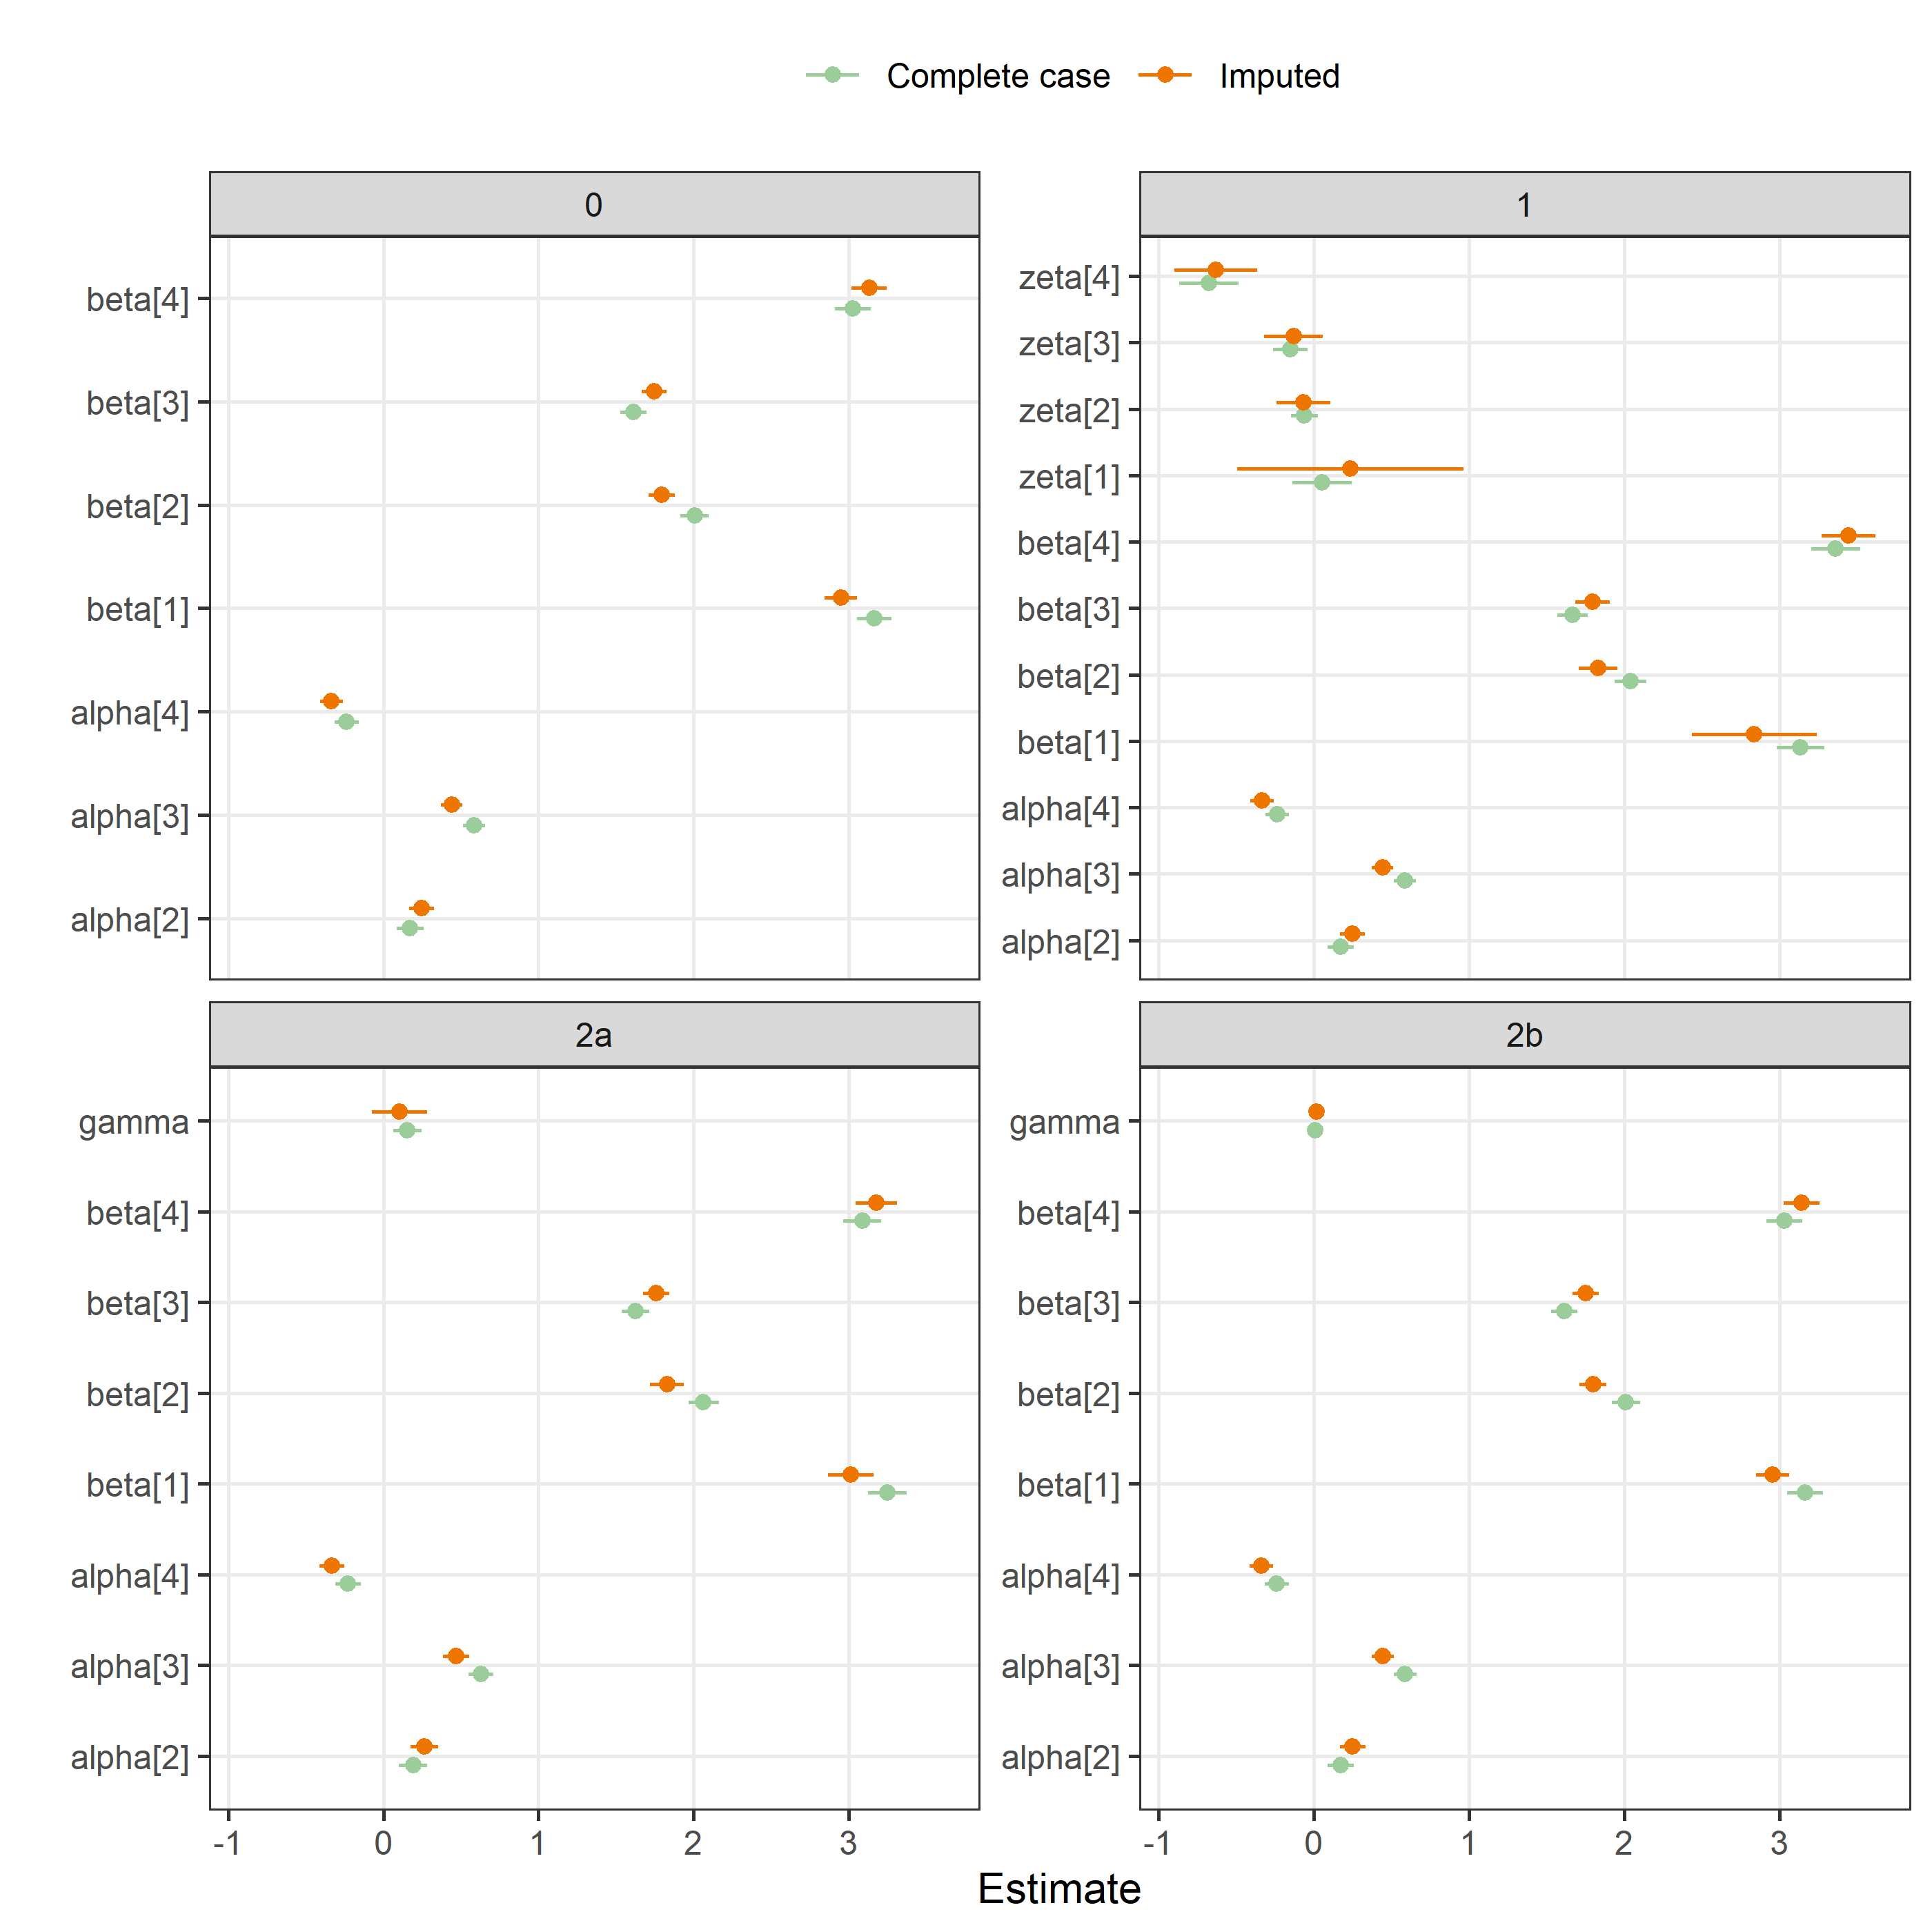

### BMJ Open, experience

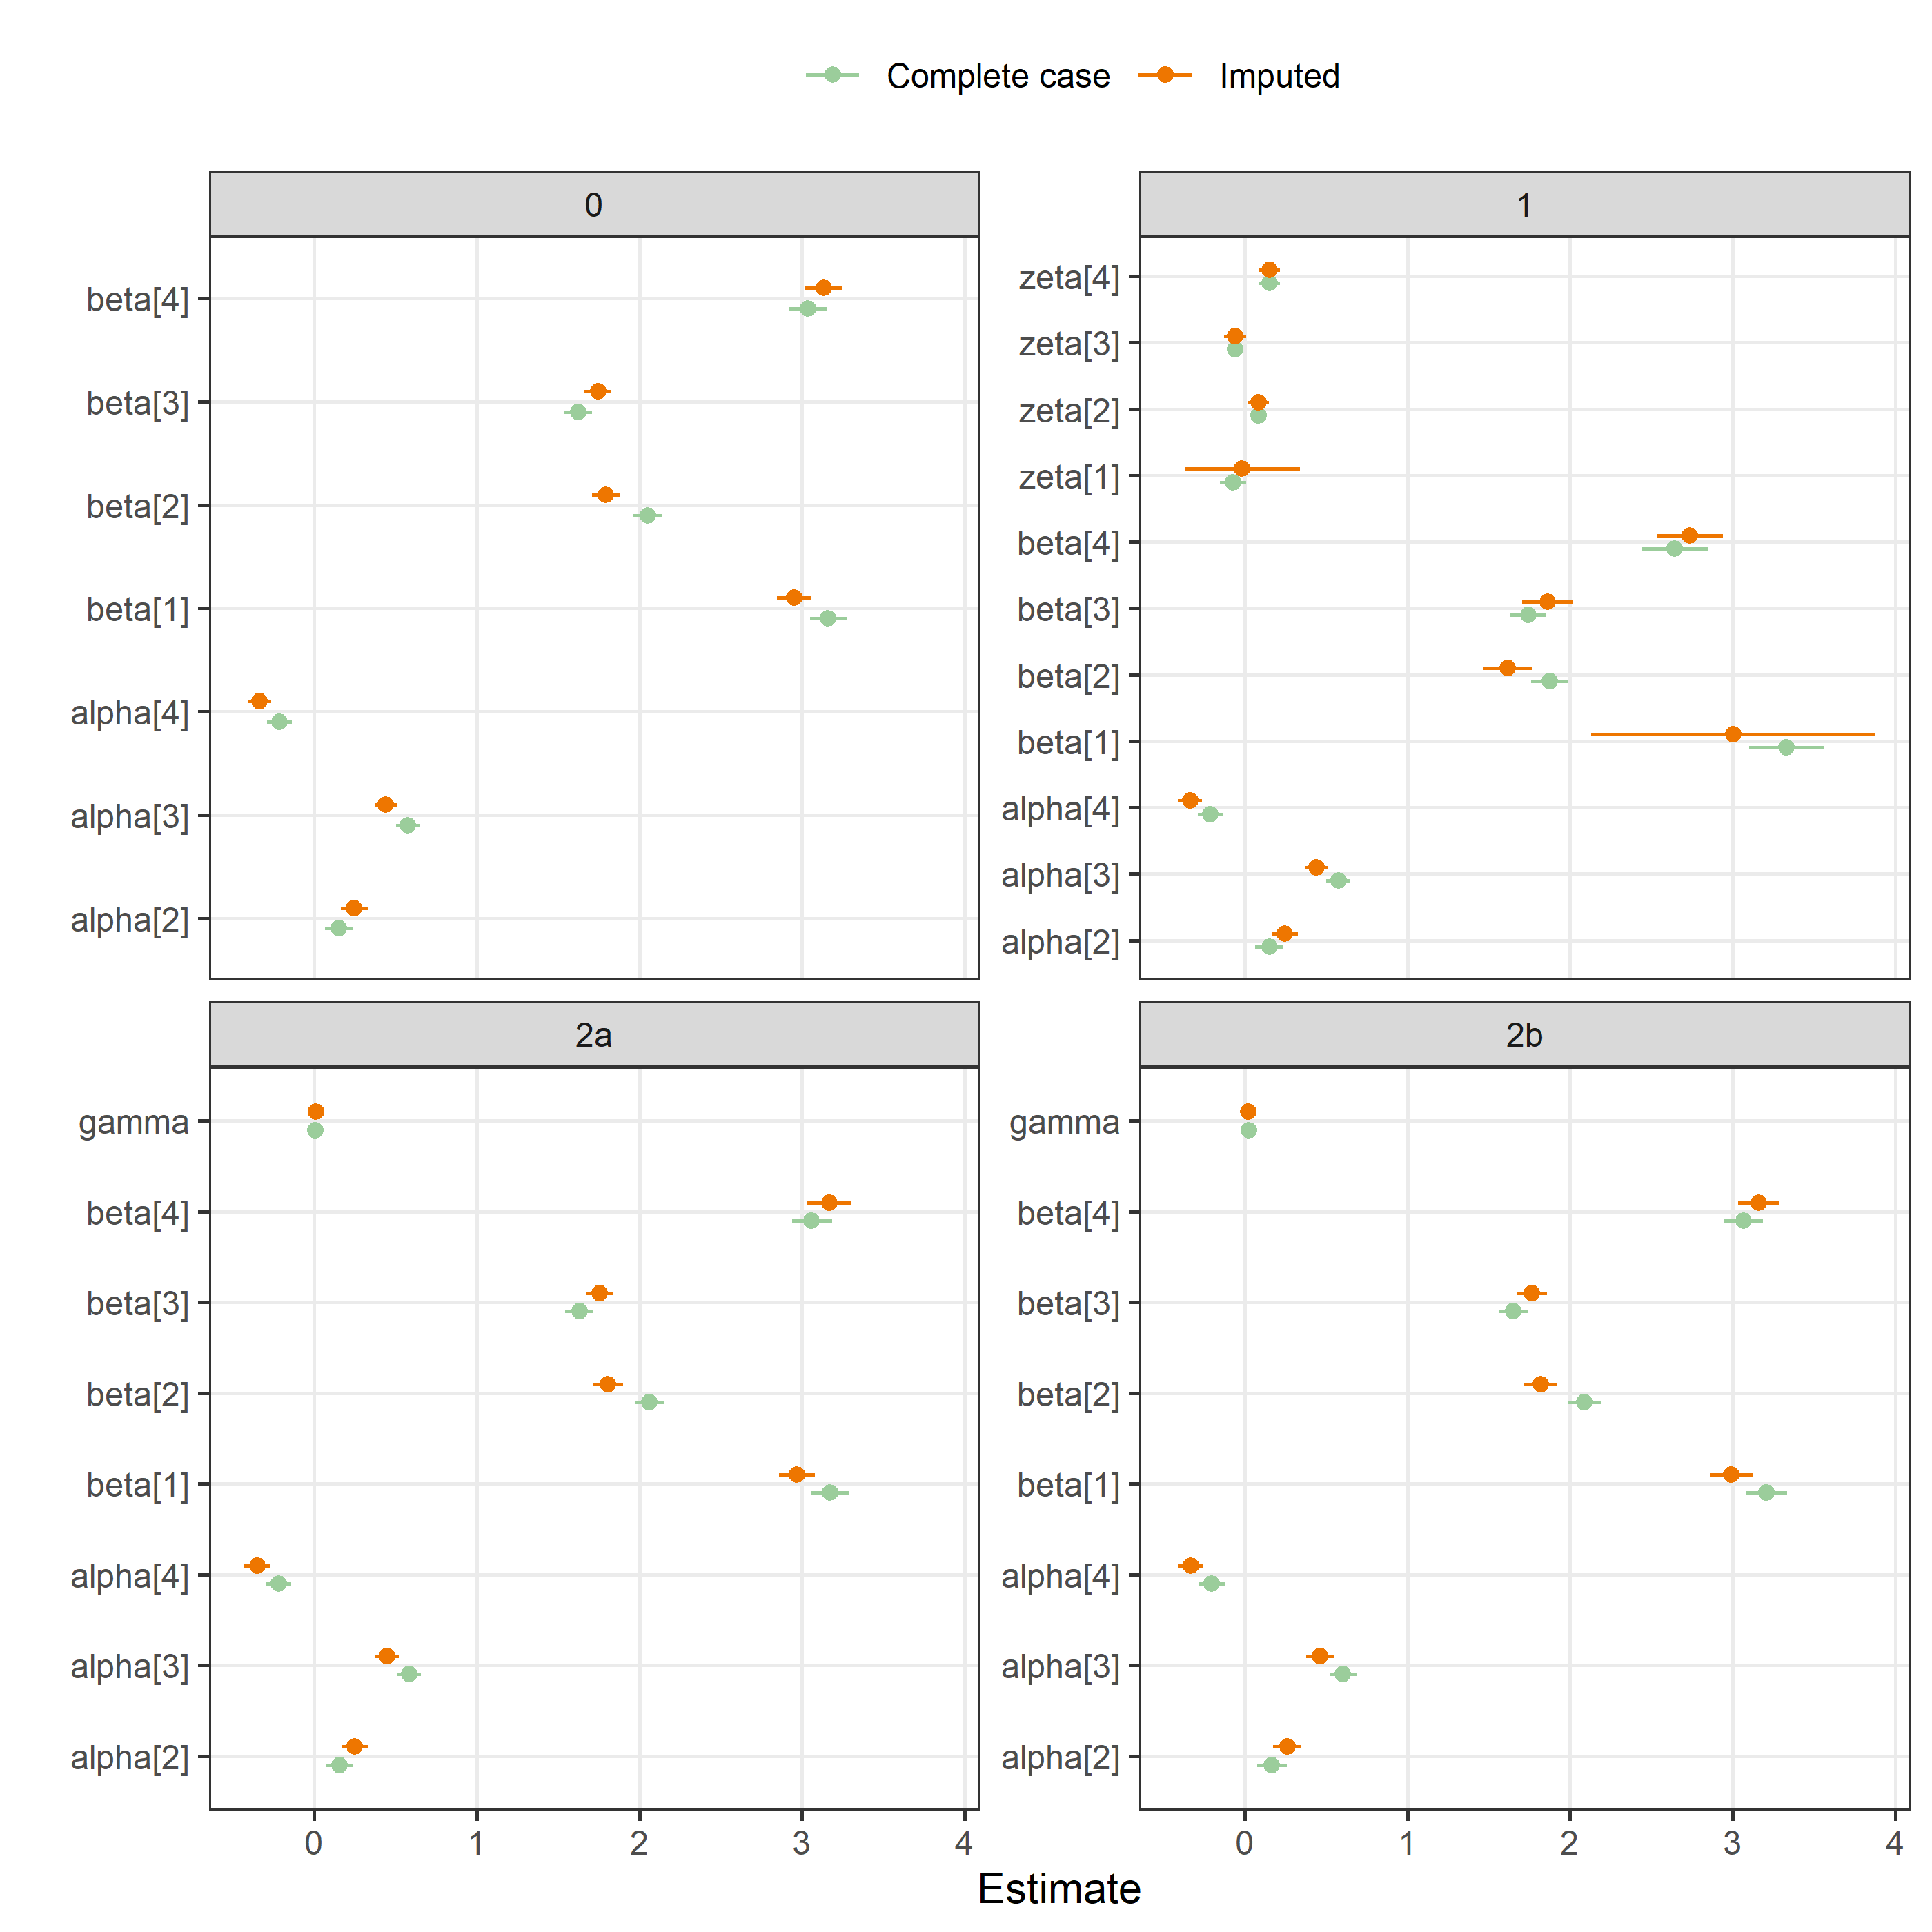

### BMJ Open, time taken on review

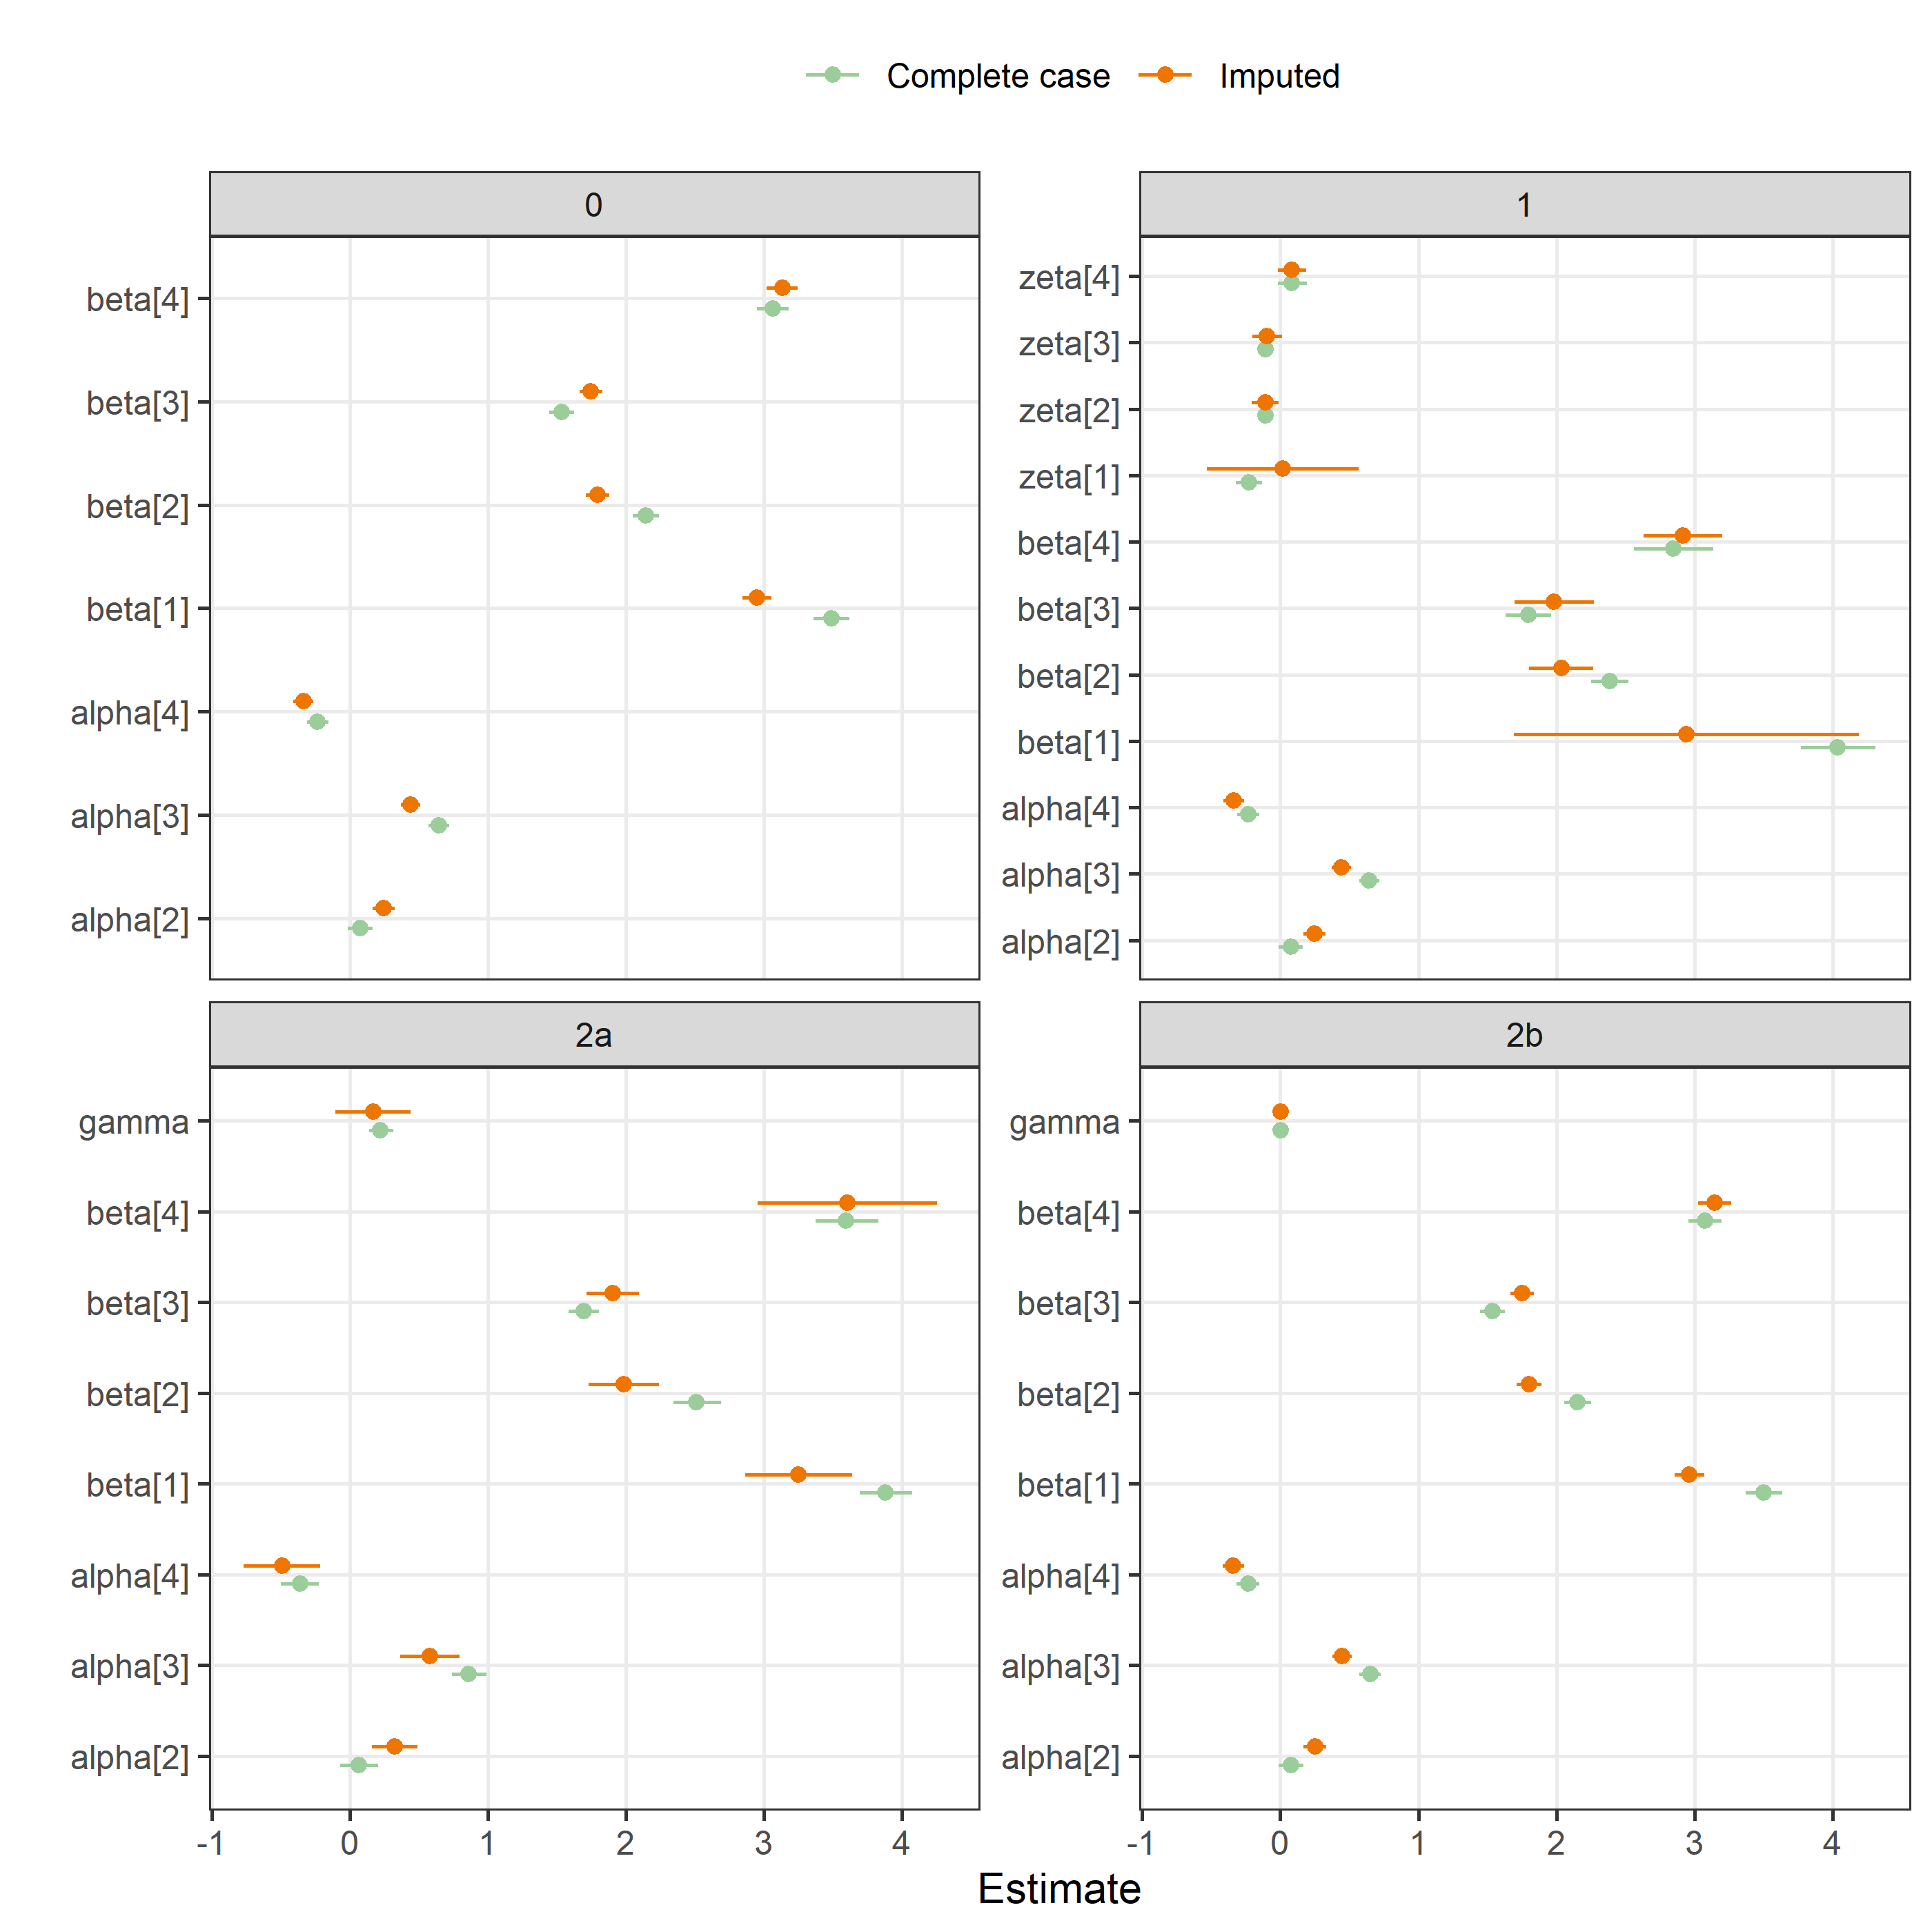

### BMJ Open, version

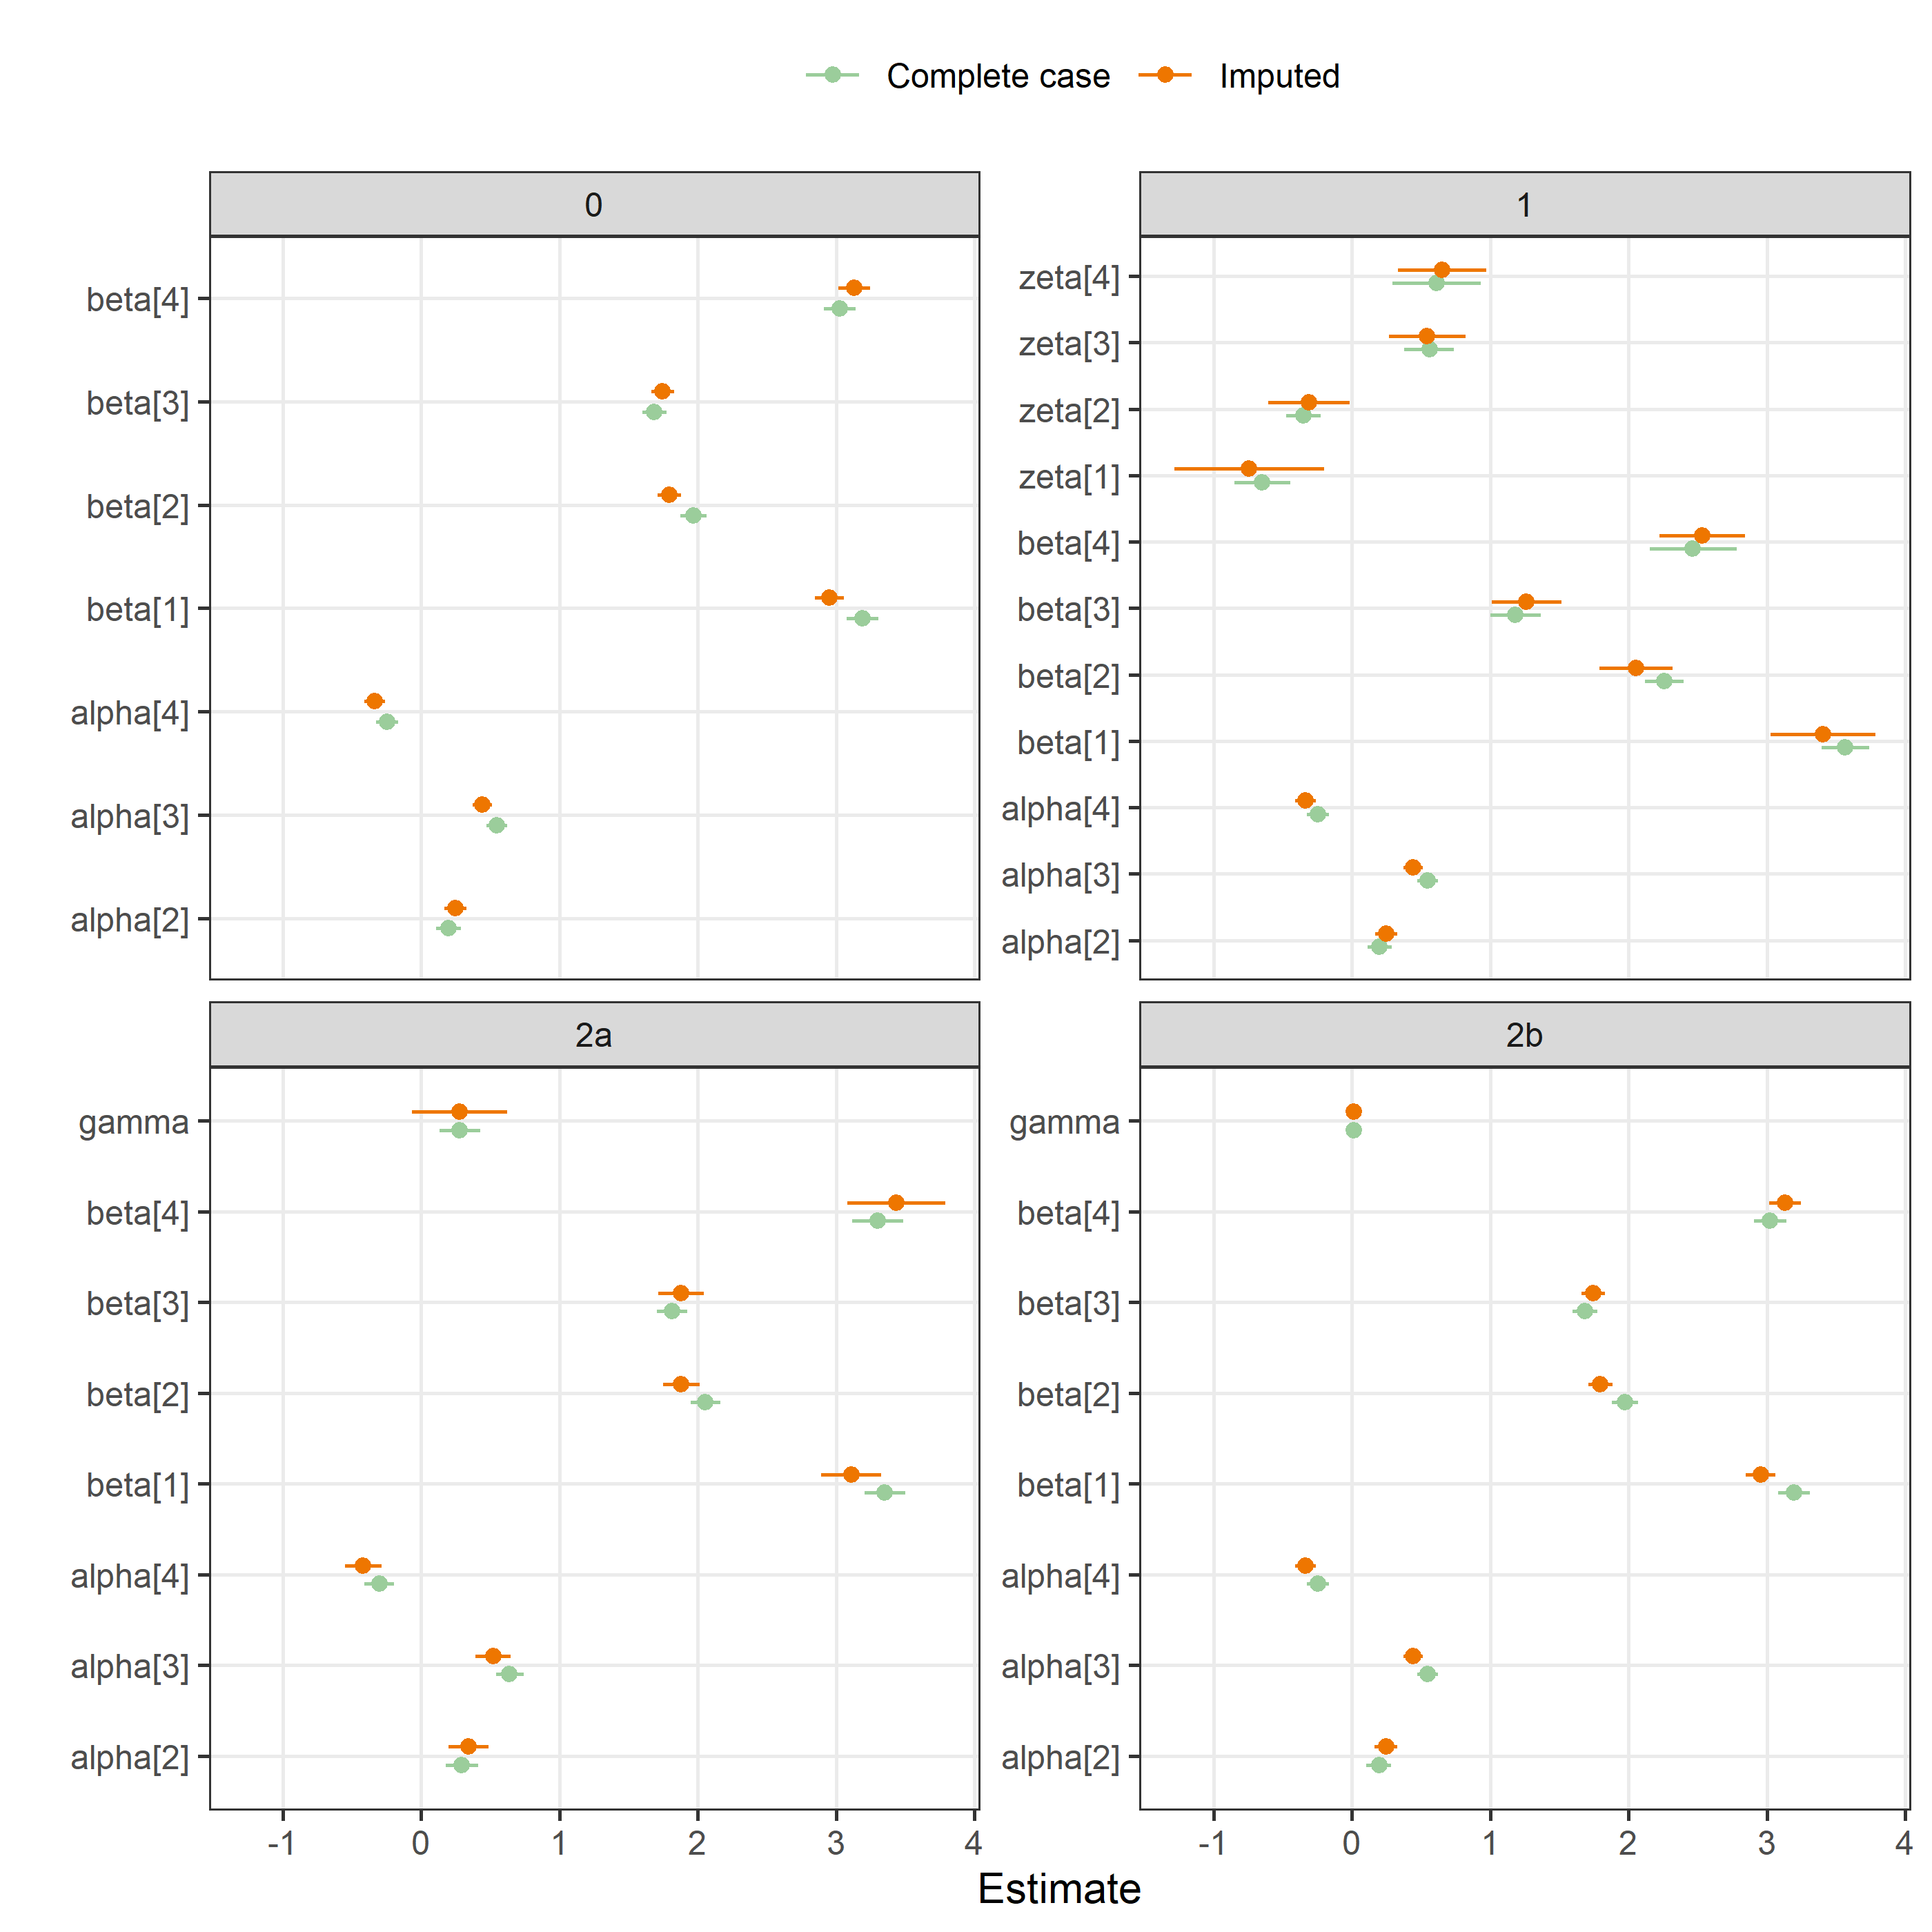

### BMJ Open, time to peer review

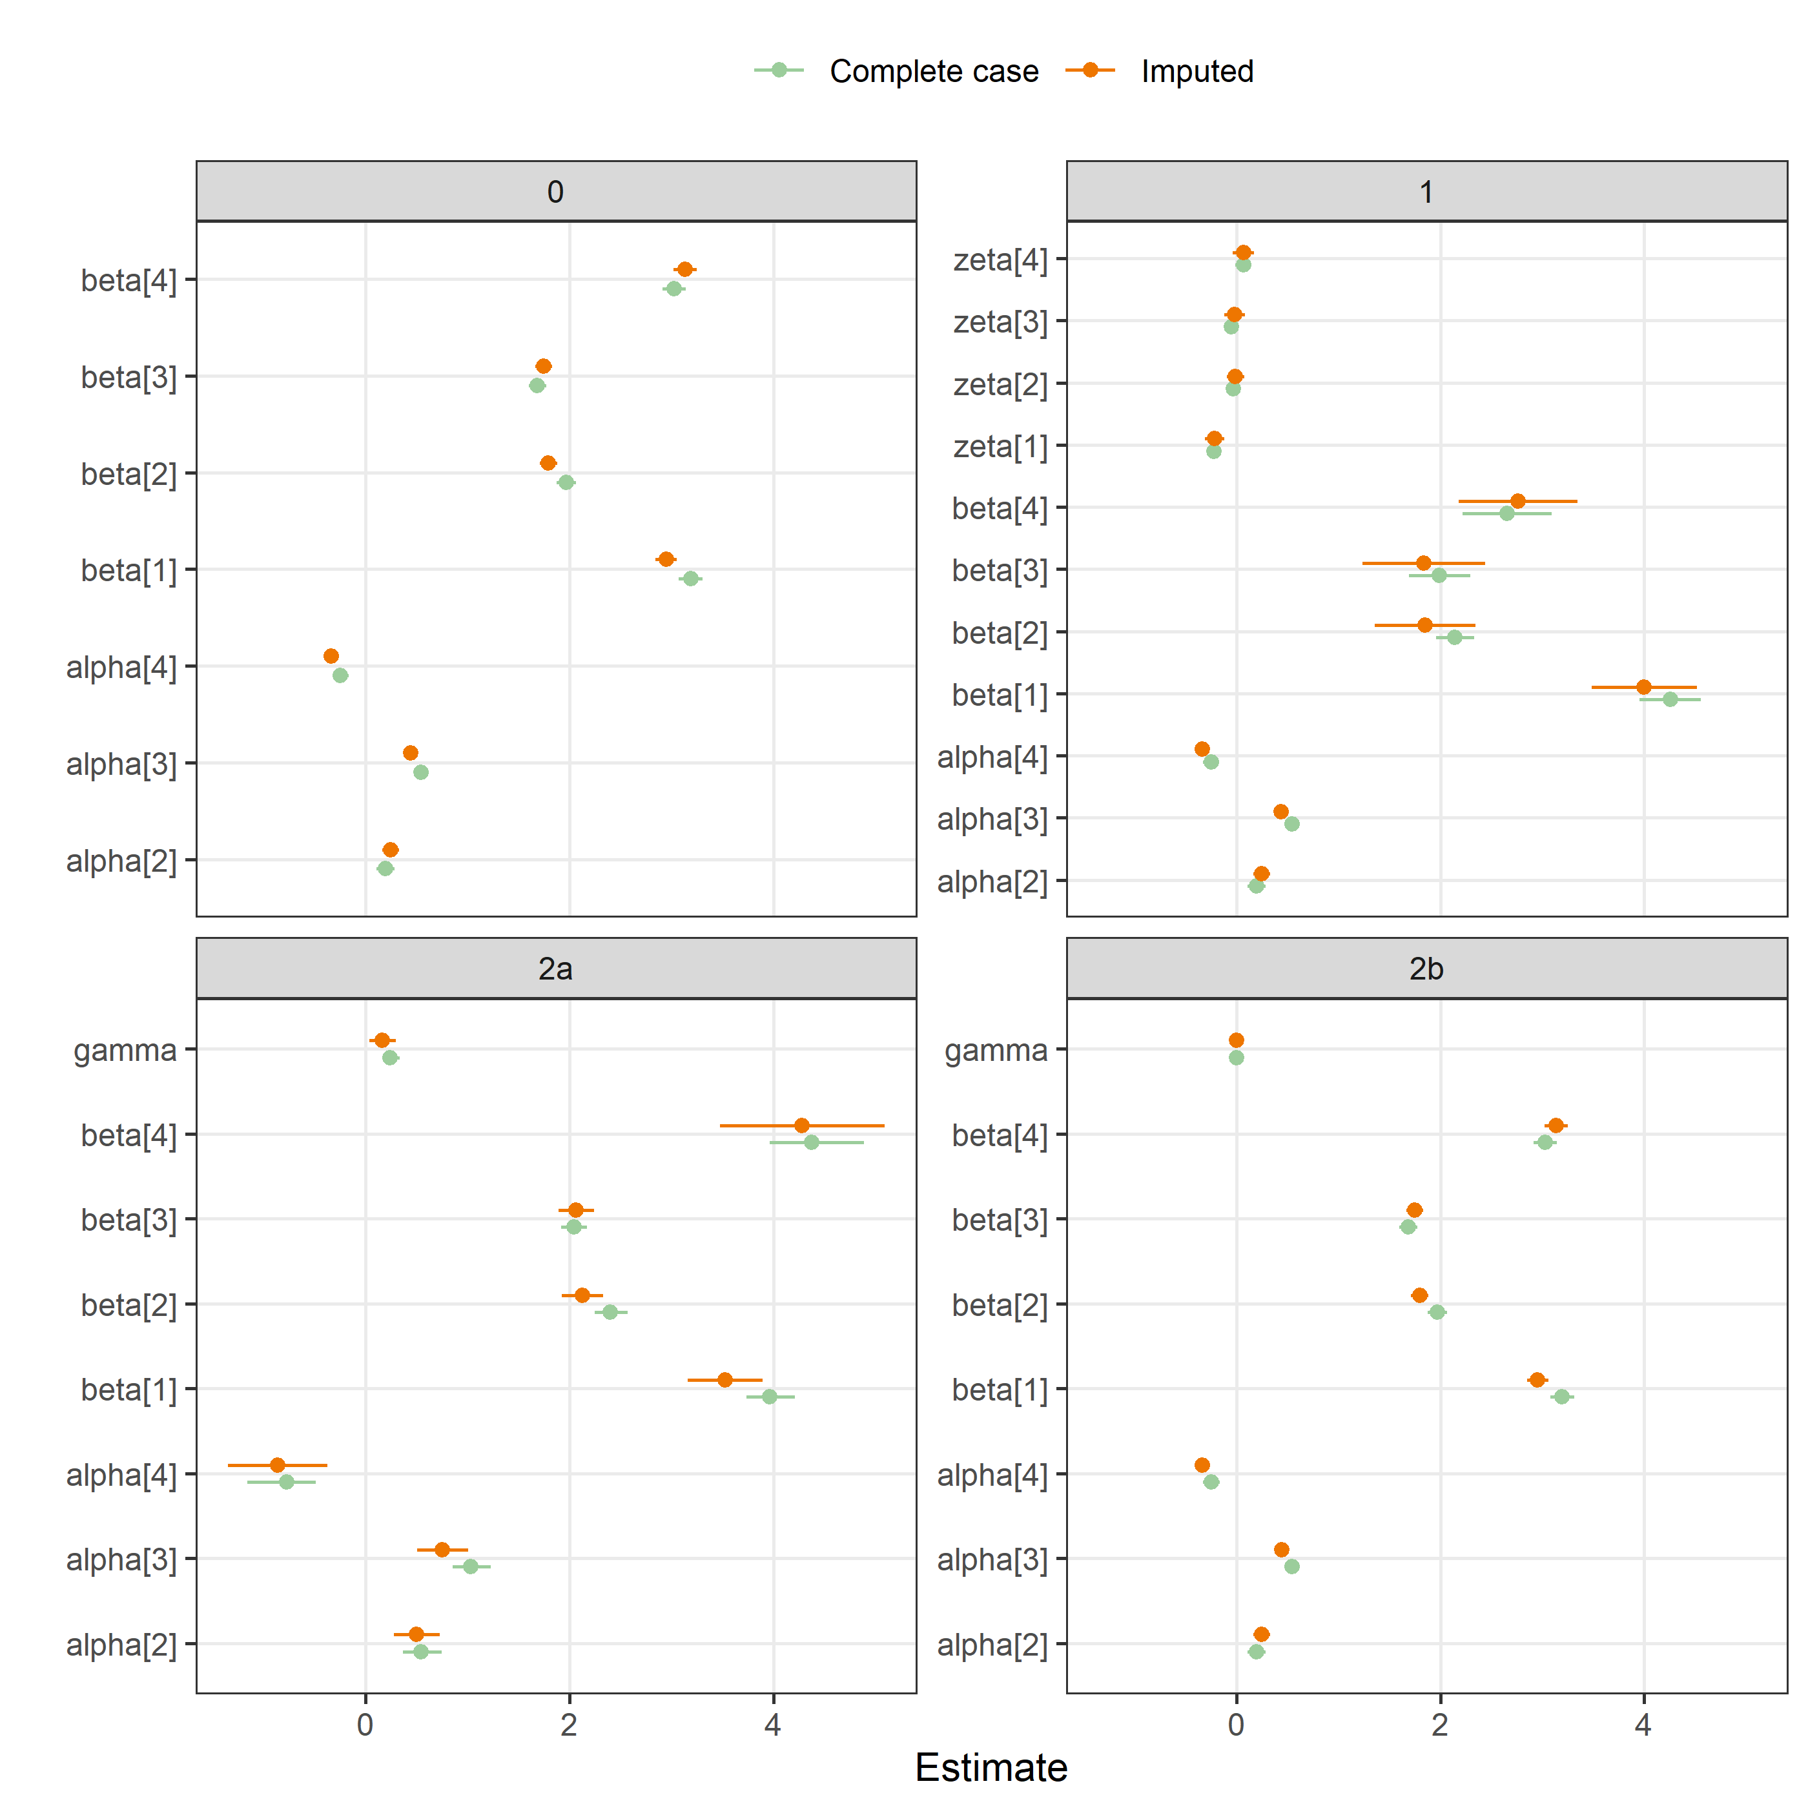

### BMJ Open, protocol

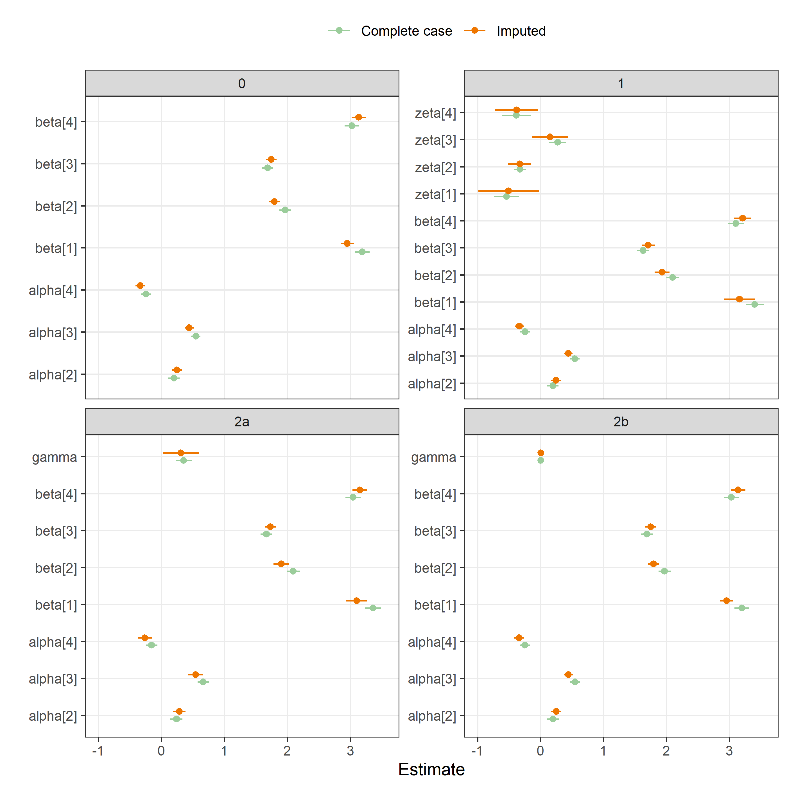

### F1000, gender

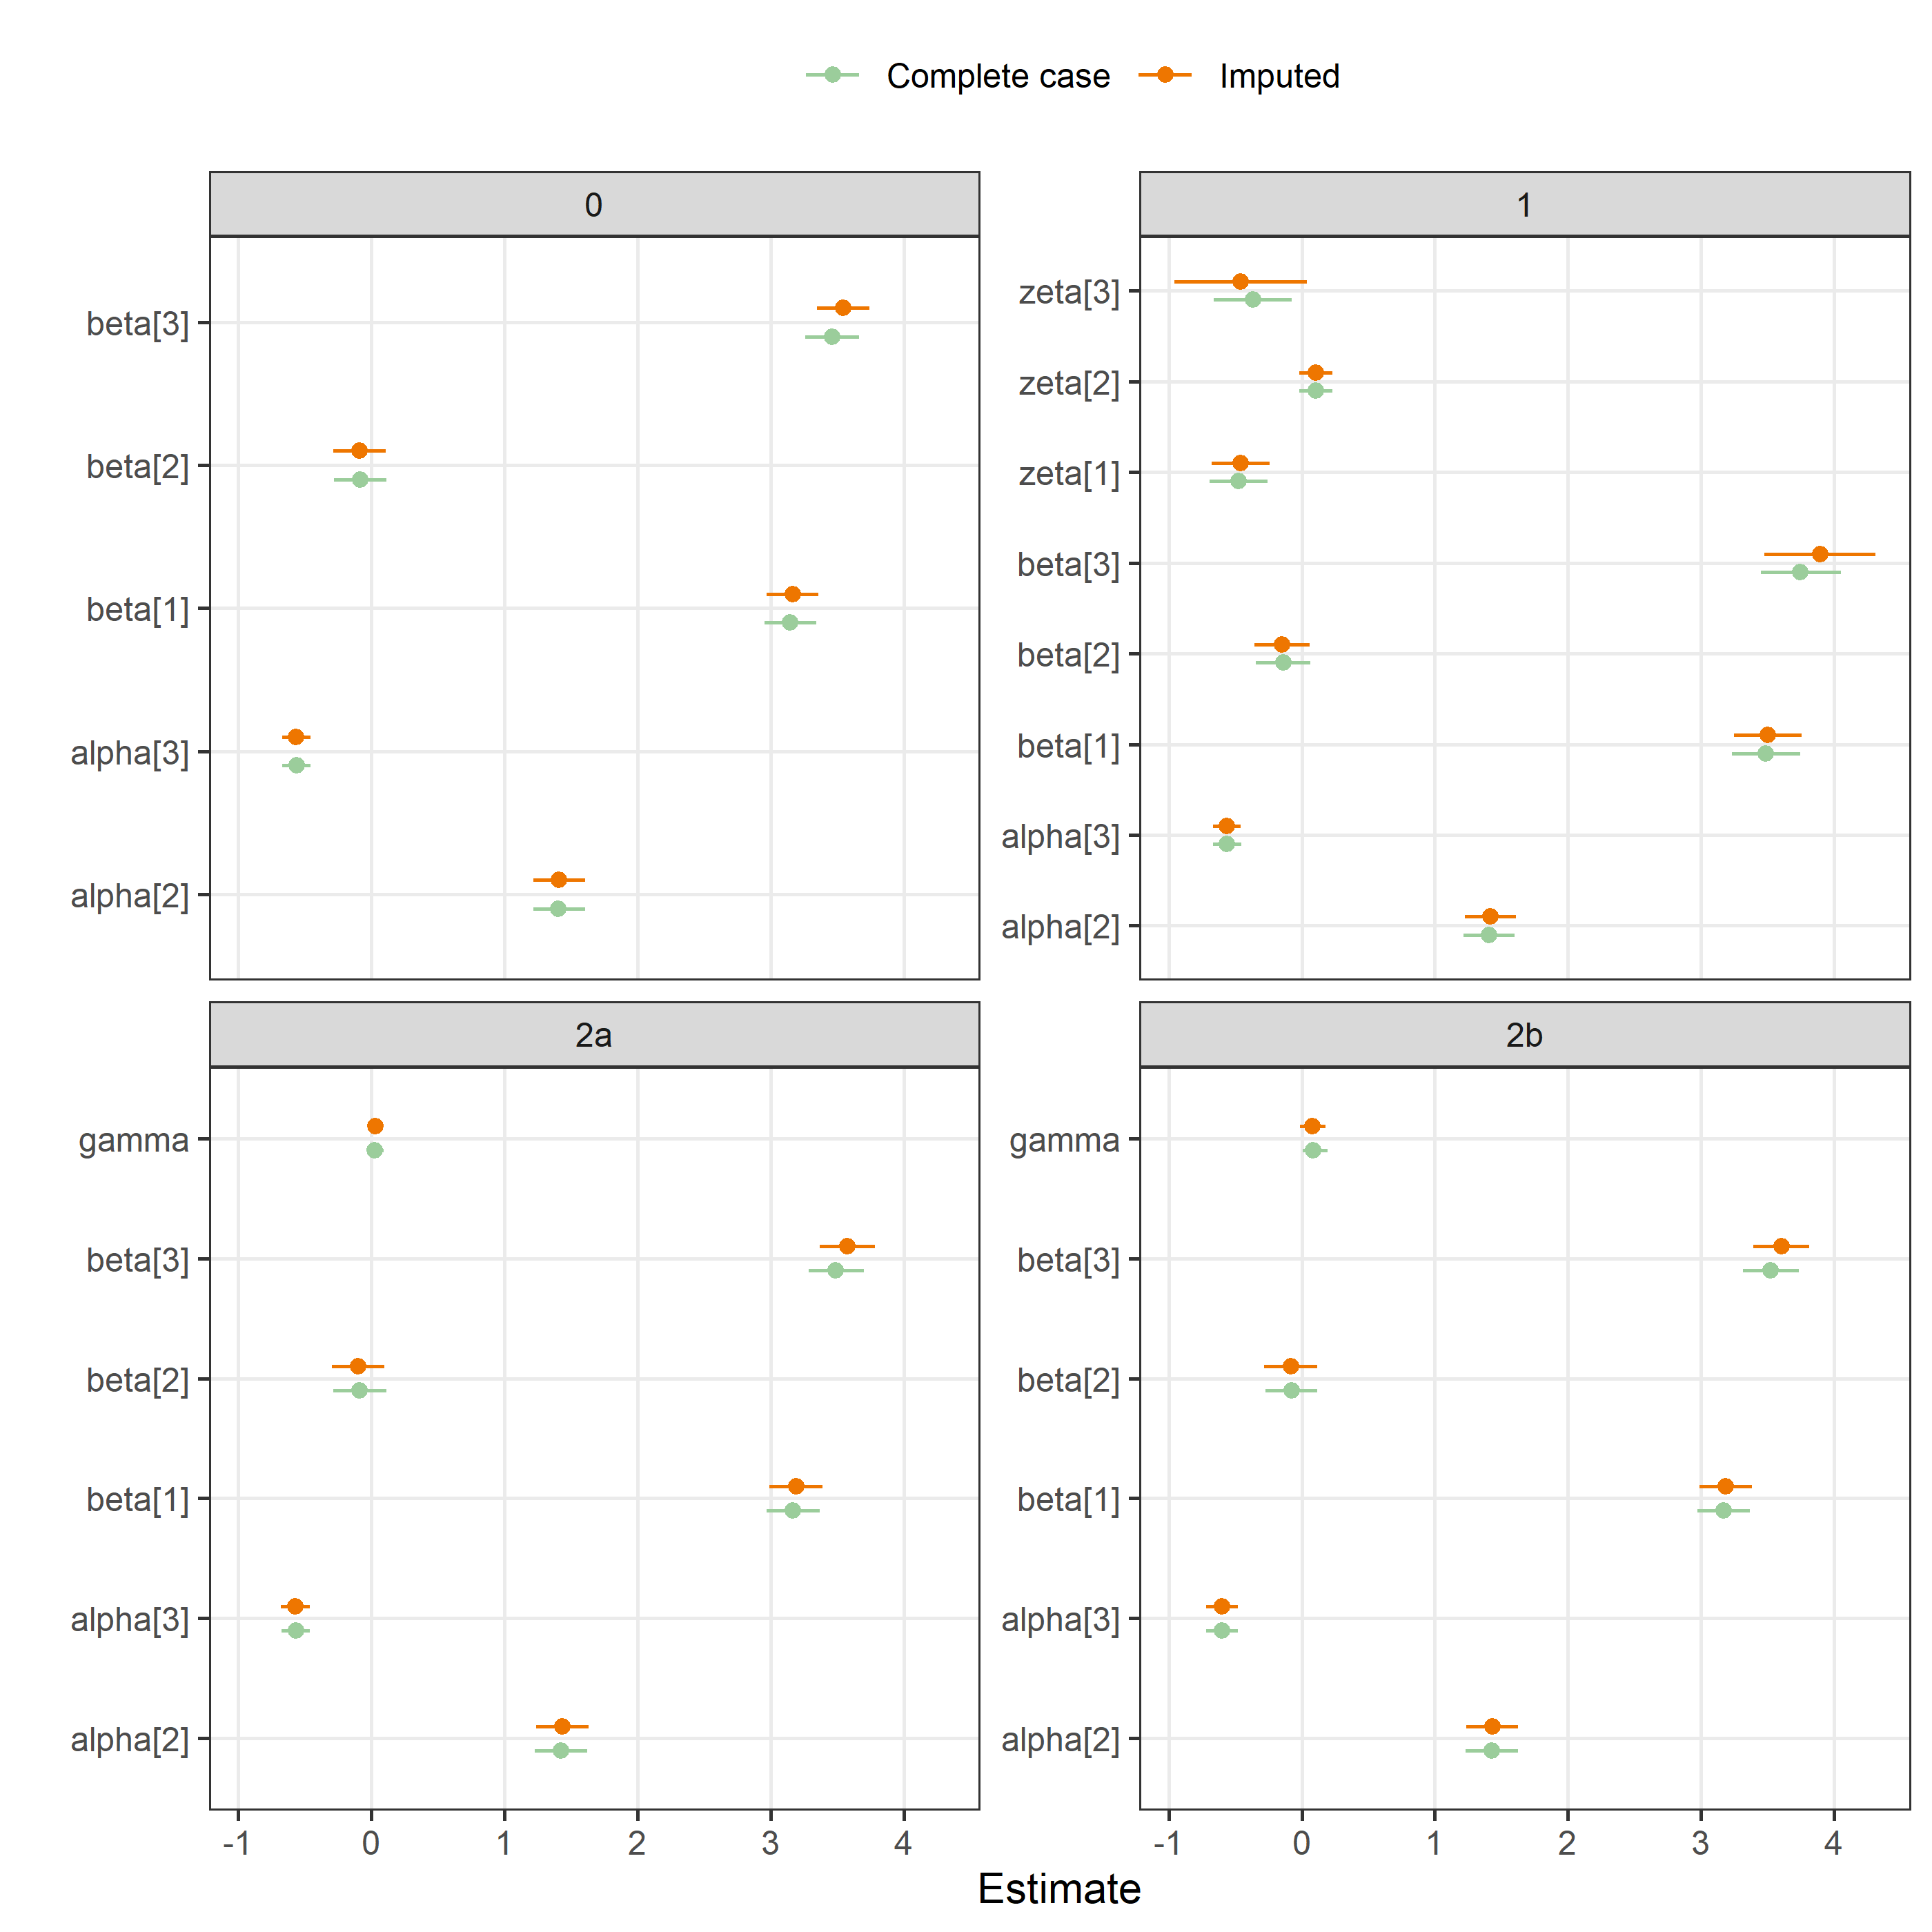

### F1000, experience

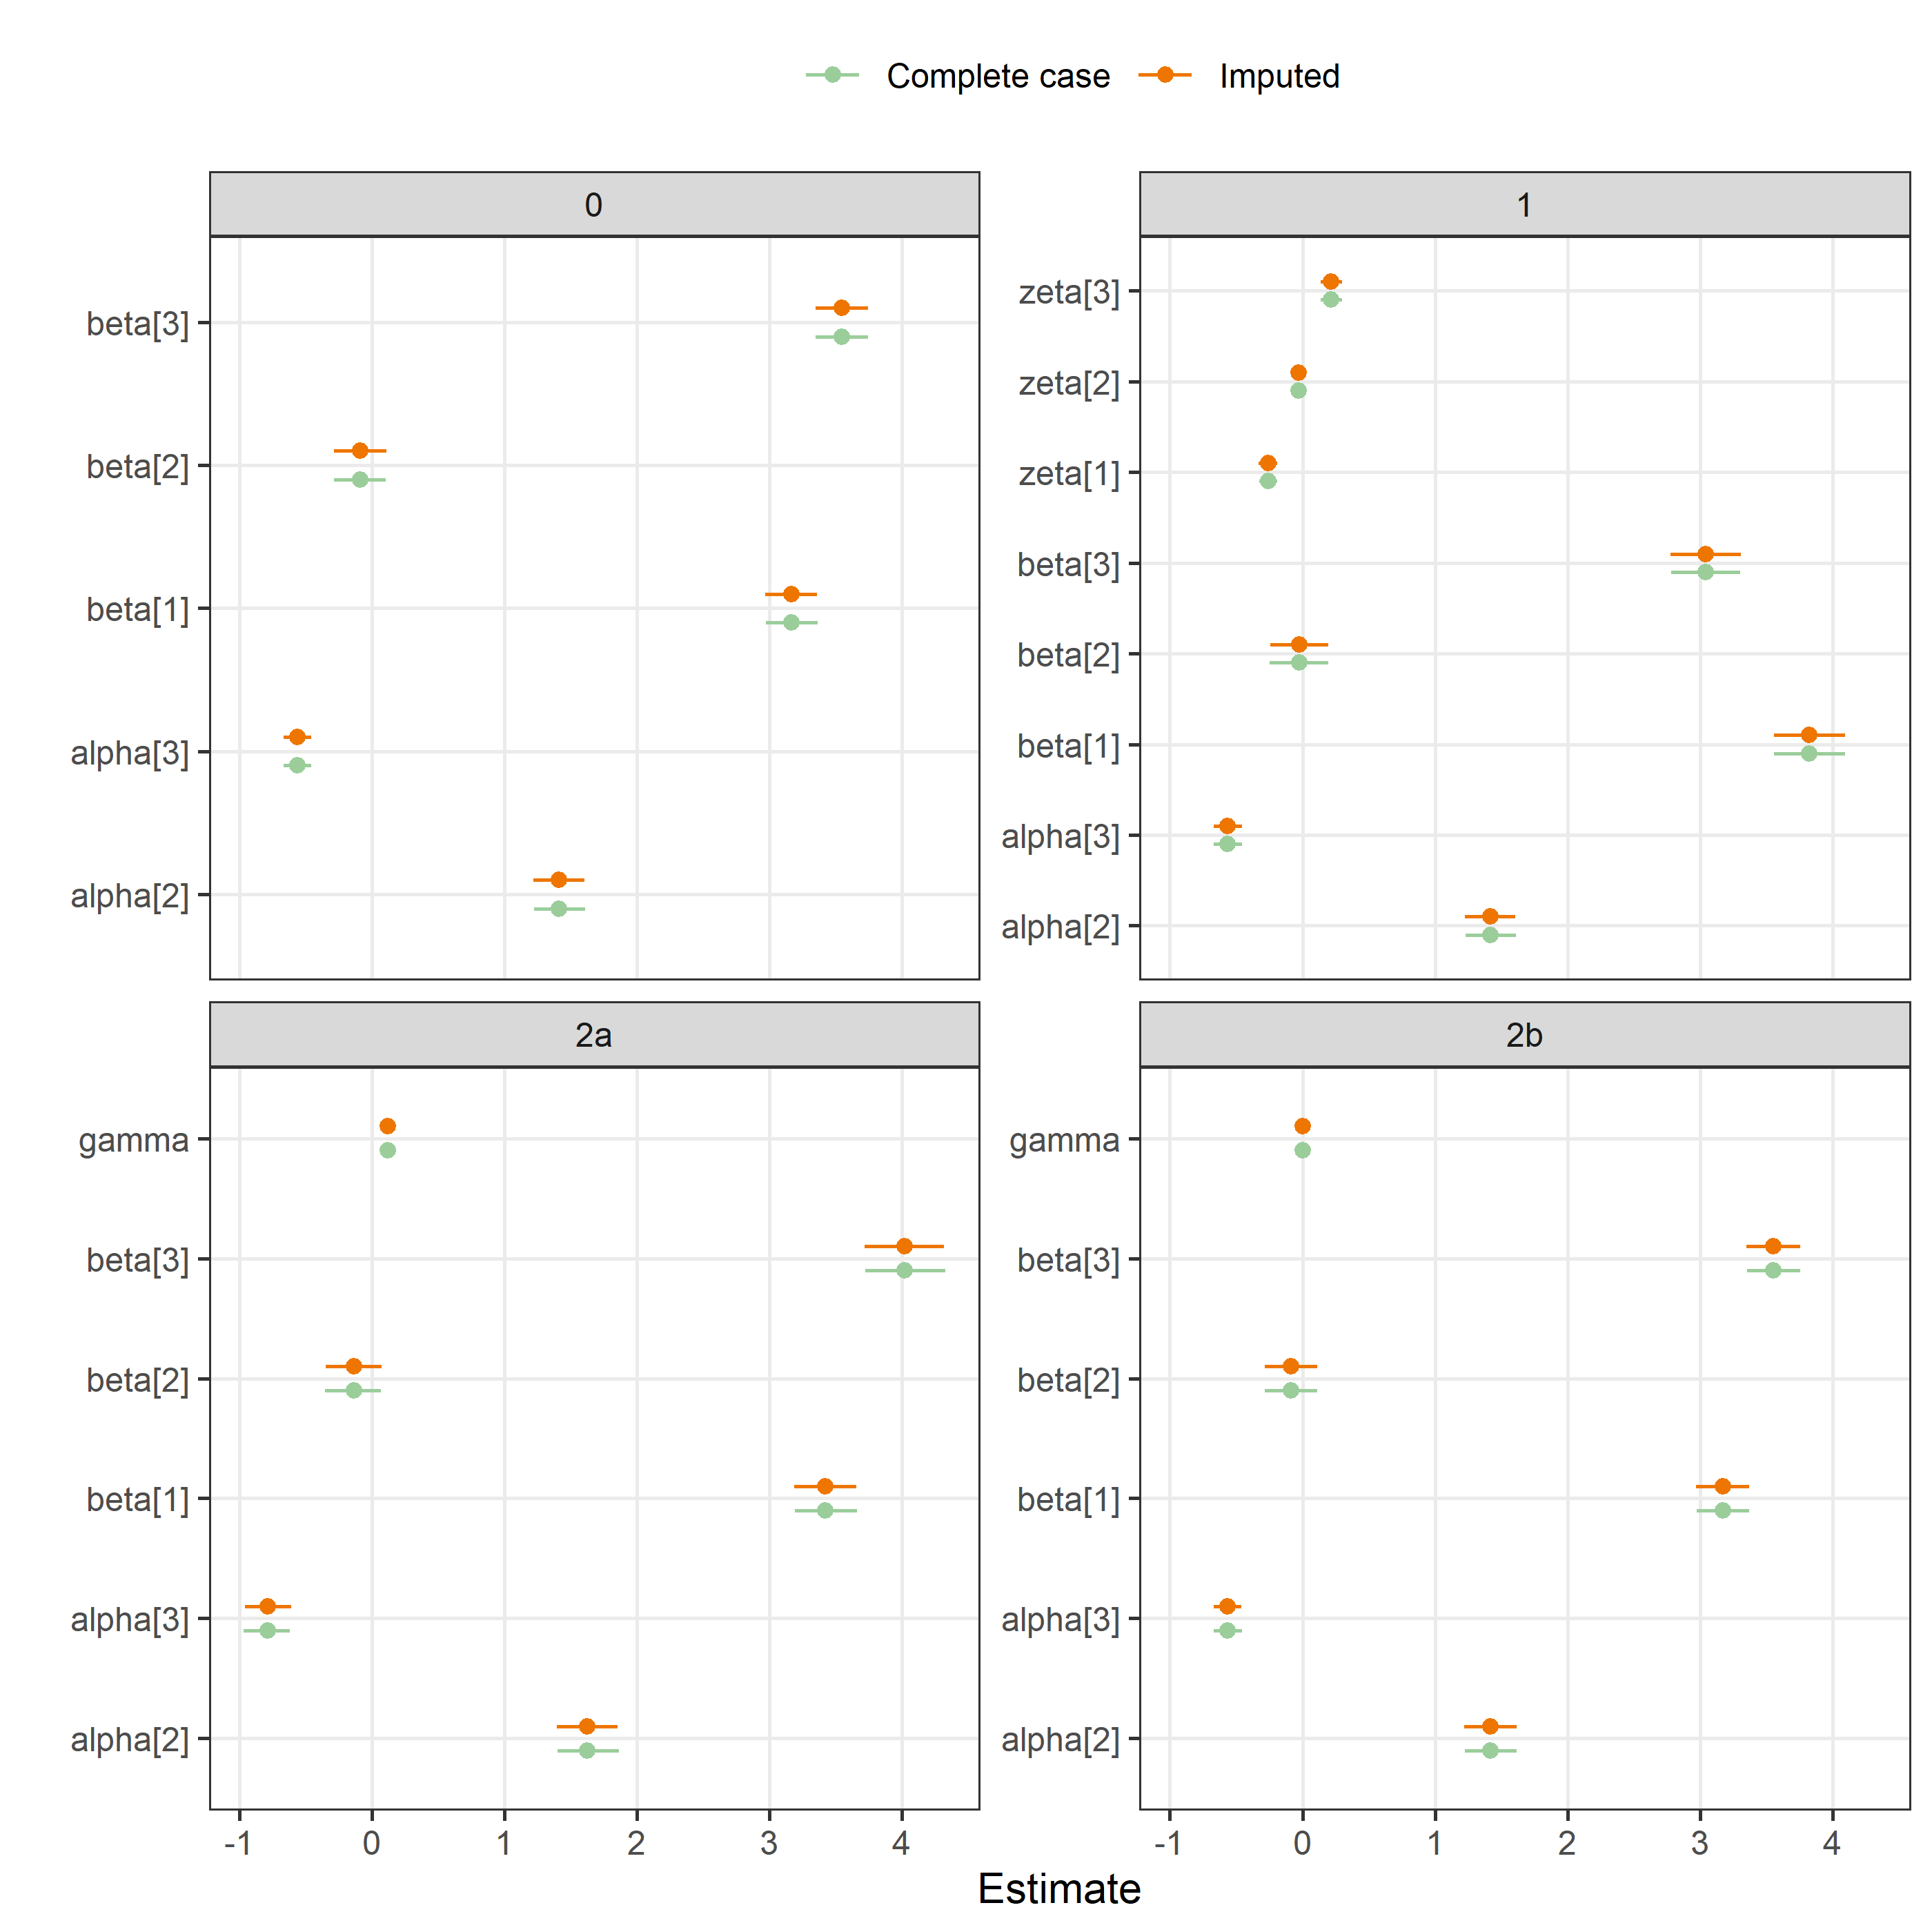

### F1000, time taken on review

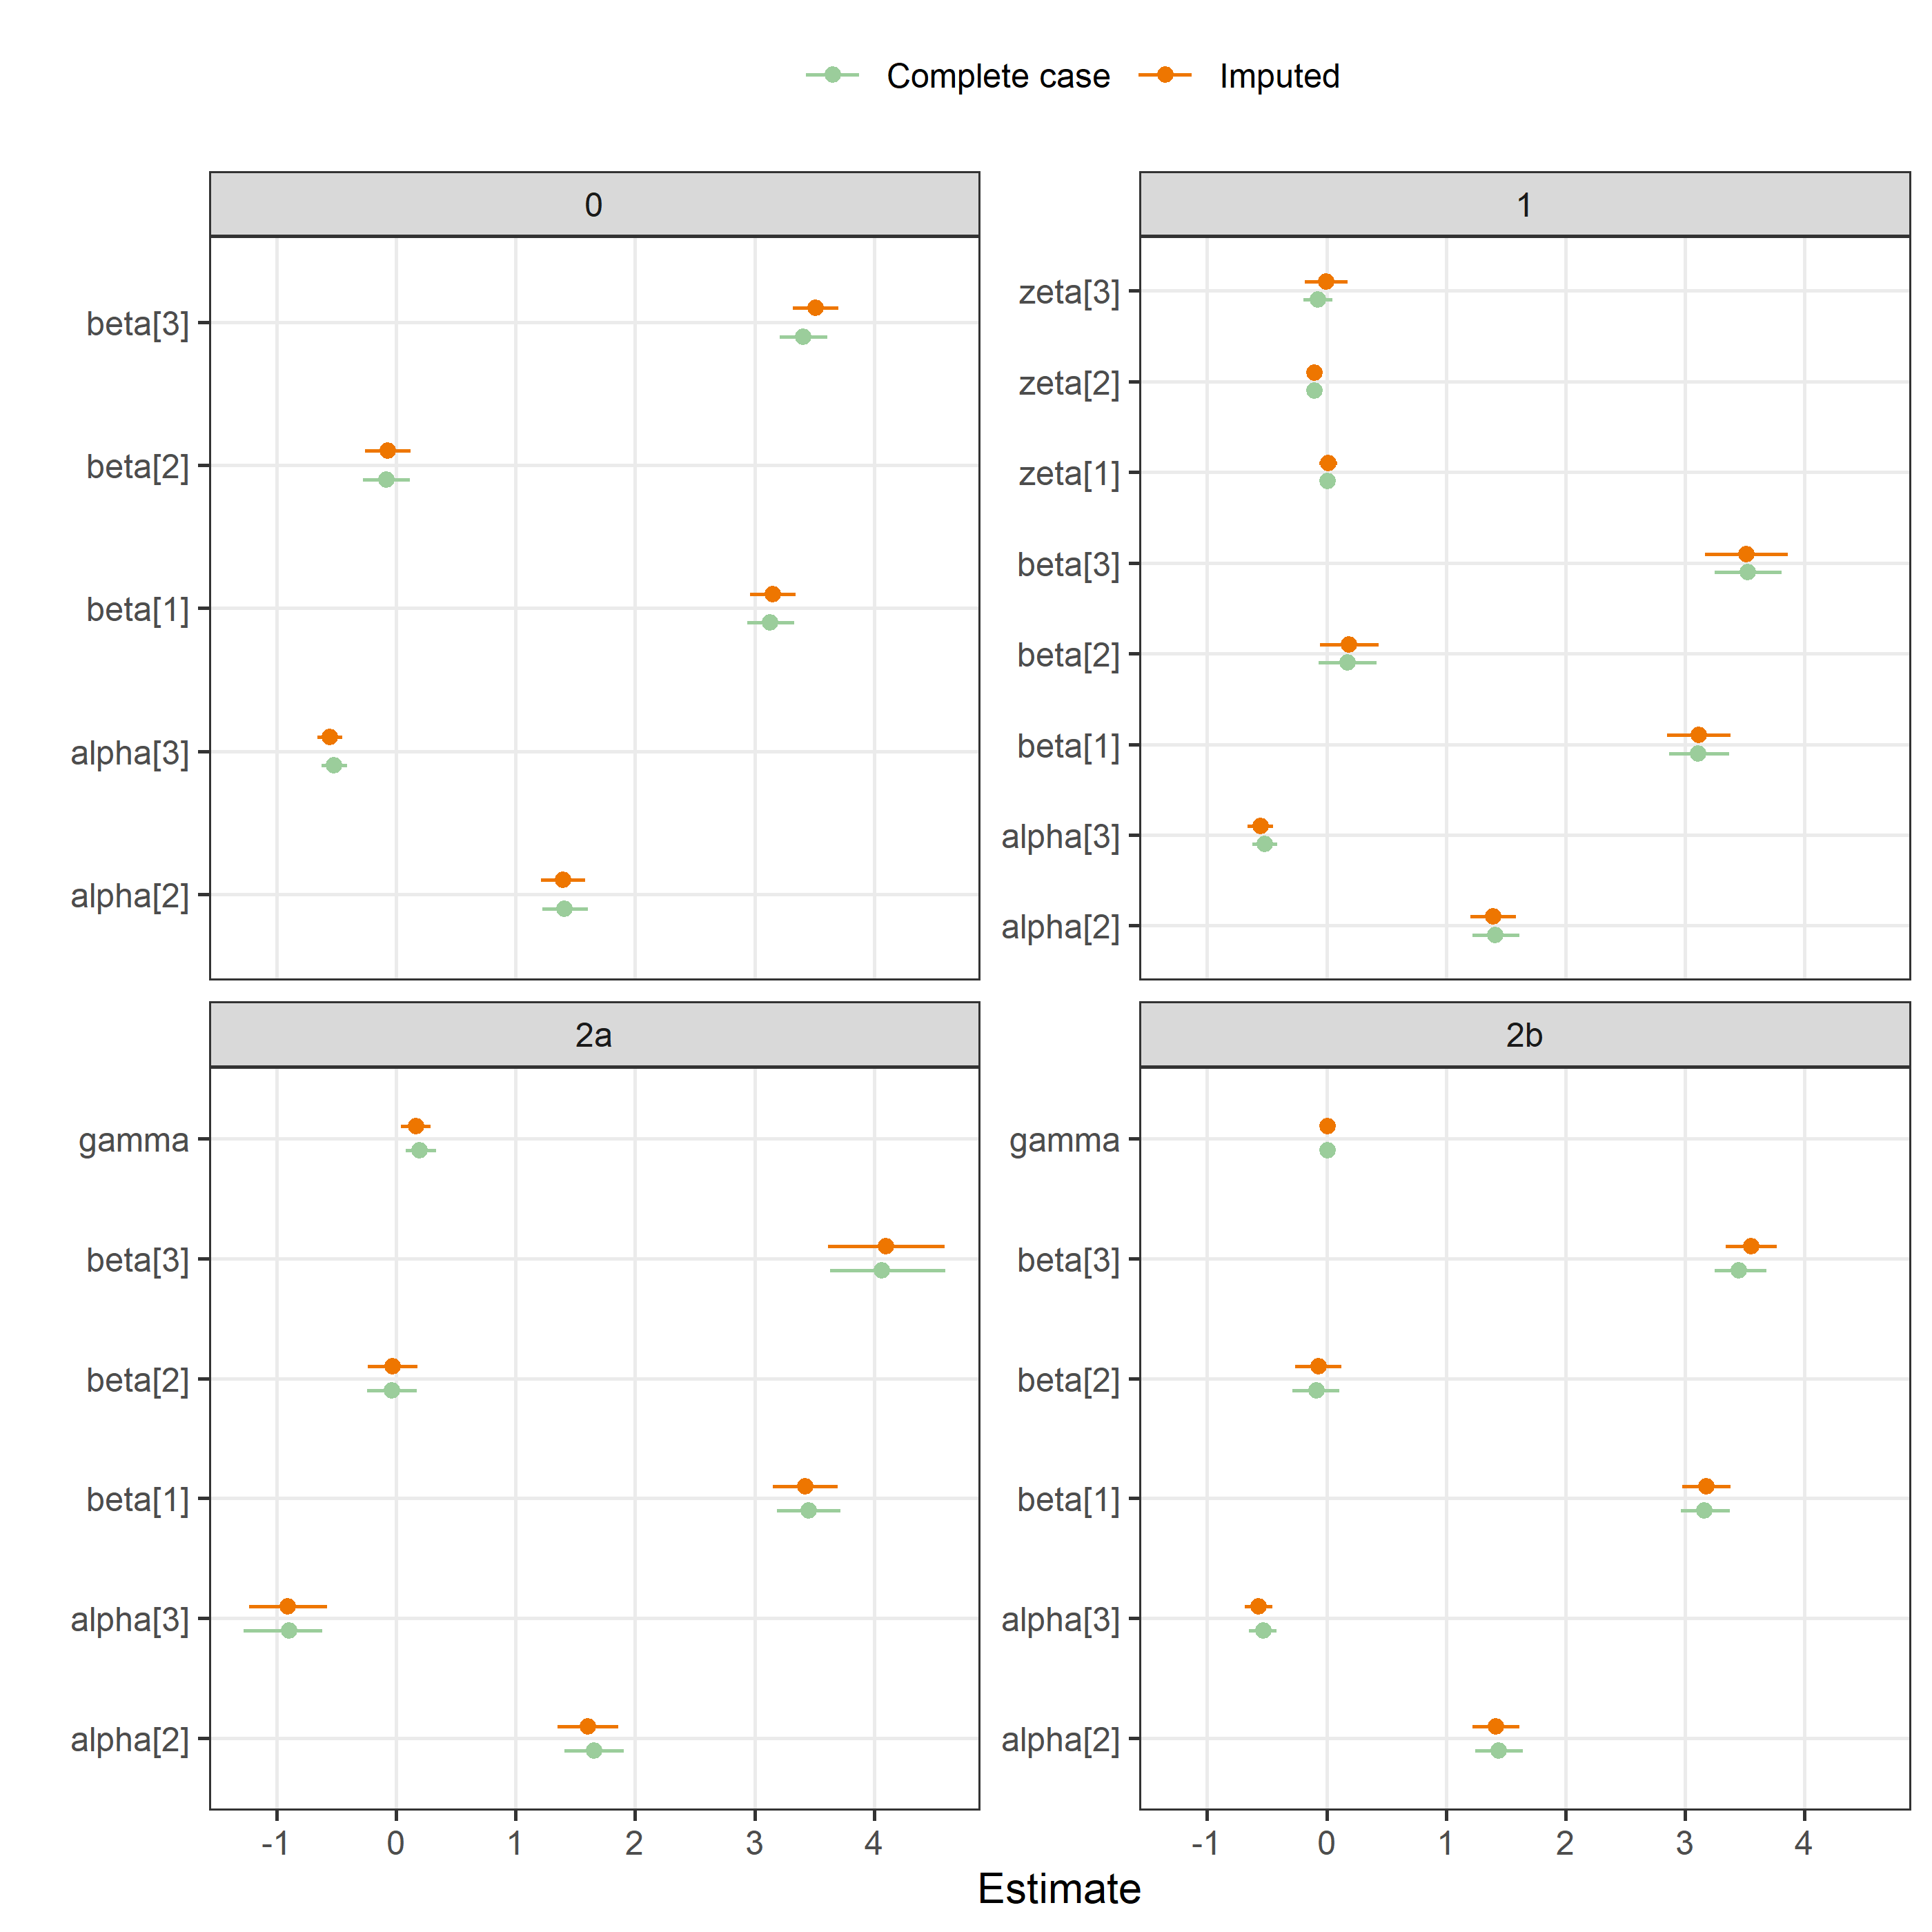

### F1000, version

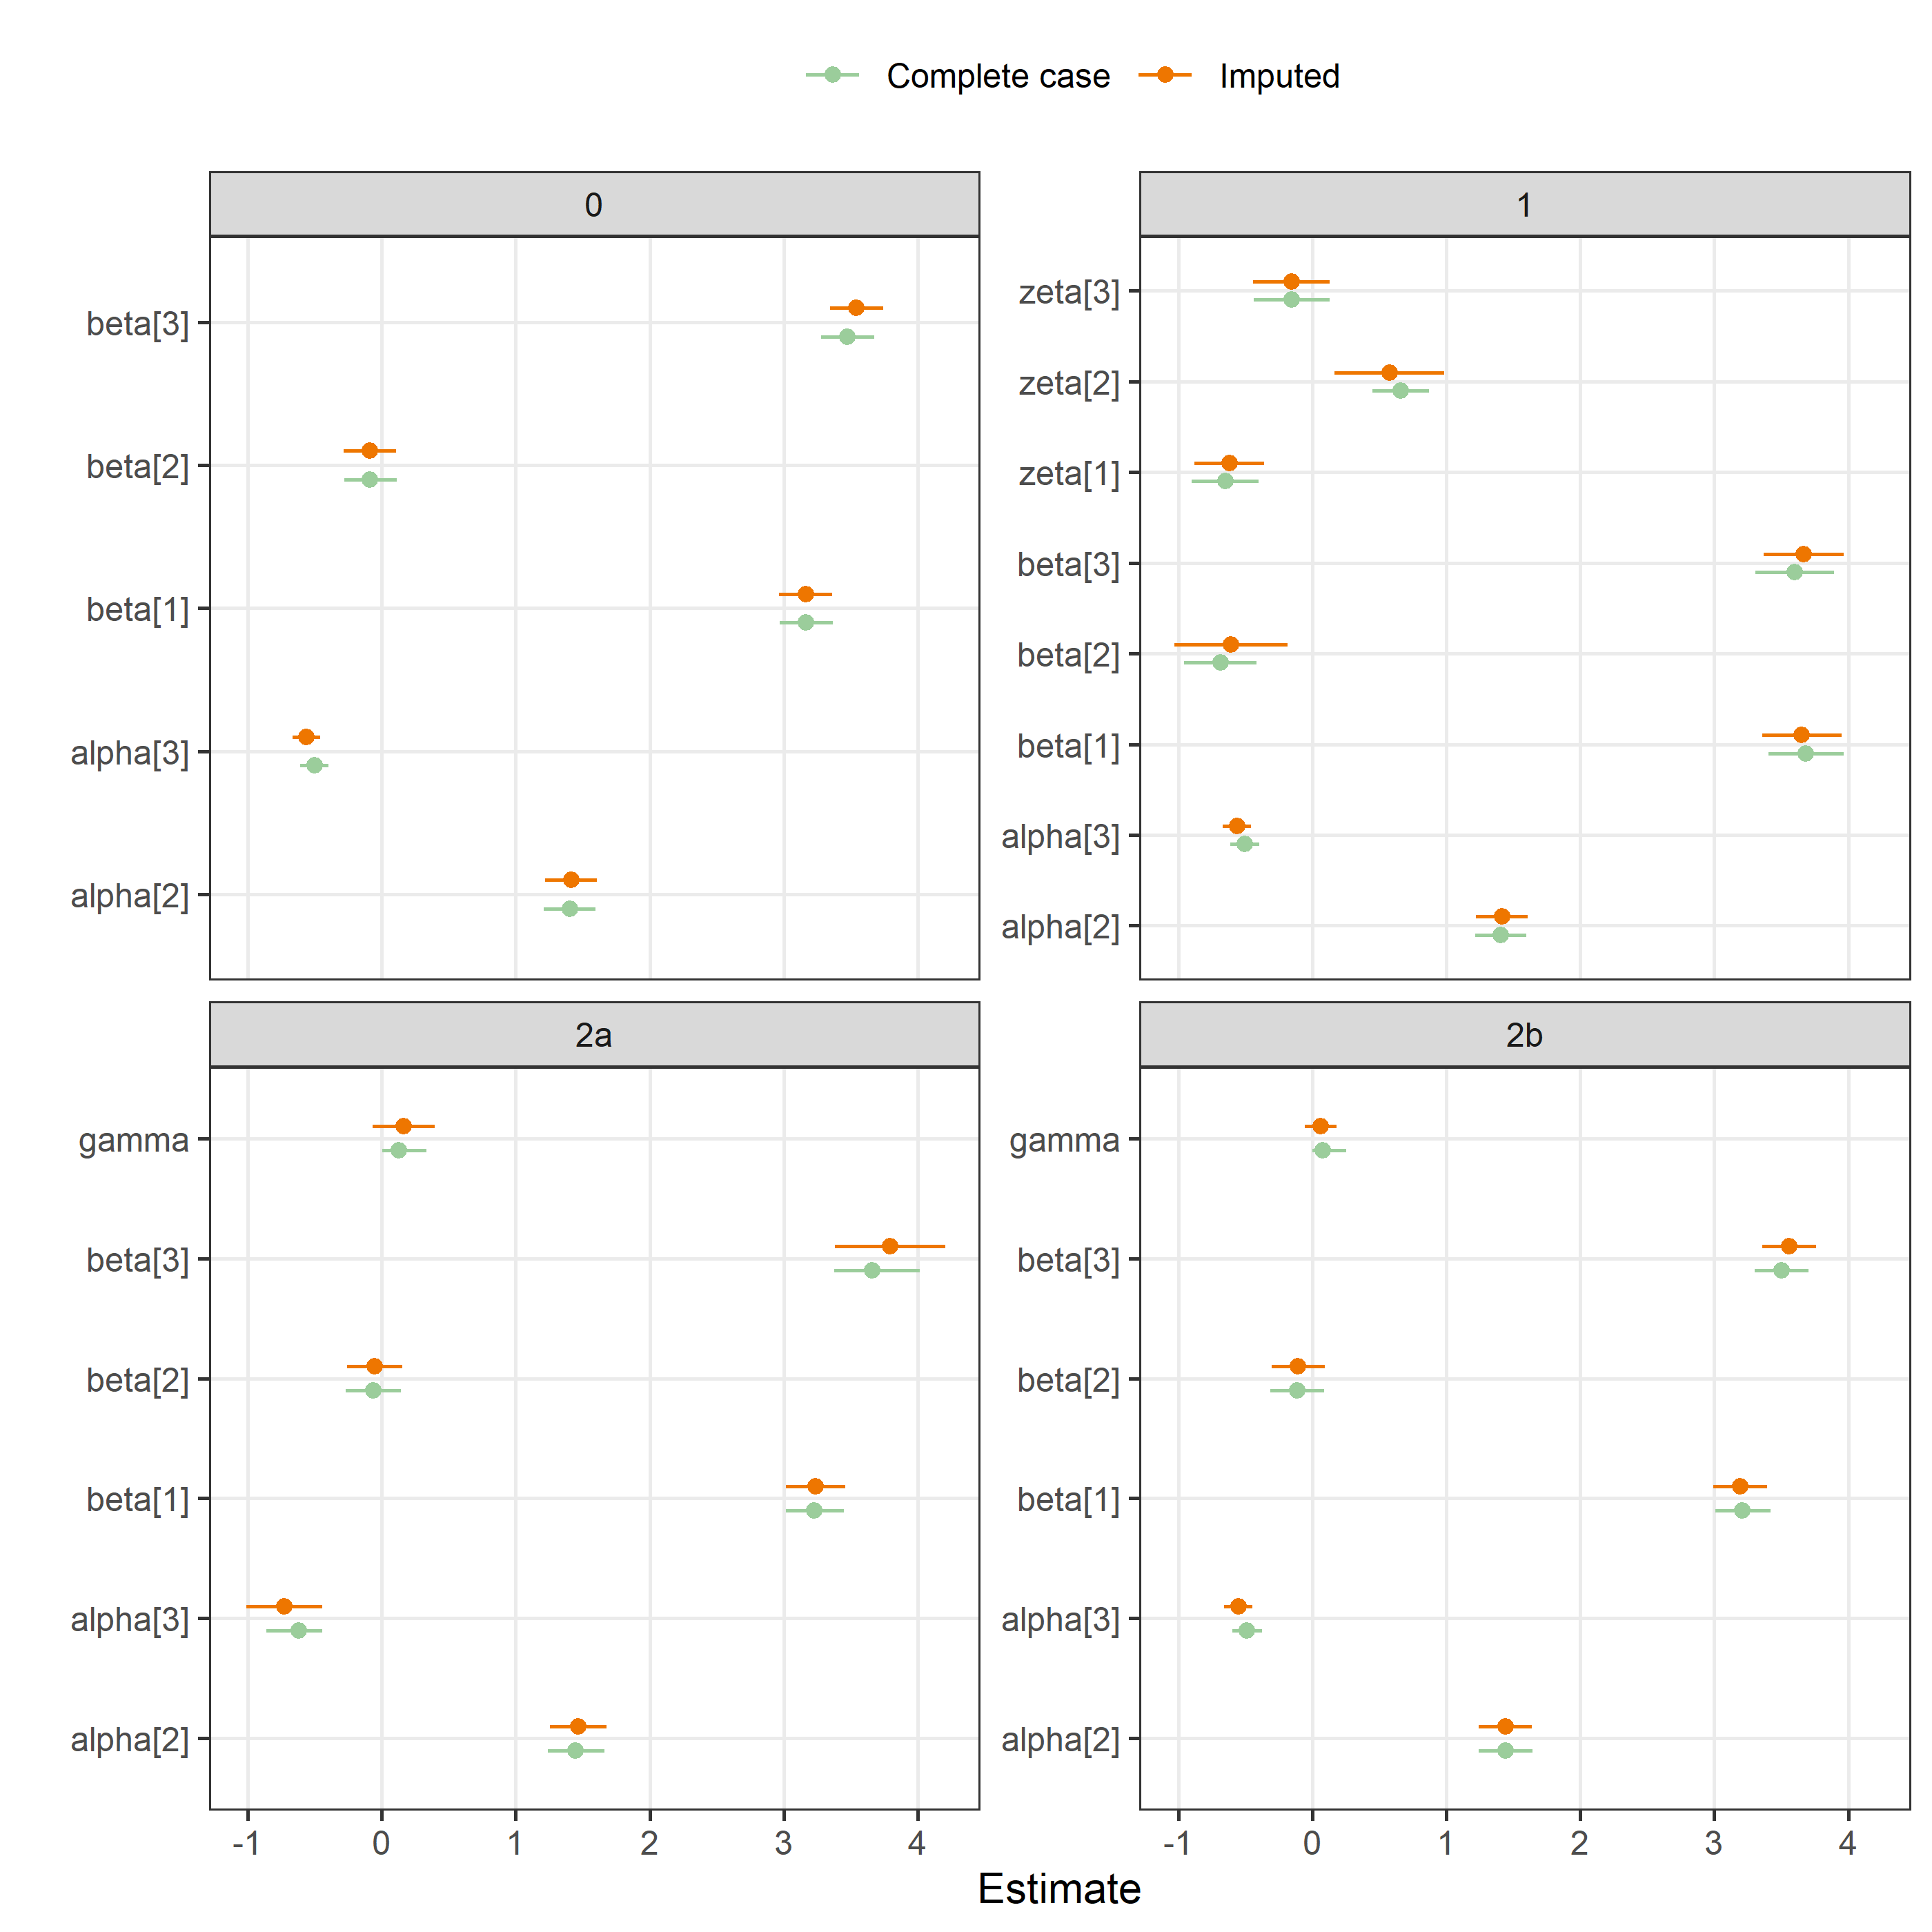

### F1000, time to peer review

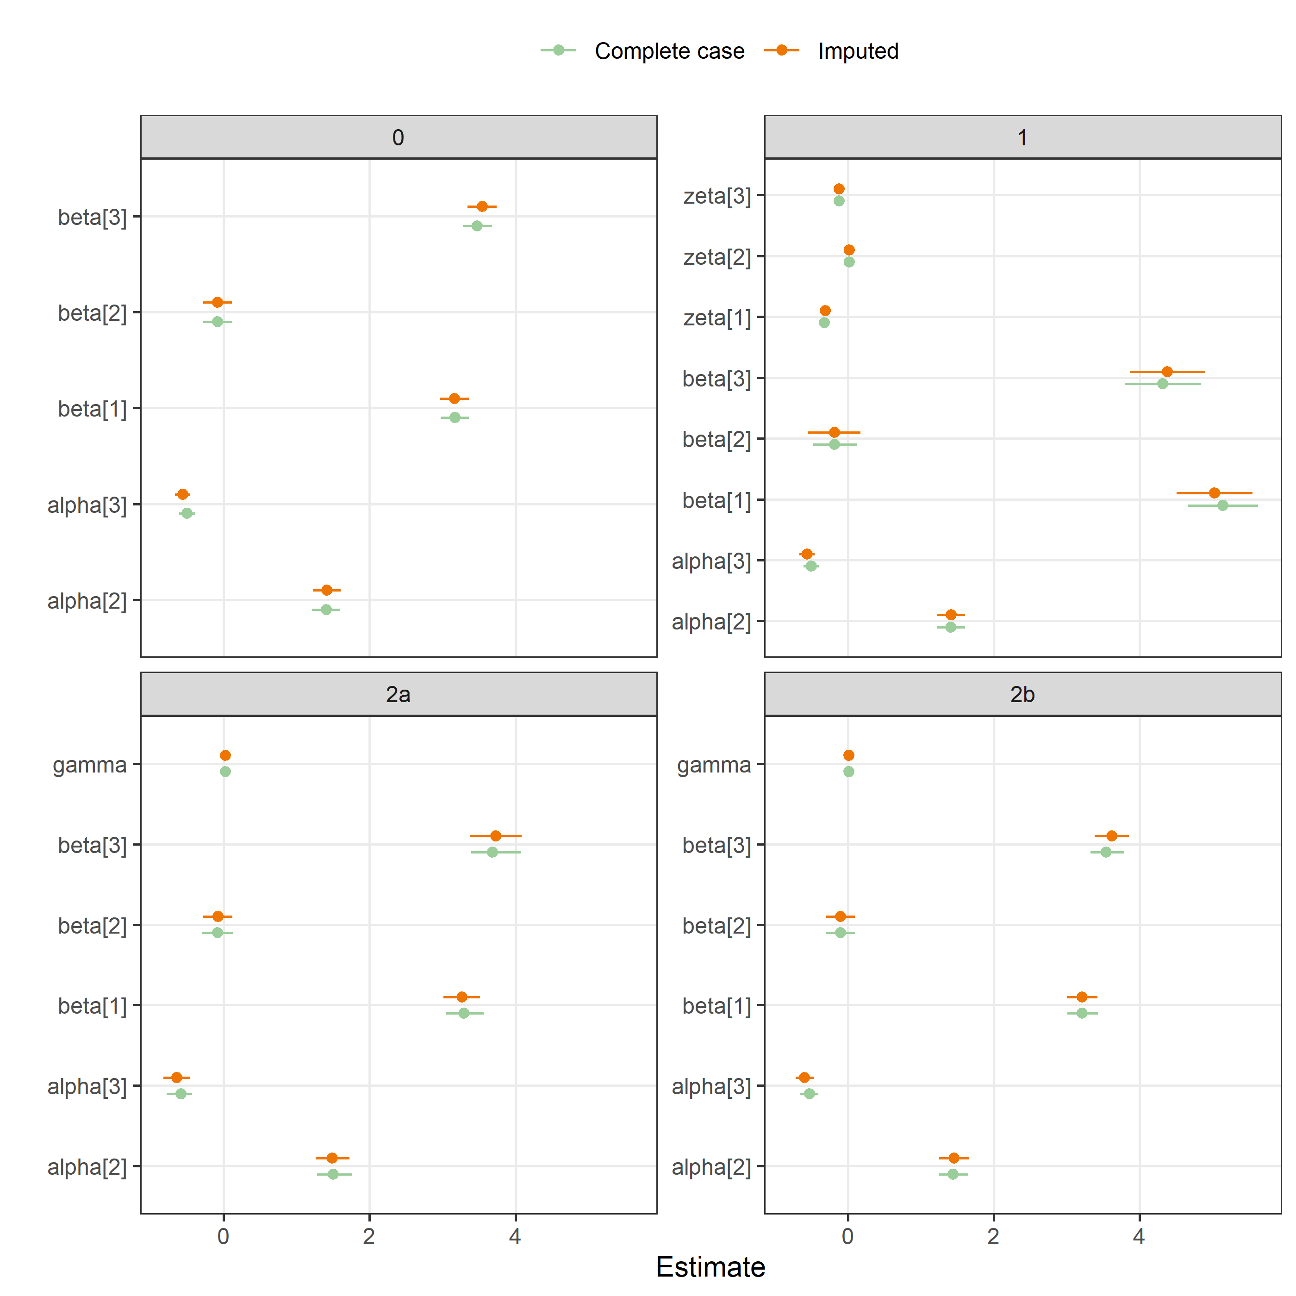

### F1000, protocol

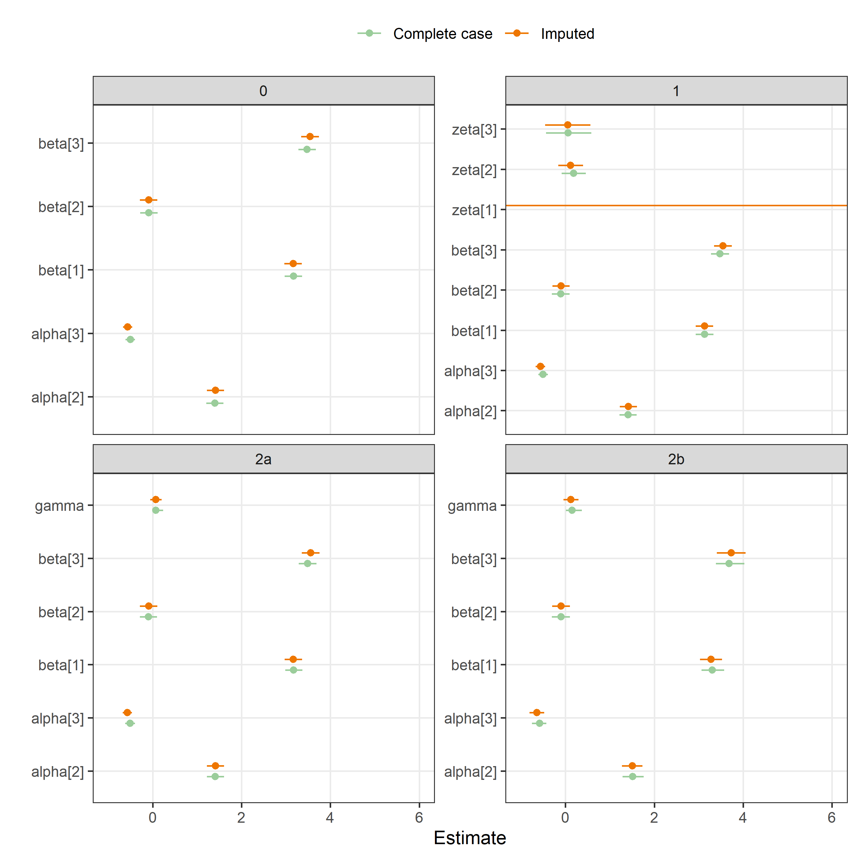

The estimates for zeta[1] in model 1 were very uncertain and so the plot has been truncates.

### Epidemiology, gender

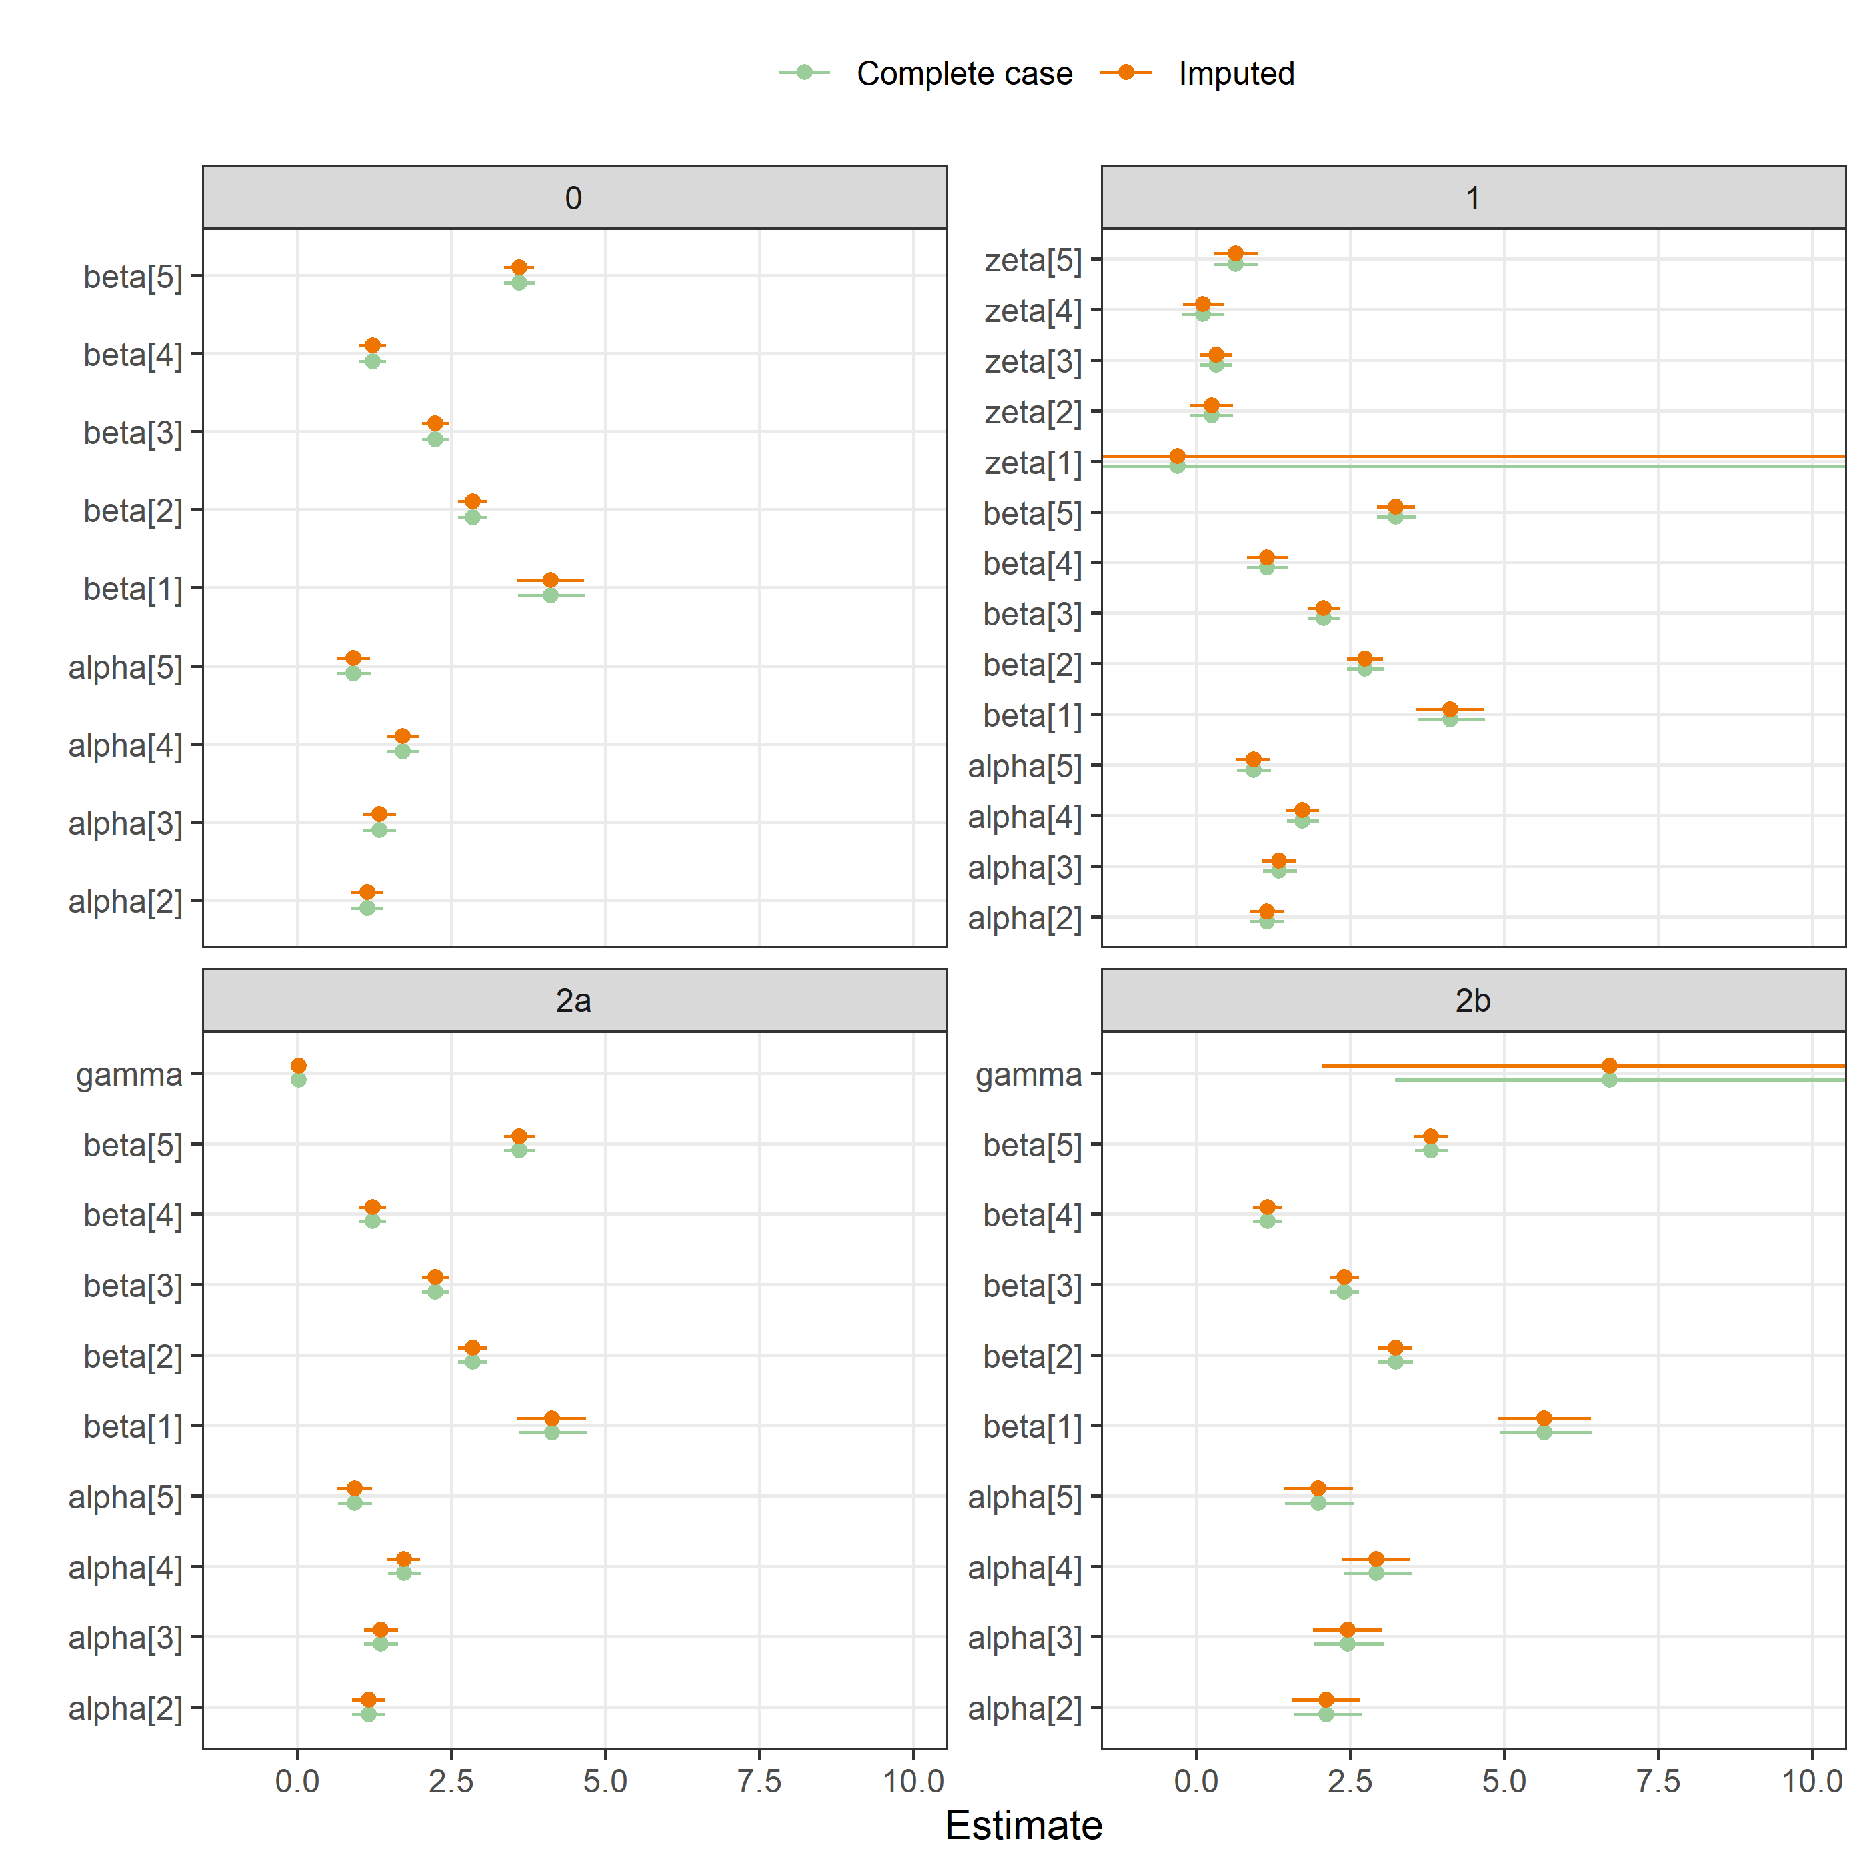

The estimates for zeta[1] in model 1 were very uncertain and so the plot has been truncates.

### Epidemiology, experience

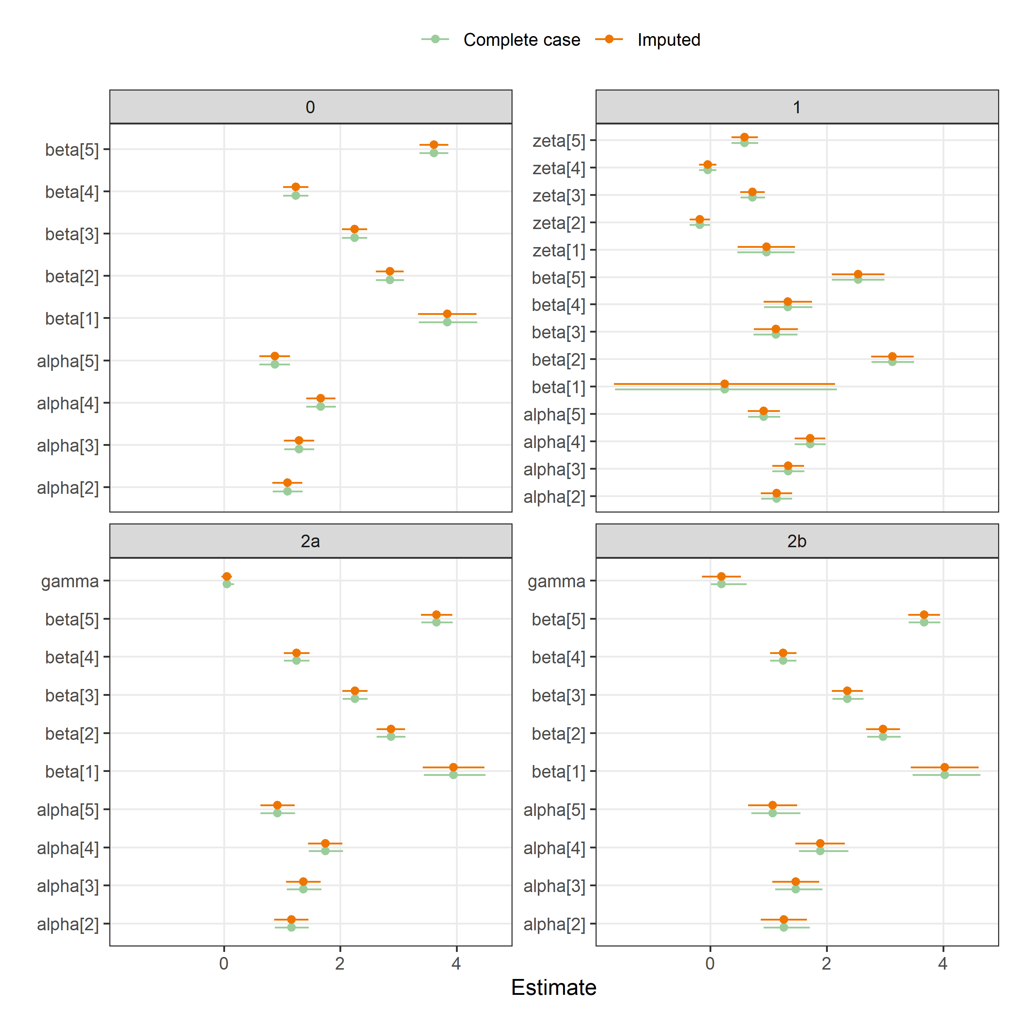

### Epidemiology, time taken on review

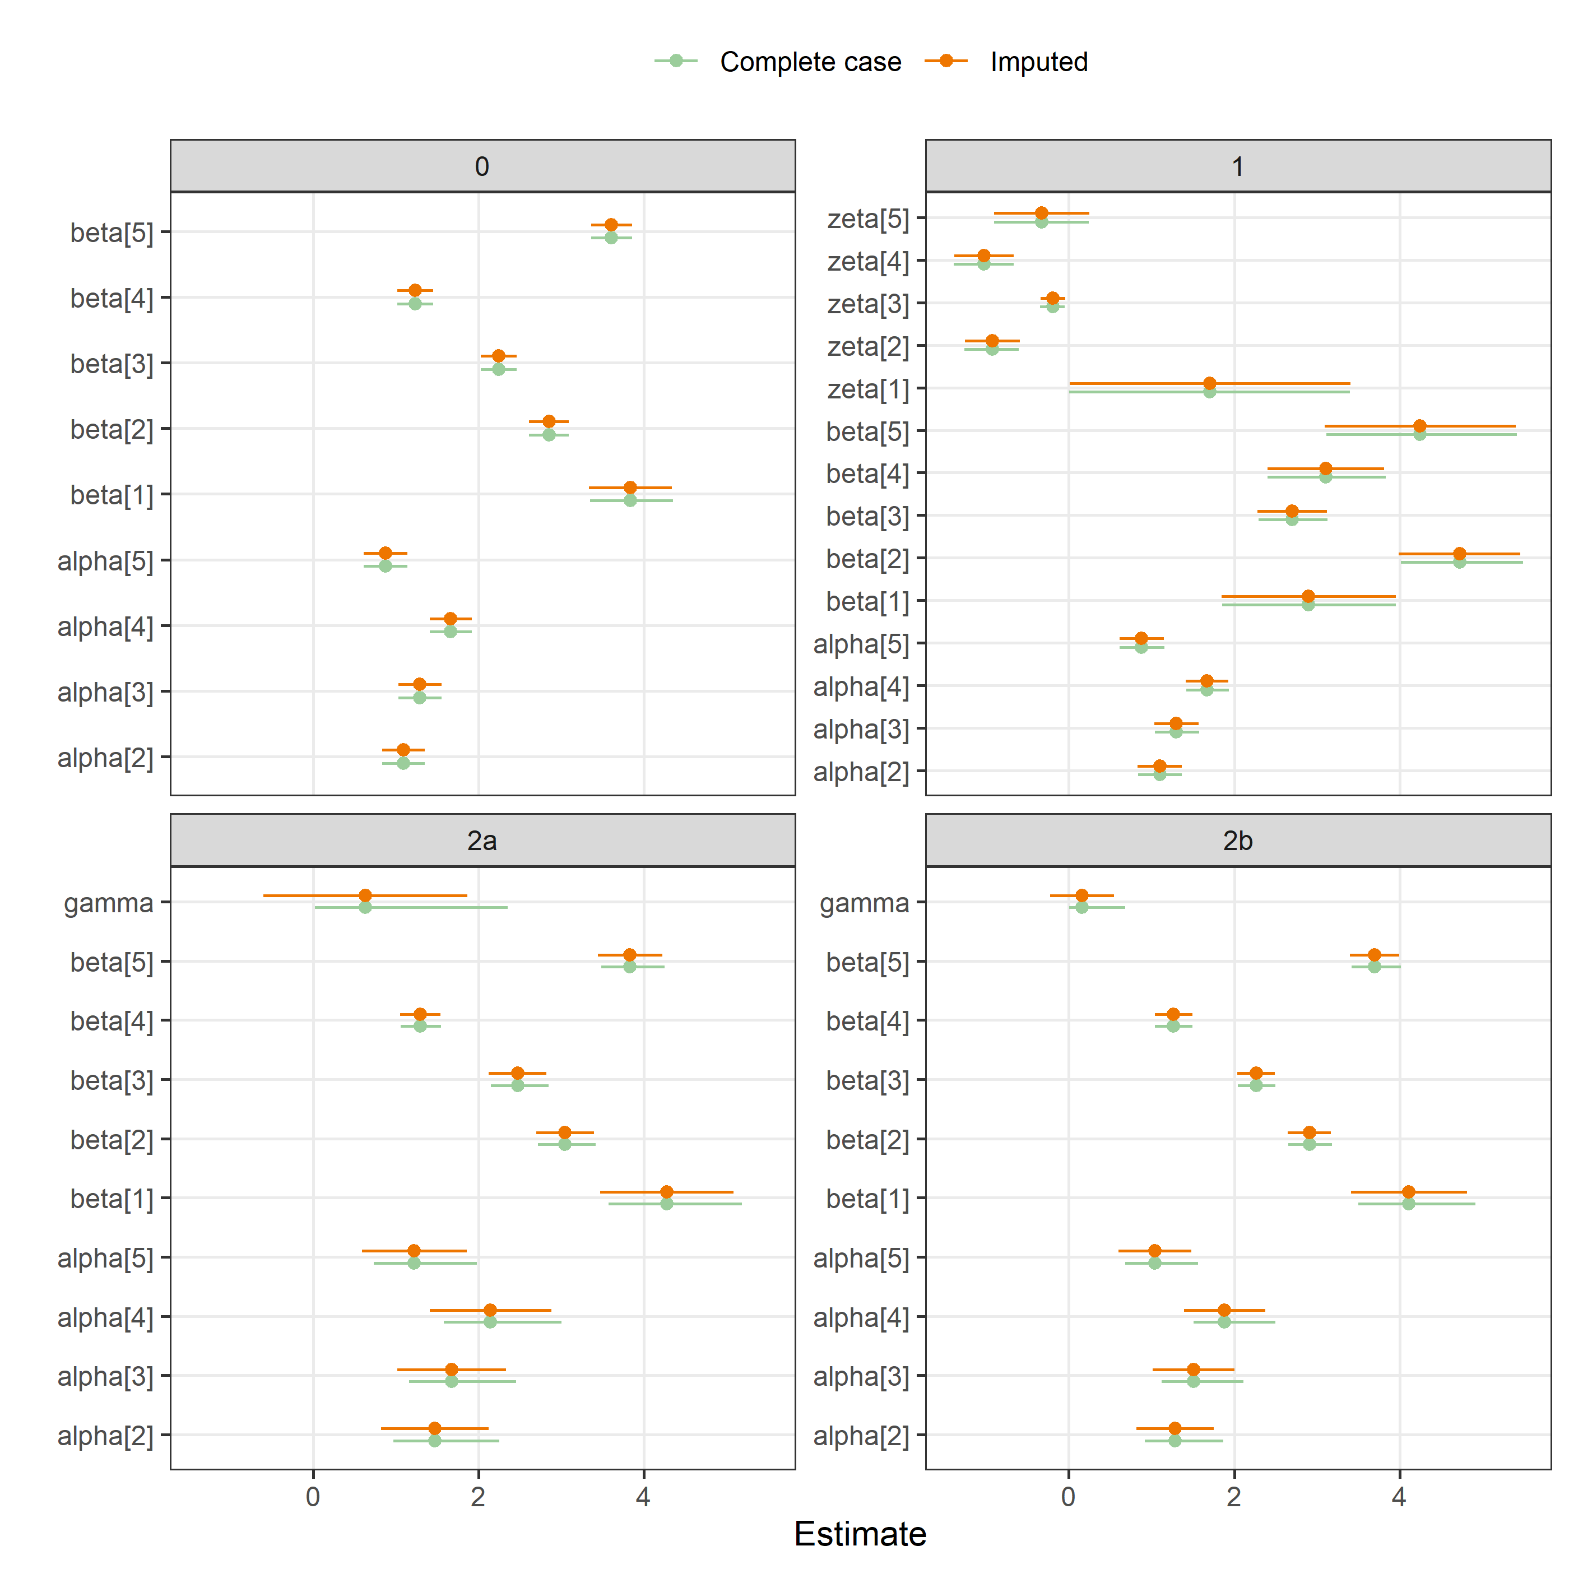

### Epidemiology, time to peer review

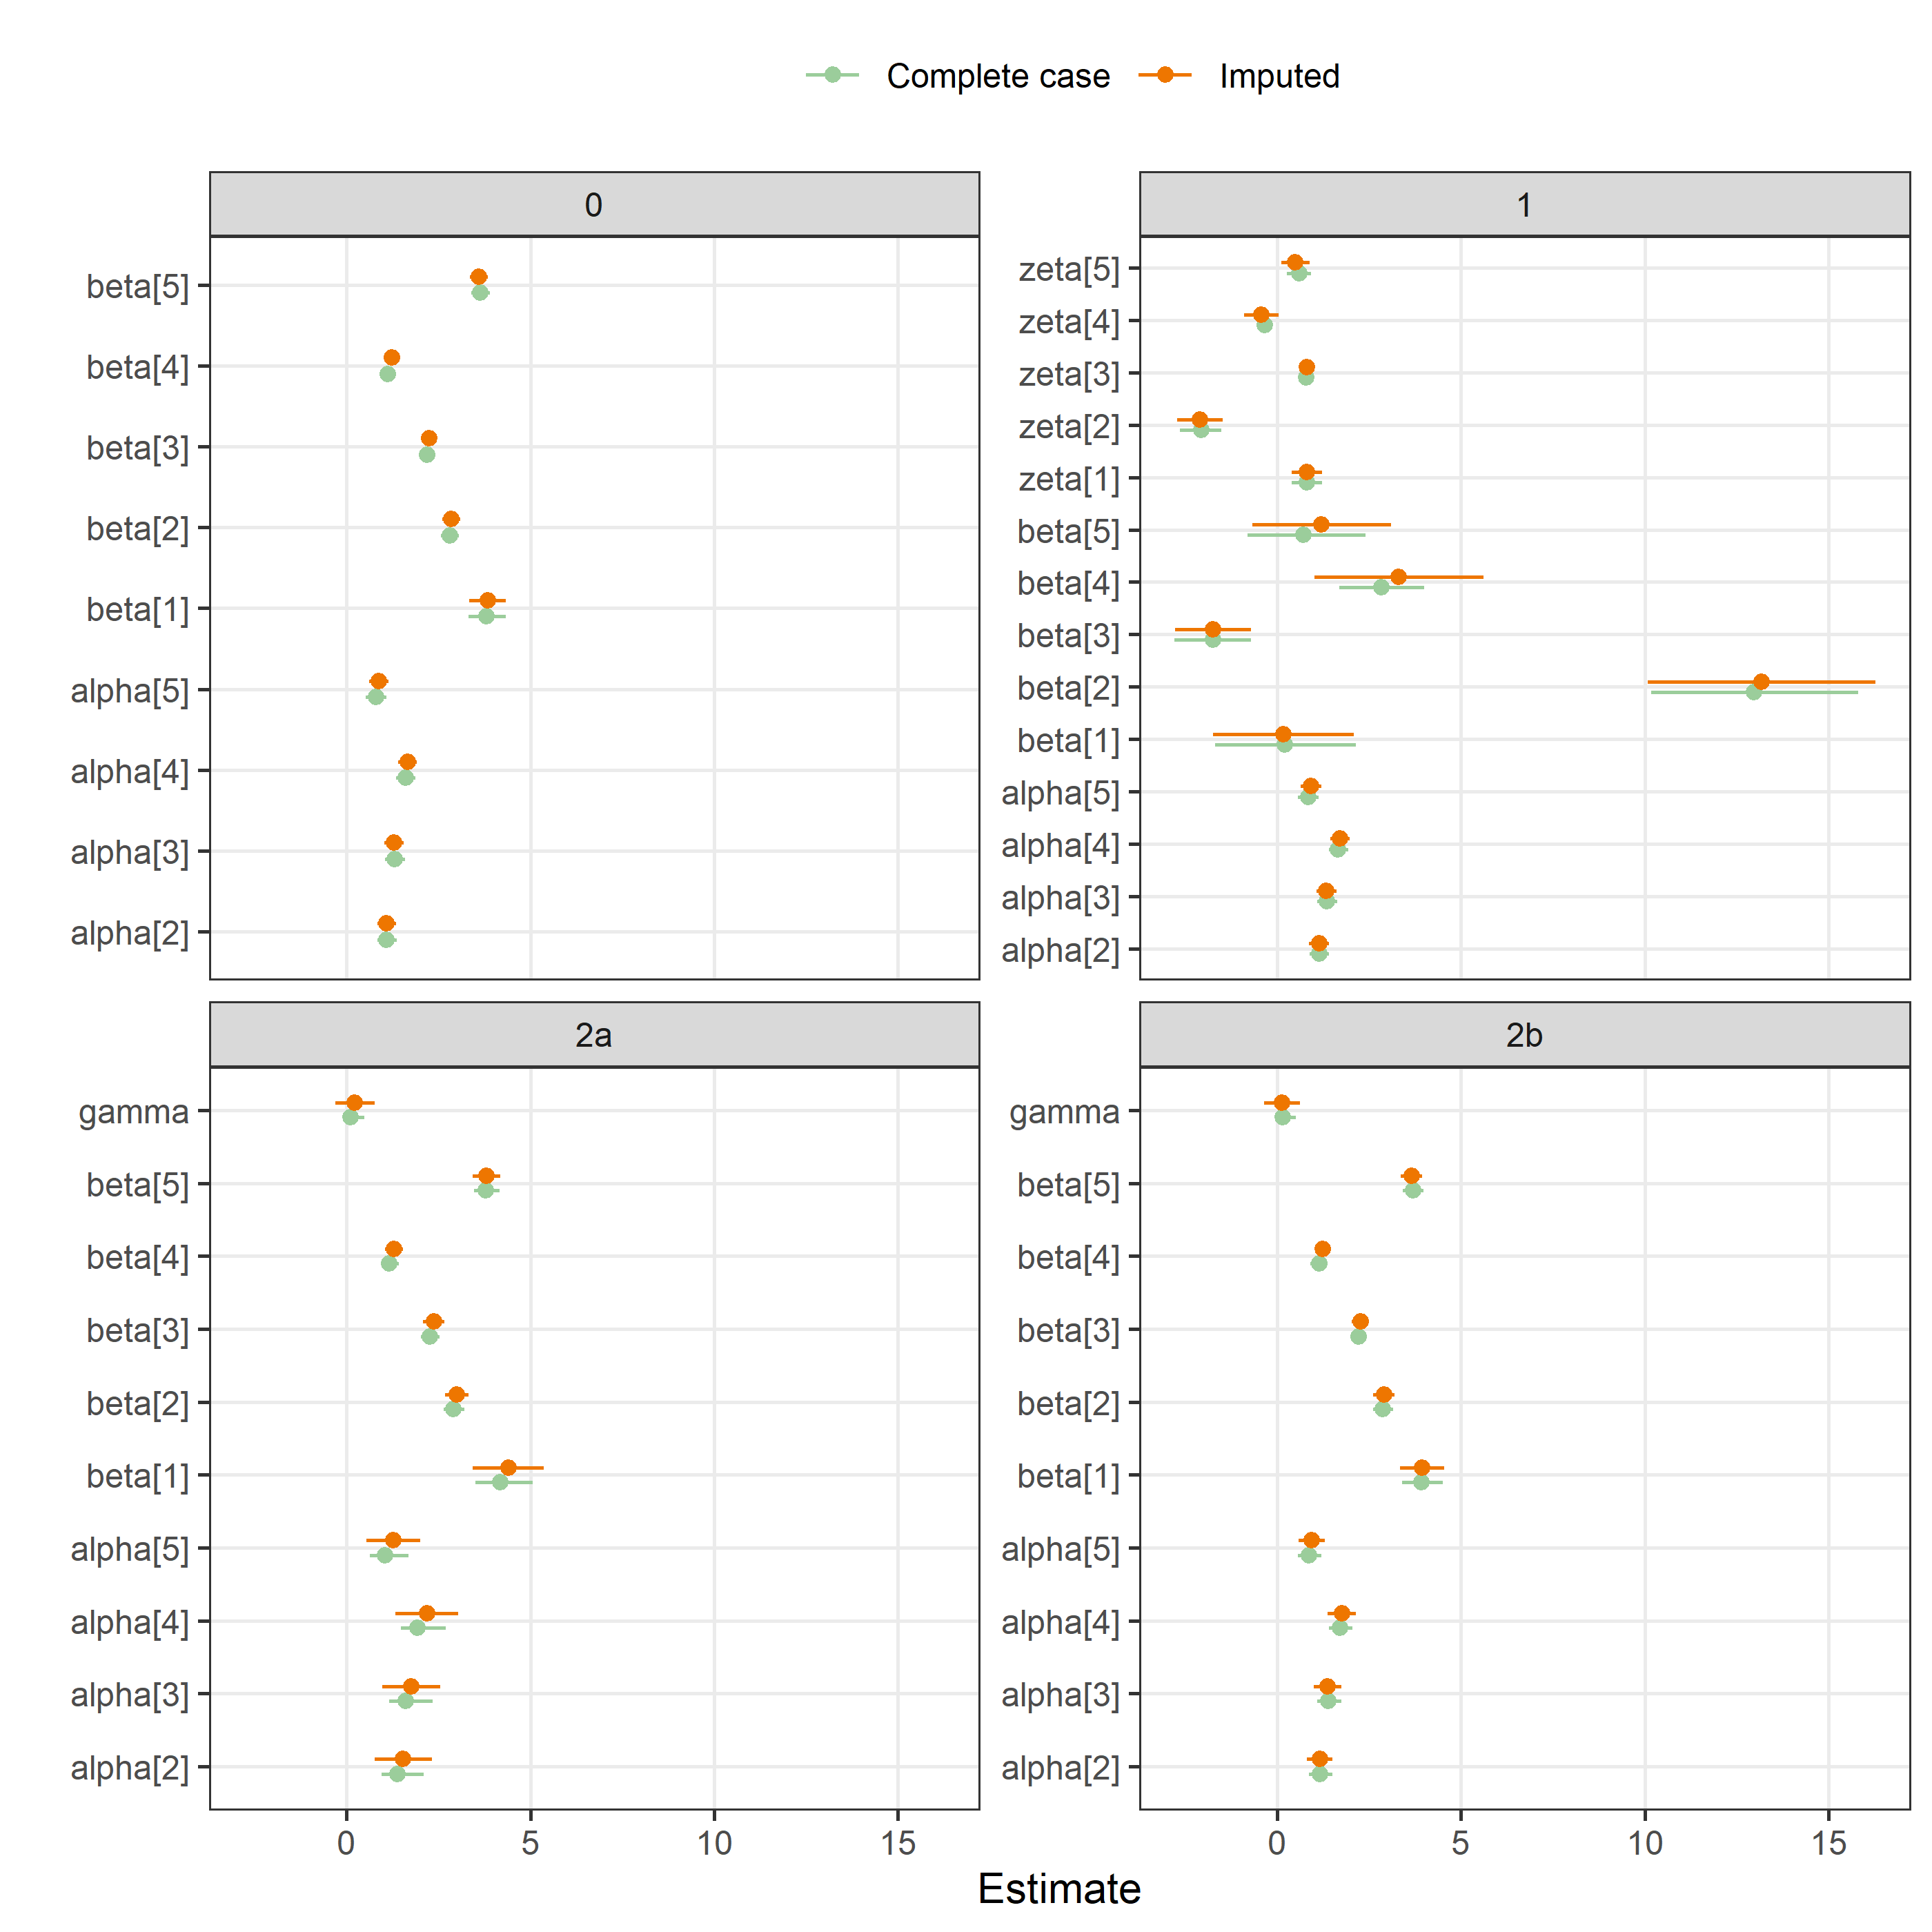

# Compare fitted results for best model

Comparing the probability estimates for the complete case and imputed data.

## BMJ and protocol

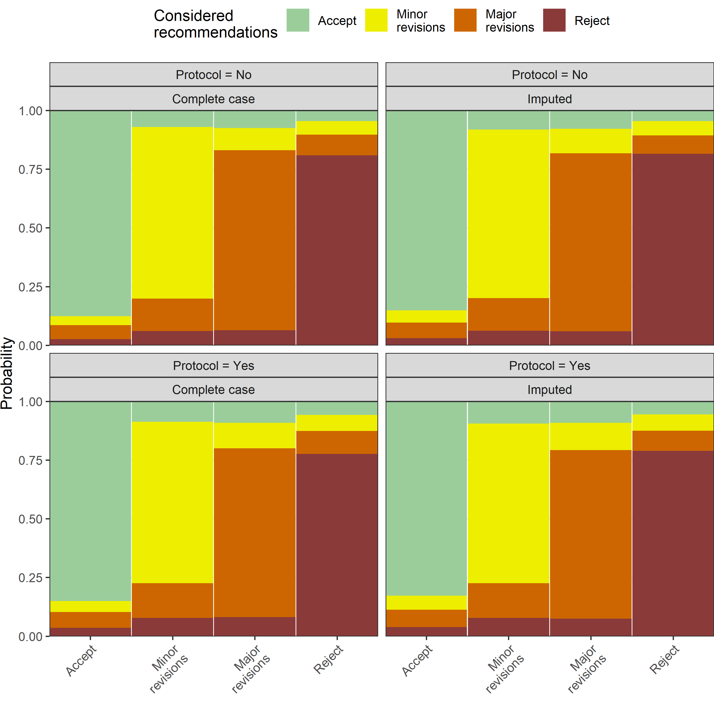

## Epidemiology and gender

