Figure 1: Percentages of reviews and submissions by hour of day and journal.

Figure 2: Estimates of when countries are most likely to submit submissions or peer reviews compared with the average. The x-axis is the peak time and the y-axis is the probability ratio, which gives the relative change from the average.

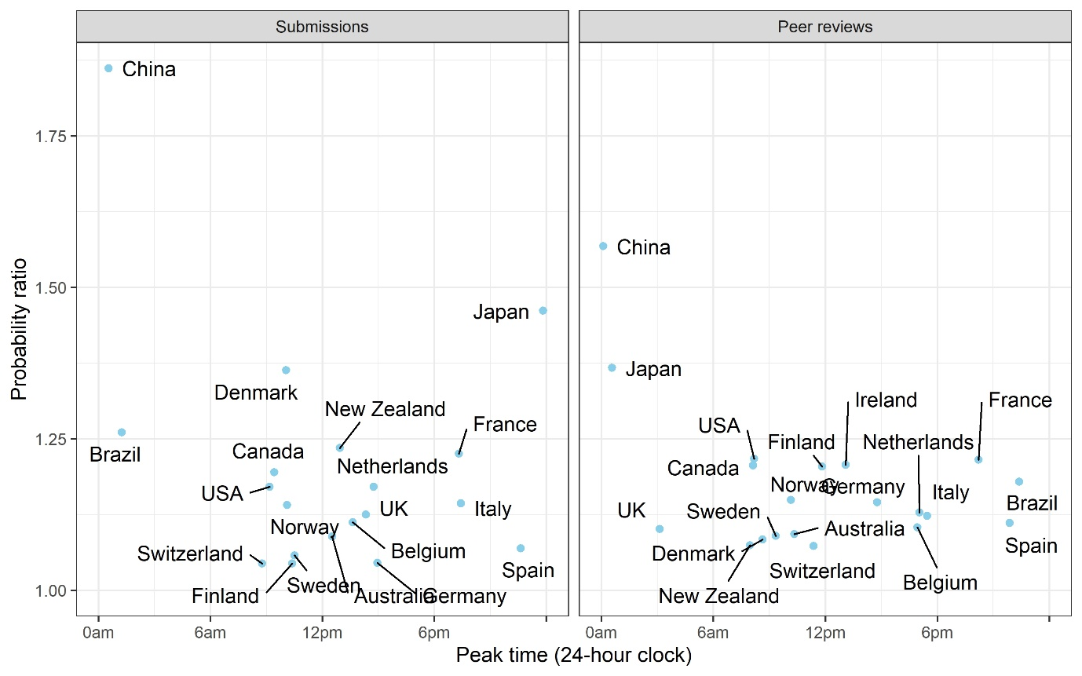

Figure 3: Country-specific probabilities for weekend submissions to The BMJ and BMJ Open. The dots are the means and the horizontal lines are 95% credible intervals

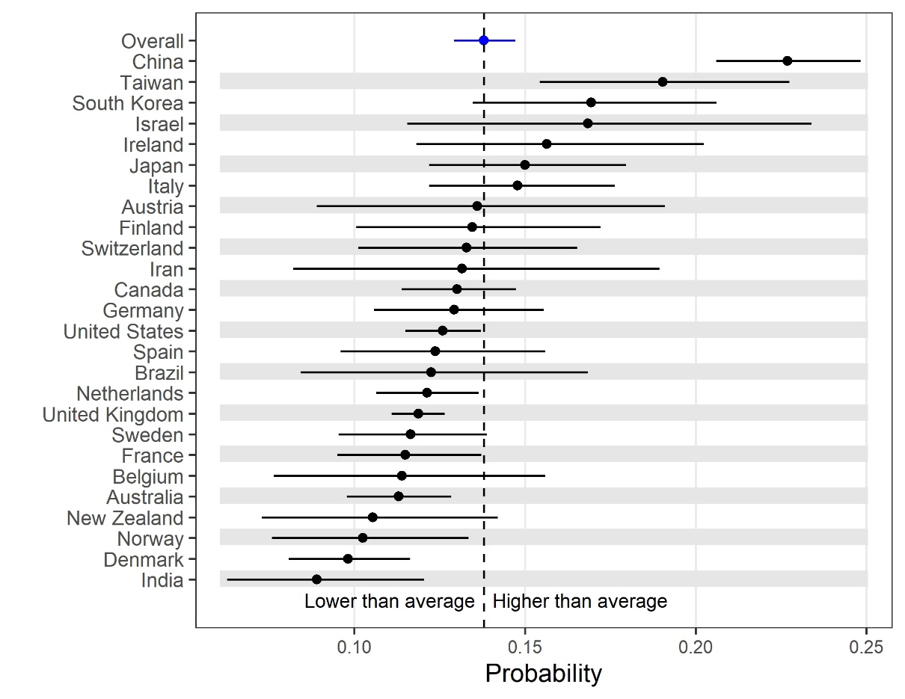

Figure 4: Each country’s probability of submitting on weekends and holidays. Countries are ordered based on their average probability. The plot only includes countries with over 100 submissions or peer reviews for all 8 outcomes.

