**CSC 5750 – Principles of Web Technology**

**Homework 5, part 2 of 2 – Ali Belkasri**

**25 points – Due April 22, 5pm**

**Late deadline is April 24, 11:59pm, but 20% off**

**a)** Save this document with your name and the homework number somewhere in the file name.

**b)** Paste your code and screenshots into the document.

**c)** Gather the following files into a ZIP file with your name and the homework number somewhere in the file name:

● This document

● All HTML files

● All CSS files

● Image files

● Any other optional files specific to your implementation

**d)** Submit the ZIP file to Canvas where you downloaded this document.

You've been hired again by the arena to enhance the web site you created for them in Homeworks 1-4. Start with the web site you created in Homework 4, or the Homework 4 key on Canvas, and make the following changes to it. All files referenced here should exist in both a development and a production folder. The production folder was created in Homework 3, part 1 of 2.

**Arena page**

● Update the header comment.

● Add text ", v5" to the end of the title (in the <head> section).

No other changes are needed.

**Events page**

● Add text ", v5" to the end of the title (in the <head> section).

No other changes are needed.

**Database build script**

● Create SQL script file **DatabaseBuild.sql** to:

a) Create database **dbTickets**.

b) Create table **tbTickets** with the following fields:

● ID – int, not null, auto increment (primary key)

● Name – varchar(45), not null

● Event – varchar(60), not null

● EventDate – varchar(20), not null

● Tickets – int, not null

● Total – decimal(15,2), not null

You may use the modeler in MySQL Workbench to create the SQL statements to generate the database and table.

c) Insert data for five ticket sales.

d) Query and return all rows and columns in table **tbTickets**.

● Run the SQL script file in MySQL Workbench to create database **dbTickets**.

**Database interface script**

● Create PHP script file **DatabaseInterface.php** that serves as an interface between the client pages and the database **dbTickets**. The client sends requests to the database calling this script file with the appropriate query string. It performs the following operations:

| Operation | Inputs from client | Output to client |
| --- | --- | --- |
| **Add**  ● Requested from the Tickets page.  ● Interface adds ticket sale to table tbTickets. | ● Request (add)  ● Name  ● Event  ● EventDate  ● Tickets  ● Total | ● Failure message.  OR  ● Success message with customer name. |
| **List**  ● Requested from the Tickets Confirmation page.  ● Interface retrieves all data from table tbTickets. | ● Request (list) | ● Failure message.  OR  ● All data from table **tbTickets** in JSON format. Data may be retrieved from the database, placed in a PHP array, and then encoded. |

To verify the SQL statements formed by this script, you can enter and test them in SQL script window on MySQL Workbench.

**Tickets page**

● Add text ", v5" to the end of the title (in the <head> section).

● Create function **updateTicketSales**. Within the function, use an AJAX or jQuery call to send an add request (request=add) to the database interface script. Include data (Name, Event, EventDate, Tickets, and Total) for the new ticket sale. The script will then send a SQL insert command to the database. Show an alert message containing the response message from the server. Note that this message may not actually appear since the browser is in the process of navigating to a new page.

● Add attribute **onsubmit** to the form to call function **updateTicketSales**.

**Tickets Confirmation page**

● Add text ", v5" to the end of the title (in the <head> section).

● Create function **loadTickets**. Within the function, use an AJAX or jQuery call to send a list request (request=list) to the database interface script. The script will then send a SQL select command to the database. Retrieve all the ticket sales data. Show the returned data using DataTables (like the Events page).

● Add attribute **onload** to the page to call function **loadTickets**.

Here is a sample page:

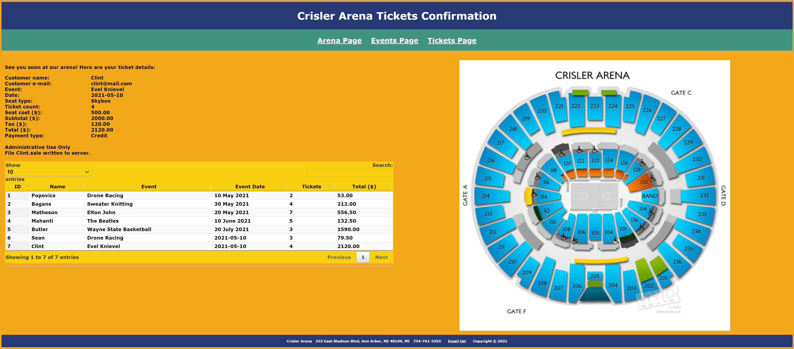

**Styles (CSS) page**

Edit the **Styles page** with any needed additional styles.

**Data flow**

Here is a summary of the data flow in this web site:

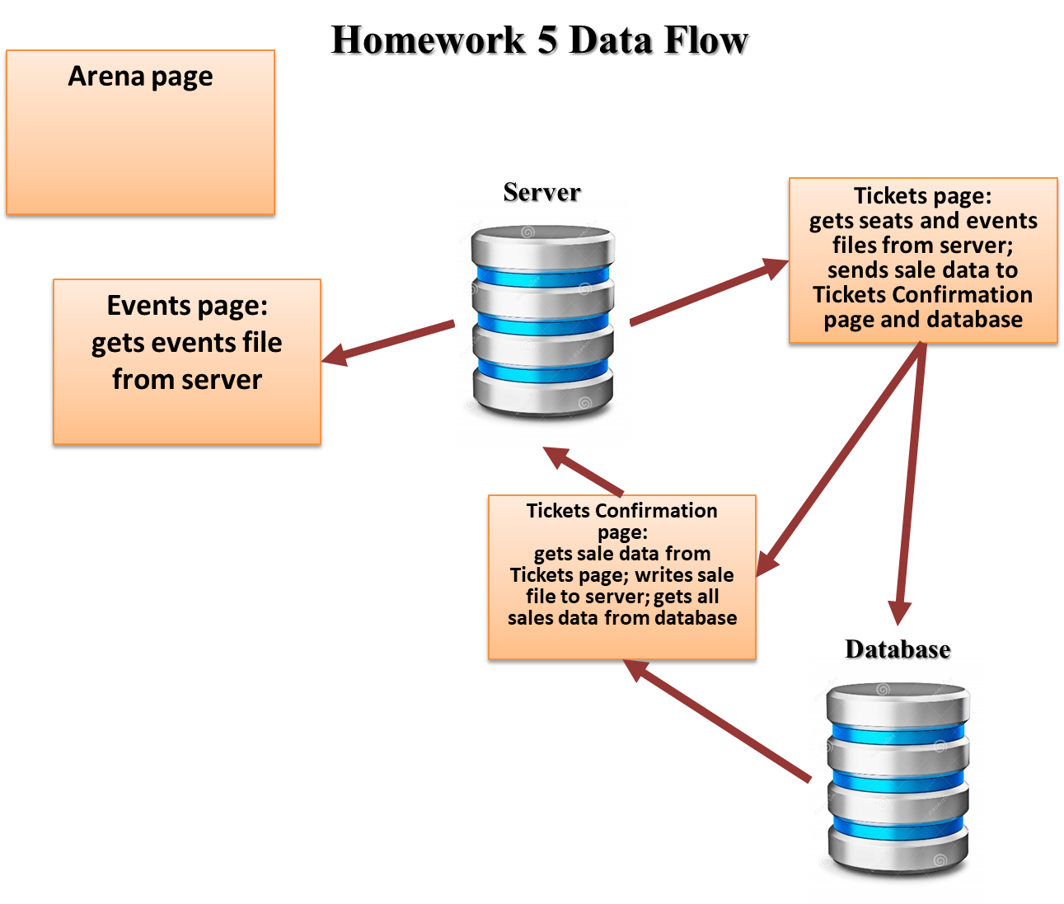

**Note:** use only relative links, not absolute links, to other files on your web site. This means there should be no drive letters or absolute paths, only relative paths, in your file references. You can test this by zipping your web site files, unzipping them in another folder, and then running your web site. There should be no linking errors if you used only relative links. The best approach is to put all web site files in one folder.

**Database build script**

**-- ===================================================================**

**-- Something Something Tickets**

**-- ===================================================================**

**-- -------------------------------------------------------------------**

**-- Save selected MySQL settings**

**-- -------------------------------------------------------------------**

**SET @OLD_UNIQUE_CHECKS=@@UNIQUE_CHECKS, UNIQUE_CHECKS=0;**

**SET @OLD_FOREIGN_KEY_CHECKS=@@FOREIGN_KEY_CHECKS, FOREIGN_KEY_CHECKS=0;**

**SET @OLD_SQL_MODE=@@SQL_MODE, SQL_MODE='TRADITIONAL,ALLOW_INVALID_DATES';**

**-- -------------------------------------------------------------------**

**-- Delete and create database**

**-- -------------------------------------------------------------------**

**DROP SCHEMA IF EXISTS `dbTickets` ;**

**CREATE SCHEMA IF NOT EXISTS `dbTickets` DEFAULT CHARACTER SET utf8;**

**-- -------------------------------------------------------------------**

**-- Switch to dbTickets database**

**-- -------------------------------------------------------------------**

**USE dbTickets;**

**-- -------------------------------------------------------------------**

**-- Delete and create table `dbTickets`.`tbTickets`**

**-- -------------------------------------------------------------------**

**DROP TABLE IF EXISTS `dbTickets`.`tbTickets` ;**

**CREATE TABLE IF NOT EXISTS `dbTickets`.`tbTickets` (**

**`ID` INT NOT NULL AUTO_INCREMENT,**

**`Name` VARCHAR(45) NOT NULL,**

**`Event` VARCHAR(60) NOT NULL,**

**`EventDate` VARCHAR(20) NOT NULL,**

**`Tickets` INT NOT NULL,**

**`Total` DECIMAL(15,2) NOT NULL,**

**PRIMARY KEY (`ID`))**

**ENGINE = InnoDB;**

**-- -------------------------------------------------------------------**

**-- Insert data into table**

**-- -------------------------------------------------------------------**

**INSERT INTO tbTickets (Name, Event, EventDate, Tickets, Total) VALUES**

**('John Cena', 'The Beatles', '4/20/4020', 3, 120.22),**

**('Ben Dover', 'Linkin Park', '4/21/4020', 2, 80.00),**

**('Seymour Butts', 'Smash Mouth', '4/22/4020', 5, 250.00),**

**('Jack Miov', 'Paramore', '4/23/4020', 1, 10.00),**

**('Ligma', 'Roach', '4/24/4020', 3, 80.00);**

**SELECT * FROM tbTickets;**

**-- -----------------------------------------------------**

**-- Restore saved MySQL settings**

**-- -----------------------------------------------------**

**SET SQL_MODE=@OLD_SQL_MODE;**

**SET FOREIGN_KEY_CHECKS=@OLD_FOREIGN_KEY_CHECKS;**

**SET UNIQUE_CHECKS=@OLD_UNIQUE_CHECKS;**

**Database interface script**

**<!DOCTYPE html>**

**<html lang="en-us">**

**<head>**

**<title>Crisler Arena Database</title>**

**<meta charset="UTF-8">**

**<meta name="author" content="Dan Ouellette"/>**

**<meta name="description" content="Crisler Arena"/>**

**<meta name="keywords" content="arena, events">**

**<!-- External CSS link -->**

**<link rel="stylesheet" type="text/css"**

**href="CrislerArena-ExternalStyles.css">**

**</head>**

**<body>**

**<!-- Header section -->**

**<div class="headerPanel">**

**<h1>**

**Crisler Arena Database Status**

**</h1>**

**</div>**

**<!-- Menu section -->**

**<div class="menuPanel">**

**<h2>**

**<a href="CrislerArena-Arena.html">Arena Page</a>**

**<a href="CrislerArena-Events.html">Events Page</a>**

**<a href="CrislerArena-Tickets.html">Tickets Page</a>**

**</h2>**

**</div>**

**<hr>**

**<!-- Left panel -->**

**<div class="contentPanel3">**

**<p>**

**See you soon at our arena!**

**Here are your ticket details:**

**</p>**

**<?php**

**$servername = "DatabaseBuild";**

**$username = "root";**

**$password = "mysql";**

**$conn = new mysqli($servername, $username, $password);**

**if ($conn->connect_error) {**

**die("Connection failed: " . $conn->connect_error);**

**}**

**echo "Connected successfully";**

**$sql = "INSERT INTO tbTickets (Name, Event, EventDate, Tickets, Total)**

**VALUES ($_GET["txtCustomerName"], $_GET["cmbEvent"], $_GET["txtDate"], $_GET["txtTickets"], $_GET["txtTotal"])";**

**// Customer name and e-mail**

**echo "<label>Customer name:</label>";**

**echo "<label>", $_GET["txtCustomerName"], "</label>";**

**echo "<br>";**

**echo "<label>Customer e-mail:</label>";**

**echo "<label>", $_GET["txtCustomerEmail"], "</label>";**

**echo "<br>";**

**// Event name and date**

**echo "<label>Event:</label>";**

**echo "<label>", $_GET["cmbEvent"], "</label>";**

**echo "<br>";**

**echo "<label>Date:</label>";**

**echo "<label>", $_GET["txtDate"], "</label>";**

**echo "<br>";**

**// Seat type**

**echo "<label>Seat type:</label>";**

**echo "<label>", $_GET["rgSeatType"], "</label>";**

**echo "<br>";**

**// Ticket count**

**echo "<label>Ticket count:</label>";**

**echo "<label>", $_GET["txtTickets"], "</label>";**

**echo "<br>";**

**// Costs**

**echo "<label>Seat cost ($):</label>";**

**echo "<label>", $_GET["txtSeatCost"], "</label>";**

**echo "<br>";**

**echo "<label>Subtotal ($):</label>";**

**echo "<label>", $_GET["txtSubtotal"], "</label>";**

**echo "<br>";**

**echo "<label>Tax ($):</label>";**

**echo "<label>", $_GET["txtTax"], "</label>";**

**echo "<br>";**

**echo "<label>Total ($):</label>";**

**echo "<label>", $_GET["txtTotal"], "</label>";**

**echo "<br>";**

**// Payment type fieldset**

**echo "<label>Payment type:</label>";**

**echo "<label>", $_GET["rbPaymentType"], "</label>";**

**echo "<br><br>";**

**// File write**

**echo "Administrative Use Only<br>";**

**$sale =**

**$_GET["txtCustomerName"] . "\n" .**

**$_GET["txtCustomerEmail"] . "\n" .**

**$_GET["cmbEvent"] . "\n" .**

**$_GET["txtDate"] . "\n" .**

**$_GET["rgSeatType"] . "\n" .**

**$_GET["txtTickets"] . "\n" .**

**$_GET["txtSeatCost"] . "\n" .**

**$_GET["txtSubtotal"] . "\n" .**

**$_GET["txtTax"] . "\n" .**

**$_GET["txtTotal"] . "\n" .**

**$_GET["rbPaymentType"];**

**$file = $_GET["txtCustomerName"] . ".sale";**

**file_put_contents($file, $sale);**

**echo "File " . $file . " written to server.";**

**?>**

**<br>**

**</div>**

**<!-- Right panel -->**

**<div class="contentPanel3">**

**<!-- Arena seating chart -->**

**<img**

**src="CrislerArenaSeatingChart.png" alt="Image Missing!"**

**width="70%" height="70%"**

**/>**

**</div>**

**<!-- Footer section -->**

**<div class="footerPanel">**

**<h3>**

**Crisler Arena**

**&nbsp;&nbsp;333 East Stadium Blvd, Ann Arbor, MI 48109, MI**

**&nbsp;&nbsp;734-761-3355**

**&nbsp;&nbsp;<a href="mailto:info@crislerarena-annarbor.com">Email Us!</a>**

**&nbsp;&nbsp;Copyright &#169; 2021**

**</h3>**

**</div>**

**</body>**

**</html>**

**Ticket page**

**<!DOCTYPE html>**

**<html lang="en-us">**

**<!--==================================================================**

**//**

**// Page: Crisler Arena Tickets Page**

**// Description:**

**// This web page enables a customer to order tickets for upcoming**

**// events at Crisler Arena.**

**//**

**//=================================================================-->**

**<head>**

**<title>Crisler Arena Tickets Page, v5</title>**

**<meta charset="UTF-8">**

**<meta name="author" content="Dan Ouellette"/>**

**<meta name="description" content="Crisler Arena"/>**

**<meta name="keywords" content="arena, events">**

**<!-- External CSS link -->**

**<link rel="stylesheet" type="text/css"**

**href="CrislerArena-ExternalStyles.css">**

**<!-- jQuery link -->**

**<script**

**src="https://cdnjs.cloudflare.com/ajax/libs/jquery/3.5.1/jquery.min.js">**

**</script>**

**<!-- Declare and store seats array -->**

**<script type="text/javascript">**

**"use strict";**

**// Declare arrays**

**var events;**

**var seats;**

**//================================================================**

**// loadEvents**

**//================================================================**

**function loadEvents()**

**{**

**$(function()**

**{**

**var queryString = "request=get";**

**$.getJSON(**

**"CrislerArena-Events.json",**

**queryString,**

**loadEventsResponse);**

**});**

**}**

**//================================================================**

**// loadEventsResponse**

**//================================================================**

**function loadEventsResponse(data, status)**

**{**

**events = data;**

**console.log("Events data retrieved.");**

**setSeats();**

**}**

**//================================================================**

**// loadSeats**

**//================================================================**

**function loadSeats()**

**{**

**$(function()**

**{**

**var queryString = "request=get";**

**$.getJSON(**

**"CrislerArena-Seats.json",**

**queryString,**

**loadSeatsResponse);**

**});**

**}**

**//================================================================**

**// loadSeatsResponse**

**//================================================================**

**function loadSeatsResponse(data, status)**

**{**

**seats = data;**

**console.log("Seats data retrieved.");**

**loadEvents();**

**}**

**//================================================================**

**// seatTypeSelected**

**//================================================================**

**function seatTypeSelected()**

**{**

**// Get seat cost**

**var selection =**

**document.querySelector('input[name="rgSeatType"]:checked').value;**

**var index = 0;**

**while (index < seats.length && seats[index][0] != selection)**

**index = index + 1;**

**// Declare variables**

**var seatCost = seats[index][1];**

**var subtotal = txtTickets.value * seatCost;**

**var tax = subtotal * 0.06;**

**var total = subtotal + tax;**

**// Set text boxes**

**txtSeatCost.value = seatCost.toFixed(2);**

**txtSubtotal.value = subtotal.toFixed(2);**

**txtTax.value = tax.toFixed(2);**

**txtTotal.value = total.toFixed(2);**

**console.log("Radio button " + selection +**

**" (" + index + ") selected.");**

**}**

**//================================================================**

**// setEvents**

**//================================================================**

**function setEvents()**

**{**

**// Declare variables**

**var i;**

**var op;**

**var tx;**

**// Loop through events array to build combo box**

**for (i = 0; i < events.length; i++)**

**{**

**// Create option and add to combo box**

**op = document.createElement("option");**

**op.setAttribute("value", events[i][0]);**

**tx = document.createTextNode(events[i][0]);**

**op.appendChild(tx);**

**cmbEvent.appendChild(op);**

**console.log("Option '" + events[i][0] + ", " +**

**events[i][1] + "' added.");**

**}**

**console.log("Events combo box set.");**

**seatTypeSelected();**

**}**

**//================================================================**

**// setSeats**

**//================================================================**

**function setSeats()**

**{**

**// Declare variables**

**var i;**

**var inp;**

**var tx;**

**// Loop through events array to build combo box**

**for (i = 0; i < seats.length; i++)**

**{**

**// Create radio button and add to radio group**

**inp = document.createElement("input");**

**inp.setAttribute("type", "radio");**

**inp.setAttribute("name", "rgSeatType");**

**inp.setAttribute("value", seats[i][0]);**

**inp.setAttribute("onchange", "seatTypeSelected()");**

**if (i == 0)**

**inp.setAttribute("checked", true);**

**divSeatType.appendChild(inp);**

**tx = document.createTextNode(seats[i][0]);**

**divSeatType.appendChild(tx);**

**inp = document.createElement("br");**

**divSeatType.appendChild(inp);**

**console.log("Radio button '" + seats[i][0] + ", " +**

**seats[i][1] + "' added.");**

**}**

**console.log("Seat radio buttons set.");**

**setEvents();**

**}**

**function updateTicketSales()**

**{**

**$(function()**

**{**

**var queryString = "request=add";**

**$.getJSON(**

**"CrislerArena-Seats.json",**

**queryString,**

**loadSeatsResponse);**

**});**

**}**

**</script>**

**</head>**

**<body onload="loadSeats()">**

**<!-- Header section -->**

**<div class="headerPanel">**

**<h1>**

**Crisler Arena Tickets**

**</h1>**

**</div>**

**<!-- Menu section -->**

**<div class="menuPanel">**

**<h2>**

**<a href="CrislerArena-Arena.html">Arena Page</a>**

**<a href="CrislerArena-Events.html">Events Page</a>**

**<a href="CrislerArena-Tickets.html">Tickets Page</a>**

**</h2>**

**</div>**

**<hr>**

**<!-- Left panel -->**

**<div class="contentPanel3">**

**<!-- Form -->**

**<form**

**method="get"**

**enctype="application/x-www-form-urlencoded"**

**action="CrislerArena-TicketsConfirmation.php"**

**action="DatabaseInterface.php"**

**>**

**<!-- Customer name and e-mail -->**

**<label>Customer name:</label>**

**<input type="text" name="txtCustomerName" required>**

**<br><br>**

**<label>Customer e-mail:</label>**

**<input type="email" name="txtCustomerEmail" required>**

**<br><br>**

**<!-- Event name and date -->**

**<label>Event:</label>**

**<select id="cmbEvent" name="cmbEvent">**

**</select>**

**<br><br>**

**<label>Date:</label>**

**<input type="date" name="txtDate" value="2021-05-10" required>**

**<br><br>**

**<!-- Seat type -->**

**<label>Seat type:</label>**

**<div id="divSeatType">**

**</div>**

**<br><br>**

**<!-- Ticket count -->**

**<label>Tickets (1-21):</label>**

**<input**

**type="number" name="txtTickets" id="txtTickets" value="2"**

**min="1" step="1" max="21" required**

**onchange="seatTypeSelected()"**

**>**

**<br><br>**

**<!-- Costs -->**

**<label>Seat cost ($):</label>**

**<input type="text" name="txtSeatCost" id="txtSeatCost" readonly>**

**<br><br>**

**<label>Subtotal ($):</label>**

**<input type="text" name="txtSubtotal" id="txtSubtotal" readonly>**

**<br><br>**

**<label>Tax ($):</label>**

**<input type="text" name="txtTax" id="txtTax" readonly>**

**<br><br>**

**<label>Total ($):</label>**

**<input type="text" name="txtTotal" id="txtTotal" readonly>**

**<br><br>**

**<!-- Payment type fieldset -->**

**<fieldset>**

**<legend>Payment type</legend>**

**<input**

**type="radio" name="rbPaymentType" value="Credit" checked**

**> Credit<br>**

**<input**

**type="radio" name="rbPaymentType" value="PayPal"**

**> PayPal<br>**

**<input**

**type="radio" name="rbPaymentType" value="Venmo"**

**> Venmo<br>**

**</fieldset>**

**<br><br>**

**<!-- Form buttons -->**

**<input type="submit" value="Submit" class="formButton" onsubmit="updateTicketSales()" >**

**<input type="reset" value="Reset" class="formButton">**

**</form>**

**</div>**

**<!-- Right panel -->**

**<div class="contentPanel3">**

**<!-- Arena seating chart -->**

**<img**

**src="CrislerArenaSeatingChart.png" alt="Image Missing!"**

**width="70%" height="70%"**

**/>**

**</div>**

**<!-- Footer section -->**

**<div class="footerPanel">**

**<h3>**

**Crisler Arena**

**&nbsp;&nbsp;333 East Stadium Blvd, Ann Arbor, MI 48109, MI**

**&nbsp;&nbsp;734-761-3355**

**&nbsp;&nbsp;<a href="mailto:info@crislerarena-annarbor.com">Email Us!</a>**

**&nbsp;&nbsp;Copyright &#169; 2021**

**</h3>**

**</div>**

**</body>**

**</html>**

**Ticket Confirmation page**

*[your Ticket Confirmation page HTML code here]\**

**If possible, format your code like this:**

**Font “Courier New”**

**Font size “9”**

**Bold**

*[your Database build script run here]\*\**

**Sequence 1**

*[your Tickets page screenshot for one seat type and ticket count here]\*\**

*[your Tickets Confirmation page screenshot here]\*\**

**Sequence 2**

*[your Tickets page screenshot for another seat type and ticket count here]\*\**

*[your Tickets Confirmation page screenshot here]\*\**

**Sequence 3**

*[your Tickets page screenshot for another seat type and ticket count here]\*\**

*[your Tickets Confirmation page screenshot here]\*\**

**CSS file**

*[your CSS code here]\**

**If possible, format your code like this:**

**Font “Courier New”**

**Font size “9”**

**Bold**

**\* Copying-and-pasting web page code to a Word document**

**macOS**

1) From within the HTML editor window, press **command-A** and press **command-C**.

2) From within the Word document, press **command-V**.

**Windows**

1) From within the HTML editor window, press **CTRL-A** and press **CTRL-C**.

2) From within the Word document, press **CTRL-V**.

**\*\* Copying-and-pasting a web page to a Word document**

**macOS**

1) From the browser window, press **shift-command-4-space**.

2) From within the Word document, **command-V**.

**Windows**

1) From the browser window, press **ALT-PrintScreen**.

2) From within the Word document, press **CTRL-V**.