SQL INJECTION ON WEB APPLICATION

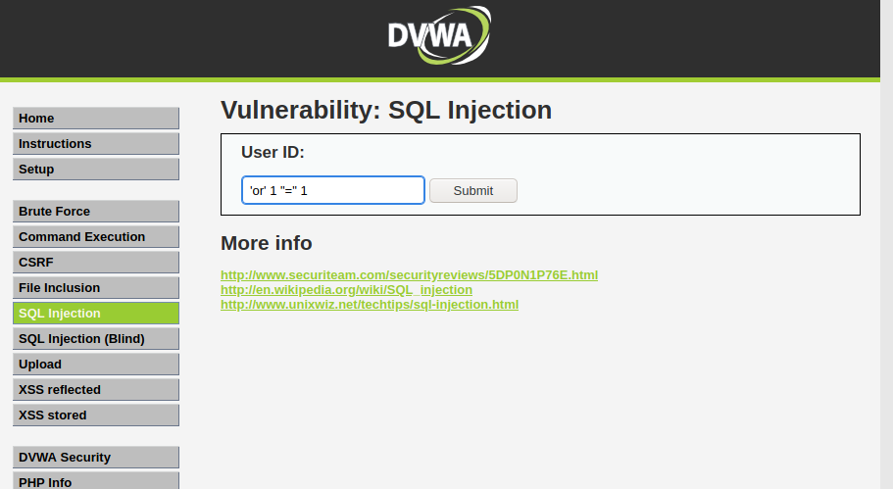

Injection SQL code on text input to bypass and retrieve all the content in the table

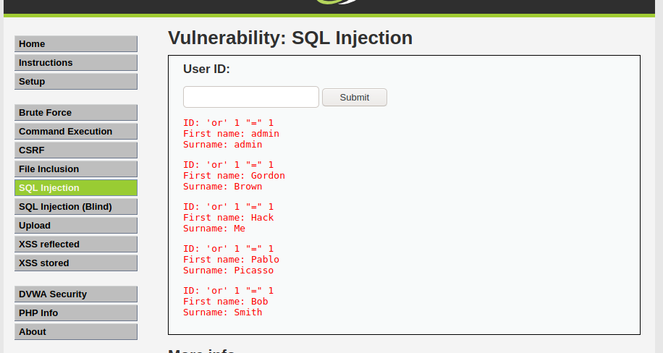

Content of the dump table in the database

Using SQLMap and Burp Suit for SQL injection



Installation of SQLMAP

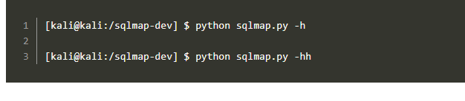

Running of SQLMAP

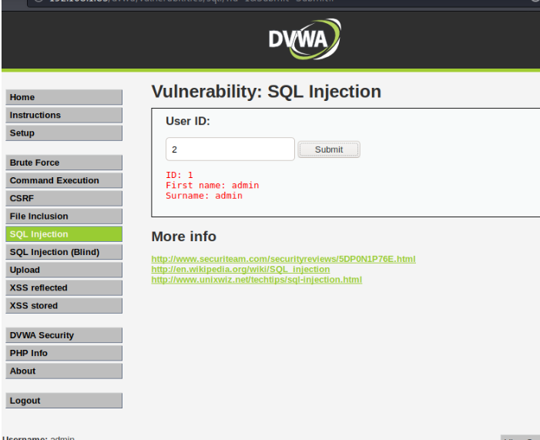

Logining in to Web app to get the session ID

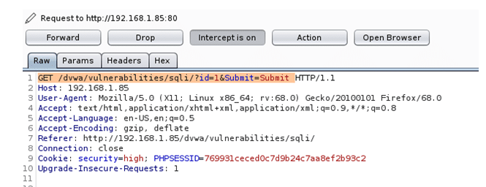

Create a request file in Burp suite

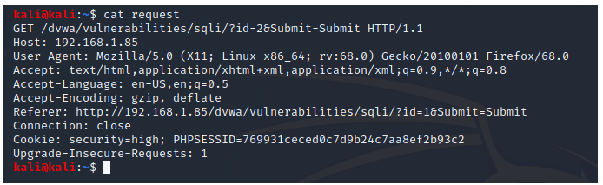

Display of the request file create with Burp Suite

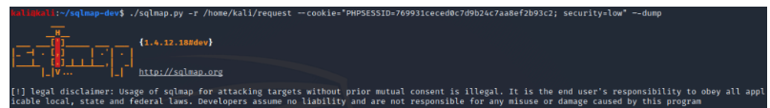

Running of the SQLMap with the Request file created for SQL injection attack

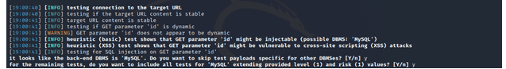

Running and dumping of web database

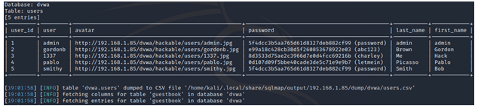

Content of dump database on the server