Password Policy Audit – Evidence File

# Section 1: Pre-Audit Configuration Screenshots

📸 Minimum Password Length (8 characters)

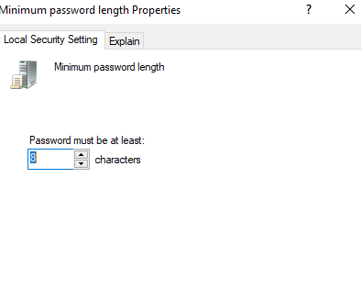

📸 Password Complexity Disabled

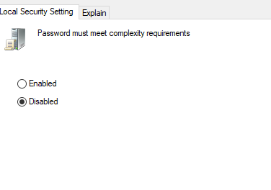

📸 Password History Set to 1

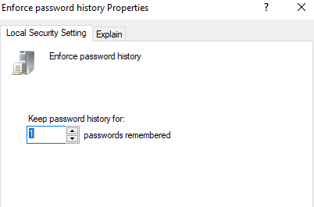

📸 Password Age Set to 180 Days

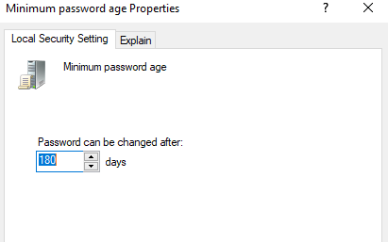

📸 Account Lockout Duration = 5 Minutes

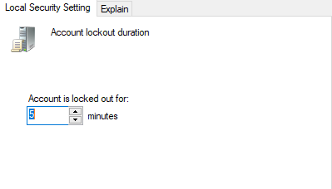

📸 Account Lockout Threshold = 20 Attempts

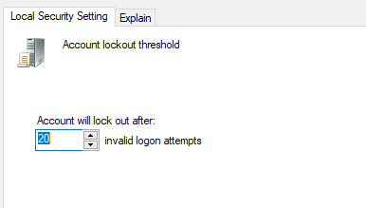

📸 net accounts Output (Pre-Fix)

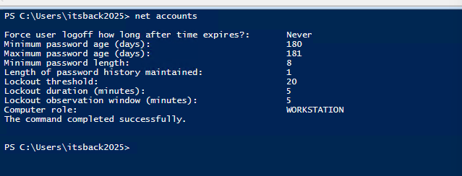

📸 PasswordLastSet Output (Pre-Fix)

