Password Policy Audit – Evidence File

# Section 1: Pre-Audit Configuration Screenshots

See previous version of this file for before-remediation evidence.

# Section 2: Post-Remediation Verification

The following configurations were remediated by IT Lead *Stone Cold Steve Austin* in alignment with PCI DSS Requirement 8. Changes were verified via direct observation and CLI output. Separation of duties was maintained — auditor did not apply changes directly.

📸 Minimum Password Length Set to 12

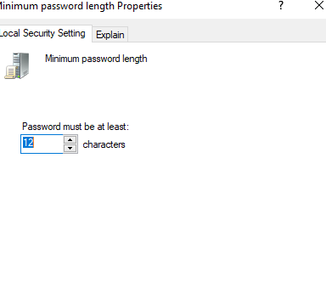

📸 Password Complexity Enabled

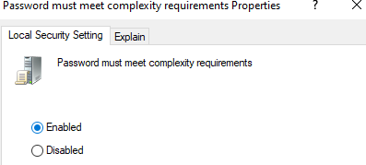

📸 Password History Set to 4

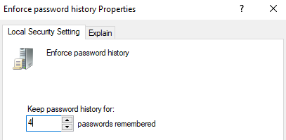

📸 Maximum Password Age Set to 90 Days

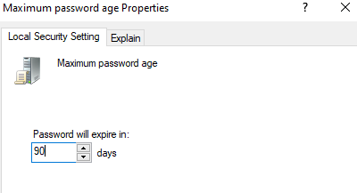

📸 Lockout Threshold Set to 10

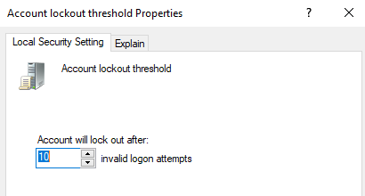

📸 (Duplicate) Lockout Threshold Screenshot

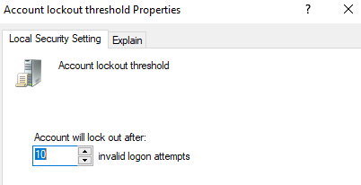

📸 Lockout Duration Set to 30 Minutes

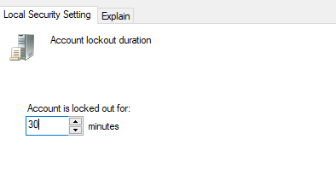

📸 CLI Output – net accounts Confirmation

